Over-The-Counter FX Margin Trading Report

(January 2025 ～ )

Monthly Report
January 2025
February 2025
March 2025
April 2025
May 2025
June 2025
July 2025
August 2025

The Financial Futures Association of Japan, Research Department

NBF Ogawamachi Building 1-3 , Kanda Ogawamachi ,
Chiyoda-ku , Tokyo 101-0052 Tel:(03)5280-0881 E-mail : ffaj@ffaj.or.jp

This publication has been prepared by the FFAJ and is provided for information purpose only. The monthly information contained in this publication has been obtained from FFAJ's members that is believed to be reliable, however the FFAJ does not represent or warrant that it is accurate or complete. In no event the FFAJ nor its employees have any liability for any consequential damages arising from any use of this publications or its contents. This publication does not constitute any investment advice.

Monthly statistical report on Over-The-Counter Retail FX Margin Trading

：August , 2025
Publication date: 12 September. 2025
Number of Over-The-Counter Retail FX Margin Trading Operators as of 31 August. 2025 :45
Number of members reported :45
【Trading Volume】
(Unit: hundred million Yen, %)
 | Over-The-Counter | USDJPY, Cross Yen | On-Exchange*(for reference)
This month | 9,802,167 | 9,513,252 | 12,504
Previous month | 11,655,237 | 11,330,550 | 15,767
Change | -15.90% | -16.04% | -20.70%
*source : Monthly Trading Volume of Tokyo Financial exchange Inc.(The FFAJ converts the total number of contracts into the trading volume on the settlement prices of the end of the month)
【Open Positions】
(Unit: hundred million Yen)
 | Short | Long | Total
This month | 41,486 | 51,275 | 92,762
Previous month | 46,364 | 41,855 | 88,220
Change | -4,877 | 9,419 | 4,542

・USDJPY, Cross Yen Open Positions
(Unit: hundred million Yen)
 | ① Short | ② Long | Net long=②-①
This month | 46,912 | 34,253 | -12,658
Previous month | 36,826 | 40,539 | 3,712

（Reference：USDJPY Monthly Rate＊）
（Unit: Yen）
End of last Month*1 | Highest of the Month | Lowest of the Month | End of the Month*1 | Average*2
149.39 | 150.91 | 146.22 | 147.01 | 147.67
*source : BOJ's Main Time-series Statistics (Monthly)
*1) Spot Rate at 17:00 in JST, End of Month, Tokyo Market
*2) Average of Central Rate in the Month, Tokyo Market

○ Notes
The volume of this month was approximately 980 trillion yen (a decrease of 15.9% from the previous month), the trading volume on a business day basis excluding weekends decreased.
The open positions balance at the end of the month increased since the end of the previous month,
short positions decreased, but long positions increased, totaling approximately 9.3 trillion yen.

～Tables and Historical Graphs～
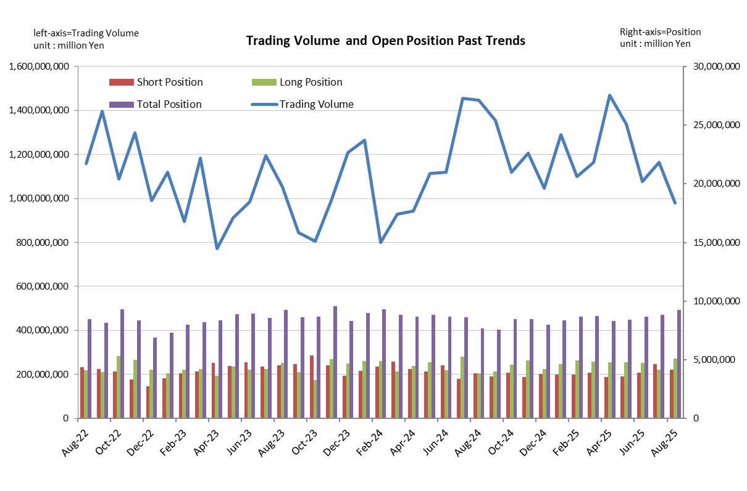
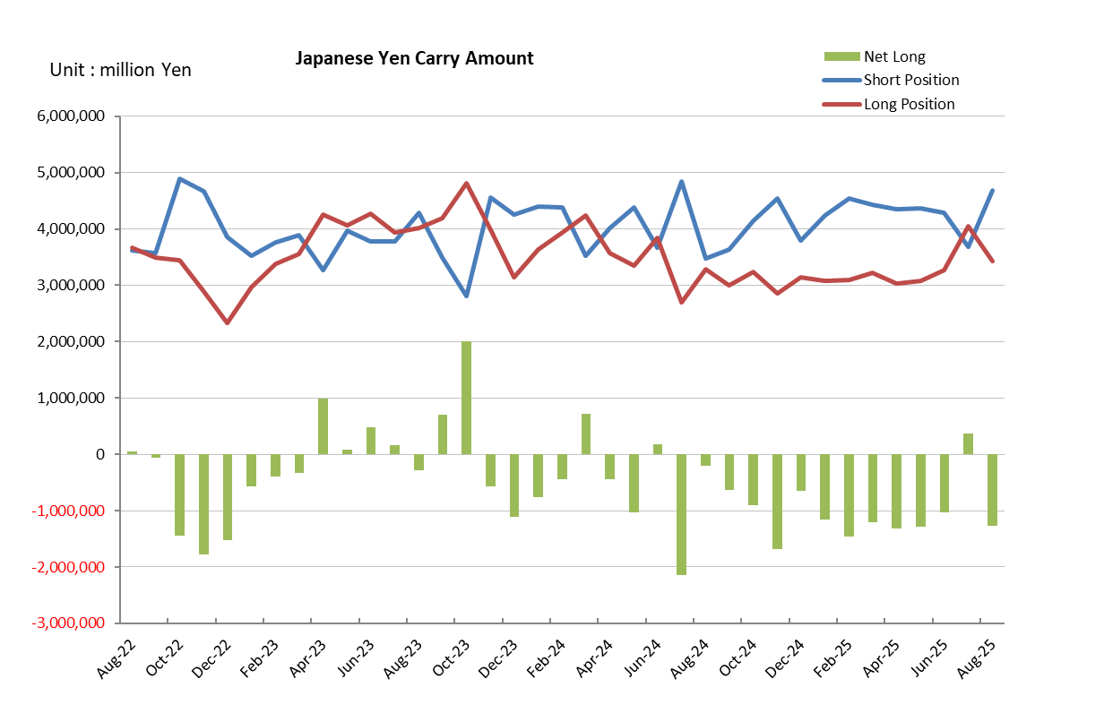

Monthly statistical report on Over-The-Counter Retail FX Margin Trading

：July , 2025
Publication date: 15 August. 2025
Number of Over-The-Counter Retail FX Margin Trading Operators as of 31 July. 2025 :45
Number of members reported :45
【Trading Volume】
(Unit: hundred million Yen, %)
 | Over-The-Counter | USDJPY, Cross Yen | On-Exchange*(for reference)
This month | 11,655,237 | 11,330,550 | 15,767
Previous month | 10,778,220 | 10,443,908 | 13,195
Change | 8.14% | 8.49% | 19.49%
*source : Monthly Trading Volume of Tokyo Financial exchange Inc.(The FFAJ converts the total number of contracts into the trading volume on the settlement prices of the end of the month)
【Open Positions】
(Unit: hundred million Yen)
 | Short | Long | Total
This month | 46,364 | 41,855 | 88,220
Previous month | 39,144 | 47,583 | 86,727
Change | 7,220 | -5,727 | 1,492

・USDJPY, Cross Yen Open Positions
(Unit: hundred million Yen)
 | ① Short | ② Long | Net long=②-①
This month | 36,826 | 40,539 | 3,712
Previous month | 42,932 | 32,698 | -10,233

（Reference：USDJPY Monthly Rate＊）
（Unit: Yen）
End of last Month*1 | Highest of the Month | Lowest of the Month | End of the Month*1 | Average*2
144.13 | 149.72 | 143.03 | 149.39 | 146.71
*source : BOJ's Main Time-series Statistics (Monthly)
*1) Spot Rate at 17:00 in JST, End of Month, Tokyo Market
*2) Average of Central Rate in the Month, Tokyo Market

○ Notes
The volume for this month was approximately 1,166 trillion yen (an increase of approximately 8.1% from the previous month), but the volume on a business day basis excluding weekends decreased.
The open positions balance at the end of the month increased since the end of the previous month,
short positions increased, but long positions decreased, totaling approximately 8.8 trillion yen.

～Tables and Historical Graphs～
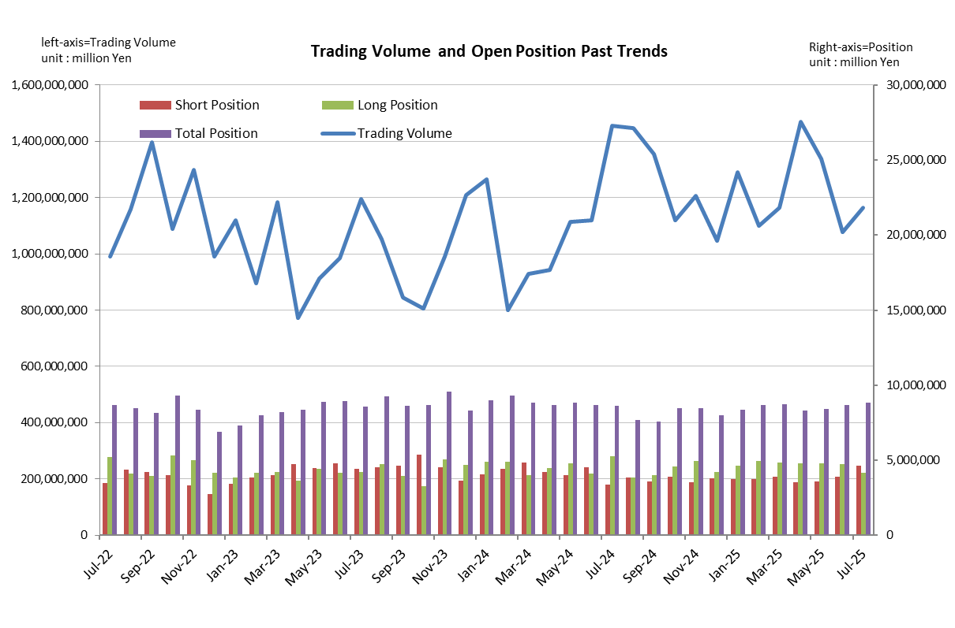
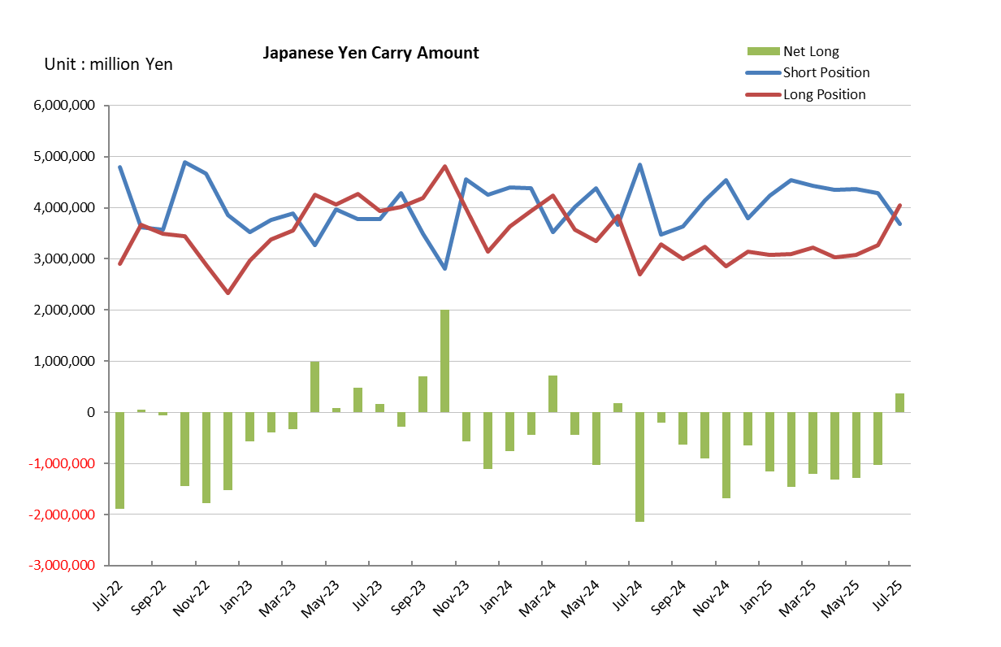

Monthly statistical report on Over-The-Counter Retail FX Margin Trading

：June , 2025
Publication date: 14 July. 2025
Number of Over-The-Counter Retail FX Margin Trading Operators as of 30 June. 2025 :46
Number of members reported :46
【Trading Volume】
(Unit: hundred million Yen, %)
 | Over-The-Counter | USDJPY, Cross Yen | On-Exchange*(for reference)
This month | 10,778,220 | 10,443,908 | 13,195
Previous month | 13,383,773 | 13,036,561 | 16,329
Change | -19.47% | -19.89% | -19.19%
*source : Monthly Trading Volume of Tokyo Financial exchange Inc.(The FFAJ converts the total number of contracts into the trading volume on the settlement prices of the end of the month)
【Open Positions】
(Unit: hundred million Yen)
 | Short | Long | Total
This month | 39,144 | 47,583 | 86,727
Previous month | 35,879 | 48,121 | 84,001
Change | 3,264 | -538 | 2,726

・USDJPY, Cross Yen Open Positions
(Unit: hundred million Yen)
 | ① Short | ② Long | Net long=②-①
This month | 42,932 | 32,698 | -10,233
Previous month | 43,591 | 30,772 | -12,819

（Reference：USDJPY Monthly Rate＊）
（Unit: Yen）
End of last Month*1 | Highest of the Month | Lowest of the Month | End of the Month*1 | Average*2
144.04 | 147.39 | 142 | 144.13 | 144.5
*source : BOJ's Main Time-series Statistics (Monthly)
*1) Spot Rate at 17:00 in JST, End of Month, Tokyo Market
*2) Average of Central Rate in the Month, Tokyo Market

○ Notes
The volume of this month was approximately 1,078 trillion yen (a decrease of 19.5% from the previous month), the trading volume on a business day basis excluding weekends decreased.
The open positions balance at the end of the month increased since the end of the previous month,
short positions increased, but long positions decreased, totaling approximately 8.7 trillion yen.

～Tables and Historical Graphs～
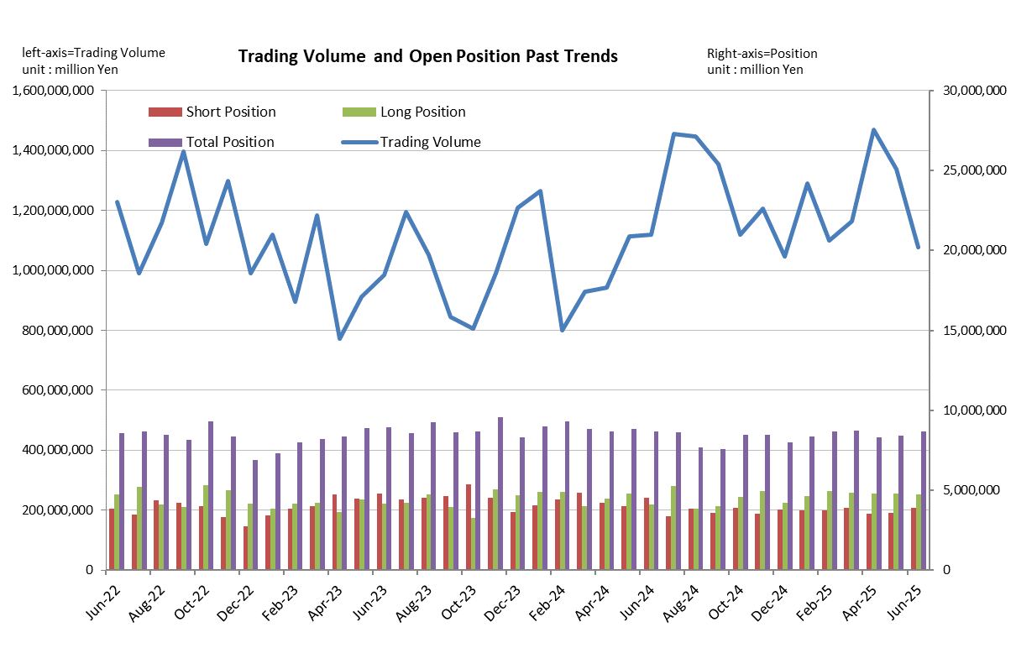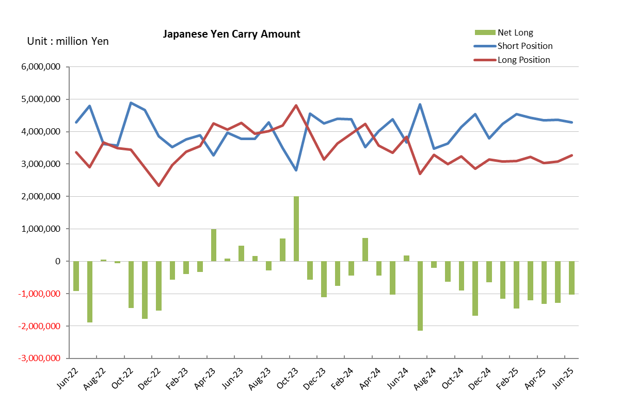

Monthly statistical report on Over-The-Counter Retail FX Margin Trading

：May , 2025
Publication date: 13 June. 2025
Number of Over-The-Counter Retail FX Margin Trading Operators as of 31 May. 2025 :46
Number of members reported :46
【Trading Volume】
(Unit: hundred million Yen, %)
 | Over-The-Counter | USDJPY, Cross Yen | On-Exchange*(for reference)
This month | 13,383,773 | 13,036,561 | 16,329
Previous month | 14,686,240 | 14,184,605 | 25,649
Change | -8.87% | -8.09% | -36.34%
*source : Monthly Trading Volume of Tokyo Financial exchange Inc.(The FFAJ converts the total number of contracts into the trading volume on the settlement prices of the end of the month)
【Open Positions】
(Unit: hundred million Yen)
 | Short | Long | Total
This month | 35,879 | 48,121 | 84,001
Previous month | 35,318 | 47,922 | 83,241
Change | 561 | 198 | 760

・USDJPY, Cross Yen Open Positions
(Unit: hundred million Yen)
 | ① Short | ② Long | Net long=②-①
This month | 43,591 | 30,772 | -12,819
Previous month | 43,516 | 30,345 | -13,171

（Reference：USDJPY Monthly Rate＊）
（Unit: Yen）
End of last Month*1 | Highest of the Month | Lowest of the Month | End of the Month*1 | Average*2
142.81 | 148.46 | 142.11 | 144.04 | 144.75
*source : BOJ's Main Time-series Statistics (Monthly)
*1) Spot Rate at 17:00 in JST, End of Month, Tokyo Market
*2) Average of Central Rate in the Month, Tokyo Market

○ Notes
The volume of this month was approximately 1,338 trillion yen (a decrease of 8.8% from the previous month), the trading volume on a business day basis excluding weekends decreased.
The open positions balance at the end of the month increased since the end of the previous month for both long positions and short positions, with the overall open position balance decreased to approximately 8.4 trillion yen at the end of the month.

～Tables and Historical Graphs～
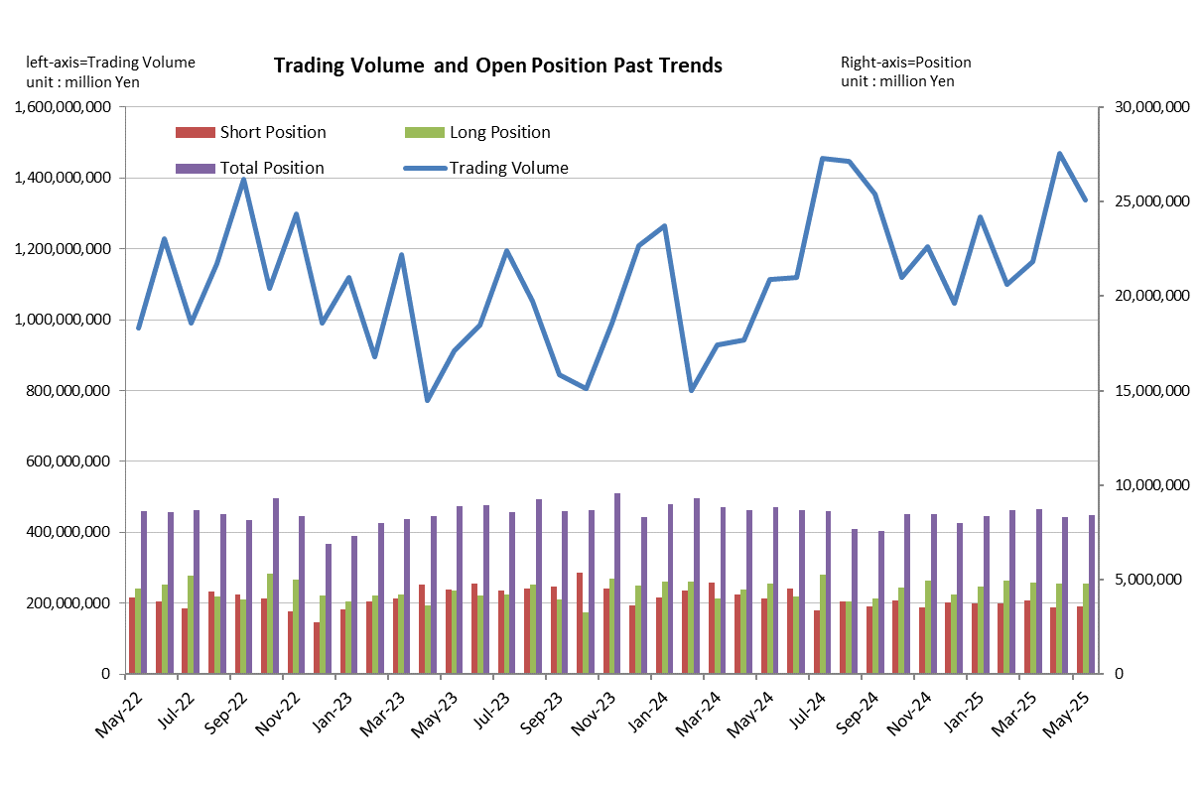
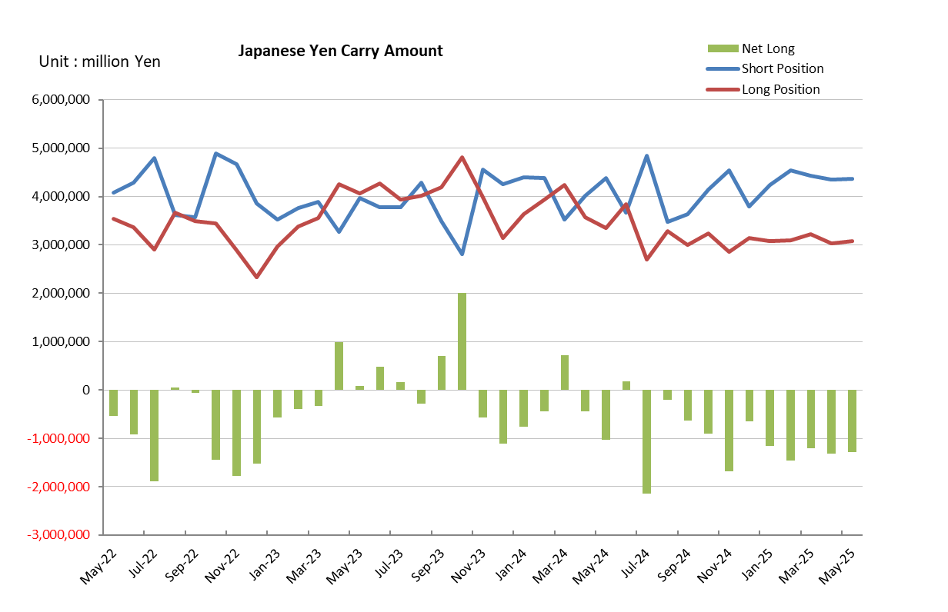

Monthly statistical report on Over-The-Counter Retail FX Margin Trading

：April , 2025
Publication date: 16 May. 2025
Number of Over-The-Counter Retail FX Margin Trading Operators as of 30 April. 2025 :46
Number of members reported :46
【Trading Volume】
(Unit: hundred million Yen, %)
 | Over-The-Counter | USDJPY, Cross Yen | On-Exchange*(for reference)
This month | 14,686,240 | 14,184,605 | 25,649
Previous month | 11,641,575 | 11,328,946 | 21,054
Change | 26.15% | 25.21% | 21.82%
*source : Monthly Trading Volume of Tokyo Financial exchange Inc.(The FFAJ converts the total number of contracts into the trading volume on the settlement prices of the end of the month)
【Open Positions】
(Unit: hundred million Yen)
 | Short | Long | Total
This month | 35,318 | 47,922 | 83,241
Previous month | 39,128 | 48,409 | 87,537
Change | -3,810 | -486 | -4,296

・USDJPY, Cross Yen Open Positions
(Unit: hundred million Yen)
 | ① Short | ② Long | Net long=②-①
This month | 43,516 | 30,345 | -13,171
Previous month | 44,309 | 32,259 | -12,050

（Reference：USDJPY Monthly Rate＊）
（Unit: Yen）
End of last Month*1 | Highest of the Month | Lowest of the Month | End of the Month*1 | Average*2
149.14 | 150.12 | 139.89 | 142.81 | 144.39
*source : BOJ's Main Time-series Statistics (Monthly)
*1) Spot Rate at 17:00 in JST, End of Month, Tokyo Market
*2) Average of Central Rate in the Month, Tokyo Market

○ Notes
The volume of this month was approximately 1,469 trillion yen (an increase of 26.2% from the previous month), the trading volume on a business day basis excluding weekends increased.
The open positions balance at the end of the month decreased since the end of the previous month for both long positions and short positions, with the overall open position balance decreased to approximately 8.3 trillion yen at the end of the month.

～Tables and Historical Graphs～
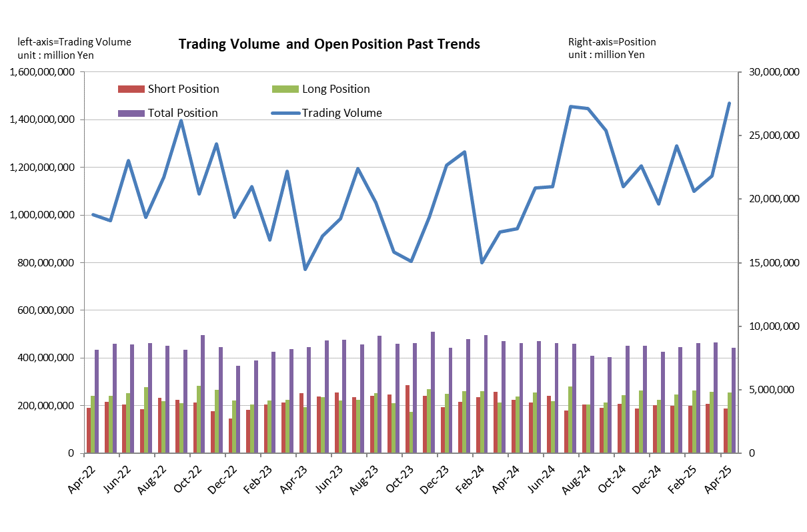
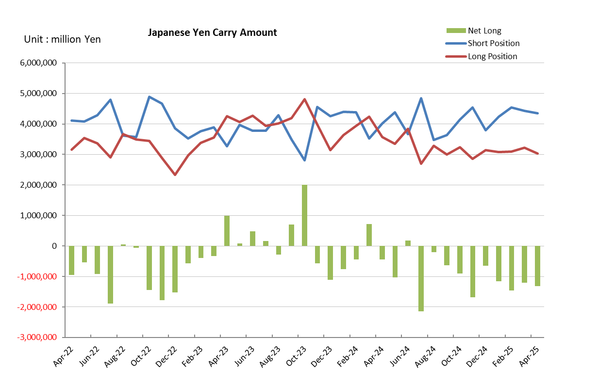

Monthly statistical report on Over-The-Counter Retail FX Margin Trading

：March , 2025
Publication date: 14 April. 2025
Number of Over-The-Counter Retail FX Margin Trading Operators as of 31 March. 2025 :46
Number of members reported :46
【Trading Volume】
(Unit: hundred million Yen, %)
 | Over-The-Counter | USDJPY, Cross Yen | On-Exchange*(for reference)
This month | 11,641,574 | 11,328,945 | 21,054
Previous month | 10,988,639 | 10,737,064 | 19,183
Change | 5.94% | 5.51% | 9.75%
*source : Monthly Trading Volume of Tokyo Financial exchange Inc.(The FFAJ converts the total number of contracts into the trading volume on the settlement prices of the end of the month)
【Open Positions】
(Unit: hundred million Yen)
 | Short | Long | Total
This month | 39,128 | 48,409 | 87,537
Previous month | 37,379 | 49,435 | 86,815
Change | 1,748 | -1,026 | 722

・USDJPY, Cross Yen Open Positions
(Unit: hundred million Yen)
 | ① Short | ② Long | Net long=②-①
This month | 44,309 | 32,259 | -12,050
Previous month | 45,407 | 30,879 | -14,528

（Reference：USDJPY Monthly Rate＊）
（Unit: Yen）
End of last Month*1 | Highest of the Month | Lowest of the Month | End of the Month*1 | Average*2
150.44 | 151.21 | 146.55 | 149.14 | 149.18
*source : BOJ's Main Time-series Statistics (Monthly)
*1) Spot Rate at 17:00 in JST, End of Month, Tokyo Market
*2) Average of Central Rate in the Month, Tokyo Market

○ Notes
The volume of this month was approximately 1,164 trillion yen (an increase of 5.9% from the previous month), the trading volume on a business day basis excluding weekends increased.
The open positions balance at the end of the month increased since the end of the previous month,
short positions increased, but long positions decreased, totaling approximately 8.4 trillion yen.

～Tables and Historical Graphs～
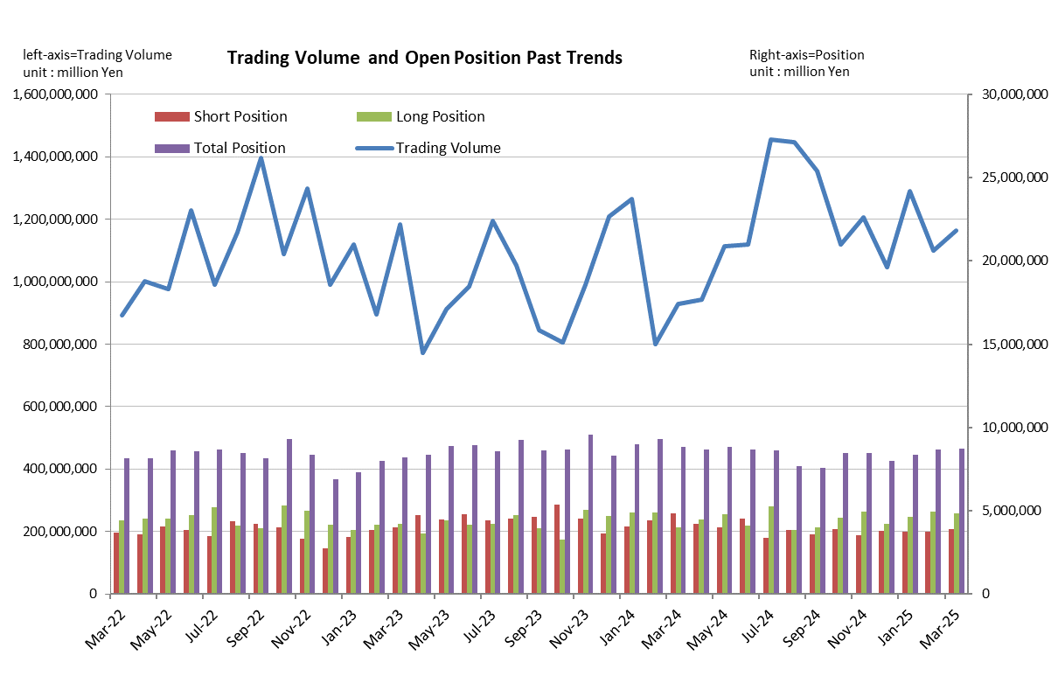
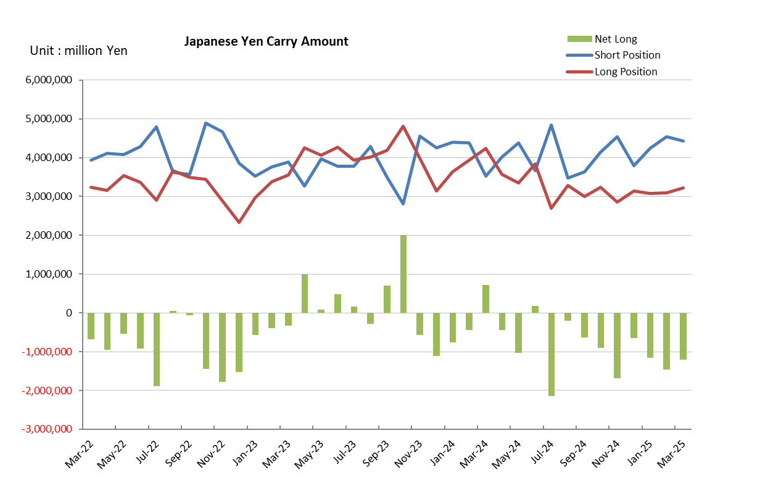

Monthly statistical report on Over-The-Counter Retail FX Margin Trading

：February , 2025
Publication date: 14 March. 2025
Number of Over-The-Counter Retail FX Margin Trading Operators as of 31 February. 2025 :46
Number of members reported :46
【Trading Volume】
(Unit: hundred million Yen, %)
 | Over-The-Counter | USDJPY, Cross Yen | On-Exchange*(for reference)
This month | 10,988,639 | 10,737,064 | 19,183
Previous month | 12,916,297 | 12,537,093 | 18,236
Change | -14.92% | -14.36% | 5.19%
*source : Monthly Trading Volume of Tokyo Financial exchange Inc.(The FFAJ converts the total number of contracts into the trading volume on the settlement prices of the end of the month)
【Open Positions】
(Unit: hundred million Yen)
 | Short | Long | Total
This month | 37,379 | 49,435 | 86,815
Previous month | 37,348 | 46,272 | 83,620
Change | 31 | 3,163 | 3,195

・USDJPY, Cross Yen Open Positions
(Unit: hundred million Yen)
 | ① Short | ② Long | Net long=②-①
This month | 45,407 | 30,879 | -14,528
Previous month | 42,324 | 30,824 | -11,499

（Reference：USDJPY Monthly Rate＊）
（Unit: Yen）
End of last Month*1 | Highest of the Month | Lowest of the Month | End of the Month*1 | Average*2
154.66 | 155.87 | 148.63 | 150.44 | 151.96
*source : BOJ's Main Time-series Statistics (Monthly)
*1) Spot Rate at 17:00 in JST, End of Month, Tokyo Market
*2) Average of Central Rate in the Month, Tokyo Market

○ Notes
The volume of this month was approximately 1,099 trillion yen (a decrease of 14.9% from the previous month), the trading volume on a business day basis excluding weekends decreased.
The open positions balance at the end of the month increased since the end of the previous month for both long positions and short positions, with the overall open position balance decreased to approximately 8.7 trillion yen at the end of the month.

～Tables and Historical Graphs～
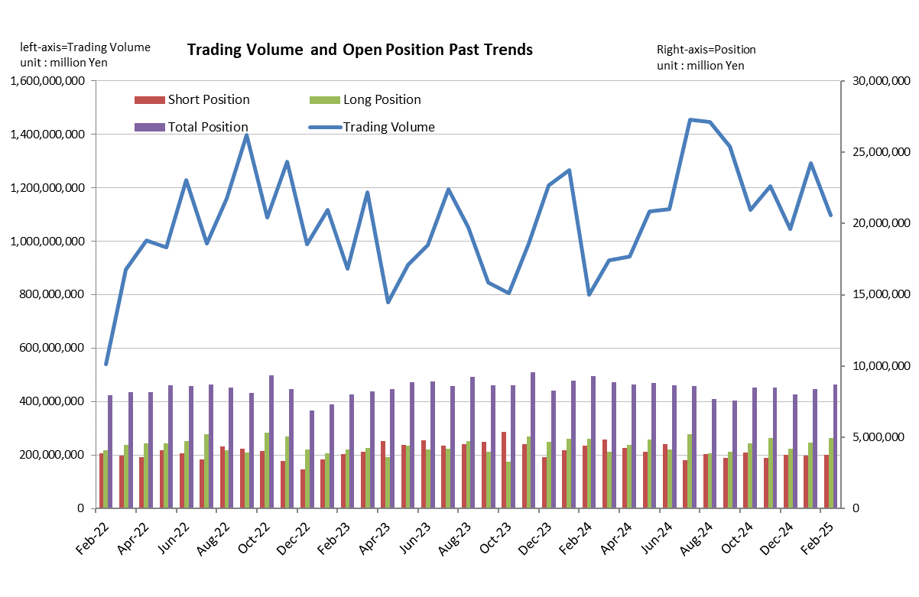
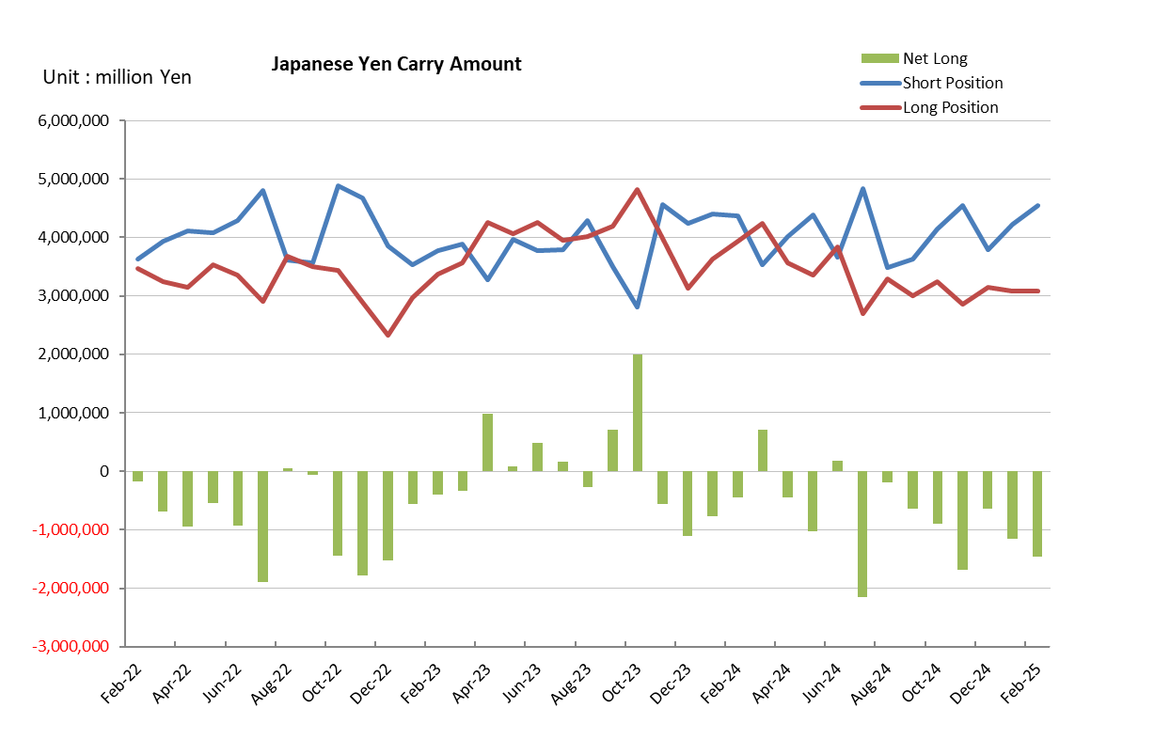

Monthly statistical report on Over-The-Counter Retail FX Margin Trading

：January , 2025
Publication date: 17 February. 2025
Number of Over-The-Counter Retail FX Margin Trading Operators as of 31 January. 2025 :47
Number of members reported :47
【Trading Volume】
(Unit: hundred million Yen, %)
 | Over-The-Counter | USDJPY, Cross Yen | On-Exchange*(for reference)
This month | 12,916,297 | 12,537,093 | 18,236
Previous month | 10,471,549 | 10,210,346 | 15,398
Change | 23.35% | 22.79% | 18.43%
*source : Monthly Trading Volume of Tokyo Financial exchange Inc.(The FFAJ converts the total number of contracts into the trading volume on the settlement prices of the end of the month)
【Open Positions】
(Unit: hundred million Yen)
 | Short | Long | Total
This month | 37,348 | 46,272 | 83,620
Previous month | 37,870 | 42,050 | 79,920
Change | -522 | 4,222 | 3,700

・USDJPY, Cross Yen Open Positions
(Unit: hundred million Yen)
 | ① Short | ② Long | Net long=②-①
This month | 42,324 | 30,824 | -11,499
Previous month | 37,911 | 31,445 | -6,466

（Reference：USDJPY Monthly Rate＊）
（Unit: Yen）
End of last Month*1 | Highest of the Month | Lowest of the Month | End of the Month*1 | Average*2
157.89 | 158.45 | 153.94 | 154.66 | 156.49
*source : BOJ's Main Time-series Statistics (Monthly)
*1) Spot Rate at 17:00 in JST, End of Month, Tokyo Market
*2) Average of Central Rate in the Month, Tokyo Market

○ Notes
The volume of this month was approximately 1,292 trillion yen (an increase of 23.4% from the previous month), the trading volume on a business day basis excluding weekends increased.
The open positions balance at the end of the month increased since the end of the previous month,
short positions decreased, but long positions increased, totaling approximately 8.4 trillion yen.

～Tables and Historical Graphs～
