Over-The-Counter FX Margin Trading Report

(January 2023 ～ )

Monthly Report
January 2023
February 2023
March 2023
April 2023
May 2023
June 2023
July 2023
August 2023
September 2023
October 2023
November 2023
December 2023

The Financial Futures Association of Japan, Research Department

NBF Ogawamachi Building 1-3 , Kanda Ogawamachi ,
Chiyoda-ku , Tokyo 101-0052 Tel:(03)5280-0881 E-mail : ffaj@ffaj.or.jp

This publication has been prepared by the FFAJ and is provided for information purpose only. The monthly information contained in this publication has been obtained from FFAJ's members that is believed to be reliable, however the FFAJ does not represent or warrant that it is accurate or complete. In no event the FFAJ nor its employees have any liability for any consequential damages arising from any use of this publications or its contents. This publication does not constitute any investment advice.

Monthly statistical report on Over-The-Counter Retail FX Margin Trading

：December , 2023
Publication date: 18 January. 2024
Number of Over-The-Counter Retail FX Margin Trading Operators as of 31 December. 2023 :47
Number of members reported :47
【Trading Volume】
(Unit: hundred million Yen, %)
 | Over-The-Counter | USDJPY, Cross Yen | On-Exchange*(for reference)
This month | 12,093,097 | 11,802,716 | 26,383
Previous month | 9,911,023 | 9,481,014 | 25,154
Change | 22.02% | 24.49% | 4.89%
*source : Monthly Trading Volume of Tokyo Financial exchange Inc.(The FFAJ converts the total number of contracts into the trading volume on the settlement prices of the end of the month)
【Open Positions】
(Unit: hundred million Yen)
 | Short | Long | Total
This month | 36,180 | 46,643 | 82,823
Previous month | 45,418 | 50,365 | 95,784
Change | -9,238 | -3,722 | -12,960

・USDJPY, Cross Yen Open Positions
(Unit: hundred million Yen)
 | - Short | - Long | Net long=②-①
This month | 42,485 | 31,359 | -11,126
Previous month | 45,546 | 39,867 | -5,678

（Reference：USDJPY Monthly Rate＊）
（Unit: Yen）
End of last Month*1 | Highest of the Month | Lowest of the Month | End of the Month*1 | Average*2
147.06 | 148.3 | 140.72 | 141.4 | 144.07
*source : BOJ's Main Time-series Statistics (Monthly)
*1) Spot Rate at 17:00 in JST, End of Month, Tokyo Market
*2) Average of Central Rate in the Month, Tokyo Market

○ Notes
The volume of this month was approximately 1,209 trillion yen (aｎ increase of 22.0% from the previous month), the trading volume on a business day basis excluding weekends also increased.
The open positions balance at the end of the month decreased since the end of the previous month for both long positions and short positions, with the overall open position balance decreased to approximately 8.3 trillion yen at the end of the month.

～Tables and Historical Graphs～
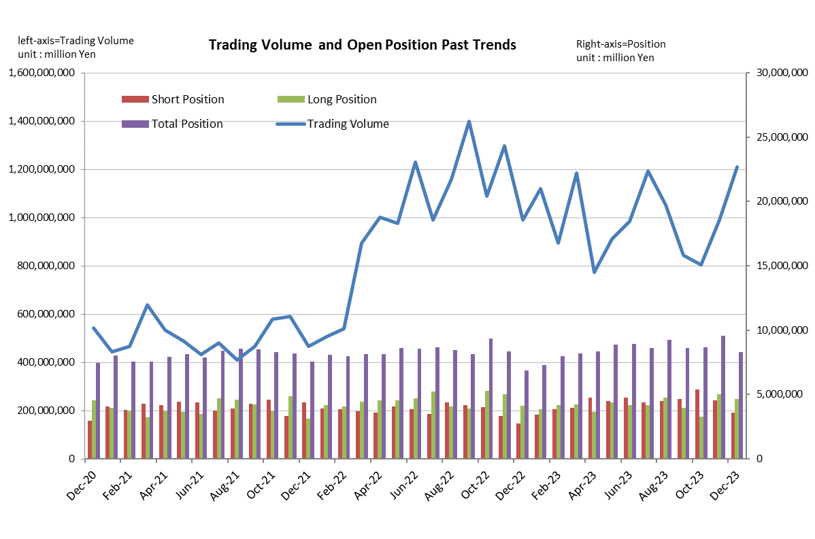

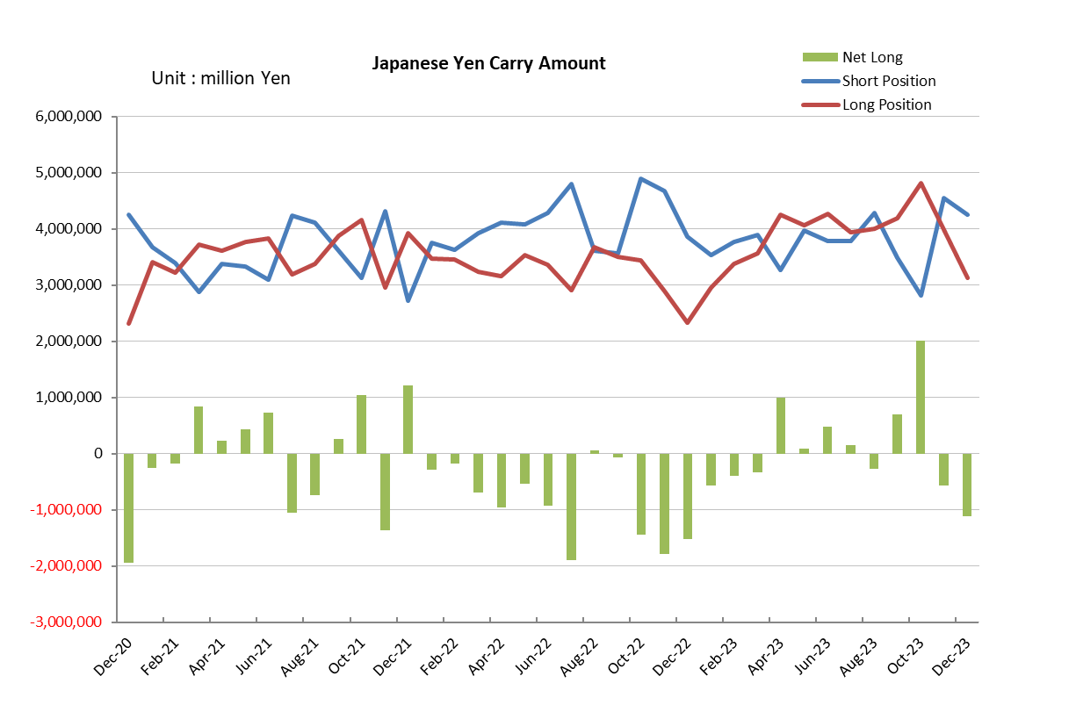

Monthly statistical report on Over-The-Counter Retail FX Margin Trading

：November , 2023
Publication date: 14 December. 2023
Number of Over-The-Counter Retail FX Margin Trading Operators as of 30 November. 2023 :47
Number of members reported :47
【Trading Volume】
(Unit: hundred million Yen, %)
 | Over-The-Counter | USDJPY, Cross Yen | On-Exchange*(for reference)
This month | 9,911,023 | 9,481,014 | 25,154
Previous month | 8,051,380 | 7,530,278 | 24,129
Change | 23.10% | 25.91% | 4.25%
*source : Monthly Trading Volume of Tokyo Financial exchange Inc.(The FFAJ converts the total number of contracts into the trading volume on the settlement prices of the end of the month)
【Open Positions】
(Unit: hundred million Yen)
 | Short | Long | Total
This month | 45,418 | 50,365 | 95,784
Previous month | 53,907 | 32,764 | 86,672
Change | -8,488 | 17,601 | 9,112

・USDJPY, Cross Yen Open Positions
(Unit: hundred million Yen)
 | - Short | - Long | Net long=②-①
This month | 45,546 | 39,867 | -5,678
Previous month | 28,116 | 48,155 | 20,039

（Reference：USDJPY Monthly Rate＊）
（Unit: Yen）
End of last Month*1 | Highest of the Month | Lowest of the Month | End of the Month*1 | Average*2
150.29 | 151.8 | 146.68 | 147.06 | 149.83
*source : BOJ's Main Time-series Statistics (Monthly)
*1) Spot Rate at 17:00 in JST, End of Month, Tokyo Market
*2) Average of Central Rate in the Month, Tokyo Market

○ Notes
The volume of this month was approximately 991 trillion yen (aｎ increase of 23.1% from the previous month), the trading volume on a business day basis excluding weekends also increased.
The open positions balance at the end of the month increased since the end of the previous month,
short positions decreased, but long positions increased, totaling approximately 9.6 trillion yen.

～Tables and Historical Graphs～

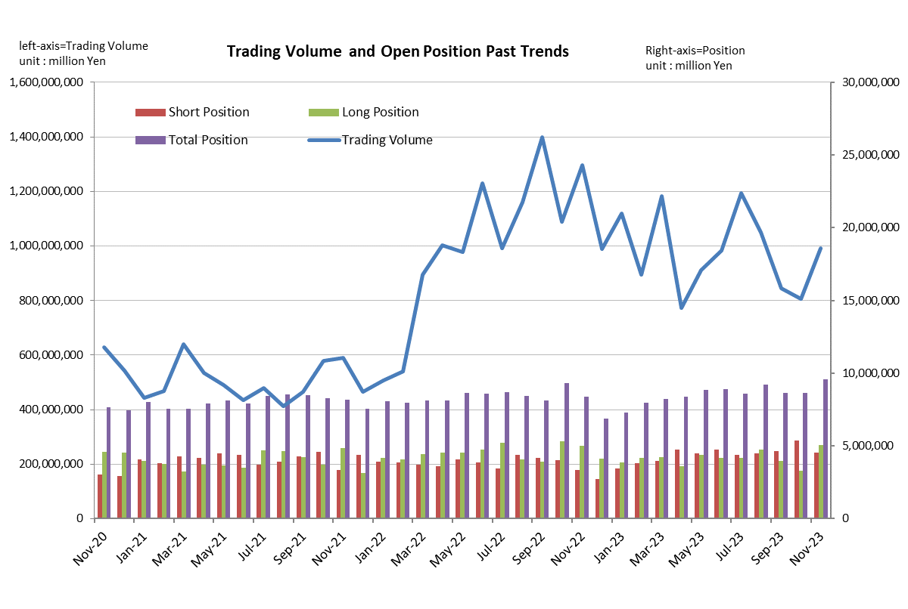

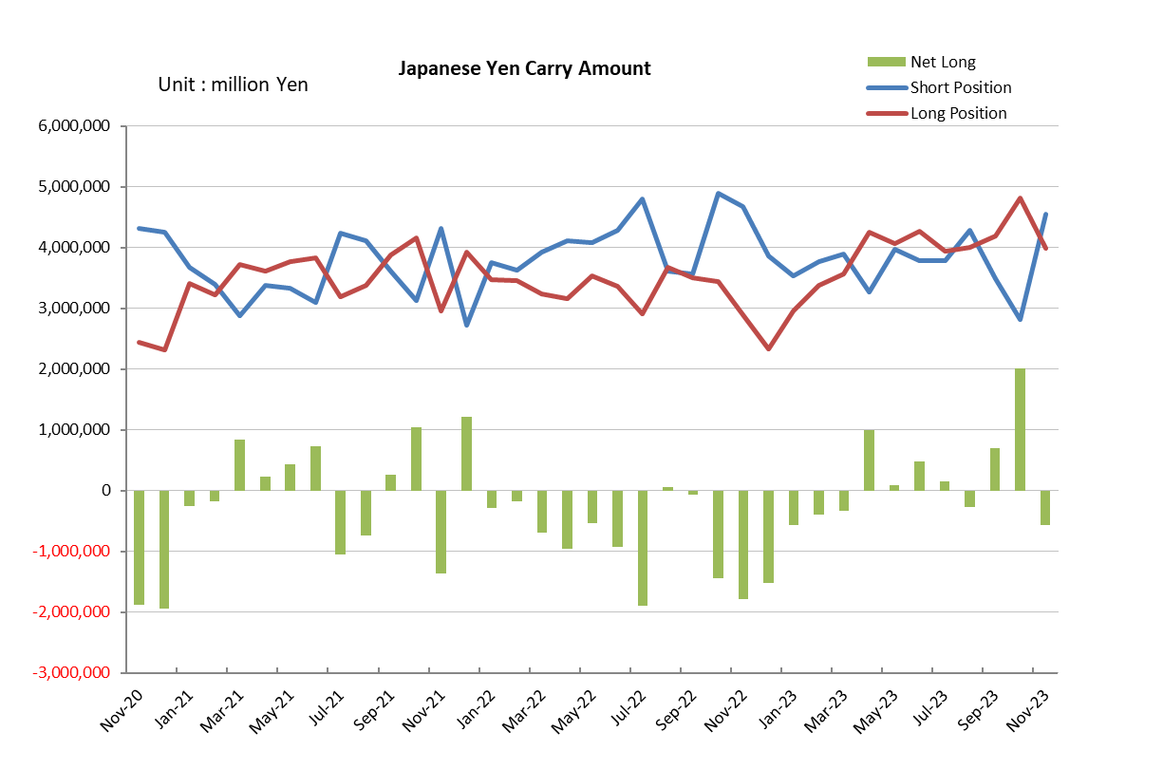

Monthly statistical report on Over-The-Counter Retail FX Margin Trading

：October , 2023
Publication date: 15 November. 2023
Number of Over-The-Counter Retail FX Margin Trading Operators as of 31 October. 2023 :47
Number of members reported :47
【Trading Volume】
(Unit: hundred million Yen, %)
 | Over-The-Counter | USDJPY, Cross Yen | On-Exchange*(for reference)
This month | 8,051,380 | 7,530,278 | 24,129
Previous month | 8,444,762 | 8,127,054 | 22,302
Change | -4.66% | -7.34% | 8.19%
*source : Monthly Trading Volume of Tokyo Financial exchange Inc.(The FFAJ converts the total number of contracts into the trading volume on the settlement prices of the end of the month)
【Open Positions】
(Unit: hundred million Yen)
 | Short | Long | Total
This month | 53,907 | 32,764 | 86,672
Previous month | 46,553 | 39,744 | 86,297
Change | 7,354 | -6,979 | 374

・USDJPY, Cross Yen Open Positions
(Unit: hundred million Yen)
 | - Short | - Long | Net long=②-①
This month | 28,116 | 48,155 | 20,039
Previous month | 34,939 | 41,975 | 7,036

（Reference：USDJPY Monthly Rate＊）
（Unit: Yen）
End of last Month*1 | Highest of the Month | Lowest of the Month | End of the Month*1 | Average*2
148.77 | 150.77 | 148.17 | 150.29 | 149.53
*source : BOJ's Main Time-series Statistics (Monthly)
*1) Spot Rate at 17:00 in JST, End of Month, Tokyo Market
*2) Average of Central Rate in the Month, Tokyo Market

○ Notes
The volume of this month was approximately 805 trillion yen (a decrease of 4.7% from the previous month), the trading volume on a business day basis excluding weekends also decreased.
The open positions balance at the end of the month decreased since the end of the previous month,
short positions increased, but long positions decreased, totaling approximately 8.7 trillion yen.

～Tables and Historical Graphs～

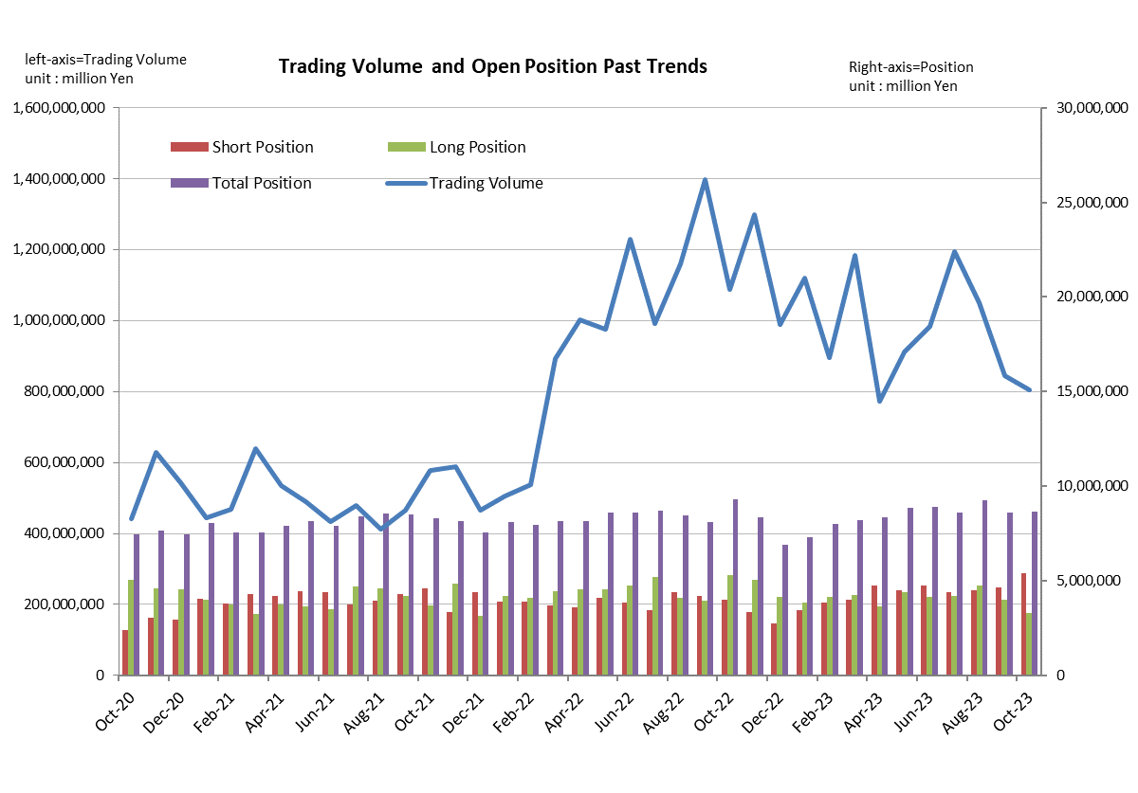

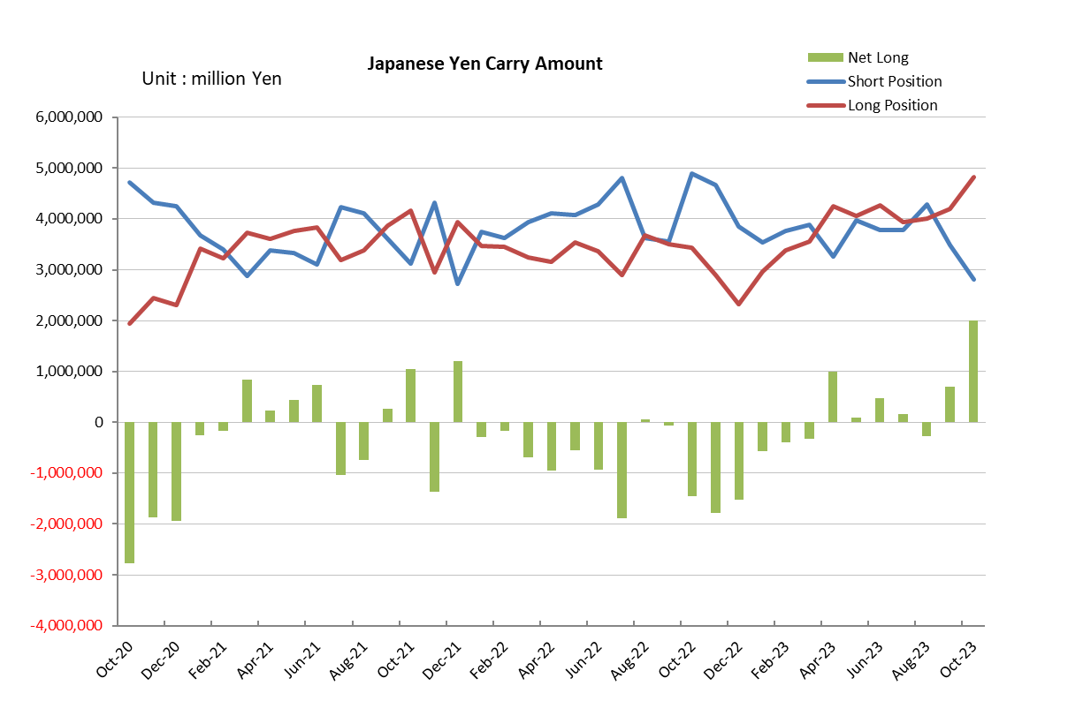

Monthly statistical report on Over-The-Counter Retail FX Margin Trading

：September , 2023
Publication date: 16 October. 2023
Number of Over-The-Counter Retail FX Margin Trading Operators as of 30 September. 2023 :47
Number of members reported :47
【Trading Volume】
(Unit: hundred million Yen, %)
 | Over-The-Counter | USDJPY, Cross Yen | On-Exchange*(for reference)
This month | 8,444,762 | 8,127,054 | 22,302
Previous month | 10,510,237 | 10,184,543 | 26,910
Change | -19.65% | -20.20% | -17.12%
*source : Monthly Trading Volume of Tokyo Financial exchange Inc.(The FFAJ converts the total number of contracts into the trading volume on the settlement prices of the end of the month)
【Open Positions】
(Unit: hundred million Yen)
 | Short | Long | Total
This month | 46,553 | 39,744 | 86,297
Previous month | 45,014 | 47,339 | 92,353
Change | 1,539 | -7,594 | -6,055

・USDJPY, Cross Yen Open Positions
(Unit: hundred million Yen)
 | - Short | ② Long | Net long=②-①
This month | 34,939 | 41,975 | 7,036
Previous month | 42,850 | 40,085 | -2,764

（Reference：USDJPY Monthly Rate＊）
（Unit: Yen）
End of last Month*1 | Highest of the Month | Lowest of the Month | End of the Month*1 | Average*2
145.91 | 149.54 | 145.24 | 148.77 | 147.67
*source : BOJ's Main Time-series Statistics (Monthly)
*1) Spot Rate at 17:00 in JST, End of Month, Tokyo Market
*2) Average of Central Rate in the Month, Tokyo Market

○ Notes
The volume of this month was approximately 844 trillion yen (a decrease of 19.7% from the previous month), the trading volume on a business day basis excluding weekends also decreased.
The open positions balance at the end of the month decreased since the end of the previous month,
short positions increased, but long positions decreased, totaling approximately 8.6 trillion yen.

～Tables and Historical Graphs～
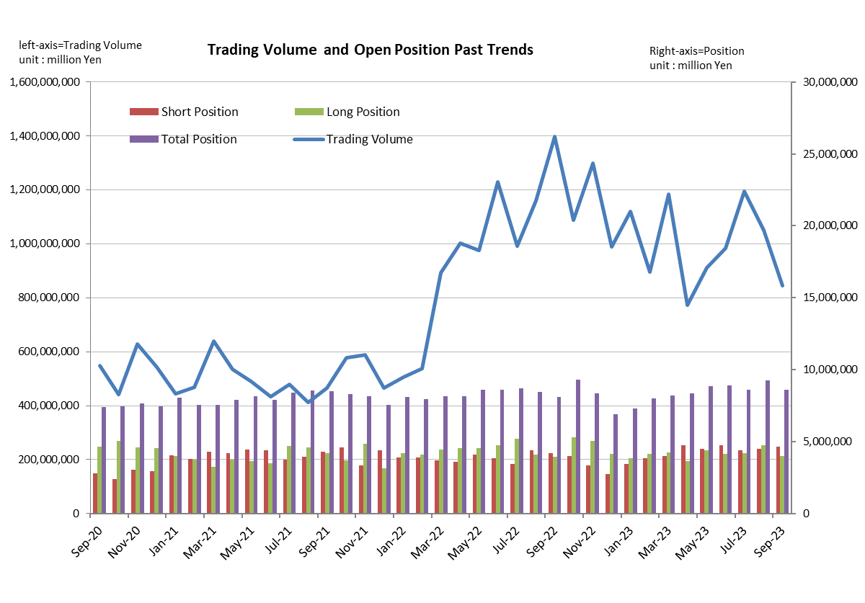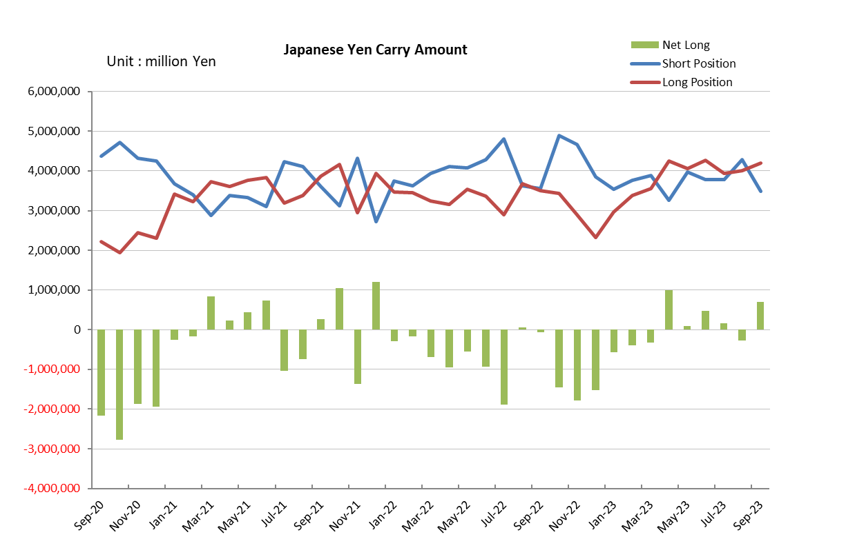

Monthly statistical report on Over-The-Counter Retail FX Margin Trading

：August , 2023
Publication date: 14 September. 2023
Number of Over-The-Counter Retail FX Margin Trading Operators as of 31 August. 2023 :48
Number of members reported :48
【Trading Volume】
(Unit: hundred million Yen, %)
 | Over-The-Counter | USDJPY, Cross Yen | On-Exchange*(for reference)
This month | 10,510,237 | 10,184,543 | 26,910
Previous month | 11,943,278 | 11,639,689 | 28,520
Change | -12.00% | -12.50% | -5.65%
*source : Monthly Trading Volume of Tokyo Financial exchange Inc.(The FFAJ converts the total number of contracts into the trading volume on the settlement prices of the end of the month)
【Open Positions】
(Unit: hundred million Yen)
 | Short | Long | Total
This month | 45,014 | 47,339 | 92,353
Previous month | 43,981 | 41,963 | 85,945
Change | 1,033 | 5,375 | 6,408

・USDJPY, Cross Yen Open Positions
(Unit: hundred million Yen)
 | - Short | ② Long | Net long=②-①
This month | 42,850 | 40,085 | -2,764
Previous month | 37,857 | 39,439 | 1,581

（Reference：USDJPY Monthly Rate＊）
（Unit: Yen）
End of last Month*1 | Highest of the Month | Lowest of the Month | End of the Month*1 | Average*2
142.18 | 146.61 | 141.52 | 145.91 | 144.77
*source : BOJ's Main Time-series Statistics (Monthly)
*1) Spot Rate at 17:00 in JST, End of Month, Tokyo Market
*2) Average of Central Rate in the Month, Tokyo Market

○ Notes
The volume of this month was approximately 1,051 trillion yen (a decrease of 12.0% from the previous month), the trading volume on a business day basis excluding weekends also decreased.
The open positions balance at the end of the month increased since the end of the previous month for both long positions and short positions, with the overall open position balance increased to approximately 9.2 trillion yen at the end of the month.

～Tables and Historical Graphs～

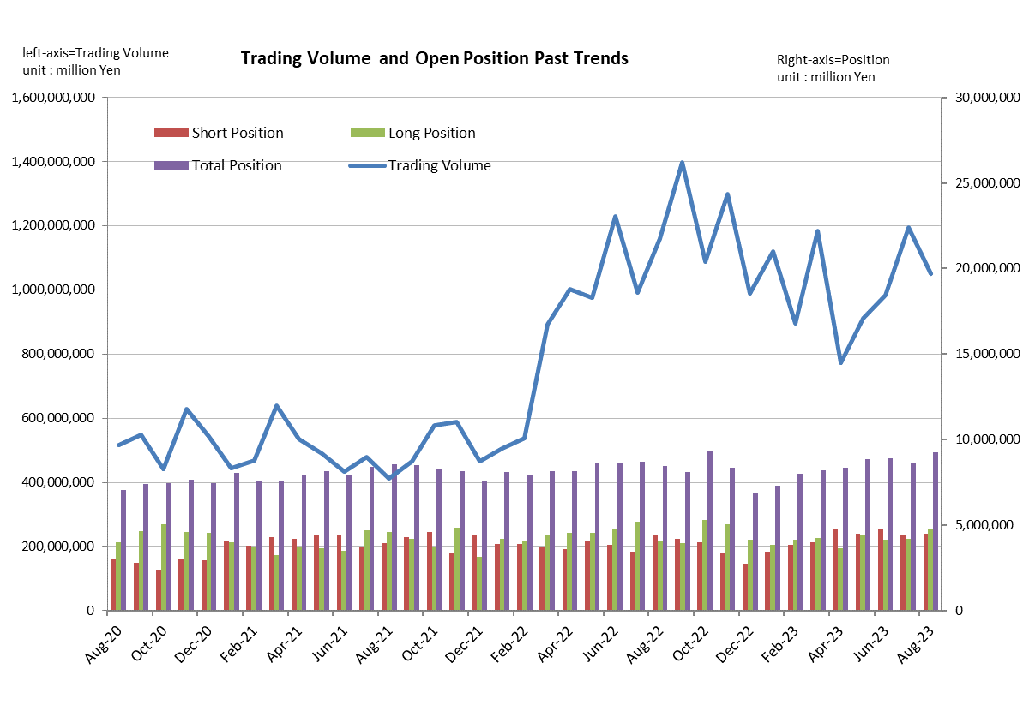
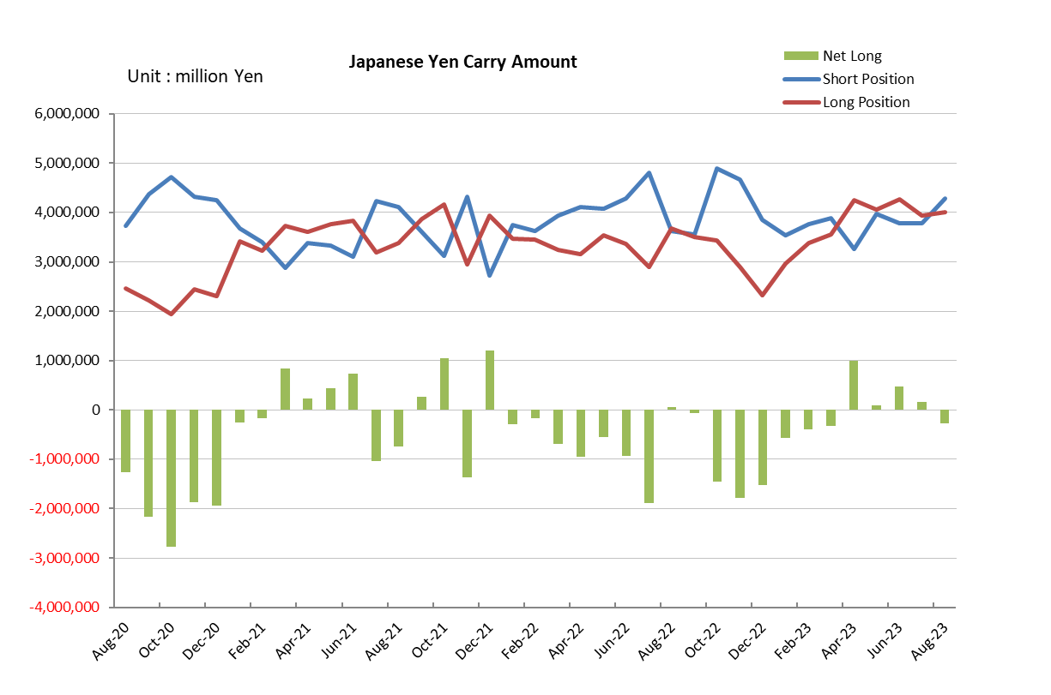

Monthly statistical report on Over-The-Counter Retail FX Margin Trading

：July , 2023
Publication date: 15 August. 2023
Number of Over-The-Counter Retail FX Margin Trading Operators as of 31 July. 2023 :49
Number of members reported :49
【Trading Volume】
(Unit: hundred million Yen, %)
 | Over-The-Counter | USDJPY, Cross Yen | On-Exchange*(for reference)
This month | 11,943,278 | 11,639,689 | 28,520
Previous month | 9,846,615 | 9,538,886 | 29,158
Change | 21.29% | 22.02% | -2.19%
*source : Monthly Trading Volume of Tokyo Financial exchange Inc.(The FFAJ converts the total number of contracts into the trading volume on the settlement prices of the end of the month)
【Open Positions】
(Unit: hundred million Yen)
 | Short | Long | Total
This month | 43,981 | 41,963 | 85,945
Previous month | 47,673 | 41,544 | 89,217
Change | -3,692 | 419 | -3,272

・USDJPY, Cross Yen Open Positions
(Unit: hundred million Yen)
 | - Short | ② Long | Net long=②-①
This month | 37,857 | 39,439 | 1,581
Previous month | 37,818 | 42,632 | 4,814

（Reference：USDJPY Monthly Rate＊）
（Unit: Yen）
End of last Month*1 | Highest of the Month | Lowest of the Month | End of the Month*1 | Average*2
144.85 | 144.85 | 137.27 | 142.18 | 141.21
*source : BOJ's Main Time-series Statistics (Monthly)
*1) Spot Rate at 17:00 in JST, End of Month, Tokyo Market
*2) Average of Central Rate in the Month, Tokyo Market

○ Notes
The volume of this month was approximately 1,194 trillion yen (aｎ increase of 21.3% from the previous month), the trading volume on a business day basis excluding weekends also increased.
The open positions balance at the end of the month decreased since the end of the previous month,
short positions decreased, but long positions increased, totaling approximately 8.9 trillion yen.

～Tables and Historical Graphs～

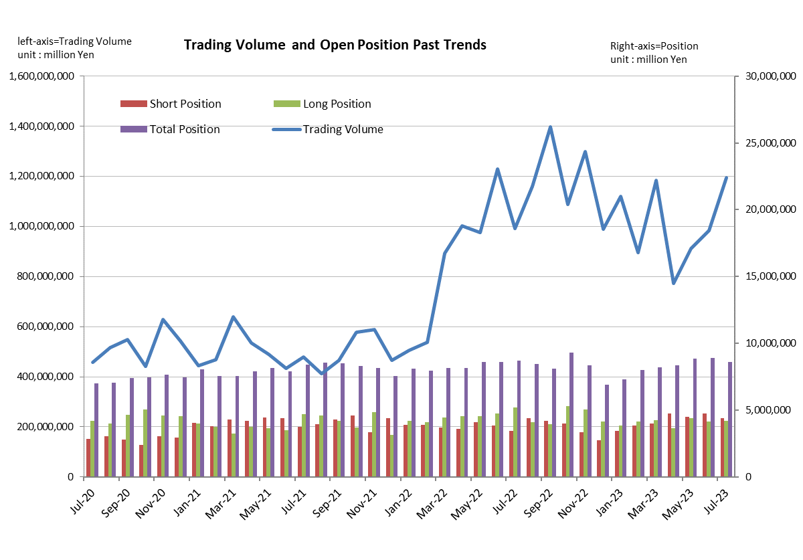
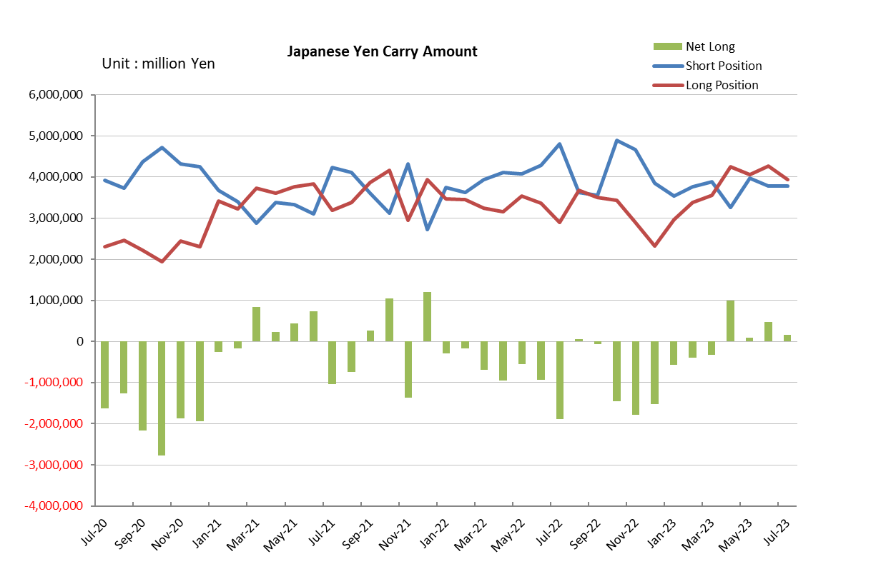

Monthly statistical report on Over-The-Counter Retail FX Margin Trading

：June , 2023
Publication date: 14 July. 2023
Number of Over-The-Counter Retail FX Margin Trading Operators as of 30 June. 2023 :49
Number of members reported :49
【Trading Volume】
(Unit: hundred million Yen, %)
 | Over-The-Counter | USDJPY, Cross Yen | On-Exchange*(for reference)
This month | 9,846,615 | 9,538,886 | 29,158
Previous month | 9,109,179 | 8,766,685 | 25,475
Change | 8.10% | 8.81% | 14.46%
*source : Monthly Trading Volume of Tokyo Financial exchange Inc.(The FFAJ converts the total number of contracts into the trading volume on the settlement prices of the end of the month)
【Open Positions】
(Unit: hundred million Yen)
 | Short | Long | Total
This month | 47,673 | 41,544 | 89,217
Previous month | 44,751 | 44,038 | 88,790
Change | 2,922 | -2,494 | 427

・USDJPY, Cross Yen Open Positions
(Unit: hundred million Yen)
 | - Short | ② Long | Net long=②-①
This month | 37,818 | 42,632 | 4,814
Previous month | 39,751 | 40,596 | 844

（Reference：USDJPY Monthly Rate＊）
（Unit: Yen）
End of last Month*1 | Highest of the Month | Lowest of the Month | End of the Month*1 | Average*2
139.75 | 145.07 | 138.6 | 144.85 | 141.19
*source : BOJ's Main Time-series Statistics (Monthly)
*1) Spot Rate at 17:00 in JST, End of Month, Tokyo Market
*2) Average of Central Rate in the Month, Tokyo Market

○ Notes
The volume of this month was approximately 985 trillion yen (aｎ increase of 8.1% from the previous month), the trading volume on a business day basis excluding weekends also increased.
The open positions balance at the end of the month increased since the end of the previous month,
short positions increased, but long positions decreased, totaling approximately 8.9 trillion yen.

～Tables and Historical Graphs～

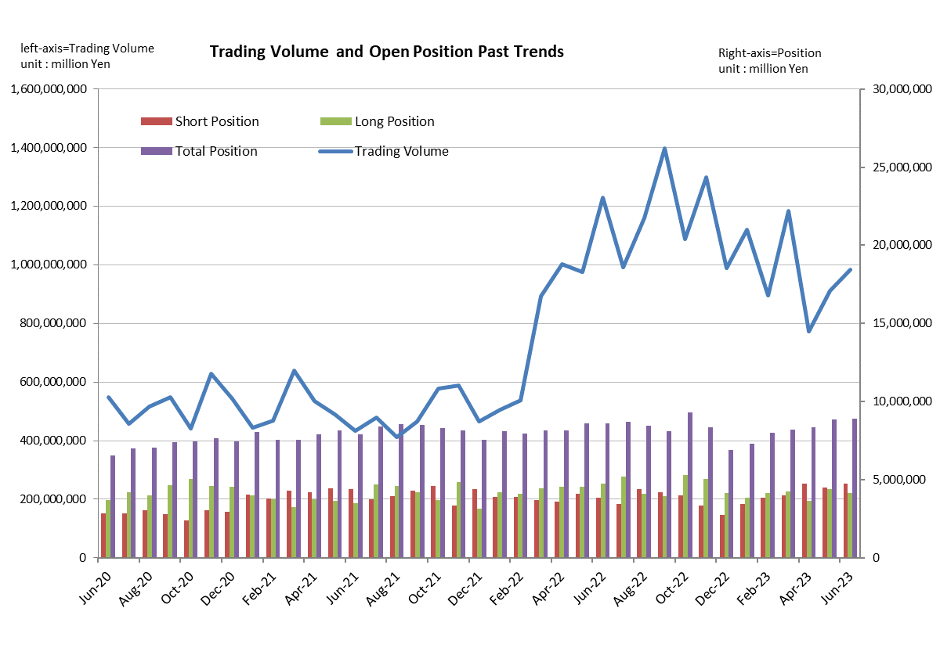

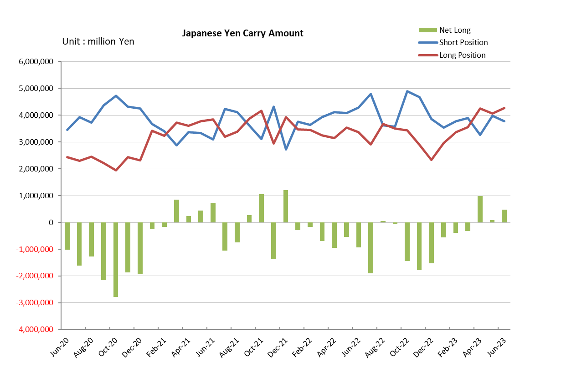

Monthly statistical report on Over-The-Counter Retail FX Margin Trading

：May , 2023
Publication date: 14 June. 2023
Number of Over-The-Counter Retail FX Margin Trading Operators as of 31 May. 2023 :50
Number of members reported :50
【Trading Volume】
(Unit: hundred million Yen, %)
 | Over-The-Counter | USDJPY, Cross Yen | On-Exchange*(for reference)
This month | 9,109,179 | 8,766,685 | 25,475
Previous month | 7,721,507 | 7,401,753 | 20,948
Change | 17.97% | 18.44% | 21.61%
*source : Monthly Trading Volume of Tokyo Financial exchange Inc.(The FFAJ converts the total number of contracts into the trading volume on the settlement prices of the end of the month)
【Open Positions】
(Unit: hundred million Yen)
 | Short | Long | Total
This month | 44,751 | 44,038 | 88,790
Previous month | 47,382 | 36,266 | 83,649
Change | -2,631 | 7,772 | 5,141

・USDJPY, Cross Yen Open Positions
(Unit: hundred million Yen)
 | - Short | ② Long | Net long=②-①
This month | 39,751 | 40,596 | 844
Previous month | 32,679 | 42,577 | 9,898

（Reference：USDJPY Monthly Rate＊）
（Unit: Yen）
End of last Month*1 | Highest of the Month | Lowest of the Month | End of the Month*1 | Average*2
135.73 | 140.92 | 133.9 | 139.75 | 137.37
*source : BOJ's Main Time-series Statistics (Monthly)
*1) Spot Rate at 17:00 in JST, End of Month, Tokyo Market
*2) Average of Central Rate in the Month, Tokyo Market

○ Notes
The volume of this month was approximately 911 trillion yen (aｎ increase of 18.0% from the previous month), the trading volume on a business day basis excluding weekends also increased.
The open positions balance at the end of the month increased since the end of the previous month,
short positions decreased, but long positions increased, totaling approximately 8.9 trillion yen.

～Tables and Historical Graphs～

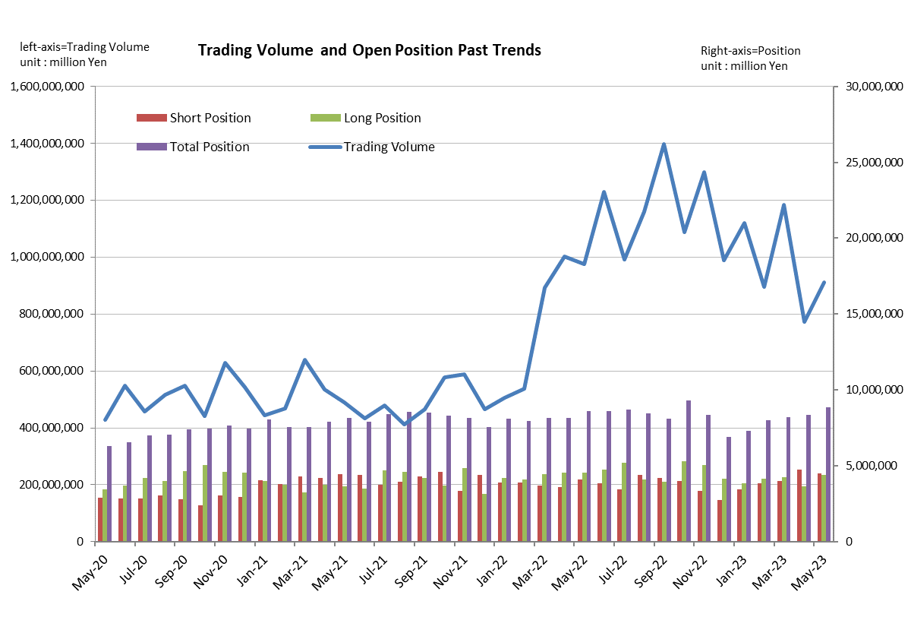

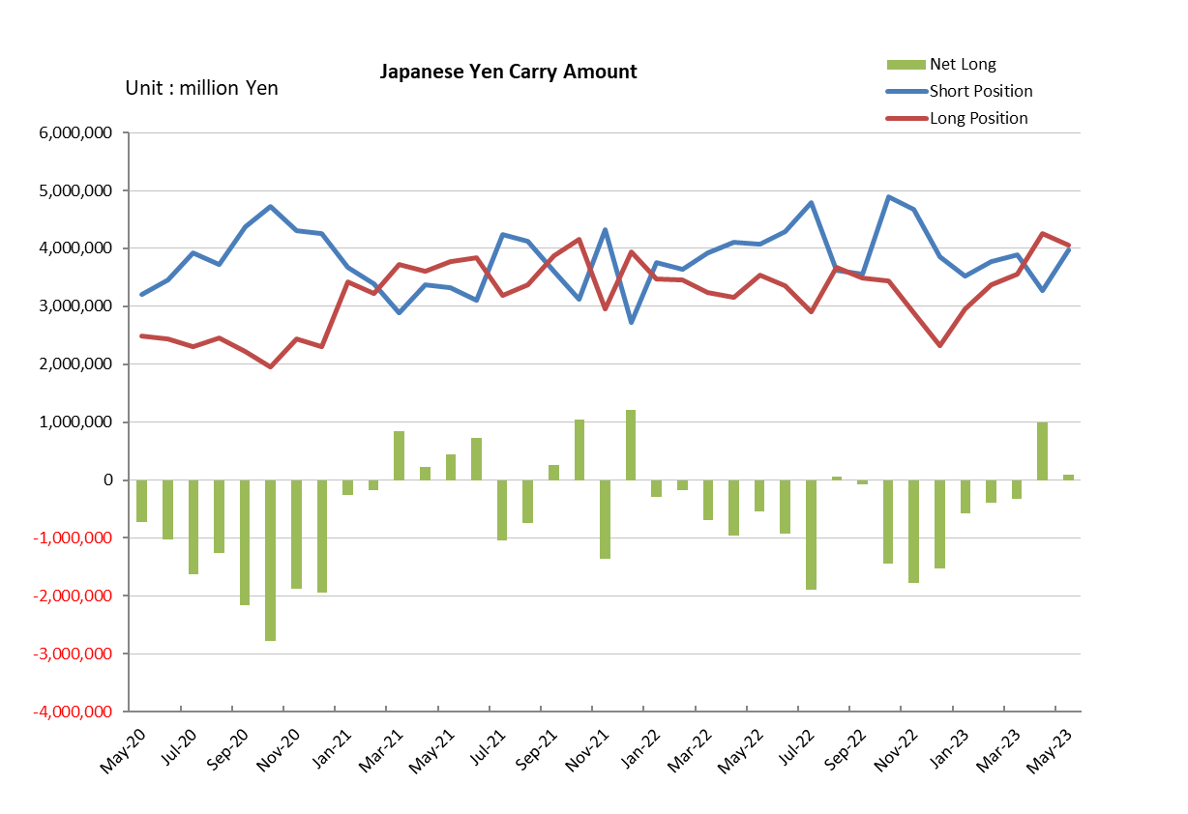

Monthly statistical report on Over-The-Counter Retail FX Margin Trading

：April , 2023
Publication date: 17 May. 2023
Number of Over-The-Counter Retail FX Margin Trading Operators as of 30 April. 2023 :50
Number of members reported :50
【Trading Volume】
(Unit: hundred million Yen, %)
 | Over-The-Counter | USDJPY, Cross Yen | On-Exchange*(for reference)
This month | 7,721,507 | 7,401,753 | 20,948
Previous month | 11,840,341 | 11,434,255 | 37,378
Change | -34.79% | -35.27% | -43.96%
*source : Monthly Trading Volume of Tokyo Financial exchange Inc.(The FFAJ converts the total number of contracts into the trading volume on the settlement prices of the end of the month)
【Open Positions】
(Unit: hundred million Yen)
 | Short | Long | Total
This month | 47,382 | 36,266 | 83,649
Previous month | 39,866 | 42,268 | 82,135
Change | 7,515 | -6,002 | 1,513

・USDJPY, Cross Yen Open Positions
(Unit: hundred million Yen)
 | - Short | ② Long | Net long=②-①
This month | 32,679 | 42,577 | 9,898
Previous month | 38,870 | 35,584 | -3,285

（Reference：USDJPY Monthly Rate＊）
（Unit: Yen）
End of last Month*1 | Highest of the Month | Lowest of the Month | End of the Month*1 | Average*2
133.13 | 135.85 | 130.79 | 135.73 | 133.33
*source : BOJ's Main Time-series Statistics (Monthly)
*1) Spot Rate at 17:00 in JST, End of Month, Tokyo Market
*2) Average of Central Rate in the Month, Tokyo Market

○ Notes
The volume of this month was approximately 772 trillion yen (a decrease of 34.8% from the previous month), the trading volume on a business day basis excluding weekends also decreased.
The open positions balance at the end of the month increased since the end of the previous month,
short positions increased, but long positions decreased, totaling approximately 8.4 trillion yen.

～Tables and Historical Graphs～

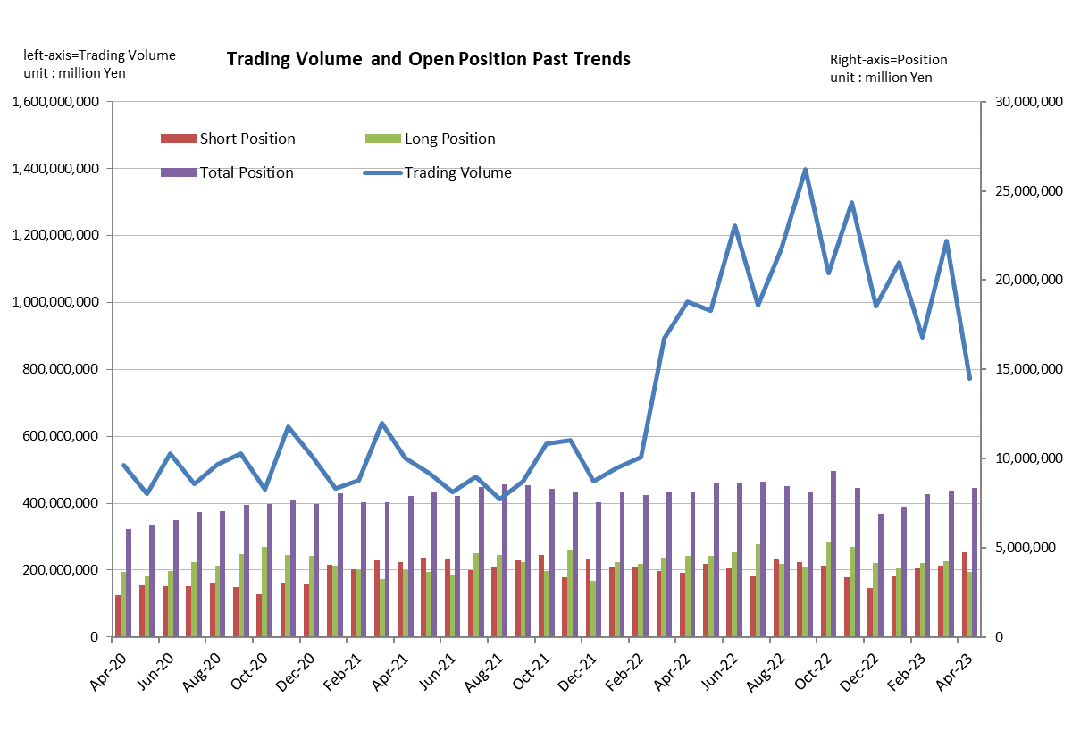

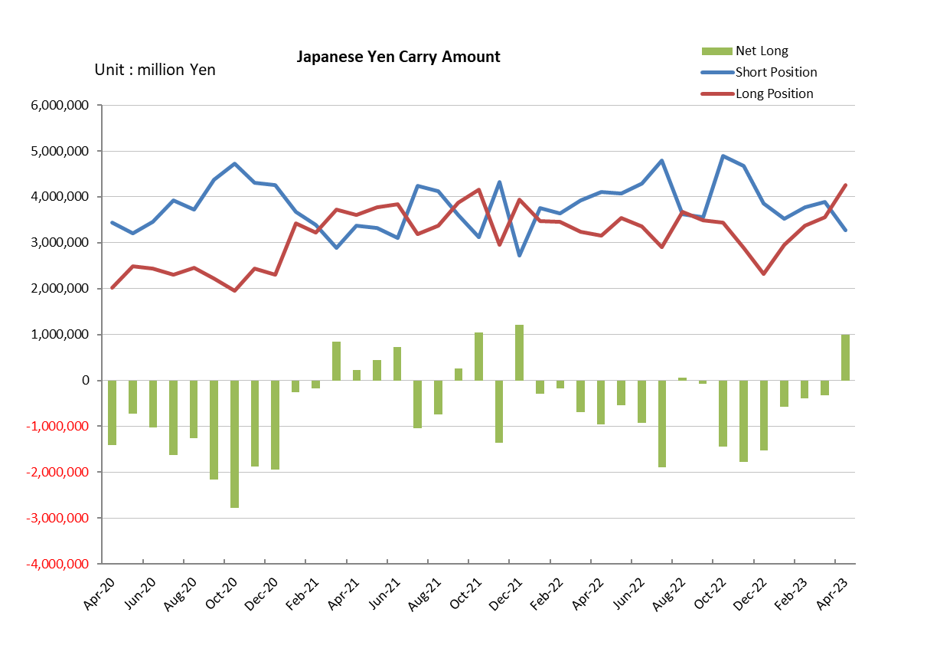

Monthly statistical report on Over-The-Counter Retail FX Margin Trading

：March , 2023
Publication date: 14 April. 2023
Number of Over-The-Counter Retail FX Margin Trading Operators as of 31 March. 2023 :49
Number of members reported :49
【Trading Volume】
(Unit: hundred million Yen, %)
 | Over-The-Counter | USDJPY, Cross Yen | On-Exchange*(for reference)
This month | 11,840,341 | 11,434,255 | 37,378
Previous month | 8,960,226 | 8,561,137 | 26,756
Change | 32.14% | 33.56% | 39.70%
*source : Monthly Trading Volume of Tokyo Financial exchange Inc.(The FFAJ converts the total number of contracts into the trading volume on the settlement prices of the end of the month)
【Open Positions】
(Unit: hundred million Yen)
 | Short | Long | Total
This month | 39,866 | 42,268 | 82,135
Previous month | 38,379 | 41,519 | 79,898
Change | 1,487 | 749 | 2,236

・USDJPY, Cross Yen Open Positions
(Unit: hundred million Yen)
 | ① Short | ② Long | Net long=②-①
This month | 38,870 | 35,584 | -3,285
Previous month | 37,674 | 33,754 | -3,920

（Reference：USDJPY Monthly Rate＊）
（Unit: Yen）
End of last Month*1 | Highest of the Month | Lowest of the Month | End of the Month*1 | Average*2
136.76 | 137.9 | 130.06 | 133.13 | 133.85
*source : BOJ's Main Time-series Statistics (Monthly)
*1) Spot Rate at 17:00 in JST, End of Month, Tokyo Market
*2) Average of Central Rate in the Month, Tokyo Market

○ Notes
The volume of this month was approximately 1,184 trillion yen (an increase of 32.1% from the previous month), the trading volume on a business day basis excluding weekends also increased.
The open positions balance at the end of the month increased since the end of the previous month for both long positions and short positions, with the overall open position balance increased to approximately 8.2 trillion yen at the end of the month.

～Tables and Historical Graphs～

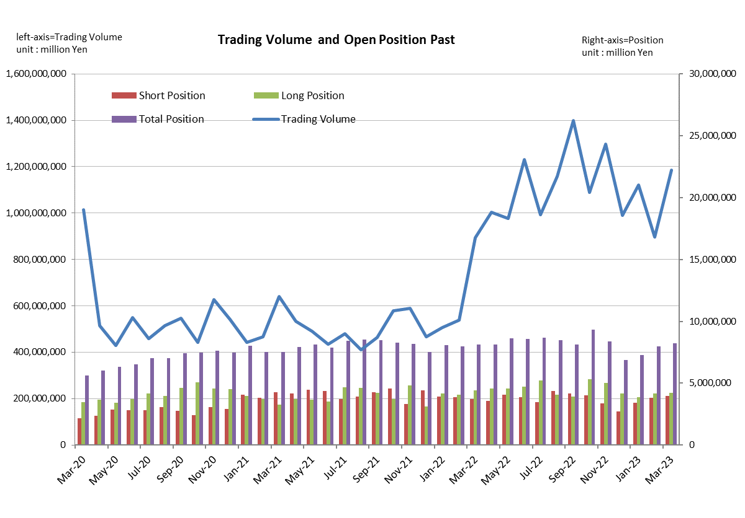

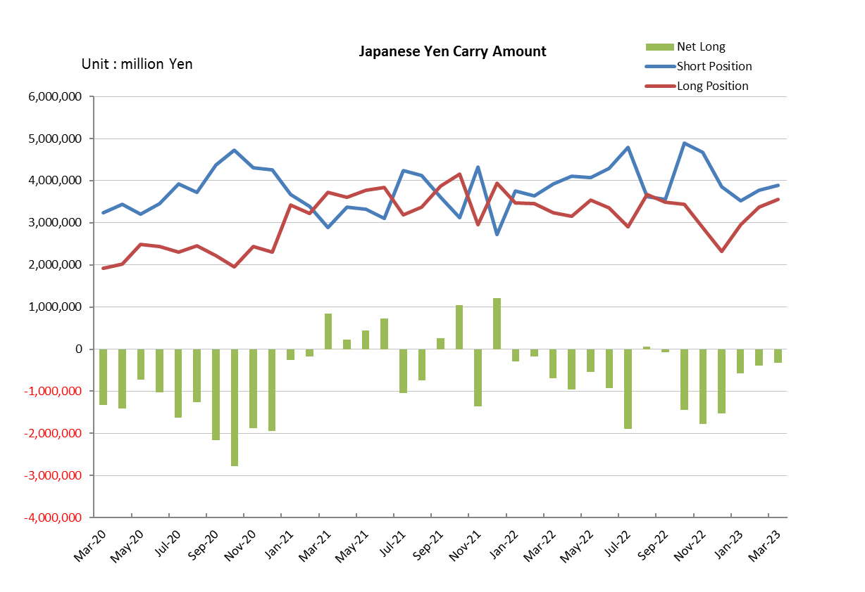

Monthly statistical report on Over-The-Counter Retail FX Margin Trading

：February , 2023
Publication date: 14 March. 2023
Number of Over-The-Counter Retail FX Margin Trading Operators as of 28 February. 2023 :49
Number of members reported :49
【Trading Volume】
(Unit: hundred million Yen, %)
 | Over-The-Counter | USDJPY, Cross Yen | On-Exchange*(for reference)
This month | 8,960,226 | 8,561,137 | 26,756
Previous month | 11,209,328 | 10,772,449 | 30,135
Change | -20.06% | -20.53% | -11.21%
*source : Monthly Trading Volume of Tokyo Financial exchange Inc.(The FFAJ converts the total number of contracts into the trading volume on the settlement prices of the end of the month)
【Open Positions】
(Unit: hundred million Yen)
 | Short | Long | Total
This month | 38,379 | 41,519 | 79,898
Previous month | 34,418 | 38,528 | 72,947
Change | 3,961 | 2,990 | 6,951

・USDJPY, Cross Yen Open Positions
(Unit: hundred million Yen)
 | ① Short | ② Long | Net long=②-①
This month | 37,674 | 33,754 | -3,920
Previous month | 35,305 | 29,636 | -5,669

（Reference：USDJPY Monthly Rate＊）
（Unit: Yen）
End of last Month*1 | Highest of the Month | Lowest of the Month | End of the Month*1 | Average*2
130.15 | 136.82 | 128.18 | 136.76 | 132.68
*source : BOJ's Main Time-series Statistics (Monthly)
*1) Spot Rate at 17:00 in JST, End of Month, Tokyo Market
*2) Average of Central Rate in the Month, Tokyo Market

○ Notes
The volume of this month was approximately 896 trillion yen (a decrease of 20.1% from the previous month), the trading volume on a business day basis excluding weekends also decreased.
The open positions balance at the end of the month increased since the end of the previous month for both long positions and short positions, with the overall open position balance increased to approximately 8.0 trillion yen at the end of the month.

～Tables and Historical Graphs～
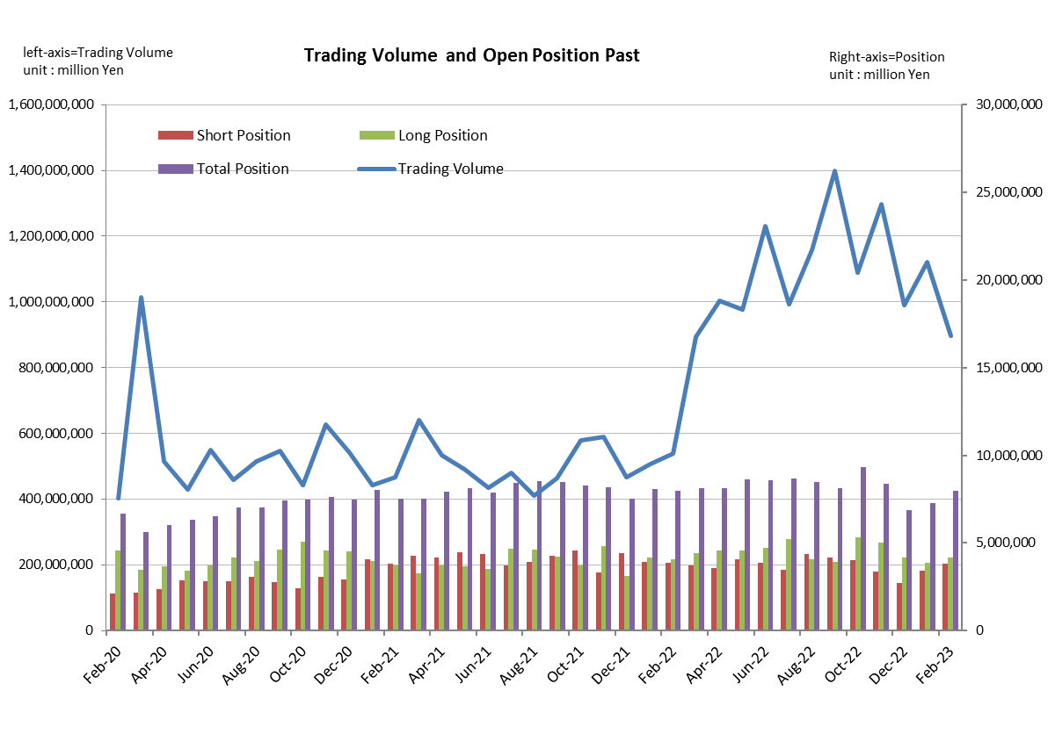
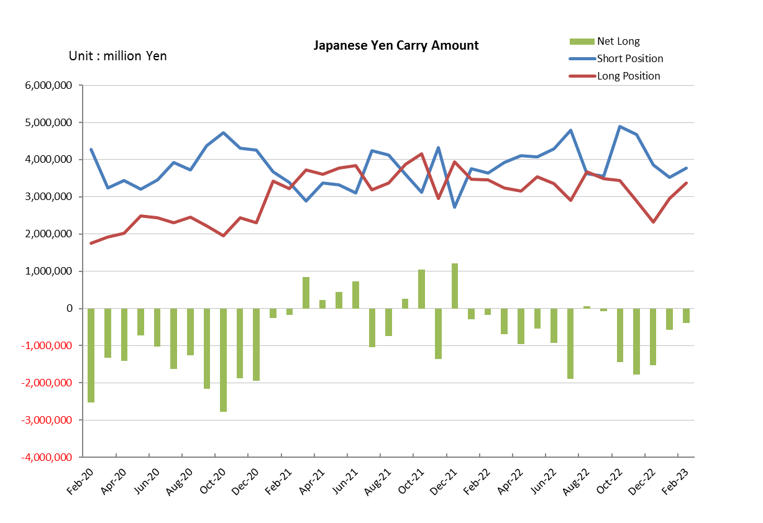

Monthly statistical report on Over-The-Counter Retail FX Margin Trading

：January , 2023
Publication date: 14 February. 2023
Number of Over-The-Counter Retail FX Margin Trading Operators as of 31 January. 2023 :49
Number of members reported :49
【Trading Volume】
(Unit: hundred million Yen, %)
 | Over-The-Counter | USDJPY, Cross Yen | On-Exchange*(for reference)
This month | 11,209,328 | 10,772,449 | 30,135
Previous month | 9,900,878 | 9,452,098 | 34,287
Change | 13.22% | 13.97% | -12.11%
*source : Monthly Trading Volume of Tokyo Financial exchange Inc.(The FFAJ converts the total number of contracts into the trading volume on the settlement prices of the end of the month)
【Open Positions】
(Unit: hundred million Yen)
 | Short | Long | Total
This month | 34,418 | 38,528 | 72,947
Previous month | 27,336 | 41,490 | 68,827
Change | 7,081 | -2,961 | 4,119

・USDJPY, Cross Yen Open Positions
(Unit: hundred million Yen)
 | ① Short | ② Long | Net long=②-①
This month | 35,305 | 29,636 | -5,669
Previous month | 38,565 | 23,291 | -15,273

（Reference：USDJPY Monthly Rate＊）
（Unit: Yen）
End of last Month*1 | Highest of the Month | Lowest of the Month | End of the Month*1 | Average*2
132.14 | 134.37 | 127.22 | 130.15 | 130.2
*source : BOJ's Main Time-series Statistics (Monthly)
*1) Spot Rate at 17:00 in JST, End of Month, Tokyo Market
*2) Average of Central Rate in the Month, Tokyo Market

○ Notes
The volume of this month was approximately 1,121 trillion yen (an increase of 13.2% from the previous month), the trading volume on a business day basis excluding weekends also increased.
The open positions balance at the end of the month increased since the end of the previous month,
short positions increased, but long positions decreased, totaling approximately 7.2 trillion yen.

～Tables and Historical Graphs～

