Over-The-Counter FX Margin Trading Report

(January 2022 ～ )

Monthly Report
January 2022
February 2022
March 2022
April 2022
May 2022
June 2022
July 2022
August 2022
September 2022
October 2022
November 2022
December 2022

The Financial Futures Association of Japan, Research Department

NBF Ogawamachi Building 1-3 , Kanda Ogawamachi ,
Chiyoda-ku , Tokyo 101-0052 Tel:(03)5280-0881 E-mail : ffaj@ffaj.or.jp

This publication has been prepared by the FFAJ and is provided for information purpose only. The monthly information contained in this publication has been obtained from FFAJ's members that is believed to be reliable, however the FFAJ does not represent or warrant that it is accurate or complete. In no event the FFAJ nor its employees have any liability for any consequential damages arising from any use of this publications or its contents. This publication does not constitute any investment advice.

Monthly statistical report on Over-The-Counter Retail FX Margin Trading

：December , 2022
Publication date : 18 January. 2022
Number of Over-The-Counter Retail FX Margin Trading Operators as of 31 December. 2022 :49
Number of members reported :49
【Trading Volume】
(Unit: hundred million Yen, %)
 | Over-The-Counter | USDJPY, Cross Yen | On-Exchange*(for reference)
This month | 9,900,878 | 9,452,098 | 34,287
Previous month | 12,976,651 | 12,197,931 | 35,812
Change | -23.70% | -22.51% | -4.26%
*source : Monthly Trading Volume of Tokyo Financial exchange Inc.(The FFAJ converts the total number of contracts into the trading volume on the settlement prices of the end of the month)
【Open Positions】
(Unit: hundred million Yen)
 | Short | Long | Total
This month | 27,336 | 41,490 | 68,827
Previous month | 33,448 | 50,258 | 83,706
Change | -6,111 | -8,767 | -14,879

・USDJPY, Cross Yen Open Positions
(Unit: hundred million Yen)
 | ① Short | ② Long | Net long=②-①
This month | 38,565 | 23,291 | -15,273
Previous month | 46,701 | 28,888 | -17,812

（Reference：USDJPY Monthly Rate＊）
（Unit: Yen）
End of last Month*1 | Highest of the Month | Lowest of the Month | End of the Month*1 | Average*2
138.53 | 138.11 | 131.5 | 132.14 | 134.93
*source : BOJ's Main Time-series Statistics (Monthly)
*1) Spot Rate at 17:00 in JST, End of Month, Tokyo Market
*2) Average of Central Rate in the Month, Tokyo Market

○ Notes
The volume of this month was about 990.1 trillion yen (a decrease of about 23.7% from the previous month),
the trading volume on a business day basis excluding weekends also decreased.
The open positions balance at the end of the month was about 6.9 trillion yen in total, with both short positions and long positions decreasing from the end of the previous month.

～Tables and Historical Graphs～

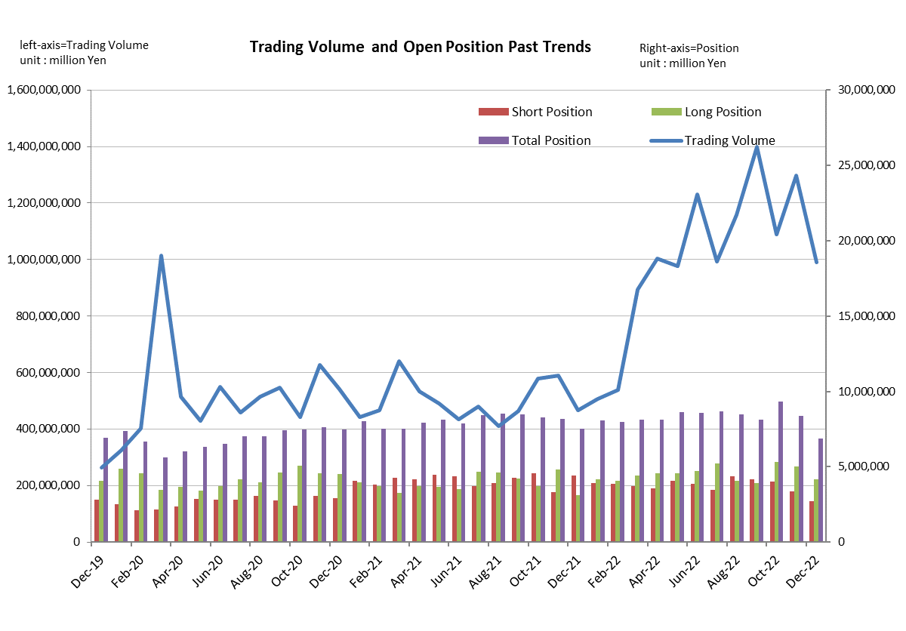

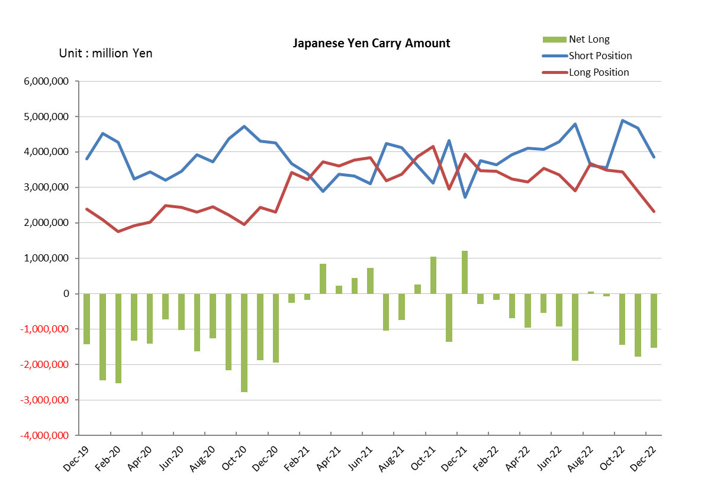

Monthly statistical report on Over-The-Counter Retail FX Margin Trading

：November , 2022
Publication date : 14 December. 2022
Number of Over-The-Counter Retail FX Margin Trading Operators as of 30 November. 2022 :49
Number of members reported :49
【Trading Volume】
(Unit: hundred million Yen, %)
 | Over-The-Counter | USDJPY, Cross Yen | On-Exchange*(for reference)
This month | 12,976,651 | 12,197,931 | 35,812
Previous month | 10,882,488 | 9,730,488 | 45,911
Change | 19.24% | 25.36% | -22.00%
*source : Monthly Trading Volume of Tokyo Financial exchange Inc.(The FFAJ converts the total number of contracts into the trading volume on the settlement prices of the end of the month)
【Open Positions】
(Unit: hundred million Yen)
 | Short | Long | Total
This month | 33,448 | 50,258 | 83,706
Previous month | 40,201 | 53,117 | 93,318
Change | -6,752 | -2,859 | -9,612

・USDJPY, Cross Yen Open Positions
(Unit: hundred million Yen)
 | ① Short | ② Long | Net long=②-①
This month | 46,701 | 28,888 | -17,812
Previous month | 48,888 | 34,390 | -14,497

（Reference：USDJPY Monthly Rate＊）
（Unit: Yen）
End of last Month*1 | Highest of the Month | Lowest of the Month | End of the Month*1 | Average*2
148.01 | 148.82 | 137.81 | 138.53 | 142.44
*source : BOJ's Main Time-series Statistics (Monthly)
*1) Spot Rate at 17:00 in JST, End of Month, Tokyo Market
*2) Average of Central Rate in the Month, Tokyo Market

○ Notes
The volume of this month was about 1297.7 trillion yen (an increase of about 19.2% from the previous month),
the trading volume on a business day basis excluding weekends also increased.
The open positions balance at the end of the month was about 8.4 trillion yen in total, with both short positions and long positions decreasing from the end of the previous month.

～Tables and Historical Graphs～

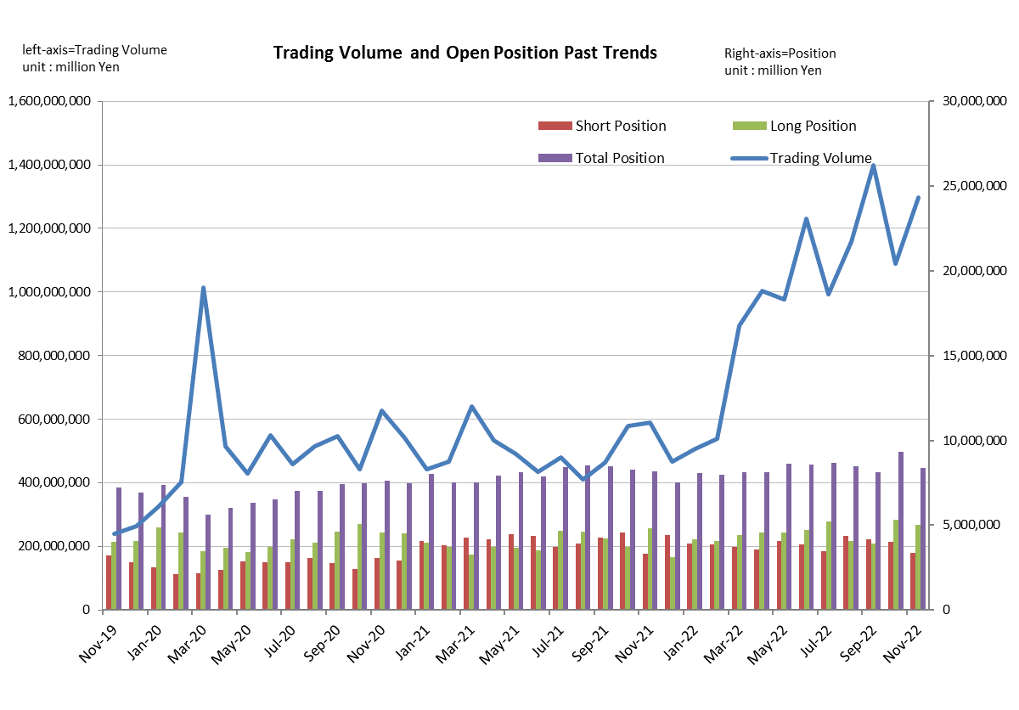

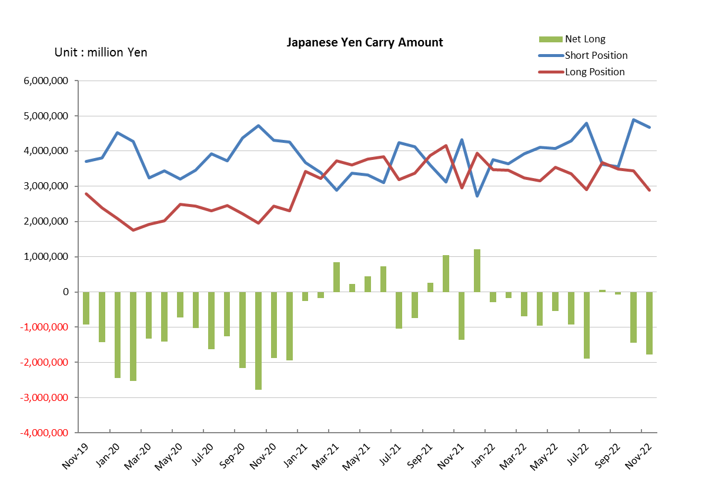

Monthly statistical report on Over-The-Counter Retail FX Margin Trading

：October , 2022
Publication date : 15 November. 2022
Number of Over-The-Counter Retail FX Margin Trading Operators as of 31 October. 2022 :49
Number of members reported :49
【Trading Volume】
(Unit: hundred million Yen, %)
 | Over-The-Counter | USDJPY, Cross Yen | On-Exchange*(for reference)
This month | 10,882,488 | 9,730,488 | 45,911
Previous month | 13,980,484 | 12,997,668 | 44,662
Change | -22.16% | -25.14% | 2.80%
*source : Monthly Trading Volume of Tokyo Financial exchange Inc.(The FFAJ converts the total number of contracts into the trading volume on the settlement prices of the end of the month)
【Open Positions】
(Unit: hundred million Yen)
 | Short | Long | Total
This month | 40,201 | 53,117 | 93,318
Previous month | 41,906 | 39,388 | 81,294
Change | -1,705 | 13,729 | 12,024

・USDJPY, Cross Yen Open Positions
(Unit: hundred million Yen)
 | ① Short | ② Long | Net long=②-①
This month | 48,888 | 34,390 | -14,497
Previous month | 35,643 | 34,970 | -672

（Reference：USDJPY Monthly Rate＊）
（Unit: Yen）
End of last Month*1 | Highest of the Month | Lowest of the Month | End of the Month*1 | Average*2
144.32 | 150.48 | 143.55 | 148.01 | 147.01
*source : BOJ's Main Time-series Statistics (Monthly)
*1) Spot Rate at 17:00 in JST, End of Month, Tokyo Market
*2) Average of Central Rate in the Month, Tokyo Market

○ Notes
The volume of this month was about 1088.2 trillion yen (a decrease of about 22.2% from the previous month),
the trading volume on a business day basis excluding weekends also decreased.
The open positions balance at the end of the month increased since the end of the previous month,
short positions decreased, but long positions increased, totaling about 9.3 trillion yen.

～Tables and Historical Graphs～

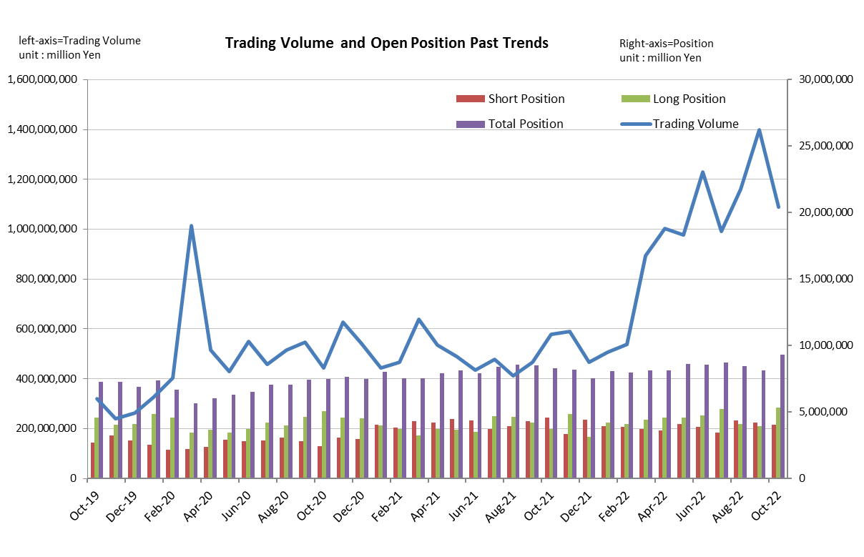

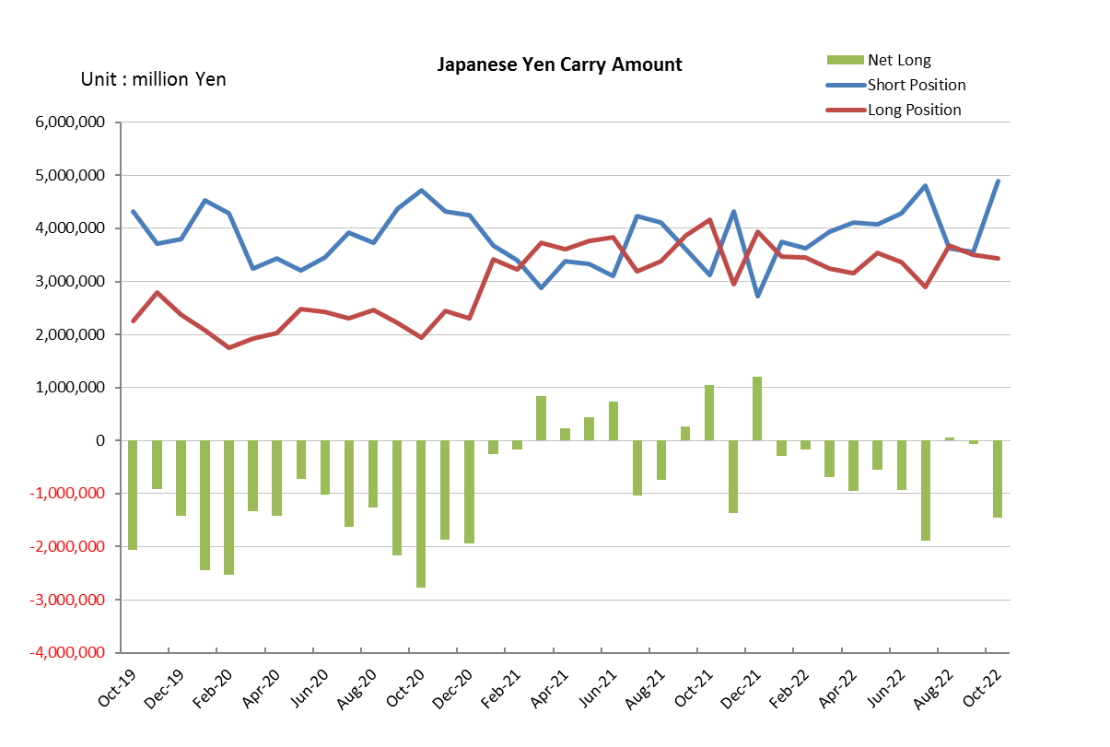

Monthly statistical report on Over-The-Counter Retail FX Margin Trading

：September , 2022
Publication date : 17 October. 2022
Number of Over-The-Counter Retail FX Margin Trading Operators as of 30 September. 2022 :49
Number of members reported :49
【Trading Volume】
(Unit: hundred million Yen, %)
 | Over-The-Counter | USDJPY, Cross Yen | On-Exchange*(for reference)
This month | 13,980,484 | 12,997,668 | 44,662
Previous month | 11,597,370 | 10,996,083 | 32,451
Change | 20.55% | 18.20% | 37.63%
*source : Monthly Trading Volume of Tokyo Financial exchange Inc.(The FFAJ converts the total number of contracts into the trading volume on the settlement prices of the end of the month)
【Open Positions】
(Unit: hundred million Yen)
 | Short | Long | Total
This month | 41,906 | 39,388 | 81,294
Previous month | 43,742 | 40,894 | 84,637
Change | -1,836 | -1,506 | -3,342

・USDJPY, Cross Yen Open Positions
(Unit: hundred million Yen)
 | ① Short | ② Long | Net long=②-①
This month | 35,643 | 34,970 | -672
Previous month | 36,172 | 36,717 | 545

（Reference：USDJPY Monthly Rate＊）
（Unit: Yen）
End of last Month*1 | Highest of the Month | Lowest of the Month | End of the Month*1 | Average*2
138.6 | 145.9 | 139.03 | 144.32 | 143.14
*source : BOJ's Main Time-series Statistics (Monthly)
*1) Spot Rate at 17:00 in JST, End of Month, Tokyo Market
*2) Average of Central Rate in the Month, Tokyo Market

○ Notes
The volume of this month was about 1398.0 trillion yen (an increase of about 20.6% from the previous month), the trading volume on a business day basis excluding weekends also increased.
The open positions balance at the end of the month decreased since the end of the previous month in both the buy and sell positions, with the total open positions balance at about 8.1 trillion yen.

～Tables and Historical Graphs～

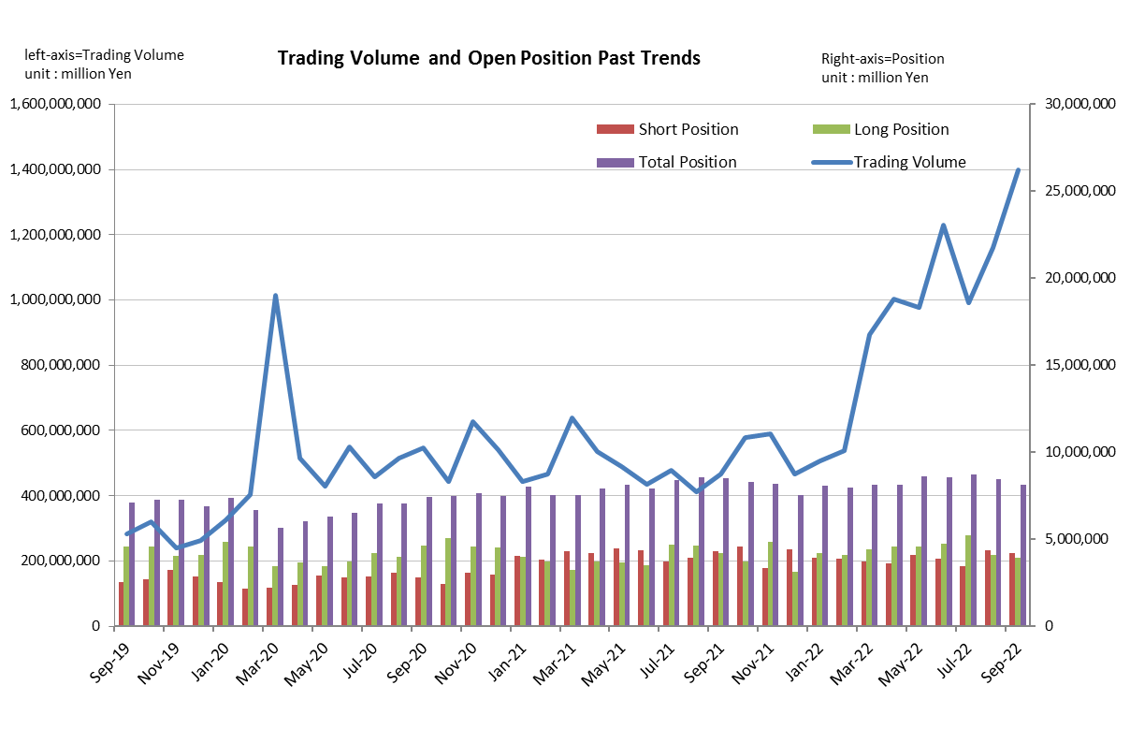

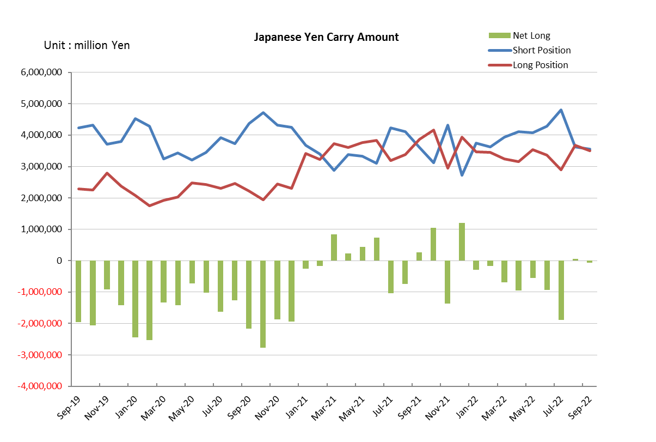

Monthly statistical report on Over-The-Counter Retail FX Margin Trading

：August , 2022
Publication date : 14 September. 2022
Number of Over-The-Counter Retail FX Margin Trading Operators as of 31 August. 2022 :49
Number of members reported :49
【Trading Volume】
(Unit: hundred million Yen, %)
 | Over-The-Counter | USDJPY, Cross Yen | On-Exchange*(for reference)
This month | 11,597,370 | 10,996,083 | 32,451
Previous month | 9,917,400 | 9,166,195 | 32,050
Change | 16.94% | 19.96% | 1.25%
*source : Monthly Trading Volume of Tokyo Financial exchange Inc.(The FFAJ converts the total number of contracts into the trading volume on the settlement prices of the end of the month)
【Open Positions】
(Unit: hundred million Yen)
 | Short | Long | Total
This month | 43,742 | 40,894 | 84,637
Previous month | 34,684 | 52,247 | 86,932
Change | 9,057 | -11,352 | -2,295

・USDJPY, Cross Yen Open Positions
(Unit: hundred million Yen)
 | ① Short | ② Long | Net long=②-①
This month | 36,172 | 36,717 | 545
Previous month | 47,982 | 29,050 | -18,931

（Reference：USDJPY Monthly Rate＊）
（Unit: Yen）
End of last Month*1 | Highest of the Month | Lowest of the Month | End of the Month*1 | Average*2
132.78 | 139 | 130.4 | 138.6 | 135.24
*source : BOJ's Main Time-series Statistics (Monthly)
*1) Spot Rate at 17:00 in JST, End of Month, Tokyo Market
*2) Average of Central Rate in the Month, Tokyo Market

○ Notes
The volume of this month was about 1159.7 trillion yen (an increase of about 16.9% from the previous month), the trading volume on a business day basis excluding weekends also increased.
The open positions balance at the end of the month decreased since the end of the previous month,
short positions increased, but long positions decreased, totaling about 8.5 trillion yen.

～Tables and Historical Graphs～

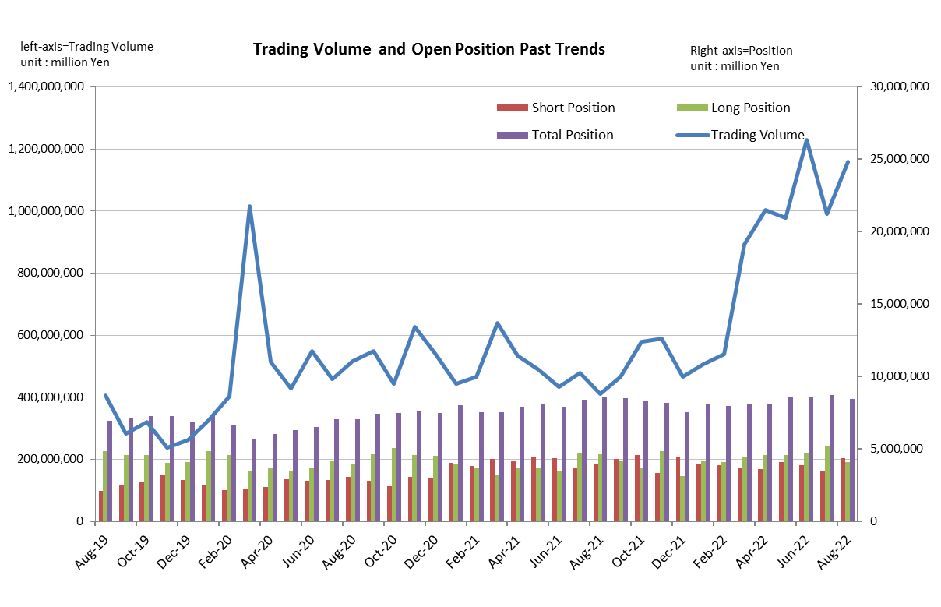

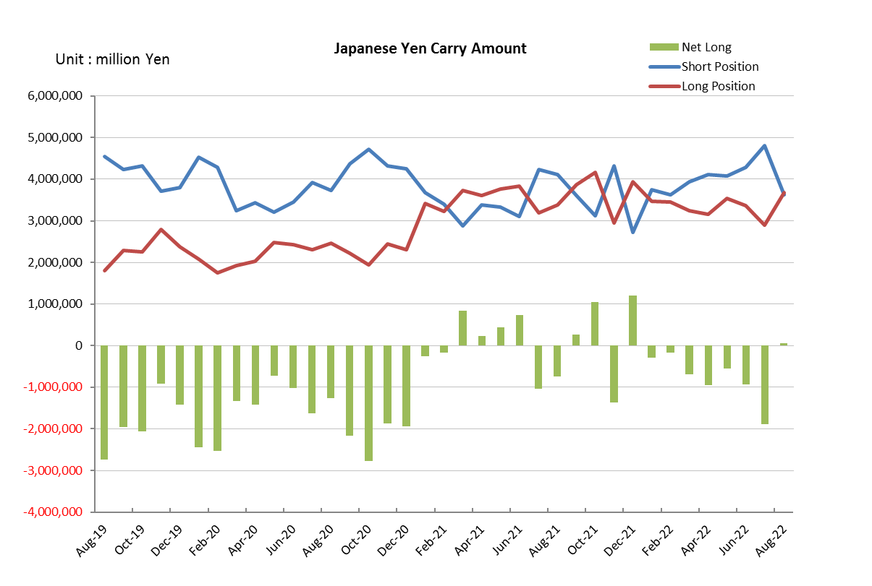

Monthly statistical report on Over-The-Counter Retail FX Margin Trading

：July , 2022
Publication date : 15 Angust. 2022
Number of Over-The-Counter Retail FX Margin Trading Operators as of 31 July. 2022 :49
Number of members reported :49
【Trading Volume】
(Unit: hundred million Yen, %)
 | Over-The-Counter | USDJPY, Cross Yen | On-Exchange*(for reference)
This month | 9,917,400 | 9,166,195 | 32,050
Previous month | 12,298,960 | 11,789,599 | 47,304
Change | -19.36% | -22.25% | -32.25%
*source : Monthly Trading Volume of Tokyo Financial exchange Inc.(The FFAJ converts the total number of contracts into the trading volume on the settlement prices of the end of the month)
【Open Positions】
(Unit: hundred million Yen)
 | Short | Long | Total
This month | 34,684 | 52,247 | 86,932
Previous month | 38,542 | 47,281 | 85,824
Change | -3,857 | 4,965 | 1,107

・USDJPY, Cross Yen Open Positions
(Unit: hundred million Yen)
 | ① Short | ② Long | Net long=②-①
This month | 47,982 | 29,050 | -18,931
Previous month | 42,874 | 33,603 | -9,271

（Reference：USDJPY Monthly Rate＊）
（Unit: Yen）
End of last Month*1 | Highest of the Month | Lowest of the Month | End of the Month*1 | Average*2
136.2 | 139.18 | 132.51 | 132.78 | 136.63
*source : BOJ's Main Time-series Statistics (Monthly)
*1) Spot Rate at 17:00 in JST, End of Month, Tokyo Market
*2) Average of Central Rate in the Month, Tokyo Market

○ Notes
The volume of this month was about 991.7 trillion yen (a decrease of about 19.4% from the previous month), the trading volume on a business day basis excluding weekends also decreased.
The open positions balance at the end of the month increased since the end of the previous month,
short positions decreased, but long positions increased, totaling about 8.7 trillion yen.

～Tables and Historical Graphs～

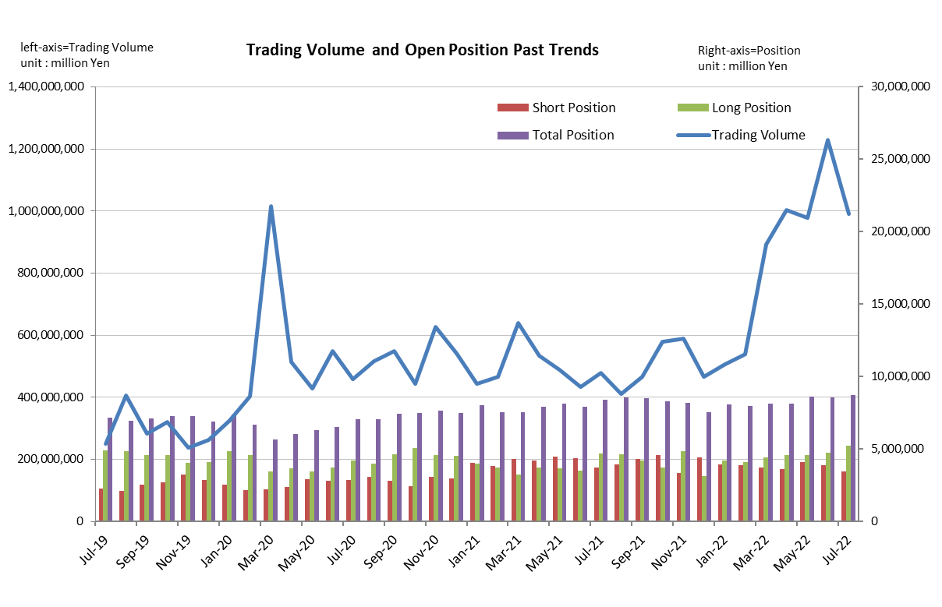

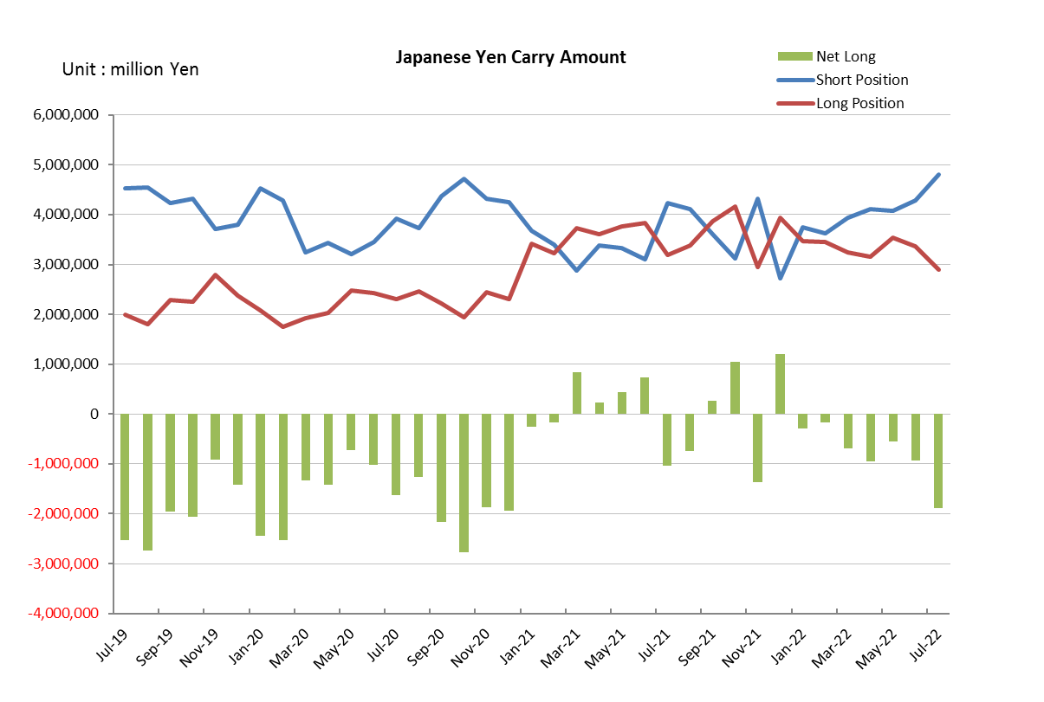

Monthly statistical report on Over-The-Counter Retail FX Margin Trading

：June , 2022
Publication date : 14 July. 2022
Number of Over-The-Counter Retail FX Margin Trading Operators as of 30 June. 2022 :49
Number of members reported :49
【Trading Volume】
(Unit: hundred million Yen, %)
 | Over-The-Counter | USDJPY, Cross Yen | On-Exchange*(for reference)
This month | 12,298,960 | 11,789,599 | 47,304
Previous month | 9,770,044 | 9,196,085 | 36,797
Change | 25.88% | 28.20% | 28.55%
*source : Monthly Trading Volume of Tokyo Financial exchange Inc.(The FFAJ converts the total number of contracts into the trading volume on the settlement prices of the end of the month)
【Open Positions】
(Unit: hundred million Yen)
 | Short | Long | Total
This month | 38,542 | 47,281 | 85,824
Previous month | 40,759 | 45,500 | 86,260
Change | -2,216 | 1,780 | -435

・USDJPY, Cross Yen Open Positions
(Unit: hundred million Yen)
 | ① Short | ② Long | Net long=②-①
This month | 42,874 | 33,603 | -9,271
Previous month | 40,808 | 35,372 | -5,436

（Reference：USDJPY Monthly Rate＊）
（Unit: Yen）
End of last Month*1 | Highest of the Month | Lowest of the Month | End of the Month*1 | Average*2
127.76 | 136.8 | 128.65 | 136.2 | 133.86
*source : BOJ's Main Time-series Statistics (Monthly)
*1) Spot Rate at 17:00 in JST, End of Month, Tokyo Market
*2) Average of Central Rate in the Month, Tokyo Market

○ Notes
The volume of this month was about 1230 trillion yen (an increase of about 25.9% from the previous month), the trading volume on a business day basis excluding weekends also increased.
The open positions balance at the end of the month decreased since the end of the previous month,
short positions decreased, but long positions increased, totaling about 8.6 trillion yen.

～Tables and Historical Graphs～

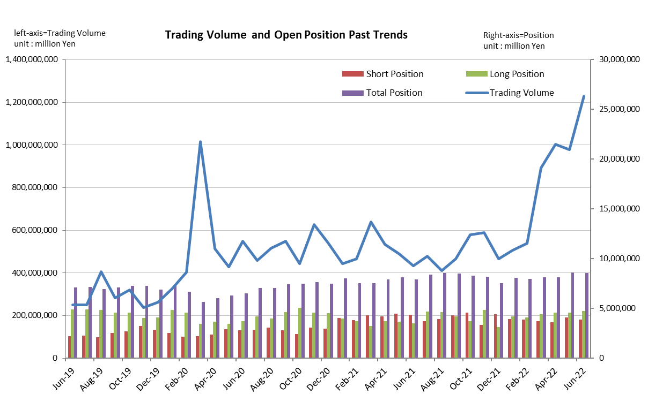

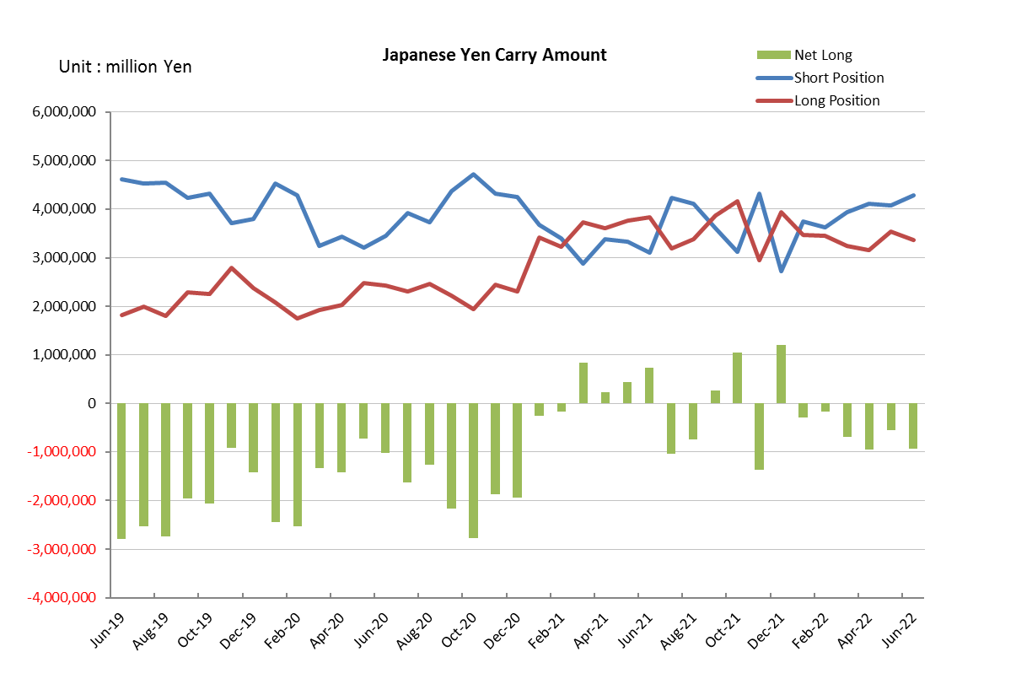

Monthly statistical report on Over-The-Counter Retail FX Margin Trading

：May , 2022
Publication date : 14 June. 2022
Number of Over-The-Counter Retail FX Margin Trading Operators as of 31 May. 2022 :50
Number of members reported :50
【Trading Volume】
(Unit: hundred million Yen, %)
 | Over-The-Counter | USDJPY, Cross Yen | On-Exchange*(for reference)
This month | 9,770,044 | 9,196,085 | 36,797
Previous month | 10,024,042 | 9,495,182 | 40,689
Change | -2.53% | -3.15% | -9.57%
*source : Monthly Trading Volume of Tokyo Financial exchange Inc.(The FFAJ converts the total number of contracts into the trading volume on the settlement prices of the end of the month)
【Open Positions】
(Unit: hundred million Yen)
 | Short | Long | Total
This month | 40,759 | 45,500 | 86,260
Previous month | 35,909 | 45,514 | 81,423
Change | 4,850 | -13 | 4,836

・USDJPY, Cross Yen Open Positions
(Unit: hundred million Yen)
 | ① Short | ② Long | Net long=②-①
This month | 40,808 | 35,372 | -5,436
Previous month | 41,075 | 31,543 | -9,532

（Reference：USDJPY Monthly Rate＊）
（Unit: Yen）
End of last Month*1 | Highest of the Month | Lowest of the Month | End of the Month*1 | Average*2
130.6 | 131.34 | 126.56 | 127.76 | 128.78
*source : BOJ's Main Time-series Statistics (Monthly)
*1) Spot Rate at 17:00 in JST, End of Month, Tokyo Market
*2) Average of Central Rate in the Month, Tokyo Market

○ Notes
The volume of this month was about 977 trillion yen (a decrease of about 2.5% from the previous month), the trading volume on a business day basis excluding weekends also decreased.
The open positions balance at the end of the month increased since the end of the previous month,
short positions increased, but long positions decreased, totaling about 8.6 trillion yen.

～Tables and Historical Graphs～

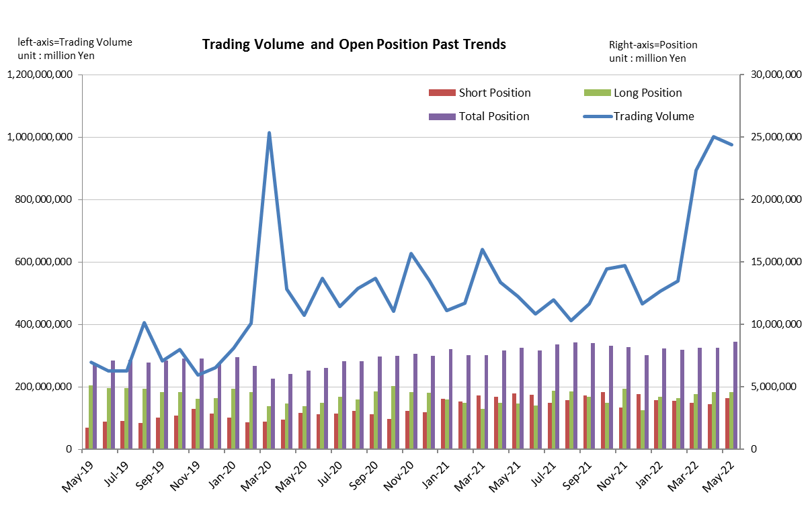

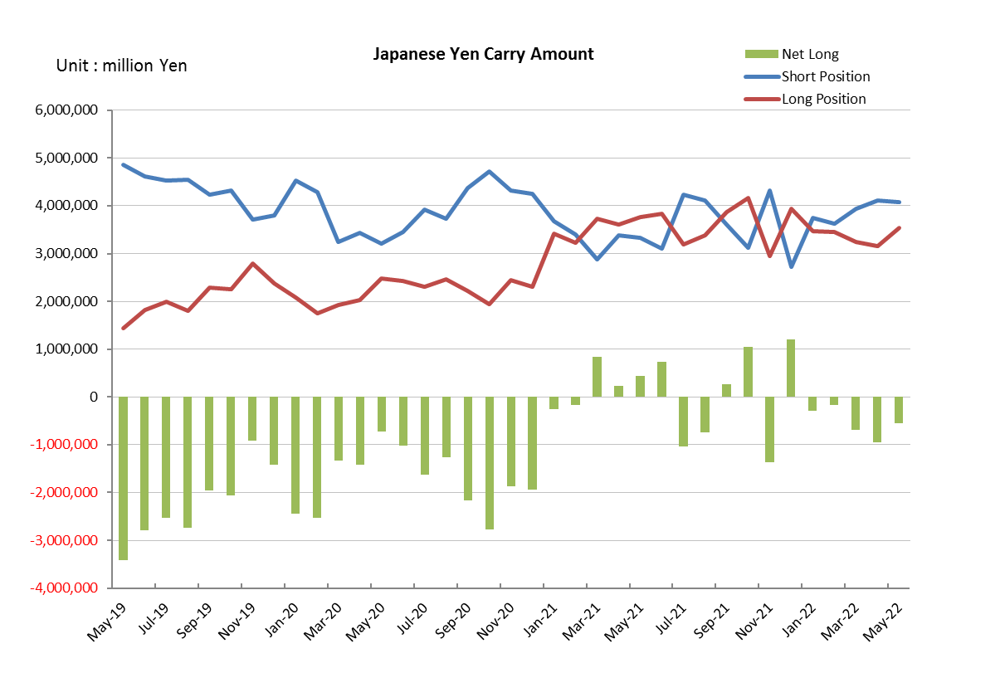

Monthly statistical report on Over-The-Counter Retail FX Margin Trading

：April , 2022
Publication date : 18 May. 2022
Number of Over-The-Counter Retail FX Margin Trading Operators as of 30 April. 2022 :50
Number of members reported :50
【Trading Volume】
(Unit: hundred million Yen, %)
 | Over-The-Counter | USDJPY, Cross Yen | On-Exchange*(for reference)
This month | 10,024,042 | 9,495,182 | 40,689
Previous month | 8,936,514 | 8,108,427 | 38,070
Change | 12.17% | 17.10% | 6.88%
*source : Monthly Trading Volume of Tokyo Financial exchange Inc.(The FFAJ converts the total number of contracts into the trading volume on the settlement prices of the end of the month)
【Open Positions】
(Unit: hundred million Yen)
 | Short | Long | Total
This month | 35,909 | 45,514 | 81,423
Previous month | 36,983 | 44,383 | 81,367
Change | -1,074 | 1,130 | 55

・USDJPY, Cross Yen Open Positions
(Unit: hundred million Yen)
 | ① Short | ② Long | Net long=②-①
This month | 41,075 | 31,543 | -9,532
Previous month | 39,317 | 32,436 | -6,880

（Reference：USDJPY Monthly Rate＊）
（Unit: Yen）
End of last Month*1 | Highest of the Month | Lowest of the Month | End of the Month*1 | Average*2
121.64 | 130.68 | 121.7 | 130.6 | 126.04
*source : BOJ's Main Time-series Statistics (Monthly)
*1) Spot Rate at 17:00 in JST, End of Month, Tokyo Market
*2) Average of Central Rate in the Month, Tokyo Market

○ Notes
The volume of this month was about 1,002 trillion yen (an increase of about 12.2% from the previous month), the trading volume on a business day basis excluding weekends also increased.
The open positions balance at the end of the month increased since the end of the previous month,
short positions decreased, but long positions increased, totaling about 8.1 trillion yen.

～Tables and Historical Graphs～

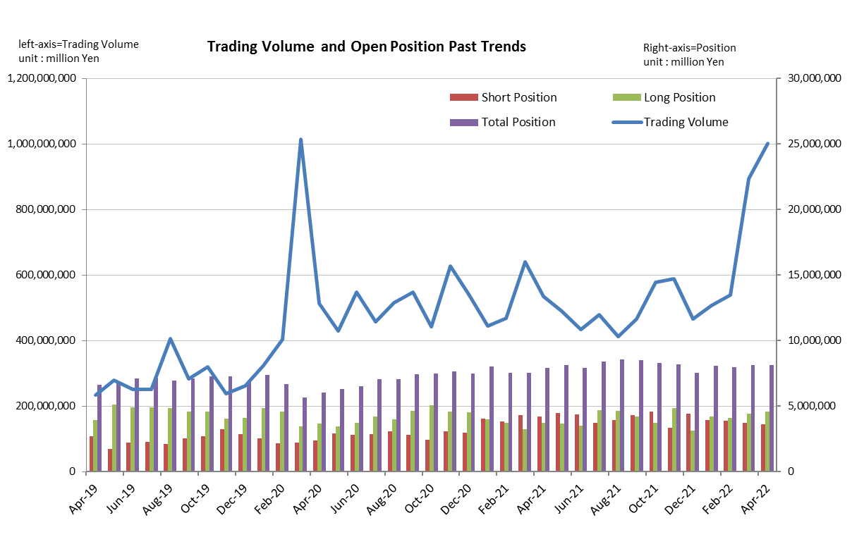

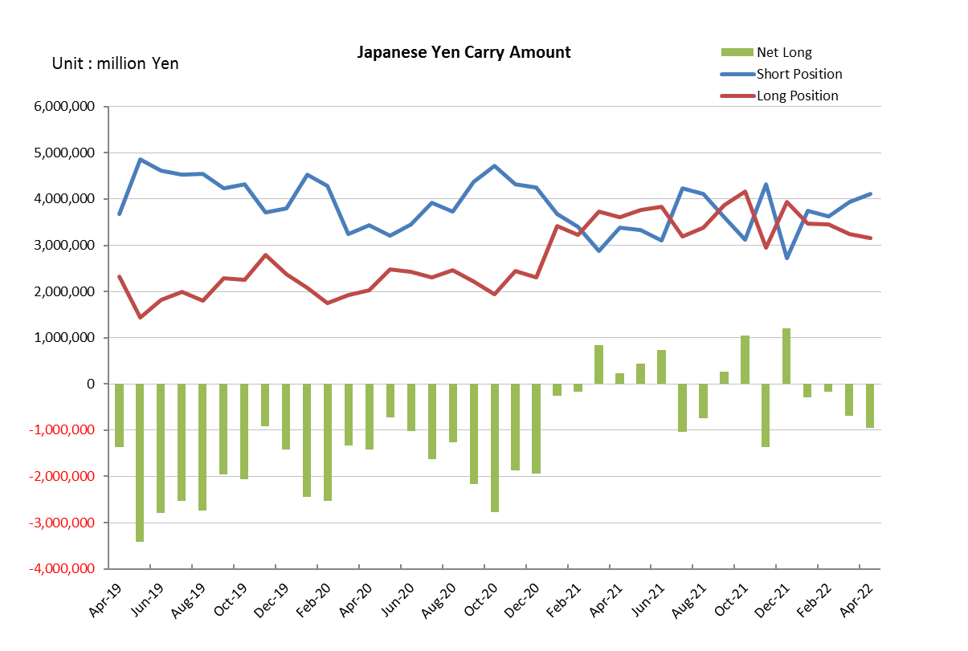

Monthly statistical report on Over-The-Counter Retail FX Margin Trading

：March , 2022
Publication date : 14 April. 2022
Number of Over-The-Counter Retail FX Margin Trading Operators as of 31 March. 2022 :50
Number of members reported :50
【Trading Volume】
(Unit: hundred million Yen, %)
 | Over-The-Counter | USDJPY, Cross Yen | On-Exchange*(for reference)
This month | 8,936,654 | 8,108,427 | 38,070
Previous month | 5,388,187 | 4,881,260 | 19,340
Change | 65.86% | 66.11% | 96.85%
*source : Monthly Trading Volume of Tokyo Financial exchange Inc.(The FFAJ converts the total number of contracts into the trading volume on the settlement prices of the end of the month)
【Open Positions】
(Unit: hundred million Yen)
 | Short | Long | Total
This month | 36,983 | 44,383 | 81,367
Previous month | 38,798 | 40,925 | 79,723
Change | -1,814 | 3,458 | 1,643

・USDJPY, Cross Yen Open Positions
(Unit: hundred million Yen)
 | ① Short | ② Long | Net long=②-①
This month | 39,317 | 32,436 | -6,880
Previous month | 36,318 | 34,600 | -1,717

（Reference：USDJPY Monthly Rate＊）
（Unit: Yen）
End of last Month*1 | Highest of the Month | Lowest of the Month | End of the Month*1 | Average*2
115.5 | 124.31 | 114.79 | 121.64 | 118.51
*source : BOJ's Main Time-series Statistics (Monthly)
*1) Spot Rate at 17:00 in JST, End of Month, Tokyo Market
*2) Average of Central Rate in the Month, Tokyo Market

○ Notes
The volume of this month was about 894 trillion yen (an increase of 65.9% from the previous month), the trading volume on a business day basis excluding weekends also increased.
The open positions balance at the end of the month increased since the end of the previous month,
short positions decreased, but long positions increased, totaling about 8.1 trillion yen.

～Tables and Historical Graphs～

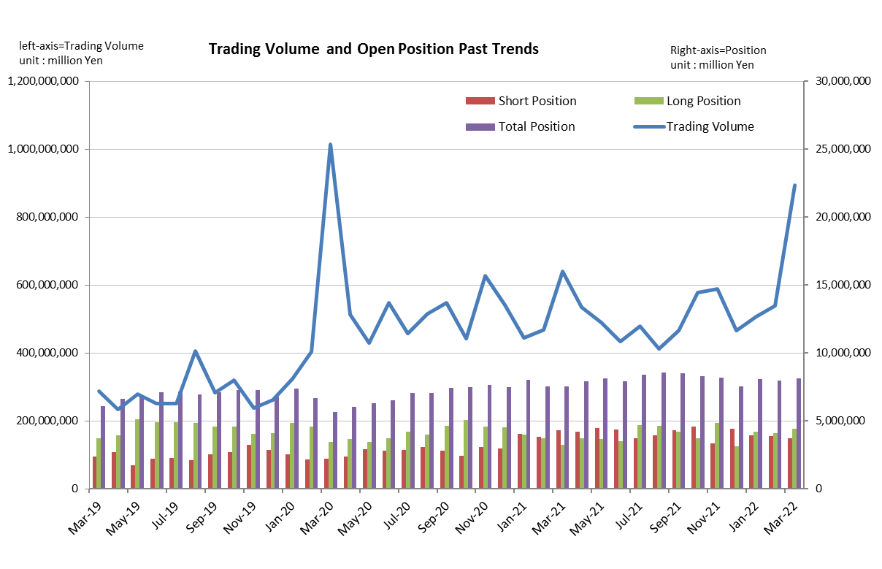

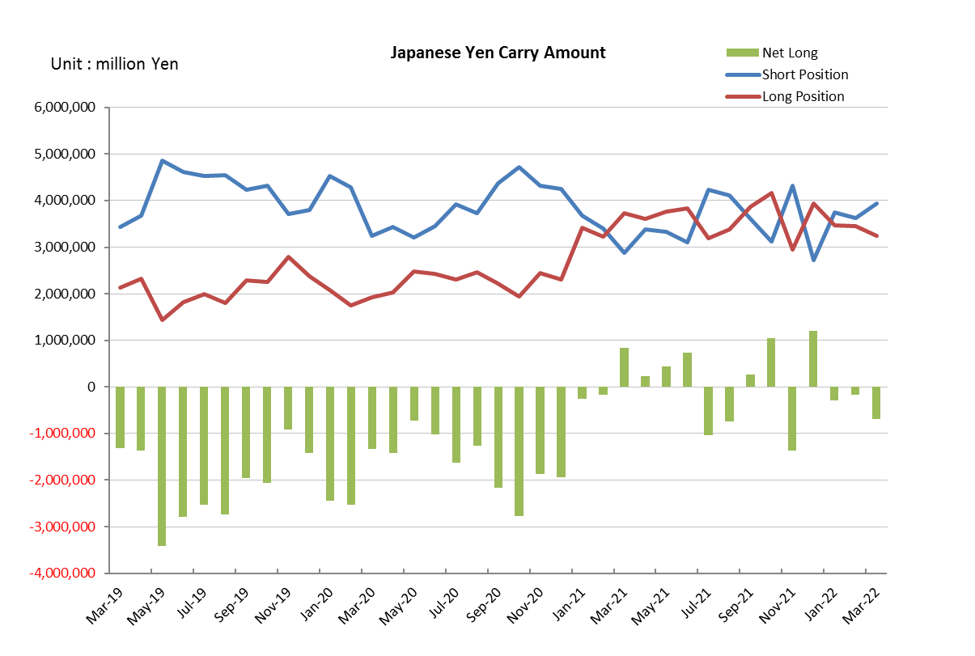

Monthly statistical report on Over-The-Counter Retail FX Margin Trading

：February , 2022
Publication date : 14 March. 2022
Number of Over-The-Counter Retail FX Margin Trading Operators as of 28 February. 2022 :50
Number of members reported :50
【Trading Volume】
(Unit: hundred million Yen, %)
 | Over-The-Counter | USDJPY, Cross Yen | On-Exchange*(for reference)
This month | 5,388,187 | 4,881,260 | 19,340
Previous month | 5,063,365 | 4,692,366 | 17,611
Change | 6.42% | 4.03% | 9.82%
*source : Monthly Trading Volume of Tokyo Financial exchange Inc.(The FFAJ converts the total number of contracts into the trading volume on the settlement prices of the end of the month)
【Open Positions】
(Unit: hundred million Yen)
 | Short | Long | Total
This month | 38,798 | 40,925 | 79,723
Previous month | 39,135 | 41,749 | 80,884
Change | -337 | -823 | -1,161

・USDJPY, Cross Yen Open Positions
(Unit: hundred million Yen)
 | ① Short | ② Long | Net long=②-①
This month | 36,318 | 34,600 | -1,717
Previous month | 37,554 | 34,649 | -2,905

（Reference：USDJPY Monthly Rate＊）
（Unit: Yen）
End of last Month*1 | Highest of the Month | Lowest of the Month | End of the Month*1 | Average*2
115.43 | 115.79 | 114.33 | 115.5 | 115.2
*source : BOJ's Main Time-series Statistics (Monthly)
*1) Spot Rate at 17:00 in JST, End of Month, Tokyo Market
*2) Average of Central Rate in the Month, Tokyo Market

○ Notes
The volume of this month was about 538 trillion yen (an increase of 6.4% from the previous month), the trading volume on a business day basis excluding weekends also increased.
The open positions balance at the end of the month was about 7.9 trillion yen in total, with both short positions and long positions decreasing from the end of the previous month.

～Tables and Historical Graphs～

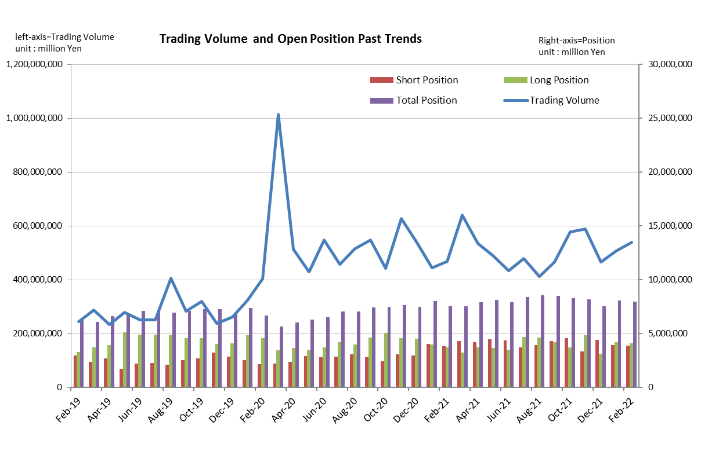

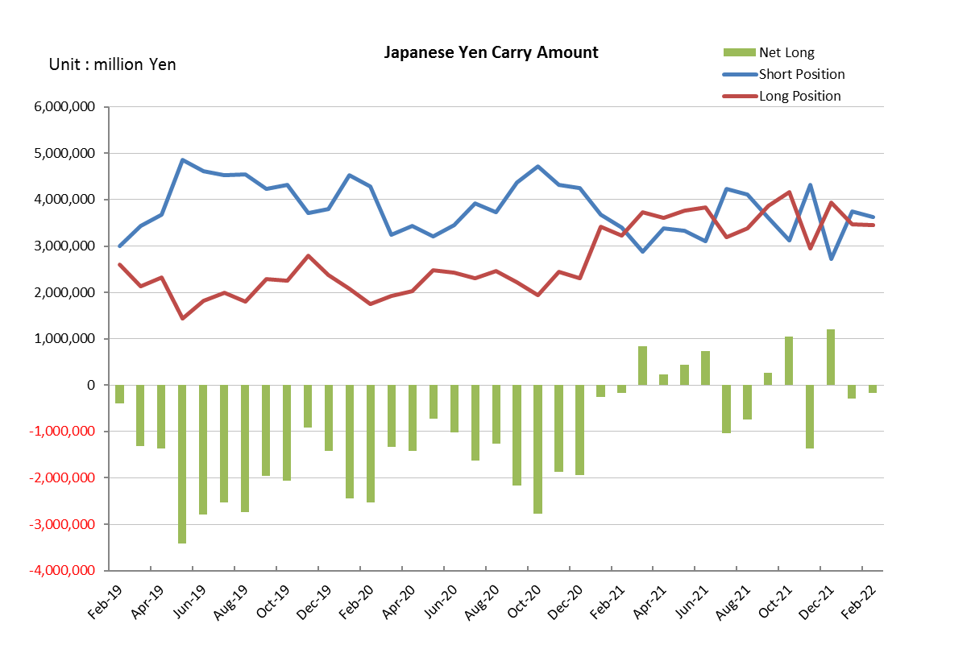

Monthly statistical report on Over-The-Counter Retail FX Margin Trading

：January , 2022
Publication date : 15 February. 2022
Number of Over-The-Counter Retail FX Margin Trading Operators as of 31 January. 2022 :50
Number of members reported :50
【Trading Volume】
(Unit: hundred million Yen, %)
 | Over-The-Counter | USDJPY, Cross Yen | On-Exchange*(for reference)
This month | 5,063,365 | 4,692,366 | 17,611
Previous month | 4,663,160 | 4,300,607 | 17,488
Change | 8.58% | 9.11% | 0.70%
*source : Monthly Trading Volume of Tokyo Financial exchange Inc.(The FFAJ converts the total number of contracts into the trading volume on the settlement prices of the end of the month)
【Open Positions】
(Unit: hundred million Yen)
 | Short | Long | Total
This month | 39,135 | 41,749 | 80,884
Previous month | 44,052 | 31,356 | 75,408
Change | -4,917 | 10,393 | 5,476

・USDJPY, Cross Yen Open Positions
(Unit: hundred million Yen)
 | ① Short | ② Long | Net long=②-①
This month | 37,554 | 34,649 | -2,905
Previous month | 27,236 | 39,332 | 12,095

（Reference：USDJPY Monthly Rate＊）
（Unit: Yen）
End of last Month*1 | Highest of the Month | Lowest of the Month | End of the Month*1 | Average*2
115.12 | 116.24 | 113.63 | 115.43 | 114.83
*source : BOJ's Main Time-series Statistics (Monthly)
*1) Spot Rate at 17:00 in JST, End of Month, Tokyo Market
*2) Average of Central Rate in the Month, Tokyo Market

○ Notes
The volume of this month was about 506 trillion yen (an increase of 8.6% from the previous month), the trading volume on a business day basis excluding weekends also increased.
The open positions balance at the end of the month increased since the end of the previous month,
short positions decreased, but long positions increased, totaling about 8.1 trillion yen.

～Tables and Historical Graphs～

