Over-The-Counter FX Margin Trading Report

(January 2021 ～ )

Monthly Report
January 2021
February 2021
March 2021
April 2021
May 2021
June 2021
July 2021
August 2021
September 2021
October 2021
November 2021
December 2021

The Financial Futures Association of Japan, Research Department

NBF Ogawamachi Building 1-3 , Kanda Ogawamachi ,
Chiyoda-ku , Tokyo 101-0052 Tel:(03)5280-0881 E-mail : ffaj@ffaj.or.jp

This publication has been prepared by the FFAJ and is provided for information purpose only. The monthly information contained in this publication has been obtained from FFAJ's members that is believed to be reliable, however the FFAJ does not represent or warrant that it is accurate or complete. In no event the FFAJ nor its employees have any liability for any consequential damages arising from any use of this publications or its contents. This publication does not constitute any investment advice.

Monthly statistical report on Over-The-Counter Retail FX Margin Trading

：December , 2021
Publication date : 18 January. 2022
Number of Over-The-Counter Retail FX Margin Trading Operators as of 31 December. 2021 :50
Number of members reported :50
【Trading Volume】
(Unit: hundred million Yen, %)
 | Over-The-Counter | USDJPY, Cross Yen | On-Exchange*(for reference)
This month | 4,663,160 | 4,300,607 | 17,488
Previous month | 5,897,279 | 5,467,210 | 21,612
Change | -20.93% | -21.34% | -19.08%
*source : Monthly Trading Volume of Tokyo Financial exchange Inc.(The FFAJ converts the total number of contracts into the trading volume on the settlement prices of the end of the month)
【Open Positions】
(Unit: hundred million Yen)
 | Short | Long | Total
This month | 44,052 | 31,356 | 75,408
Previous month | 33,246 | 48,424 | 81,670
Change | 10,806 | -17,068 | -6,261

・USDJPY, Cross Yen Open Positions
(Unit: hundred million Yen)
 | ① Short | ② Long | Net long=②-①
This month | 27,236 | 39,332 | 12,095
Previous month | 43,173 | 29,510 | -13,663

（Reference：USDJPY Monthly Rate＊）
（Unit: Yen）
End of last Month*1 | Highest of the Month | Lowest of the Month | End of the Month*1 | Average*2
113.19 | 115.2 | 112.65 | 115.12 | 113.87
*source : BOJ's Main Time-series Statistics (Monthly)
*1) Spot Rate at 17:00 in JST, End of Month, Tokyo Market
*2) Average of Central Rate in the Month, Tokyo Market

○ Notes
The volume of this month was about 466.3 trillion yen (a decrease of about 20.9% from the previous month), the trading volume on a business day basis excluding weekends also decreased.
The open positions balance at the end of the month decreased since the end of the previous month, short positions increased, but long positions decreased, totaling about 7.5 trillion yen.

～Tables and Historical Graphs～

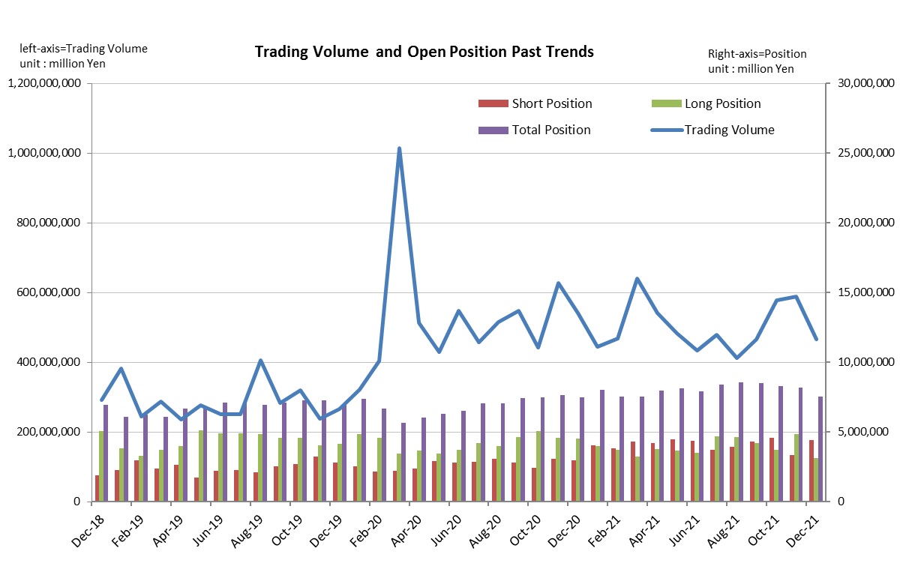

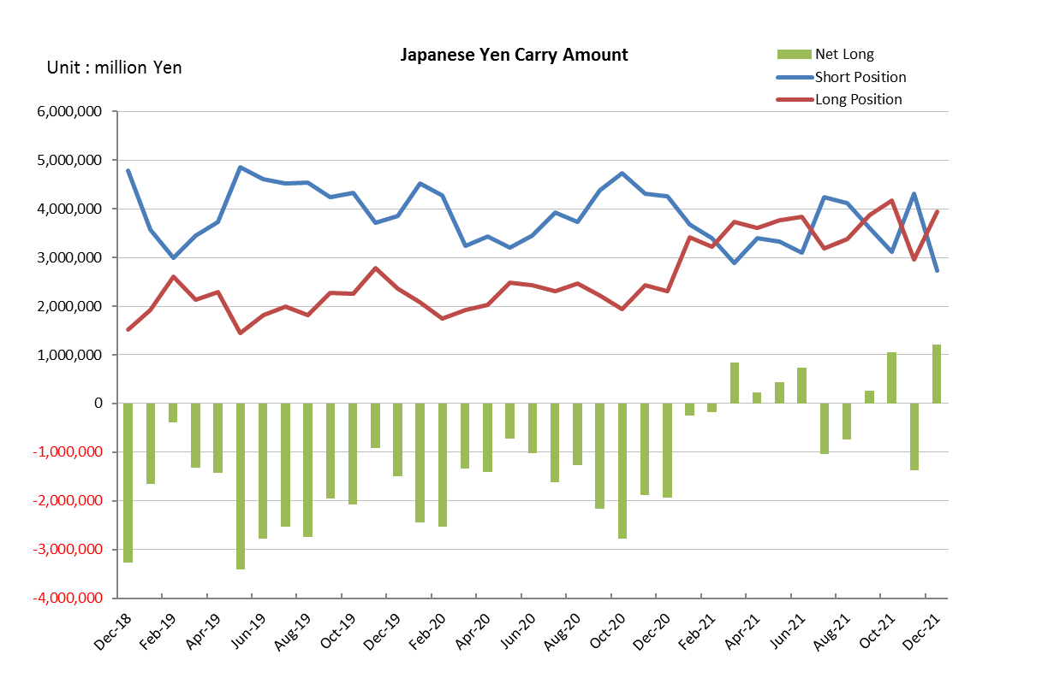

Monthly statistical report on Over-The-Counter Retail FX Margin Trading

：November , 2021
Publication date : 14 December. 2021
Number of Over-The-Counter Retail FX Margin Trading Operators as of 30 November. 2021 :50
Number of members reported :50
【Trading Volume】
(Unit: hundred million Yen, %)
 | Over-The-Counter | USDJPY, Cross Yen | On-Exchange*(for reference)
This month | 5,897,279 | 5,467,210 | 21,612
Previous month | 5,785,099 | 5,413,398 | 21,048
Change | 1.94% | 0.99% | 2.68%
*source : Monthly Trading Volume of Tokyo Financial exchange Inc.(The FFAJ converts the total number of contracts into the trading volume on the settlement prices of the end of the month)
【Open Positions】
(Unit: hundred million Yen)
 | Short | Long | Total
This month | 33,246 | 48,424 | 81,670
Previous month | 45,832 | 37,010 | 82,843
Change | -12,586 | 11,413 | -1,172

・USDJPY, Cross Yen Open Positions
(Unit: hundred million Yen)
 | ① Short | ② Long | Net long=②-①
This month | 43,173 | 29,510 | -13,663
Previous month | 31,213 | 41,658 | 10,444

（Reference：USDJPY Monthly Rate＊）
（Unit: Yen）
End of last Month*1 | Highest of the Month | Lowest of the Month | End of the Month*1 | Average*2
113.61 | 115.45 | 112.73 | 113.19 | 114.13
*source : BOJ's Main Time-series Statistics (Monthly)
*1) Spot Rate at 17:00 in JST, End of Month, Tokyo Market
*2) Average of Central Rate in the Month, Tokyo Market

○ Notes
The volume of this month was about 589.7 trillion yen (an increase of about 1.9% from the previous month), the trading volume on a business day basis excluding weekends also increased.
The open positions balance at the end of the month decreased since the end of the previous month, short positions decreased, but long positions increased, totaling about 8.2 trillion yen.

～Tables and Historical Graphs～

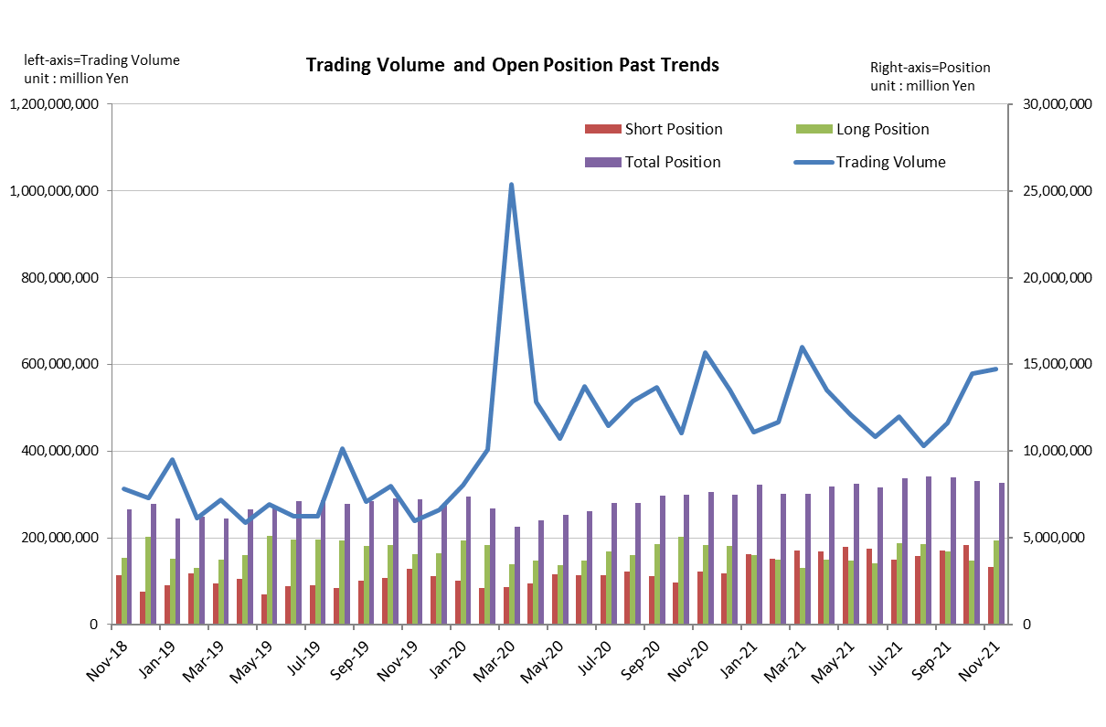

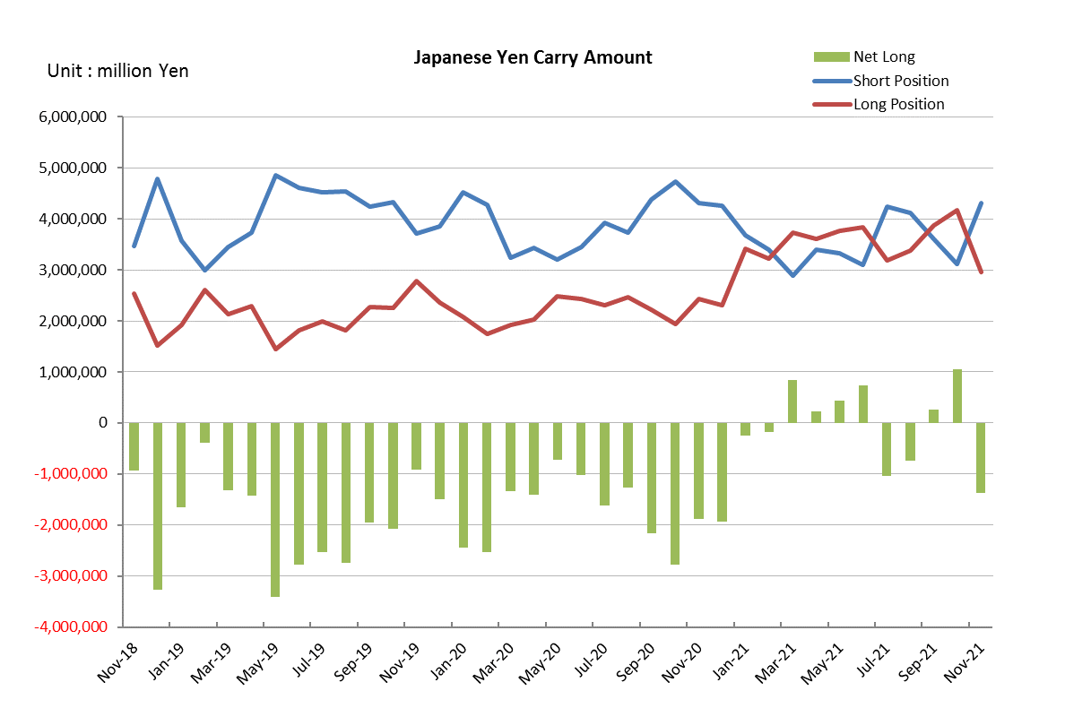

Monthly statistical report on Over-The-Counter Retail FX Margin Trading

：October , 2021
Publication date : 15 November. 2021
Number of Over-The-Counter Retail FX Margin Trading Operators as of 31 October. 2021 :50
Number of members reported :51
【Trading Volume】
(Unit: hundred million Yen, %)
 | Over-The-Counter | USDJPY, Cross Yen | On-Exchange*(for reference)
This month | 5,785,099 | 5,413,398 | 21,048
Previous month | 4,651,357 | 4,212,035 | 18,129
Change | 24.37% | 28.52% | 16.10%
*source : Monthly Trading Volume of Tokyo Financial exchange Inc.(The FFAJ converts the total number of contracts into the trading volume on the settlement prices of the end of the month)
【Open Positions】
(Unit: hundred million Yen)
 | Short | Long | Total
This month | 45,832 | 37,010 | 82,843
Previous month | 42,897 | 42,094 | 84,991
Change | 2,935 | -5,084 | -2,148

・USDJPY, Cross Yen Open Positions
(Unit: hundred million Yen)
 | ① Short | ② Long | Net long=②-①
This month | 31,213 | 41,658 | 10,444
Previous month | 36,086 | 38,756 | 2,669

（Reference：USDJPY Monthly Rate＊）
（Unit: Yen）
End of last Month*1 | Highest of the Month | Lowest of the Month | End of the Month*1 | Average*2
111.88 | 114.69 | 110.88 | 113.61 | 113.1
*source : BOJ's Main Time-series Statistics (Monthly)
*1) Spot Rate at 17:00 in JST, End of Month, Tokyo Market
*2) Average of Central Rate in the Month, Tokyo Market

○ Notes
The volume of this month was about 578.5 trillion yen (an increase of about 24.8% from the previous month), the trading volume on a business day basis excluding weekends also increased.
The open positions balance at the end of the month decreased since the end of the previous month, short positions increased, but long positions decreased, totaling about 8.3 trillion yen.

～Tables and Historical Graphs～

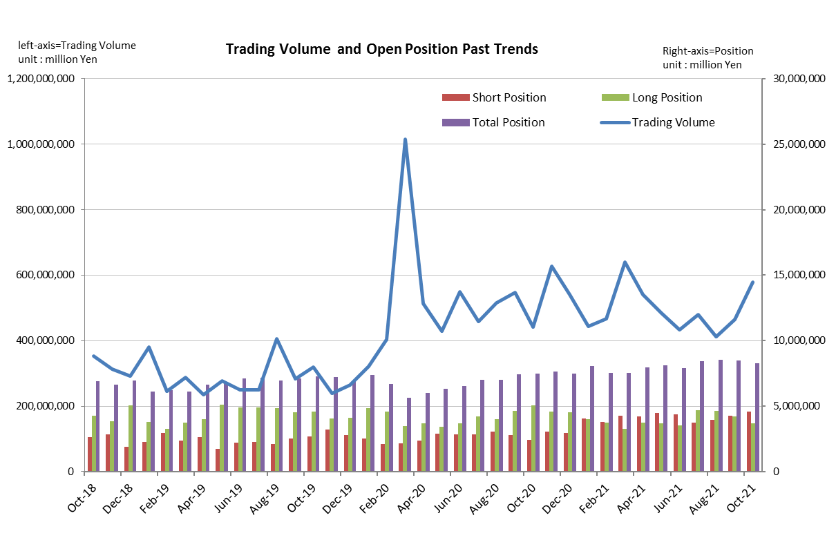

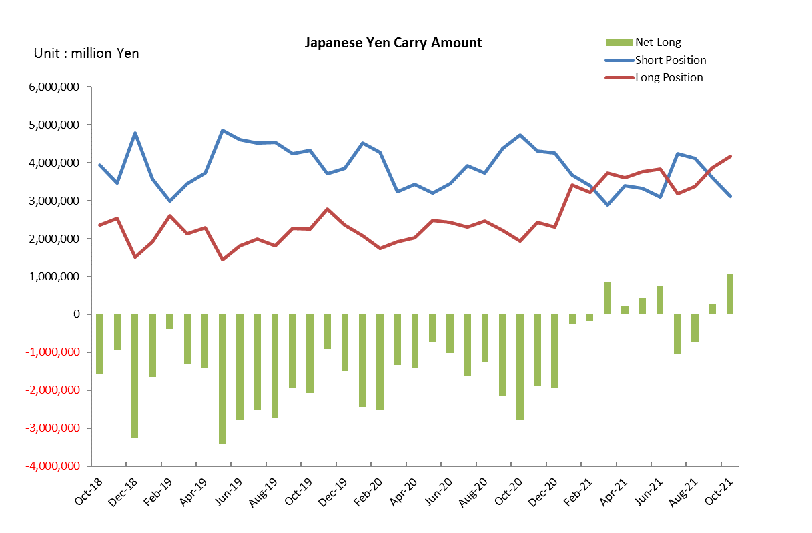

Monthly statistical report on Over-The-Counter Retail FX Margin Trading

：September , 2021
Publication date : 14 October. 2021
Number of Over-The-Counter Retail FX Margin Trading Operators as of 30 September. 2021 :51
Number of members reported :51
【Trading Volume】
(Unit: hundred million Yen, %)
 | Over-The-Counter | USDJPY, Cross Yen | On-Exchange*(for reference)
This month | 4,651,357 | 4,212,035 | 18,129
Previous month | 4,114,938 | 3,724,696 | 14,080
Change | 13.04% | 13.08% | 28.76%
*source : Monthly Trading Volume of Tokyo Financial exchange Inc.(The FFAJ converts the total number of contracts into the trading volume on the settlement prices of the end of the month)
【Open Positions】
(Unit: hundred million Yen)
 | Short | Long | Total
This month | 42,897 | 42,094 | 84,991
Previous month | 39,250 | 46,196 | 85,446
Change | 3,647 | -4,101 | -454

・USDJPY, Cross Yen Open Positions
(Unit: hundred million Yen)
 | ① Short | ② Long | Net long=②-①
This month | 36,086 | 38,756 | 2,669
Previous month | 41,165 | 33,776 | -7,388

（Reference：USDJPY Monthly Rate＊）
（Unit: Yen）
End of last Month*1 | Highest of the Month | Lowest of the Month | End of the Month*1 | Average*2
109.82 | 112.05 | 109.12 | 111.88 | 110.17
*source : BOJ's Main Time-series Statistics (Monthly)
*1) Spot Rate at 17:00 in JST, End of Month, Tokyo Market
*2) Average of Central Rate in the Month, Tokyo Market

○ Notes
The volume of this month was about 465.1 trillion yen (an increase of about 13.0% from the previous month), the trading volume on a business day basis excluding weekends also increased.
The open positions balance at the end of the month decreased slightly since the end of the previous month,
short positions increased, but long positions decreased, totaling about 8.5 trillion yen.

～Tables and Historical Graphs～

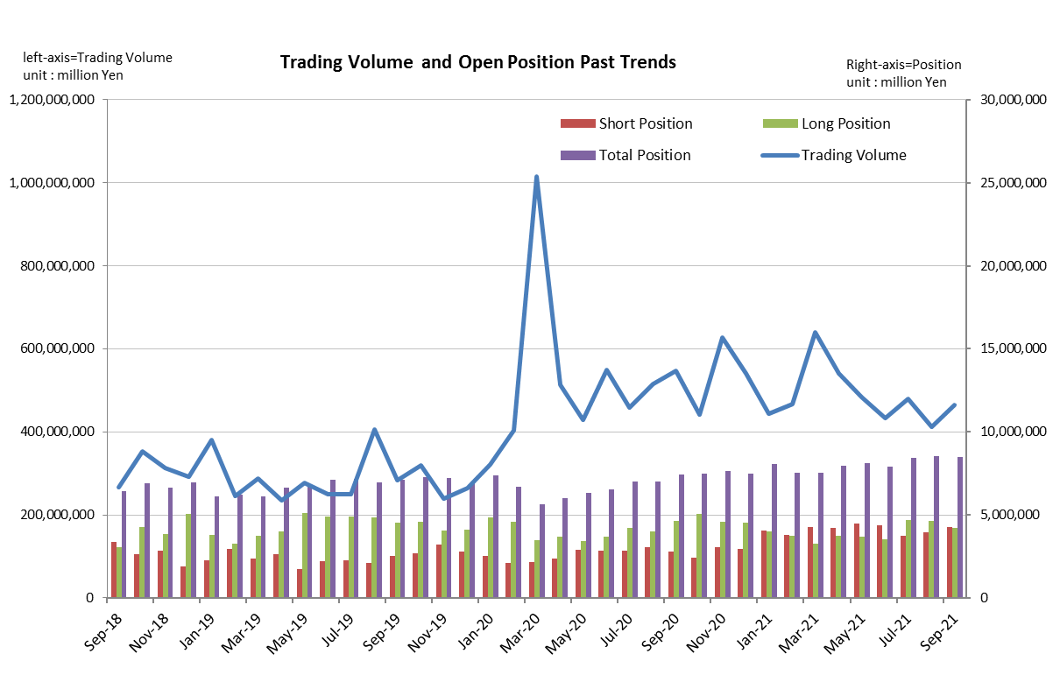

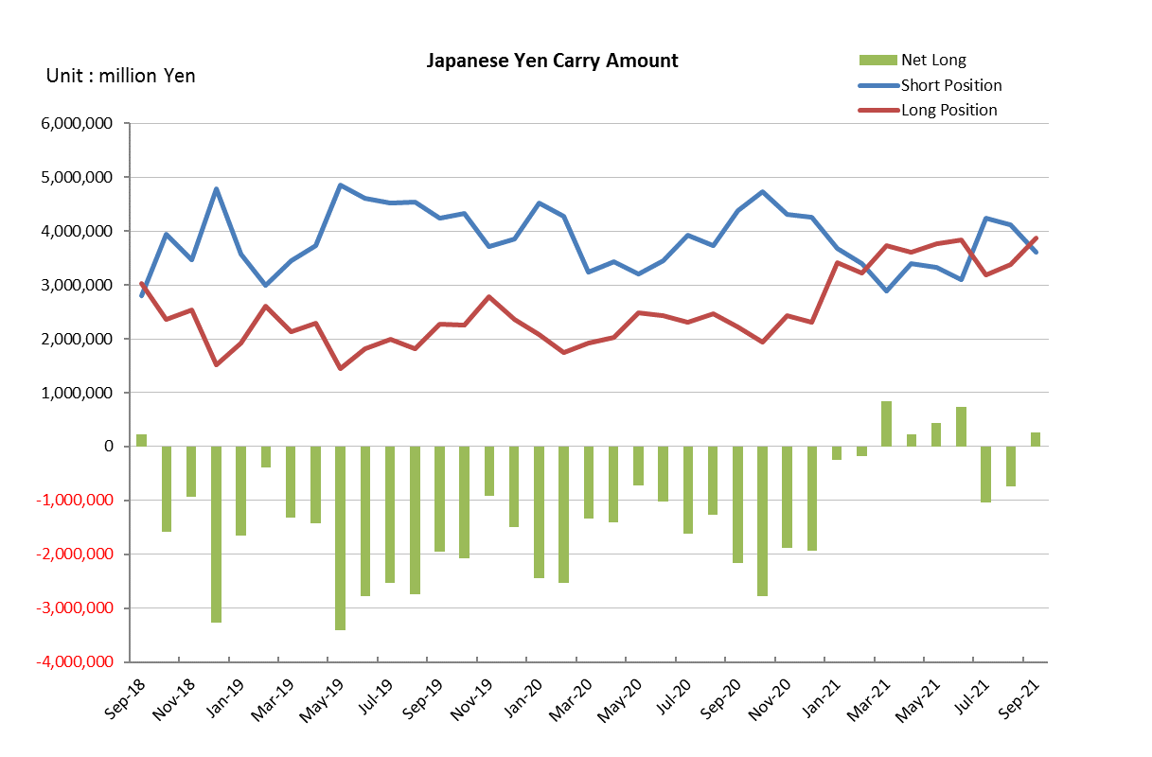

Monthly statistical report on Over-The-Counter Retail FX Margin Trading

：August , 2021
Publication date : 14 September. 2021
Number of Over-The-Counter Retail FX Margin Trading Operators as of 31 August. 2021 :51
Number of members reported :51
【Trading Volume】
(Unit: hundred million Yen, %)
 | Over-The-Counter | USDJPY, Cross Yen | On-Exchange*(for reference)
This month | 4,114,938 | 3,724,696 | 14,080
Previous month | 4,792,091 | 4,309,473 | 18,133
Change | -14.13% | -13.57% | -22.35%
*source : Monthly Trading Volume of Tokyo Financial exchange Inc.(The FFAJ converts the total number of contracts into the trading volume on the settlement prices of the end of the month)
【Open Positions】
(Unit: hundred million Yen)
 | Short | Long | Total
This month | 39,250 | 46,196 | 85,446
Previous month | 37,297 | 46,866 | 84,163
Change | 1,952 | -670 | 1,282

・USDJPY, Cross Yen Open Positions
(Unit: hundred million Yen)
 | ① Short | ② Long | Net long=②-①
This month | 41,165 | 33,776 | -7,388
Previous month | 42,347 | 31,906 | -10,440

（Reference：USDJPY Monthly Rate＊）
（Unit: Yen）
End of last Month*1 | Highest of the Month | Lowest of the Month | End of the Month*1 | Average*2
109.53 | 110.79 | 108.93 | 109.82 | 109.84
*source : BOJ's Main Time-series Statistics (Monthly)
*1) Spot Rate at 17:00 in JST, End of Month, Tokyo Market
*2) Average of Central Rate in the Month, Tokyo Market

○ Notes
The volume of this month was about 411.4 trillion yen (a decrease of about 14.1% from the previous month), the trading volume on a business day basis excluding weekends also decreased.
The open positions balance at the end of the month was about 8.5trillion yen in total, with both short positions and long positions increasing from the end of the previous month.

～Tables and Historical Graphs～

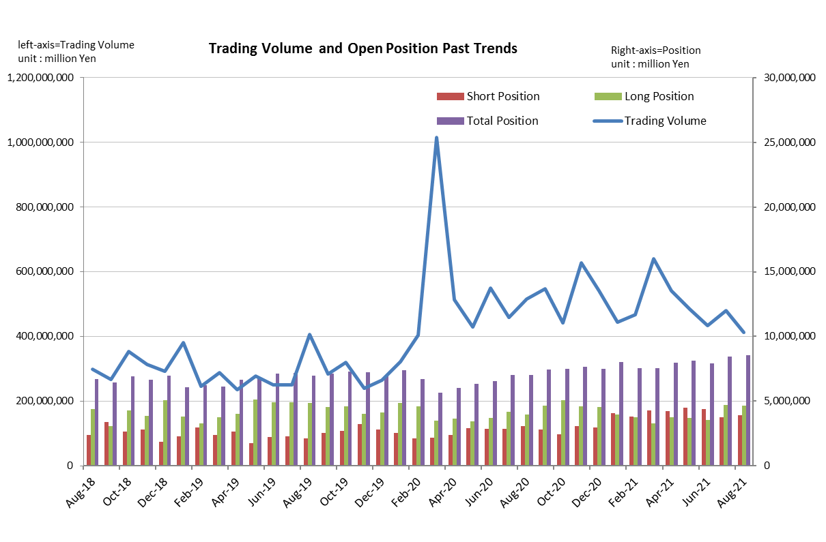

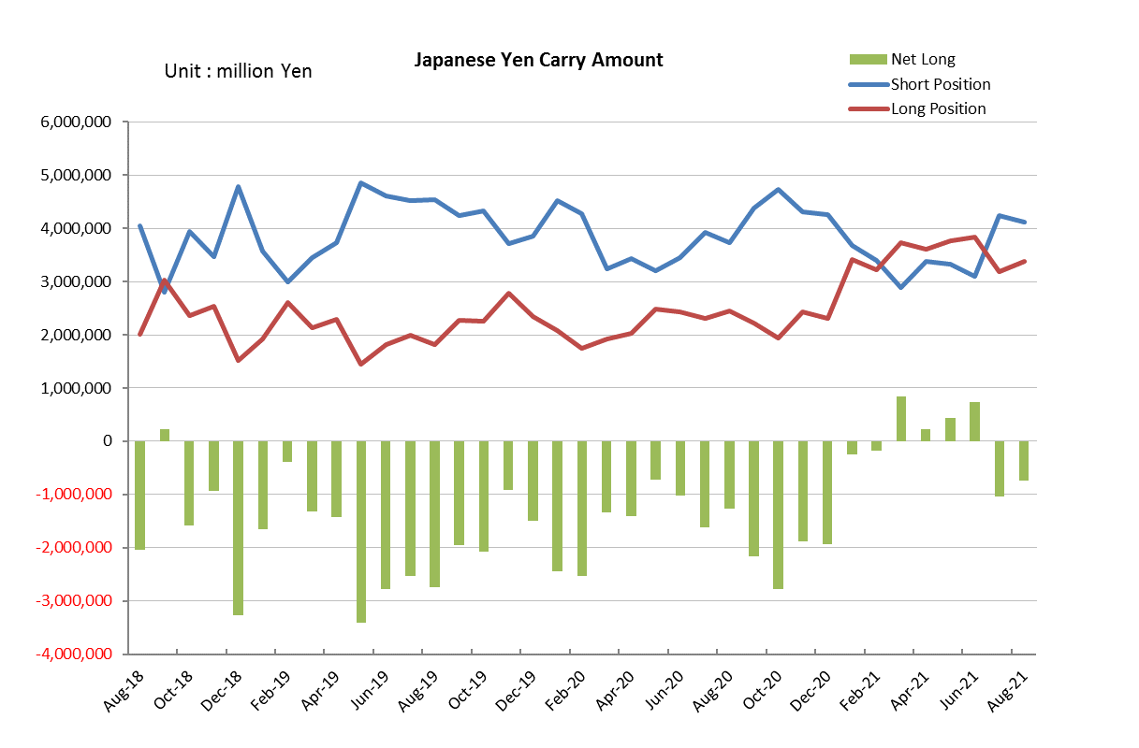

Monthly statistical report on Over-The-Counter Retail FX Margin Trading

：July , 2021
Publication date : 16 August. 2021
Number of Over-The-Counter Retail FX Margin Trading Operators as of 31 July. 2021 :51
Number of members reported :51
【Trading Volume】
(Unit: hundred million Yen, %)
 | Over-The-Counter | USDJPY, Cross Yen | On-Exchange*(for reference)
This month | 4,792,091 | 4,309,473 | 18,133
Previous month | 4,336,644 | 3,855,158 | 18,102
Change | 10.50% | 11.78% | 0.17%
*source : Monthly Trading Volume of Tokyo Financial exchange Inc.(The FFAJ converts the total number of contracts into the trading volume on the settlement prices of the end of the month)
【Open Positions】
(Unit: hundred million Yen)
 | Short | Long | Total
This month | 37,297 | 46,866 | 84,163
Previous month | 43,850 | 35,115 | 78,966
Change | -6,553 | 11,751 | 5,197

・USDJPY, Cross Yen Open Positions
(Unit: hundred million Yen)
 | ① Short | ② Long | Net long=②-①
This month | 42,347 | 31,906 | -10,440
Previous month | 31,016 | 38,356 | 7,339

（Reference：USDJPY Monthly Rate＊）
（Unit: Yen）
End of last Month*1 | Highest of the Month | Lowest of the Month | End of the Month*1 | Average*2
110.55 | 111.66 | 109.37 | 109.53 | 110.29
*source : BOJ's Main Time-series Statistics (Monthly)
*1) Spot Rate at 17:00 in JST, End of Month, Tokyo Market
*2) Average of Central Rate in the Month, Tokyo Market

○ Notes
The volume of this month was about 479 trillion yen (an increase of about 10.5% from the previous month), the trading volume on a business day basis excluding weekends also increased.
The open positions balance at the end of the month increased since the end of the previous month,
short positions decreased, but long positions increased, totaling about 8.4 trillion yen.

～Tables and Historical Graphs～

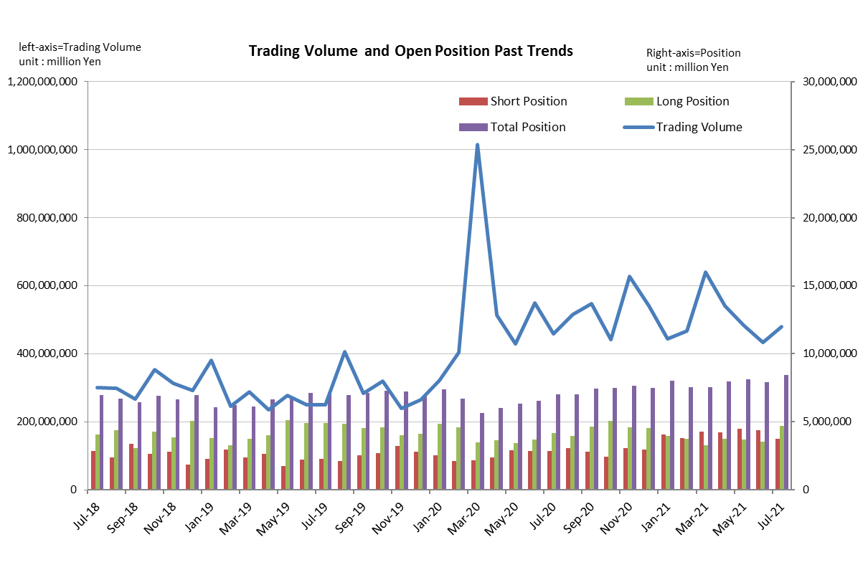

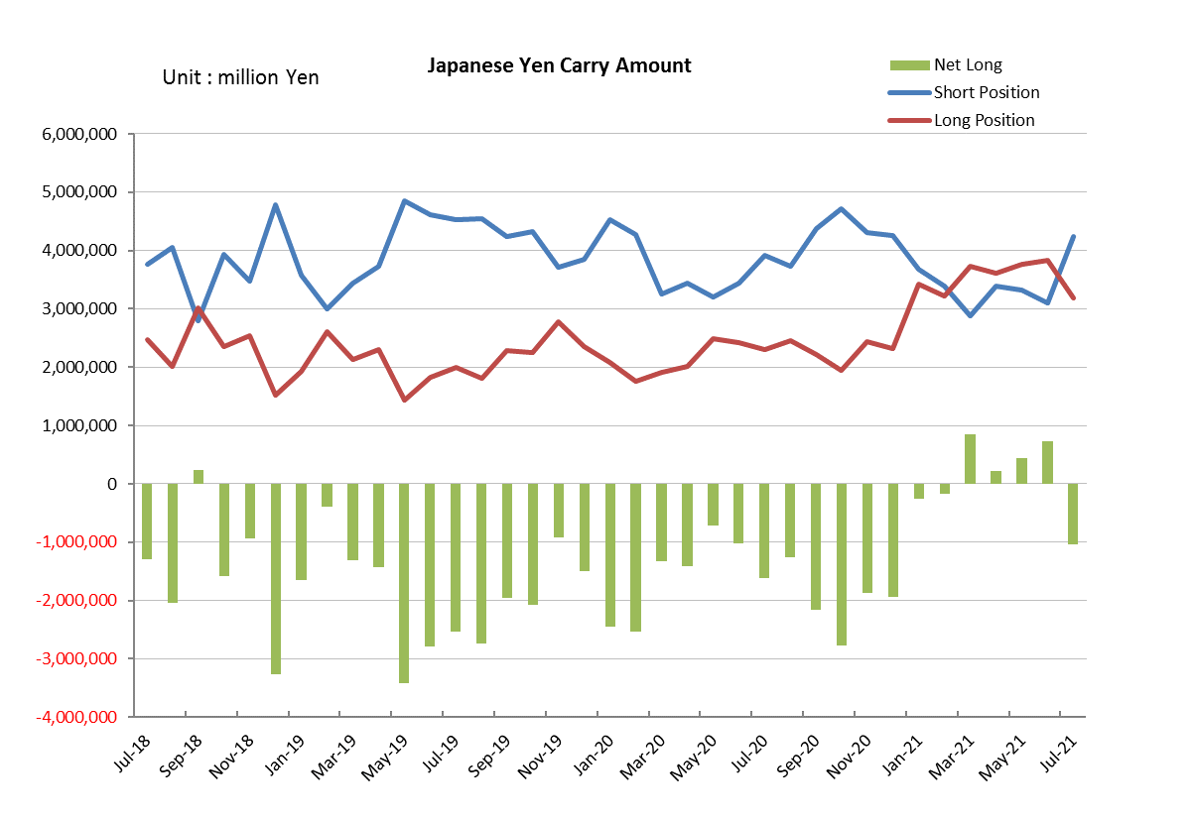

Monthly statistical report on Over-The-Counter Retail FX Margin Trading

：June , 2021
Publication date : 14 July. 2021
Number of Over-The-Counter Retail FX Margin Trading Operators as of 30 June. 2021 :52
Number of members reported :52
【Trading Volume】
(Unit: hundred million Yen, %)
 | Over-The-Counter | USDJPY, Cross Yen | On-Exchange*(for reference)
This month | 4,490,633 | 4,003,886 | 18,102
Previous month | 4,829,656 | 4,353,125 | 17,320
Change | -7.02% | -8.02% | 4.52%
*source : Monthly Trading Volume of Tokyo Financial exchange Inc.(The FFAJ converts the total number of contracts into the trading volume on the settlement prices of the end of the month)
【Open Positions】
(Unit: hundred million Yen)
 | Short | Long | Total
This month | 43,850 | 35,118 | 78,968
Previous month | 44,654 | 36,692 | 81,347
Change | -804 | -1,574 | -2,378

・USDJPY, Cross Yen Open Positions
(Unit: hundred million Yen)
 | ① Short | ② Long | Net long=②-①
This month | 31,019 | 38,356 | 7,337
Previous month | 33,264 | 37,672 | 4,407

（Reference：USDJPY Monthly Rate＊）
（Unit: Yen）
End of last Month*1 | Highest of the Month | Lowest of the Month | End of the Month*1 | Average*2
109.72 | 111.11 | 109.2 | 110.55 | 110.11
*source : BOJ's Main Time-series Statistics (Monthly)
*1) Spot Rate at 17:00 in JST, End of Month, Tokyo Market
*2) Average of Central Rate in the Month, Tokyo Market

○ Notes
The volume of this month was about 449 trillion yen (a decrease of about 7.0% from the previous month), the trading volume on a business day basis excluding weekends also decreased.
The open positions balance at the end of the month was about 7.9trillion yen in total, with both short positions and long positions decreasing from the end of the previous month.

～Tables and Historical Graphs～

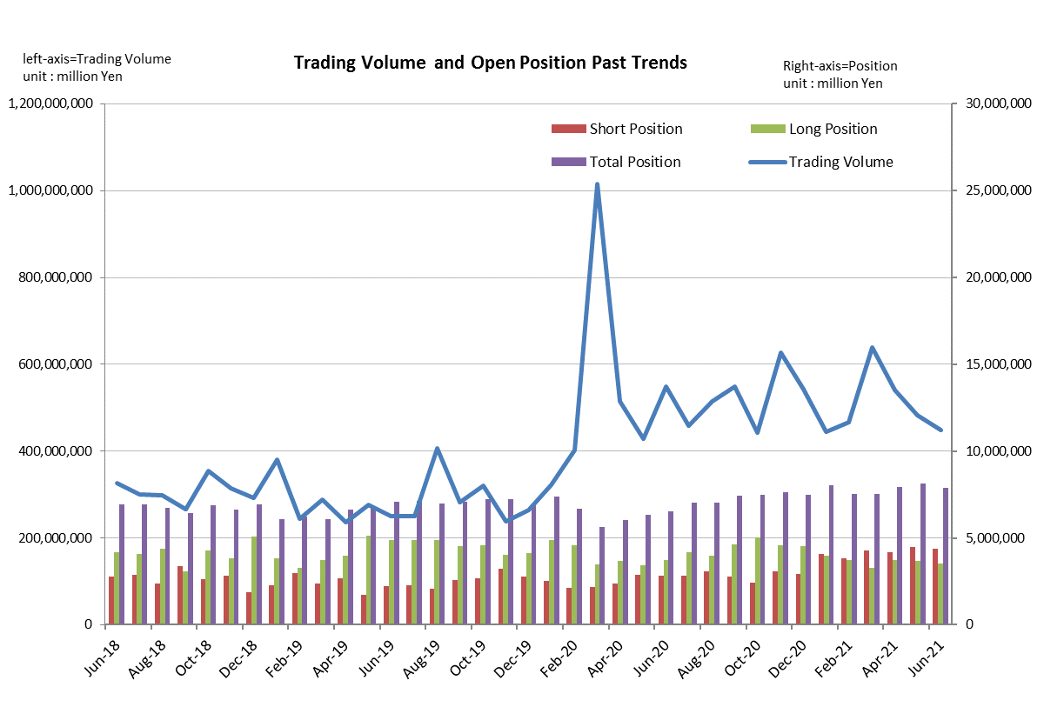

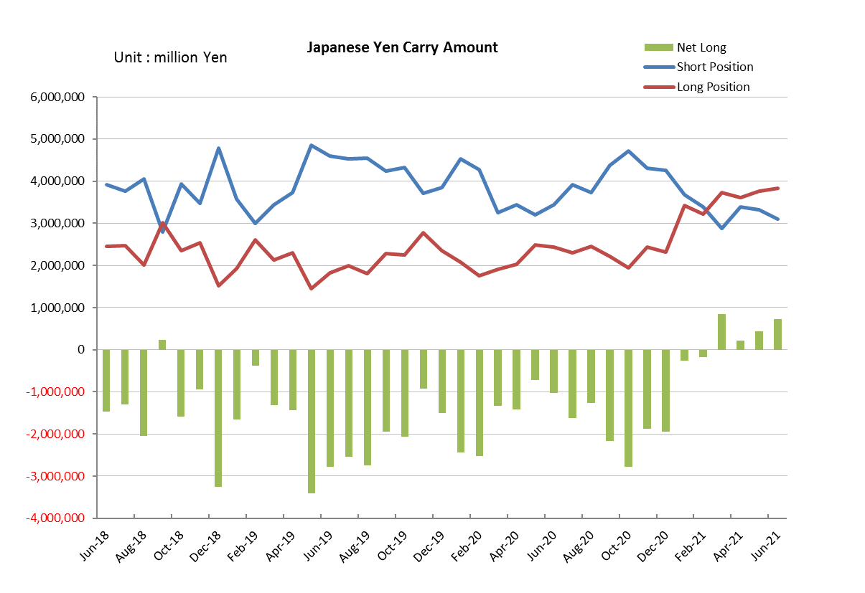

Monthly statistical report on Over-The-Counter Retail FX Margin Trading

：May , 2021
Publication date : 14 June. 2021
Number of Over-The-Counter Retail FX Margin Trading Operators as of 31 May. 2021 :52
Number of members reported :52
【Trading Volume】
(Unit: hundred million Yen, %)
 | Over-The-Counter | USDJPY, Cross Yen | On-Exchange*(for reference)
This month | 4,829,656 | 4,353,125 | 17,320
Previous month | 5,406,283 | 4,894,849 | 17,207
Change | -10.67% | -11.07% | 0.66%
*source : Monthly Trading Volume of Tokyo Financial exchange Inc.(The FFAJ converts the total number of contracts into the trading volume on the settlement prices of the end of the month)
【Open Positions】
(Unit: hundred million Yen)
 | Short | Long | Total
This month | 44,654 | 36,692 | 81,347
Previous month | 41,968 | 37,434 | 79,403
Change | 2,686 | -741 | 1,944

・USDJPY, Cross Yen Open Positions
(Unit: hundred million Yen)
 | ① Short | ② Long | Net long=②-①
This month | 33,264 | 37,672 | 4,407
Previous month | 33,889 | 36,079 | 2,190

（Reference：USDJPY Monthly Rate＊）
（Unit: Yen）
End of last Month*1 | Highest of the Month | Lowest of the Month | End of the Month*1 | Average*2
108.89 | 109.96 | 108.48 | 109.72 | 109.19
*source : BOJ's Main Time-series Statistics (Monthly)
*1) Spot Rate at 17:00 in JST, End of Month, Tokyo Market
*2) Average of Central Rate in the Month, Tokyo Market

○ Notes
The volume of this month was about 483 trillion yen (a decrease of about 10.7% from the previous month), the trading volume on a business day basis excluding weekends also decreased.
The open positions balance at the end of the month increased since the end of the previous month,
short positions increased, but long positions decreased, totaling about 8.13 trillion yen.

～Tables and Historical Graphs～

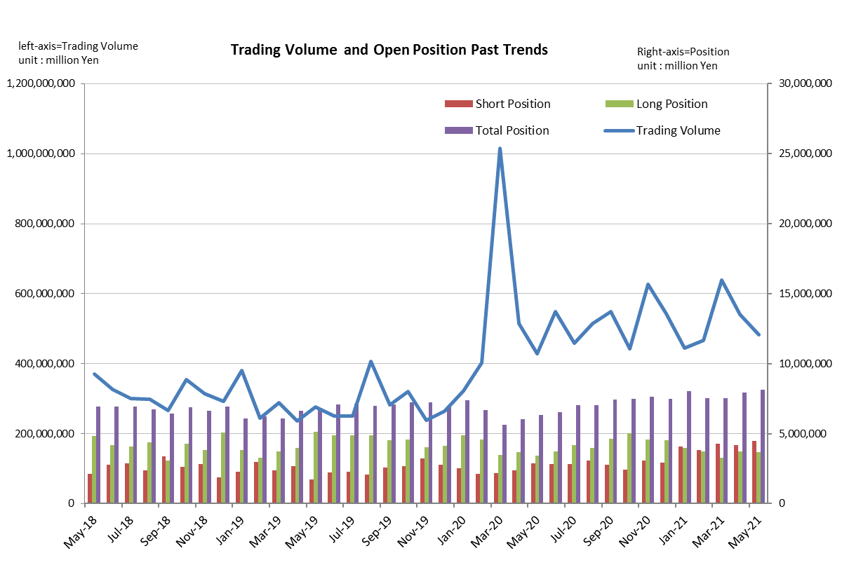

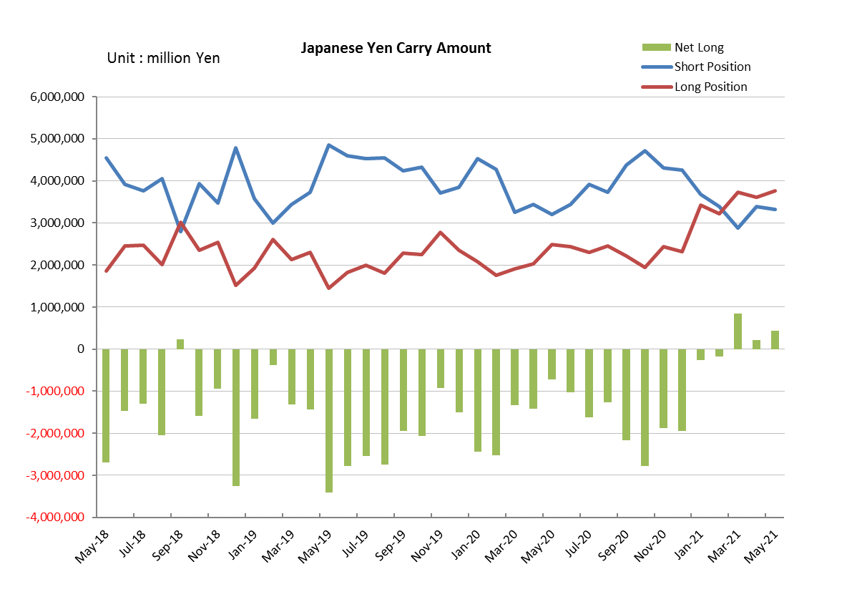

Monthly statistical report on Over-The-Counter Retail FX Margin Trading

：April , 2021
Publication date : 19 May. 2021
Number of Over-The-Counter Retail FX Margin Trading Operators as of 30 April. 2021 :52
Number of members reported :52
【Trading Volume】
(Unit: hundred million Yen, %)
 | Over-The-Counter | USDJPY, Cross Yen | On-Exchange*(for reference)
This month | 5,406,326 | 4,894,892 | 17,207
Previous month | 6,394,807 | 5,713,413 | 28,621
Change | -15.46% | -14.33% | -39.88%
*source : Monthly Trading Volume of Tokyo Financial exchange Inc.(The FFAJ converts the total number of contracts into the trading volume on the settlement prices of the end of the month)
【Open Positions】
(Unit: hundred million Yen)
 | Short | Long | Total
This month | 41,968 | 37,434 | 79,403
Previous month | 42,869 | 32,518 | 75,387
Change | -900 | 4,916 | 4,015

・USDJPY, Cross Yen Open Positions
(Unit: hundred million Yen)
 | ① Short | ② Long | Net long=②-①
This month | 33,889 | 36,079 | 2,190
Previous month | 28,824 | 37,289 | 8,464

（Reference：USDJPY Monthly Rate＊）
（Unit: Yen）
End of last Month*1 | Highest of the Month | Lowest of the Month | End of the Month*1 | Average*2
110.74 | 110.83 | 107.65 | 108.89 | 109.13
*source : BOJ's Main Time-series Statistics (Monthly)
*1) Spot Rate at 17:00 in JST, End of Month, Tokyo Market
*2) Average of Central Rate in the Month, Tokyo Market

○ Notes
The volume of this month was about 541 trillion yen (a decrease of about 15.5% from the previous month), the trading volume on a business day basis excluding weekends also decreased.
The open positions balance at the end of the month increased since the end of the previous month,
short positions decreased, but long positions increased, totaling about 7.94 trillion yen.

～Tables and Historical Graphs～

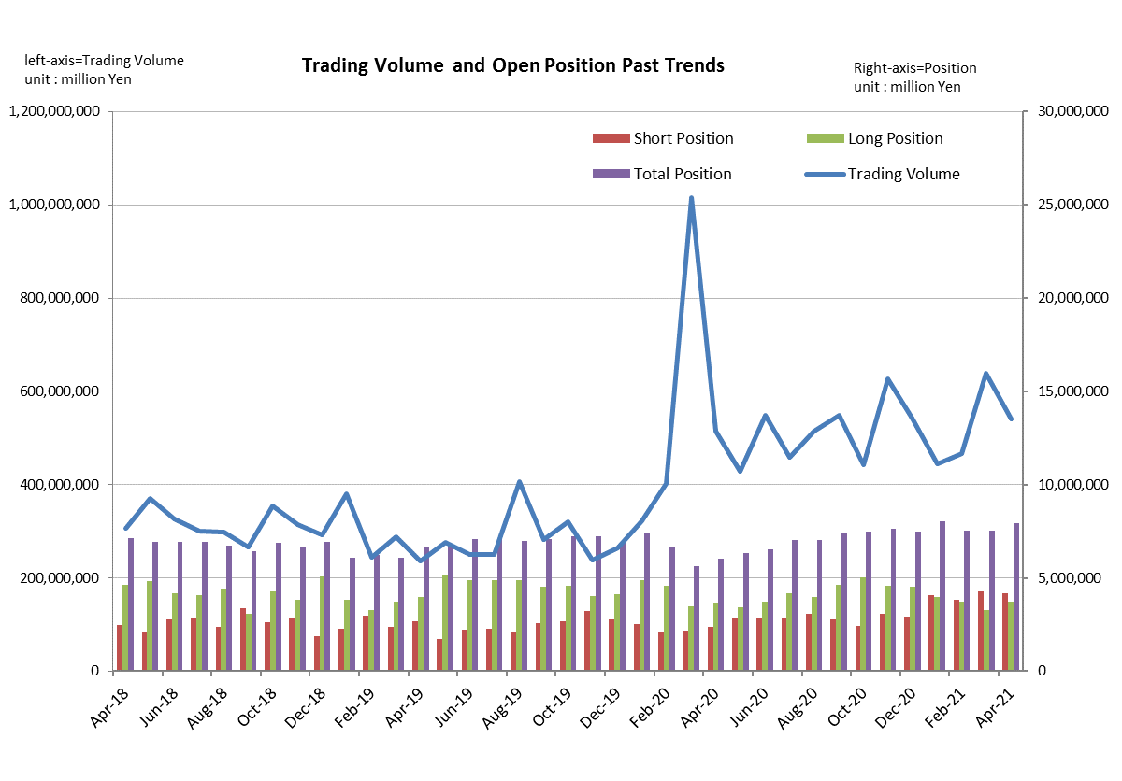

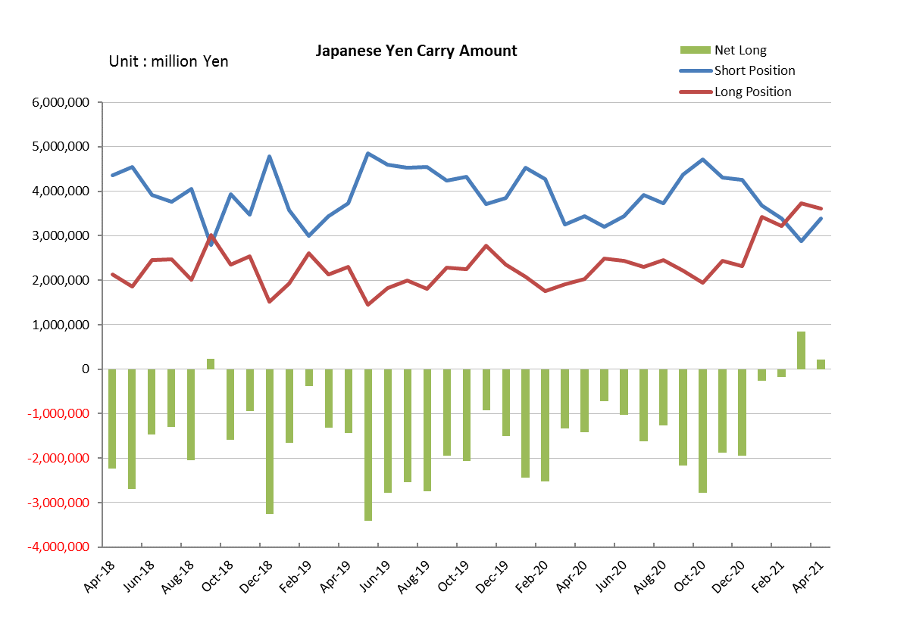

Monthly statistical report on Over-The-Counter Retail FX Margin Trading

：March , 2021
Publication date : 14 April. 2021
Number of Over-The-Counter Retail FX Margin Trading Operators as of 31 March. 2021 :51
Number of members reported :51
【Trading Volume】
(Unit: hundred million Yen, %)
 | Over-The-Counter | USDJPY, Cross Yen | On-Exchange*(for reference)
This month | 6,394,807 | 5,713,413 | 28,621
Previous month | 4,671,163 | 4,032,405 | 19,213
Change | 36.90% | 41.69% | 48.97%
*source : Monthly Trading Volume of Tokyo Financial exchange Inc.(The FFAJ converts the total number of contracts into the trading volume on the settlement prices of the end of the month)
【Open Positions】
(Unit: hundred million Yen)
 | Short | Long | Total
This month | 42,869 | 32,518 | 75,387
Previous month | 38,051 | 37,369 | 75,420
Change | 4,817 | -4,850 | -33

・USDJPY, Cross Yen Open Positions
(Unit: hundred million Yen)
 | ① Short | ② Long | Net long=②-①
This month | 28,824 | 37,289 | 8,464
Previous month | 33,977 | 32,283 | -1,693

（Reference：USDJPY Monthly Rate＊）
（Unit: Yen）
End of last Month*1 | Highest of the Month | Lowest of the Month | End of the Month*1 | Average*2
106.09 | 110.97 | 106.37 | 110.74 | 108.65
*source : BOJ's Main Time-series Statistics (Monthly)
*1) Spot Rate at 17:00 in JST, End of Month, Tokyo Market
*2) Average of Central Rate in the Month, Tokyo Market

○ Notes
The volume of this month was about 639 trillion yen (aｎ increase of 36.9% from the previous month), the trading volume on a business day basis excluding weekends also increased.
The open positions balance at the end of the month decreased since the end of the previous month,
short positions increased, but long positions decreased, totaling about 7.53 trillion yen.

～Tables and Historical Graphs～

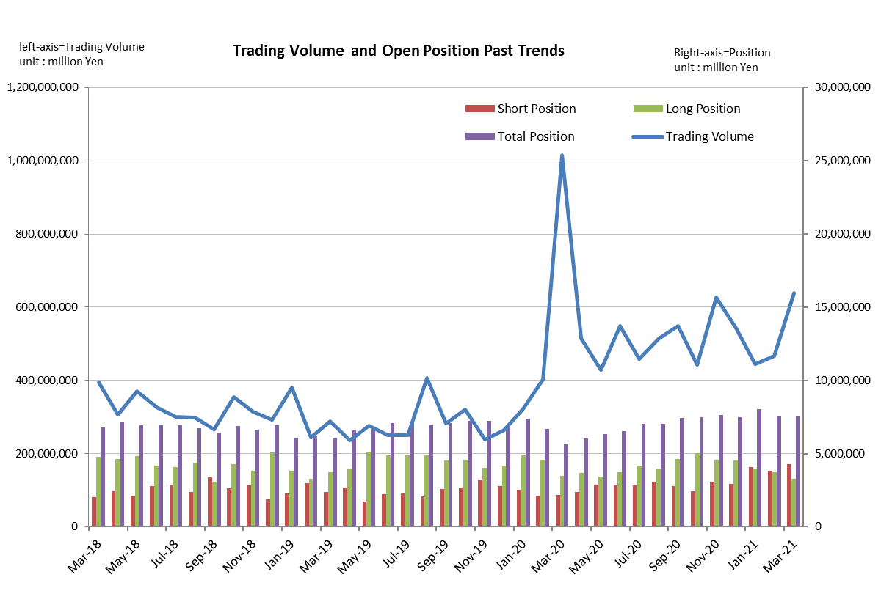
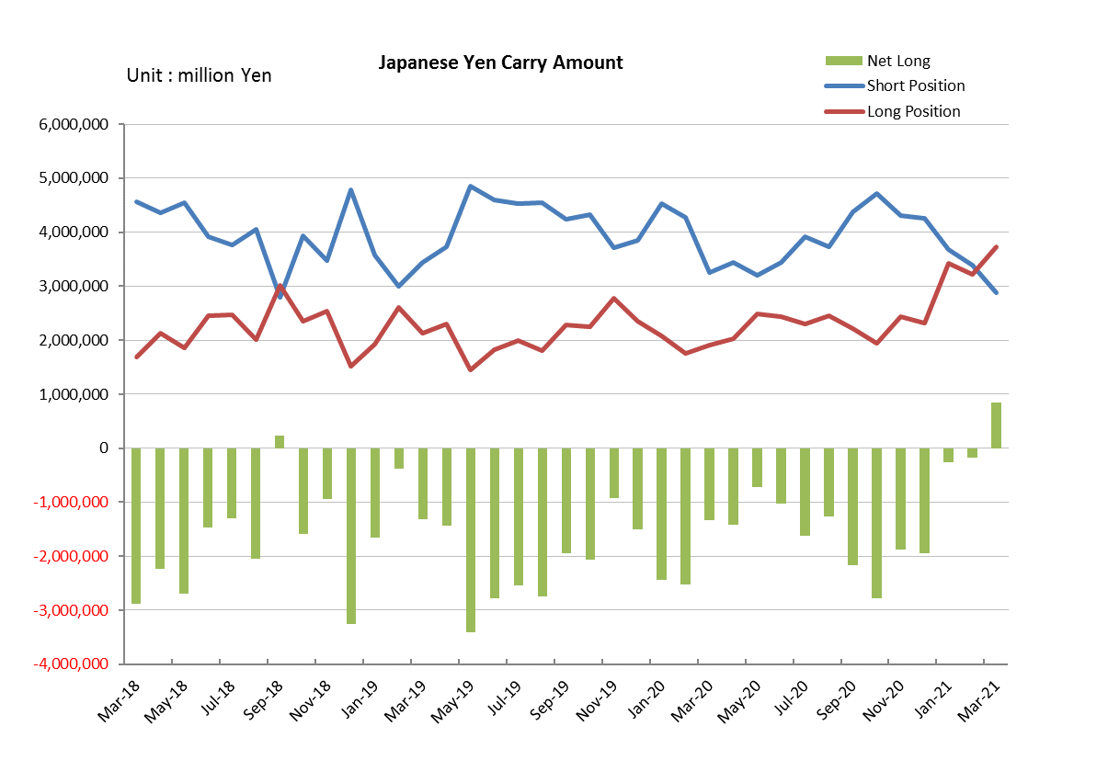

Monthly statistical report on Over-The-Counter Retail FX Margin Trading

：February , 2021
Publication date : 12 March. 2021
Number of Over-The-Counter Retail FX Margin Trading Operators as of 28 February. 2021 :51
Number of members reported :51
【Trading Volume】
(Unit: hundred million Yen, %)
 | Over-The-Counter | USDJPY, Cross Yen | On-Exchange*(for reference)
This month | 4,671,163 | 4,032,405 | 19,213
Previous month | 4,439,060 | 3,698,708 | 20,056
Change | 5.23% | 9.02% | -4.20%
*source : Monthly Trading Volume of Tokyo Financial exchange Inc.(The FFAJ converts the total number of contracts into the trading volume on the settlement prices of the end of the month)
【Open Positions】
(Unit: hundred million Yen)
 | Short | Long | Total
This month | 38,051 | 37,369 | 75,420
Previous month | 40,596 | 39,779 | 80,376
Change | -2,544 | -2,410 | -4,955

・USDJPY, Cross Yen Open Positions
(Unit: hundred million Yen)
 | ① Short | ② Long | Net long=②-①
This month | 33,977 | 32,283 | -1,693
Previous month | 36,723 | 34,167 | -2,556

（Reference：USDJPY Monthly Rate＊）
（Unit: Yen）
End of last Month*1 | Highest of the Month | Lowest of the Month | End of the Month*1 | Average*2
104.55 | 106.43 | 104.51 | 106.09 | 105.36
*source : BOJ's Main Time-series Statistics (Monthly)
*1) Spot Rate at 17:00 in JST, End of Month, Tokyo Market
*2) Average of Central Rate in the Month, Tokyo Market

○ Notes
The volume of this month was about 467 trillion yen (aｎ increase of 5.2% from the previous month), the trading volume on a business day basis excluding weekends also increased.
On the other hand, the open positions balance at the end of the month was about 7.54 trillion yen in total, with both short positions and long positions decreasing from the end of the previous month.

～Tables and Historical Graphs～

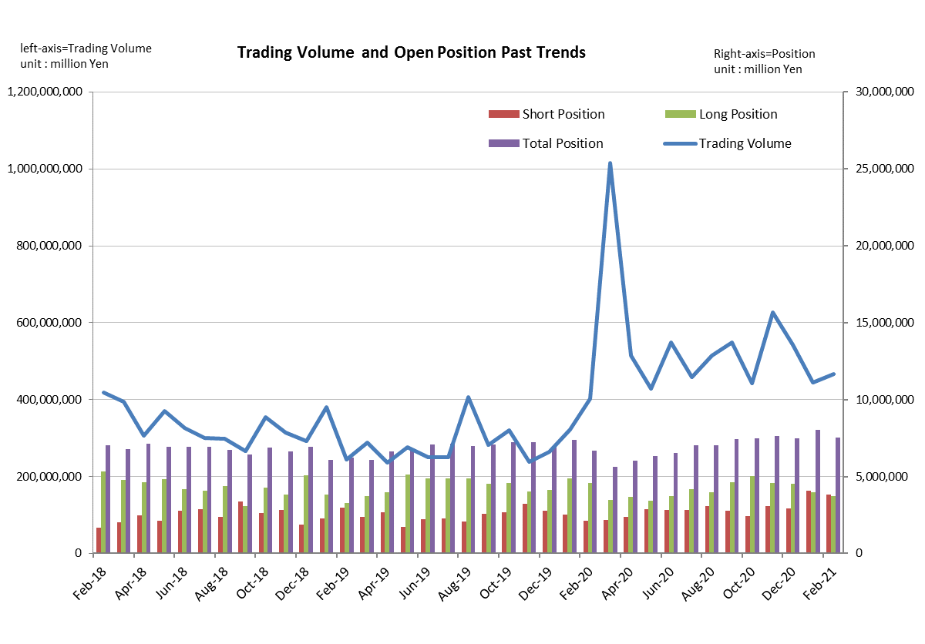
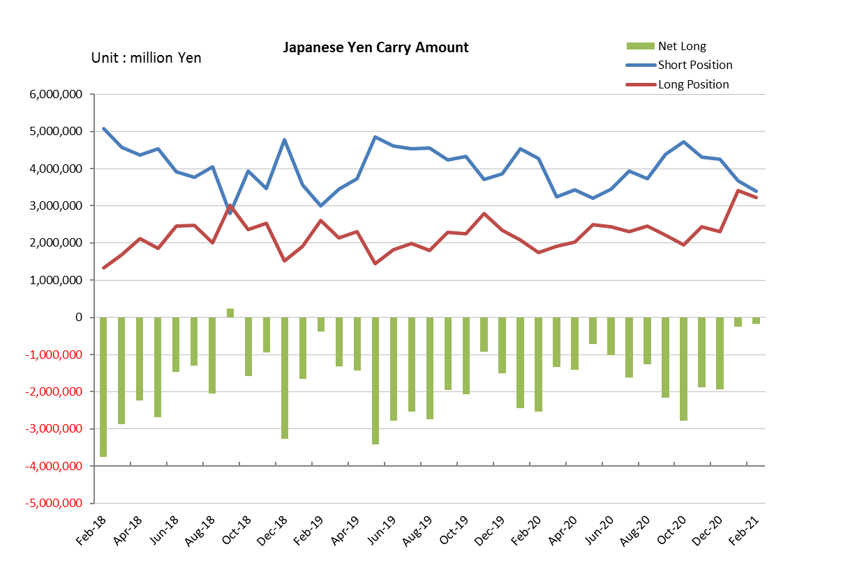

Monthly statistical report on Over-The-Counter Retail FX Margin Trading

：January , 2021
Publication date : 15 February. 2021
Number of Over-The-Counter Retail FX Margin Trading Operators as of 31 January. 2021 :51
Number of members reported :51
【Trading Volume】
(Unit: hundred million Yen, %)
 | Over-The-Counter | USDJPY, Cross Yen | On-Exchange*(for reference)
This month | 4,439,060 | 3,698,708 | 20,056
Previous month | 5,418,465 | 4,451,076 | 20,451
Change | -18.08% | -16.90% | -1.93%
*source : Monthly Trading Volume of Tokyo Financial exchange Inc.(The FFAJ converts the total number of contracts into the trading volume on the settlement prices of the end of the month)
【Open Positions】
(Unit: hundred million Yen)
 | Short | Long | Total
This month | 40,596 | 39,779 | 80,376
Previous month | 29,371 | 45,311 | 74,682
Change | 11,225 | -5,531 | 5,693

・USDJPY, Cross Yen Open Positions
(Unit: hundred million Yen)
 | ① Short | ② Long | Net long=②-①
This month | 36,723 | 34,167 | -2,556
Previous month | 42,528 | 23,113 | -19,414

（Reference：USDJPY Monthly Rate＊）
（Unit: Yen）
End of last Month*1 | Highest of the Month | Lowest of the Month | End of the Month*1 | Average*2
103.33 | 104.57 | 102 | 104.55 | 103.7
*source : BOJ's Main Time-series Statistics (Monthly)
*1) Spot Rate at 17:00 in JST, End of Month, Tokyo Market
*2) Average of Central Rate in the Month, Tokyo Market

○ Notes
The volume of this month was about 444 trillion yen (a decrease of 18.1% from the previous month), the trading volume on a business day basis excluding weekends also decreased.
The open positions balance at the end of the month increased since the end of the previous month,
short positions increased, but long positions decreased, totaling about 8 trillion yen.

～Tables and Historical Graphs～

