Over-The-Counter FX Margin Trading Report

(January 2020 ～ )

Monthly Report
January 2020
February 2020
March 2020
April 2020
May 2020
June 2020
July 2020
August 2020
September 2020
October 2020
November 2020
December 2020

The Financial Futures Association of Japan, Research Department

NBF Ogawamachi Building 1-3 , Kanda Ogawamachi ,
Chiyoda-ku , Tokyo 101-0052 Tel:(03)5280-0881 E-mail : ffaj@ffaj.or.jp

This publication has been prepared by the FFAJ and is provided for information purpose only. The monthly information contained in this publication has been obtained from FFAJ's members that is believed to be reliable, however the FFAJ does not represent or warrant that it is accurate or complete. In no event the FFAJ nor its employees have any liability for any consequential damages arising from any use of this publications or its contents. This publication does not constitute any investment advice.

Monthly statistical report on Over-The-Counter Retail FX Margin Trading

：December , 2020
Publication date : 18 January. 2021
Number of Over-The-Counter Retail FX Margin Trading Operators as of 31 December. 2020 :52
Number of members reported :52
【Trading Volume】
(Unit: hundred million Yen, %)
 | Over-The-Counter | USDJPY, Cross Yen | On-Exchange*(for reference)
This month | 5,418,465 | 4,451,076 | 20,451
Previous month | 6,275,682 | 5,533,769 | 18,980
Change | -13.66% | -19.57% | 7.75%
*source : Monthly Trading Volume of Tokyo Financial exchange Inc.(The FFAJ converts the total number of contracts into the trading volume on the settlement prices of the end of the month)
【Open Positions】
(Unit: hundred million Yen)
 | Short | Long | Total
This month | 29,371 | 45,311 | 74,682
Previous month | 30,528 | 45,942 | 76,470
Change | -1,156 | -631 | -1,788

・USDJPY, Cross Yen Open Positions
(Unit: hundred million Yen)
 | ① Short | ② Long | Net long=②-①
This month | 42,528 | 23,113 | -19,414
Previous month | 43,117 | 24,375 | -18,741

（Reference：USDJPY Monthly Rate＊）
（Unit: Yen）
End of last Month*1 | Highest of the Month | Lowest of the Month | End of the Month*1 | Average*2
104.03 | 104.58 | 103.09 | 103.33 | 103.82
*source : BOJ's Main Time-series Statistics (Monthly)
*1) Spot Rate at 17:00 in JST, End of Month, Tokyo Market
*2) Average of Central Rate in the Month, Tokyo Market
○ Notes
The volume of this month was about 542 trillion yen (a decrease of 13.7% from the previous month), the trading volume on a business day basis excluding weekends also decreased.
The open positions balance at the end of the month was about 7.4 trillion yen in total, with both short positions and long positions decreasing from the end of the previous month.

～Tables and Historical Graphs～

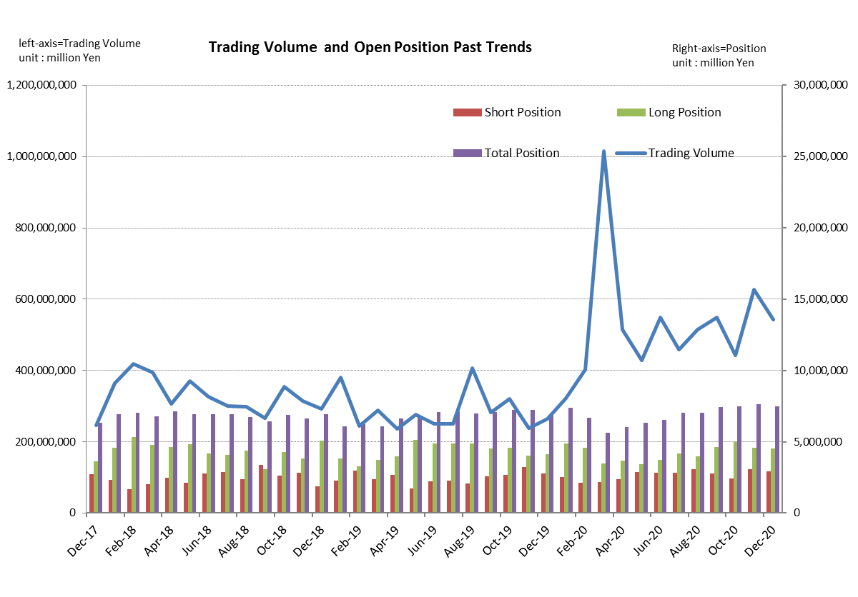

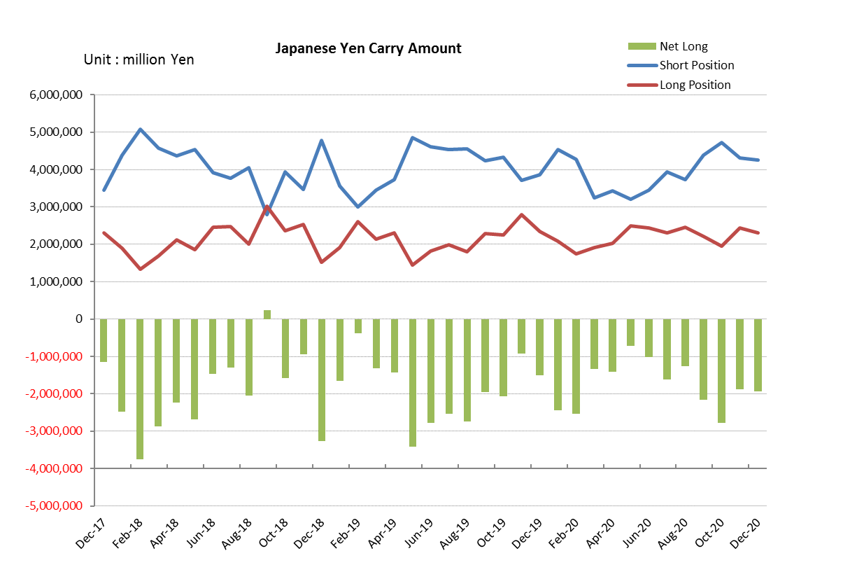

Monthly statistical report on Over-The-Counter Retail FX Margin Trading

：November , 2020
Publication date : 14 December. 2020
Number of Over-The-Counter Retail FX Margin Trading Operators as of 30 November. 2020 :52
Number of members reported :52
【Trading Volume】
(Unit: hundred million Yen, %)
 | Over-The-Counter | USDJPY, Cross Yen | On-Exchange*(for reference)
This month | 6,275,682 | 5,533,769 | 18,980
Previous month | 4,421,743 | 3,703,030 | 15,106
Change | 41.93% | 49.44% | 25.65%
*source : Monthly Trading Volume of Tokyo Financial exchange Inc.(The FFAJ converts the total number of contracts into the trading volume on the settlement prices of the end of the month)
【Open Positions】
(Unit: hundred million Yen)
 | Short | Long | Total
This month | 30,528 | 45,942 | 76,470
Previous month | 24,094 | 50,534 | 74,629
Change | 6,433 | -4,591 | 1,841

・USDJPY, Cross Yen Open Positions
(Unit: hundred million Yen)
 | ① Short | ② Long | Net long=②-①
This month | 43,117 | 24,375 | -18,741
Previous month | 47,245 | 19,476 | -27,768

（Reference：USDJPY Monthly Rate＊）
（Unit: Yen）
End of last Month*1 | Highest of the Month | Lowest of the Month | End of the Month*1 | Average*2
104.36 | 105.48 | 103.2 | 104.03 | 104.4
*source : BOJ's Main Time-series Statistics (Monthly)
*1) Spot Rate at 17:00 in JST, End of Month, Tokyo Market
*2) Average of Central Rate in the Month, Tokyo Market
○ Notes
The volume of this month was about 628 trillion yen (an increase of 41.9% from the previous month), the trading volume on a business day basis excluding weekends also increased.
The open positions balance at the end of the month was about 7.67 trillion yen in total, long positions decreased, but short positions increased, from the end of the previous month.

～Tables and Historical Graphs～
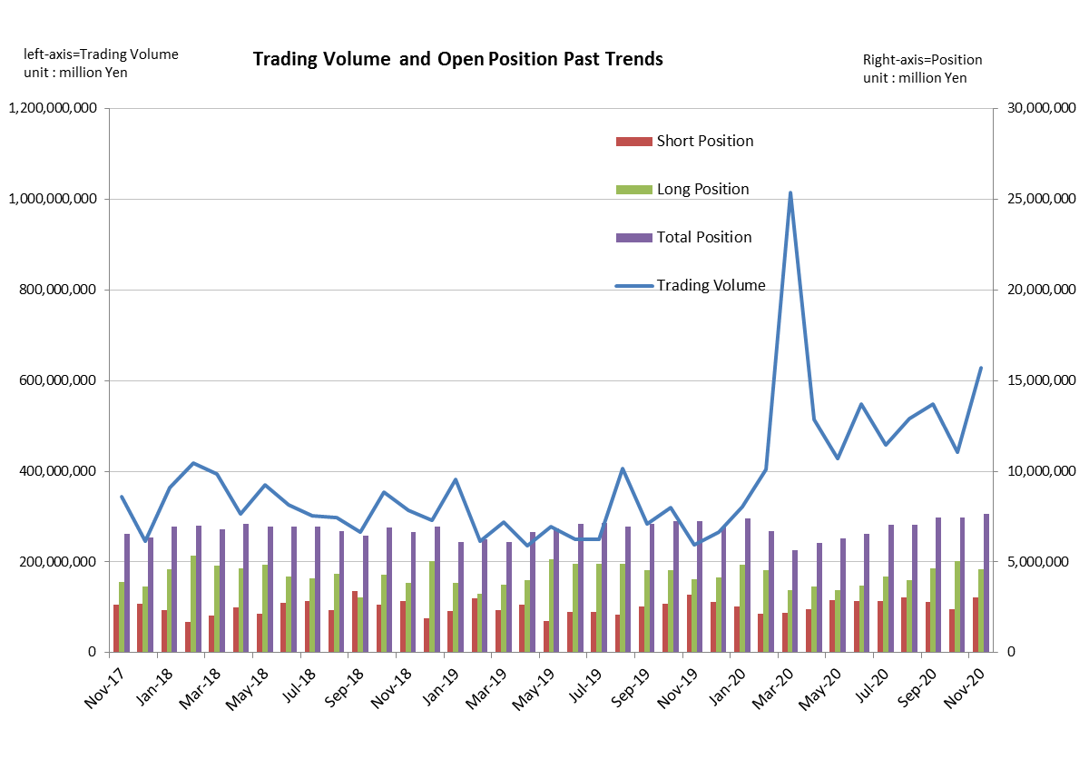
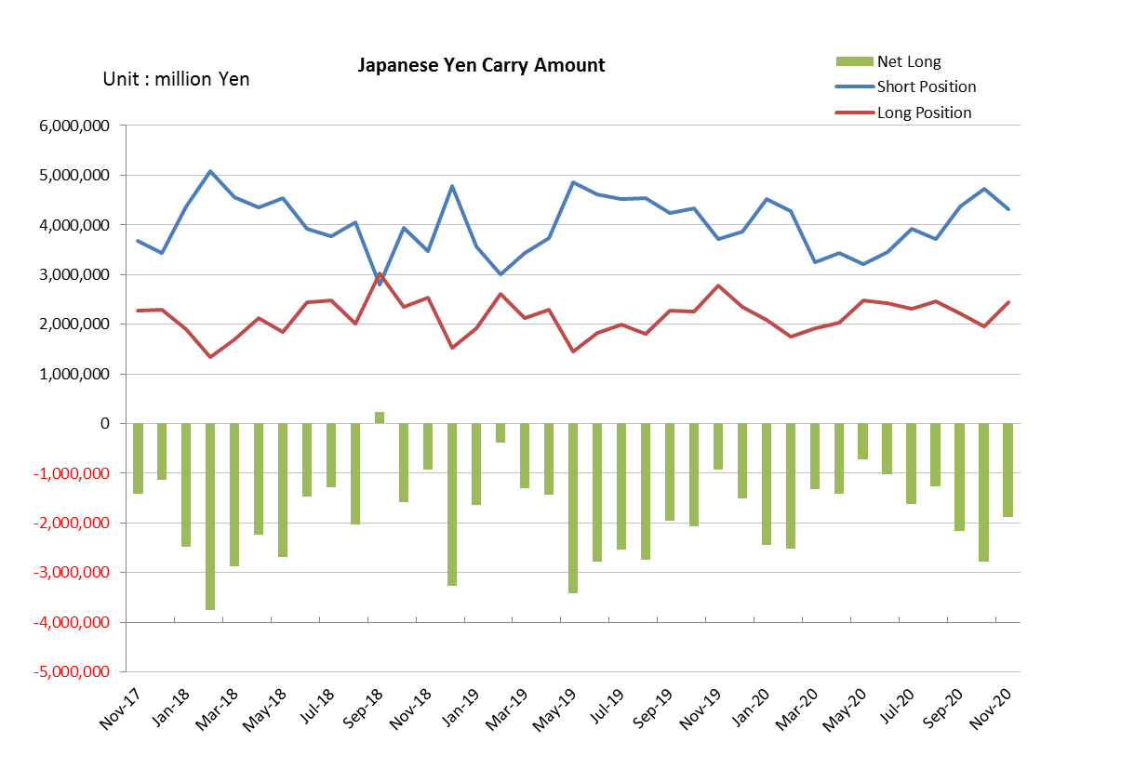

Monthly statistical report on Over-The-Counter Retail FX Margin Trading

：October , 2020
Publication date : 16 November. 2020
Number of Over-The-Counter Retail FX Margin Trading Operators as of 31 October. 2020 :52
Number of members reported :52
【Trading Volume】
(Unit: hundred million Yen, %)
 | Over-The-Counter | USDJPY, Cross Yen | On-Exchange*(for reference)
This month | 4,421,743 | 3,703,030 | 15,106
Previous month | 5,479,286 | 4,590,833 | 16,550
Change | -19.30% | -19.34% | -8.73%
*source : Monthly Trading Volume of Tokyo Financial exchange Inc.(The FFAJ converts the total number of contracts into the trading volume on the settlement prices of the end of the month)
【Open Positions】
(Unit: hundred million Yen)
 | Short | Long | Total
This month | 24,094 | 50,534 | 74,629
Previous month | 27,804 | 46,428 | 74,233
Change | -3,709 | 4,105 | 395

・USDJPY, Cross Yen Open Positions
(Unit: hundred million Yen)
 | ① Short | ② Long | Net long=②-①
This month | 47,245 | 19,476 | -27,768
Previous month | 43,762 | 22,147 | -21,615

（Reference：USDJPY Monthly Rate＊）
（Unit: Yen）
End of last Month*1 | Highest of the Month | Lowest of the Month | End of the Month*1 | Average*2
105.62 | 106.11 | 104.13 | 104.36 | 105.24
*source : BOJ's Main Time-series Statistics (Monthly)
*1) Spot Rate at 17:00 in JST, End of Month, Tokyo Market
*2) Average of Central Rate in the Month, Tokyo Market
○ Notes
The volume of this month was about 442 trillion yen (a decrease of 19.3% from the previous month), the trading volume on a business day basis excluding weekends also decreased.
The open positions balance at the end of the month was about 7.46 trillion yen in total, long positions increased, but short positions decreased, from the end of the previous month.

～Tables and Historical Graphs～
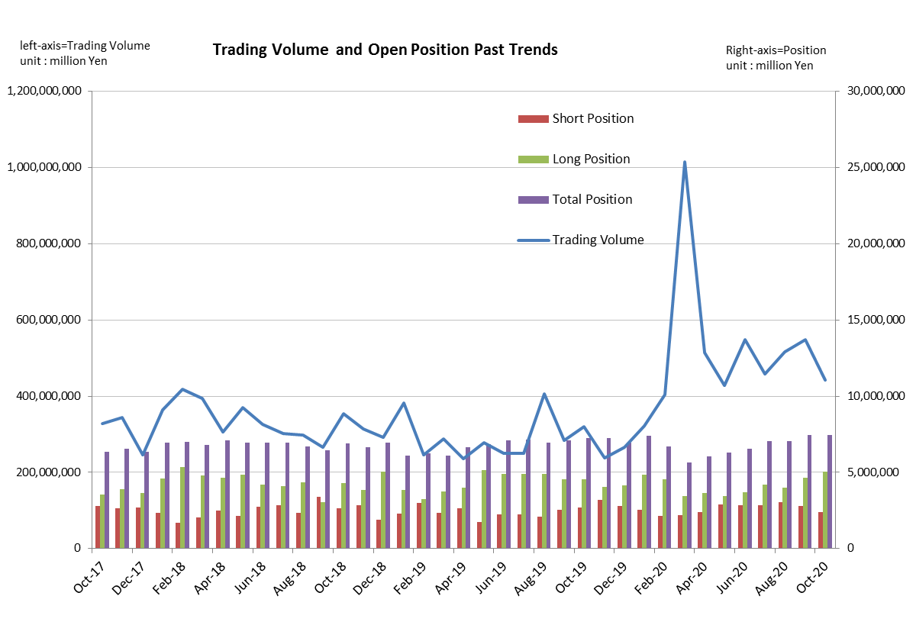
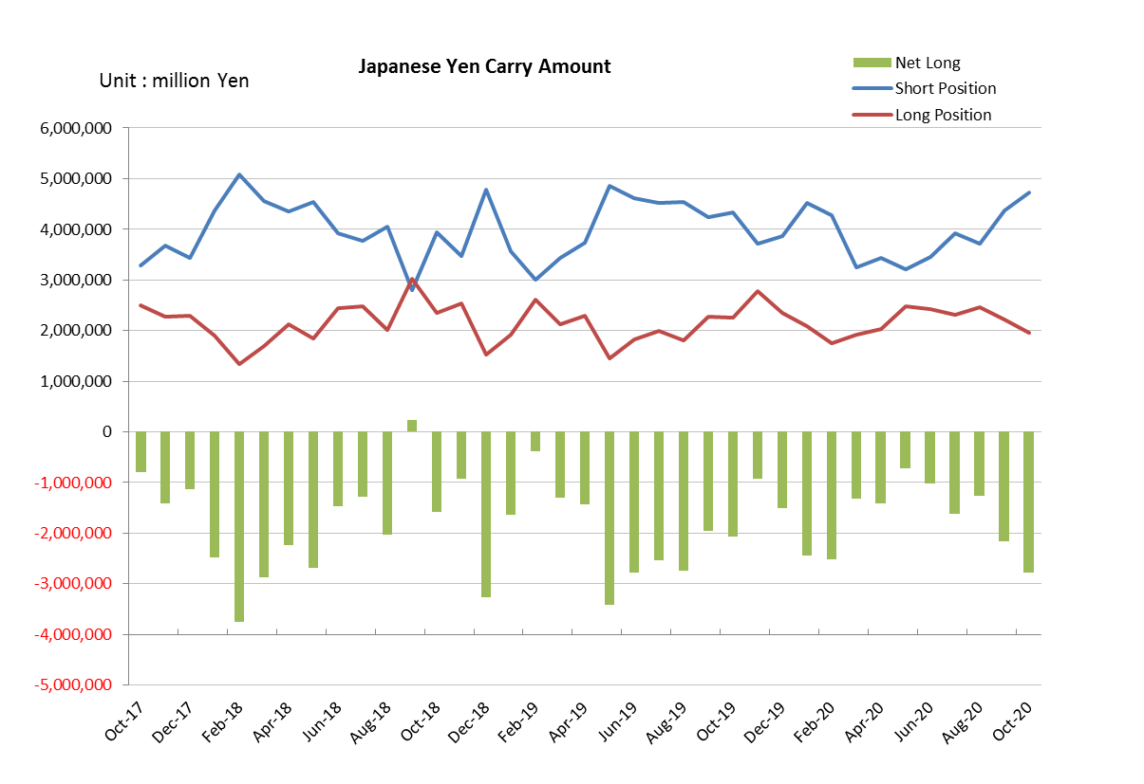

Monthly statistical report on Over-The-Counter Retail FX Margin Trading

：September , 2020
Publication date : 14 October. 2020
Number of Over-The-Counter Retail FX Margin Trading Operators as of 30 September. 2020 :54
Number of members reported :54
【Trading Volume】
(Unit: hundred million Yen, %)
 | Over-The-Counter | USDJPY, Cross Yen | On-Exchange*(for reference)
This month | 5,479,286 | 4,590,833 | 16,550
Previous month | 5,155,965 | 4,396,711 | 14,438
Change | 6.27% | 4.42% | 14.63%
*source : Monthly Trading Volume of Tokyo Financial exchange Inc.(The FFAJ converts the total number of contracts into the trading volume on the settlement prices of the end of the month)
【Open Positions】
(Unit: hundred million Yen)
 | Short | Long | Total
This month | 27,804 | 46,429 | 74,233
Previous month | 30,518 | 39,796 | 70,315
Change | -2,714 | 6,632 | 3,917

・USDJPY, Cross Yen Open Positions
(Unit: hundred million Yen)
 | ① Short | ② Long | Net long=②-①
This month | 43,762 | 22,147 | -21,614
Previous month | 37,236 | 24,574 | -12,661

（Reference：USDJPY Monthly Rate＊）
（Unit: Yen）
End of last Month*1 | Highest of the Month | Lowest of the Month | End of the Month*1 | Average*2
105.83 | 106.39 | 104.55 | 105.62 | 105.74
*source : BOJ's Main Time-series Statistics (Monthly)
*1) Spot Rate at 17:00 in JST, End of Month, Tokyo Market
*2) Average of Central Rate in the Month, Tokyo Market
○ Notes
The volume of this month was about 548 trillion yen (an increase of 6.3% from the previous month), the trading volume on a business day basis excluding weekends also increased.
The open positions balance at the end of the month was about 7.42 trillion yen in total, long positions increased, but short positions decreased, from the end of the previous month.

～Tables and Historical Graphs～
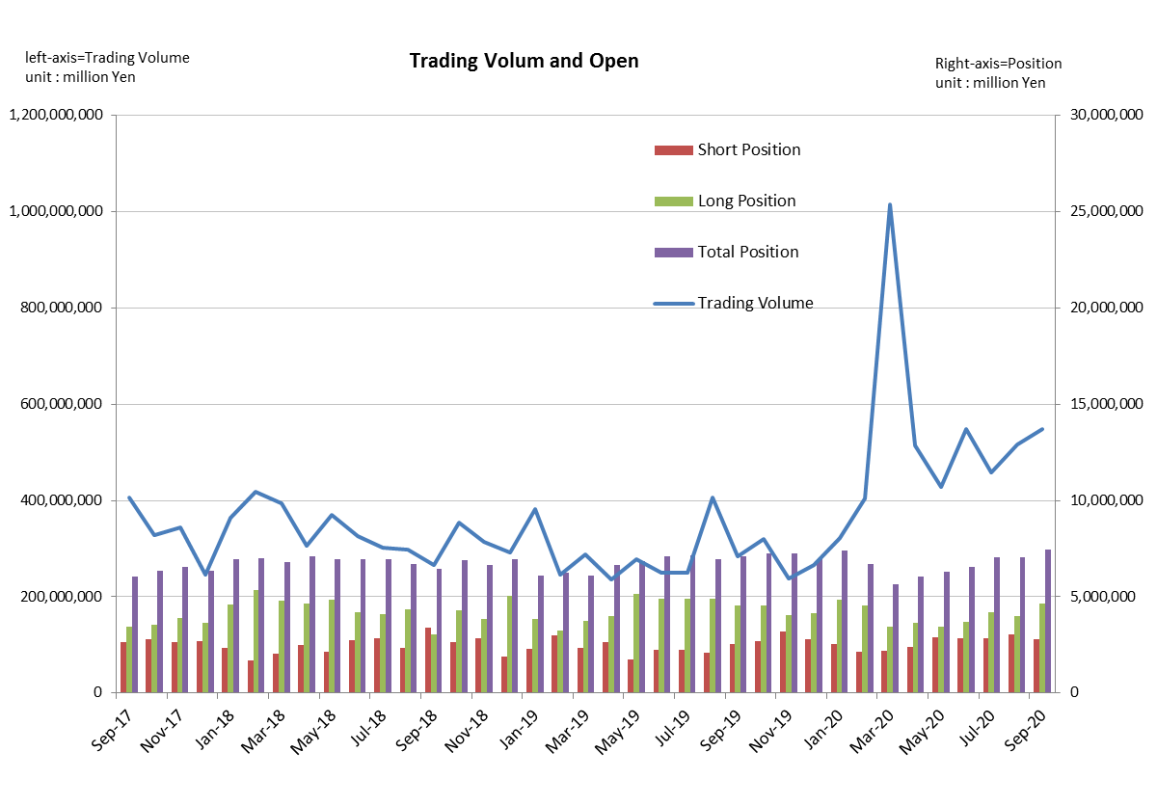
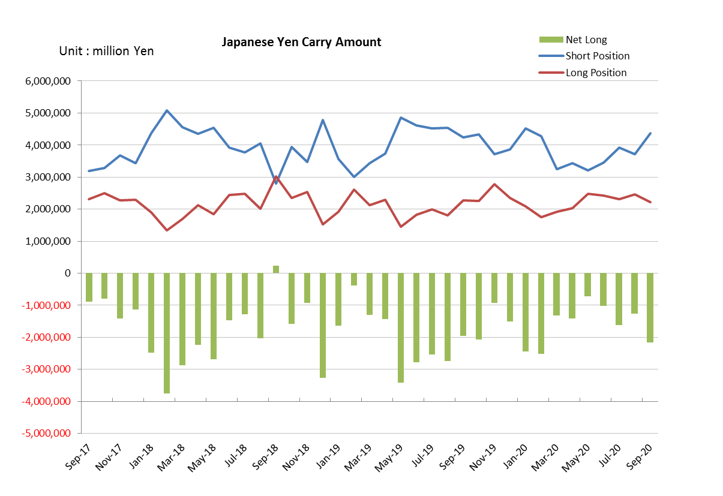

Monthly statistical report on Over-The-Counter Retail FX Margin Trading

：August , 2020
Publication date : 14 September. 2020
Number of Over-The-Counter Retail FX Margin Trading Operators as of 31 August. 2020 :53
Number of members reported :53
【Trading Volume】
(Unit: hundred million Yen, %)
 | Over-The-Counter | USDJPY, Cross Yen | On-Exchange*(for reference)
This month | 5,155,965 | 4,396,711 | 14,438
Previous month | 4,578,590 | 3,897,102 | 16,002
Change | 12.61% | 12.82% | -9.77%
*source : Monthly Trading Volume of Tokyo Financial exchange Inc.(The FFAJ converts the total number of contracts into the trading volume on the settlement prices of the end of the month)
【Open Positions】
(Unit: hundred million Yen)
 | Short | Long | Total
This month | 30,518 | 39,796 | 70,315
Previous month | 28,354 | 41,921 | 70,276
Change | 2,164 | -2,124 | 39

・USDJPY, Cross Yen Open Positions
(Unit: hundred million Yen)
 | ① Short | ② Long | Net long=②-①
This month | 37,236 | 24,574 | -12,661
Previous month | 39,255 | 23,064 | -16,190

（Reference：USDJPY Monthly Rate＊）
（Unit: Yen）
End of last Month*1 | Highest of the Month | Lowest of the Month | End of the Month*1 | Average*2
104.45 | 107.04 | 105.1 | 105.83 | 106.04
*source : BOJ's Main Time-series Statistics (Monthly)
*1) Spot Rate at 17:00 in JST, End of Month, Tokyo Market
*2) Average of Central Rate in the Month, Tokyo Market
○ Notes
The volume of this month was about 516 trillion yen (an increase of 12.6% from the previous month), the trading volume on a business day basis excluding weekends also increased.
The open positions balance at the end of the month was about 7.03 trillion yen in total, long positions decreased, but short positions increased, from the end of the previous month.

～Tables and Historical Graphs～
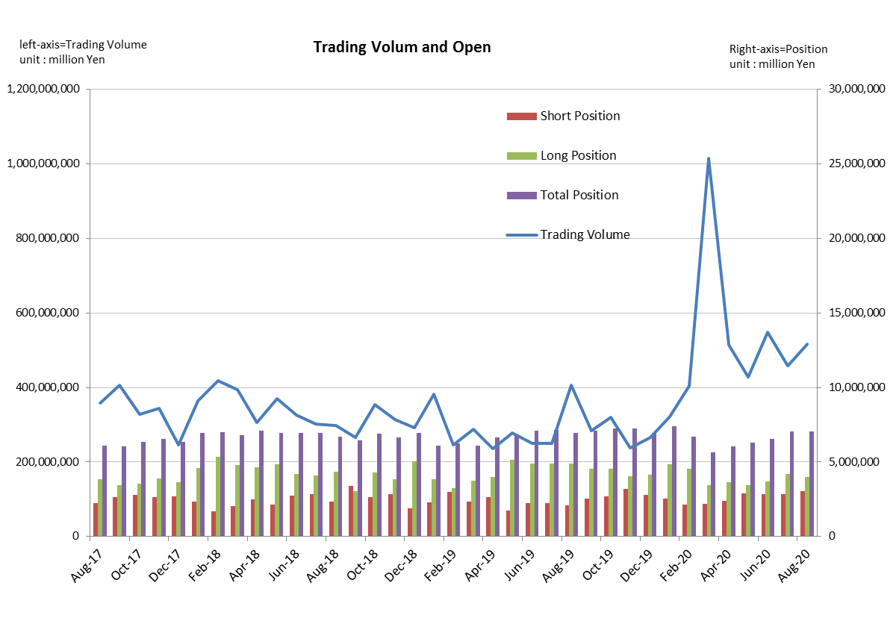
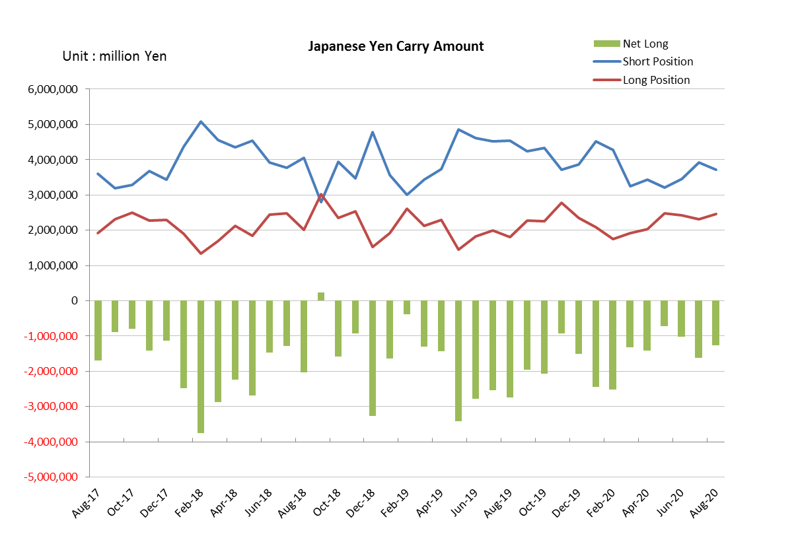

Monthly statistical report on Over-The-Counter Retail FX Margin Trading

：July , 2020
Publication date : 17 August. 2020
Number of Over-The-Counter Retail FX Margin Trading Operators as of 31 July. 2020 :53
Number of members reported :53
【Trading Volume】
(Unit: hundred million Yen, %)
 | Over-The-Counter | USDJPY, Cross Yen | On-Exchange*(for reference)
This month | 4,578,590 | 3,897,102 | 16,002
Previous month | 5,486,485 | 4,931,550 | 22,271
Change | -16.55% | -20.98% | -28.15%
*source : Monthly Trading Volume of Tokyo Financial exchange Inc.(The FFAJ converts the total number of contracts into the trading volume on the settlement prices of the end of the month)
【Open Positions】
(Unit: hundred million Yen)
 | Short | Long | Total
This month | 28,354 | 41,921 | 70,276
Previous month | 28,231 | 37,102 | 65,333
Change | 122 | 4,819 | 4,942

・USDJPY, Cross Yen Open Positions
(Unit: hundred million Yen)
 | ① Short | ② Long | Net long=②-①
This month | 39,255 | 23,064 | -16,190
Previous month | 34,498 | 24,300 | -10,198

（Reference：USDJPY Monthly Rate＊）
（Unit: Yen）
End of last Month*1 | Highest of the Month | Lowest of the Month | End of the Month*1 | Average*2
107.73 | 108.16 | 104.2 | 104.45 | 106.78
*source : BOJ's Main Time-series Statistics (Monthly)
*1) Spot Rate at 17:00 in JST, End of Month, Tokyo Market
*2) Average of Central Rate in the Month, Tokyo Market
○ Notes
The volume of this month was about 458 trillion yen (a decrease of 16.6% from the previous month), the trading volume on a business day basis excluding weekends also decreased.
On the other hand, the open positions balance at the end of the month was about 7.02 trillion yen in total, with both short positions and long positions increasing from the end of the previous month.

～Tables and Historical Graphs～
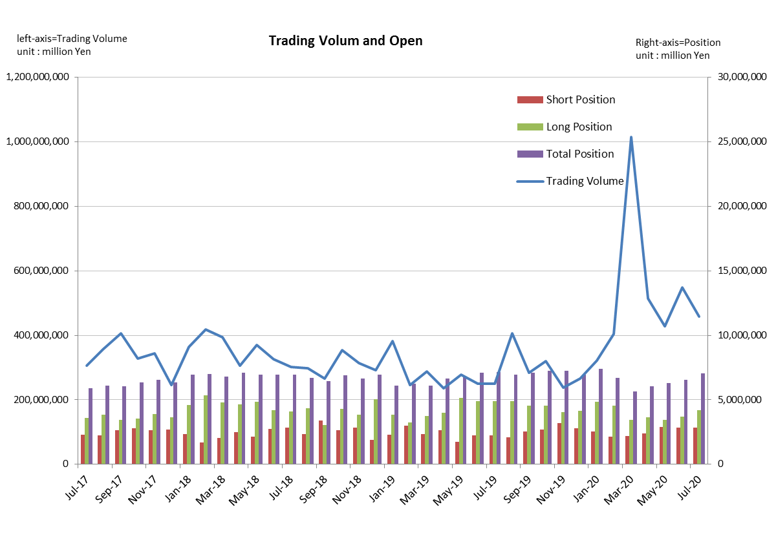
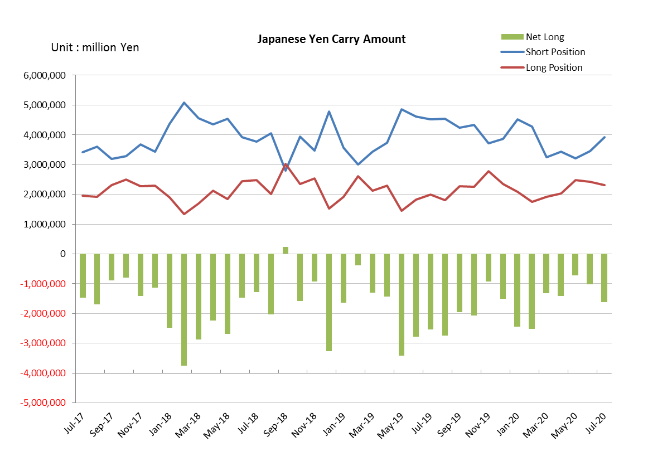

Monthly statistical report on Over-The-Counter Retail FX Margin Trading

：June , 2020
Publication date : 14 July. 2020
Number of Over-The-Counter Retail FX Margin Trading Operators as of 30 June. 2020 :53
Number of members reported :53
【Trading Volume】
(Unit: hundred million Yen, %)
 | Over-The-Counter | USDJPY, Cross Yen | On-Exchange*(for reference)
This month | 5,486,485 | 4,931,550 | 22,271
Previous month | 4,285,354 | 3,773,375 | 18,086
Change | 28.03% | 30.69% | 23.14%
*source : Monthly Trading Volume of Tokyo Financial exchange Inc.(The FFAJ converts the total number of contracts into the trading volume on the settlement prices of the end of the month)
【Open Positions】
(Unit: hundred million Yen)
 | Short | Long | Total
This month | 28,231 | 37,102 | 65,333
Previous month | 28,829 | 34,278 | 63,108
Change | -597 | 2,823 | 2,225

・USDJPY, Cross Yen Open Positions
(Unit: hundred million Yen)
 | ① Short | ② Long | Net long=②-①
This month | 34,498 | 24,300 | -10,198
Previous month | 32,042 | 24,857 | -7,185

（Reference：USDJPY Monthly Rate＊）
（Unit: Yen）
End of last Month*1 | Highest of the Month | Lowest of the Month | End of the Month*1 | Average*2
107.21 | 109.69 | 106.39 | 107.73 | 107.56
*source : BOJ's Main Time-series Statistics (Monthly)
*1) Spot Rate at 17:00 in JST, End of Month, Tokyo Market
*2) Average of Central Rate in the Month, Tokyo Market
○ Notes
The volume of this month was about 549 trillion yen (an increase of 28.0% from the previous month), the trading volume on a business day basis excluding weekends also increased.
The open positions balance at the end of the month was about 6.5 trillion yen in total, long positions increased, but short positions decreased, from the end of the previous month.

～Tables and Historical Graphs～
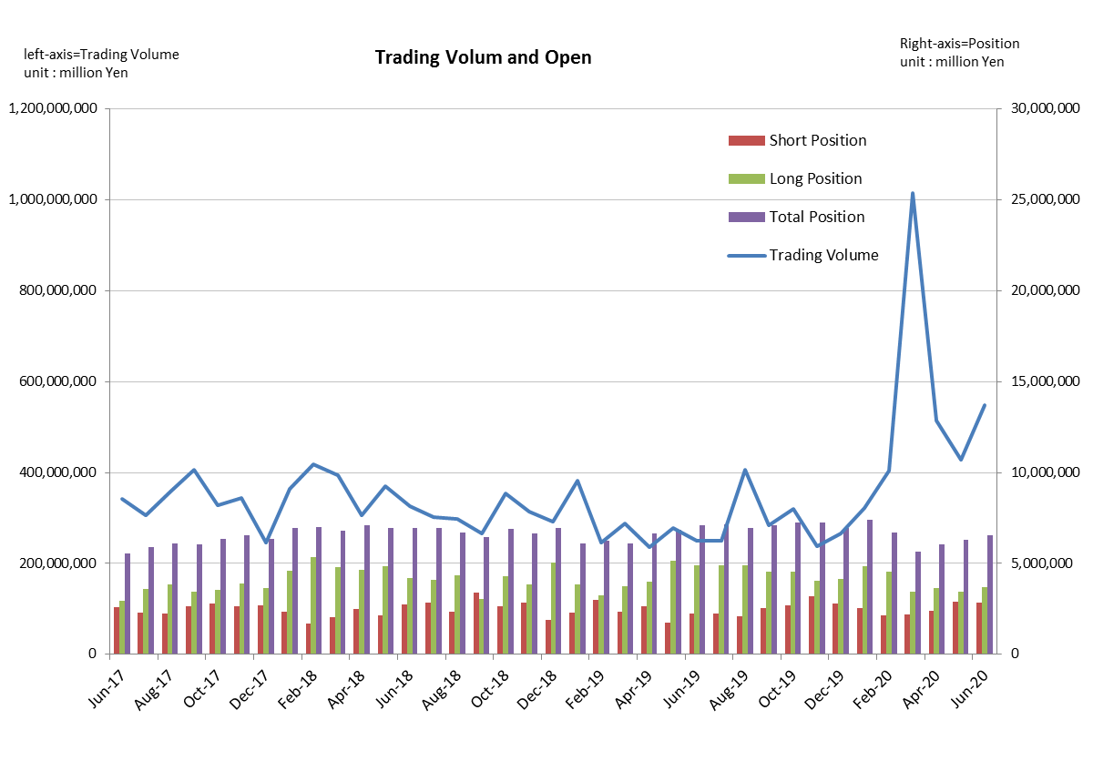
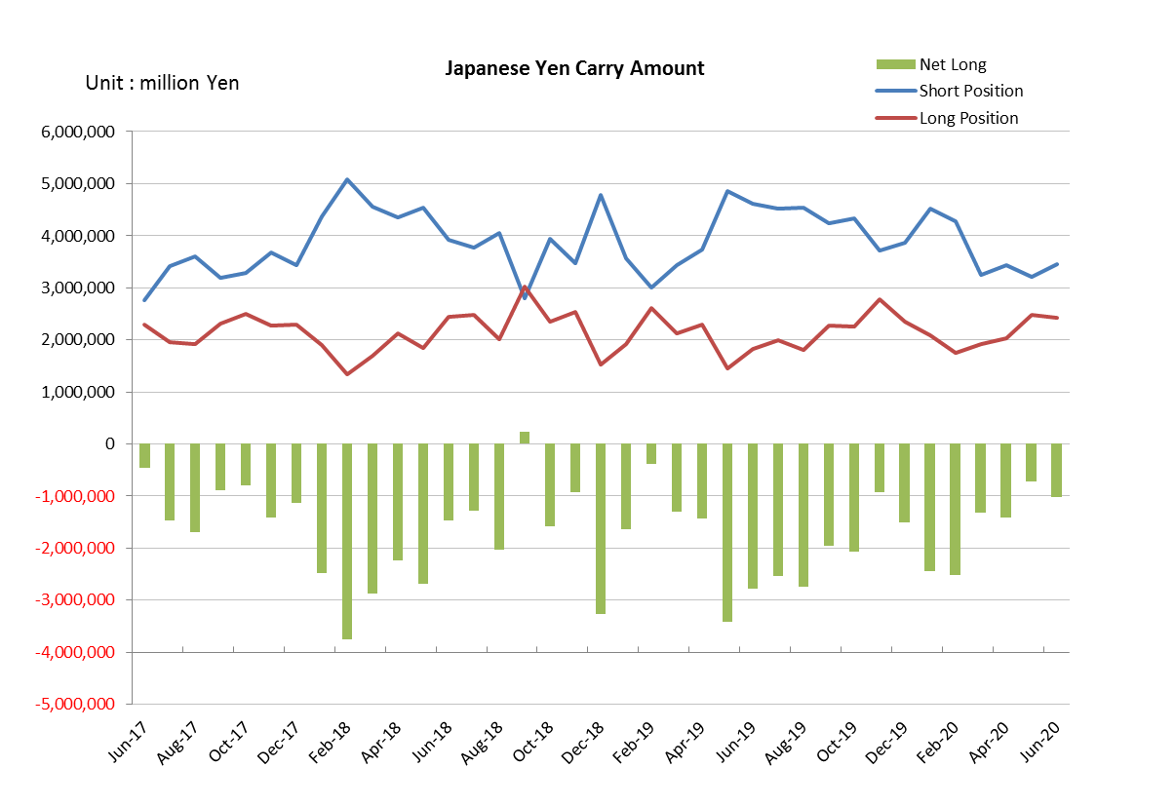

Monthly statistical report on Over-The-Counter Retail FX Margin Trading

：May , 2020
Publication date : 12 June. 2020
Number of Over-The-Counter Retail FX Margin Trading Operators as of 31 May. 2020 :53
Number of members reported :53
【Trading Volume】
(Unit: hundred million Yen, %)
 | Over-The-Counter | USDJPY, Cross Yen | On-Exchange*(for reference)
This month | 4,285,354 | 3,773,375 | 18,086
Previous month | 5,137,957 | 4,574,424 | 19,691
Change | -16.59% | -17.51% | -8.15%
*source : Monthly Trading Volume of Tokyo Financial exchange Inc.(The FFAJ converts the total number of contracts into the trading volume on the settlement prices of the end of the month)
【Open Positions】
(Unit: hundred million Yen)
 | Short | Long | Total
This month | 28,829 | 34,278 | 63,108
Previous month | 23,703 | 36,624 | 60,328
Change | 5,126 | -2,346 | 2,779

・USDJPY, Cross Yen Open Positions
(Unit: hundred million Yen)
 | ① Short | ② Long | Net long=②-①
This month | 32,042 | 24,857 | -7,185
Previous month | 34,351 | 20,208 | -14,142

（Reference：USDJPY Monthly Rate＊）
（Unit: Yen）
End of last Month*1 | Highest of the Month | Lowest of the Month | End of the Month*1 | Average*2
106.6 | 107.99 | 106 | 107.21 | 107.31
*source : BOJ's Main Time-series Statistics (Monthly)
*1) Spot Rate at 17:00 in JST, End of Month, Tokyo Market
*2) Average of Central Rate in the Month, Tokyo Market
○ Notes
The volume of this month was about 428 trillion yen (a decrease of 16.6% from the previous month), the trading volume on a business day basis excluding weekends also decreased.
The open positions balance at the end of the month was about 6.3 trillion yen in total, long positions decreased, but short positions increased, from the end of the previous month.

～Tables and Historical Graphs～
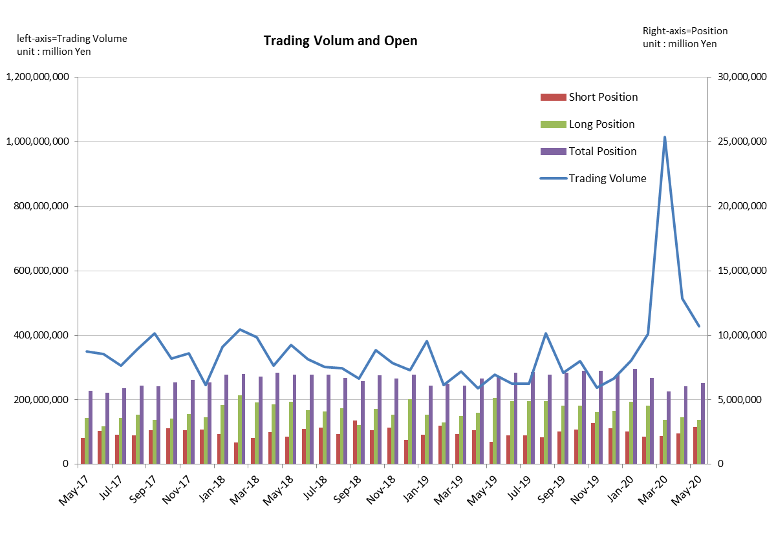
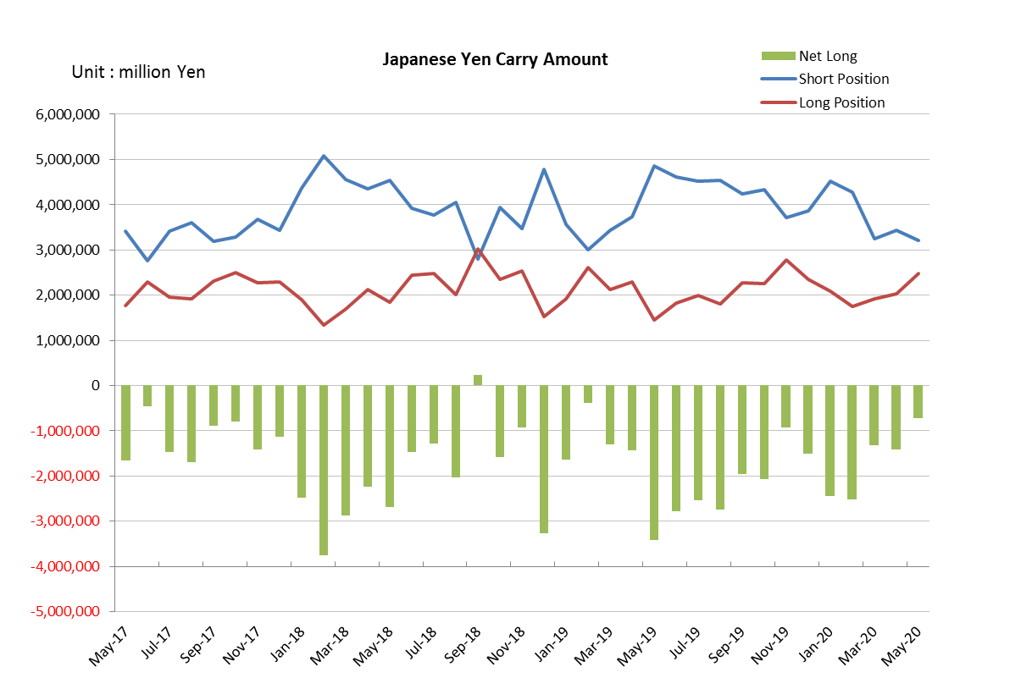

Monthly statistical report on Over-The-Counter Retail FX Margin Trading

：April , 2020
Publication date : 19 May. 2020
Number of Over-The-Counter Retail FX Margin Trading Operators as of 30 April. 2020 :54
Number of members reported :54
【Trading Volume】
(Unit: hundred million Yen, %)
 | Over-The-Counter | USDJPY, Cross Yen | On-Exchange*(for reference)
This month | 5,137,957 | 4,574,424 | 19,691
Previous month | 10,156,123 | 9,371,437 | 55,684
Change | -49.41% | -51.19% | -64.64%
*source : Monthly Trading Volume of Tokyo Financial exchange Inc.(The FFAJ converts the total number of contracts into the trading volume on the settlement prices of the end of the month)
【Open Positions】
(Unit: hundred million Yen)
 | Short | Long | Total
This month | 23,703 | 36,624 | 60,328
Previous month | 21,846 | 34,560 | 56,406
Change | 1,857 | 2,064 | 3,921

・USDJPY, Cross Yen Open Positions
(Unit: hundred million Yen)
 | ① Short | ② Long | Net long=②-①
This month | 34,351 | 20,208 | -14,142
Previous month | 32,463 | 19,174 | -13,289

（Reference：USDJPY Monthly Rate＊）
（Unit: Yen）
End of last Month*1 | Highest of the Month | Lowest of the Month | End of the Month*1 | Average*2
108.42 | 109.38 | 106.41 | 106.6 | 107.93
*source : BOJ's Main Time-series Statistics (Monthly)
*1) Spot Rate at 17:00 in JST, End of Month, Tokyo Market
*2) Average of Central Rate in the Month, Tokyo Market
○ Notes
The volume of this month was about 514 trillion yen (a decrease of 49.4% from the previous month), the trading volume on a business day basis excluding weekends also decreased.
On the other hand, the open positions balance at the end of the month was about 6 trillion yen in total, with both short positions and long positions increasing from the end of the previous month.
.

～Tables and Historical Graphs～
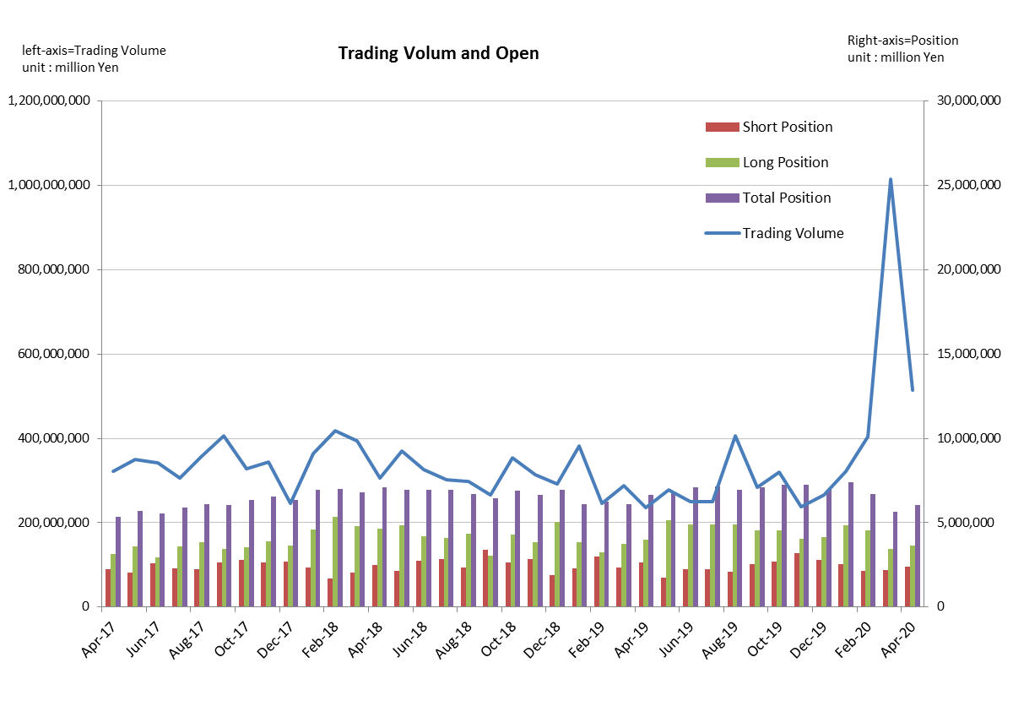
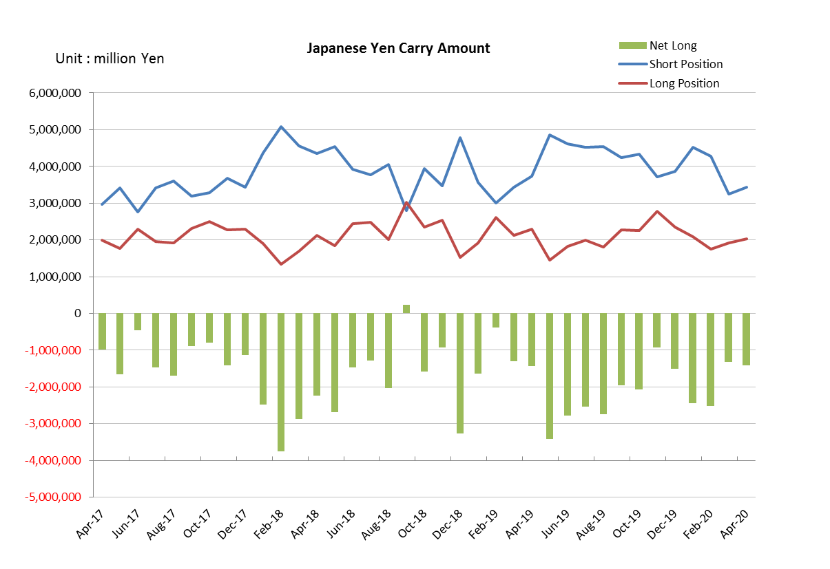

Monthly statistical report on Over-The-Counter Retail FX Margin Trading

：March , 2020
Publication date : 13 April. 2020
Number of Over-The-Counter Retail FX Margin Trading Operators as of 31 March. 2020 :53
Number of members reported :53
【Trading Volume】
(Unit: hundred million Yen, %)
 | Over-The-Counter | USDJPY, Cross Yen | On-Exchange*(for reference)
This month | 10,156,123 | 9,371,437 | 55,684
Previous month | 4,031,149 | 3,726,691 | 20,098
Change | 151.94% | 151.47% | 177.06%
*source : Monthly Trading Volume of Tokyo Financial exchange Inc.(The FFAJ converts the total number of contracts into the trading volume on the settlement prices of the end of the month)
【Open Positions】
(Unit: hundred million Yen)
 | Short | Long | Total
This month | 21,846 | 34,560 | 56,406
Previous month | 21,300 | 45,636 | 66,937
Change | 545 | -11,076 | -10,531

・USDJPY, Cross Yen Open Positions
(Unit: hundred million Yen)
 | ① Short | ② Long | Net long=②-①
This month | 32,463 | 19,174 | -13,289
Previous month | 42,795 | 17,528 | -25,266

（Reference：USDJPY Monthly Rate＊）
（Unit: Yen）
End of last Month*1 | Highest of the Month | Lowest of the Month | End of the Month*1 | Average*2
108.84 | 111.49 | 101.6 | 108.42 | 107.29
*source : BOJ's Main Time-series Statistics (Monthly)
*1) Spot Rate at 17:00 in JST, End of Month, Tokyo Market
*2) Average of Central Rate in the Month, Tokyo Market
○ Notes
The volume of this month was about 1,016 trillion yen (an increase of 151.9% from the previous month), the trading volume on a business day basis excluding weekends also increased.
The open positions balance at the end of the month decreased since the end of the previous month,
long positions decreased, but short positions increased slightly, totaling about 5.6 trillion yen.

～Tables and Historical Graphs～
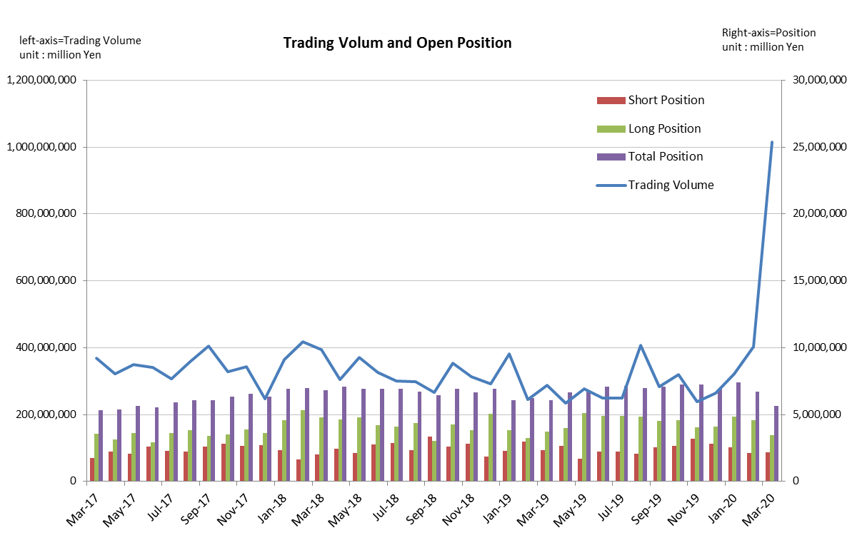
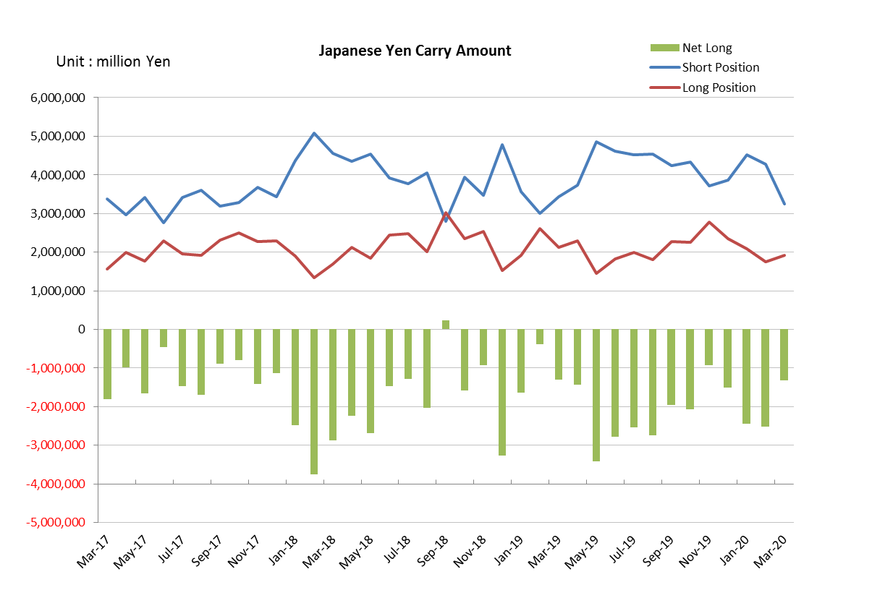

Monthly statistical report on Over-The-Counter Retail FX Margin Trading

：February , 2020
Publication date : 13 March. 2020
Number of Over-The-Counter Retail FX Margin Trading Operators as of 29 February. 2020 :53
Number of members reported :53
【Trading Volume】
(Unit: hundred million Yen, %)
 | Over-The-Counter | USDJPY, Cross Yen | On-Exchange*(for reference)
This month | 4,030,062 | 3,725,712 | 20,098
Previous month | 3,219,264 | 2,924,317 | 16,247
Change | 25.19% | 27.40% | 23.70%
*source : Monthly Trading Volume of Tokyo Financial exchange Inc.(The FFAJ converts the total number of contracts into the trading volume on the settlement prices of the end of the month)
【Open Positions】
(Unit: hundred million Yen)
 | Short | Long | Total
This month | 21,338 | 45,636 | 66,974
Previous month | 25,350 | 48,563 | 73,914
Change | -4,012 | -2,926 | -6,939

・USDJPY, Cross Yen Open Positions
(Unit: hundred million Yen)
 | ① Short | ② Long | Net long=②-①
This month | 42,793 | 17,564 | -25,229
Previous month | 45,254 | 20,813 | -24,440

（Reference：USDJPY Monthly Rate＊）
（Unit: Yen）
End of last Month*1 | Highest of the Month | Lowest of the Month | End of the Month*1 | Average*2
109.04 | 112.18 | 108.32 | 108.84 | 109.96
*source : BOJ's Main Time-series Statistics (Monthly)
*1) Spot Rate at 17:00 in JST, End of Month, Tokyo Market
*2) Average of Central Rate in the Month, Tokyo Market
○ Notes
The volume of this month was about 403 trillion yen (an increase of 25.2% from the previous month), the trading volume on a business day basis excluding weekends also increased.
On the other hand, the open positions balance at the end of the month was about 6.69 trillion yen in total, with both short positions and long positions decreasing from the end of the previous month.

～Tables and Historical Graphs～
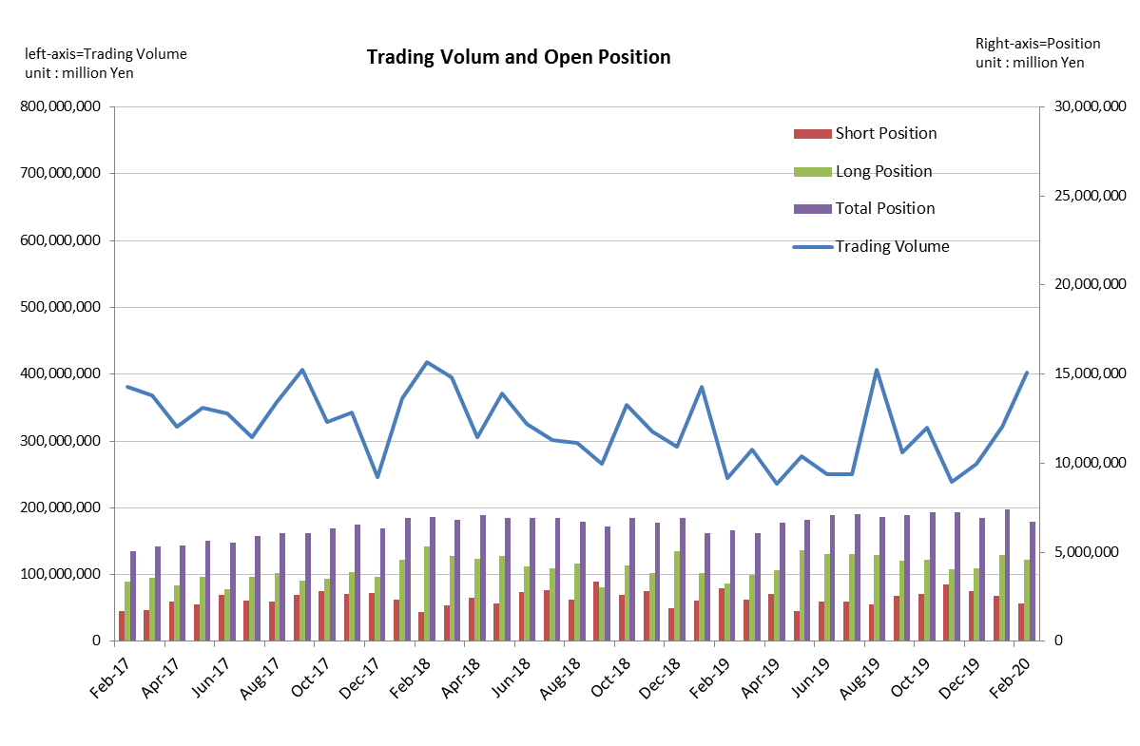
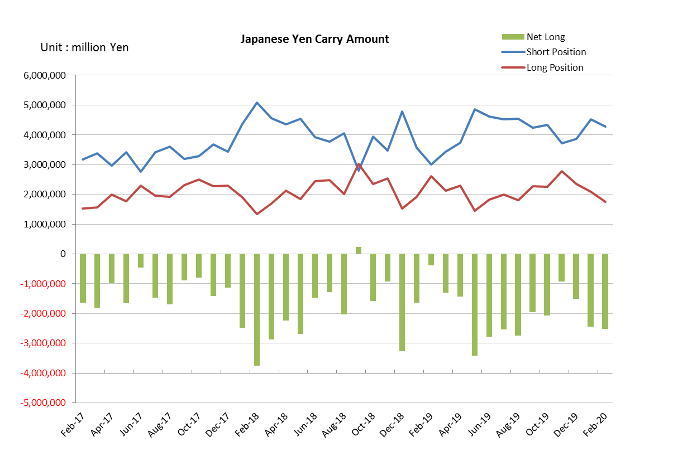

Monthly statistical report on Over-The-Counter Retail FX Margin Trading

：January , 2020
Publication date : 17 February. 2020
Number of Over-The-Counter Retail FX Margin Trading Operators as of 31 January. 2020 :53
Number of members reported :53
【Trading Volume】
(Unit: hundred million Yen, %)
 | Over-The-Counter | USDJPY, Cross Yen | On-Exchange*(for reference)
This month | 3,219,264 | 2,924,317 | 16,247
Previous month | 2,652,422 | 2,348,155 | 14,300
Change | 21.37% | 24.54% | 13.62%
*source : Monthly Trading Volume of Tokyo Financial exchange Inc.(The FFAJ converts the total number of contracts into the trading volume on the settlement prices of the end of the month)
【Open Positions】
(Unit: hundred million Yen)
 | Short | Long | Total
This month | 25,350 | 48,563 | 73,914
Previous month | 27,998 | 41,288 | 69,286
Change | -2,647 | 7,274 | 4,627

・USDJPY, Cross Yen Open Positions
(Unit: hundred million Yen)
 | ① Short | ② Long | Net long=②-①
This month | 45,254 | 20,813 | -24,440
Previous month | 38,556 | 23,525 | -15,030

（Reference：USDJPY Monthly Rate＊）
（Unit: Yen）
End of last Month*1 | Highest of the Month | Lowest of the Month | End of the Month*1 | Average*2
109.15 | 110.3 | 107.65 | 109.04 | 109.34
*source : BOJ's Main Time-series Statistics (Monthly)
*1) Spot Rate at 17:00 in JST, End of Month, Tokyo Market
*2) Average of Central Rate in the Month, Tokyo Market
○ Notes
The volume of this month was about 321 trillion yen (an increase of 21.4% from the previous month), the trading volume on a business day basis excluding weekends also increased.
The open positions balance at the end of the month increased since the end of the previous month,
short positions decreased, but long positions increased, totaling about 7.4 trillion yen.

～Tables and Historical Graphs～
