Over-The-Counter FX Margin Trading Report

(January 2019 ～ )

Monthly Report
January 2019
February 2019
March 2019
April 2019
May 2019
June2019
July2019
August 2019
September 2019
October 2019
November 2019
December 2019

The Financial Futures Association of Japan, Research Department

NBF Ogawamachi Building 1-3 , Kanda Ogawamachi ,
Chiyoda-ku , Tokyo 101-0052 Tel:(03)5280-0881 E-mail : ffaj@ffaj.or.jp

This publication has been prepared by the FFAJ and is provided for information purpose only. The monthly information contained in this publication has been obtained from FFAJ's members that is believed to be reliable, however the FFAJ does not represent or warrant that it is accurate or complete. In no event the FFAJ nor its employees have any liability for any consequential damages arising from any use of this publications or its contents. This publication does not constitute any investment advice.

Monthly statistical report on Over-The-Counter Retail FX Margin Trading

：December , 2019
Publication date : 20 January. 2020
Number of Over-The-Counter Retail FX Margin Trading Operators as of 31 December. 2019 :53
Number of members reported :53
【Trading Volume】
(Unit: hundred million Yen, %)
 | Over-The-Counter | USDJPY, Cross Yen | On-Exchange*(for reference)
This month | 2,652,422 | 2,348,155 | 14,300
Previous month | 2,384,486 | 2,148,288 | 11,807
Change | 11.24% | 9.30% | 21.11%
*source : Monthly Trading Volume of Tokyo Financial exchange Inc.(The FFAJ converts the total number of contracts into the trading volume on the settlement prices of the end of the month)
【Open Positions】
(Unit: hundred million Yen)
 | Short | Long | Total
This month | 27,998 | 41,288 | 69,286
Previous month | 32,117 | 40,325 | 72,443
Change | -4,119 | 962 | -3,156

・USDJPY, Cross Yen Open Positions
(Unit: hundred million Yen)
 | ① Short | ② Long | Net long=②-①
This month | 38,556 | 23,525 | -15,030
Previous month | 37,091 | 27,858 | -9,233

（Reference：USDJPY Monthly Rate＊）
（Unit: Yen）
End of last Month*1 | Highest of the Month | Lowest of the Month | End of the Month*1 | Average*2
109.5 | 109.73 | 108.43 | 109.15 | 109.18
*source : BOJ's Main Time-series Statistics (Monthly)
*1) Spot Rate at 17:00 in JST, End of Month, Tokyo Market
*2) Average of Central Rate in the Month, Tokyo Market
○ Notes
The volume of this month was about 265 trillion yen (a increase of 11.2% from the previous month), the trading volume on a business day basis excluding weekends also increased.
The open positions balance at the end of the month decreased since the end of the previous month,
short positions decreased, but long positions increased, totaling about 6.9 trillion yen.

～Tables and Historical Graphs～

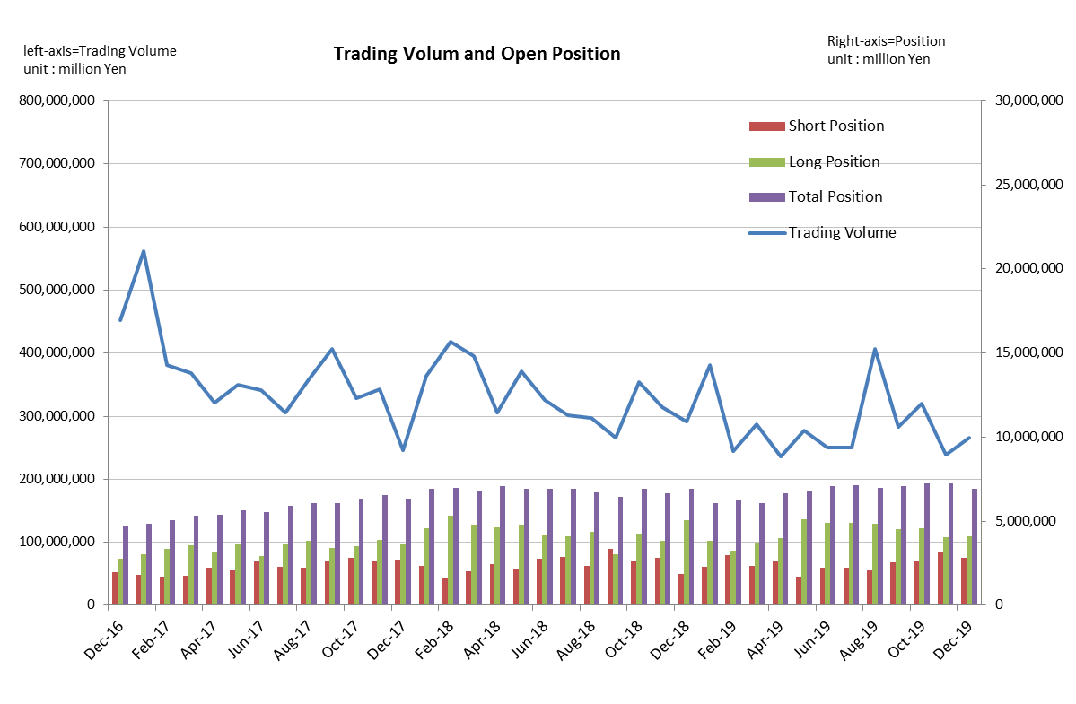
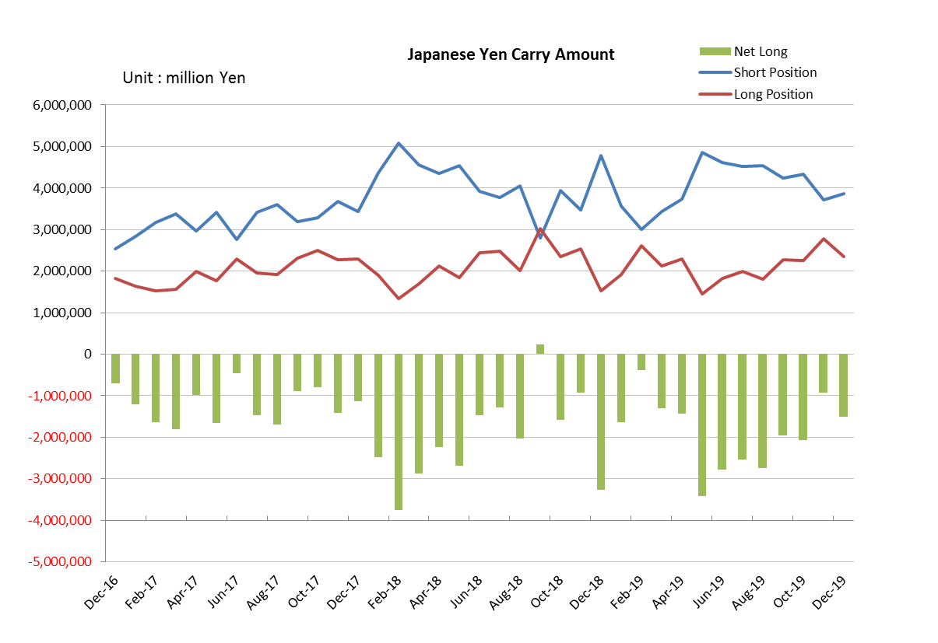

Monthly statistical report on Over-The-Counter Retail FX Margin Trading

：November , 2019
Publication date : 13 December. 2019
Number of Over-The-Counter Retail FX Margin Trading Operators as of 30 November. 2019 :53
Number of members reported :53
【Trading Volume】
(Unit: hundred million Yen, %)
 | Over-The-Counter | USDJPY, Cross Yen | On-Exchange*(for reference)
This month | 2,384,486 | 2,148,288 | 11,807
Previous month | 3,194,287 | 2,826,080 | 18,277
Change | -25.35% | -23.98% | -35.40%
*source : Monthly Trading Volume of Tokyo Financial exchange Inc.(The FFAJ converts the total number of contracts into the trading volume on the settlement prices of the end of the month)
【Open Positions】
(Unit: hundred million Yen)
 | Short | Long | Total
This month | 32,117 | 40,325 | 72,443
Previous month | 26,857 | 45,660 | 72,518
Change | 5,259 | -5,334 | -75

・USDJPY, Cross Yen Open Positions
(Unit: hundred million Yen)
 | ① Short | ② Long | Net long=②-①
This month | 37,091 | 27,858 | -9,233
Previous month | 43,248 | 22,584 | -20,664

（Reference：USDJPY Monthly Rate＊）
（Unit: Yen）
End of last Month*1 | Highest of the Month | Lowest of the Month | End of the Month*1 | Average*2
108.61 | 109.6 | 107.89 | 109.5 | 108.86
*source : BOJ's Main Time-series Statistics (Monthly)
*1) Spot Rate at 17:00 in JST, End of Month, Tokyo Market
*2) Average of Central Rate in the Month, Tokyo Market
○ Notes
The volume of this month was about 238 trillion yen (a decrease of 25.4% from the previous month), the trading volume on a business day basis excluding weekends also decreased.
The open positions balance at the end of the month decreased slightly since the end of the previous month,
short positions increased, but long positions decreased, totaling about 7.24 trillion yen.

～Tables and Historical Graphs～

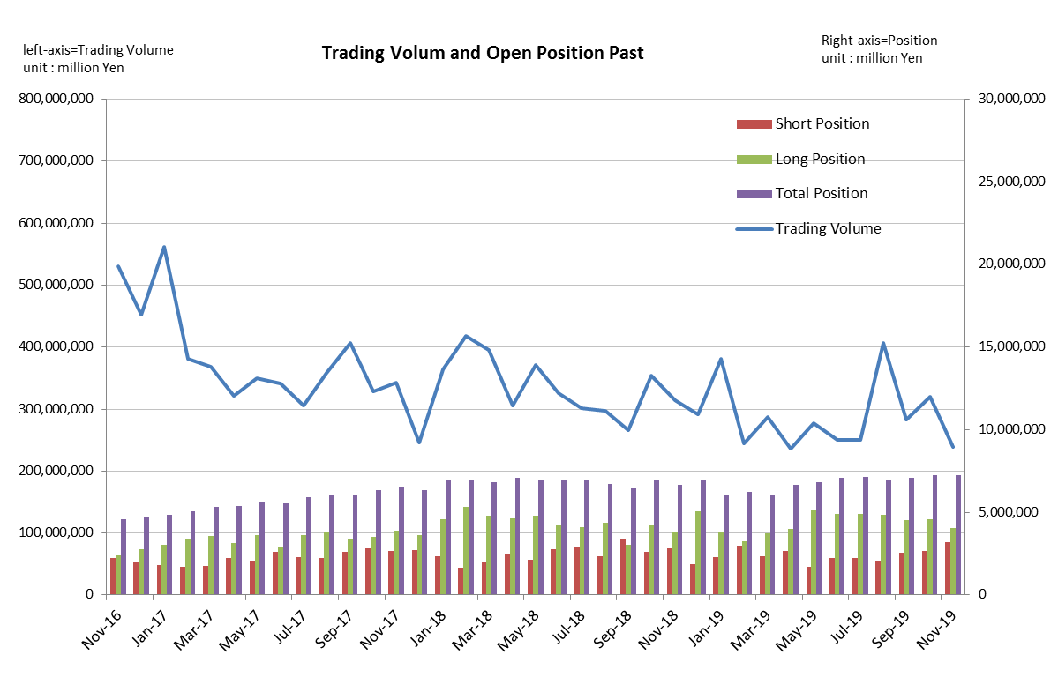
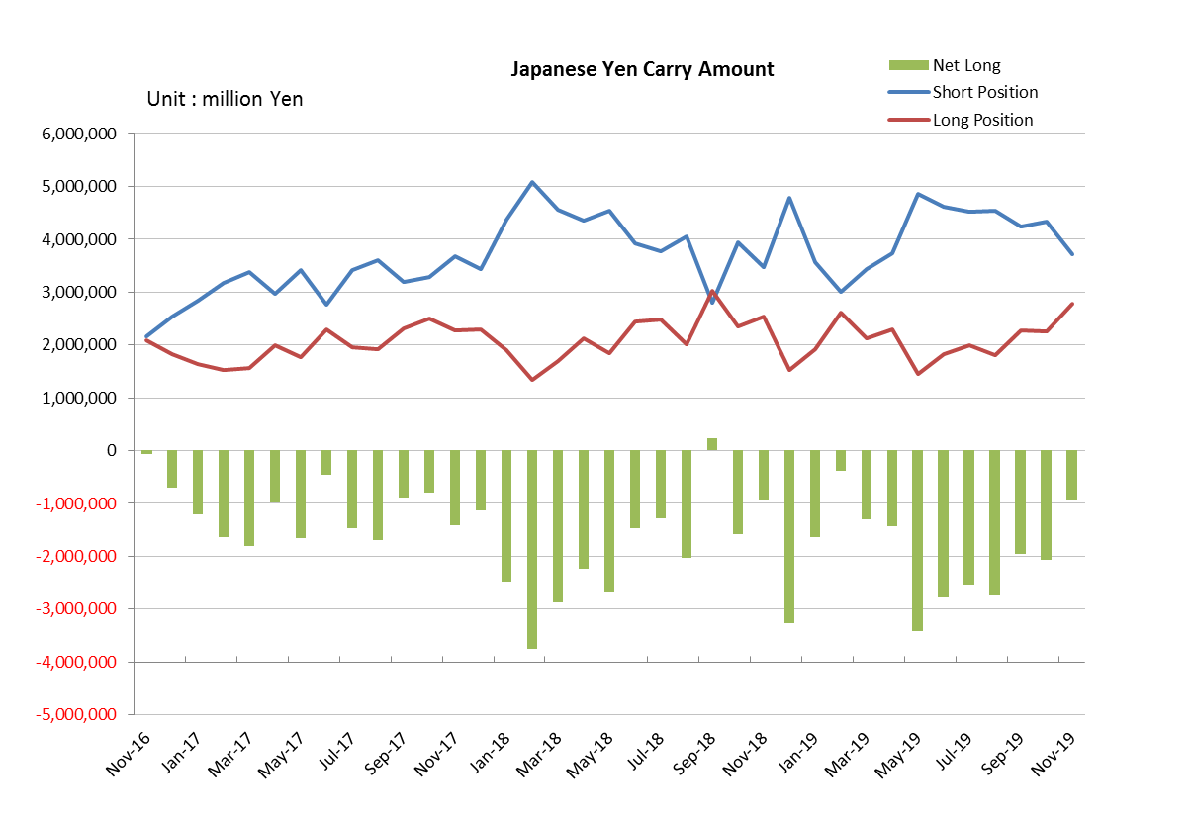

Monthly statistical report on Over-The-Counter Retail FX Margin Trading

：October , 2019
Publication date : 15 November. 2019
Number of Over-The-Counter Retail FX Margin Trading Operators as of 31 October. 2019 :53
Number of members reported :53
【Trading Volume】
(Unit: hundred million Yen, %)
 | Over-The-Counter | USDJPY, Cross Yen | On-Exchange*(for reference)
This month | 3,194,287 | 2,826,080 | 18,277
Previous month | 2,828,469 | 2,506,955 | 14,091
Change | 12.93% | 12.73% | 29.71%
*source : Monthly Trading Volume of Tokyo Financial exchange Inc.(The FFAJ converts the total number of contracts into the trading volume on the settlement prices of the end of the month)
【Open Positions】
(Unit: hundred million Yen)
 | Short | Long | Total
This month | 27,115 | 45,955 | 73,071
Previous month | 25,531 | 45,500 | 71,031
Change | 1,584 | 455 | 2,039

・USDJPY, Cross Yen Open Positions
(Unit: hundred million Yen)
 | ① Short | ② Long | Net long=②-①
This month | 43,533 | 22,827 | -20,705
Previous month | 42,332 | 22,807 | -19,525

（Reference：USDJPY Monthly Rate＊）
（Unit: Yen）
End of last Month*1 | Highest of the Month | Lowest of the Month | End of the Month*1 | Average*2
107.86 | 109.07 | 106.69 | 108.61 | 108.12
*source : BOJ's Main Time-series Statistics (Monthly)
*1) Spot Rate at 17:00 in JST, End of Month, Tokyo Market
*2) Average of Central Rate in the Month, Tokyo Market
○ Notes
The volume of this month was about 319 trillion yen (a increase of 12.9% from the previous month), the trading volume on a business day basis excluding weekends also increased.
The open positions balance at the end of the month was about 7.31 trillion yen in total, with both short positions and long positions increasing from the end of the previous month.

～Tables and Historical Graphs～

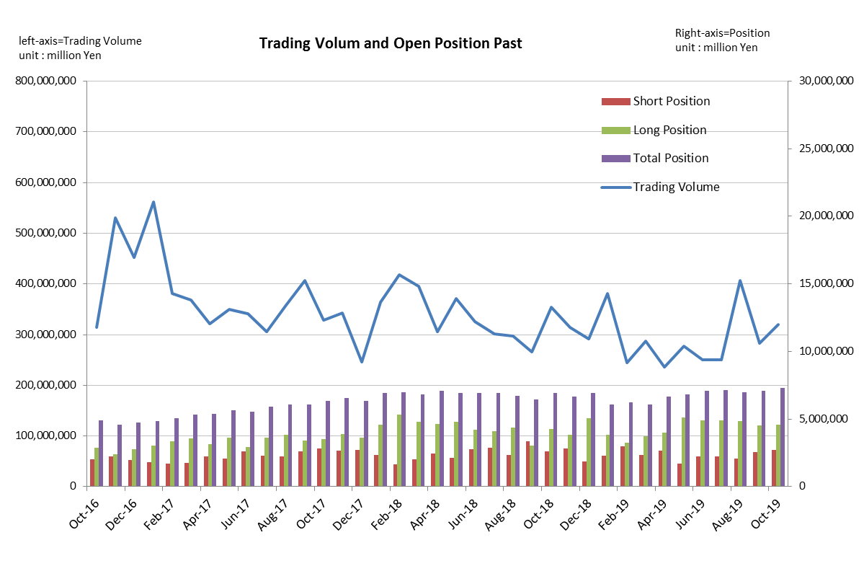
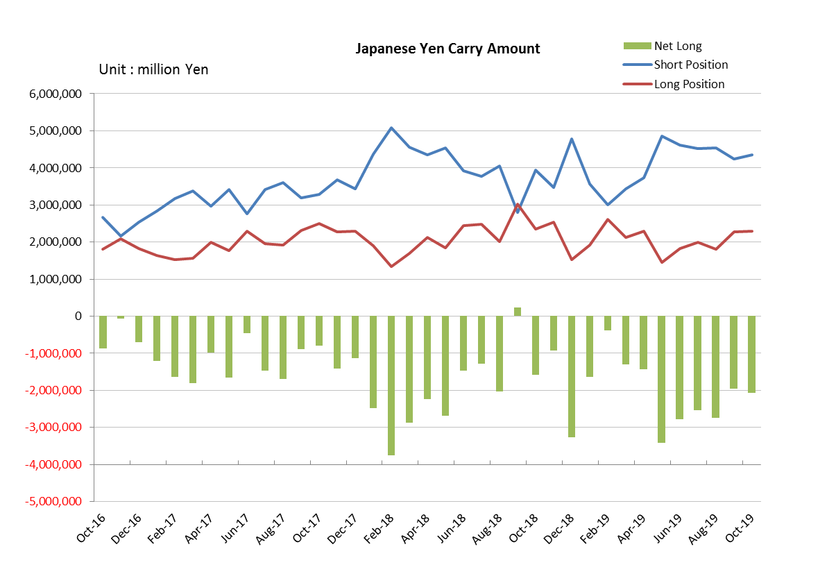

Monthly statistical report on Over-The-Counter Retail FX Margin Trading

：September , 2019
Publication date : 15 October. 2019
Number of Over-The-Counter Retail FX Margin Trading Operators as of 30 September. 2019 :53
Number of members reported :53
【Trading Volume】
(Unit: hundred million Yen, %)
 | Over-The-Counter | USDJPY, Cross Yen | On-Exchange*(for reference)
This month | 2,828,469 | 2,506,955 | 14,091
Previous month | 4,067,556 | 3,768,052 | 23,882
Change | -30.46% | -33.47% | -41.00%
*source : Monthly Trading Volume of Tokyo Financial exchange Inc.(The FFAJ converts the total number of contracts into the trading volume on the settlement prices of the end of the month)
【Open Positions】
(Unit: hundred million Yen)
 | Short | Long | Total
This month | 25,531 | 45,500 | 71,031
Previous month | 20,929 | 48,722 | 69,651
Change | 4,602 | -3,222 | 1,380

・USDJPY, Cross Yen Open Positions
(Unit: hundred million Yen)
 | ① Short | ② Long | Net long=②-①
This month | 42,332 | 22,807 | -19,525
Previous month | 45,465 | 18,089 | -27,376

（Reference：USDJPY Monthly Rate＊）
（Unit: Yen）
End of last Month*1 | Highest of the Month | Lowest of the Month | End of the Month*1 | Average*2
106.52 | 108.47 | 105.83 | 107.86 | 107.41
*source : BOJ's Main Time-series Statistics (Monthly)
*1) Spot Rate at 17:00 in JST, End of Month, Tokyo Market
*2) Average of Central Rate in the Month, Tokyo Market
○ Notes
The volume of this month was about 283 trillion yen (a decrease of 30.5% from the previous month), the trading volume on a business day basis excluding weekends also decreased.
The open positions balance at the end of the month iｎcreased since the end of the previous month,
short positions increased, but long positions decreased, totaling about 7.10 trillion yen.

～Tables and Historical Graphs～
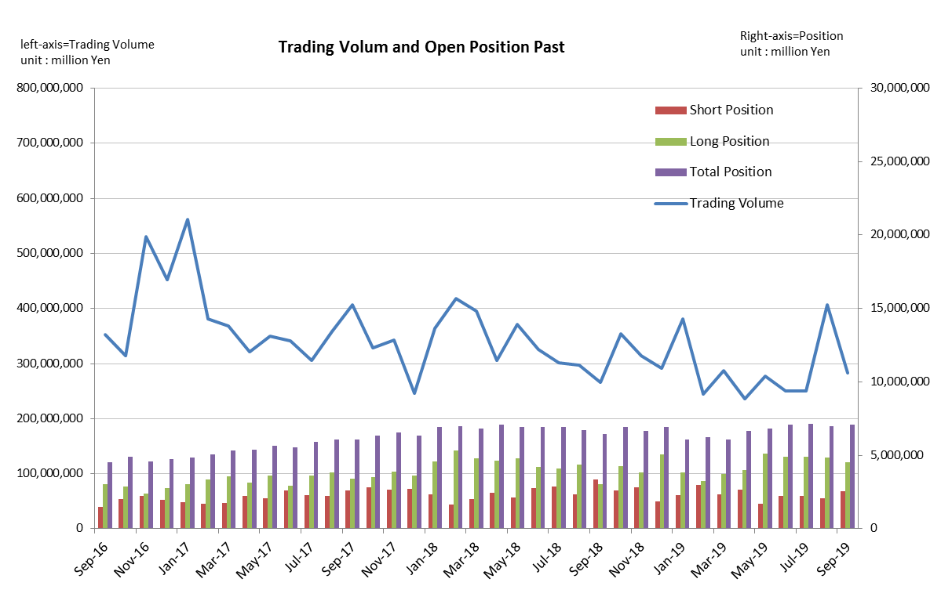
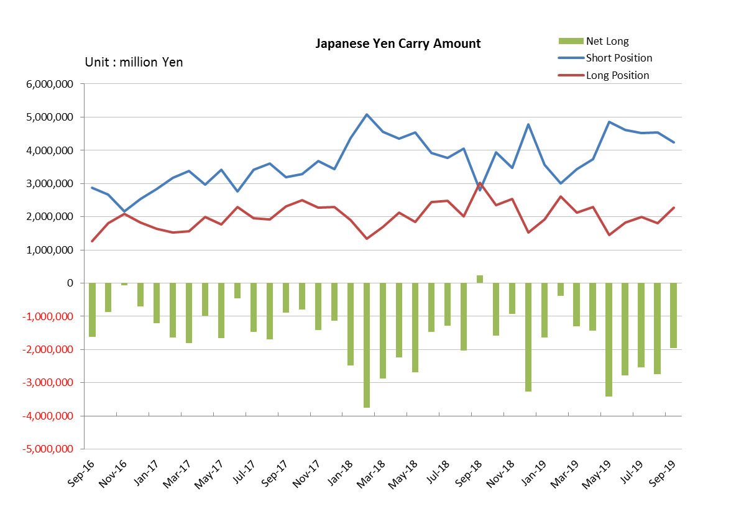

Monthly statistical report on Over-The-Counter Retail FX Margin Trading

：August , 2019
Publication date : 13 September. 2019
Number of Over-The-Counter Retail FX Margin Trading Operators as of 31 August. 2019 :53
Number of members reported :53
【Trading Volume】
(Unit: hundred million Yen, %)
 | Over-The-Counter | USDJPY, Cross Yen | On-Exchange*(for reference)
This month | 4,067,556 | 3,768,052 | 23,882
Previous month | 2,504,211 | 2,207,200 | 16,131
Change | 62.43% | 70.72% | 48.05%
*source : Monthly Trading Volume of Tokyo Financial exchange Inc.(The FFAJ converts the total number of contracts into the trading volume on the settlement prices of the end of the month)
【Open Positions】
(Unit: hundred million Yen)
 | Short | Long | Total
This month | 20,929 | 48,722 | 69,651
Previous month | 22,587 | 48,964 | 71,551
Change | -1,658 | -242 | -1,900

・USDJPY, Cross Yen Open Positions
(Unit: hundred million Yen)
 | ① Short | ② Long | Net long=②-①
This month | 45,465 | 18,089 | -27,376
Previous month | 45,246 | 19,905 | -25,341

（Reference：USDJPY Monthly Rate＊）
（Unit: Yen）
End of last Month*1 | Highest of the Month | Lowest of the Month | End of the Month*1 | Average*2
108.56 | 109.32 | 104.46 | 106.52 | 106.27
*source : BOJ's Main Time-series Statistics (Monthly)
*1) Spot Rate at 17:00 in JST, End of Month, Tokyo Market
*2) Average of Central Rate in the Month, Tokyo Market
○ Notes
The volume of this month was about 407 trillion yen (an increase of 62.4% from the previous month), the trading volume on a business day basis excluding weekends also increased.
On the other hand, the open positions balance at the end of the month was about 7.16 trillion yen in total, with both short positions and long positions decreasing from the end of the previous month.

～Tables and Historical Graphs～
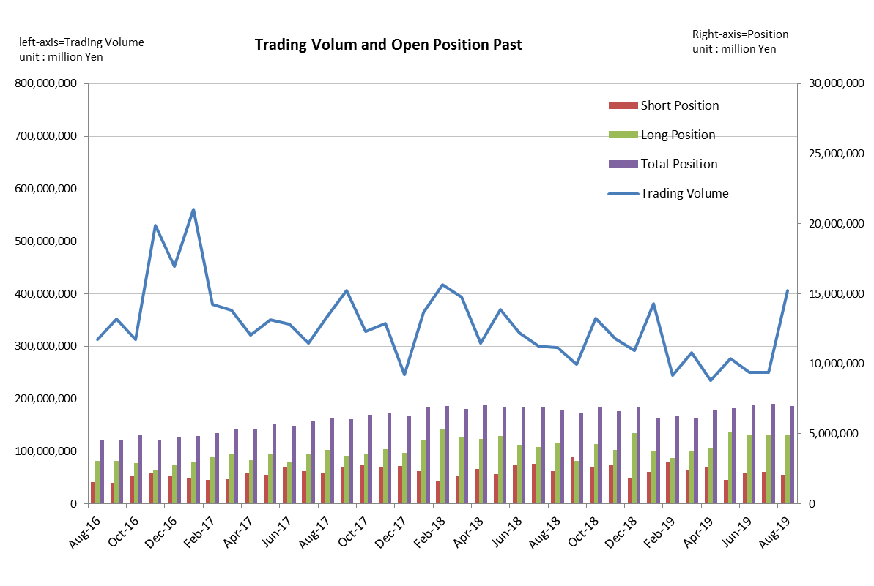
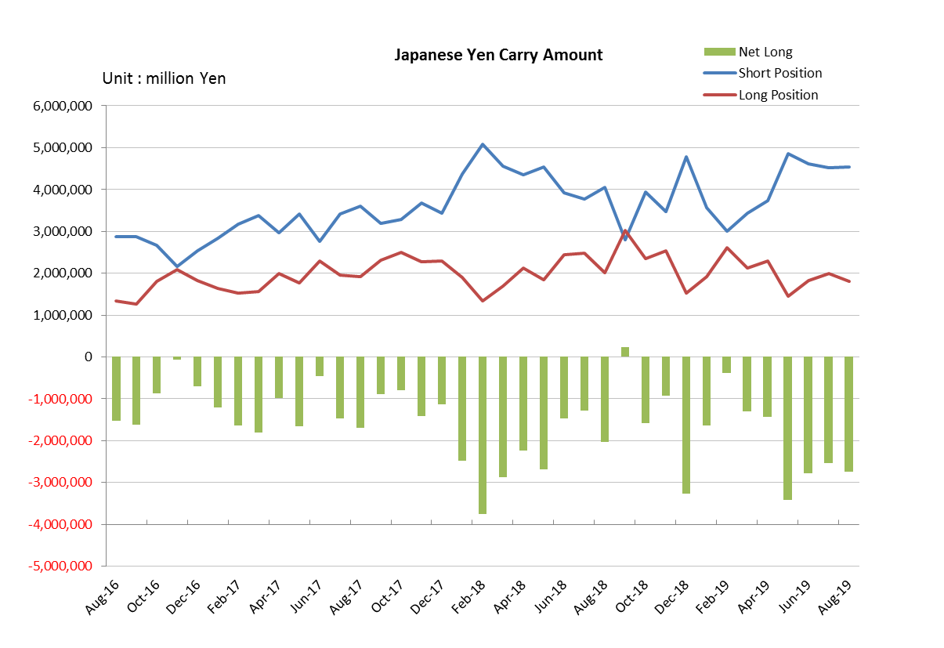

Monthly statistical report on Over-The-Counter Retail FX Margin Trading

：July , 2019
Publication date : 15 August. 2019
Number of Over-The-Counter Retail FX Margin Trading Operators as of 31 July. 2019 :54
Number of members reported :54
【Trading Volume】
(Unit: hundred million Yen, %)
 | Over-The-Counter | USDJPY, Cross Yen | On-Exchange*(for reference)
This month | 2,504,001 | 2,206,991 | 16,131
Previous month | 2,497,883 | 2,216,417 | 13,406
Change | 0.24% | -0.43% | 20.33%
*source : Monthly Trading Volume of Tokyo Financial exchange Inc.(The FFAJ converts the total number of contracts into the trading volume on the settlement prices of the end of the month)
【Open Positions】
(Unit: hundred million Yen)
 | Short | Long | Total
This month | 22,587 | 48,964 | 71,551
Previous month | 22,198 | 48,838 | 71,036
Change | 389 | 125 | 515

・USDJPY, Cross Yen Open Positions
(Unit: hundred million Yen)
 | ① Short | ② Long | Net long=②-①
This month | 45,246 | 19,905 | -25,341
Previous month | 46,073 | 18,246 | -27,827

（Reference：USDJPY Monthly Rate＊）
（Unit: Yen）
End of last Month*1 | Highest of the Month | Lowest of the Month | End of the Month*1 | Average*2
107.64 | 108.99 | 107.22 | 108.56 | 108.22
*source : BOJ's Main Time-series Statistics (Monthly)
*1) Spot Rate at 17:00 in JST, End of Month, Tokyo Market
*2) Average of Central Rate in the Month, Tokyo Market
○ Notes
The volume of this month was about 250 trillion yen (an increase of 0.2% from the previous month), but, the trading volume on a business day basis excluding weekends decreased.
On the other hand, the open positions balance at the end of the month was about 7.16 trillion yen in total, with both short positions and long positions increasing from the end of the previous month.

～Tables and Historical Graphs～
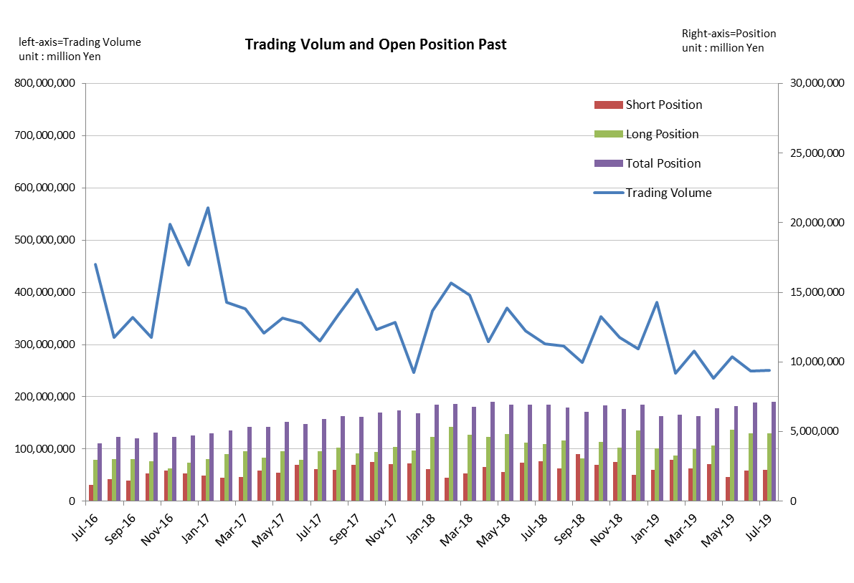
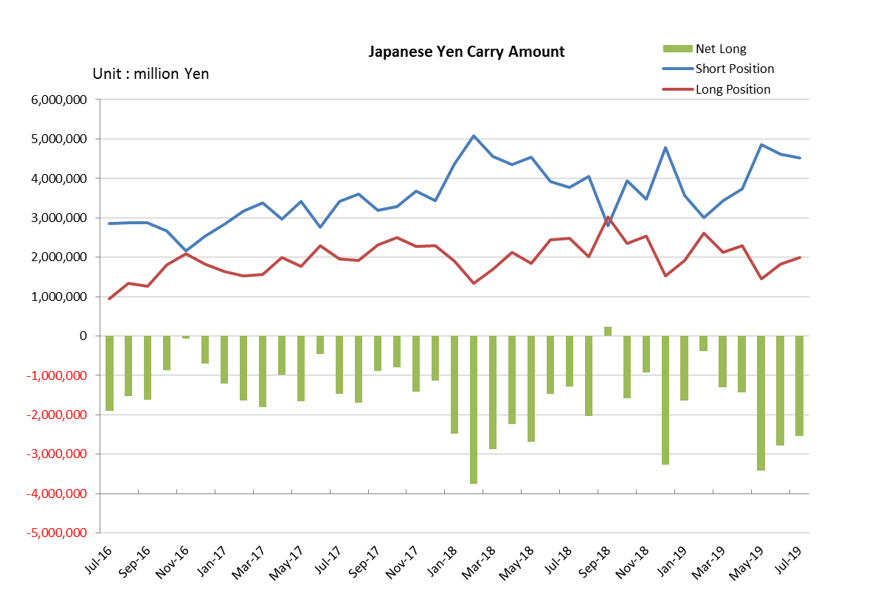

Monthly statistical report on Over-The-Counter Retail FX Margin Trading

：June , 2019
Publication date : 12 July. 2019
Number of Over-The-Counter Retail FX Margin Trading Operators as of 30 June. 2019 :54
Number of members reported :54
【Trading Volume】
(Unit: hundred million Yen, %)
 | Over-The-Counter | USDJPY, Cross Yen | On-Exchange*(for reference)
This month | 2,497,899 | 2,216,433 | 13,406
Previous month | 2,770,599 | 2,495,544 | 17,456
Change | -9.84% | -11.18% | -23.20%
*source : Monthly Trading Volume of Tokyo Financial exchange Inc.(The FFAJ converts the total number of contracts into the trading volume on the settlement prices of the end of the month)
【Open Positions】
(Unit: hundred million Yen)
 | Short | Long | Total
This month | 22,197 | 48,835 | 71,033
Previous month | 17,238 | 51,191 | 68,429
Change | 4,959 | -2,355 | 2,604

・USDJPY, Cross Yen Open Positions
(Unit: hundred million Yen)
 | ① Short | ② Long | Net long=②-①
This month | 46,072 | 18,246 | -27,826
Previous month | 48,557 | 14,430 | -34,127

（Reference：USDJPY Monthly Rate＊）
（Unit: Yen）
End of last Month*1 | Highest of the Month | Lowest of the Month | End of the Month*1 | Average*2
108.78 | 108.7 | 106.78 | 107.64 | 108.06
*source : BOJ's Main Time-series Statistics (Monthly)
*1) Spot Rate at 17:00 in JST, End of Month, Tokyo Market
*2) Average of Central Rate in the Month, Tokyo Market
○ Notes
The volume of this month was about 250 trillion yen (a decrease of 9.8% from the previous month), but, the trading volume on a business day basis excluding weekends increased.
The open positions balance at the end of the month iｎcreased since the end of the previous month,
short positions increased, but long positions decreased, totaling about 7.10 trillion yen.

～Tables and Historical Graphs～

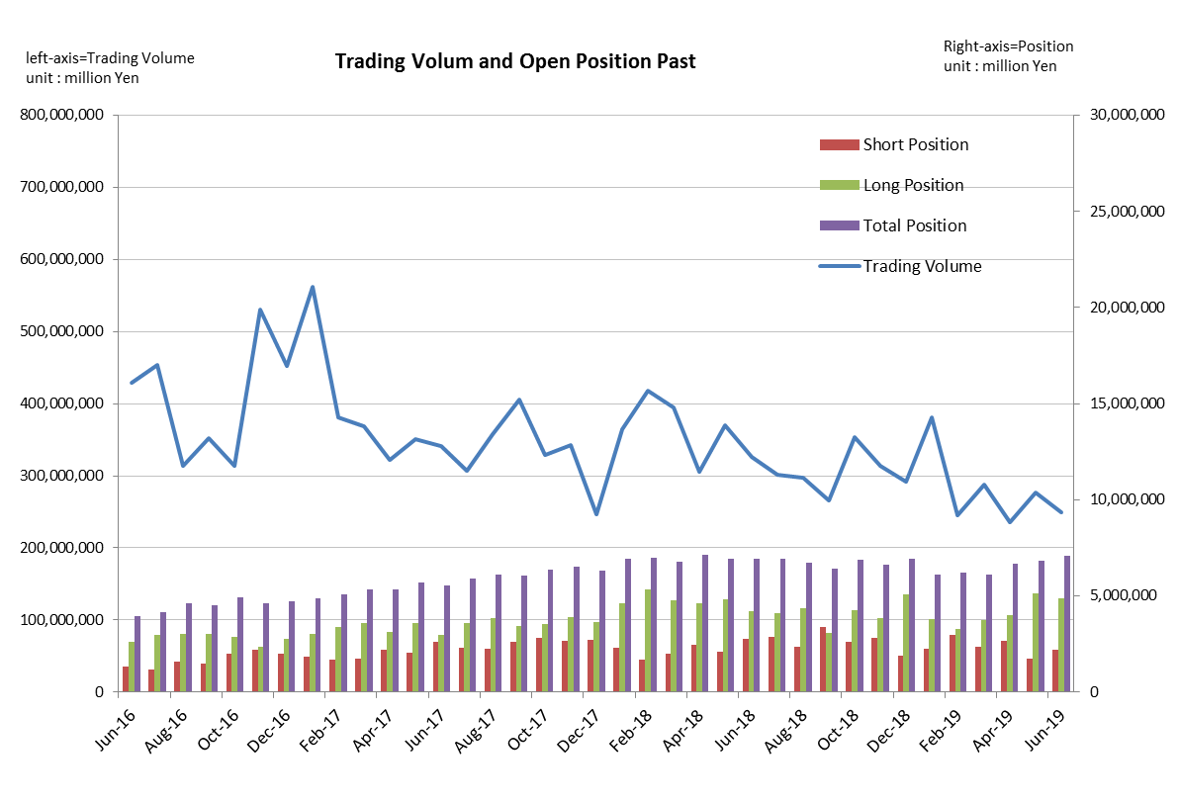
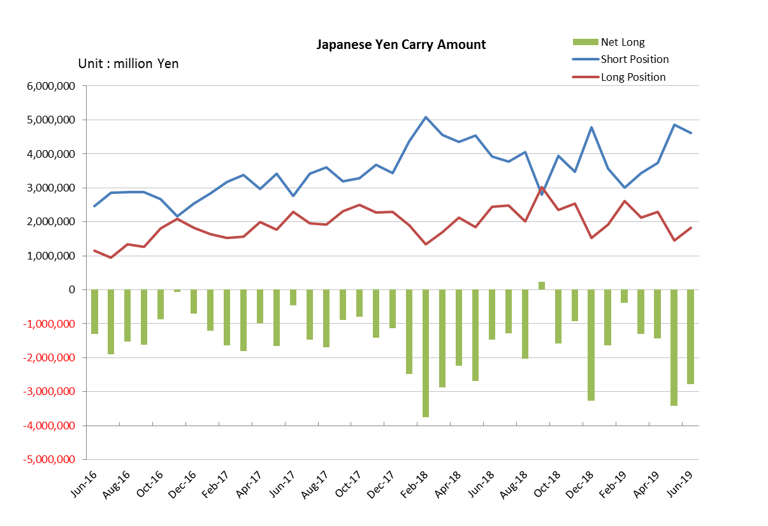

Monthly statistical report on Over-The-Counter Retail FX Margin Trading

：May , 2019
Publication date : 14 June. 2019
Number of Over-The-Counter Retail FX Margin Trading Operators as of 31 May. 2019 :54
Number of members reported :54
【Trading Volume】
(Unit: hundred million Yen, %)
 | Over-The-Counter | USDJPY, Cross Yen | On-Exchange*(for reference)
This month | 2,770,599 | 2,495,544 | 17,456
Previous month | 2,354,516 | 2,034,394 | 14,534
Change | 17.67% | 22.67% | 20.10%
*source : Monthly Trading Volume of Tokyo Financial exchange Inc.(The FFAJ converts the total number of contracts into the trading volume on the settlement prices of the end of the month)
【Open Positions】
(Unit: hundred million Yen)
 | Short | Long | Total
This month | 17,238 | 51,191 | 68,429
Previous month | 26,578 | 39,986 | 66,564
Change | -9,340 | 11,204 | 1,864

・USDJPY, Cross Yen Open Positions
(Unit: hundred million Yen)
 | ① Short | ② Long | Net long=②-①
This month | 48,557 | 14,430 | -34,127
Previous month | 37,275 | 22,965 | -14,310

（Reference：USDJPY Monthly Rate＊）
（Unit: Yen）
End of last Month*1 | Highest of the Month | Lowest of the Month | End of the Month*1 | Average*2
111.68 | 110.85 | 108.75 | 108.78 | 109.83
*source : BOJ's Main Time-series Statistics (Monthly)
*1) Spot Rate at 17:00 in JST, End of Month, Tokyo Market
*2) Average of Central Rate in the Month, Tokyo Market
○ Notes
The volume of this month was about 277 trillion yen (an increase of 17.7% from the previous month), the trading volume on a business day basis excluding weekends also increased.
The open positions balance at the end of the month iｎcreased since the end of the previous month,
short positions decreased, but long positions increased, totaling about 6.84 trillion yen.

～Tables and Historical Graphs～

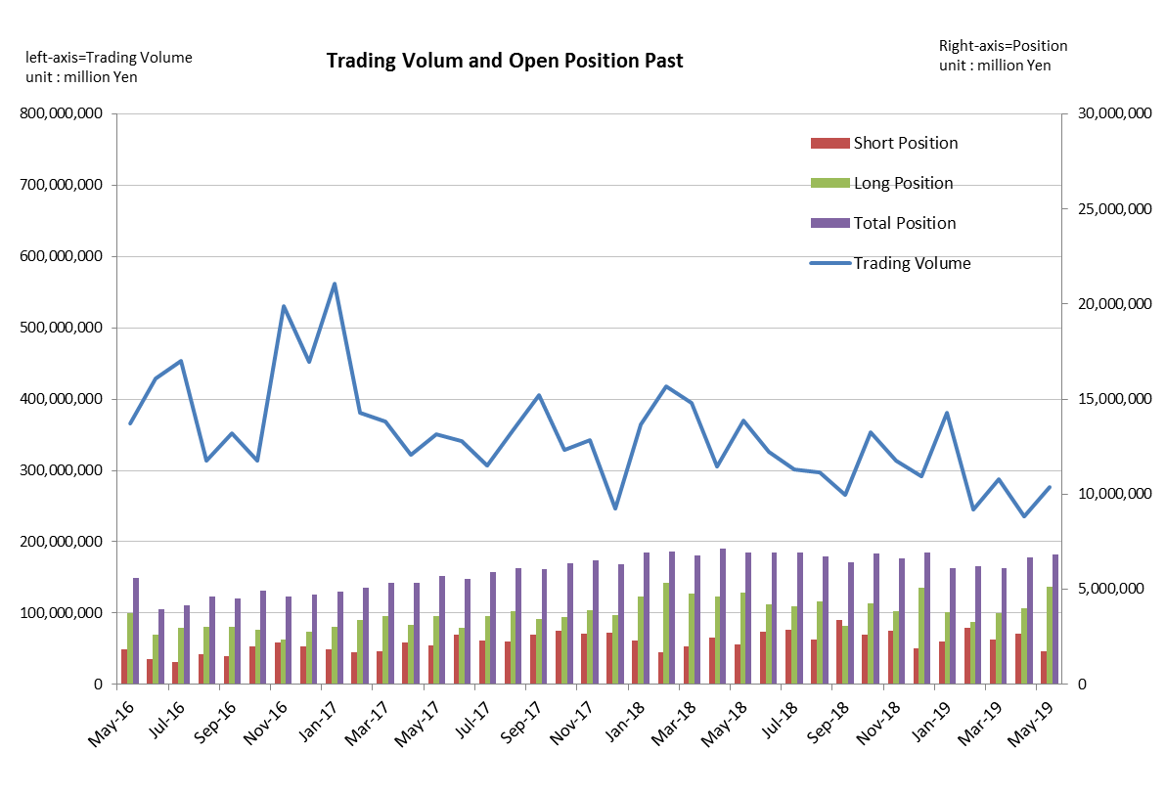
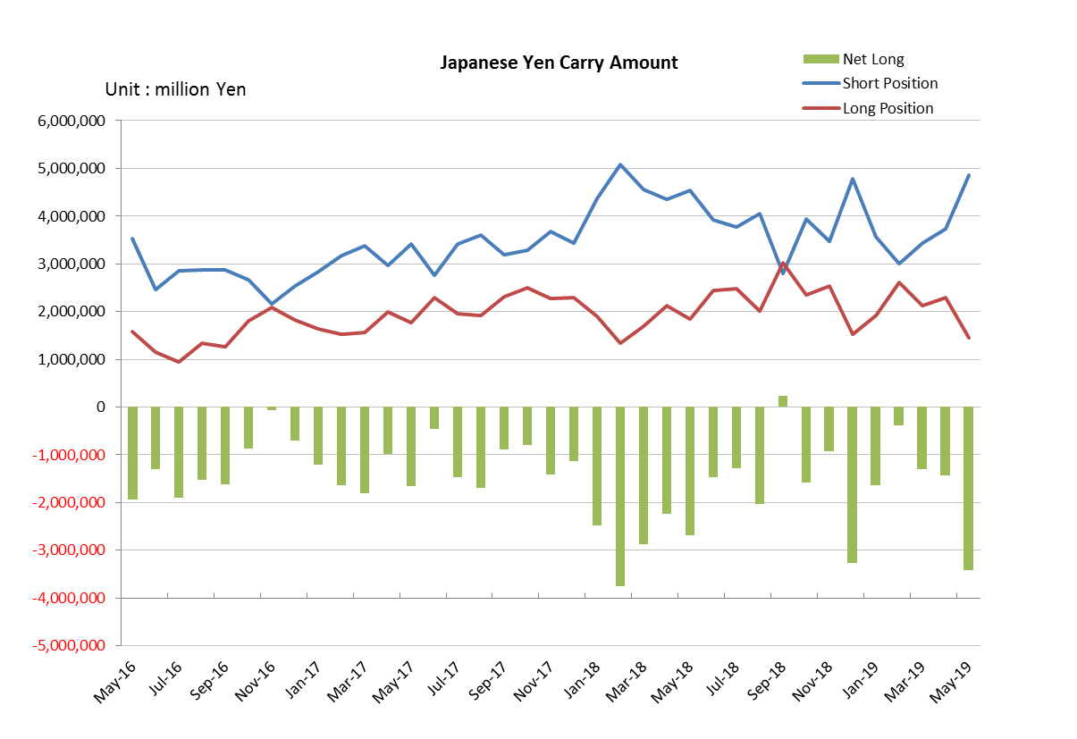

Monthly statistical report on Over-The-Counter Retail FX Margin Trading

：April , 2019
Publication date : 20 May. 2019
Number of Over-The-Counter Retail FX Margin Trading Operators as of 30 April. 2019 :54
Number of members reported :54
【Trading Volume】
(Unit: hundred million Yen, %)
 | Over-The-Counter | USDJPY, Cross Yen | On-Exchange*(for reference)
This month | 2,354,516 | 2,034,394 | 14,534
Previous month | 2,878,570 | 2,493,896 | 19,812
Change | -18.21% | -18.43% | -26.64%
*source : Monthly Trading Volume of Tokyo Financial exchange Inc.(The FFAJ converts the total number of contracts into the trading volume on the settlement prices of the end of the month)
【Open Positions】
(Unit: hundred million Yen)
 | Short | Long | Total
This month | 26,578 | 39,986 | 66,564
Previous month | 23,601 | 37,357 | 60,959
Change | 2,976 | 2,629 | 5,605

・USDJPY, Cross Yen Open Positions
(Unit: hundred million Yen)
 | ① Short | ② Long | Net long=②-①
This month | 37,275 | 22,965 | -14,310
Previous month | 34,432 | 21,320 | -13,111

（Reference：USDJPY Monthly Rate＊）
（Unit: Yen）
End of last Month*1 | Highest of the Month | Lowest of the Month | End of the Month*1 | Average*2
110.75 | 112.24 | 110.88 | 111.68 | 111.66
*source : BOJ's Main Time-series Statistics (Monthly)
*1) Spot Rate at 17:00 in JST, End of Month, Tokyo Market
*2) Average of Central Rate in the Month, Tokyo Market
○ Notes
The volume of this month was about 235 trillion yen (a decrease of 18.2% from the previous month), the trading volume on a business day basis excluding weekends also decreased.
On the other hand, the open positions balance at the end of the month was about 6.66 trillion yen in total, with both short positions and long positions increasing from the end of the previous month.

～Tables and Historical Graphs～

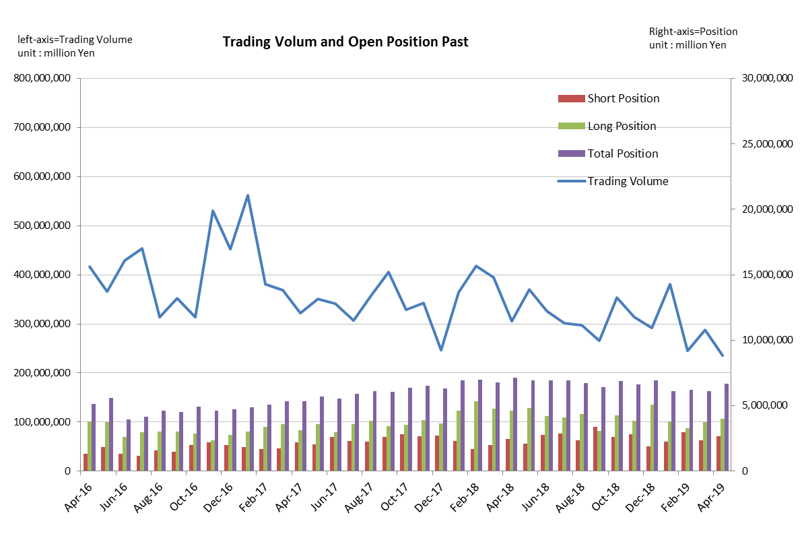
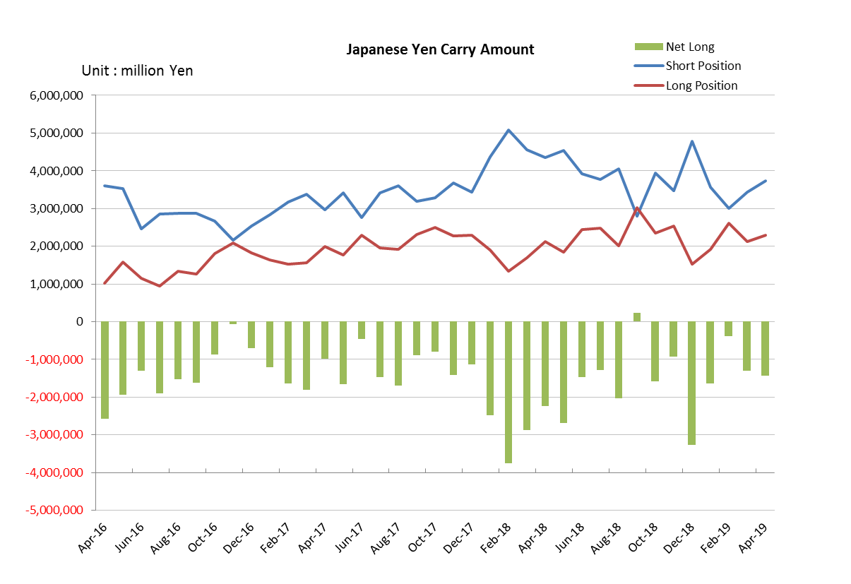

Monthly statistical report on Over-The-Counter Retail FX Margin Trading

：March , 2019
Publication date : 12 April. 2019
Number of Over-The-Counter Retail FX Margin Trading Operators as of 31 March. 2019 :54
Number of members reported :54
【Trading Volume】
(Unit: hundred million Yen, %)
 | Over-The-Counter | USDJPY, Cross Yen | On-Exchange*(for reference)
This month | 2,878,570 | 2,493,896 | 19,812
Previous month | 2,452,297 | 2,127,477 | 17,550
Change | 17.38% | 17.22% | 12.89%
*source : Monthly Trading Volume of Tokyo Financial exchange Inc.(The FFAJ converts the total number of contracts into the trading volume on the settlement prices of the end of the month)
【Open Positions】
(Unit: hundred million Yen)
 | Short | Long | Total
This month | 23,601 | 37,357 | 60,959
Previous month | 29,699 | 32,603 | 62,303
Change | -6,097 | 4,753 | -1,343

・USDJPY, Cross Yen Open Positions
(Unit: hundred million Yen)
 | ① Short | ② Long | Net long=②-①
This month | 34,432 | 21,320 | -13,111
Previous month | 29,942 | 26,085 | -3,856

（Reference：USDJPY Monthly Rate＊）
（Unit: Yen）
End of last Month*1 | Highest of the Month | Lowest of the Month | End of the Month*1 | Average*2
110.76 | 112.01 | 109.7 | 110.75 | 111.21
*source : BOJ's Main Time-series Statistics (Monthly)
*1) Spot Rate at 17:00 in JST, End of Month, Tokyo Market
*2) Average of Central Rate in the Month, Tokyo Market
○ Notes
The volume of this month was about 288 trillion yen (an increase of 17.4% from the previous month), the trading volume on a business day basis excluding weekends also increased.
The open positions balance at the end of the month decreased since the end of the previous month,
short positions decreased, but long positions increased, totaling about 6.10 trillion yen.

～Tables and Historical Graphs～

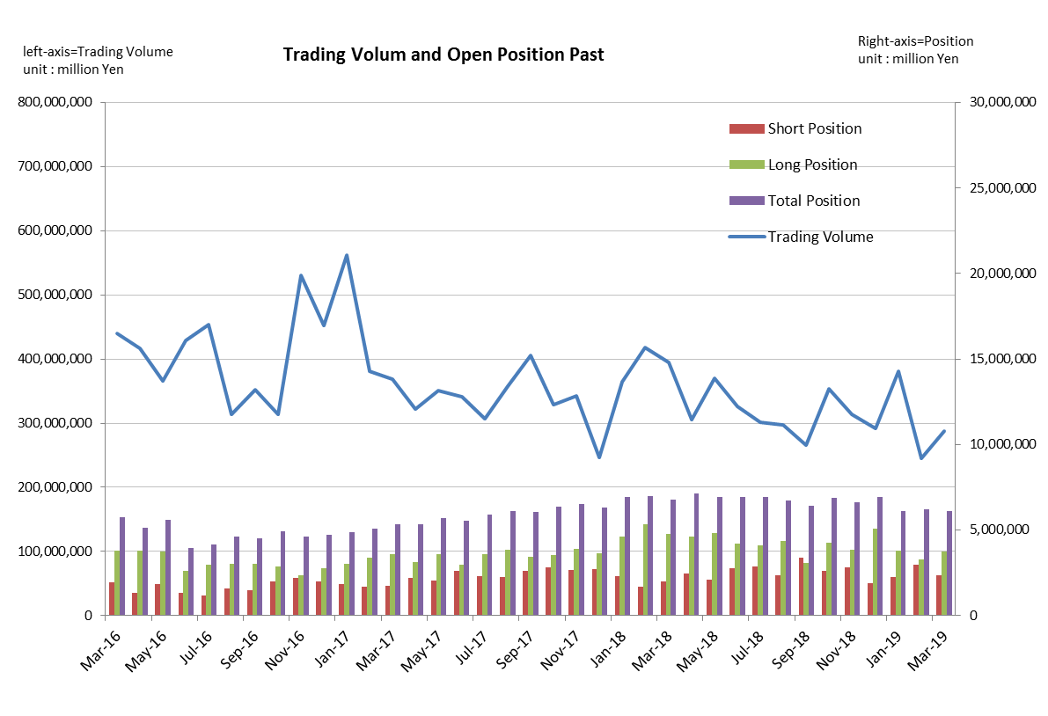
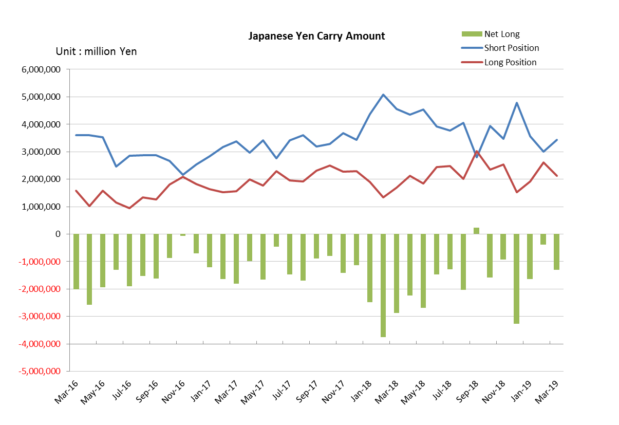

Monthly statistical report on Over-The-Counter Retail FX Margin Trading

：February , 2019
Publication date : 14 March. 2019
Number of Over-The-Counter Retail FX Margin Trading Operators as of 28 February. 2019 :54
Number of members reported :54
【Trading Volume】
(Unit: hundred million Yen, %)
 | Over-The-Counter | USDJPY, Cross Yen | On-Exchange*(for reference)
This month | 2,452,328 | 2,127,508 | 17,550
Previous month | 3,811,087 | 3,427,113 | 24,210
Change | -35.65% | -37.92% | -27.51%
*source : Monthly Trading Volume of Tokyo Financial exchange Inc.(The FFAJ converts the total number of contracts into the trading volume on the settlement prices of the end of the month)
【Open Positions】
(Unit: hundred million Yen)
 | Short | Long | Total
This month | 29,699 | 32,603 | 62,303
Previous month | 22,702 | 38,182 | 60,885
Change | 6,996 | -5,578 | 1,417

・USDJPY, Cross Yen Open Positions
(Unit: hundred million Yen)
 | ① Short | ② Long | Net long=②-①
This month | 29,942 | 26,085 | -3,856
Previous month | 35,694 | 19,206 | -16,487

（Reference：USDJPY Monthly Rate＊）
（Unit: Yen）
End of last Month*1 | Highest of the Month | Lowest of the Month | End of the Month*1 | Average*2
108.73 | 111.13 | 108.73 | 110.76 | 110.36
*source : BOJ's Main Time-series Statistics (Monthly)
*1) Spot Rate at 17:00 in JST, End of Month, Tokyo Market
*2) Average of Central Rate in the Month, Tokyo Market
○ Notes
The volume of this month was about 245 trillion yen (a decrease of 35.7% from the previous month), the trading volume on a business day basis excluding weekends also decreased.
The open positions balance at the end of the month increased since the end of the previous month,
short positions increased, but long positions decreased, totaling about 6.23 trillion yen.

～Tables and Historical Graphs～
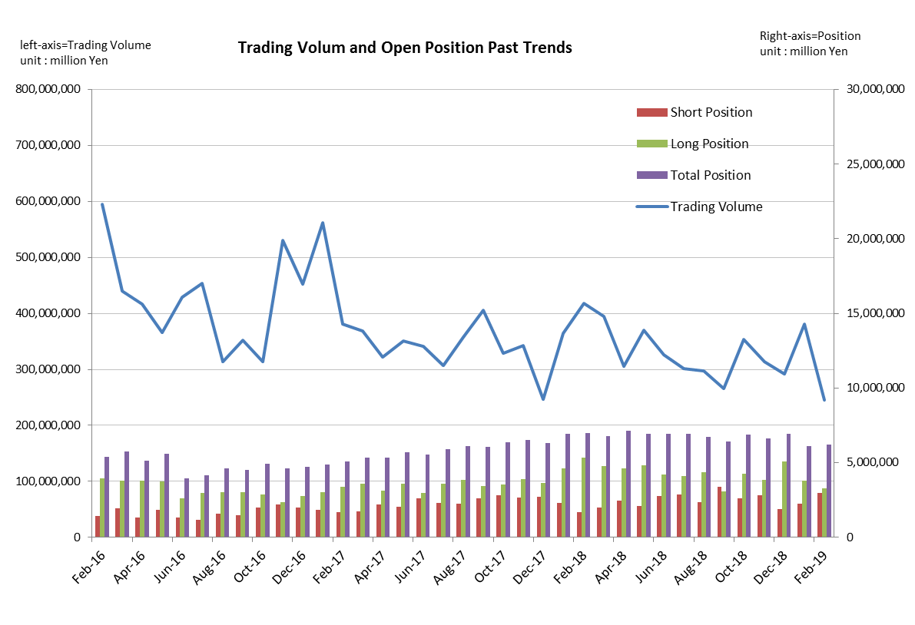
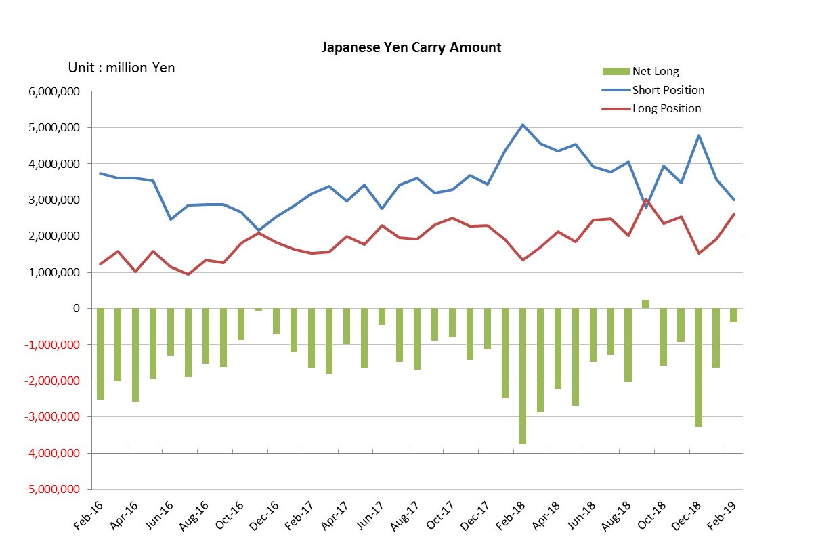

Monthly statistical report on Over-The-Counter Retail FX Margin Trading

：January , 2019
Publication date : 15 February. 2019
Number of Over-The-Counter Retail FX Margin Trading Operators as of 31 January. 2019 :54
Number of members reported :54
【Trading Volume】
(Unit: hundred million Yen, %)
 | Over-The-Counter | USDJPY, Cross Yen | On-Exchange*(for reference)
This month | 3,811,087 | 3,427,113 | 24,210
Previous month | 2,918,181 | 2,530,954 | 20,641
Change | 30.60% | 35.41% | 17.29%
*source : Monthly Trading Volume of Tokyo Financial exchange Inc.(The FFAJ converts the total number of contracts into the trading volume on the settlement prices of the end of the month)
【Open Positions】
(Unit: hundred million Yen)
 | Short | Long | Total
This month | 22,702 | 38,182 | 60,885
Previous month | 18,695 | 50,655 | 69,351
Change | 4,006 | -12,472 | -8,466

・USDJPY, Cross Yen Open Positions
(Unit: hundred million Yen)
 | ① Short | ② Long | Net long=②-①
This month | 35,694 | 19,206 | -16,487
Previous month | 47,852 | 15,224 | -32,628

（Reference：USDJPY Monthly Rate＊）
（Unit: Yen）
End of last Month*1 | Highest of the Month | Lowest of the Month | End of the Month*1 | Average*2
110.4 | 109.87 | 107.52 | 108.73 | 108.95
*source : BOJ's Main Time-series Statistics (Monthly)
*1) Spot Rate at 17:00 in JST, End of Month, Tokyo Market
*2) Average of Central Rate in the Month, Tokyo Market
○ Notes
The volume of this month was about 381 trillion yen (an increase of 30.6% from the previous month), the trading volume on a business day basis excluding weekends also increased.
The open positions balance at the end of the month decreased since the end of the previous month,
short positions increased, but long positions decreased, totaling about 6.09 trillion yen.

～Tables and Historical Graphs～
