Over-The-Counter FX Margin Trading Report

(January 2018 ～ )

Monthly Report
January 2018
February 2018
March 2018
April 2018
May 2018
June 2018
July 2018
August 2018
September 2018
October 2018
November 2018
December 2018

The Financial Futures Association of Japan, Research Department

NBF Ogawamachi Building 1-3 , Kanda Ogawamachi ,
Chiyoda-ku , Tokyo 101-0052 Tel:(03)5280-0881 E-mail : ffaj@ffaj.or.jp

This publication has been prepared by the FFAJ and is provided for information purpose only. The monthly information contained in this publication has been obtained from FFAJ's members that is believed to be reliable, however the FFAJ does not represent or warrant that it is accurate or complete. In no event the FFAJ nor its employees have any liability for any consequential damages arising from any use of this publications or its contents. This publication does not constitute any investment advice.

Monthly statistical report on Over-The-Counter Retail FX Margin Trading

：December , 2018
Publication date : 18 January. 2019
Number of Over-The-Counter Retail FX Margin Trading Operators as of 31 December. 2018 :53
Number of members reported :53
【Trading Volume】
(Unit: hundred million Yen, %)
 | Over-The-Counter | USDJPY, Cross Yen | On-Exchange*(for reference)
This month | 2,918,181 | 2,530,954 | 20,641
Previous month | 3,140,282 | 2,687,149 | 22,284
Change | -7.07% | -5.81% | -7.37%
*source : Monthly Trading Volume of Tokyo Financial exchange Inc.(The FFAJ converts the total number of contracts into the trading volume on the settlement prices of the end of the month)
【Open Positions】
(Unit: hundred million Yen)
 | Short | Long | Total
This month | 18,695 | 50,655 | 69,351
Previous month | 28,182 | 38,267 | 66,450
Change | -9,486 | 12,387 | 2,901

・USDJPY, Cross Yen Open Positions
(Unit: hundred million Yen)
 | ① Short | ② Long | Net long=②-①
This month | 47,852 | 15,224 | -32,628
Previous month | 34,727 | 25,353 | -9,374

（Reference：USDJPY Monthly Rate＊）
（Unit: Yen）
End of last Month*1 | Highest of the Month | Lowest of the Month | End of the Month*1 | Average*2
113.47 | 113.82 | 110 | 110.4 | 112.45
*source : BOJ's Main Time-series Statistics (Monthly)
*1) Spot Rate at 17:00 in JST, End of Month, Tokyo Market
*2) Average of Central Rate in the Month, Tokyo Market
○ Notes
The volume of this month was about 292 trillion yen (a decrease of 7.1% from the previous month), the trading volume on a business day basis excluding weekends decreased.
The open positions balance at the end of the month increased since the end of the previous month,
short positions decreased, but long positions increased, totaling about 6.93 trillion yen.

～Tables and Historical Graphs～
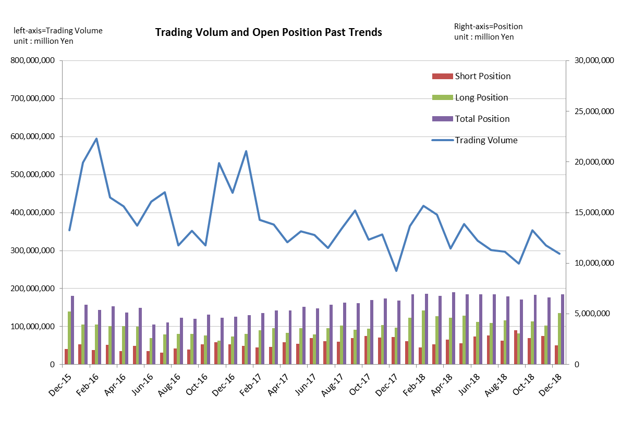
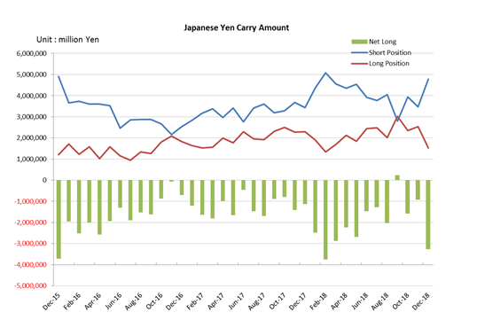

Monthly statistical report on Over-The-Counter Retail FX Margin Trading

：November , 2018
Publication date : 14 December. 2018
Number of Over-The-Counter Retail FX Margin Trading Operators as of 30 November. 2018 :53
Number of members reported :53
【Trading Volume】
(Unit: hundred million Yen, %)
 | Over-The-Counter | USDJPY, Cross Yen | On-Exchange*(for reference)
This month | 3,140,282 | 2,687,149 | 22,284
Previous month | 3,535,231 | 3,144,122 | 24,956
Change | -11.17% | -14.53% | -10.71%
*source : Monthly Trading Volume of Tokyo Financial exchange Inc.(The FFAJ converts the total number of contracts into the trading volume on the settlement prices of the end of the month)
【Open Positions】
(Unit: hundred million Yen)
 | Short | Long | Total
This month | 28,182 | 38,267 | 66,450
Previous month | 26,221 | 42,846 | 69,067
Change | 1,960 | -4,578 | -2,617

・USDJPY, Cross Yen Open Positions
(Unit: hundred million Yen)
 | ① Short | ② Long | Net long=②-①
This month | 34,727 | 25,353 | -9,374
Previous month | 39,367 | 23,562 | -15,804

（Reference：USDJPY Monthly Rate＊）
（Unit: Yen）
End of last Month*1 | Highest of the Month | Lowest of the Month | End of the Month*1 | Average*2
113.2 | 114.21 | 112.4 | 113.47 | 113.37
*source : BOJ's Main Time-series Statistics (Monthly)
*1) Spot Rate at 17:00 in JST, End of Month, Tokyo Market
*2) Average of Central Rate in the Month, Tokyo Market
○ Notes
The volume of this month was about 314 trillion yen (a decrease of 11.2% from the previous month), the trading volume on a business day basis excluding weekends decreased.
The open positions balance at the end of the month decreased since the end of the previous month,
short positions increased, but long positions decreased, totaling about 6.65 trillion yen.

～Tables and Historical Graphs～

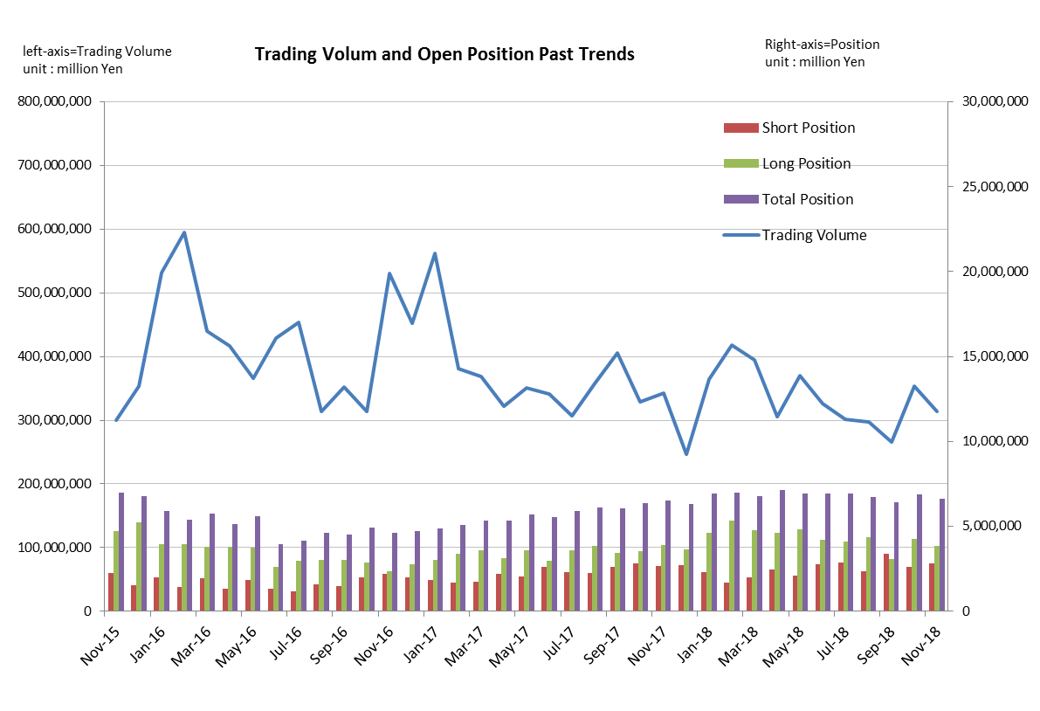

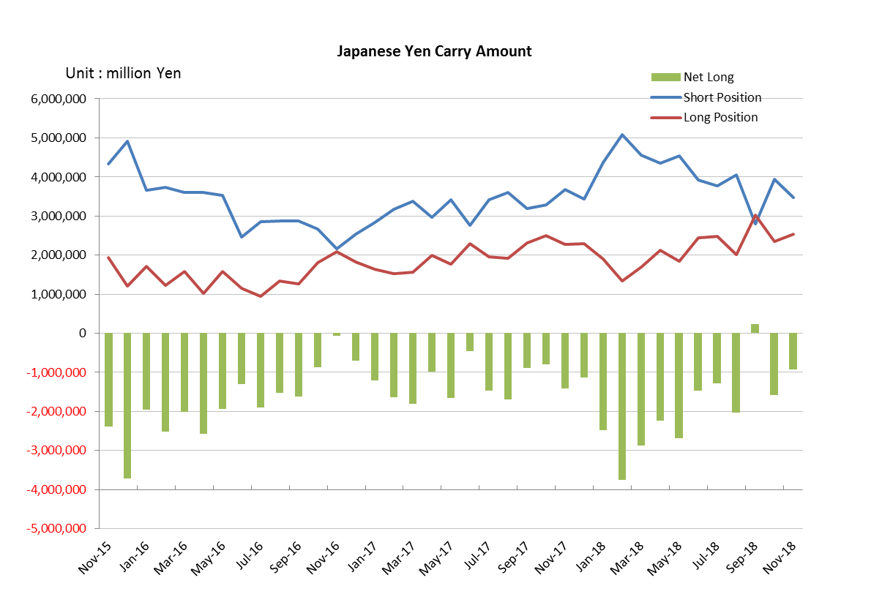

Monthly statistical report on Over-The-Counter Retail FX Margin Trading

：October , 2018
Publication date : 14 November. 2018
Number of Over-The-Counter Retail FX Margin Trading Operators as of 31 October. 2018 :53
Number of members reported :53
【Trading Volume】
(Unit: hundred million Yen, %)
 | Over-The-Counter | USDJPY, Cross Yen | On-Exchange*(for reference)
This month | 3,535,231 | 3,144,122 | 24,956
Previous month | 2,658,485 | 2,284,828 | 20,918
Change | 32.98% | 37.61% | 19.30%
*source : Monthly Trading Volume of Tokyo Financial exchange Inc.(The FFAJ converts the total number of contracts into the trading volume on the settlement prices of the end of the month)
【Open Positions】
(Unit: hundred million Yen)
 | Short | Long | Total
This month | 26,221 | 42,846 | 69,067
Previous month | 33,835 | 30,529 | 64,365
Change | -7,613 | 12,316 | 4,702

・USDJPY, Cross Yen Open Positions
(Unit: hundred million Yen)
 | ① Short | ② Long | Net long=②-①
This month | 39,367 | 23,562 | -15,804
Previous month | 27,924 | 30,239 | 2,314

（Reference：USDJPY Monthly Rate＊）
（Unit: Yen）
End of last Month*1 | Highest of the Month | Lowest of the Month | End of the Month*1 | Average*2
113.44 | 114.55 | 111.69 | 113.2 | 112.78
*source : BOJ's Main Time-series Statistics (Monthly)
*1) Spot Rate at 17:00 in JST, End of Month, Tokyo Market
*2) Average of Central Rate in the Month, Tokyo Market
○ Notes
The volume of this month was about 354 trillion yen (a increase of 33.0% from the previous month), the trading volume on a business day basis excluding weekends increased.
The open positions balance at the end of the month increased since the end of the previous month,
short positions decreased, but long positions increased, totaling about 6.91 trillion yen.

～Tables and Historical Graphs～

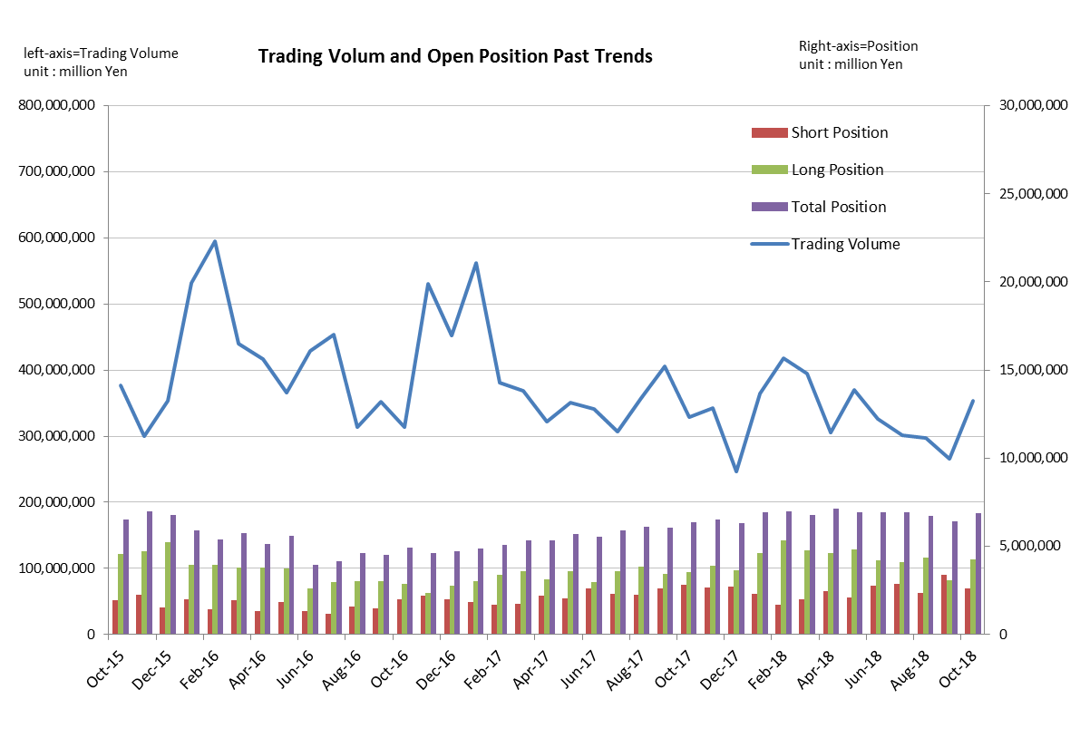
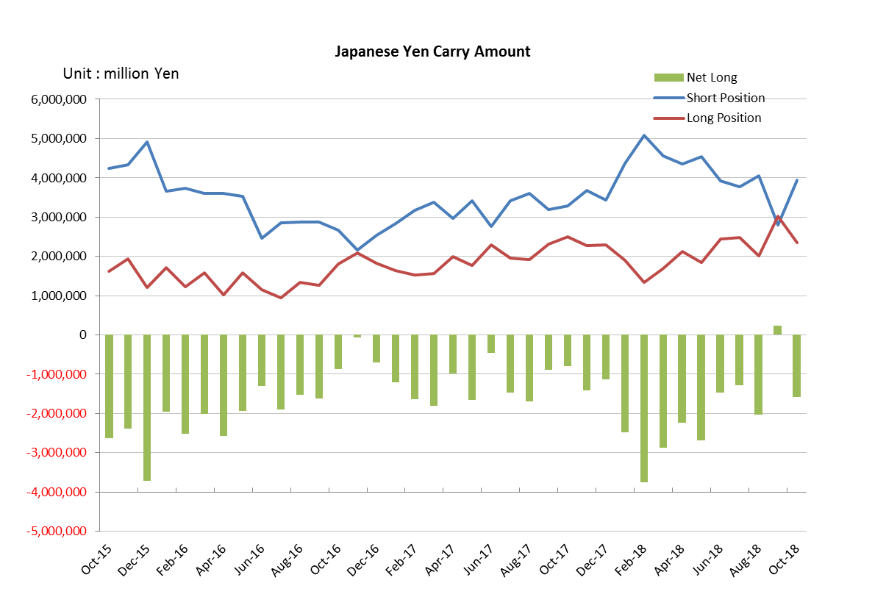

Monthly statistical report on Over-The-Counter Retail FX Margin Trading

：September , 2018
Publication date : 15 October. 2018
Number of Over-The-Counter Retail FX Margin Trading Operators as of 30 September. 2018 :53
Number of members reported :53
【Trading Volume】
(Unit: hundred million Yen, %)
 | Over-The-Counter | USDJPY, Cross Yen | On-Exchange*(for reference)
This month | 2,658,485 | 2,284,828 | 20,918
Previous month | 2,978,243 | 2,575,151 | 25,256
Change | -10.74% | -11.27% | -17.18%
*source : Monthly Trading Volume of Tokyo Financial exchange Inc.(The FFAJ converts the total number of contracts into the trading volume on the settlement prices of the end of the month)
【Open Positions】
(Unit: hundred million Yen)
 | Short | Long | Total
This month | 33,835 | 30,529 | 64,365
Previous month | 23,524 | 43,647 | 67,172
Change | 10,310 | -13,118 | -2,807

・USDJPY, Cross Yen Open Positions
(Unit: hundred million Yen)
 | ① Short | ② Long | Net long=②-①
This month | 27,924 | 30,239 | 2,314
Previous month | 40,541 | 20,127 | -20,414

（Reference：USDJPY Monthly Rate＊）
（Unit: Yen）
End of last Month*1 | Highest of the Month | Lowest of the Month | End of the Month*1 | Average*2
110.81 | 113.67 | 110.39 | 113.44 | 111.89
*source : BOJ's Main Time-series Statistics (Monthly)
*1) Spot Rate at 17:00 in JST, End of Month, Tokyo Market
*2) Average of Central Rate in the Month, Tokyo Market
○ Notes
The volume of this month was about 266 trillion yen (a decrease of 10.7% from the previous month),but the trading volume on a business day basis excluding weekends increased slightly.
The open positions balance at the end of the month decreased since the end of the previous month,
short positions increased, but long positions decreased, totaling about 6.43 trillion yen.

～Tables and Historical Graphs～

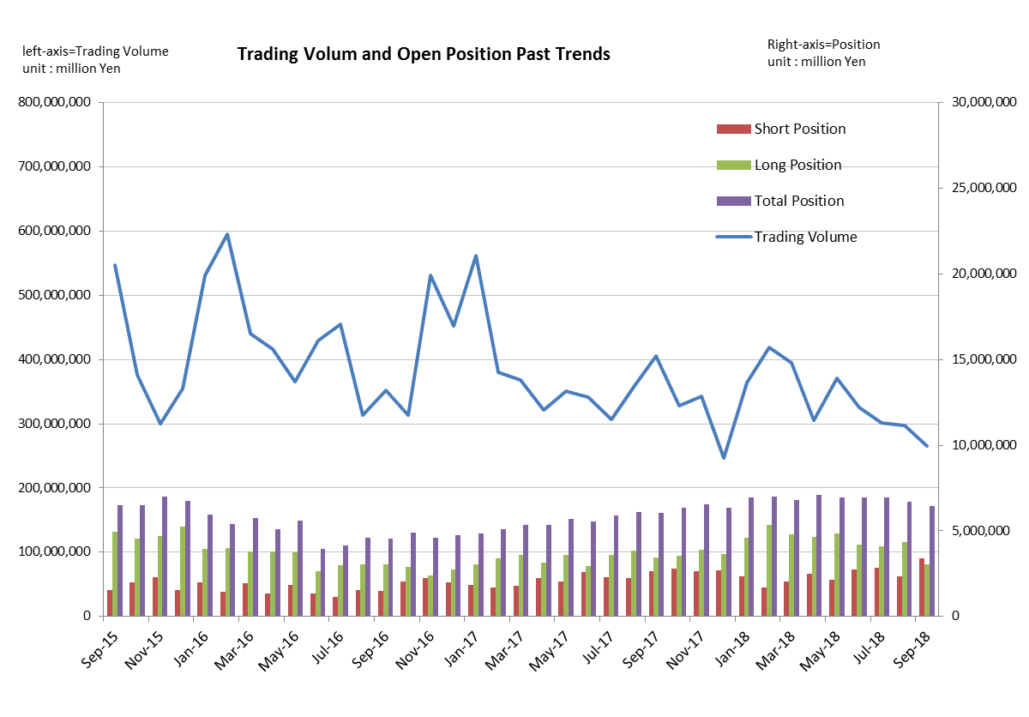

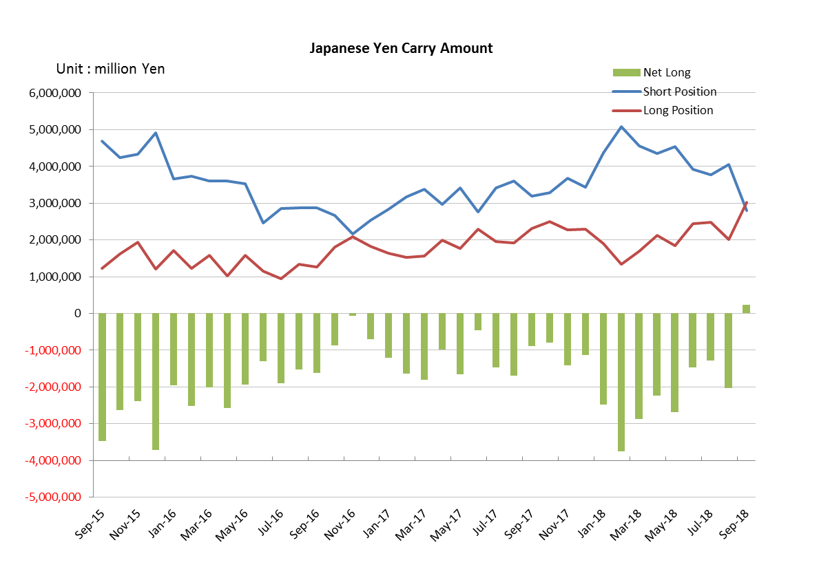

Monthly statistical report on Over-The-Counter Retail FX Margin Trading

：August , 2018
Publication date : 14 September. 2018
Number of Over-The-Counter Retail FX Margin Trading Operators as of 31 August. 2018 :53
Number of members reported :53
【Trading Volume】
(Unit: hundred million Yen, %)
 | Over-The-Counter | USDJPY, Cross Yen | On-Exchange*(for reference)
This month | 2,978,243 | 2,575,151 | 25,256
Previous month | 3,010,418 | 2,649,298 | 24,210
Change | -1.07% | -2.80% | 4.32%
*source : Monthly Trading Volume of Tokyo Financial exchange Inc.(The FFAJ converts the total number of contracts into the trading volume on the settlement prices of the end of the month)
【Open Positions】
(Unit: hundred million Yen)
 | Short | Long | Total
This month | 23,524 | 43,647 | 67,172
Previous month | 28,536 | 40,840 | 69,377
Change | -5,012 | 2,806 | -2,205

・USDJPY, Cross Yen Open Positions
(Unit: hundred million Yen)
 | ① Short | ② Long | Net long=②-①
This month | 40,541 | 20,127 | -20,414
Previous month | 37,691 | 24,780 | -12,910

（Reference：USDJPY Monthly Rate＊）
（Unit: Yen）
End of last Month*1 | Highest of the Month | Lowest of the Month | End of the Month*1 | Average*2
111.4 | 112.15 | 109.78 | 110.81 | 111.06
*source : BOJ's Main Time-series Statistics (Monthly)
*1) Spot Rate at 17:00 in JST, End of Month, Tokyo Market
*2) Average of Central Rate in the Month, Tokyo Market
○ Notes
The volume of this month was about 298 trillion yen (a decrease of 1.1% from the previous month), the trading volume on a business day basis excluding weekends also decreased.
The open positions balance at the end of the month decreased since the end of the previous month,
short positions decreased, but long positions increased, totaling about 6.72 trillion yen.

～Tables and Historical Graphs～

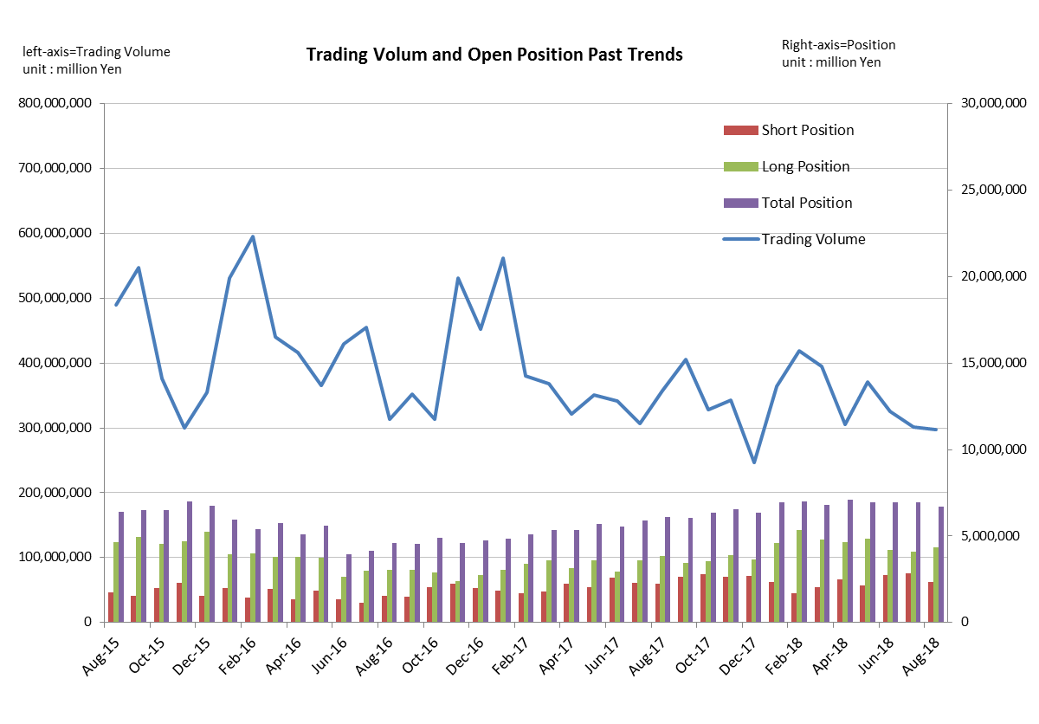

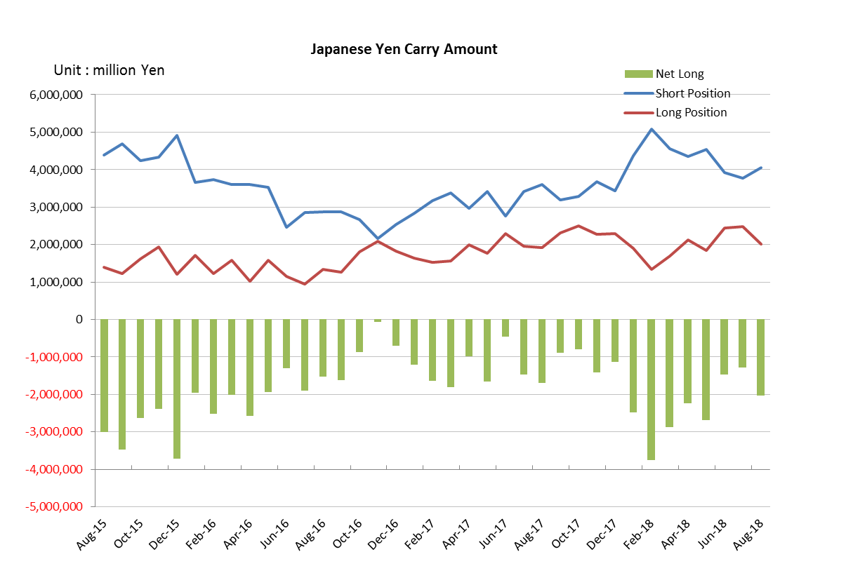

Monthly statistical report on Over-The-Counter Retail FX Margin Trading

：July , 2018
Publication date : 14 August. 2018
Number of Over-The-Counter Retail FX Margin Trading Operators as of 31 July. 2018 :53
Number of members reported :53
【Trading Volume】
(Unit: hundred million Yen, %)
 | Over-The-Counter | USDJPY, Cross Yen | On-Exchange*(for reference)
This month | 3,010,418 | 2,649,298 | 24,210
Previous month | 3,258,218 | 2,812,489 | 23,790
Change | -7.61% | -5.80% | 1.77%
*source : Monthly Trading Volume of Tokyo Financial exchange Inc.(The FFAJ converts the total number of contracts into the trading volume on the settlement prices of the end of the month)
【Open Positions】
(Unit: hundred million Yen)
 | Short | Long | Total
This month | 28,536 | 40,840 | 69,377
Previous month | 27,551 | 41,930 | 69,482
Change | 985 | -1,090 | -104

・USDJPY, Cross Yen Open Positions
(Unit: hundred million Yen)
 | ① Short | ② Long | Net long=②-①
This month | 37,691 | 24,780 | -12,910
Previous month | 39,193 | 24,495 | -14,697

（Reference：USDJPY Monthly Rate＊）
（Unit: Yen）
End of last Month*1 | Highest of the Month | Lowest of the Month | End of the Month*1 | Average*2
110.64 | 113.14 | 110.27 | 111.4 | 111.37
*source : BOJ's Main Time-series Statistics (Monthly)
*1) Spot Rate at 17:00 in JST, End of Month, Tokyo Market
*2) Average of Central Rate in the Month, Tokyo Market
○ Notes
The volume of this month was about 301 trillion yen (a decrease of 7.6% from the previous month), the trading volume on a business day basis excluding weekends also decreased.
The open positions balance at the end of the month decreased slightly since the end of the previous month,
short positions increased, but long positions decreased, totaling about 6.93 trillion yen.

～Tables and Historical Graphs～

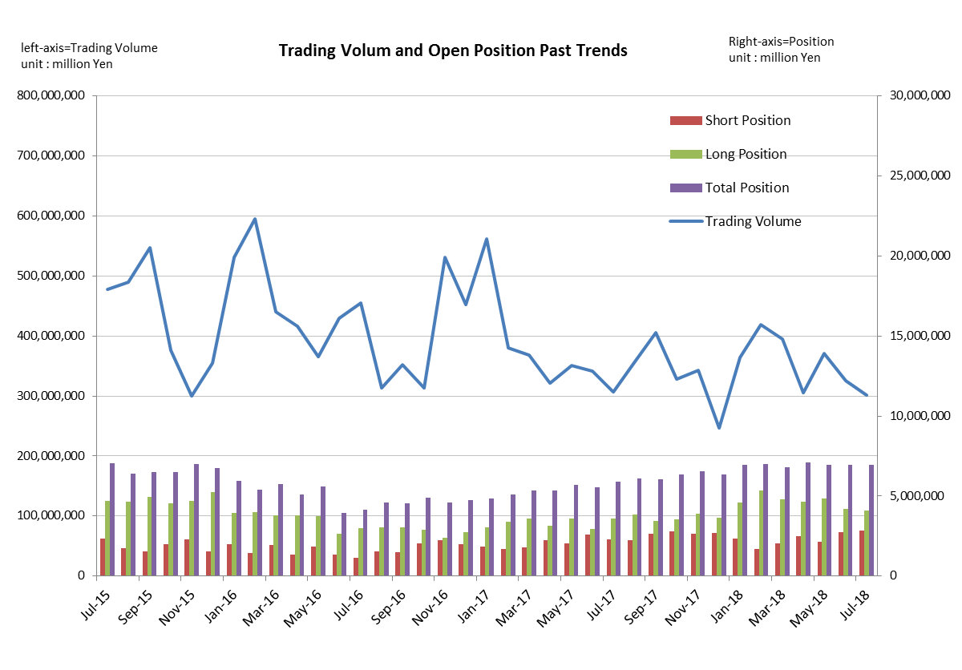

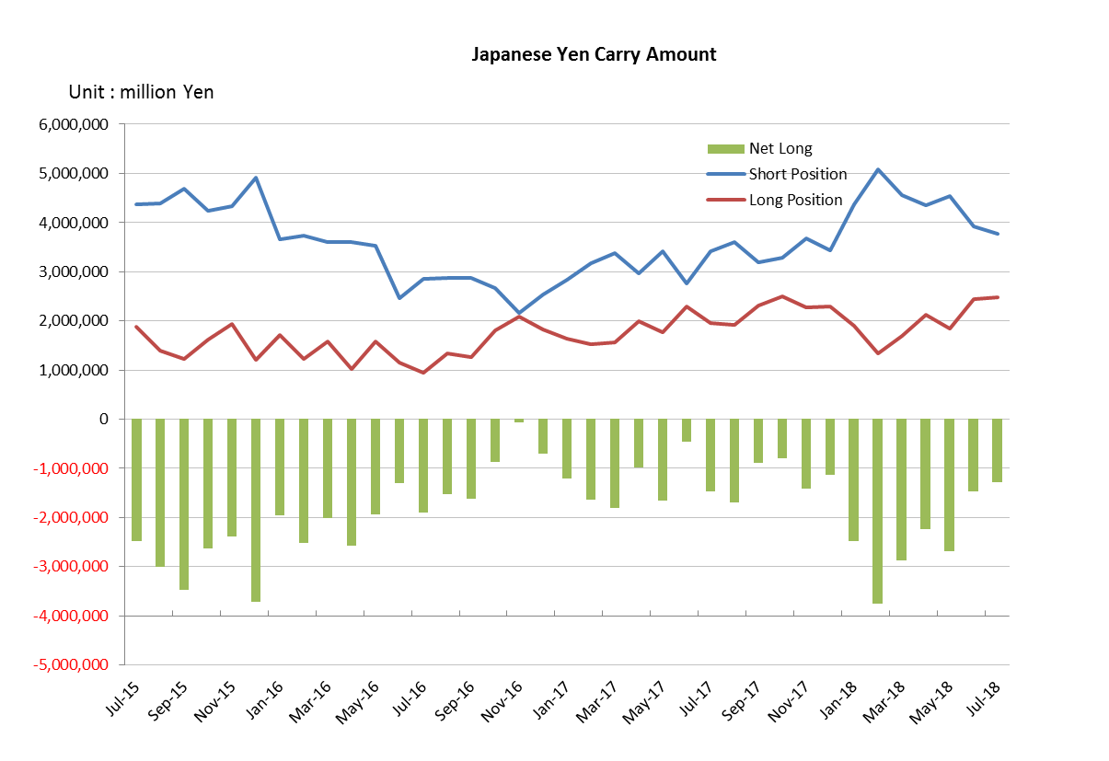

Monthly statistical report on Over-The-Counter Retail FX Margin Trading

：June , 2018
Publication date : 13 July. 2018
Number of Over-The-Counter Retail FX Margin Trading Operators as of 30 June. 2018 :53
Number of members reported :53
【Trading Volume】
(Unit: hundred million Yen, %)
 | Over-The-Counter | USDJPY, Cross Yen | On-Exchange*(for reference)
This month | 3,258,218 | 2,812,489 | 23,790
Previous month | 3,706,137 | 3,239,902 | 26,943
Change | -12.09% | -13.19% | -11.70%
*source : Monthly Trading Volume of Tokyo Financial exchange Inc.(The FFAJ converts the total number of contracts into the trading volume on the settlement prices of the end of the month)
【Open Positions】
(Unit: hundred million Yen)
 | Short | Long | Total
This month | 27,551 | 41,930 | 69,482
Previous month | 21,240 | 48,182 | 69,422
Change | 6,311 | -6,251 | 59

・USDJPY, Cross Yen Open Positions
(Unit: hundred million Yen)
 | ① Short | ② Long | Net long=②-①
This month | 39,193 | 24,495 | -14,697
Previous month | 45,399 | 18,507 | -26,891

（Reference：USDJPY Monthly Rate＊）
（Unit: Yen）
End of last Month*1 | Highest of the Month | Lowest of the Month | End of the Month*1 | Average*2
108.77 | 110.9 | 108.73 | 110.64 | 110.03
*source : BOJ's Main Time-series Statistics (Monthly)
*1) Spot Rate at 17:00 in JST, End of Month, Tokyo Market
*2) Average of Central Rate in the Month, Tokyo Market
○ Notes
The volume of this month was about 325 trillion yen (a decrease of 12.1% from the previous month), the trading volume on a business day basis excluding weekends also decreased.
The open positions balance at the end of the month increased slightly since the end of the previous month,
short positions increased, but long positions decreased, totaling about 6.94 trillion yen.

～Tables and Historical Graphs～

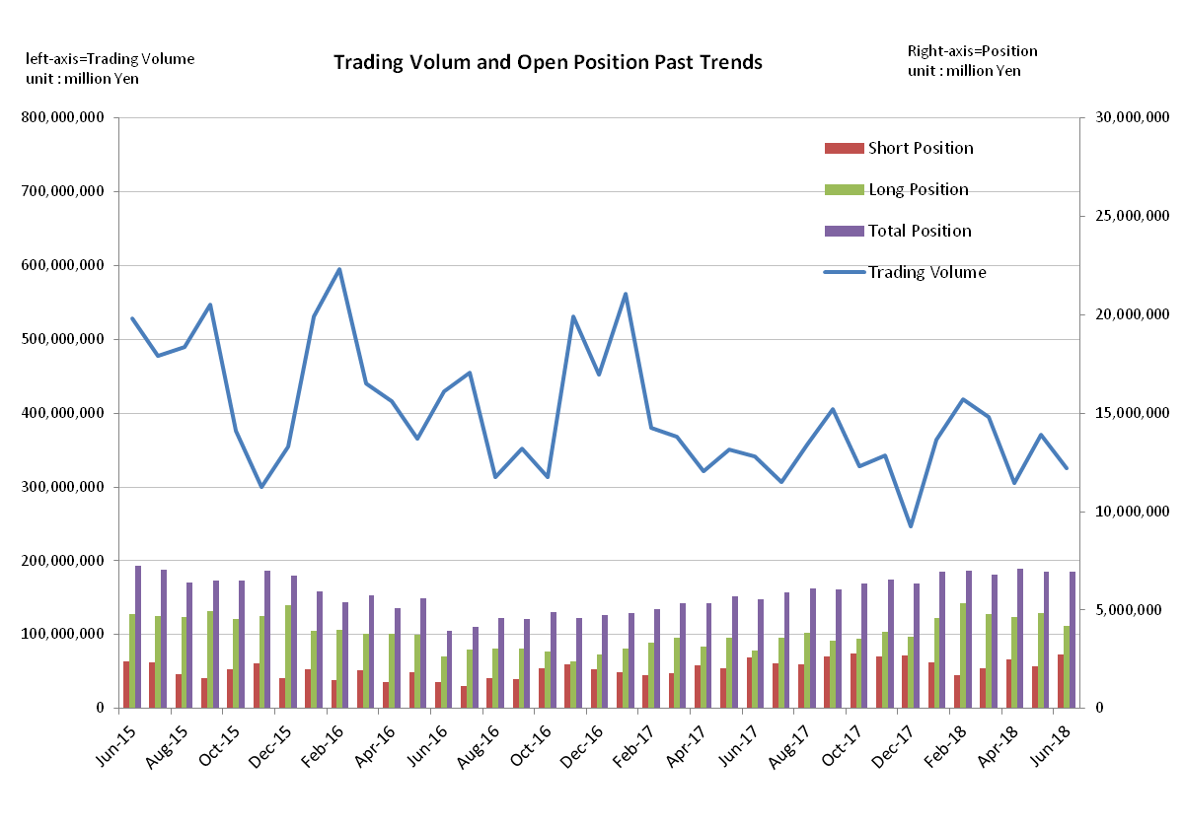

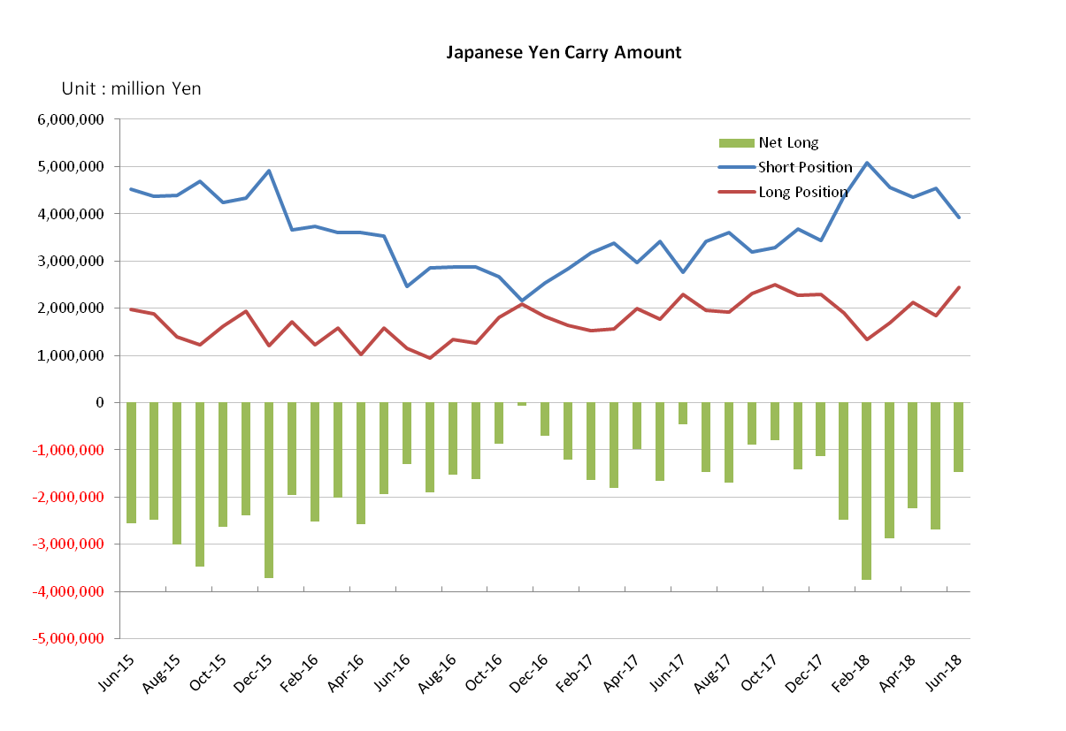

Monthly statistical report on Over-The-Counter Retail FX Margin Trading

：May , 2018
Publication date : 14 June. 2018
Number of Over-The-Counter Retail FX Margin Trading Operators as of 31 May. 2018 :53
Number of members reported :53
【Trading Volume】
(Unit: hundred million Yen, %)
 | Over-The-Counter | USDJPY, Cross Yen | On-Exchange*(for reference)
This month | 3,706,137 | 3,239,902 | 26,943
Previous month | 3,056,871 | 2,726,132 | 23,384
Change | 21.24% | 18.85% | 15.22%
*source : Monthly Trading Volume of Tokyo Financial exchange Inc.(The FFAJ converts the total number of contracts into the trading volume on the settlement prices of the end of the month)
【Open Positions】
(Unit: hundred million Yen)
 | Short | Long | Total
This month | 21,240 | 48,182 | 69,422
Previous month | 24,718 | 46,422 | 71,141
Change | -3,478 | 1,759 | -1,719

・USDJPY, Cross Yen Open Positions
(Unit: hundred million Yen)
 | ① Short | ② Long | Net long=②-①
This month | 45,399 | 18,507 | -26,891
Previous month | 43,603 | 21,240 | -22,363

（Reference：USDJPY Monthly Rate＊）
（Unit: Yen）
End of last Month*1 | Highest of the Month | Lowest of the Month | End of the Month*1 | Average*2
109.4 | 111.39 | 108.36 | 108.77 | 109.69
*source : BOJ's Main Time-series Statistics (Monthly)
*1) Spot Rate at 17:00 in JST, End of Month, Tokyo Market
*2) Average of Central Rate in the Month, Tokyo Market
○ Notes
The volume of this month was about 370 trillion yen (a increase of 21.2% from the previous month), the trading volume on a business day basis excluding weekends also increased.
The open positions balance at the end of the month decreased since the end of the previous month,
short positions decreased, but long positions increased, totaling about 6.94 trillion yen.

～Tables and Historical Graphs～

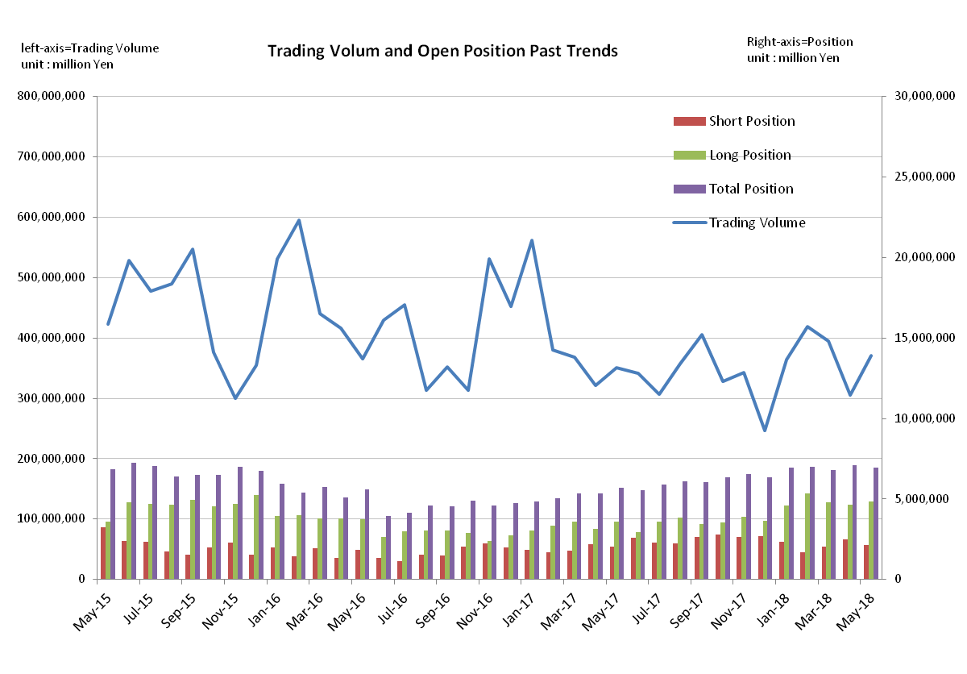

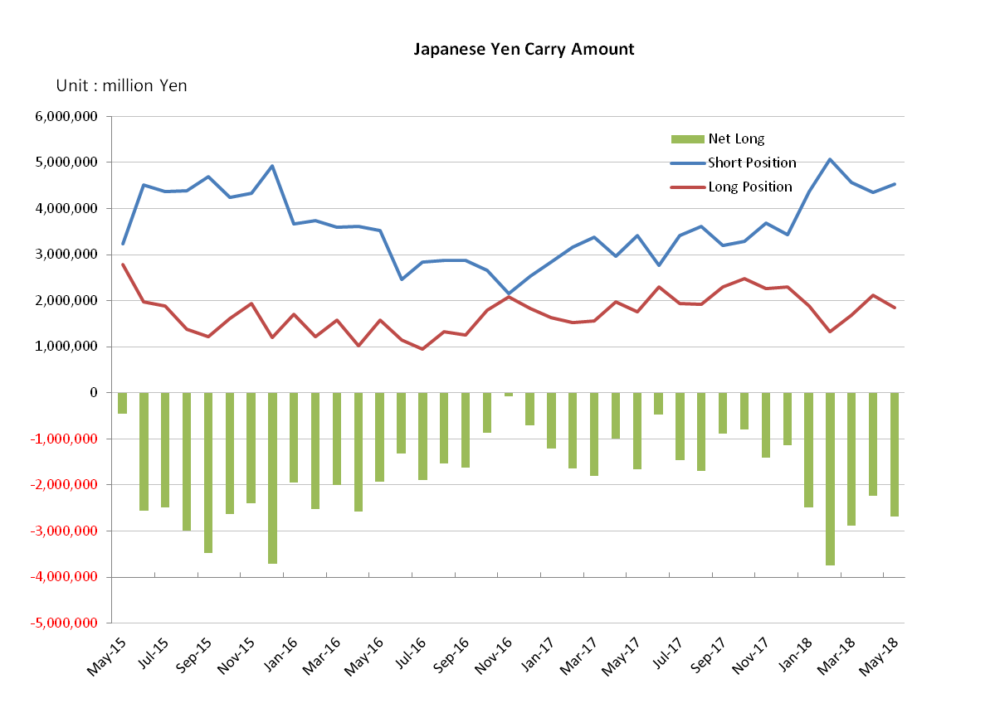

Monthly statistical report on Over-The-Counter Retail FX Margin Trading

：April , 2018
Publication date : 16 May. 2018
Number of Over-The-Counter Retail FX Margin Trading Operators as of 30 April. 2018 :53
Number of members reported :54
【Trading Volume】
(Unit: hundred million Yen, %)
 | Over-The-Counter | USDJPY, Cross Yen | On-Exchange*(for reference)
This month | 3,056,871 | 2,726,132 | 23,384
Previous month | 3,945,731 | 3,583,334 | 28,389
Change | -22.53% | -23.92% | -17.63%
*source : Monthly Trading Volume of Tokyo Financial exchange Inc.(The FFAJ converts the total number of contracts into the trading volume on the settlement prices of the end of the month)
【Open Positions】
(Unit: hundred million Yen)
 | Short | Long | Total
This month | 24,718 | 46,422 | 71,141
Previous month | 20,186 | 47,806 | 67,993
Change | 4,531 | -1,383 | 3,148

・USDJPY, Cross Yen Open Positions
(Unit: hundred million Yen)
 | ① Short | ② Long | Net long=②-①
This month | 43,603 | 21,240 | -22,363
Previous month | 45,632 | 16,897 | -28,735

（Reference：USDJPY Monthly Rate＊）
（Unit: Yen）
End of last Month*1 | Highest of the Month | Lowest of the Month | End of the Month*1 | Average*2
106.19 | 109.49 | 105.70 | 109.40 | 107.43
*source : BOJ's Main Time-series Statistics (Monthly)
*1) Spot Rate at 17:00 in JST, End of Month, Tokyo Market
*2) Average of Central Rate in the Month, Tokyo Market
○ Notes
The volume of this month was about 305 trillion yen (a decrease of 22.5% from the previous month), the trading volume on a business day basis excluding weekends also decreased.
The open positions balance at the end of the month increased since the end of the previous month,
short positions increased, but long positions decreased, totaling about 7.11 trillion yen.

～Tables and Historical Graphs～

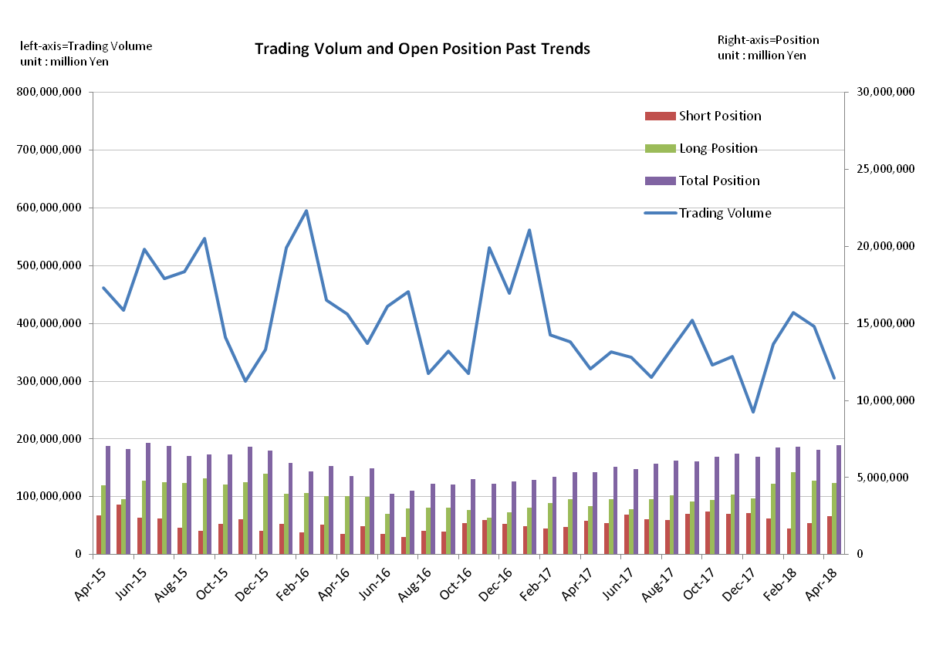

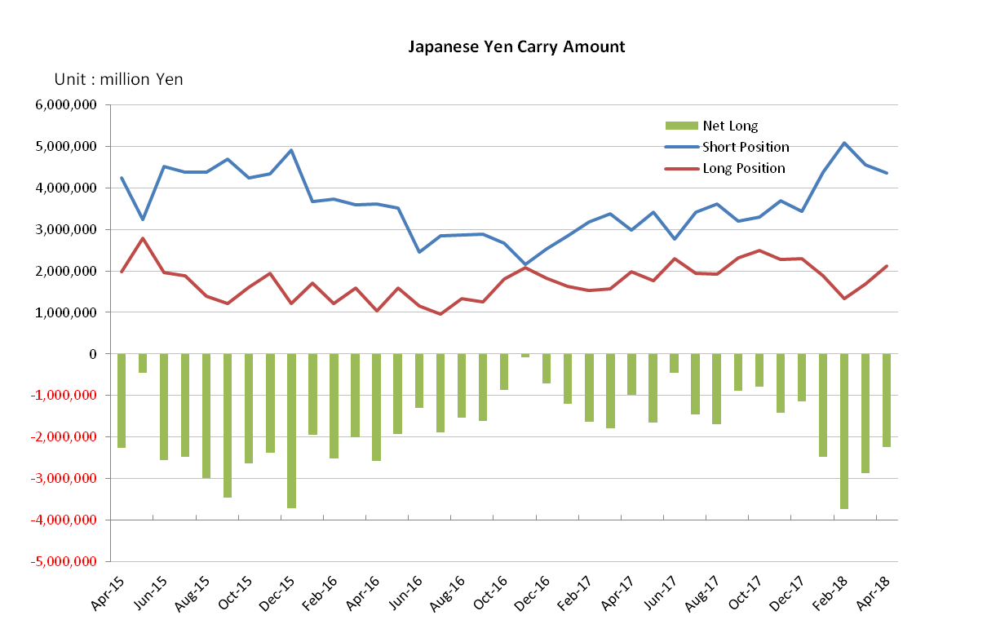

Monthly statistical report on Over-The-Counter Retail FX Margin Trading

：March , 2018
Publication date : 13 April. 2018
Number of Over-The-Counter Retail FX Margin Trading Operators as of 31 March. 2018 :54
Number of members reported :54
【Trading Volume】
(Unit: hundred million Yen, %)
 | Over-The-Counter | USDJPY, Cross Yen | On-Exchange*(for reference)
This month | 3,945,731 | 3,583,334 | 28,389
Previous month | 4,182,596 | 3,805,165 | 32,133
Change | -5.66% | -5.83% | -11.65%
*source : Monthly Trading Volume of Tokyo Financial exchange Inc.(The FFAJ converts the total number of contracts into the trading volume on the settlement prices of the end of the month)
【Open Positions】
(Unit: hundred million Yen)
 | Short | Long | Total
This month | 20,186 | 47,806 | 67,993
Previous month | 16,776 | 53,322 | 70,098
Change | +3,409 | -5,515 | -2,105

・USDJPY, Cross Yen Open Positions
(Unit: hundred million Yen)
 | ① Short | ② Long | Net long=②-①
This month | 45,632 | 16,897 | -28,735
Previous month | 50,799 | 13,312 | -37,486

（Reference：USDJPY Monthly Rate＊）
（Unit: Yen）
End of last Month*1 | Highest of the Month | Lowest of the Month | End of the Month*1 | Average*2
107.08 | 106.99 | 104.64 | 106.19 | 106
*source : BOJ's Main Time-series Statistics (Monthly)
*1) Spot Rate at 17:00 in JST, End of Month, Tokyo Market
*2) Average of Central Rate in the Month, Tokyo Market
○ Notes
The volume of this month was about 394 trillion yen (a decrease of 5.7% from the previous month), the trading volume on a business day basis excluding weekends also decreased.
The open positions balance at the end of the month decreased since the end of the previous month,
short positions increased, but long positions decreased, totaling about 6.79 trillion yen.

～Tables and Historical Graphs～

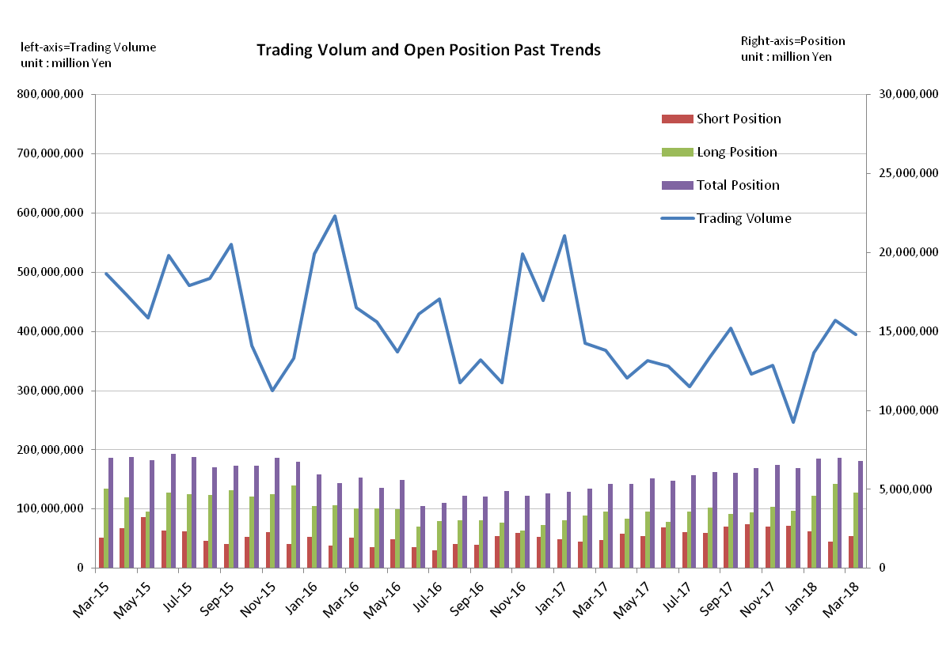

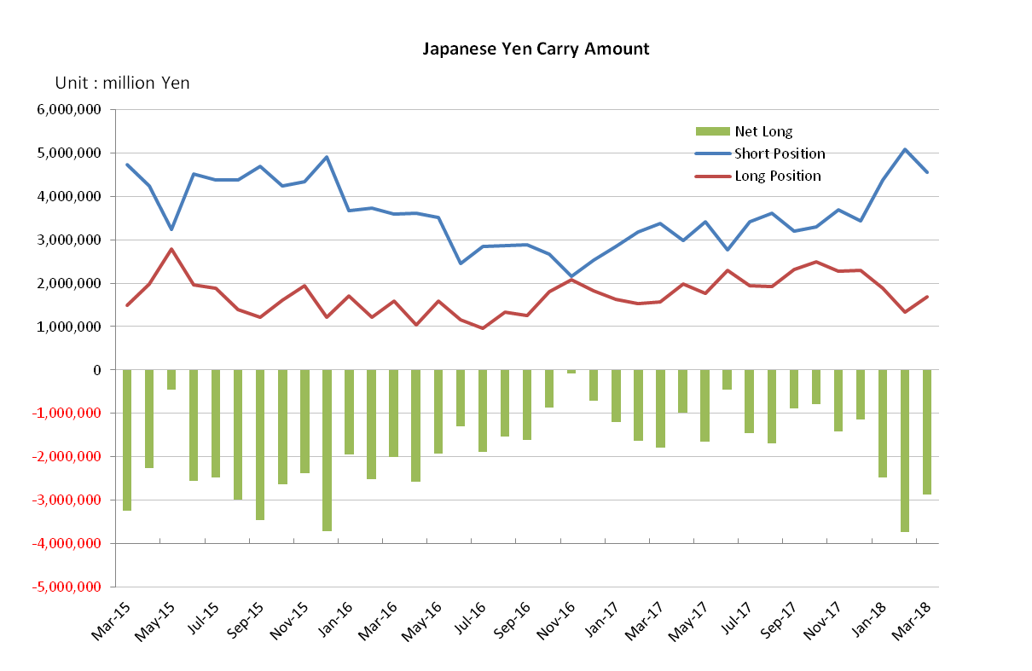

Monthly statistical report on Over-The-Counter Retail FX Margin Trading

：February , 2018
Publication date : 14 March. 2018
Number of Over-The-Counter Retail FX Margin Trading Operators as of 28 February. 2018 :54
Number of members reported :54
【Trading Volume】
(Unit: hundred million Yen, %)
 | Over-The-Counter | USDJPY, Cross Yen | On-Exchange*(for reference)
This month | 4,182,596 | 3,805,165 | 32,133
Previous month | 3,641,454 | 3,183,105 | 24,857
Change | +14.86% | +19.54% | +29.27%
*source : Monthly Trading Volume of Tokyo Financial exchange Inc.(The FFAJ converts the total number of contracts into the trading volume on the settlement prices of the end of the month)
【Open Positions】
(Unit: hundred million Yen)
 | Short | Long | Total
This month | 16,776 | 53,322 | 70,098
Previous month | 23,259 | 45,972 | 69,232
Change | -6,483 | +7,349 | +866

・USDJPY, Cross Yen Open Positions
(Unit: hundred million Yen)
 | ① Short | ② Long | Net long=②-①
This month | 50,799 | 13,312 | -37,486
Previous month | 43,747 | 18,916 | -24,831

（Reference：USDJPY Monthly Rate＊）
（Unit: Yen）
End of last Month*1 | Highest of the Month | Lowest of the Month | End of the Month*1 | Average*2
108.7 | 110.29 | 105.55 | 107.08 | 107.82
*source : BOJ's Main Time-series Statistics (Monthly)
*1) Spot Rate at 17:00 in JST, End of Month, Tokyo Market
*2) Average of Central Rate in the Month, Tokyo Market
○ Notes
The volume of this month was about 418 trillion yen (a increase of 14.9% from the previous month), the trading volume on a business day basis excluding weekends also increased.
The open positions balance at the end of the month increased since the end of the previous month,
short positions decreased, but long positions increased, totaling about 7.00 trillion yen.

～Tables and Historical Graphs～

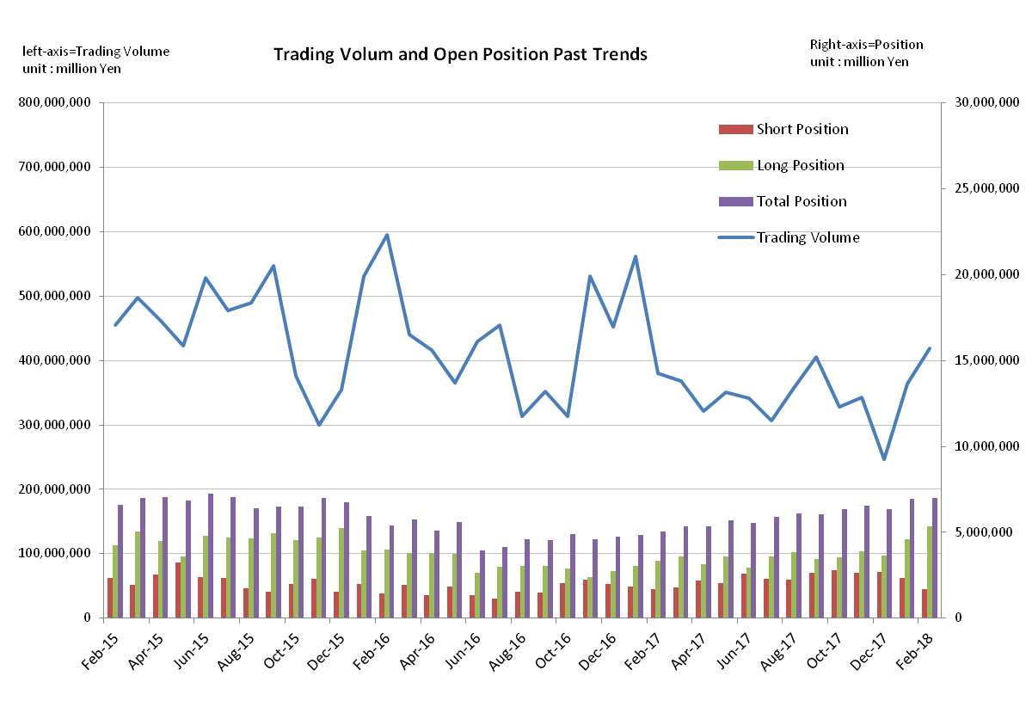

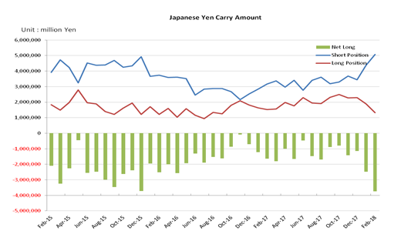

Monthly statistical report on Over-The-Counter Retail FX Margin Trading

：January , 2018
Publication date : 15 February. 2018
Number of Over-The-Counter Retail FX Margin Trading Operators as of 31 January. 2018 :54
Number of members reported :54
【Trading Volume】
(Unit: hundred million Yen, %)
 | Over-The-Counter | USDJPY, Cross Yen | On-Exchange*(for reference)
This month | 3,654,697 | 3,195,333 | 24,857
Previous month | 2,466,134 | 2,227,638 | 20,161
Change | +48.20% | +43.44% | +23.29%
*source : Monthly Trading Volume of Tokyo Financial exchange Inc.(The FFAJ converts the total number of contracts into the trading volume on the settlement prices of the end of the month)
【Open Positions】
(Unit: hundred million Yen)
 | Short | Long | Total
This month | 23,259 | 45,972 | 69,232
Previous month | 27,035 | 36,267 | 63,303
Change | -3,775 | +9,705 | +5,929

・USDJPY, Cross Yen Open Positions
(Unit: hundred million Yen)
 | ① Short | ② Long | Net long=②-①
This month | 43,747 | 18,916 | -24,831
Previous month | 34,409 | 22,999 | -11,410

（Reference：USDJPY Monthly Rate＊）
（Unit: Yen）
End of last Month*1 | Highest of the Month | Lowest of the Month | End of the Month*1 | Average*2
112.65 | 113.18 | 108.51 | 108.7 | 110.77
*source : BOJ's Main Time-series Statistics (Monthly)
*1) Spot Rate at 17:00 in JST, End of Month, Tokyo Market
*2) Average of Central Rate in the Month, Tokyo Market
○ Notes
The volume of this month was about 365 trillion yen (a increase of 48.2% from the previous month), the trading volume on a business day basis excluding weekends also increased.
The open positions balance at the end of the month increased since the end of the previous month,
short positions decreased, but long positions increased, totaling about 6.92 trillion yen.

～Tables and Historical Graphs～

