Over-The-Counter FX Margin Trading Report

(January 2017 ～ )

Monthly Report
January 2017
February 2017
March 2017
April 2017
May 2017
June 2017
July 2017
August 2017
September 2017
October 2017
November 2017
December 2017

The Financial Futures Association of Japan, Research Department

NBF Ogawamachi Building 1-3 , Kanda Ogawamachi ,
Chiyoda-ku , Tokyo 101-0052 Tel:(03)5280-0881 E-mail : ffaj@ffaj.or.jp

This publication has been prepared by the FFAJ and is provided for information purpose only. The monthly information contained in this publication has been obtained from FFAJ's members that is believed to be reliable, however the FFAJ does not represent or warrant that it is accurate or complete. In no event the FFAJ nor its employees have any liability for any consequential damages arising from any use of this publications or its contents. This publication does not constitute any investment advice.

Monthly statistical report on Over-The-Counter Retail FX Margin Trading

：December, 2017
Publication date : 18 January. 2018
Number of Over-The-Counter Retail FX Margin Trading Operators as of 31 december. 2017 :54
Number of members reported :54
【Trading Volume】
(Unit: hundred million Yen, %)
 | Over-The-Counter | USDJPY, Cross Yen | On-Exchange*(for reference)
This month | 2,466,134 | 2,227,638 | 20,161
Previous month | 3,431,255 | 3,142,486 | 22,288
Change | -28.13% | -29.11% | -9.54%
*source : Monthly Trading Volume of Tokyo Financial exchange Inc.(The FFAJ converts the total number of contracts into the trading volume on the settlement prices of the end of the month)
【Open Positions】
(Unit: hundred million Yen)
 | Short | Long | Total
This month | 27,035 | 36,267 | 63,303
Previous month | 26,435 | 38,911 | 65,346
Change | 600 | -2,643 | -2,042

・USDJPY, Cross Yen Open Positions
(Unit: hundred million Yen)
 | ① Short | ② Long | Net long=②-①
This month | 34,409 | 22,999 | -11,410
Previous month | 36,838 | 22,706 | -14,131

（Reference：USDJPY Monthly Rate＊）
（Unit: Yen）
End of last Month*1 | Highest of the Month | Lowest of the Month | End of the Month*1 | Average*2
112.29 | 113.69 | 111.99 | 112.65 | 112.97
*source : BOJ's Main Time-series Statistics (Monthly)
*1) Spot Rate at 17:00 in JST, End of Month, Tokyo Market
*2) Average of Central Rate in the Month, Tokyo Market
○ Notes
The volume of this month was about 247 trillion yen (a decrease of 28.1% from the previous month),
the trading volume on a business day basis excluding weekends also decreased.
Meanwhile, The open positions balance at the end of the month increased since the end of the previous month,
short positions increased, but long positions decreased, totaling about 6.3 trillion yen.

～Tables and Historical Graphs～

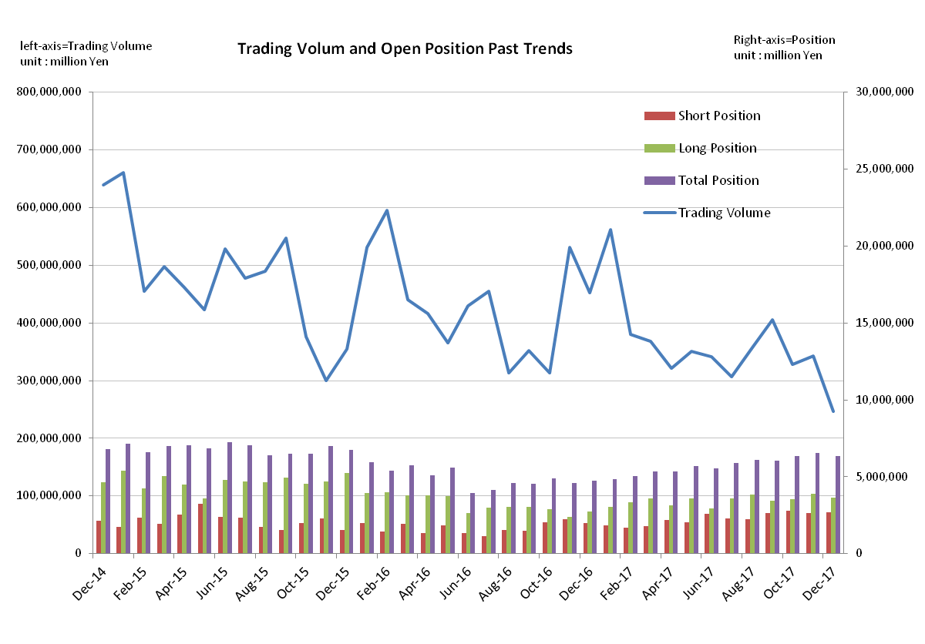
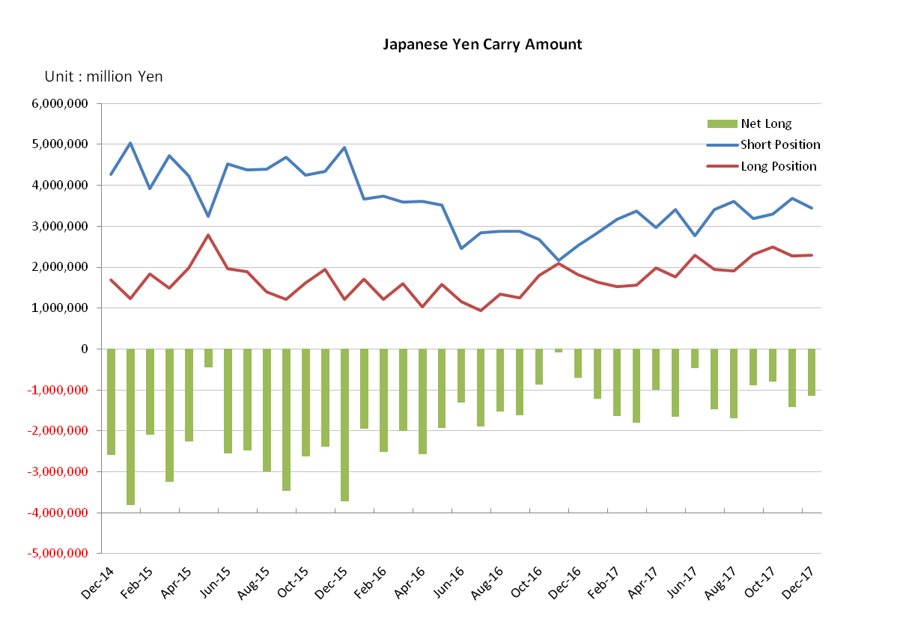

Monthly statistical report on Over-The-Counter Retail FX Margin Trading

：November, 2017
Publication date : 14 December. 2017
Number of Over-The-Counter Retail FX Margin Trading Operators as of 30 November. 2017 :54
Number of members reported :54
【Trading Volume】
(Unit: hundred million Yen, %)
 | Over-The-Counter | USDJPY, Cross Yen | On-Exchange*(for reference)
This month | 3,431,255 | 3,142,486 | 22,288
Previous month | 3,286,624 | 2,990,111 | 20,744
Change | 4.40% | 5.10% | 7.44%
*source : Monthly Trading Volume of Tokyo Financial exchange Inc.(The FFAJ converts the total number of contracts into the trading volume on the settlement prices of the end of the month)
【Open Positions】
(Unit: hundred million Yen)
 | Short | Long | Total
This month | 26,435 | 38,911 | 65,346
Previous month | 28,113 | 35,346 | 63,460
Change | -1,678 | 3,565 | 1,886

・USDJPY, Cross Yen Open Positions
(Unit: hundred million Yen)
 | ① Short | ② Long | Net long=②-①
This month | 36,838 | 22,706 | -14,131
Previous month | 32,891 | 24,892 | -7,998

（Reference：USDJPY Monthly Rate＊）
（Unit: Yen）
End of last Month*1 | Highest of the Month | Lowest of the Month | End of the Month*1 | Average*2
113.09 | 114.74 | 110.94 | 112.29 | 112.92
*source : BOJ's Main Time-series Statistics (Monthly)
*1) Spot Rate at 17:00 in JST, End of Month, Tokyo Market
*2) Average of Central Rate in the Month, Tokyo Market
○ Notes
The volume of this month was about 343 trillion yen (a increase of 4.4% from the previous month), the trading volume on a business day basis excluding weekends increased.
Meanwhile, The open positions balance at the end of the month increased since the end of the previous month,
long positions increased, but short positions decreased, totaling about 6.5 trillion yen.

～Tables and Historical Graphs～
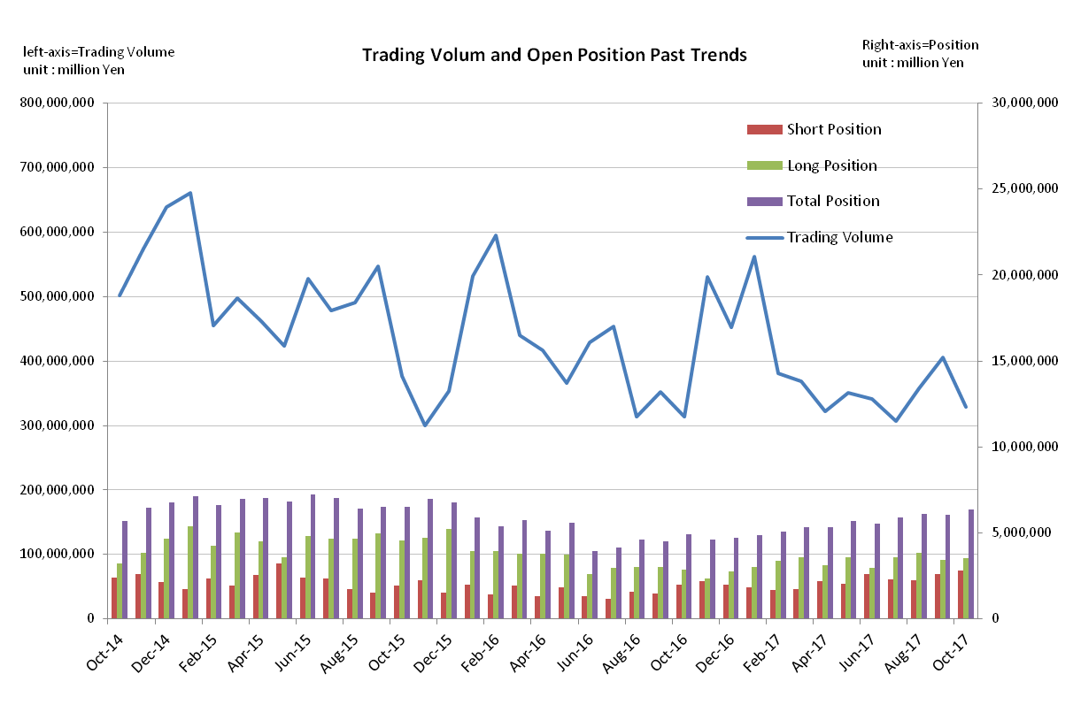
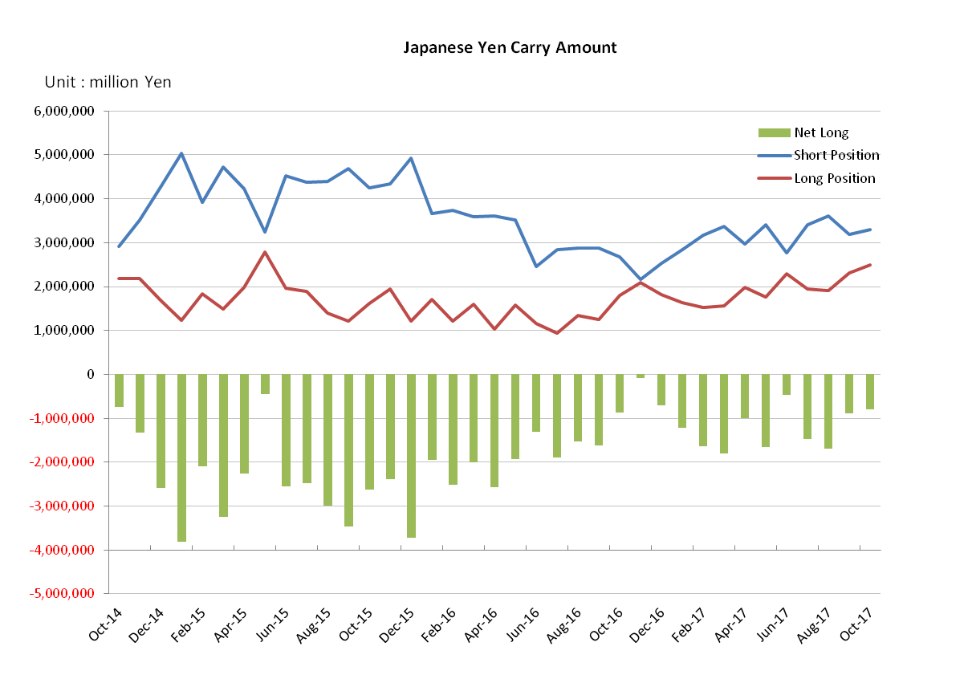

Monthly statistical report on Over-The-Counter Retail FX Margin Trading

：October, 2017
Publication date : 15 November. 2017
Number of Over-The-Counter Retail FX Margin Trading Operators as of 31 October. 2017 :54
Number of members reported :54
【Trading Volume】
(Unit: hundred million Yen, %)
 | Over-The-Counter | USDJPY, Cross Yen | On-Exchange*(for reference)
This month | 3,286,624 | 2,990,111 | 20,744
Previous month | 4,059,470 | 3,721,212 | 26,771
Change | -19.04% | -19.65% | -22.51%
*source : Monthly Trading Volume of Tokyo Financial exchange Inc.(The FFAJ converts the total number of contracts into the trading volume on the settlement prices of the end of the month)
【Open Positions】
(Unit: hundred million Yen)
 | Short | Long | Total
This month | 28,113 | 35,346 | 63,460
Previous month | 26,180 | 34,363 | 60,543
Change | 1,933 | 982 | 2,916

・USDJPY, Cross Yen Open Positions
(Unit: hundred million Yen)
 | ① Short | ② Long | Net long=②-①
This month | 32,891 | 24,892 | -7,998
Previous month | 31,913 | 23,050 | -8,862

（Reference：USDJPY Monthly Rate＊）
（Unit: Yen）
End of last Month*1 | Highest of the Month | Lowest of the Month | End of the Month*1 | Average*2
112.46 | 114.31 | 111.66 | 113.09 | 112.96
*source : BOJ's Main Time-series Statistics (Monthly)
*1) Spot Rate at 17:00 in JST, End of Month, Tokyo Market
*2) Average of Central Rate in the Month, Tokyo Market
○ Notes
The volume of this month was about 328 trillion yen (a decrease of 19.0% from the previous month), the trading volume on a business day basis excluding weekends also decreased.
Meanwhile, the open positions balance at the end of the month increased since the end of the previous month,
both long position and short position , totaling about 6.34 trillion yen.

～Tables and Historical Graphs～

Monthly statistical report on Over-The-Counter Retail FX Margin Trading

：September, 2017
Publication date : 16 October. 2017
Number of Over-The-Counter Retail FX Margin Trading Operators as of 30 September. 2017 :54
Number of members reported :54
【Trading Volume】
(Unit: hundred million Yen, %)
 | Over-The-Counter | USDJPY, Cross Yen | On-Exchange*(for reference)
This month | 4,059,470 | 3,721,212 | 26,771
Previous month | 3,576,465 | 3,246,672 | 23,959
Change | 13.51% | 14.62% | 11.74%
*source : Monthly Trading Volume of Tokyo Financial exchange Inc.(The FFAJ converts the total number of contracts into the trading volume on the settlement prices of the end of the month)
【Open Positions】
(Unit: hundred million Yen)
 | Short | Long | Total
This month | 26,180 | 34,363 | 60,543
Previous month | 22,475 | 38,419 | 60,894
Change | 3,704 | -4,055 | -351

・USDJPY, Cross Yen Open Positions
(Unit: hundred million Yen)
 | ① Short | ② Long | Net long=②-①
This month | 31,913 | 23,050 | -8,862
Previous month | 36,096 | 19,163 | -16,932

（Reference：USDJPY Monthly Rate＊）
（Unit: Yen）
End of last Month*1 | Highest of the Month | Lowest of the Month | End of the Month*1 | Average*2
110.49 | 113.21 | 107.59 | 112.46 | 110.68
*source : BOJ's Main Time-series Statistics (Monthly)
*1) Spot Rate at 17:00 in JST, End of Month, Tokyo Market
*2) Average of Central Rate in the Month, Tokyo Market
○ Notes
The volume of this month was about 405 trillion yen (an increase of 13.5% from the previous month), the trading volume on a business day basis excluding weekends also increased.
The open positions balance at the end of the month decreased since the end of the previous month,
Short positions increased, but long positions decreased, totaling about 6.05 trillion yen.

～Tables and Historical Graphs～
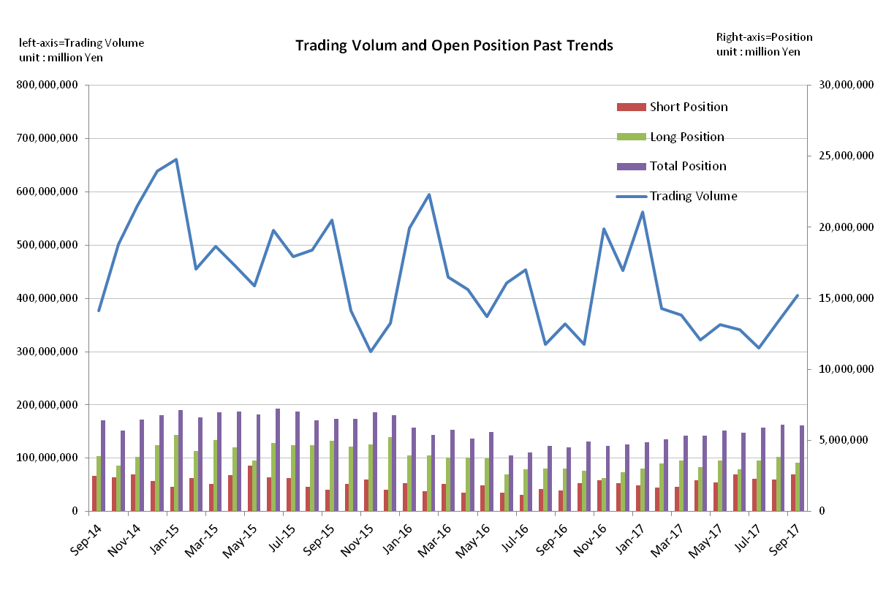
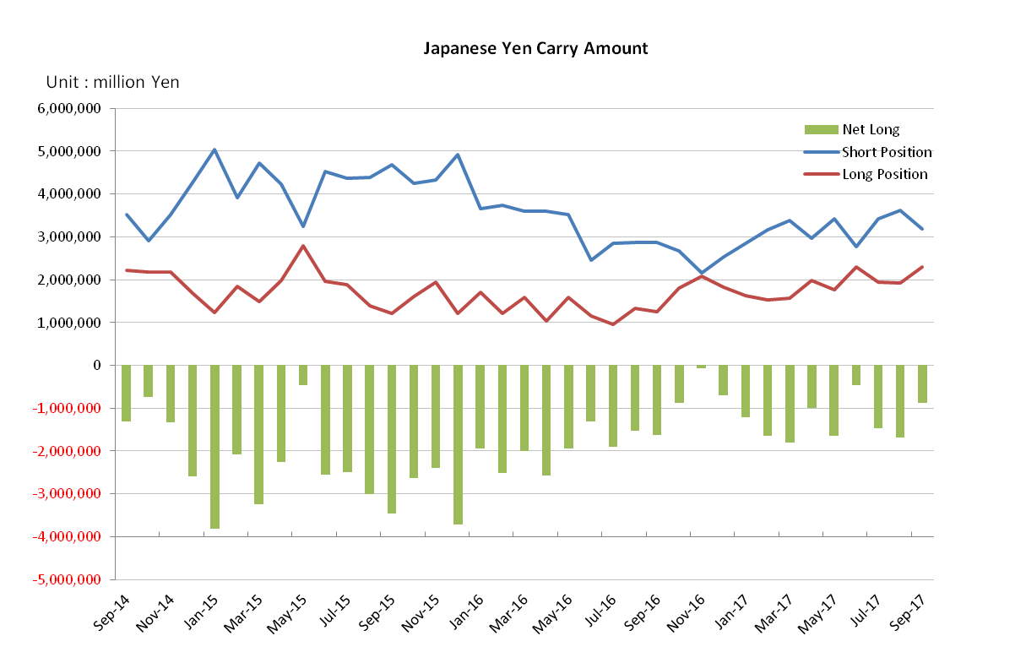

Monthly statistical report on Over-The-Counter Retail FX Margin Trading

：August, 2017
Publication date : 14 September. 2017
Number of Over-The-Counter Retail FX Margin Trading Operators as of 31 August. 2017 :54
Number of members reported :54
【Trading Volume】
(Unit: hundred million Yen, %)
 | Over-The-Counter | USDJPY, Cross Yen | On-Exchange*(for reference)
This month | 3,576,465 | 3,246,672 | 23,959
Previous month | 3,063,369 | 2,844,426 | 23,158
Change | 16.75% | 14.14% | 3.46%
*source : Monthly Trading Volume of Tokyo Financial exchange Inc.(The FFAJ converts the total number of contracts into the trading volume on the settlement prices of the end of the month)
【Open Positions】
(Unit: hundred million Yen)
 | Short | Long | Total
This month | 22,475 | 38,419 | 60,894
Previous month | 23,091 | 36,049 | 59,141
Change | -616 | 2,369 | 1,753

・USDJPY, Cross Yen Open Positions
(Unit: hundred million Yen)
 | ① Short | ② Long | Net long=②-①
This month | 36,096 | 19,163 | -16,932
Previous month | 34,163 | 19,479 | -14,684

（Reference：USDJPY Monthly Rate＊）
（Unit: Yen）
End of last Month*1 | Highest of the Month | Lowest of the Month | End of the Month*1 | Average*2
110.63 | 110.93 | 108.33 | 110.49 | 109.91
*source : BOJ's Main Time-series Statistics (Monthly)
*1) Spot Rate at 17:00 in JST, End of Month, Tokyo Market
*2) Average of Central Rate in the Month, Tokyo Market
○ Notes
The volume of this month was about 358 trillion yen (an increase of 16.8% from the previous month), the trading volume on a business day basis excluding weekends also increased.
The open positions balance at the end of the month increased since the end of the previous month,
short positions decreased, but long positions increased, totaling about 6.09 trillion yen.

～Tables and Historical Graphs～
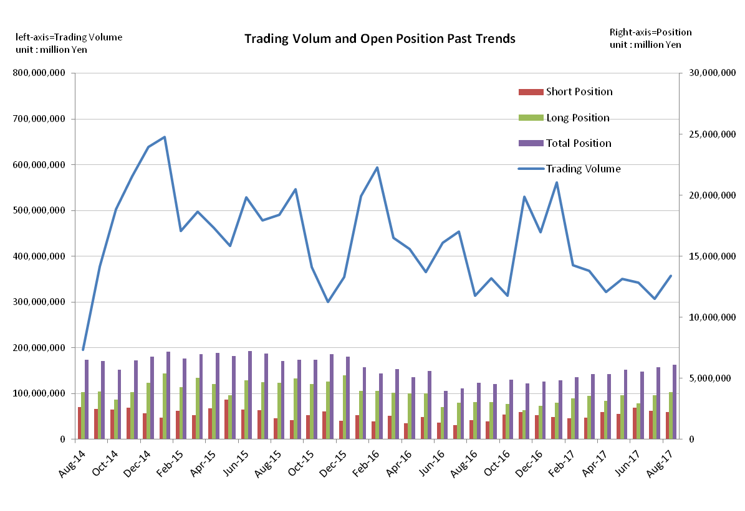
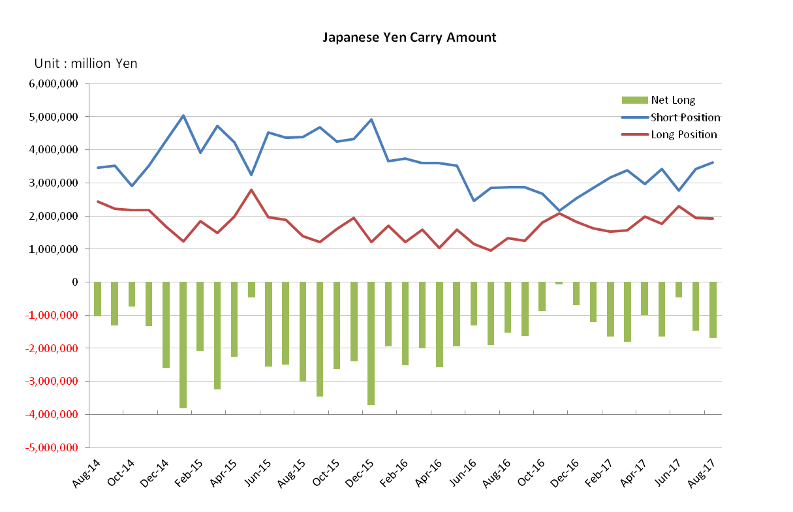

Monthly statistical report on Over-The-Counter Retail FX Margin Trading

：July, 2017
Publication date : 15 August. 2017
Number of Over-The-Counter Retail FX Margin Trading Operators as of 31 July. 2017 :54
Number of members reported :54
【Trading Volume】
(Unit: hundred million Yen, %)
 | Over-The-Counter | USDJPY, Cross Yen | On-Exchange*(for reference)
This month | 3,063,369 | 2,844,426 | 23,158
Previous month | 3,418,490 | 3,188,659 | 24,652
Change | -10.39% | -10.80% | -6.06%
*source : Monthly Trading Volume of Tokyo Financial exchange Inc.(The FFAJ converts the total number of contracts into the trading volume on the settlement prices of the end of the month)
【Open Positions】
(Unit: hundred million Yen)
 | Short | Long | Total
This month | 23,091 | 36,049 | 59,141
Previous month | 26,091 | 29,569 | 55,660
Change | -2,999 | 6,479 | 3,480

・USDJPY, Cross Yen Open Positions
(Unit: hundred million Yen)
 | ① Short | ② Long | Net long=②-①
This month | 34,163 | 19,479 | -14,684
Previous month | 27,625 | 23,004 | -4,620

（Reference：USDJPY Monthly Rate＊）
（Unit: Yen）
End of last Month*1 | Highest of the Month | Lowest of the Month | End of the Month*1 | Average*2
112.06 | 114.47 | 110.30 | 110.63 | 112.44
*source : BOJ's Main Time-series Statistics (Monthly)
*1) Spot Rate at 17:00 in JST, End of Month, Tokyo Market
*2) Average of Central Rate in the Month, Tokyo Market
○ Notes
The volume of this month was about 306 trillion yen (a decrease of 10.4% from the previous month), the trading volume on a business day basis excluding weekends also decreased.
The open positions balance at the end of the month increased since the end of the previous month,
short positions decreased, but long positions increased, totaling about 5.91 trillion yen.

～Tables and Historical Graphs～
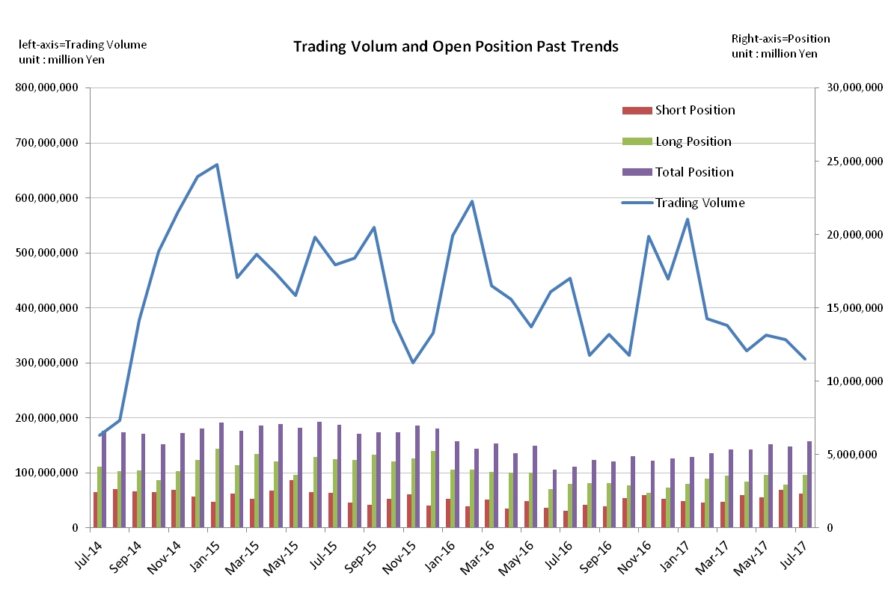

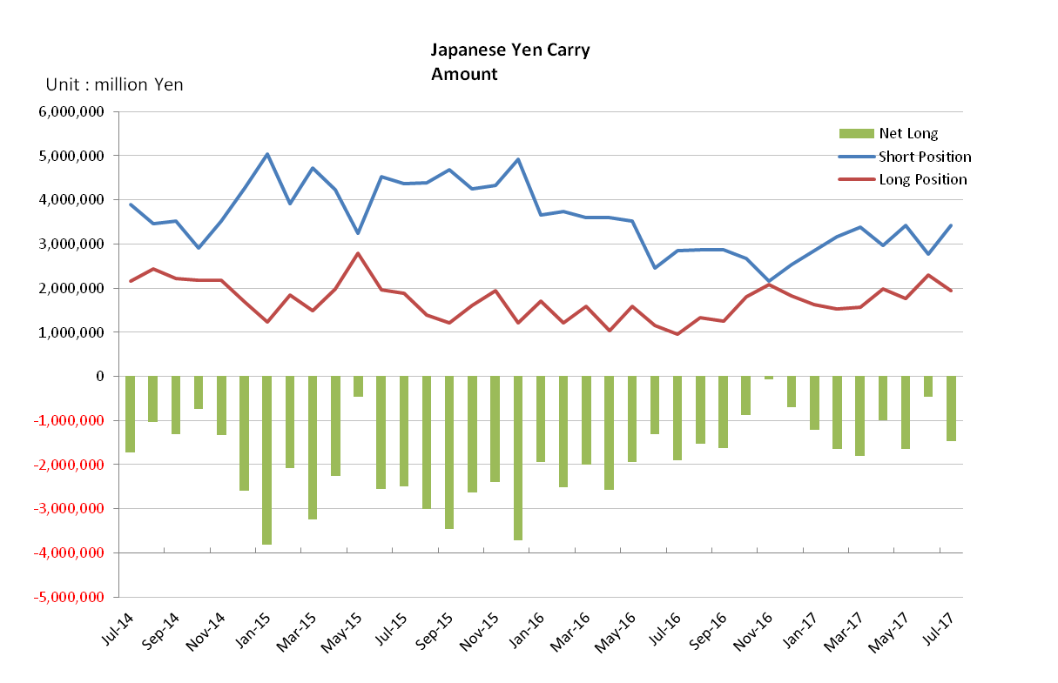

Monthly statistical report on Over-The-Counter Retail FX Margin Trading

：June, 2017
Publication date : 14 July. 2017
Number of Over-The-Counter Retail FX Margin Trading Operators as of 30 June. 2017 :54
Number of members reported :54
【Trading Volume】
(Unit: hundred million Yen, %)
 | Over-The-Counter | USDJPY, Cross Yen | On-Exchange*(for reference)
This month | 3,418,490 | 3,188,659 | 24,652
Previous month | 3,502,930 | 3,300,878 | 21,609
Change | -2.41% | -3.40% | +14.08%
*source : Monthly Trading Volume of Tokyo Financial exchange Inc.(The FFAJ converts the total number of contracts into the trading volume on the settlement prices of the end of the month)
【Open Positions】
(Unit: hundred million Yen)
 | Short | Long | Total
This month | 26,091 | 29,569 | 55,660
Previous month | 20,615 | 36,128 | 56,744
Change | 5,475 | -6,559 | -1,083

・USDJPY, Cross Yen Open Positions
(Unit: hundred million Yen)
 | ① Short | ② Long | Net long=②-①
This month | 27,625 | 23,004 | -4,620
Previous month | 34,130 | 17,625 | -16,505

（Reference：USDJPY Monthly Rate＊）
（Unit: Yen）
End of last Month*1 | Highest of the Month | Lowest of the Month | End of the Month*1 | Average*2
110.96 | 112.58 | 109.22 | 112.06 | 110.91
*source : BOJ's Main Time-series Statistics (Monthly)
*1) Spot Rate at 17:00 in JST, End of Month, Tokyo Market
*2) Average of Central Rate in the Month, Tokyo Market
○ Notes
The volume of this month was about 341 trillion yen (a decrease of 2.4% from the previous month), but the trading volume on a business day basis excluding weekends increased.
The open positions balance at the end of the month decreased since the end of the previous month,
short positions increased, but long positions decreased, totaling about 5.56 trillion yen.

～Tables and Historical Graphs～
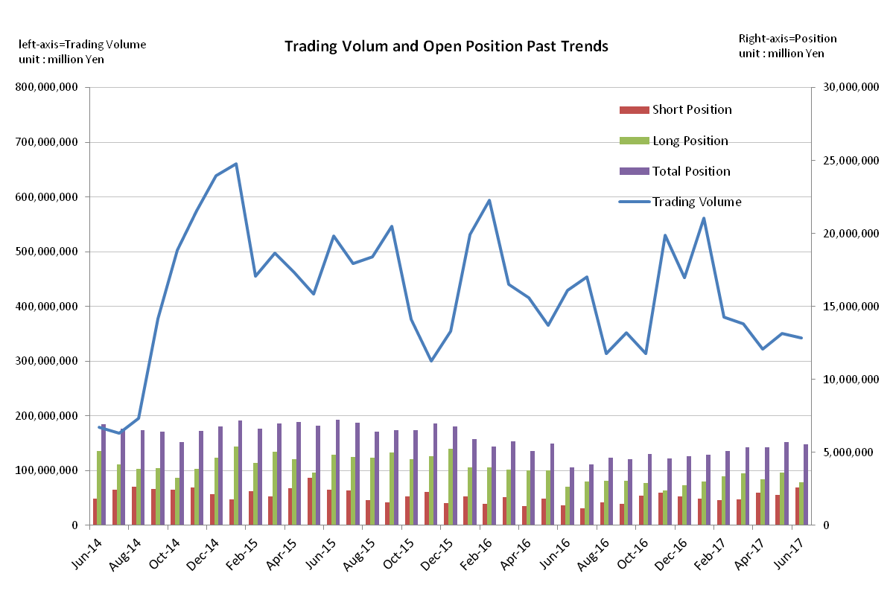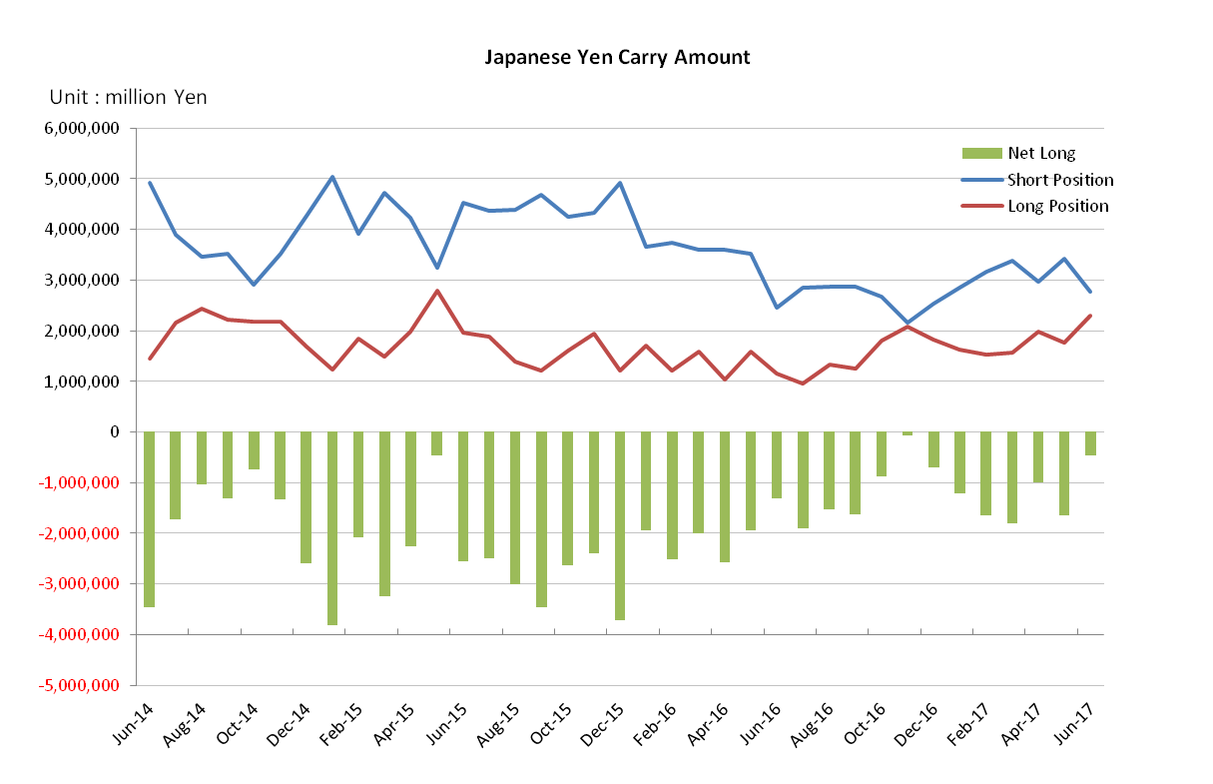

Monthly statistical report on Over-The-Counter Retail FX Margin Trading

：May, 2017
Publication date : 14 June. 2017
Number of Over-The-Counter Retail FX Margin Trading Operators as of 31 May. 2017 :54
Number of members reported :54
【Trading Volume】
(Unit: hundred million Yen, %)
 | Over-The-Counter | USDJPY, Cross Yen | On-Exchange*(for reference)
This month | 3,502,930 | 3,300,878 | 21,609
Previous month | 3,217,567 | 3,065,665 | 22,544
Change | +8.87% | +7.67% | -4.15%
*source : Monthly Trading Volume of Tokyo Financial exchange Inc.(The FFAJ converts the total number of contracts into the trading volume on the settlement prices of the end of the month)
【Open Positions】
(Unit: hundred million Yen)
 | Short | Long | Total
This month | 20,615 | 36,128 | 56,744
Previous month | 22,058 | 31,479 | 53,537
Change | -1,442 | +4,649 | -3,207

・USDJPY, Cross Yen Open Positions
(Unit: hundred million Yen)
 | ① Short | ② Long | Net long=②-①
This month | 34,130 | 17,625 | -16,505
Previous month | 29,750 | 19,834 | -9,916

（Reference：USDJPY Monthly Rate＊）
（Unit: Yen）
End of last Month*1 | Highest of the Month | Lowest of the Month | End of the Month*1 | Average*2
111.29 | 114.37 | 110.72 | 110.96 | 112.21
*source : BOJ's Main Time-series Statistics (Monthly)
*1) Spot Rate at 17:00 in JST, End of Month, Tokyo Market
*2) Average of Central Rate in the Month, Tokyo Market
○ Notes
The volume of this month was about 350 trillion yen (a increase of 8.9% from the previous month), but the trading volume on a business day basis excluding weekends decreased.
The open positions balance at the end of the month increased since the end of the previous month, long position increased, but short position decreased, totaling about 5.67 trillion yen.

～Tables and Historical Graphs～
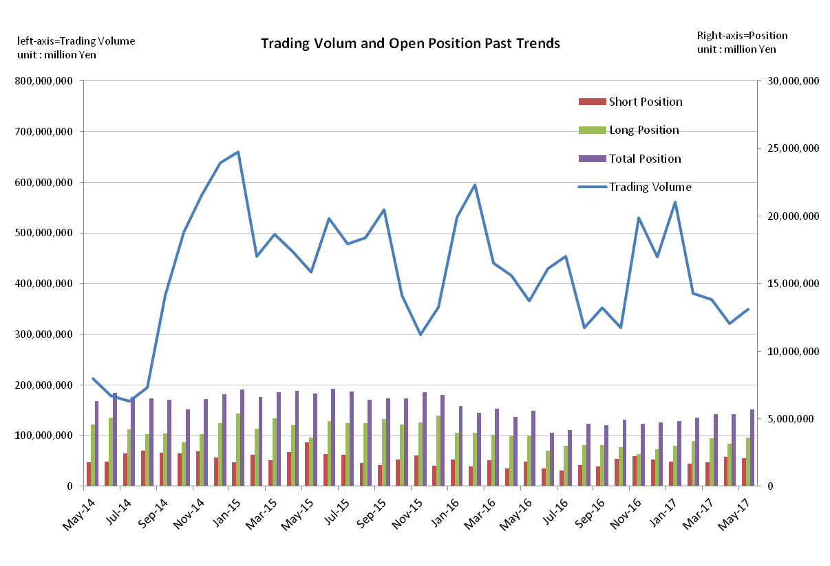
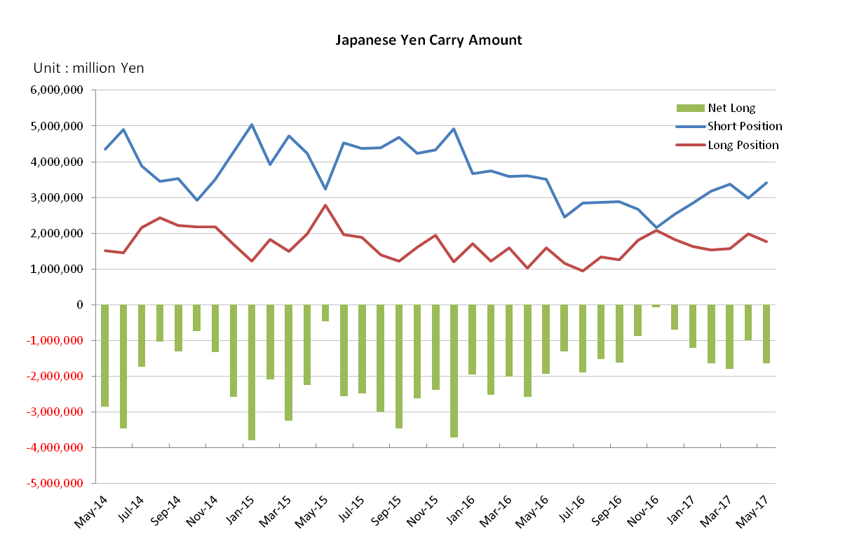

Monthly statistical report on Over-The-Counter Retail FX Margin Trading

：April, 2017
Publication date : 17 May. 2017
Number of Over-The-Counter Retail FX Margin Trading Operators as of 30 April. 2017 :54
Number of members reported :54
【Trading Volume】
(Unit: hundred million Yen, %)
 | Over-The-Counter | USDJPY, Cross Yen | On-Exchange*(for reference)
This month | 3,217,567 | 3,065,665 | 22,544
Previous month | 3,685,848 | 3,481,332 | 27,652
Change | －12.70 | －11.94 | －18.47
*source : Monthly Trading Volume of Tokyo Financial exchange Inc.(The FFAJ converts the total number of contracts into the trading volume on the settlement prices of the end of the month)
【Open Positions】
(Unit: hundred million Yen)
 | Short | Long | Total
This month | 22,058 | 31,479 | 53,537
Previous month | 17,629 | 35,753 | 53,382
Change | +4,428 | － 2,114 | + 155

・USDJPY, Cross Yen Open Positions
(Unit: hundred million Yen)
 | ① Short | ② Long | Net long=②-①
This month | 29,750 | 19,834 | －9,916
Previous month | 33,717 | 15,691 | －18,026

（Reference：USDJPY Monthly Rate＊）
（Unit: Yen）
End of last Month*1 | Highest of the Month | Lowest of the Month | End of the Month*1 | Average*2
111.80 | 111.59 | 108.13 | 111.29 | 110.06
*source : BOJ's Main Time-series Statistics (Monthly)
*1) Spot Rate at 17:00 in JST, End of Month, Tokyo Market
*2) Average of Central Rate in the Month, Tokyo Market
○ Notes
The volume of this month was about 321 trillion yen (a decrease of12.7% from the previous month), and it decreased for 3 consecutive months.
The open positions balance at the end of the month increased slightly from the end of the previous month, long position has decreased, but, short position has increased, totaling about 5.35 trillion yen.

～Tables and Historical Graphs～

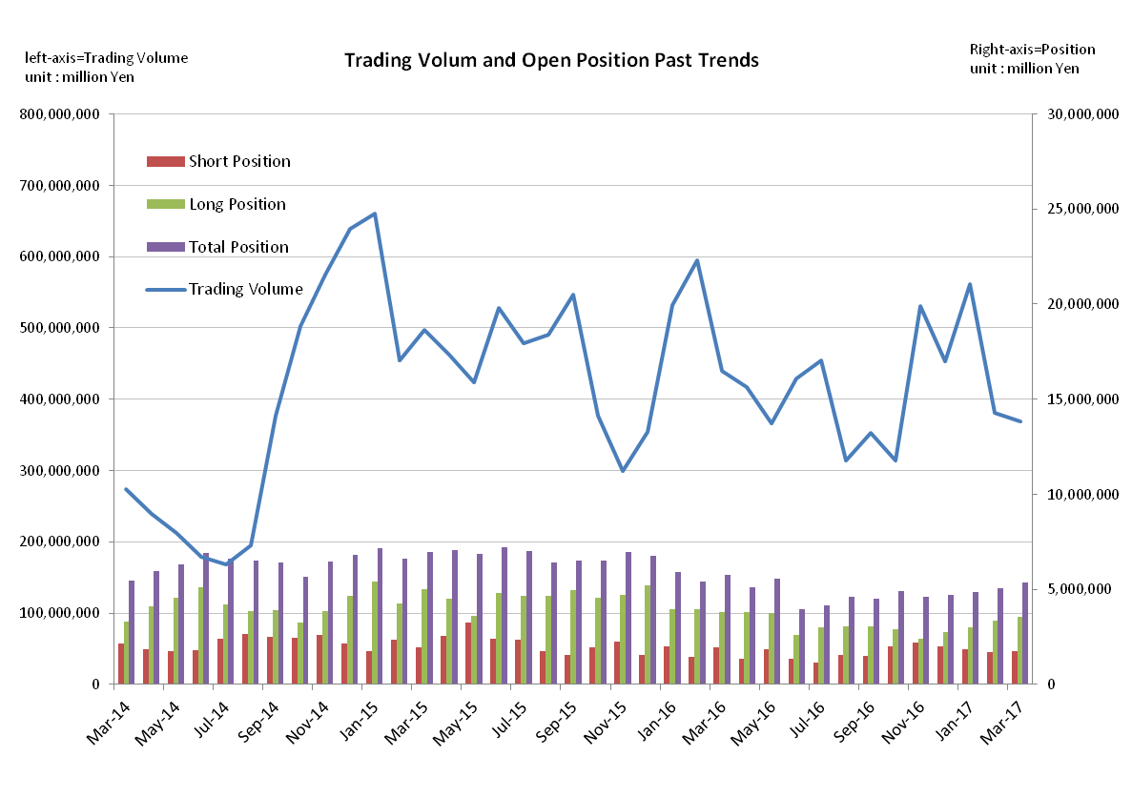
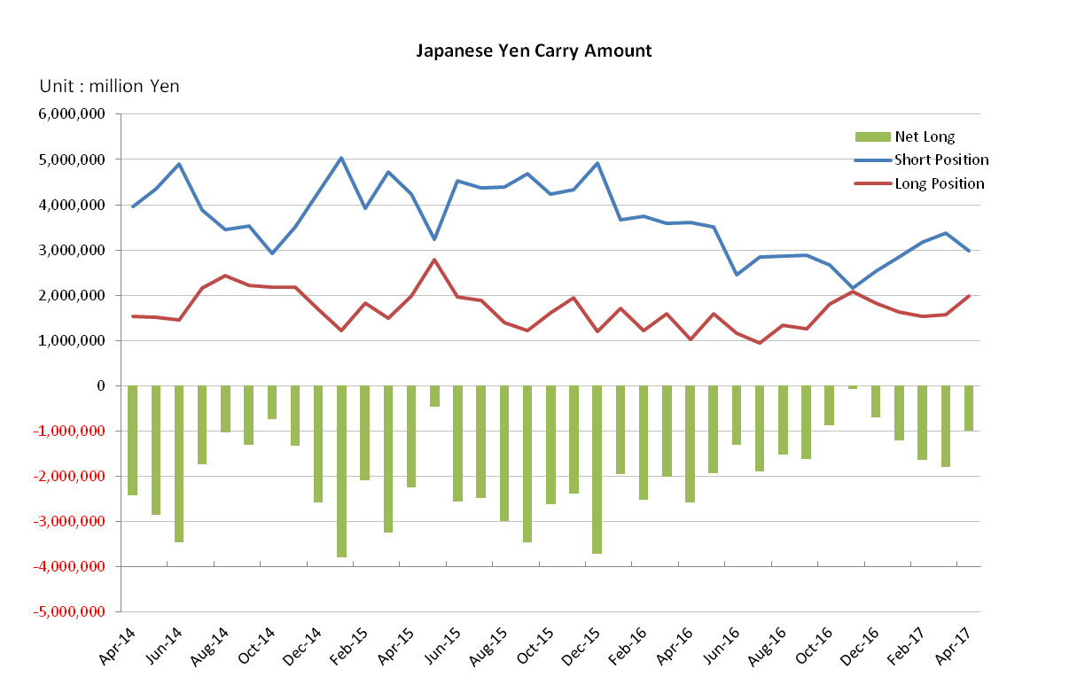

Monthly statistical report on Over-The-Counter Retail FX Margin Trading

：March , 2017
Publication date : 14 April. 2017
Number of Over-The-Counter Retail FX Margin Trading Operators as of 31 March. 2017 :53
Number of members reported :53
【Trading Volume】
(Unit: hundred million Yen, %)
 | Over-The-Counter | USDJPY, Cross Yen | On-Exchange*(for reference)
This month | 3,655,848 | 3,481,332 | 27,652
Previous month | 3,804,821 | 3,630,432 | 25,432
Change | － 3.13 | － 4.11 | + 8.73
*source : Monthly Trading Volume of Tokyo Financial exchange Inc.(The FFAJ converts the total number of contracts into the trading volume on the settlement prices of the end of the month)
【Open Positions】
(Unit: hundred million Yen)
 | Short | Long | Total
This month | 17,629 | 35,753 | 53,382
Previous month | 17,007 | 33,638 | 50,645
Change | +621 | + 2,114 | + 2,736

・USDJPY, Cross Yen Open Positions
(Unit: hundred million Yen)
 | ① Short | ② Long | Net long=②-①
This month | 33,717 | 15,691 | －18,026
Previous month | 31,720 | 15,261 | －16,459

（Reference：USDJPY Monthly Rate＊）
（Unit: Yen）
End of last Month*1 | Highest of the Month | Lowest of the Month | End of the Month*1 | Average*2
112.31 | 115.46 | 110.12 | 111.80 | 113.01
*source : BOJ's Main Time-series Statistics (Monthly)
*1) Spot Rate at 17:00 in JST, End of Month, Tokyo Market
*2) Average of Central Rate in the Month, Tokyo Market
○ Notes
The volume of this month was about 369 trillion yen (a decrease of 3.13% from the previous month), and it decreased for 2 consecutive months.
Meanwhile, the open positions balance at the end of the month increased from the end of the previous month, both long position and short position, totaling about 5.3 trillion yen.

～Tables and Historical Graphs～

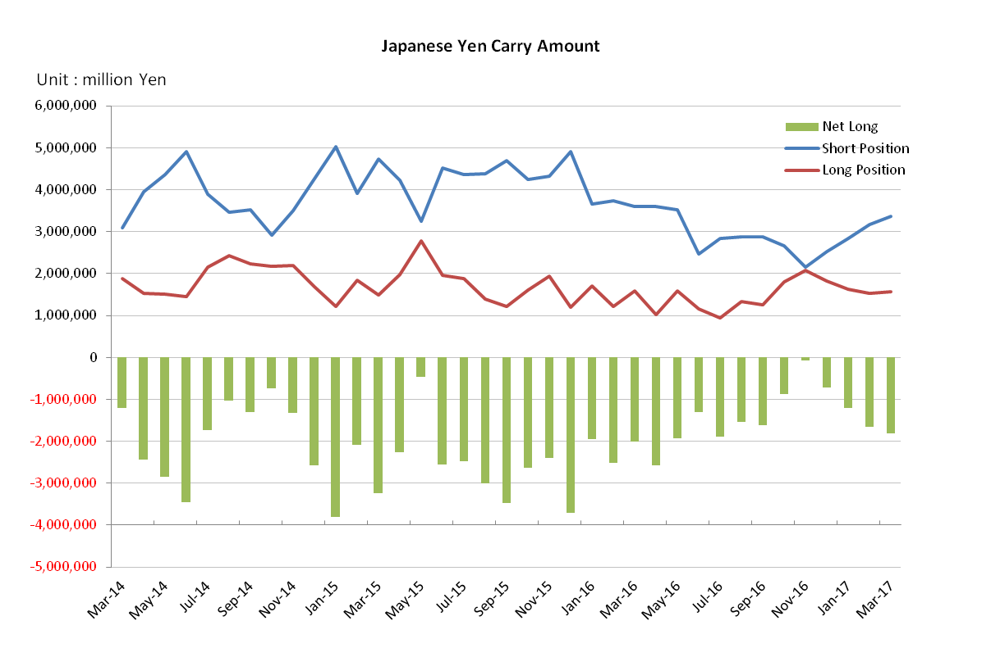

Monthly statistical report on Over-The-Counter Retail FX Margin Trading

：February , 2017
Publication date : 14 March. 2017
Number of Over-The-Counter Retail FX Margin Trading Operators as of 28 February. 2017 :53
Number of members reported :53
【Trading Volume】
(Unit: hundred million Yen, %)
 | Over-The-Counter | USDJPY, Cross Yen | On-Exchange*(for reference)
This month | 3,804,821 | 3,630,432 | 25,432
Previous month | 5,614,390 | 5,370,508 | 33,157
Change | － 32.23 | － 32.40 | － 23.30
*source : Monthly Trading Volume of Tokyo Financial exchange Inc.(The FFAJ converts the total number of contracts into the trading volume on the settlement prices of the end of the month)
【Open Positions】
(Unit: hundred million Yen)
 | Short | Long | Total
This month | 17,007 | 33,638 | 50,645
Previous month | 18,327 | 30,184 | 48,511
Change | －1,319 | + 3,454 | + 2,134

・USDJPY, Cross Yen Open Positions
(Unit: hundred million Yen)
 | ① Short | ② Long | Net long=②-①
This month | 31,720 | 15,261 | －16,459
Previous month | 28,440 | 16,314 | － 12,125

（Reference：USDJPY Monthly Rate＊）
（Unit: Yen）
End of last Month*1 | Highest of the Month | Lowest of the Month | End of the Month*1 | Average*2
113.53 | 114.59 | 111.59 | 112.31 | 113.06
*source : BOJ's Main Time-series Statistics (Monthly)
*1) Spot Rate at 17:00 in JST, End of Month, Tokyo Market
*2) Average of Central Rate in the Month, Tokyo Market
○ Notes
The trading volume of the month decreased by 32.23% from the previous month, falling below 400 trillion yen for the first time in 4 months (about 380 trillion yen).
As of the end of the month, the open positions balance at the end of the month has increased slightly since the end of the previous month, totaling about 5 trillion yen.

～Tables and Historical Graphs～

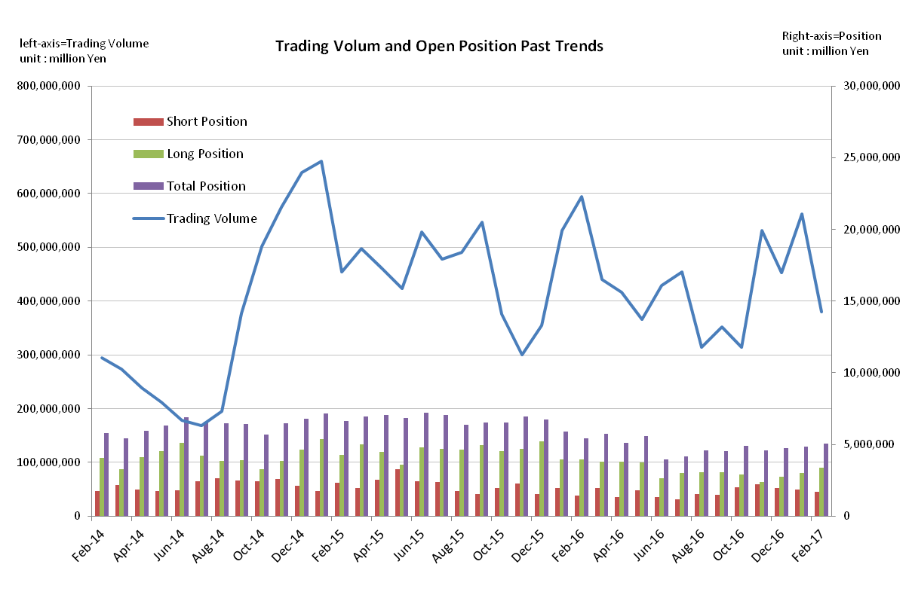

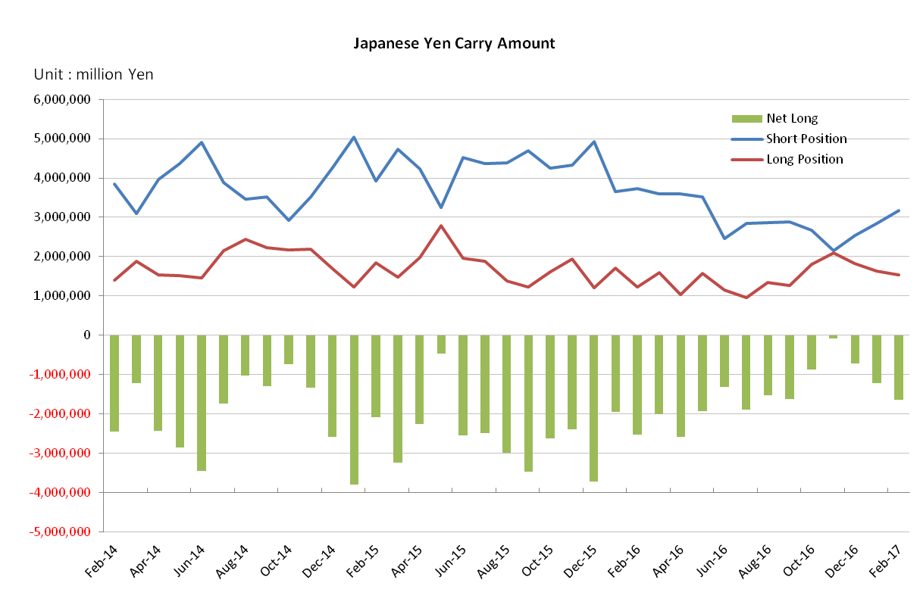

Monthly statistical report on Over-The-Counter Retail FX Margin Trading

：January , 2017
Publication date : 14 February. 2017
Number of Over-The-Counter Retail FX Margin Trading Operators as of 31 January. 2017 :53
Number of members reported :53
【Trading Volume】
(Unit: hundred million Yen, %)
 | Over-The-Counter | USDJPY, Cross Yen | On-Exchange*(for reference)
This month | 5,614,390 | 5,370,508 | 33,157
Previous month | 4,523,691 | 4,300,527 | 36,391
Change | + 24.11 | + 24.88 | － 8.88
*source : Monthly Trading Volume of Tokyo Financial exchange Inc.(The FFAJ converts the total number of contracts into the trading volume on the settlement prices of the end of the month)
【Open Positions】
(Unit: hundred million Yen)
 | Short | Long | Total
This month | 18,327 | 30,184 | 48,511
Previous month | 19,815 | 27,473 | 47,288
Change | －1,487 | + 2,710 | + 1,222

・USDJPY, Cross Yen Open Positions
(Unit: hundred million Yen)
 | ① Short | ② Long | Net long=②-①
This month | 28,440 | 16,314 | －12,125
Previous month | 25,341 | 18,247 | － 7,093

（Reference：USDJPY Monthly Rate＊）
（Unit: Yen）
End of last Month*1 | Highest of the Month | Lowest of the Month | End of the Month*1 | Average*2
117.11 | 118.18 | 112.53 | 113.53 | 114.73
*source : BOJ's Main Time-series Statistics (Monthly)
*1) Spot Rate at 17:00 in JST, End of Month, Tokyo Market
*2) Average of Central Rate in the Month, Tokyo Market
○ Notes
The trading volume of the first month in 2017 increased by 24.11% from the previous month to 561 trillion yen, and it made a smooth start.
In the other hand, the open positions balance of all currencies at the end of the month had increased slightly from the end of the previous month to 4.8 trillion yen, but it remained at a low level continuing from the previous year's June.

～Tables and Historical Graphs～

