Over-The-Counter FX Margin Trading Report

(January 2016 ～December 2016)

Monthly Report
January 2016
February 2016
March 2016
April 2016
May 2016
June 2016
July 2016
Augusut 2016
September 2016
October 2016
November 2016
December2016

The Financial Futures Association of Japan, Research Department

NBF Ogawamachi Building 1-3 , Kanda Ogawamachi ,
Chiyoda-ku , Tokyo 101-0052 Tel:(03)5280-0881 E-mail : ffaj@ffaj.or.jp

This publication has been prepared by the FFAJ and is provided for information purpose only. The monthly information contained in this publication has been obtained from FFAJ's members that is believed to be reliable, however the FFAJ does not represent or warrant that it is accurate or complete. In no event the FFAJ nor its employees have any liability for any consequential damages arising from any use of this publications or its contents. This publication does not constitute any investment advice.

Monthly statistical report on Over-The-Counter Retail FX Margin Trading

：December , 2016

Publication date : 18 January. 2017
Number of Over-The-Counter Retail FX Margin Trading Operators as of 31 December.2016 :53
Number of members reported :53

【Trading Volume】
(Unit: hundred million Yen, %)
 | Over-The-Counter | USDJPY, Cross Yen | On-Exchange*(for reference)
November | 4,523,691 | 4,300,527 | 36,391
Previous month | 5,305,453 | 5,078,808 | 49,628
Change | －14.73 | －15.32 | －26.67
*source : Monthly Trading Volume of Tokyo Financial exchange Inc.(The FFAJ converts the total number of contracts into the trading volume on the settlement prices of the end of the month)
【Open Positions】
(Unit: hundred million Yen)
 | Short | Long | Total
November | 19,815 | 27,473 | 47,288
Previous month | 22,219 | 23,788 | 46,007
Change | －2,404 | 3,685 | 1,280

・USDJPY, Cross Yen Open Positions
(Unit: hundred million Yen)
 | ① Short | ② Long | Net long=②-①
November | 25,341 | 18,247 | －7,093
Previous month | 21,605 | 20,847 | －758

（Reference：USDJPY Monthly Rate＊）
（Unit: Yen）
End of last Month*1 | Highest of the Month | Lowest of the Month | End of the Month*1 | Average*2
112.73 | 118.39 | 112.87 | 117.11 | 115.95
*source : BOJ's Main Time-series Statistics (Monthly)
*1) Spot Rate at 17:00 in JST, End of Month, Tokyo Market
*2) Average of Central Rate in the Month, Tokyo Market
○ Notes
The trading volume of OTC FX margin trading of this month decreased by 14.7% compared to the previous month, it was 452 trillion yen. In addition, the total annual trading volume of 2016 was 5,194 trillion yen, and the average monthly trading volume was 432 trillion yen.
As of the end of the previous month, open positions where the balance of short position and long position approached sharply, at the end of the month the net yen short position grew sharply because of turning to foreign currency repurchase. As a result, total of Open positions also increased by 128 billion yen.

～Tables and Historical Graphs～

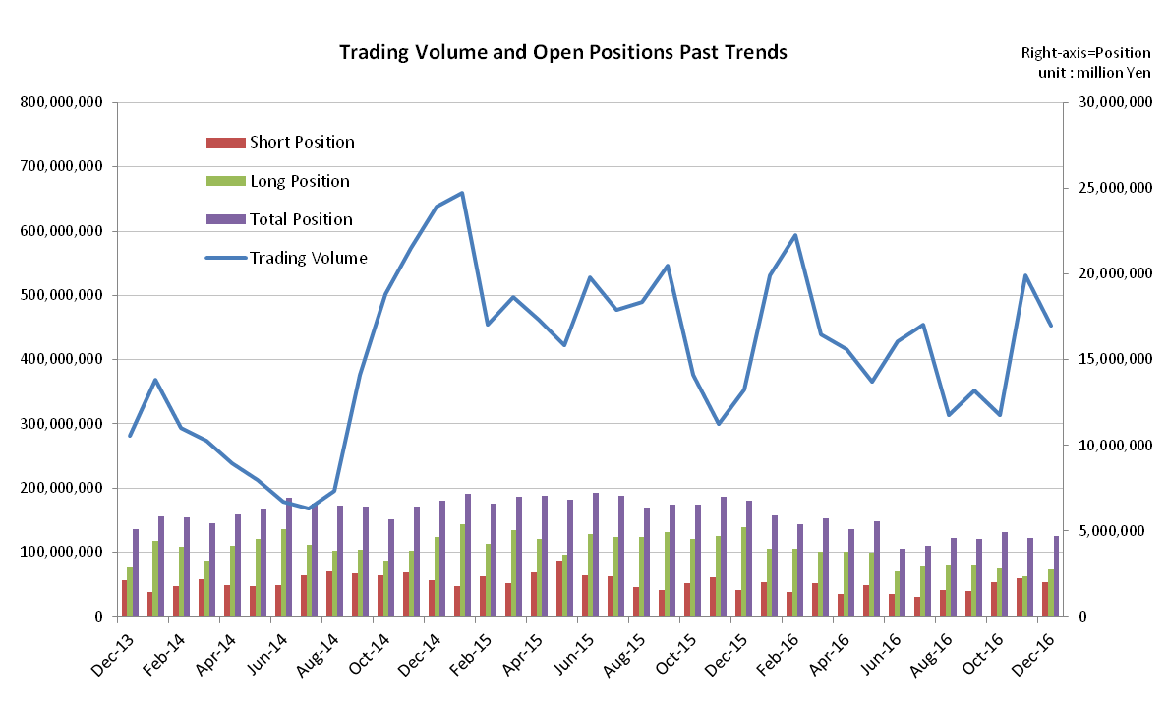

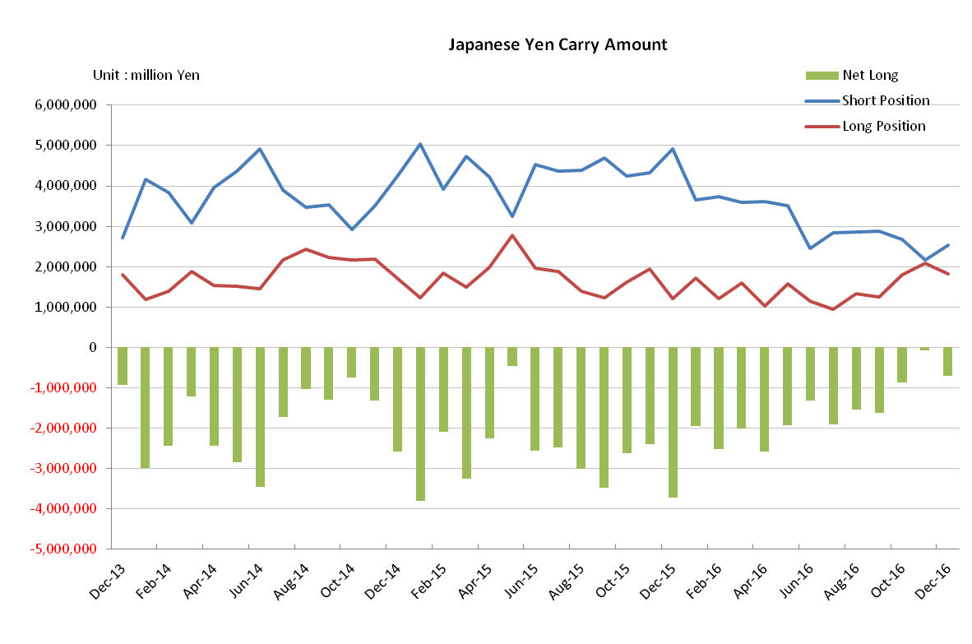

Monthly statistical report on Over-The-Counter Retail FX Margin Trading

：November , 2016

Publication date : 14 December. 2016
Number of Over-The-Counter Retail FX Margin Trading Operators as of 30 November . 2016 :53
Number of members reported :53

【Trading Volume】
(Unit: hundred million Yen, %)
 | Over-The-Counter | USDJPY, Cross Yen | On-Exchange*(for reference)
November | 5,302,512 | 5,073,531 | 49,628
Previous month | 3,136,777 | 2,885,908 | 33,583
Change | + 69.04 | + 75.80 | + 47.77
*source : Monthly Trading Volume of Tokyo Financial exchange Inc.(The FFAJ converts the total number of contracts into the trading volume on the settlement prices of the end of the month)
【Open Positions】
(Unit: hundred million Yen)
 | Short | Long | Total
November | 22,234 | 23,799 | 46,034
Previous month | 20,170 | 28,895 | 49,066
Change | + 2,063 | －5,095 | －3,032

・USDJPY, Cross Yen Open Positions
(Unit: hundred million Yen)
 | ① Short | ② Long | Net long=②-①
November | 21,620 | 20,851 | － 768
Previous month | 26,688 | 17,992 | －8,696

（Reference：USDJPY Monthly Rate＊）
（Unit: Yen）
End of last Month*1 | Highest of the Month | Lowest of the Month | End of the Month*1 | Average*2
104.92 | 113.9 | 101.19 | 112.73 | 108.18
*source : BOJ's Main Time-series Statistics (Monthly)
*1) Spot Rate at 17:00 in JST, End of Month, Tokyo Market
*2) Average of Central Rate in the Month, Tokyo Market
○ Notes
After the US presidential election, the trading volume of OTC FX margins trading of this month increased by 69.04% from the previous month to 530 trillion yen against the strong of the dollar exchange rate. The volume of USDJPY exceeded 80% of the total trading volume, which was almost 429 trillion yen, almost doubling the previous month.
As of the end of the month, the total positions decreased by 303.2 billion yen because the decrease in the long position was greater than the increase in the short position.

The position of USDJPY pair turned over oversold and the net Yen short position at the end of the month fell sharply to 76.8 billion yen from 869.6 billion yen at the end of last month.

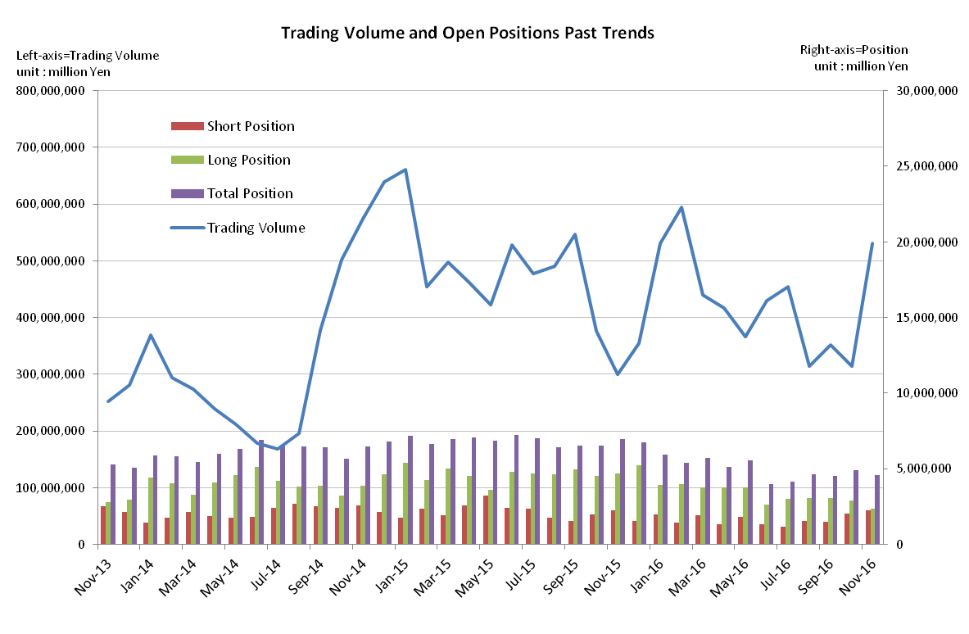
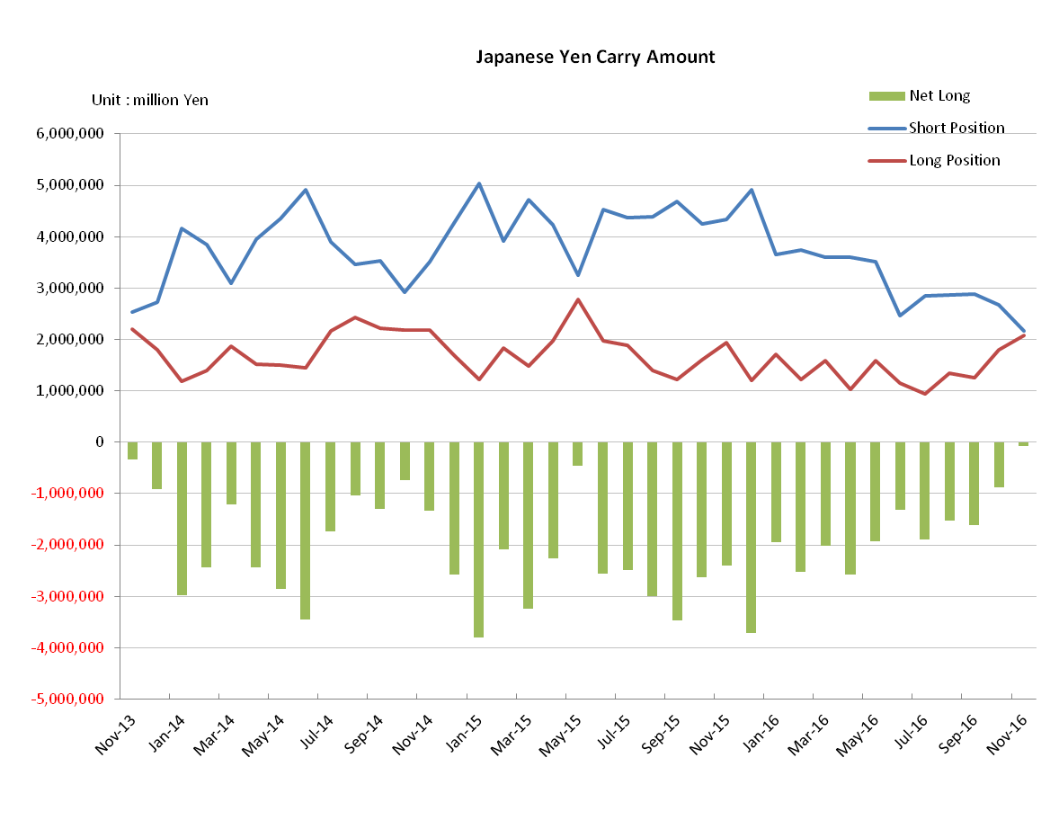
～Tables and Historical Graphs～

Monthly statistical report on Over-The-Counter Retail FX Margin Trading

：October , 2016

Publication date : 15 November. 2016
Number of Over-The-Counter Retail FX Margin Trading Operators as of 31 October . 2016 :53
Number of members reported :53

【Trading Volume】
(Unit: hundred million Yen, %)
 | Over-The-Counter | USDJPY, Cross Yen | On-Exchange*(for reference)
October | 3,136,777 | 2,885,908 | 33,583
Previous month | 3,524,658 | 3,361,100 | 31,777
Change | －11.00 | －14.13 | + 5.68
*source : Monthly Trading Volume of Tokyo Financial exchange Inc.(The FFAJ converts the total number of contracts into the trading volume on the settlement prices of the end of the month)
【Open Positions】
(Unit: hundred million Yen)
 | Short | Long | Total
October | 20,170 | 28,895 | 49,066
Previous month | 14,726 | 30,486 | 45,212
Change | +5,444 | －1,590 | +3,853

・USDJPY, Cross Yen Open Positions
(Unit: hundred million Yen)
 | ① Short | ② Long | Net long=②-①
October | 26,688 | 17,992 | －8,696
Previous month | 28,777 | 12,568 | －16,209

（Reference：USDJPY Monthly Rate＊）
（Unit: Yen）
End of last Month*1 | Highest of the Month | Lowest of the Month | End of the Month*1 | Average*2
100.90 | 105.42 | 101.21 | 104.92 | 103.82
*source : BOJ's Main Time-series Statistics (Monthly)
*1) Spot Rate at 17:00 in JST, End of Month, Tokyo Market
*2) Average of Central Rate in the Month, Tokyo Market
○ Notes
As a whole the market activity was quite low ahead of the US presidential election. The trading volume of OTC FX margins trading decreased by 11.00% compared with the previous month, and it was 313 trillion yen.
Meanwhile, the total position at the end of this month had been shifted to foreign currency selling-Japanese yen buying position, the total balance of positions had also increased. Investors were likely to keep positions while keeping awareness in the direction of yen appreciation.

～Tables and Historical Graphs～

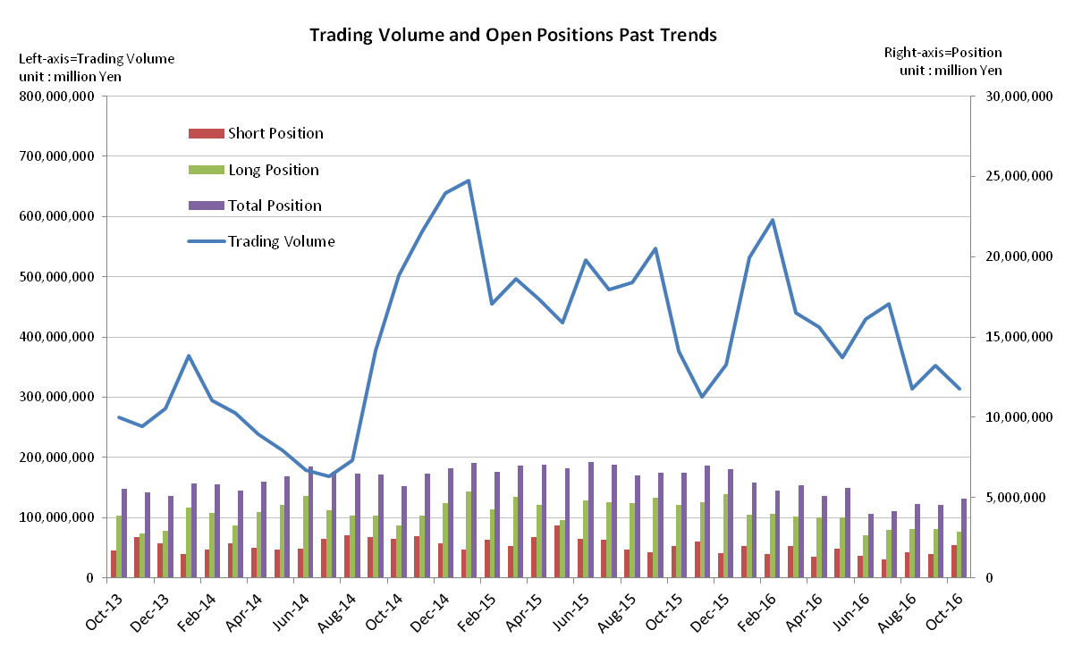

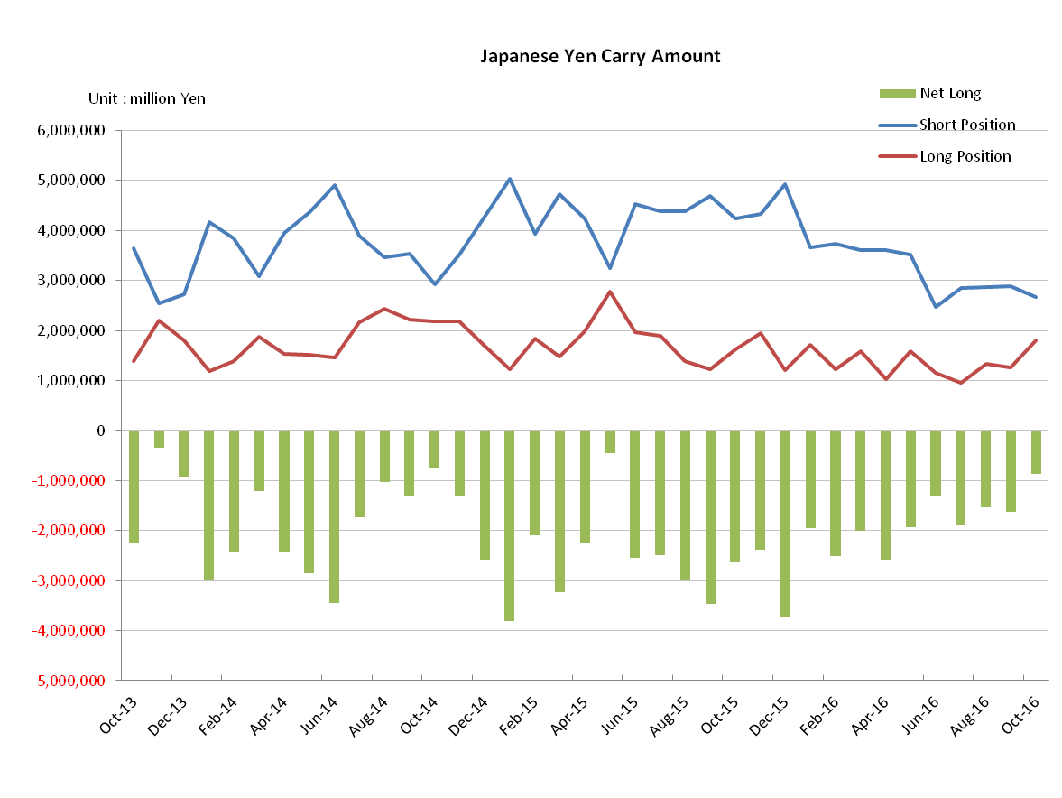

Monthly statistical report on Over-The-Counter Retail FX Margin Trading

：September , 2016
Publication date : 17 October. 2016
Number of Over-The-Counter Retail FX Margin Trading Operators as of 30 September . 2016 :53
Number of members reported :53

【Trading Volume】
(Unit: hundred million Yen, %)
 | Over-The-Counter | USDJPY, Cross Yen | On-Exchange*(for reference)
September | 3,524,636 | 3,361,078 | 31,777
Previous month | 3,135,342 | 2,966,253 | 25,247
Change | 12.41 | 13.31 | 25.86
*source : Monthly Trading Volume of Tokyo Financial exchange Inc.(The FFAJ converts the total number of contracts into the trading volume on the settlement prices of the end of the month)
【Open Positions】
(Unit: hundred million Yen)
 | Short | Long | Total
September | 14,723 | 30,484 | 45,208
Previous month | 15,599 | 30,467 | 46,066
Change | －875 | 16 | －858

・USDJPY, Cross Yen Open Positions
(Unit: hundred million Yen)
 | ① Short | ② Long | Net long=②-①
September | 28,776 | 12,567 | －16,208
Previous month | 28,699 | 13,368 | －15,330

（Reference：USDJPY Monthly Rate＊）
（Unit: Yen）
End of last Month*1 | Highest of the Month | Lowest of the Month | End of the Month*1 | Average*2
103.28 | 104.14 | 100.09 | 100.9 | 102.04
*source : BOJ's Main Time-series Statistics (Monthly)
*1) Spot Rate at 17:00 in JST, End of Month, Tokyo Market
*2) Average of Central Rate in the Month, Tokyo Market
○ Notes
The trading volume of OTC FX margins trading recovered slightly by 12.41% compared with the previous month, and it was 352 trillion yen.
The total position at the end of this month became almost same level as the last month, and furthermore the net Yen short position stayed to increase by 87.83 billion yen.
Last month EURJPY fell below 10 trillion yen that dull business has continued. However the trading volume of this month recovered 10.6 trillion yen as milestone.

～Tables and Historical Graphs～
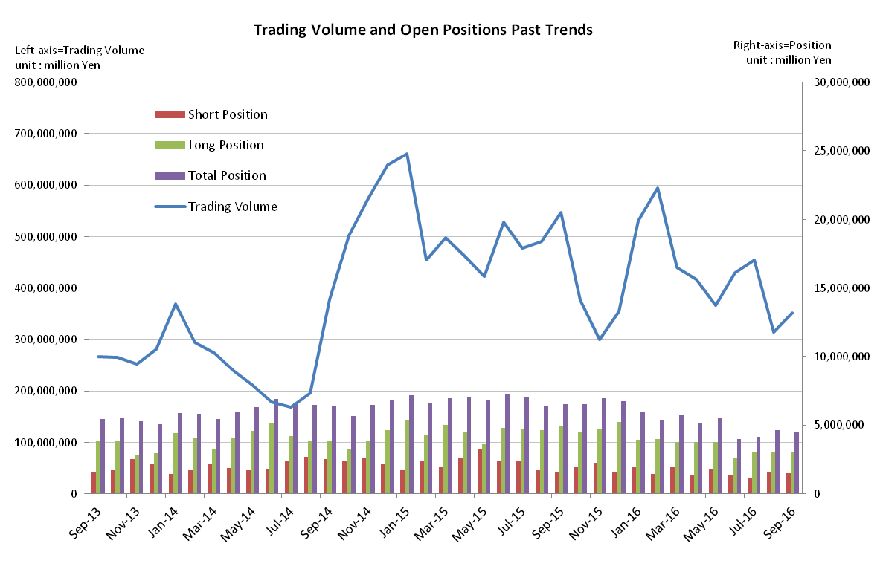
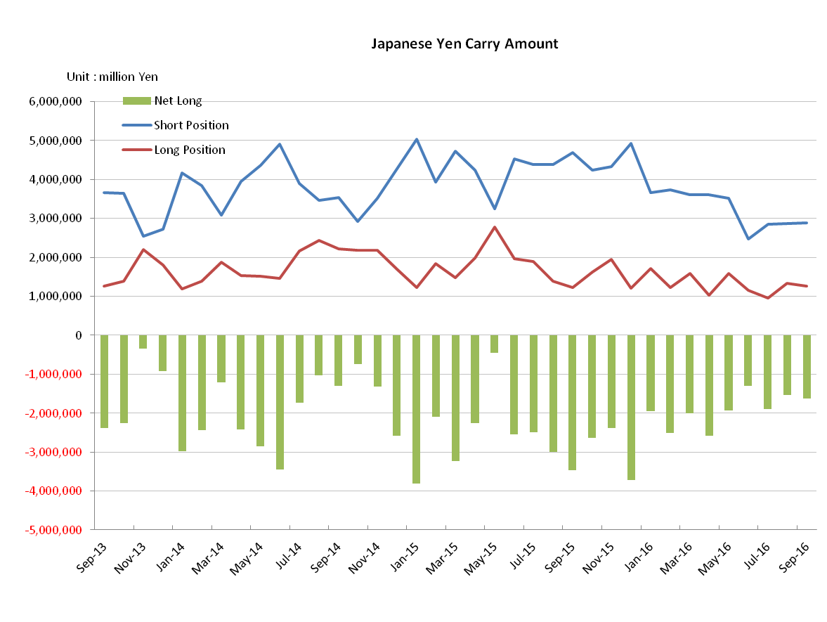

Monthly statistical report on Over-The-Counter Retail FX Margin Trading

：August , 2016
Publication date : 14 September. 2016
Number of Over-The-Counter Retail FX Margin Trading Operators as of 31 August . 2016 :53
Number of members reported :53

【Trading Volume】
(Unit: hundred million Yen, %)
 | Over-The-Counter | USDJPY, Cross Yen | On-Exchange*(for reference)
August | 3,135,342 | 2,966,253 | 25,247
Previous month | 4,543,529 | 4,319,629 | 34,083
Change | －30.99 | －31.33 | －25.92
*source : Monthly Trading Volume of Tokyo Financial exchange Inc.(The FFAJ converts the total number of contracts into the trading volume on the settlement prices of the end of the month)
【Open Positions】
(Unit: hundred million Yen)
 | Short | Long | Total
August | 15,599 | 30,467 | 46,066
Previous month | 11,608 | 29,974 | 41,583
Change | 3,990 | 492 | 4,483

・USDJPY, Cross Yen Open Positions
(Unit: hundred million Yen)
 | ① Short | ② Long | Net long=②-①
August | 28,699 | 13,368 | －15,330
Previous month | 28,470 | 9,487 | －18,982

（Reference：USDJPY Monthly Rate＊）
（Unit: Yen）
End of last Month*1 | Highest of the Month | Lowest of the Month | End of the Month*1 | Average*2
103.63 | 103.33 | 99.65 | 103.28 | 101.27
*source : BOJ's Main Time-series Statistics (Monthly)
*1) Spot Rate at 17:00 in JST, End of Month, Tokyo Market
*2) Average of Central Rate in the Month, Tokyo Market
○ Notes
The trading volume of OTC FX margins trading sharply declined by 30.99% compared with the previous month, and it was 313 trillion yen. In particular with EURJPY, GBPJPY and AUDJPY, their trading volume significantly decreased by more than 40%.
On the other hand, the net yen short position increased, and the total position at the end of this month grew by 448.3 billion yen.

～Tables and Historical Graphs～
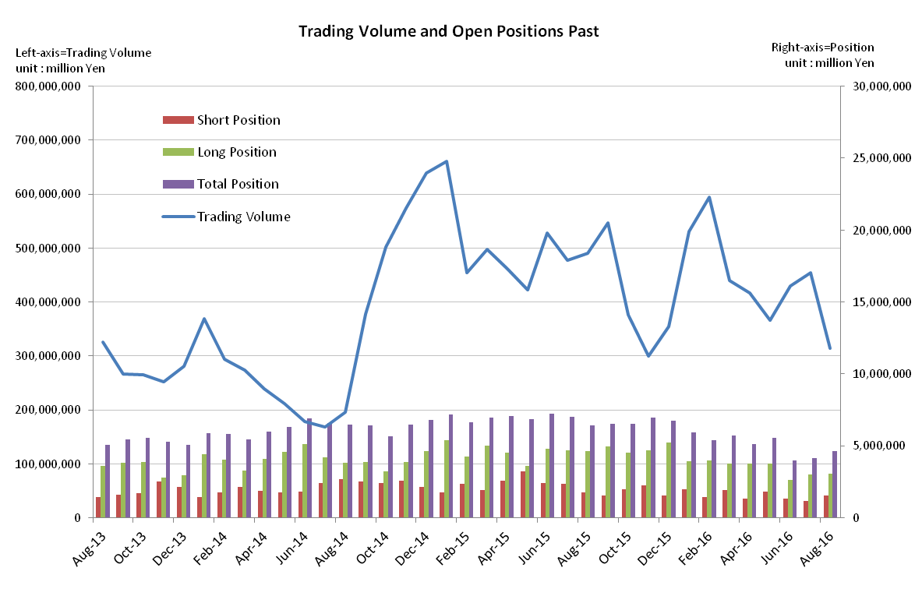
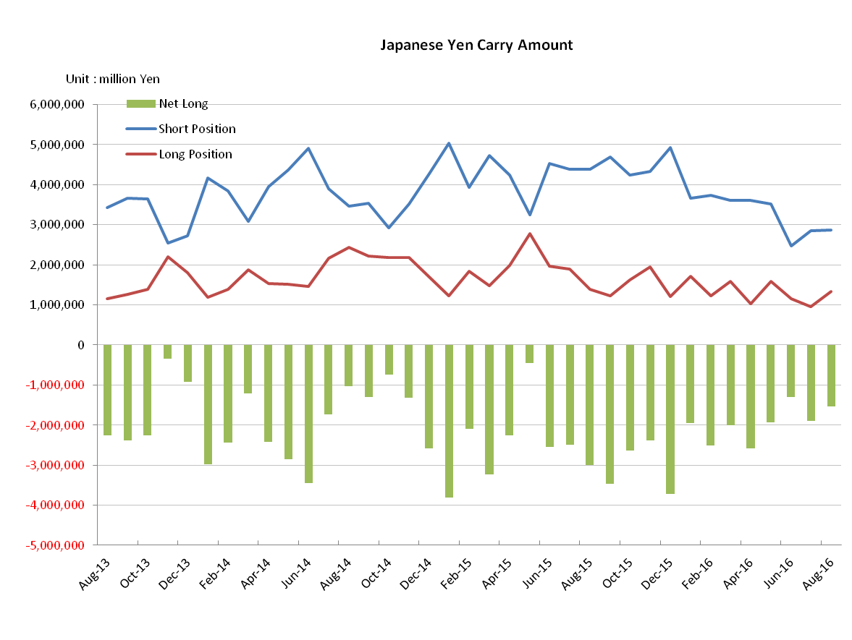

Monthly statistical report on Over-The-Counter Retail FX Margin Trading

：July , 2016
Publication date : 15 August. 2016
Number of Over-The-Counter Retail FX Margin Trading Operators as of 31 July . 2016 :52
Number of members reported :52

【Trading Volume】
(Unit: hundred million Yen, %)
 | Over-The-Counter | USDJPY, Cross Yen | On-Exchange*(for reference)
July | 4,543,529 | 4,319,629 | 34,083
Previous month | 4,293,105 | 4,017,162 | 47,351
Change | ＋5.83 | ＋7.52 | —28.02
*source : Monthly Trading Volume of Tokyo Financial exchange Inc.(The FFAJ converts the total number of contracts into the trading volume on the settlement prices of the end of the month)
【Open Positions】
(Unit: hundred million Yen)
 | Short | Long | Total
July | 11,608 | 29,974 | 41,583
Previous month | 13,438 | 26,221 | 39,660
Change | —1,829 | +3,752 | +1,923

・USDJPY, Cross Yen Open Positions
(Unit: hundred million Yen)
 | ① Short | ② Long | Net long=②-①
July | 28,470 | 9,487 | ‐18,982
Previous month | 24,609 | 11,505 | ‐13,103

（Reference：USDJPY Monthly Rate＊）
（Unit: Yen）
End of last Month*1 | Highest of the Month | Lowest of the Month | End of the Month*1 | Average*2
102.7 | 107.49 | 100.25 | 103.63 | 103.90
*source : BOJ's Main Time-series Statistics (Monthly)
*1) Spot Rate at 17:00 in JST, End of Month, Tokyo Market
*2) Average of Central Rate in the Month, Tokyo Market
○ Notes
The trading volume of OTC FX margins trading was increased after the last month and was 454 trillion yen. In contrast, the trading volume of On-exchange FX margin trading decreased by 28% compared to the previous month.
The total open position at the end of this month was increased by 193.6 billion yen from the previous month. And furthermore the net yen short positions also increased by 587.9 billion yen in reversal from the previous month.

～Tables and Historical Graphs～

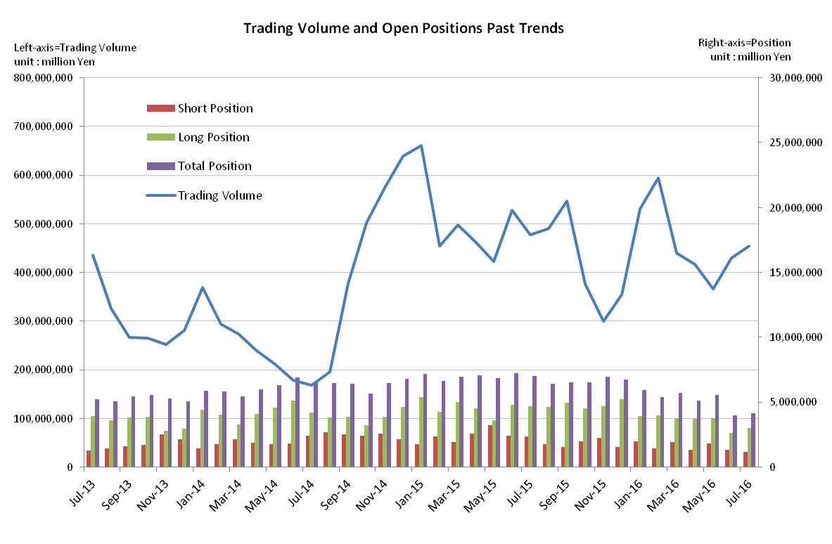

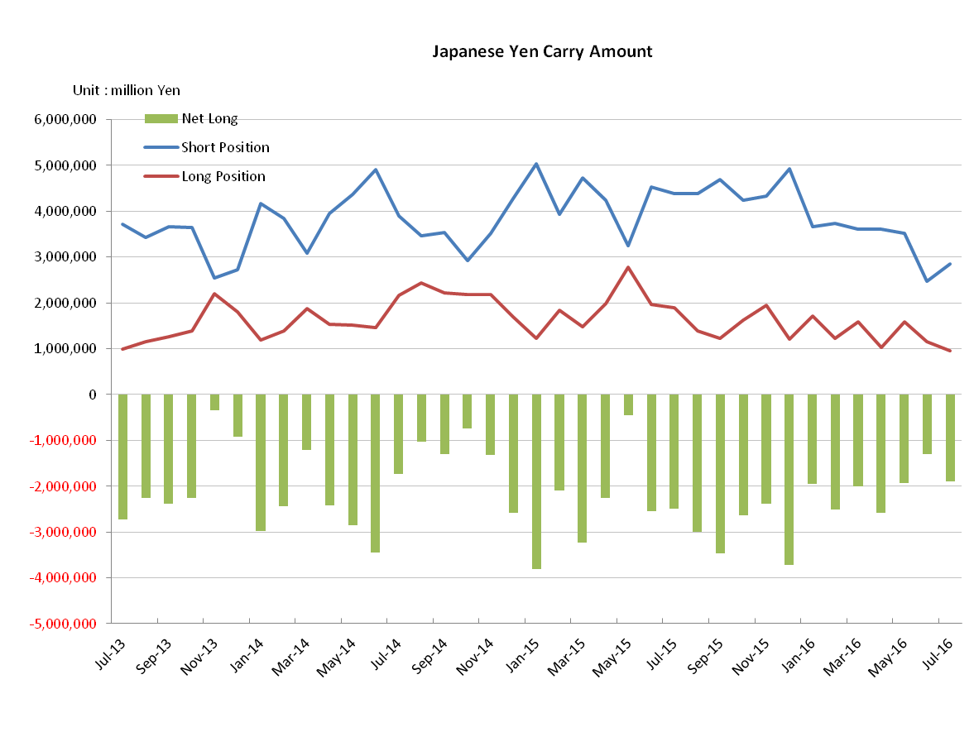

Monthly statistical report on Over-The-Counter Retail FX Margin Trading

：June , 2016
Publication date : 14 July. 2016
Number of Over-The-Counter Retail FX Margin Trading Operators as of 30 June . 2016 :52
Number of members reported :52

【Trading Volume】
(Unit: hundred million Yen, %)
 | Over-The-Counter | USDJPY, Cross Yen | On-Exchange*(for reference)
June | 4,293,105 | 4,017,162 | 47,351
Previous month | 3,658,991 | 3,431,362 | 31,407
Change | ＋17.33 | ＋17.07 | ＋50.76
*source : Monthly Trading Volume of Tokyo Financial exchange Inc.(The FFAJ converts the total number of contracts into the trading volume on the settlement prices of the end of the month)
【Open Positions】
(Unit: hundred million Yen)
 | Short | Long | Total
June | 13,438 | 26,221 | 39,660
Previous month | 18,225 | 37,543 | 55,768
Change | －4,786 | －11,321 | －16,108

・USDJPY, Cross Yen Open Positions
(Unit: hundred million Yen)
 | ① Short | ② Long | Net long=②-①
June | 24,609 | 11,505 | －13,103
Previous month | 35,187 | 15,838 | －19,349

（Reference：USDJPY Monthly Rate＊）
（Unit: Yen）
End of last Month*1 | Highest of the Month | Lowest of the Month | End of the Month*1 | Average*2
111.14 | 110.83 | 99.0 | 102.7 | 105.49
*source : BOJ's Main Time-series Statistics (Monthly)
*1) Spot Rate at 17:00 in JST, End of Month, Tokyo Market
*2) Average of Central Rate in the Month, Tokyo Market
○ Notes
The trading volume of OTC FX margins trading suddenly increased by 17.33% compared with the previous month, and it was 429 trillion yen.
Yen appreciation trend from May second half was further accelerated by the volatile currency market in response to the British referendum result of withdrawal from EU.
On the other hand, the total open position at the end of this month decreased by 1.6 trillion yen, and became 3.9 trillion yen as a result of significant decreasing the both of long and short open positions.
It seems that reduction of open positions was deeply affected by the position adjustment prior to the UK referendum, and in addition the loss-cut actions occurred before and after the result of UK referendum.

～Tables and Historical Graphs～
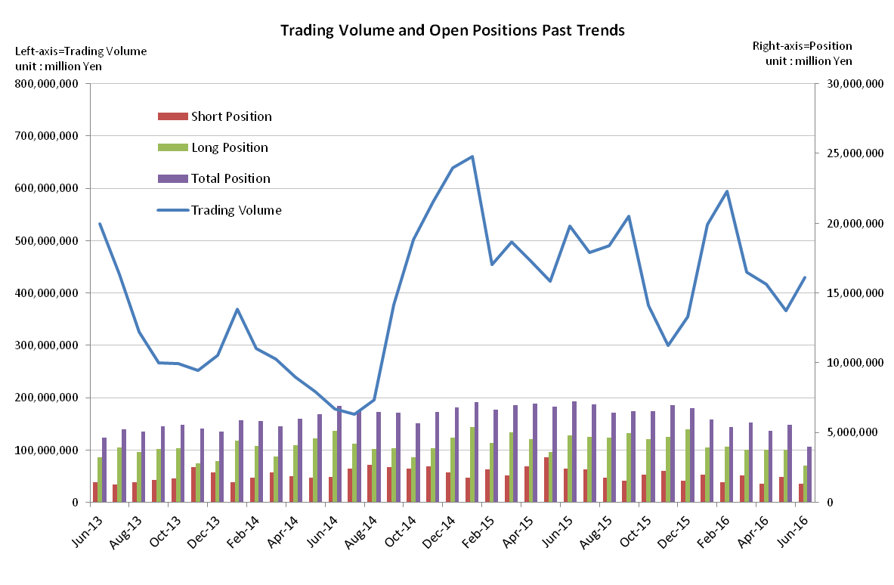

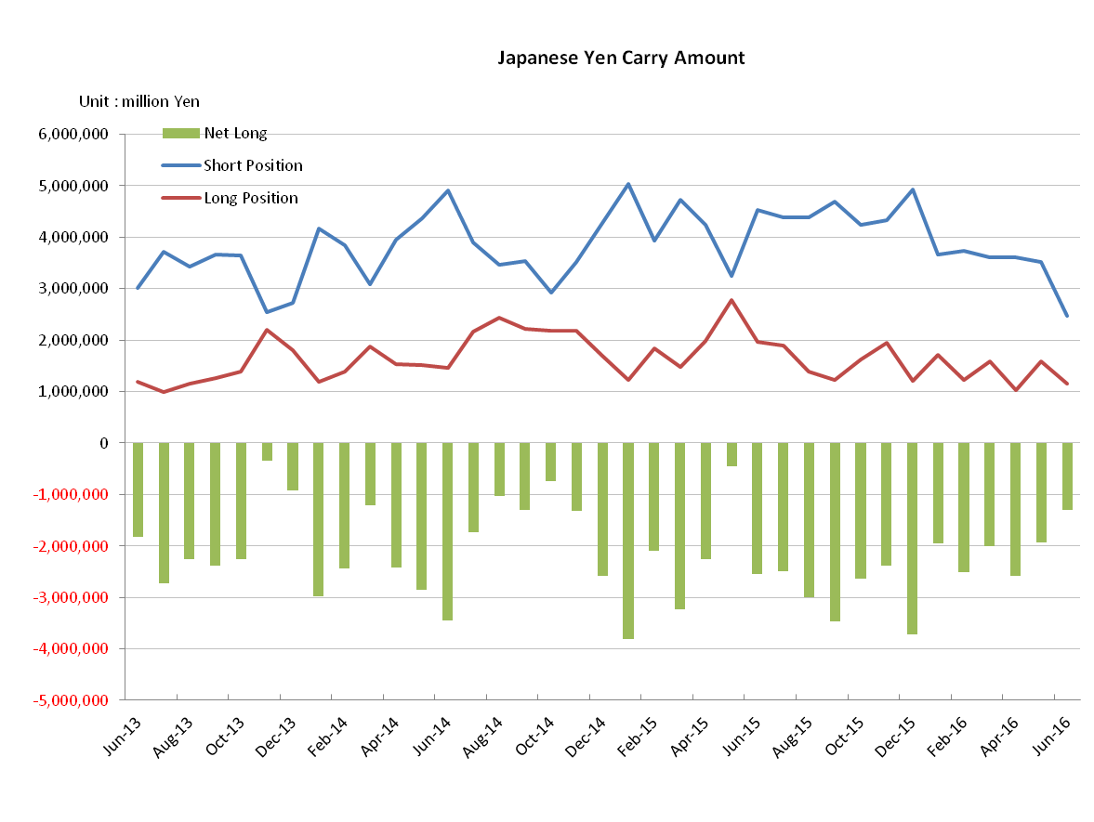

Monthly statistical report on Over-The-Counter Retail FX Margin Trading

：May , 2016
Publication date : 14 June. 2016
Number of Over-The-Counter Retail FX Margin Trading Operators as of 31 May . 2016 :52
Number of members reported :52
【Trading Volume】
(Unit: hundred million Yen, %)
 | Over-The-Counter | USDJPY, Cross Yen | On-Exchange*(for reference)
May | 3,659,948 | 3,431,478 | 31,407
Previous month | 4,164,216 | 3,890,365 | 31,728
Change | －12.10 | －11.79 | －1.01
*source : Monthly Trading Volume of Tokyo Financial exchange Inc.(The FFAJ converts the total number of contracts into the trading volume on the settlement prices of the end of the month)
【Open Positions】
(Unit: hundred million Yen)
 | Short | Long | Total
May | 18,642 | 38,109 | 56,751
Previous month | 13,318 | 37,770 | 51,088
Change | 5,324 | 339 | 5,663

・USDJPY, Cross Yen Open Positions
(Unit: hundred million Yen)
 | ① Short | ② Long | Net long=②-①
May | 35,259 | 15,908 | －19,351
Previous month | 36,056 | 10,277 | －25,779

（Reference：USDJPY Monthly Rate＊）
（Unit: Yen）
End of last Month*1 | Highest of the Month | Lowest of the Month | End of the Month*1 | Average*2
108.40 | 111.44 | 106.14 | 111.14 | 109.15
*source : BOJ's Main Time-series Statistics (Monthly)
*1) Spot Rate at 17:00 in JST, End of Month, Tokyo Market
*2) Average of Central Rate in the Month, Tokyo Market
○ Notes
The trading volume of this month was lower than the 400 trillion yen for the first time in five months,trading volume was the result of the currency pair was conspicuous that was reduced, such as currency pair (USD / JPY).
On the other hand, open positions(both of sell positions and buy positions) was increased compared to the previous month.

～Tables and Historical Graphs～

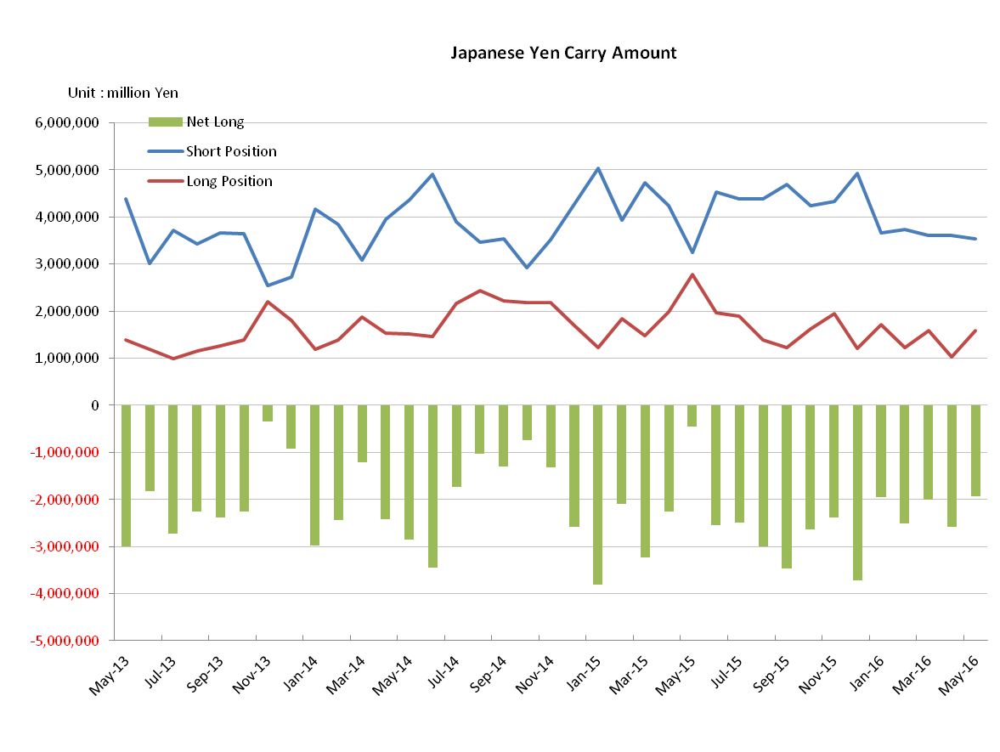
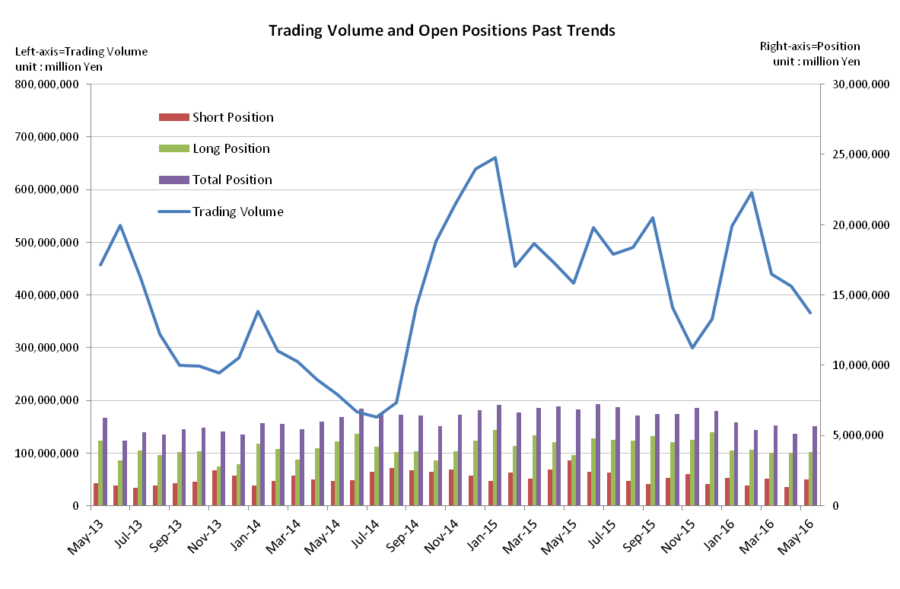

Monthly statistical report on Over-The-Counter Retail FX Margin Trading

：April , 2016
Publication date : 18 May. 2016
Number of Over-The-Counter Retail FX Margin Trading Operators as of 30 April . 2016 :52
Number of members reported :52
【Trading Volume】
(Unit: hundred million Yen, %)
 | Over-The-Counter | USDJPY, Cross Yen | On-Exchange*(for reference)
April | 4,164,108 | 3,890,314 | 31,728
Previous month | 4,398,992 | 4,002,359 | 37,281
Change | －5.33 | －2.79 | －14.89
*source : Monthly Trading Volume of Tokyo Financial exchange Inc.(The FFAJ converts the total number of contracts into the trading volume on the settlement prices of the end of the month)
【Open Positions】
(Unit: hundred million Yen)
 | Short | Long | Total
April | 13,318 | 37,770 | 51,088
Previous month | 19,445 | 37,887 | 57,333
Change | －6,127 | －117 | －6,245

・USDJPY, Cross Yen Open Positions
(Unit: hundred million Yen)
 | ① Short | ② Long | Net long=②-①
April | 36,056 | 10,277 | －25,779
Previous month | 35,983 | 15,892 | －20,091

（Reference：USDJPY Monthly Rate＊）
（Unit: Yen）
End of last Month*1 | Highest of the Month | Lowest of the Month | End of the Month*1 | Average*2
112.43 | 112.57 | 107.63 | 108.40 | 109.88
*source : BOJ's Main Time-series Statistics (Monthly)
*1) Spot Rate at 17:00 in JST, End of Month, Tokyo Market
*2) Average of Central Rate in the Month, Tokyo Market
○ Notes
The trading volume of this month, a decrease of 5.33% from the previous month, became the 416 trillion yen. Open positions tended to decrease during this month, and furthermore the yen short positions remained almost same level as the previous month. As a result the net yen short position increased by 568.8 billion yen.

～Tables and Historical Graphs～
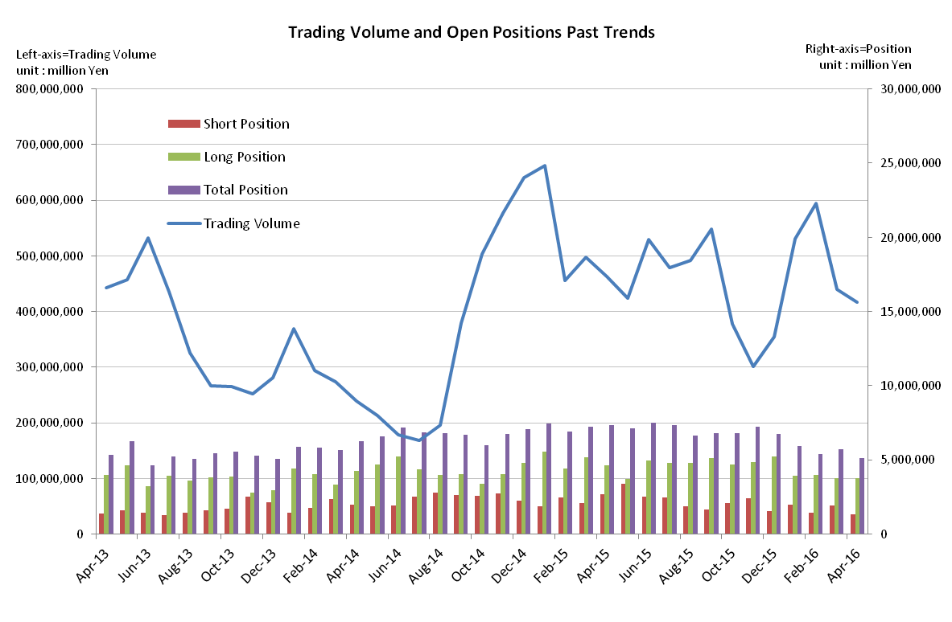

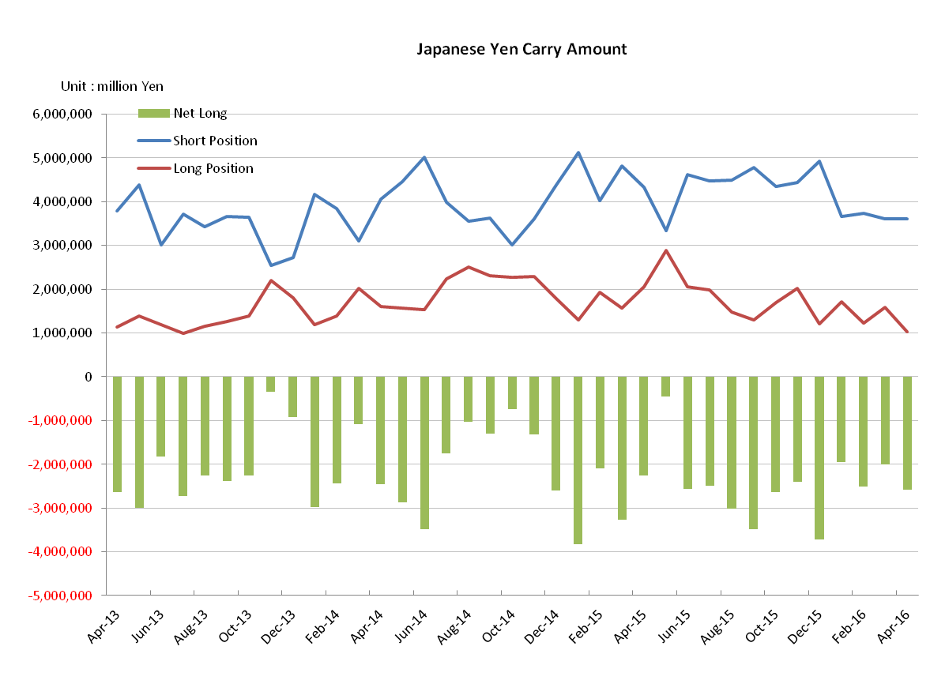

Monthly statistical report on Over-The-Counter Retail FX Margin Trading

：March , 2016
Publication date : 14 April. 2016
Number of Over-The-Counter Retail FX Margin Trading Operators as of 31 MArch . 2016 :53
Number of members reported :53
【Trading Volume】
(Unit: hundred million Yen, %)
 | Over-The-Counter | USDJPY, Cross Yen | On-Exchange*(for reference)
March | 4,398,992 | 4,002,359 | 37,281
Previous month | 5,945,366 | 5,645,829 | 48,554
Change | －26.00 | －29.10 | －23.21
*source : Monthly Trading Volume of Tokyo Financial exchange Inc.(The FFAJ converts the total number of contracts into the trading volume on the settlement prices of the end of the month)
【Open Positions】
(Unit: hundred million Yen)
 | Short | Long | Total
March | 19,445 | 37,887 | 57,333
Previous month | 14,488 | 39,674 | 54,162
Change | +4,956 | －1,786 | +3,170

・USDJPY, Cross Yen Open Positions
(Unit: hundred million Yen)
 | ① Short | ② Long | Net long=②-①
March | 35,983 | 15,892 | －20,091
Previous month | 37,370 | 12,185 | －25,185

（Reference：USDJPY Monthly Rate＊）
（Unit: Yen）
End of last Month*1 | Highest of the Month | Lowest of the Month | End of the Month*1 | Average*2
112.99 | 114.37 | 110.84 | 112.43 | 113.07
*source : BOJ's Main Time-series Statistics (Monthly)
*1) Spot Rate at 17:00 in JST, End of Month, Tokyo Market
*2) Average of Central Rate in the Month, Tokyo Market
○ Notes
Despite the trend of stronger Japanese yen was continued, as a whole, market volatility was lower, and exchange rate has settled down as compared to the previous month.
The trading volume of this month fell below 500 trillion yen again, remained in 439 trillion yen.
While the net yen short positions declined, the open position balances of all currencies at the end of the month increased by 371 billion yen. It was seen buying back Japanese yen against foreign currencies, especially Eur.

～Tables and Historical Graphs～

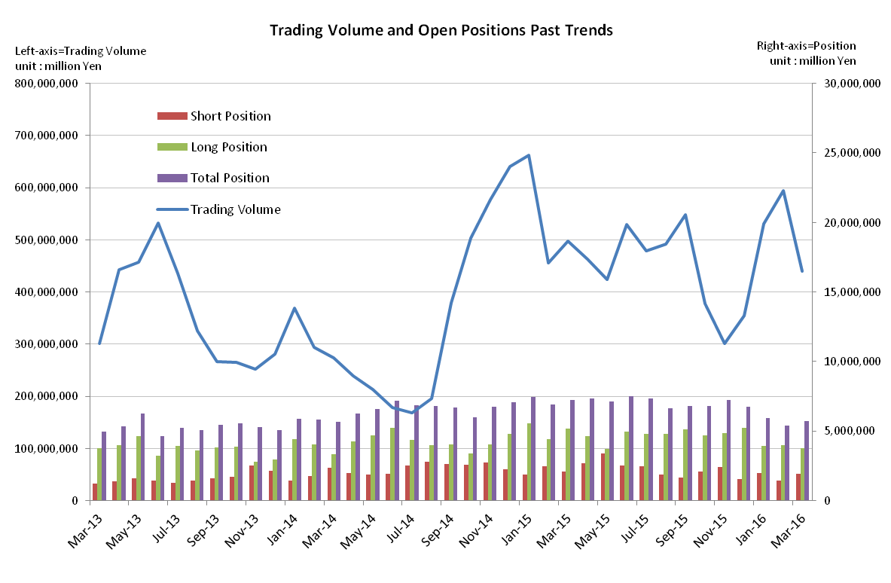

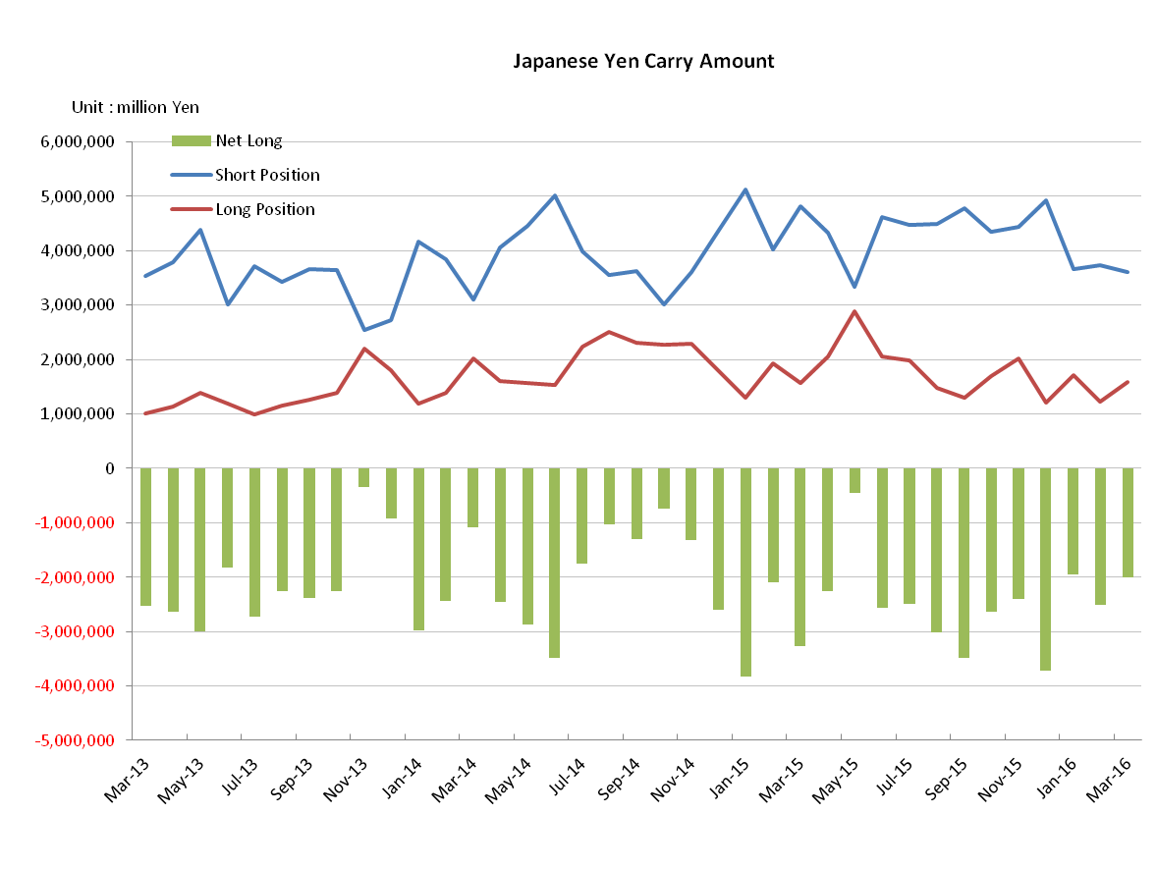

Monthly statistical report on Over-The-Counter Retail FX Margin Trading

：February , 2016
Publication date : 14 March. 2016
Number of Over-The-Counter Retail FX Margin Trading Operators as of 29 February . 2016 :53
Number of members reported :53
【Trading Volume】
(Unit: hundred million Yen, %)
 | Over-The-Counter | USDJPY, Cross Yen | On-Exchange*(for reference)
February | 5,939,705 | 5,640,168 | 48,554
Previous month | 5,309,191 | 4,949,771 | 47,573
Change | +11.8 | +13.9 | +2.0
*source : Monthly Trading Volume of Tokyo Financial exchange Inc.(The FFAJ converts the total number of contracts into the trading volume on the settlement prices of the end of the month)
【Open Positions】
(Unit: hundred million Yen)
 | Short | Long | Total
February | 14,488 | 39,674 | 54,162
Previous month | 19,790 | 39,424 | 59,215
Change | －5,301 | 249 | －5,052

・USDJPY, Cross Yen Open Positions
(Unit: hundred million Yen)
 | ① Short | ② Long | Net long=②-①
February | 37,370 | 12,185 | －25,185
Previous month | 36,620 | 17,124 | －19,496

（Reference：USDJPY Monthly Rate＊）
（Unit: Yen）
End of last Month*1 | Highest of the Month | Lowest of the Month | End of the Month*1 | Average*2
120.63 | 121.49 | 111.60 | 112.99 | 115.02
*source : BOJ's Main Time-series Statistics (Monthly)
*1) Spot Rate at 17:00 in JST, End of Month, Tokyo Market
*2) Average of Central Rate in the Month, Tokyo Market
○ Notes

In general, in the situation each currency pair of cross- Japanese yen was stronger Japanese yen, the month of the trading volume increased by 11.8% from the last month, became the month 593 trillion yen.
Open position balance of all currencies at the end of the month , 11.8% decrease to 5 trillion 416.2 billion yen from the last month, the excess amount of net sellers of Japanese Yen open position is 2 trillion 518.5 billion yen, the excess amount from the last month was increased.
～Tables and Historical Graphs～

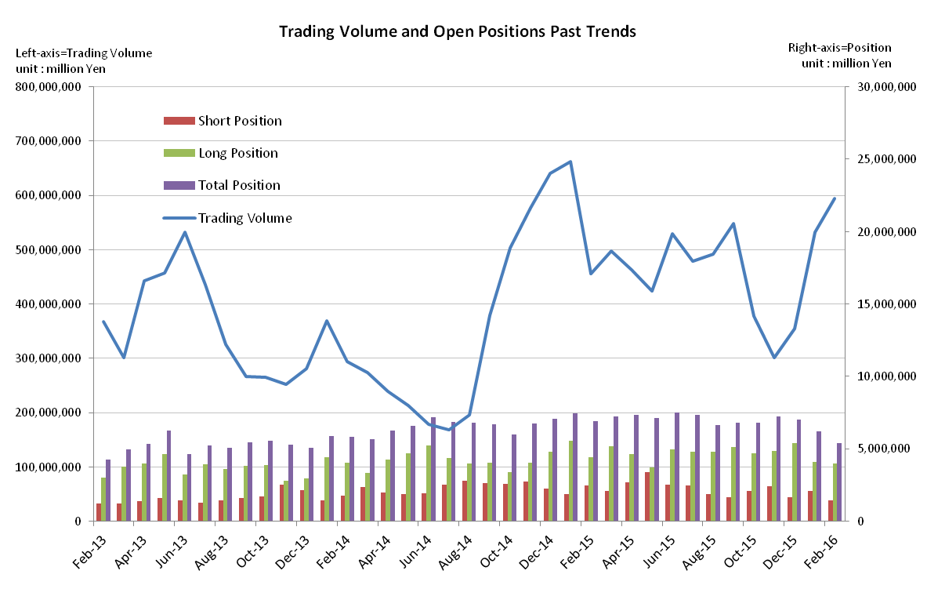
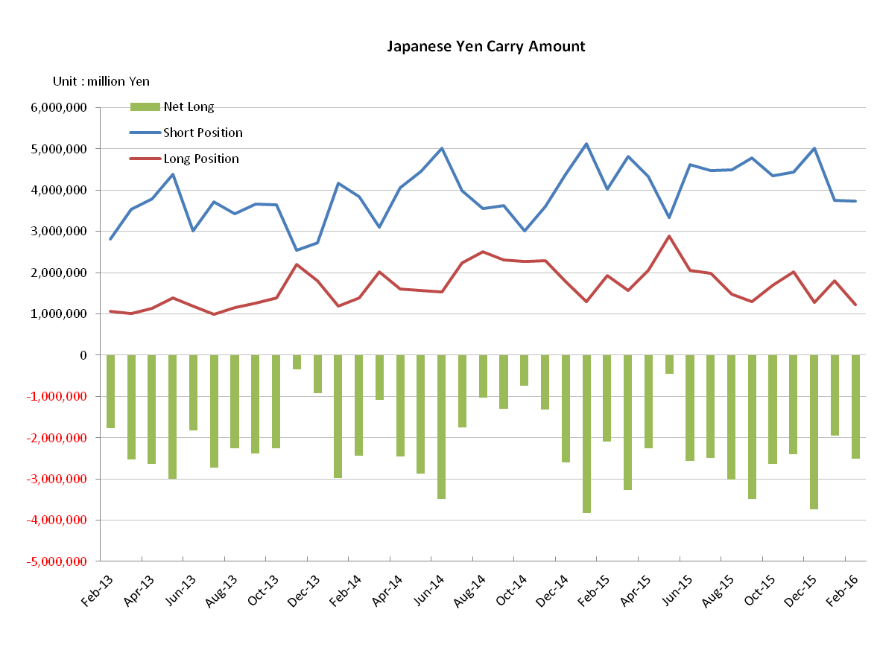
Monthly statistical report on Over-The-Counter Retail FX Margin Trading

：January , 2016
Publication date : 15 February. 2016
Number of Over-The-Counter Retail FX Margin Trading Operators as of 31 January. 2015 :53
Number of members reported :53
【Trading Volume】
(Unit: hundred million Yen, %)
 | Over-The-Counter | USDJPY, Cross Yen | On-Exchange*(for reference)
January | 5,323,272 | 4,962,920 | 47,573
Previous month | 3,549,446 | 2,963,850 | 38,848
Change | +49.9 | +67.4 | +22.4
*source : Monthly Trading Volume of Tokyo Financial exchange Inc.(The FFAJ converts the total number of contracts into the trading volume on the settlement prices of the end of the month)
【Open Positions】
(Unit: hundred million Yen)
 | Short | Long | Total
January | 21,034 | 40,815 | 61,850
Previous month | 16,512 | 53,652 | 70,164
Change | 4,522 | －12,837 | －8,314

・USDJPY, Cross Yen Open Positions
(Unit: hundred million Yen)
 | ① Short | ② Long | Net long=②-①
January | 37,554 | 17,972 | －19,581
Previous month | 50,153 | 12,818 | －37,335

（Reference：USDJPY Monthly Rate＊）
（Unit: Yen）
End of last Month*1 | Highest of the Month | Lowest of the Month | End of the Month*1 | Average*2
120.42 | 121.49 | 116.40 | 120.63 | 118.25
*source : BOJ's Main Time-series Statistics (Monthly)
*1) Spot Rate at 17:00 in JST, End of Month, Tokyo Market
*2) Average of Central Rate in the Month, Tokyo Market
○ Notes
Volatility of each currency pair including dollar Japanese yen having risen, the trading volume of this month increased by 49.9% from the last month and restored the monthly 500 trillion yen level again.

Because the trend of repurchasing Japanese yen short positions overcame a new purchase of foreign currency-denominated long positions, so the open position balance of all currencies at the end of the month deceased by 11.8 % from the previous month and was 6,185.billion yen. The net yen short positions declined to 1958.1 billion yen.
～Tables and Historical Graphs～

