Over-The-Counter FX Margin Trading Report

(January 2015 ～ December 2015 )

Monthly Report
January 2015
February 2015
March 2015
April 2015
May 2015
June 2015
July 2015
August 2015
September 2015
October 2015
Nobember 2015
December 2015

The Financial Futures Association of Japan, Research Department

NBF Ogawamachi Building 1-3 , Kanda Ogawamachi ,
Chiyoda-ku , Tokyo 101-0052 Tel:(03)5280-0881 E-mail : ffaj@ffaj.or.jp

This publication has been prepared by the FFAJ and is provided for information purpose only. The monthly information contained in this publication has been obtained from FFAJ's members that is believed to be reliable, however the FFAJ does not represent or warrant that it is accurate or complete. In no event the FFAJ nor its employees have any liability for any consequential damages arising from any use of this publications or its contents. This publication does not constitute any investment advice.

Monthly statistical report on Over-The-Counter Retail FX Margin Trading

：December , 2015
Publication date : 18 January 2016
Number of Over-The-Counter Retail FX Margin Trading Operators as of 31 December. 2015 : 53
Number of members reported : 53

【Trading Volume】
(Unit: hundred million Yen, %)
 | Over-The-Counter | USDJPY, Cross Yen | On-Exchange*(for reference)
December | 3,549,446 | 2,963,850 | 38,848
Previous month | 3,006,718 | 2,488,918 | 25,948
Change | +18.0 | +19.0 | +49.7
*source : Monthly Trading Volume of Tokyo Financial exchange Inc.(The FFAJ converts the total number of contracts into the trading volume on the settlement prices of the end of the month)
【Open Positions】
(Unit: hundred million Yen)
 | Short | Long | Total
December | 16,512 | 53,652 | 70,164
Previous month | 23,958 | 48,459 | 72,417
Change | －7,446 | +5,193 | －2,253

・USDJPY, Cross Yen Open Positions
(Unit: hundred million Yen)
 | ① Short | ② Long | Net long=②-①
December | 50,153 | 12,818 | －37,335
Previous month | 44,284 | 20,265 | －24,019

（Reference：USDJPY Monthly Rate＊）
（Unit: Yen）
End of last Month*1 | Highest of the Month | Lowest of the Month | End of the Month*1 | Average*2
122.83 | 123.59 | 120.05 | 120.42 | 121.84
*source : BOJ's Main Time-series Statistics (Monthly)
*1) Spot Rate at 17:00 in JST, End of Month, Tokyo Market
*2) Average of Central Rate in the Month, Tokyo Market
○ Notes
The trading volume of OTC FX margin trading of this month grew by 18% compared to the previous month, it was 354 trillion yen. While Open short positions decreased by 744.6 billion yen, Open long positions increased by 519.3 billion yen. As a result, total of Open positions at the end of month declined by 225.3 billion yen from last month, and which was 7,016.4 billion yen.
As for the Net Yen short position, it increased by 1,331.6 billion yen and became 3,733.5 billion yen.
In addition, the total trading volume of 2015 that was ended this month became the 5,584 trillion yen ,which increased 38.4% compared to 2014.
～Tables and Historical Graphs～

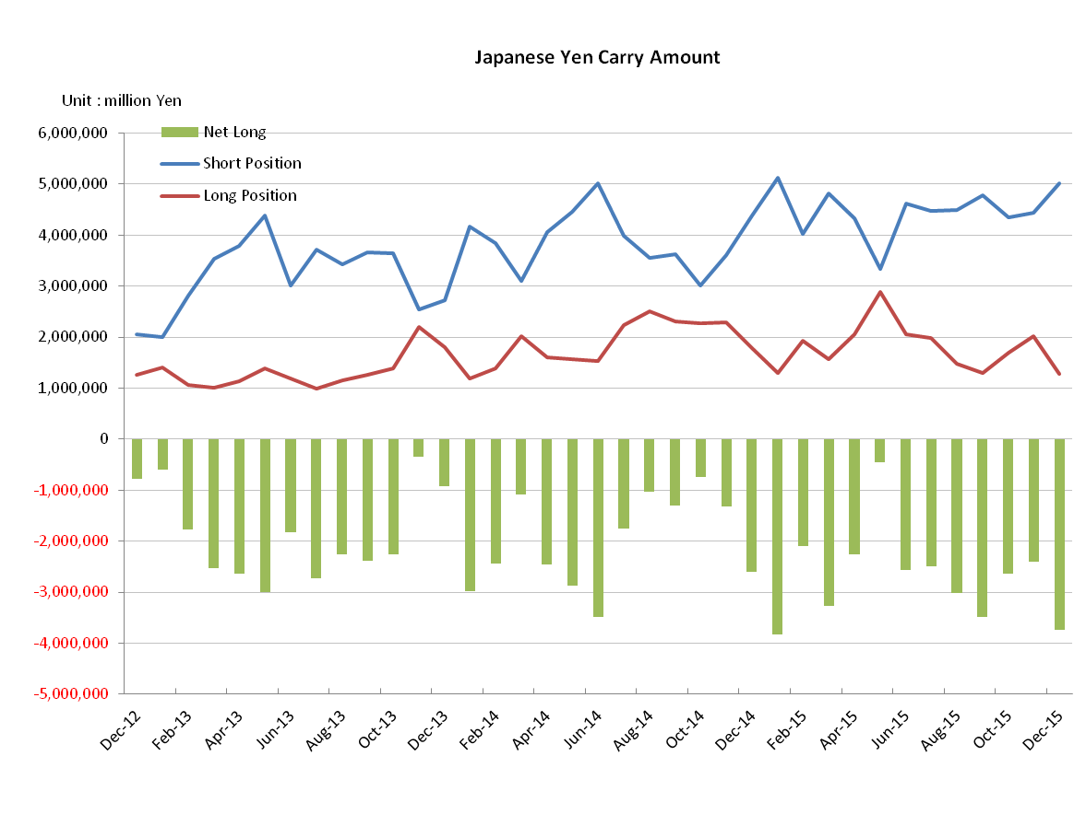
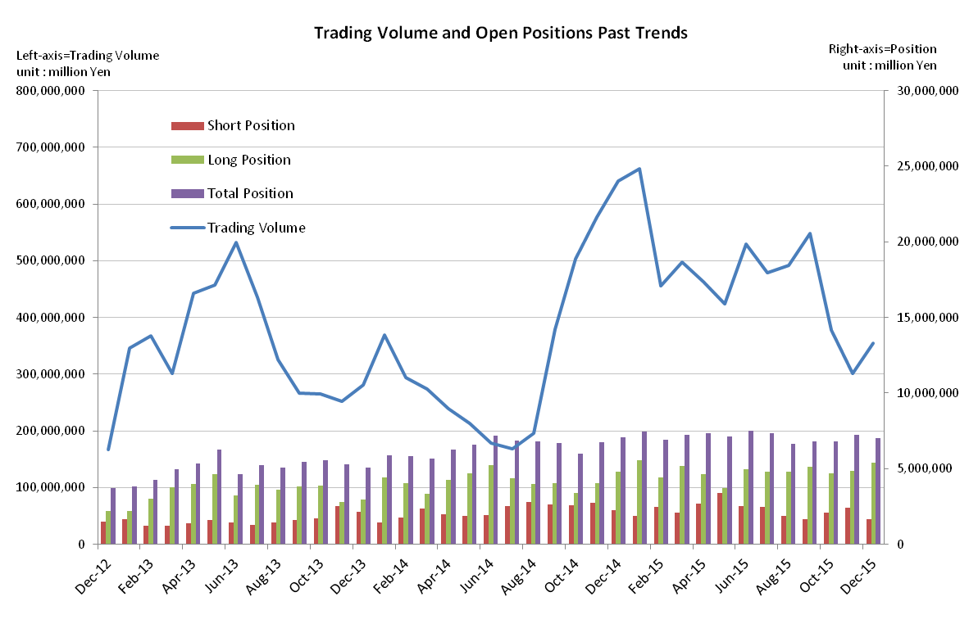

Monthly statistical report on Over-The-Counter Retail FX Margin Trading

：November , 2015
Publication date : 14 December 2015
Number of Over-The-Counter Retail FX Margin Trading Operators as of 30 November. 2015 : 53
Number of members reported : 53

【Trading Volume】
(Unit: hundred million Yen, %)
 | Over-The-Counter | USDJPY, Cross Yen | On-Exchange*(for reference)
November | 3,006,718 | 2,488,918 | 25,948
Previous month | 3,773,831 | 3,298,388 | 32,627
Change | －20.3 | －24.5 | －20.4
*source : Monthly Trading Volume of Tokyo Financial exchange Inc.(The FFAJ converts the total number of contracts into the trading volume on the settlement prices of the end of the month)
【Open Positions】
(Unit: hundred million Yen)
 | Short | Long | Total
November | 23,958 | 48,459 | 72,417
Previous month | 20,876 | 46,910 | 677,86
Change | 3,081 | 1,549 | 4,631

・USDJPY, Cross Yen Open Positions
(Unit: hundred million Yen)
 | ① Short | ② Long | Net long=②-①
November | 44,284 | 20,265 | －24,019
Previous month | 43,395 | 16,977 | －26,417

（Reference：USDJPY Monthly Rate＊）
（Unit: Yen）
End of last Month*1 | Highest of the Month | Lowest of the Month | End of the Month*1 | Average*2
120.74 | 123.64 | 120.27 | 122.83 | 122.54
*source : BOJ's Main Time-series Statistics (Monthly)
*1) Spot Rate at 17:00 in JST, End of Month, Tokyo Market
*2) Average of Central Rate in the Month, Tokyo Market
○ Notes
The trading volume of OTC FX margin trading of this month decreased more than 20% following the previous month, it was 300 trillion yen. The main reduction factor was a decrease of the trading volume of USDJPY and emerging market currencies. In contrast, the trading volume of EURUSD and GBPUSD increased.
Open positions at the end of month grew by 463.1 billion yen from the previous month. While both of Open long and short yen positions also increased, the Net Yen short position dropped by 240.2 billion yen, and was 2,401.9 billion yen.

～Tables and Historical Graphs～
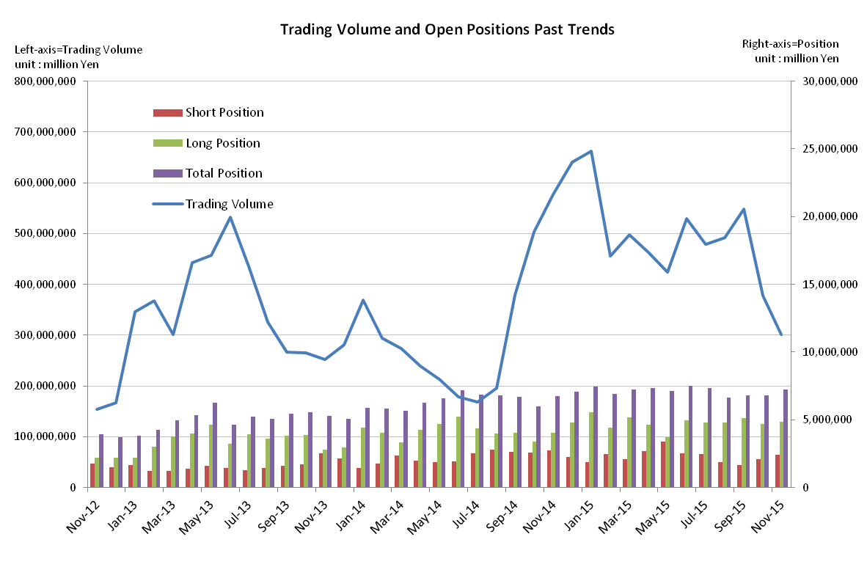

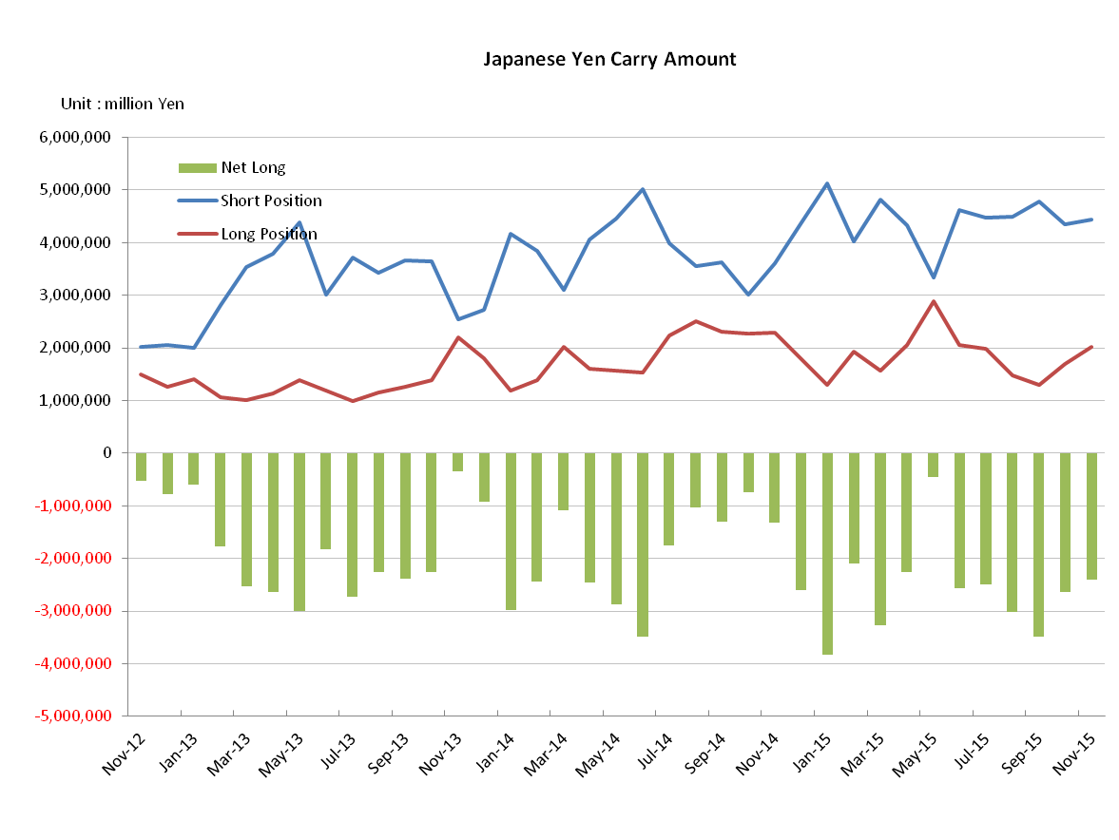

Monthly statistical report on Over-The-Counter Retail FX Margin Trading

：October , 2015
Publication date : 16 November 2015
Number of Over-The-Counter Retail FX Margin Trading Operators as of 31 October. 2015 : 53
Number of members reported : 53

【Trading Volume】
(Unit: hundred million Yen, %)
 | Over-The-Counter | USDJPY, Cross Yen | On-Exchange*(for reference)
October | 3,773,831 | 3,298,388 | 32,627
Previous month | 5,478,466 | 5,000,832 | 37,309
Change | －31.1 | －34.0 | － 12.5
*source : Monthly Trading Volume of Tokyo Financial exchange Inc.(The FFAJ converts the total number of contracts into the trading volume on the settlement prices of the end of the month)
【Open Positions】
(Unit: hundred million Yen)
 | Short | Long | Total
October | 20,876 | 46,910 | 67,786
Previous month | 16,748 | 51,017 | 67,765
Change | 4,128 | －4,107 | 21

・USDJPY, Cross Yen Open Positions
(Unit: hundred million Yen)
 | ① Short | ② Long | Net long=②-①
October | 43,395 | 16,977 | －26,417
Previous month | 47,835 | 12,955 | －34,879

（Reference：USDJPY Monthly Rate＊）
（Unit: Yen）
End of last Month*1 | Highest of the Month | Lowest of the Month | End of the Month*1 | Average*2
120.03 | 121.50 | 118.10 | 120.74 | 120.06
*source : BOJ's Main Time-series Statistics (Monthly)
*1) Spot Rate at 17:00 in JST, End of Month, Tokyo Market
*2) Average of Central Rate in the Month, Tokyo Market
○ Notes
The trading volume of OTC FX margin trading of this month was to turn from the steady growth trend and fell sharply from the previous month, it stopped to 377 trillion yen.
Both of Open long and short positions at the end of the month was balanced. In the other hand, the Net Yen short position was decreased by increasing long yen position and decreasing short yen position. There some changes had been seen on the contents of the open positions.

～Tables and Historical Graphs～

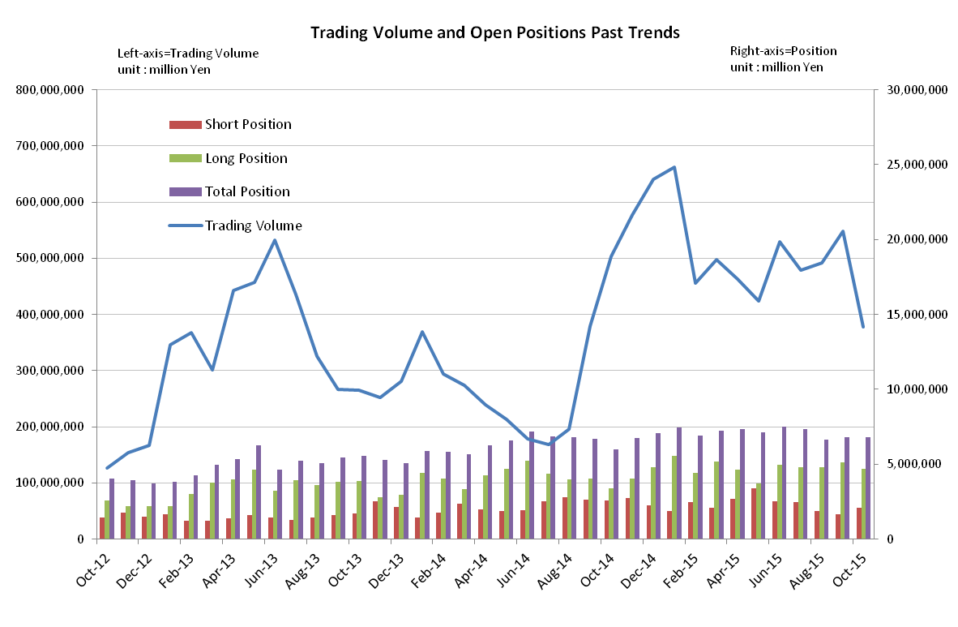

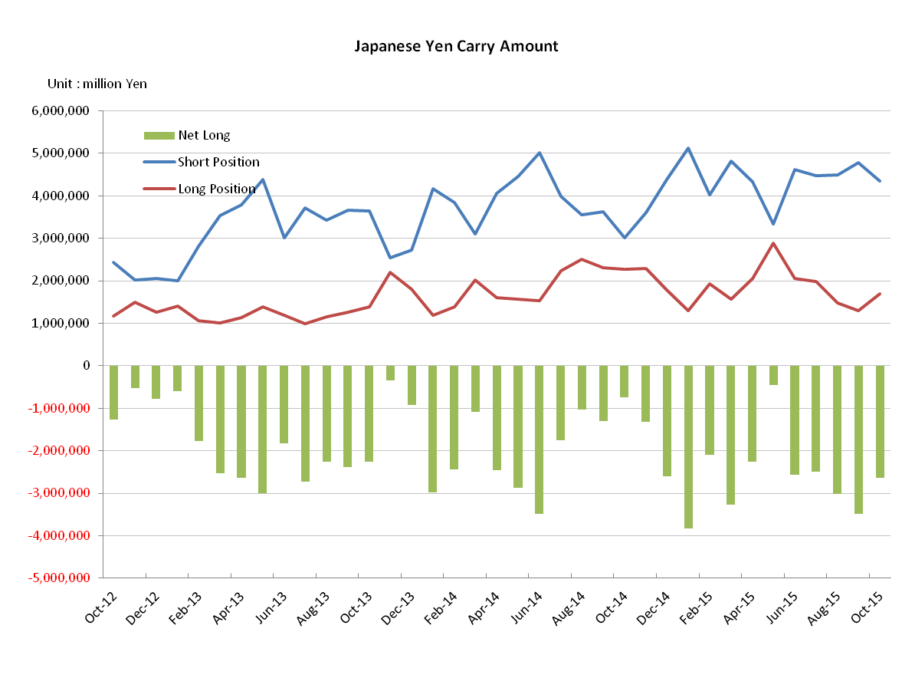

Monthly statistical report on Over-The-Counter Retail FX Margin Trading

：September , 2015
Publication date : 15 October 2015
Number of Over-The-Counter Retail FX Margin Trading Operators as of 30 September. 2015 : 55
Number of members reported : 55

【Trading Volume】
(Unit: hundred million Yen, %)
 | Over-The-Counter | USDJPY, Cross Yen | On-Exchange*(for reference)
September | 5,478,466 | 5,000,832 | 37,309
Previous month | 4,916,523 | 4,219,641 | 40,372
Change | + 11.4 | + 18.5 | － 7.5
*source : Monthly Trading Volume of Tokyo Financial exchange Inc.(The FFAJ converts the total number of contracts into the trading volume on the settlement prices of the end of the month)
【Open Positions】
(Unit: hundred million Yen)
 | Short | Long | Total
September | 16,748 | 51,017 | 67,765
Previous month | 18,658 | 47,956 | 66,614
Change | － 1,909 | 3,060 | 1,150

・USDJPY, Cross Yen Open Positions
(Unit: hundred million Yen)
 | ① Short | ② Long | Net long=②-①
September | 47,835 | 12,955 | － 34,879
Previous month | 44,854 | 14,739 | － 30,115

（Reference：USDJPY Monthly Rate＊）
（Unit: Yen）
End of last Month*1 | Highest of the Month | Lowest of the Month | End of the Month*1 | Average*2
121.19 | 121.38 | 118.81 | 120.03 | 118.81
*source : BOJ's Main Time-series Statistics (Monthly)
*1) Spot Rate at 17:00 in JST, End of Month, Tokyo Market
*2) Average of Central Rate in the Month, Tokyo Market
○ Notes
While the foreign exchange market was fluctuated quietly last month, the trading volume of OTC FX margin trading grew by 11.4% from the previous month; it was increased to 574 trillion yen, which recovered to 500 trillion levels again.
Open position at the end of the month, which had dropped at the previous month, increased slightly by 115 billion JPY from the previous month, and in the other hand the Net Yen position increased by 476.4 billion JPY compared to the previous month.
～Tables and Historical Graphs～

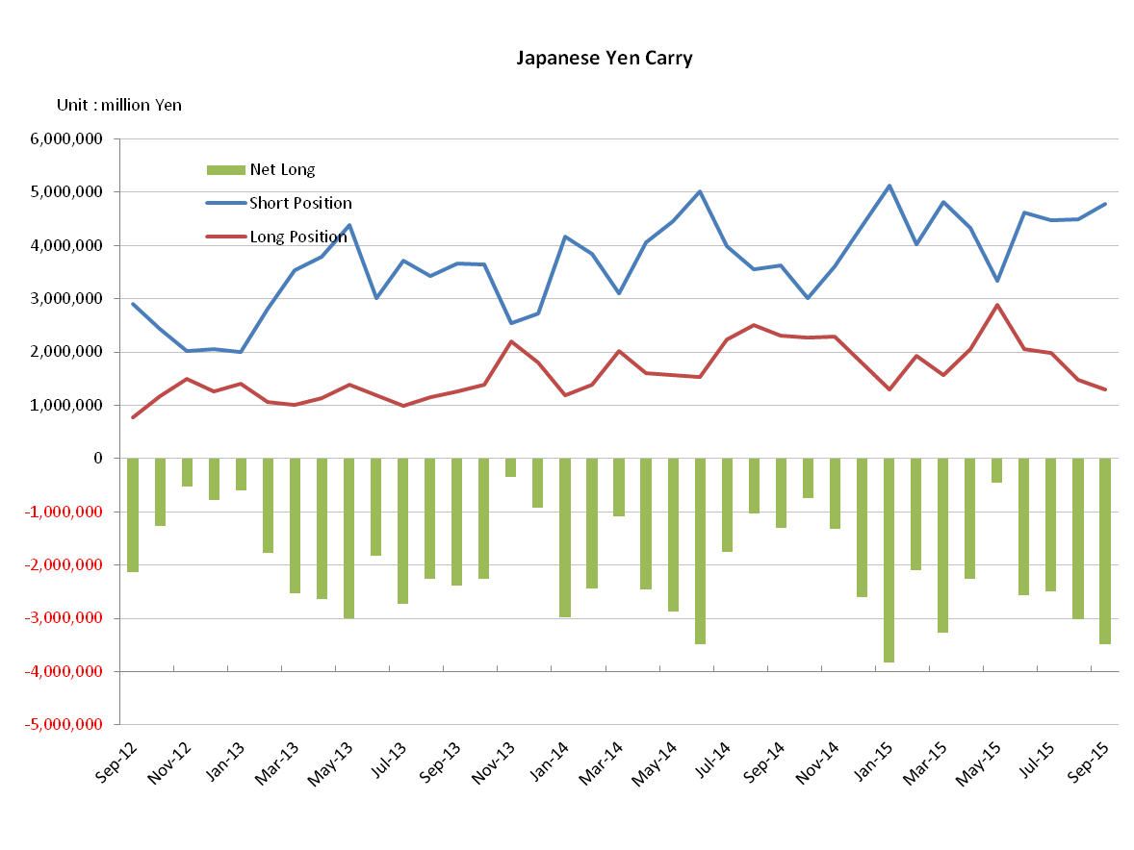
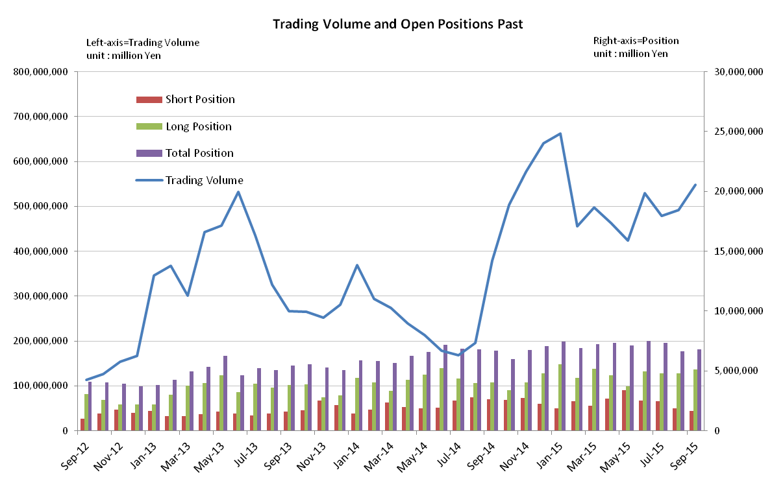

Monthly statistical report on Over-The-Counter Retail FX Margin Trading

：August , 2015
Publication date : 14 September 2015
Number of Over-The-Counter Retail FX Margin Trading Operators as of 31 August. 2015 : 55
Number of members reported : 55

【Trading Volume】
(Unit: hundred million Yen, %)
 | Over-The-Counter | USDJPY, Cross Yen | On-Exchange*(for reference)
August | 4,916,526 | 4,219,644 | 40,372
Previous month | 4,792,877 | 3,884,570 | 37,952
Change | 2.5 | 8.6 | 6.3
*source : Monthly Trading Volume of Tokyo Financial exchange Inc.(The FFAJ converts the total number of contracts into the trading volume on the settlement prices of the end of the month)
【Open Positions】
(Unit: hundred million Yen)
 | Short | Long | Total
August | 18,658 | 47,956 | 66,614
Previous month | 24,928 | 48,226 | 73,154
Change | －6,270 | －269 | －6,539

・USDJPY, Cross Yen Open Positions
(Unit: hundred million Yen)
 | ① Short | ② Long | Net long=②-①
August | 44,854 | 14,739 | －30,115
Previous month | 44,734 | 19,809 | －24,924

（Reference：USDJPY Monthly Rate＊）
（Unit: Yen）
End of last Month*1 | Highest of the Month | Lowest of the Month | End of the Month*1 | Average*2
124.22 | 125.28 | 118.25 | 121.19 | 123.23
*source : BOJ's Main Time-series Statistics (Monthly)
*1) Spot Rate at 17:00 in JST, End of Month, Tokyo Market
*2) Average of Central Rate in the Month, Tokyo Market
○ Notes
The trading volume of OTC FX margin trading of this month increased by 2.5% from the previous month, and was 491 trillion yen. The volatility was relatively higher throughout the month, especially the second half of month, that there were sudden fluctuations of twice a day such as a sharp fall of South Africa Rand that occurred in the early morning on August 24 and a soaring of yen against USD same night.
Open position at the end of the month declined by 653.9 billion JPY from the previous month, and in the other hand the Net Yen position increased by 519.1 billion JPY compared to the previous month.
～Tables and Historical Graphs～
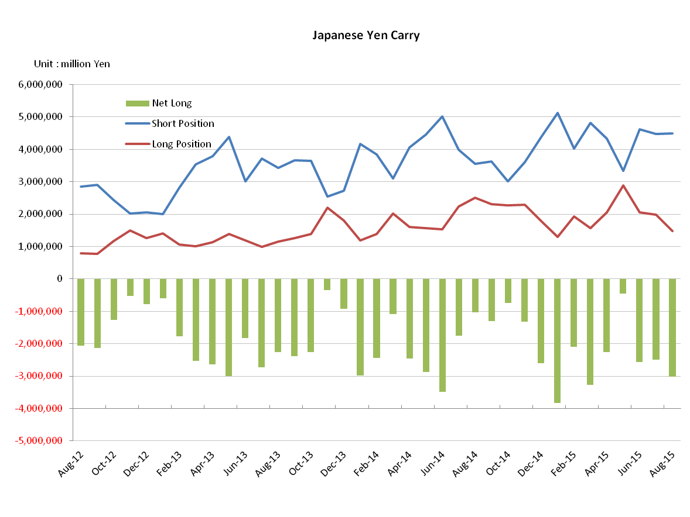
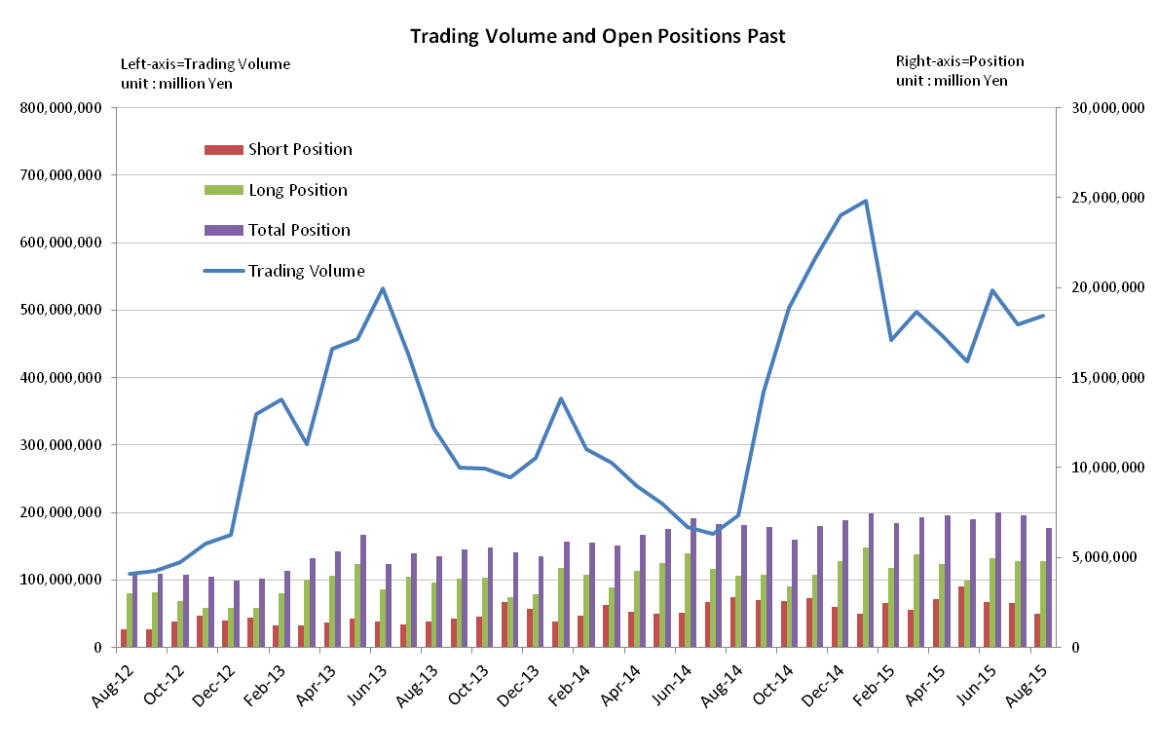
Monthly statistical report on Over-The-Counter Retail FX Margin Trading

：July , 2015
Publication date : 14 August 2015
Number of Over-The-Counter Retail FX Margin Trading Operators as of 30 July. 2015 : 56
Number of members reported : 56

【Trading Volume】
(Unit: hundred million Yen, %)
 | Over-The-Counter | USDJPY, Cross Yen | On-Exchange*(for reference)
July | 4,792,877 | 3,884,570 | 37,952
Previous month | 5,296,836 | 4,122,630 | 43,347
Change | ‐ 9.5 | ‐ 5.7 | ‐12.4
*source : Monthly Trading Volume of Tokyo Financial exchange Inc.(The FFAJ converts the total number of contracts into the trading volume on the settlement prices of the end of the month)
【Open Positions】
(Unit: hundred million Yen)
 | Short | Long | Total
July | 24,928 | 48,225 | 73,154
Previous month | 25,441 | 49,623 | 75,065
Change | ‐512 | ‐1,397 | ‐1,910

・USDJPY, Cross Yen Open Positions
(Unit: hundred million Yen)
 | ① Short | ② Long | Net long=②-①
July | 44,734 | 19,809 | ‐24,924
Previous month | 46,231 | 20,575 | ‐25,656

（Reference：USDJPY Monthly Rate＊）
（Unit: Yen）
End of last Month*1 | Highest of the Month | Lowest of the Month | End of the Month*1 | Average*2
122.25 | 124.48 | 120.47 | 124.22 | 123.23
*source : BOJ's Main Time-series Statistics (Monthly)
*1) Spot Rate at 17:00 in JST, End of Month, Tokyo Market
*2) Average of Central Rate in the Month, Tokyo Market
○ Notes
The trading volume of OTC FX margin trading of this month declined by 9.5% from the previous month, and was 479 trillion yen.
Although the total of all currency pairs’ Open positions at the end of month was slightly decreased compared to the previous month, there were no significant changes in both of the short positions and the long positions.
The net Yen position likewise, it had maintained an almost unchanging level as the end of the previous month.
～Tables and Historical Graphs～

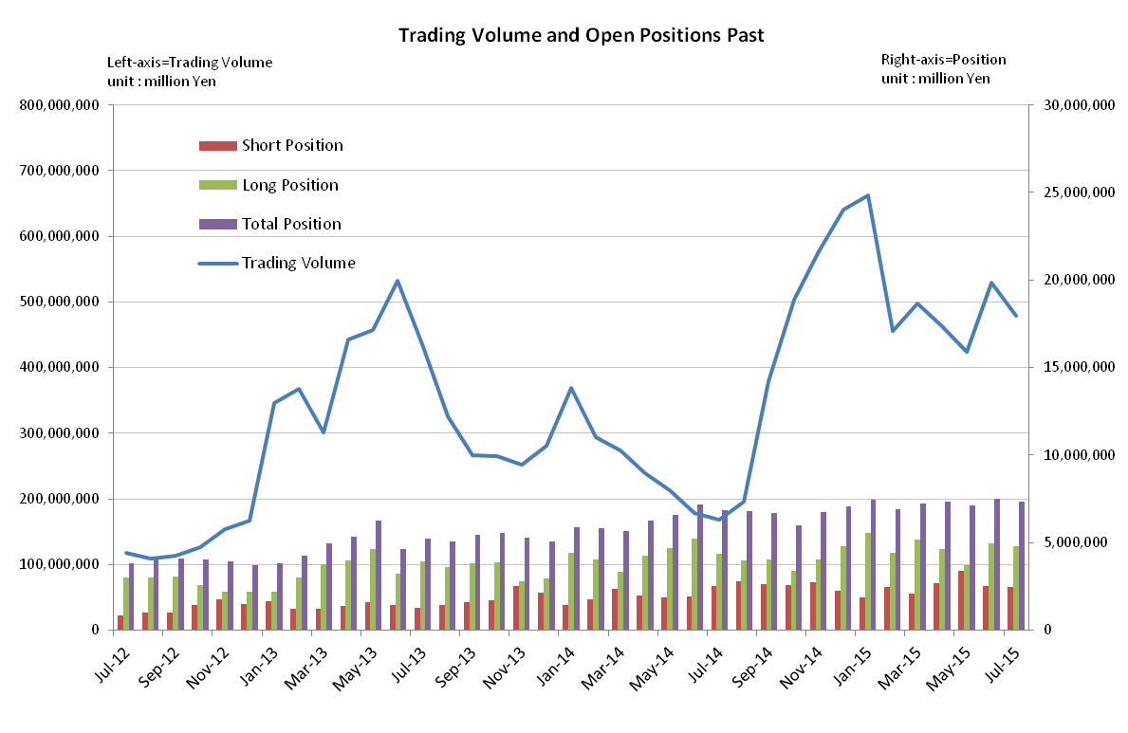
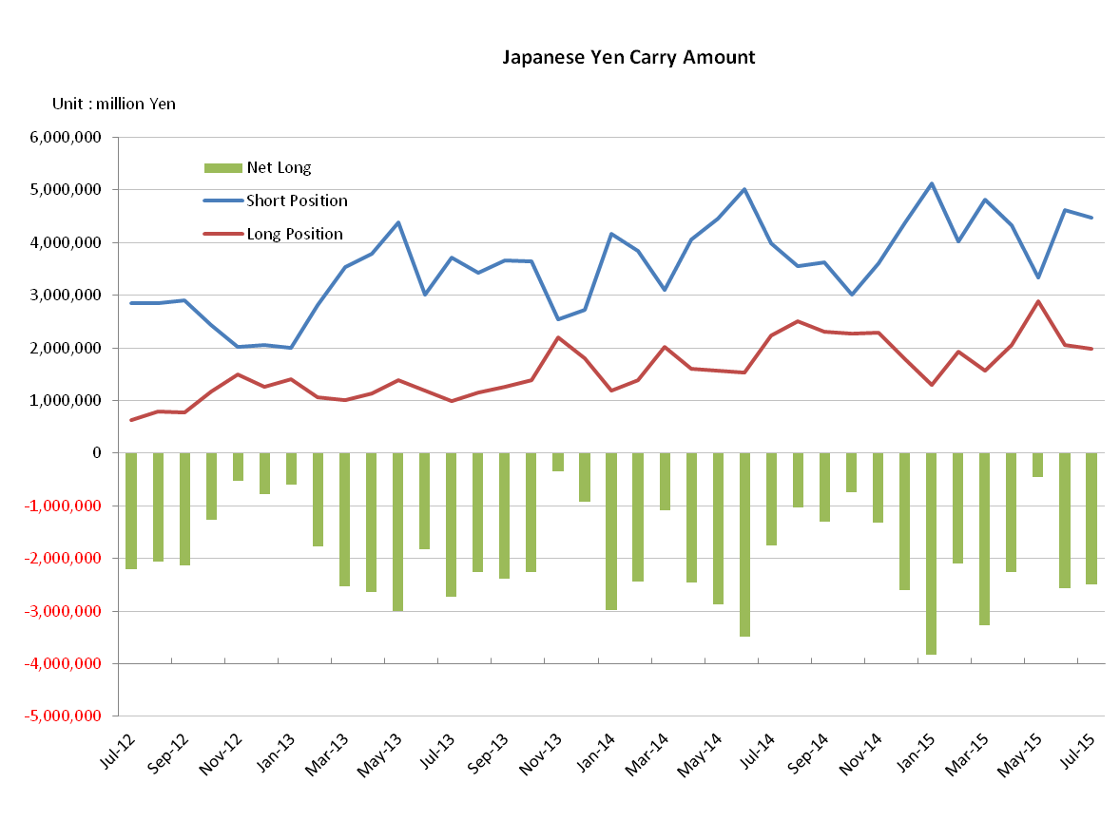

Monthly statistical report on Over-The-Counter Retail FX Margin Trading

：June , 2015
Publication date : 14 July 2015
Number of Over-The-Counter Retail FX Margin Trading Operators as of 30 June. 2015 : 56
Number of members reported : 56

【Trading Volume】
(Unit: hundred million Yen, %)
 | Over-The-Counter | USDJPY, Cross Yen | On-Exchange*(for reference)
June | 5,296,836 | 4,122,630 | 43,347
Previous month | 4,243,209 | 3,191,572 | 32,221
Change | +24.8 | +29.1 | +34.5
*source : Monthly Trading Volume of Tokyo Financial exchange Inc.(The FFAJ converts the total number of contracts into the trading volume on the settlement prices of the end of the month)
【Open Positions】
(Unit: hundred million Yen)
 | Short | Long | Total
June | 25,441 | 49,623 | 75,065
Previous month | 33,955 | 37,334 | 71,290
Change | — 8,514 | 12,289 | 3,774

・USDJPY, Cross Yen Open Positions
(Unit: hundred million Yen)
 | ① Short | ② Long | Net long=②-①
June | 46,231 | 20,575 | －25,656
Previous month | 33,404 | 28,862 | － 4,542

（Reference：USDJPY Monthly Rate＊）
（Unit: Yen）
End of last Month*1 | Highest of the Month | Lowest of the Month | End of the Month*1 | Average*2
123.75 | 125.66 | 122.05 | 122.25 | 123.75
*source : BOJ's Main Time-series Statistics (Monthly)
*1) Spot Rate at 17:00 in JST, End of Month, Tokyo Market
*2) Average of Central Rate in the Month, Tokyo Market
○ Notes
The trading volume of OTC FX margin trading of this month increased and restored to the 500trilione.level again.
The net Yen position of OTC FX margin trading at the end of the month, which both of the short position and the long position had been nearly same balanced as of the end of last month, was the net Yen short positions of 2 trillion 5,656 hundred million yen. It was due to the revitalized trends with the increasing short Yen positions and the decreasing long Yen positions.

～Tables and Historical Graphs～

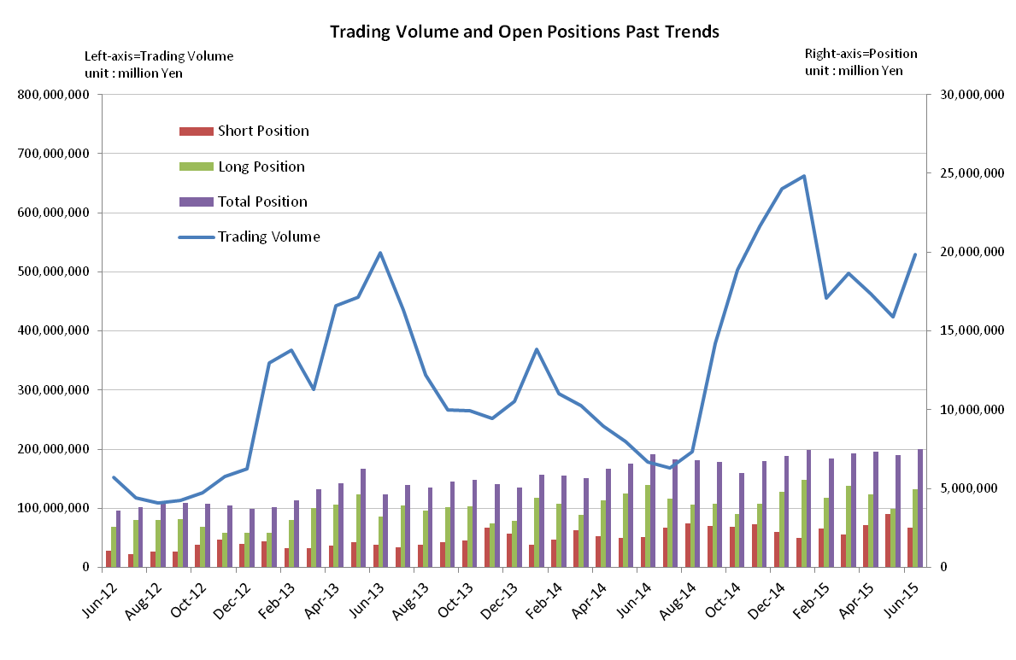

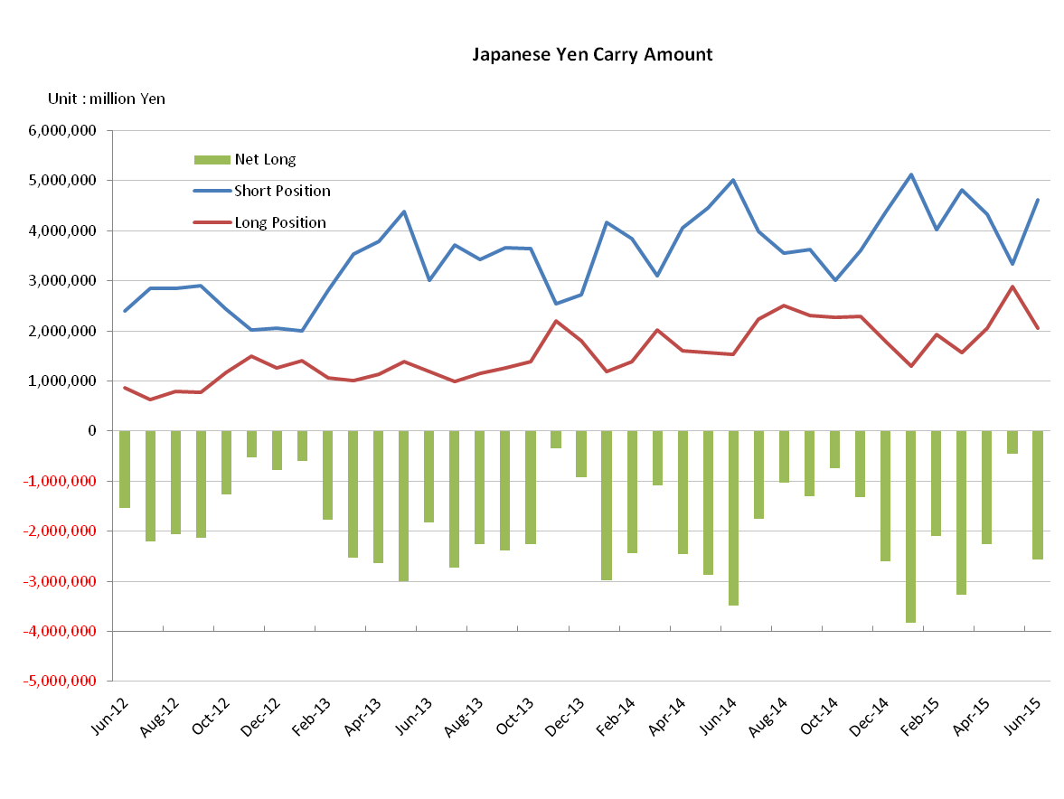

Monthly statistical report on Over-The-Counter Retail FX Margin Trading

：May , 2015
Publication date : 12 June. 2015
Number of Over-The-Counter Retail FX Margin Trading Operators as of 31 May. 2015 : 57
Number of members reported : 57

【Trading Volume】
(Unit: hundred million Yen, %)
 | Over-The-Counter | USDJPY, Cross Yen | On-Exchange*(for reference)
May | 4,243,208 | 3,191,572 | 32,221
Previous month | 4,628,994 | 3,520,121 | 32,955
Change | ‐8.33 | ‐9.33 | ‐2.2
*source : Monthly Trading Volume of Tokyo Financial exchange Inc.(The FFAJ converts the total number of contracts into the trading volume on the settlement prices of the end of the month)
【Open Positions】
(Unit: hundred million Yen)
 | Short | Long | Total
May | 33,955 | 37,334 | 71,289
Previous month | 26,857 | 46,502 | 73,359
Change | 7,097 | ‐9,167 | -2,070

・USDJPY, Cross Yen Open Positions
(Unit: hundred million Yen)
 | ① Short | ② Long | Net long=②-①
May | 33,404 | 28,861 | －4,542
Previous month | 43,288 | 20,619 | －22,668

（Reference：USDJPY Monthly Rate＊）
（Unit: Yen）
End of last Month*1 | Highest of the Month | Lowest of the Month | End of the Month*1 | Average*2
118.91 | 124.30 | 118.89 | 123.75 | 120.74
*source : BOJ's Main Time-series Statistics (Monthly)
*1) Spot Rate at 17:00 in JST, End of Month, Tokyo Market
*2) Average of Central Rate in the Month, Tokyo Market
○ Notes
The trading volume of OTC FX margin trading of this month decreased following the previous month and it was 424 trillion JPY, which was a 77.1 percent increase in year-on-year, and higher than the 2014 average monthly trading volume (336 trillion yen), while maintaining the high level trading volume.
The trend of repurchasing of Japanese yen short positions had been accelerating through the sharp change to the weak yen direction. The Net Yen short position of the end of the month significantly decreased by 1,812.6 billion JPY compared to the previous month and it was less than the milestone of 500 billion JPY.

～Tables and Historical Graphs～

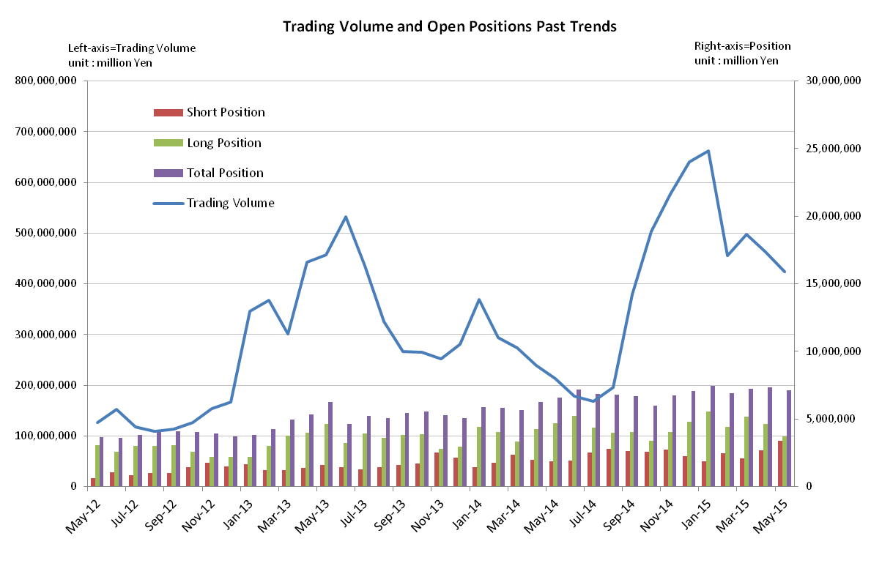

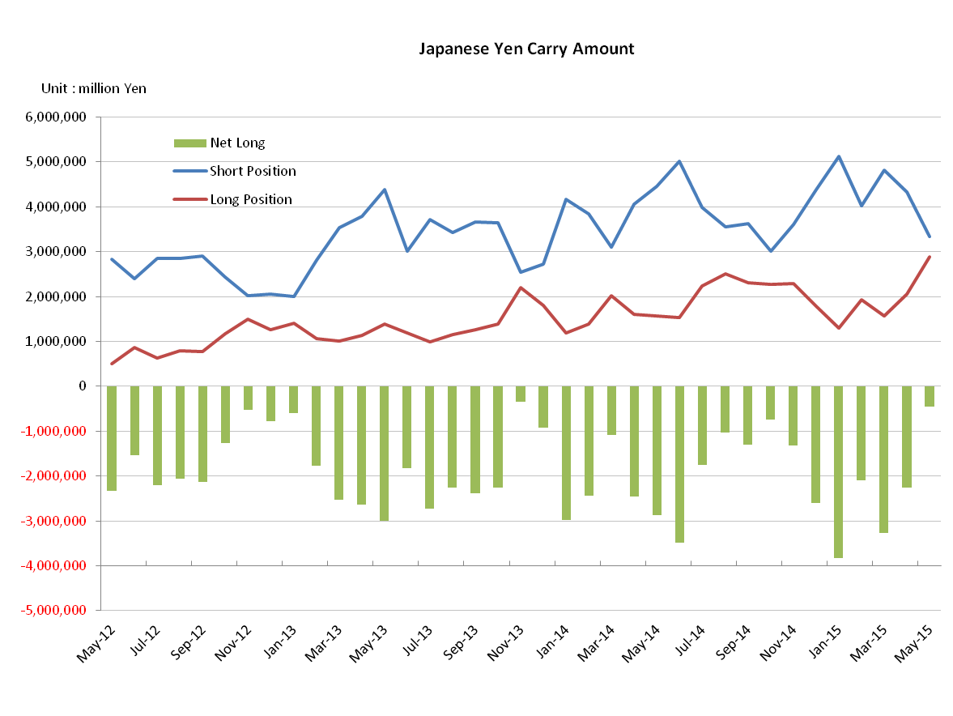

Monthly statistical report on Over-The-Counter Retail FX Margin Trading

：April , 2015
Publication date : 19 May. 2015
Number of Over-The-Counter Retail FX Margin Trading Operators as of 30 April. 2015 : 57
Number of members reported : 57
【Trading Volume】
(Unit: hundred million Yen, %)
 | Over-The-Counter | USDJPY, Cross Yen | On-Exchange*(for reference)
April | 4,628,994 | 3,520,121 | 32,955
Previous month | 4,983,326 | 3,937,577 | 34,663
Change | ‐7.1 | ‐10.6 | ‐4.9
*source : Monthly Trading Volume of Tokyo Financial exchange Inc.(The FFAJ converts the total number of contracts into the trading volume on the settlement prices of the end of the month)
【Open Positions】
(Unit: hundred million Yen)
 | Short | Long | Total
April | 27,689 | 47,702 | 75,392
Previous month | 20,688 | 51,671 | 72,359
Change | 7,001 | －3,968 | 3,032

・USDJPY, Cross Yen Open Positions
(Unit: hundred million Yen)
 | ① Short | ② Long | Net long=②-①
April | 43,667 | 20,925 | －22,742
Previous month | 48,231 | 15,611 | －32,620

（Reference：USDJPY Monthly Rate＊）
（Unit: Yen）
End of last Month*1 | Highest of the Month | Lowest of the Month | End of the Month*1 | Average*2
120.21 | 120.65 | 118.50 | 118.91 | 119.55
*source : BOJ's Main Time-series Statistics (Monthly)
*1) Spot Rate at 17:00 in JST, End of Month, Tokyo Market
*2) Average of Central Rate in the Month, Tokyo Market
○ Notes

OTC FX margin trading of this month decreased by 35 trillion yen, a 7.1%, in value terms from the last month, and it became 462 trillion yen.
The trend to buy back Japanese Yen was seen during the period, the net Yen short positions at the end of the month declined compared to the previous month by repurchasing of Japanese yen short positions.

～Tables and Historical Graphs～

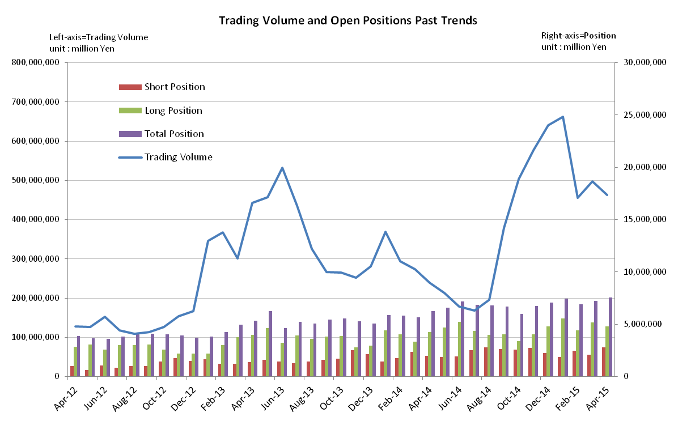

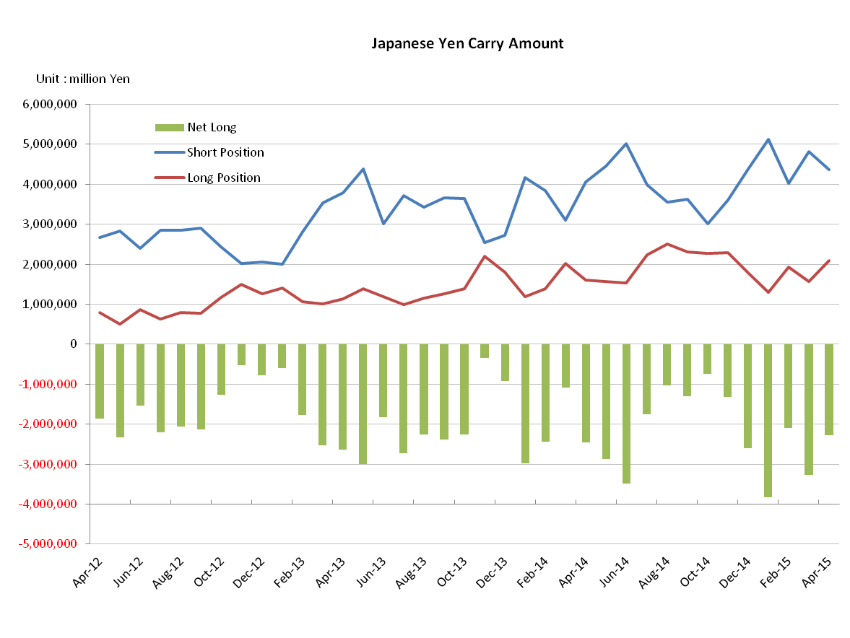

Monthly statistical report on Over-The-Counter Retail FX Margin Trading

：March , 2015
Publication date : 14 April. 2015
Number of Over-The-Counter Retail FX Margin Trading Operators as of 31 March. 2015 : 57
Number of members reported : 48
【Trading Volume】
(Unit: hundred million Yen, %)
 | Over-The-Counter | USDJPY, Cross Yen | On-Exchange*(for reference)
March | 4,983,326 | 3,937,577 | 34,663
Previous month | 4,556,429 | 4,137,177 | 31,481
Change | 9.3 | ‐4.8 | 10.1
*source : Monthly Trading Volume of Tokyo Financial exchange Inc.(The FFAJ converts the total number of contracts into the trading volume on the settlement prices of the end of the month)
【Open Positions】
(Unit: hundred million Yen)
 | Short | Long | Total
March | 20,701 | 51,652 | 72,354
Previous month | 24,832 | 44,155 | 68,988
Change | －4,131 | 7,497 | 3,366

・USDJPY, Cross Yen Open Positions
(Unit: hundred million Yen)
 | ① Short | ② Long | Net long=②-①
March | 48,210 | 15,631 | －32,578
Previous month | 40,186 | 19,199 | －20,987

（Reference：USDJPY Monthly Rate＊）
（Unit: Yen）
End of last Month*1 | Highest of the Month | Lowest of the Month | End of the Month*1 | Average*2
119.29 | 122.03 | 118.54 | 120.21 | 120.39
*source : BOJ's Main Time-series Statistics (Monthly)
*1) Spot Rate at 17:00 in JST, End of Month, Tokyo Market
*2) Average of Central Rate in the Month, Tokyo Market
○ Notes
The trading volume of this month increased to 498 trillion yen. However, after adjusting the difference of 2 days of the business day, this month trading volume was substantially same level compared to the previous month.
By the currency pairs, the trading volume with EUR was rapidly increased, in particular, the trading volume of EURUSD grew by 199.8%, which is close to three-fold of what it was in the preceding month and it was the second among all of currency pairs.
The net Yen short positions at the end of the month increased continuously, and then it grew by 1 trillion yen compared with the previous month.

～Tables and Historical Graphs～

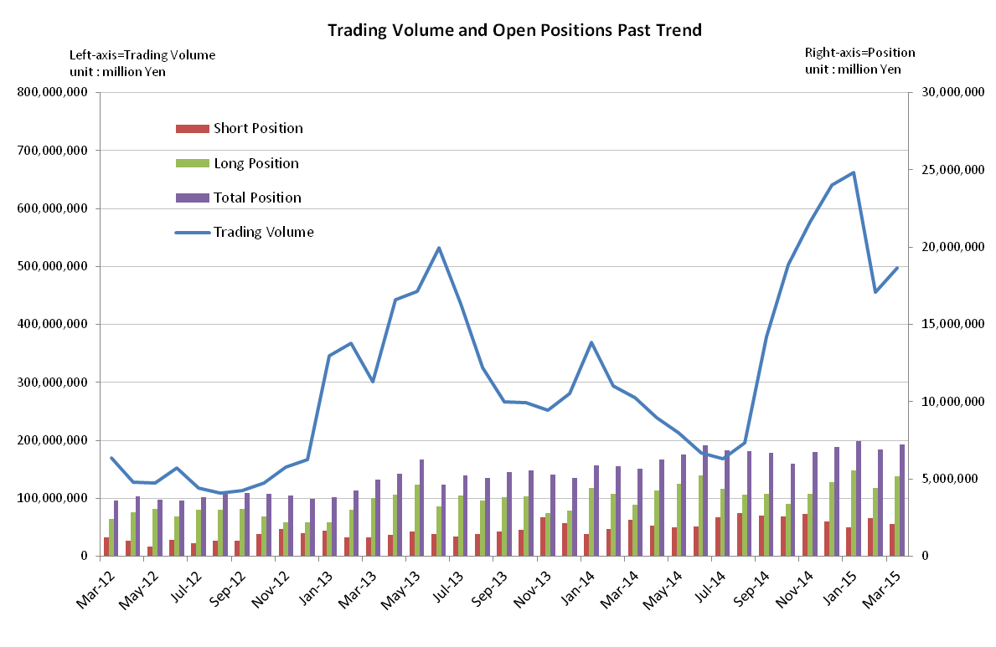
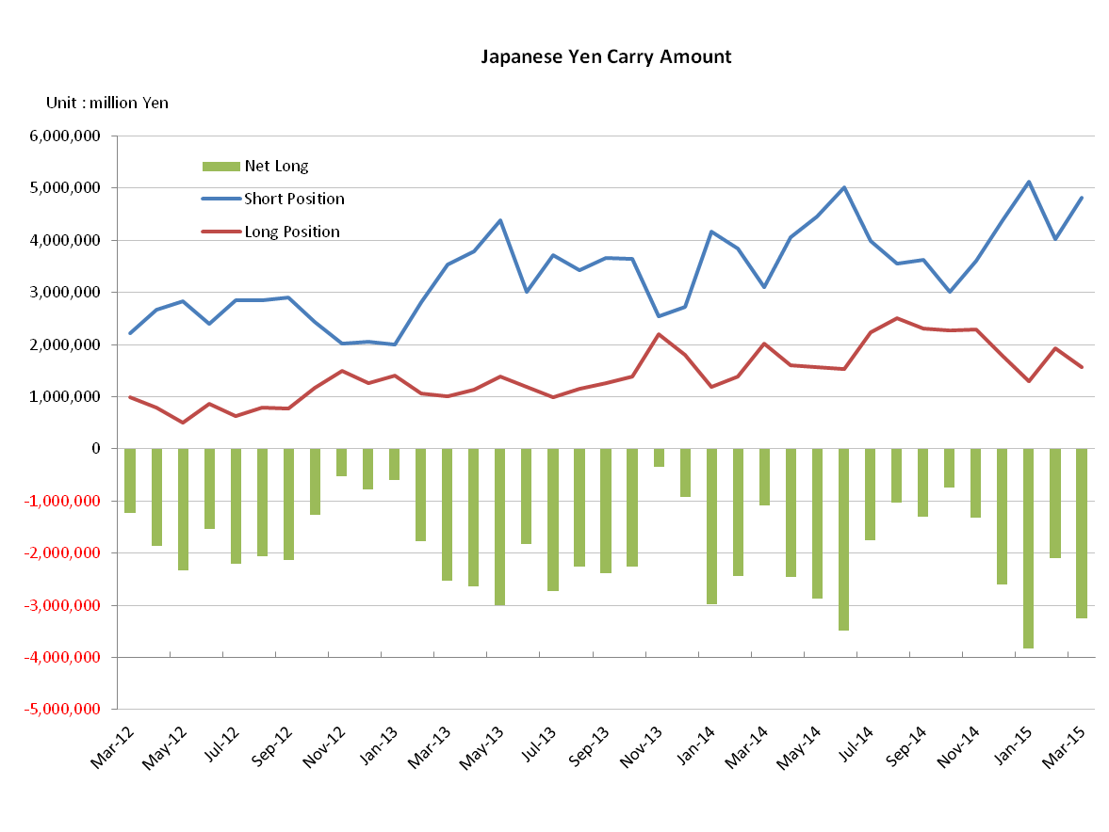
Monthly statistical report on Over-The-Counter Retail FX Margin Trading

：February , 2015
Publication date : 13 March. 2015
Number of Over-The-Counter Retail FX Margin Trading Operators as of 28 February. 2015 :57
Number of members reported :48
【Trading Volume】
(Unit: hundred million Yen, %)
 | Over-The-Counter | USDJPY, Cross Yen | On-Exchange*(for reference)
February | 4,556,429 | 4,137,177 | 31,481
Previous month | 6,618,746 | 6,115,982 | 41,971
Change | －31.0 | －32.0 | －24.9
*source : Monthly Trading Volume of Tokyo Financial exchange Inc.(The FFAJ converts the total number of contracts into the trading volume on the settlement prices of the end of the month)
【Open Positions】
(Unit: hundred million Yen)
 | Short | Long | Total
February | 24,832 | 44,155 | 68,988
Previous month | 18,808 | 55,442 | 74,250
Change | 6,024 | －11,286 | －5,262

・USDJPY, Cross Yen Open Positions
(Unit: hundred million Yen)
 | ① Short | ② Long | Net long=②-①
February | 40,186 | 19,199 | －20,987
Previous month | 51,284 | 12,980 | －38,303

（Reference：USDJPY Monthly Rate＊）
（Unit: Yen）
End of last Month*1 | Highest of the Month | Lowest of the Month | End of the Month*1 | Average*2
117.90 | 120.46 | 116.87 | 119.29 | 118.57
*source : BOJ's Main Time-series Statistics (Monthly)
*1) Spot Rate at 17:00 in JST, End of Month, Tokyo Market
*2) Average of Central Rate in the Month, Tokyo Market
○ Notes
OTC FX margin trading of this month suddenly fell by 31% from the previous month and it was 455 trillion yen,
after the trading volume of over-the-counter FX margin trading had been growing for 6 months consecutively.
The net yen short positions of the end of the month decreased by 1.7 trillion yen and it was 2 trillion yen, in
response to the combination with 71.9% up of short USDJPY position and 30.9% down of long USDJPY position.
～Tables and Historical Graphs～

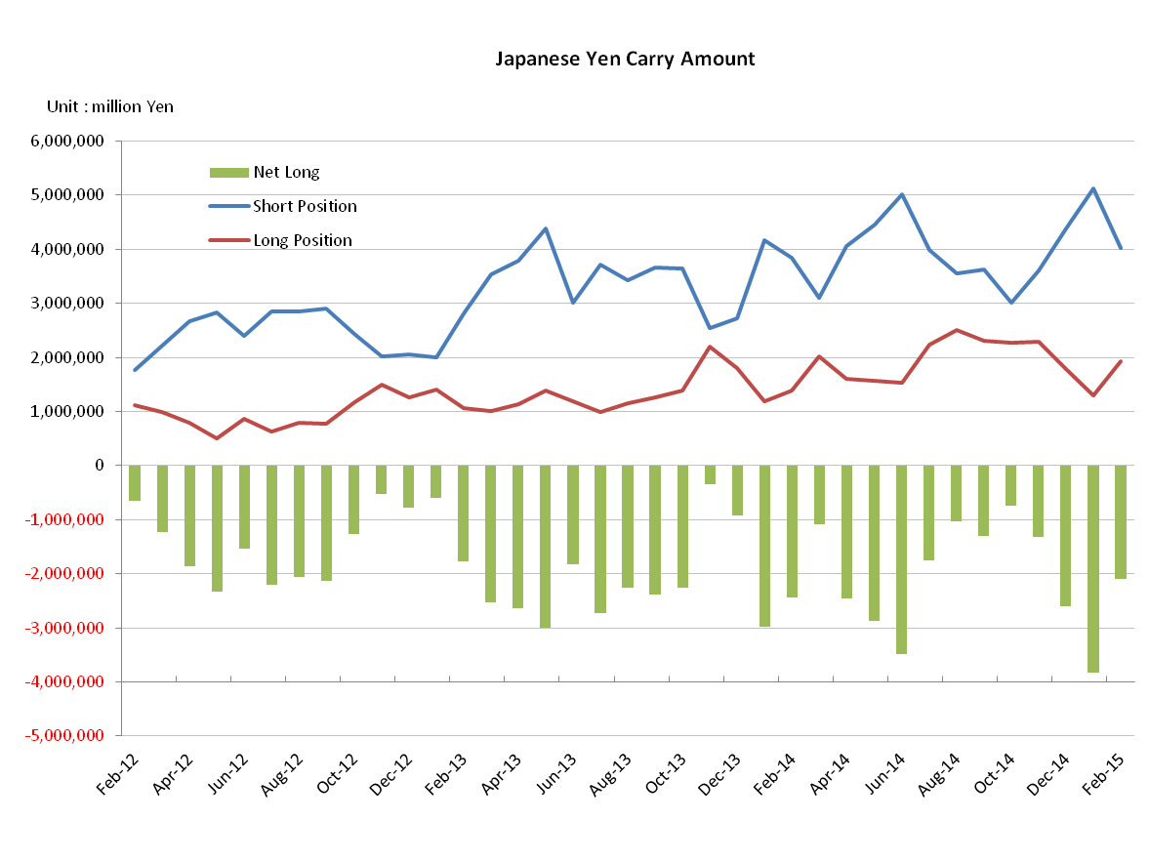
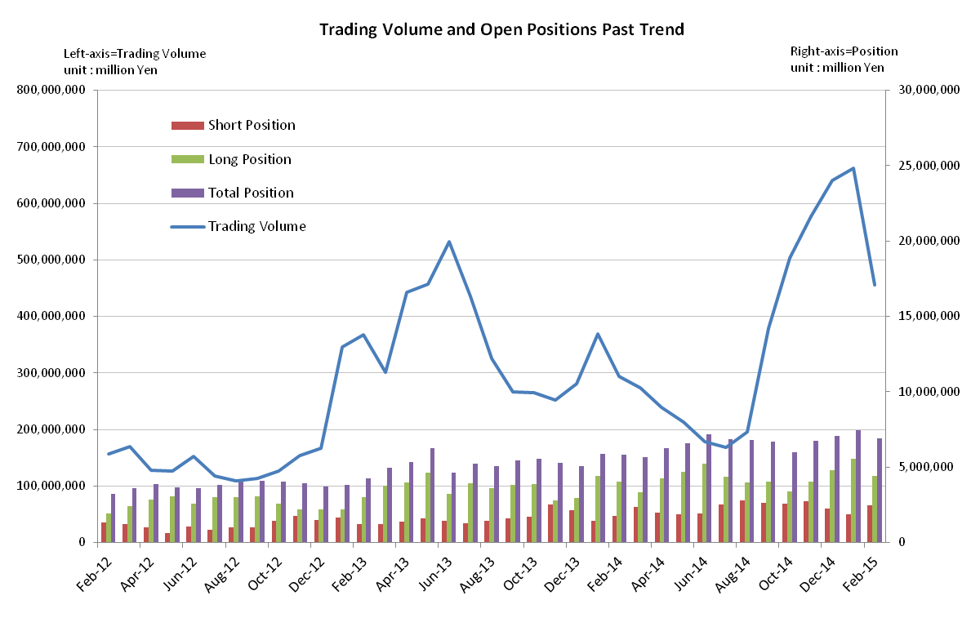
Monthly statistical report on Over-The-Counter Retail FX Margin Trading

：January , 2015
Publication date : 16 February. 2015
Number of Over-The-Counter Retail FX Margin Trading Operators as of 31 January. 2015 : 57
Number of members reported :48
【Trading Volume】
(Unit: hundred million Yen, %)
 | Over-The-Counter | USDJPY, Cross Yen | On-Exchange*(for reference)
January | 6,618,746 | 6,115,982 | 41,971
Previous month | 6,409,959 | 6,137,205 | 47,826
Change | 3.2 | －0.3 | －12.2
*source : Monthly Trading Volume of Tokyo Financial exchange Inc.(The FFAJ converts the total number of contracts into the trading volume on the settlement prices of the end of the month)
【Open Positions】
(Unit: hundred million Yen)
 | Short | Long | Total
January | 18,808 | 55,442 | 74,250
Previous month | 22,750 | 48,095 | 70,846
Change | －3,942 | 7,346 | 3,403

・USDJPY, Cross Yen Open Positions
(Unit: hundred million Yen)
 | ① Short | ② Long | Net long=②-①
January | 51,284 | 12,980 | －38,303
Previous month | 43,749 | 17,787 | －25,961

（Reference：USDJPY Monthly Rate＊）
（Unit: Yen）
End of last Month*1 | Highest of the Month | Lowest of the Month | End of the Month*1 | Average*2
119.80 | 120.68 | 115.85 | 117.90 | 118.24
*source : BOJ's Main Time-series Statistics (Monthly)
*1) Spot Rate at 17:00 in JST, End of Month, Tokyo Market
*2) Average of Central Rate in the Month, Tokyo Market
○ Notes
OTC FX margin trading volume of January was exceeded above the 600 trillion yen for two consecutive months, updated the highest record monthly volume.
The open positions of the end of the month was increased while January’s turmoil in the foreign exchange markets affected the retail margin FX trading.
The Yen short positions of the end of the month increased by 750 billion yen compared to the previous month. In contrast the Yen long positions decreased by 500 billion yen. It seems to be indicated that the anticipation of weaker Japanese Yen has spread to Japanese investors.
～Tables and Historical Graphs～

