Over-The-Counter FX Margin Trading Report

(January 2014 ～ December 2014)

Monthly Report
January 2014
February 2014
March 2014
April 2014
May 2014
June 2014
July 2014
August 2014
September 2014
October 2014
November 2014
December 2014

The Financial Futures Association of Japan, Research Department

NBF Ogawamachi Building 1-3 , Kanda Ogawamachi ,
Chiyoda-ku , Tokyo 101-0052 Tel:(03)5280-0881 E-mail : ffaj@ffaj.or.jp

This publication has been prepared by the FFAJ and is provided for information purpose only. The monthly information contained in this publication has been obtained from FFAJ's members that is believed to be reliable, however the FFAJ does not represent or warrant that it is accurate or complete. In no event the FFAJ nor its employees have any liability for any consequential damages arising from any use of this publications or its contents. This publication does not constitute any investment advice.

Monthly statistical report on Over-The-Counter Retail FX Margin Trading

：December , 2014
Publication date : 19 January. 2015
Number of Over-The-Counter Retail FX Margin Trading Operators as of 31 December. 2014 : 58
Number of members reported : 49

【Trading Volume】
(Unit: hundred million Yen, %)
 | Over-The-Counter | USDJPY, Cross Yen | On-Exchange*(for reference)
December | 6,409,959 | 6,137,205 | 47,826
Previous month | 5,765,644 | 5,465,787 | 49,798
Change | +11.1 | +12.2 | -3.9
*source : Monthly Trading Volume of Tokyo Financial exchange Inc.(The FFAJ converts the total number of contracts into the trading volume on the settlement prices of the end of the month)
【Open Positions】
(Unit: hundred million Yen)
 | Short | Long | Total
December | 22,750 | 48,095 | 70,846
Previous month | 27,396 | 40,246 | 67,642
Change | ‐4,645 | +7,848 | +3,203

・USDJPY, Cross Yen Open Positions
(Unit: hundred million Yen)
 | ① Short | ② Long | Net long=②-①
December | 43,749 | 17,787 | -25,961
Previous month | 36,114 | 22,869 | -13,245

（Reference：USDJPY Monthly Rate＊）
（Unit: Yen）
End of last Month*1 | Highest of the Month | Lowest of the Month | End of the Month*1 | Average*2
118.22 | 121.86 | 116.33 | 119.80 | 119.40
*source : BOJ's Main Time-series Statistics (Monthly)
*1) Spot Rate at 17:00 in JST, End of Month, Tokyo Market
*2) Average of Central Rate in the Month, Tokyo Market

○ Notes
OTC FX margin trading of this month was significantly higher than the 600 trillion yen, was broke the highest record monthly volume for two consecutive months.
While trading volume of over-the-counter FX margin trading grew rapidly by 11.4%, on the other hand the open positions of the end of the month was slightly increased by 4.7% .
Therefore, in the background of the current month of volume increase, it was assumed that the reason was not only other inflows of new money from the customer but also the rise in the rate of turnover of fund due to short-term trading.
～Tables and Historical Graphs～

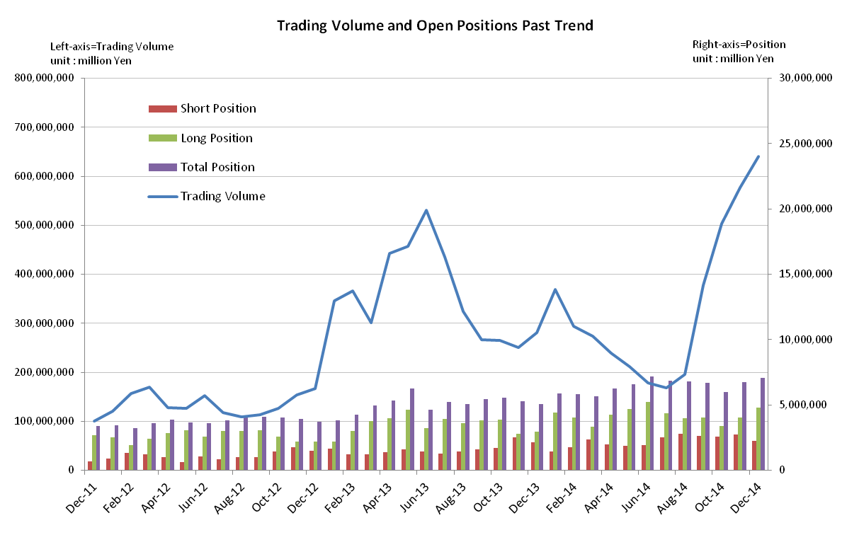

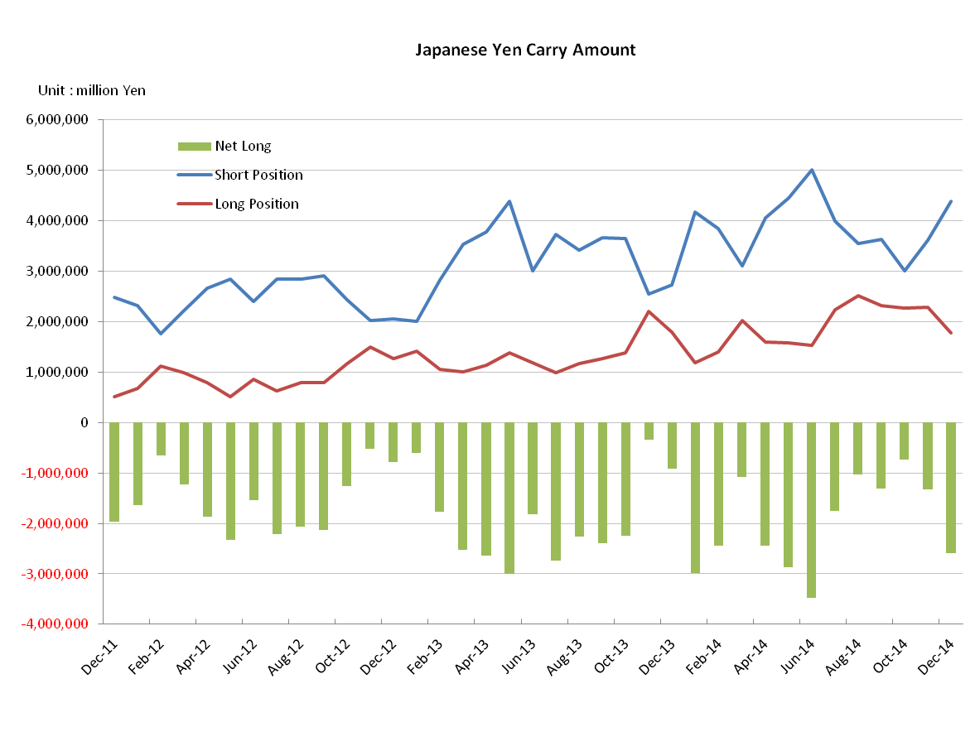

Monthly statistical report on Over-The-Counter Retail FX Margin Trading

：November , 2014
Publication date : 12 December. 2014
Number of Over-The-Counter Retail FX Margin Trading Operators as of 30 November. 2014 : 59
Number of members reported : 49

【Trading Volume】
(Unit: hundred million Yen, %)
 | Over-The-Counter | USDJPY, Cross Yen | On-Exchange*(for reference)
November | 5,765,644 | 5,465,787 | 49,798
Previous month | 5,030,789 | 4,647,932 | 46,832
Change | +14.6 | +17.5 | +6.3
*source : Monthly Trading Volume of Osaka Securities Exchange
: Monthly Trading Volume of Tokyo Financial exchange Inc.(The FFAJ converts the total number of contracts into the trading volume on the settlement prices of the end of the month)

【Open Positions】
(Unit: hundred million Yen)
 | Short | Long | Total
November | 27,396 | 40,246 | 67,642
Previous month | 25,696 | 34,016 | 59,712
Change | +1,700 | +6,230 | +7,930

・USDJPY, Cross Yen Open Positions
(Unit: hundred million Yen)
 | ① Short | ② Long | Net long=②-①
November | 36,114 | 22,869 | －13,245
Previous month | 30,075 | 22,693 | －7,381

（Reference：USDJPY Monthly Rate＊）
（Unit: Yen）
End of last Month*1 | Highest of the Month | Lowest of the Month | End of the Month*1 | Average*2
111.23 | 118.98 | 113.28 | 118.22 | 116.22
*source : BOJ's Main Time-series Statistics (Monthly)
*1) Spot Rate at 17:00 in JST, End of Month, Tokyo Market
*2) Average of Central Rate in the Month, Tokyo Market

○ Notes
OTC FX margin trading of this month was recorded 576 trillion yen, which was the highest trading volume since statistics started in 2008. Because both of short and long positions of OTC FX margin trading at the end of the month increased, it was supposed that the new fund of the investors flowed in.

～Tables and Historical Graphs～

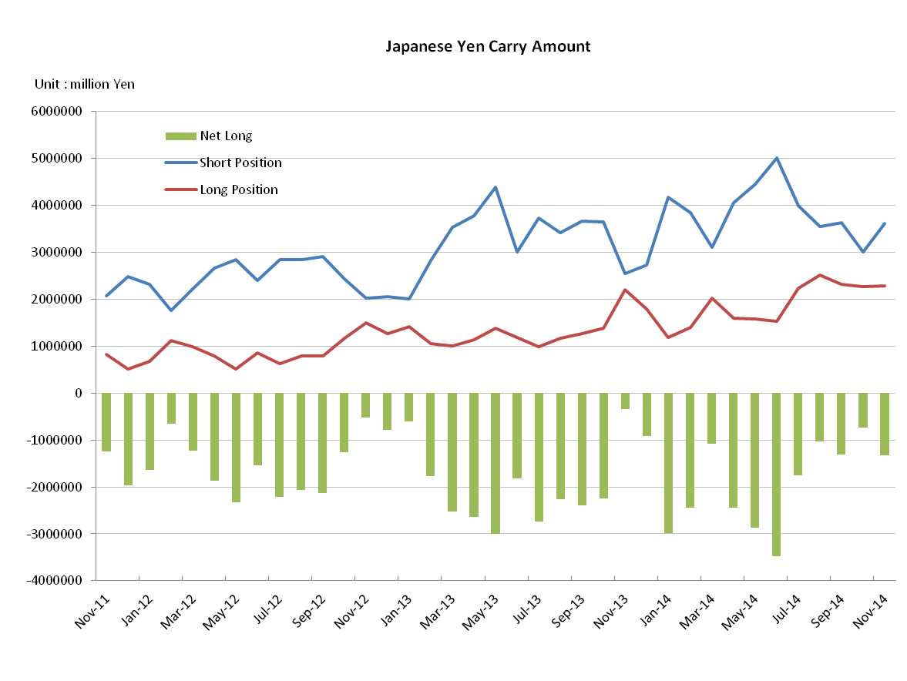
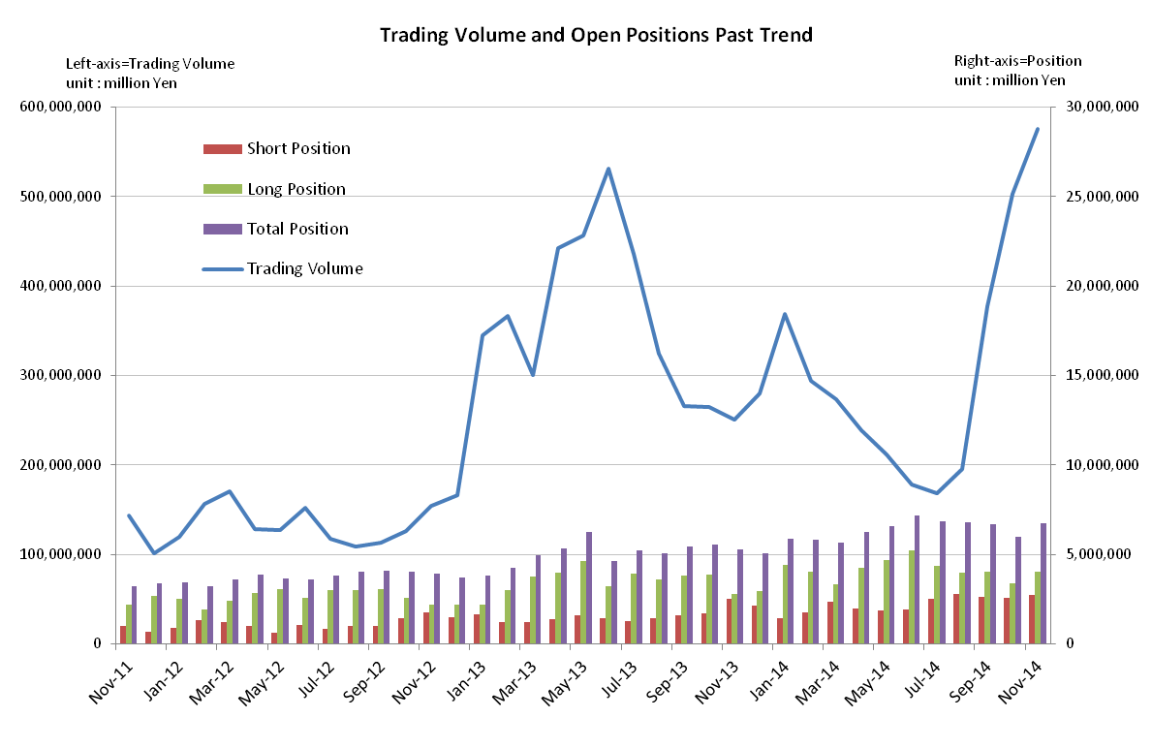

Monthly statistical report on Over-The-Counter Retail FX Margin Trading

：October , 2014
Publication date : 17 November. 2014
Number of Over-The-Counter Retail FX Margin Trading Operators as of 31 October. 2014 : 59
Number of members reported : 49

【Trading Volume】
(Unit: hundred million Yen, %)
 | Over-The-Counter | USDJPY, Cross Yen | On-Exchange*(for reference)
October | 5,030,789 | 4,647,932 | 46,832
Previous month | 3,780,783 | 3,468,700 | 38,581
Change | 33.0 | 33.9 | 21.3
*source : Monthly Trading Volume of Osaka Securities Exchange
: Monthly Trading Volume of Tokyo Financial exchange Inc.(The FFAJ converts the total number of contracts into the trading volume on the settlement prices of the end of the month)

【Open Positions】
(Unit: hundred million Yen)
 | Short | Long | Total
October | 25,696 | 34,016 | 59,712
Previous month | 26,421 | 40,421 | 66,842
Change | -725 | -6,404 | -7,130

・USDJPY, Cross Yen Open Positions
(Unit: hundred million Yen)
 | ① Short | ② Long | Net long=②-①
October | 30,075 | 22,693 | -7,381
Previous month | 36,212 | 23,104 | -13,108

（Reference：USDJPY Monthly Rate＊）
（Unit: Yen）
End of last Month*1 | Highest of the Month | Lowest of the Month | End of the Month*1 | Average*2
109.42 | 111.52 | 105.76 | 111.23 | 108.06
*source : BOJ's Main Time-series Statistics (Monthly)
*1) Spot Rate at 17:00 in JST, End of Month, Tokyo Market
*2) Average of Central Rate in the Month, Tokyo Market

○ Notes
OTC FX margin trading of this month increased by 33% from the last month, and it became 503 trillion yen, which ranked second to the 531 trillion yen in June 2013 that was the highest trading volume since statistics started in 2008.
In terms of open positions, The Yen short positions of the end of the month slightly decreased by 572.7 billion yen compared to the previous month by repurchasing of profit taking, in response to the rapid depreciation of Japanese yen. The open positions of the end of the month, while the open positions of the end of June in 2013 were 4637.5 billion yen decreased by 1622.2 billion yen, was still maintaining a high level of 5971.2 billion yen.

～Tables and Historical Graphs～
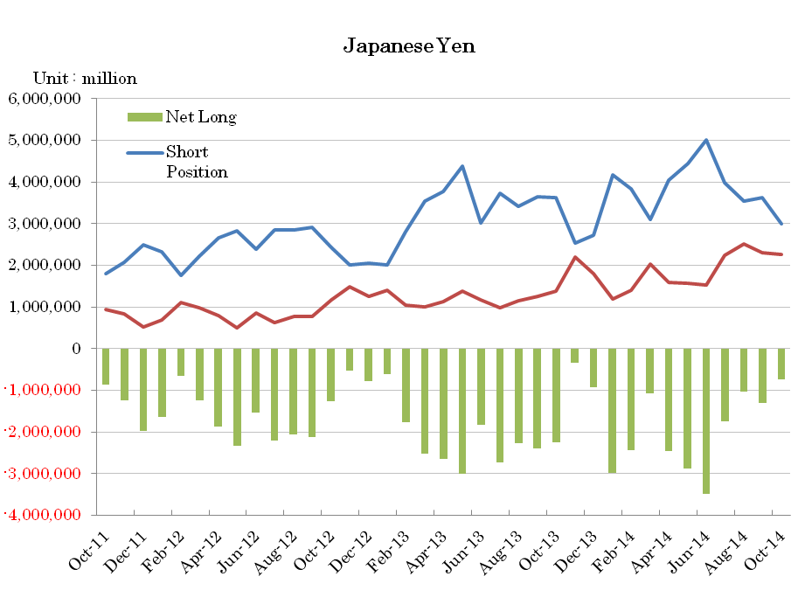
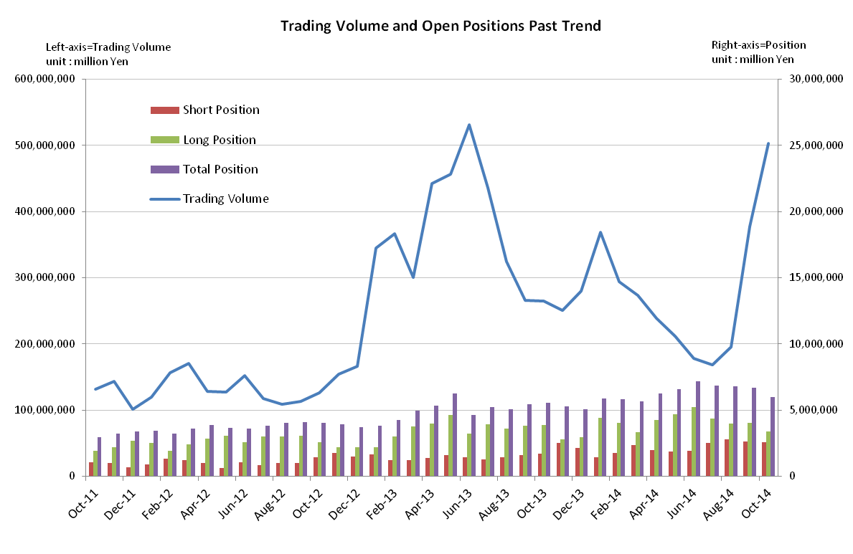

Monthly statistical report on Over-The-Counter Retail FX Margin Trading

：September , 2014
Publication date : 15 October. 2014
Number of Over-The-Counter Retail FX Margin Trading Operators as of 30 September. 2014 : 61
Number of members reported : 50

【Trading Volume】
(Unit: hundred million Yen, %)
 | Over-The-Counter | USDJPY, Cross Yen | On-Exchange*(for reference)
September | 3,780,783 | 3,468,700 | 38,581
Previous month | 1,957,612 | 1,777,783 | 22,218
Change | 93.1 | 95.1 | 73.6
*source : Monthly Trading Volume of Osaka Securities Exchange
: Monthly Trading Volume of Tokyo Financial exchange Inc.(The FFAJ converts the total number of contracts into the trading volume on the settlement prices of the end of the month)

【Open Positions】
(Unit: hundred million Yen)
 | Short | Long | Total
September | 26,421 | 40,421 | 66,842
Previous month | 27,890 | 39,858 | 67,749
Change | -1,469 | 563 | -906

・USDJPY, Cross Yen Open Positions
(Unit: hundred million Yen)
 | ① Short | ② Long | Net long=②-①
September | 36,212 | 23,104 | -13,108
Previous month | 35,533 | 25,136 | -10,396

（Reference：USDJPY Monthly Rate＊）
（Unit: Yen）
End of last Month*1 | Highest of the Month | Lowest of the Month | End of the Month*1 | Average*2
103.83 | 109.74 | 104.1 | 109.42 | 107.09
*source : BOJ's Main Time-series Statistics (Monthly)
*1) Spot Rate at 17:00 in JST, End of Month, Tokyo Market
*2) Average of Central Rate in the Month, Tokyo Market

○ Notes
Because of the rapid depreciation of the yen against the dollar, the trading volume of OTC FX margin trading of this month exceed the milestone of 300 trillion yen a month since January, and became the 378 trillion yen of 93.1% from the previous month.
Monthly total trading volume from January to September 2014 reached 2308 trillion yen.

～Tables and Historical Graphs～
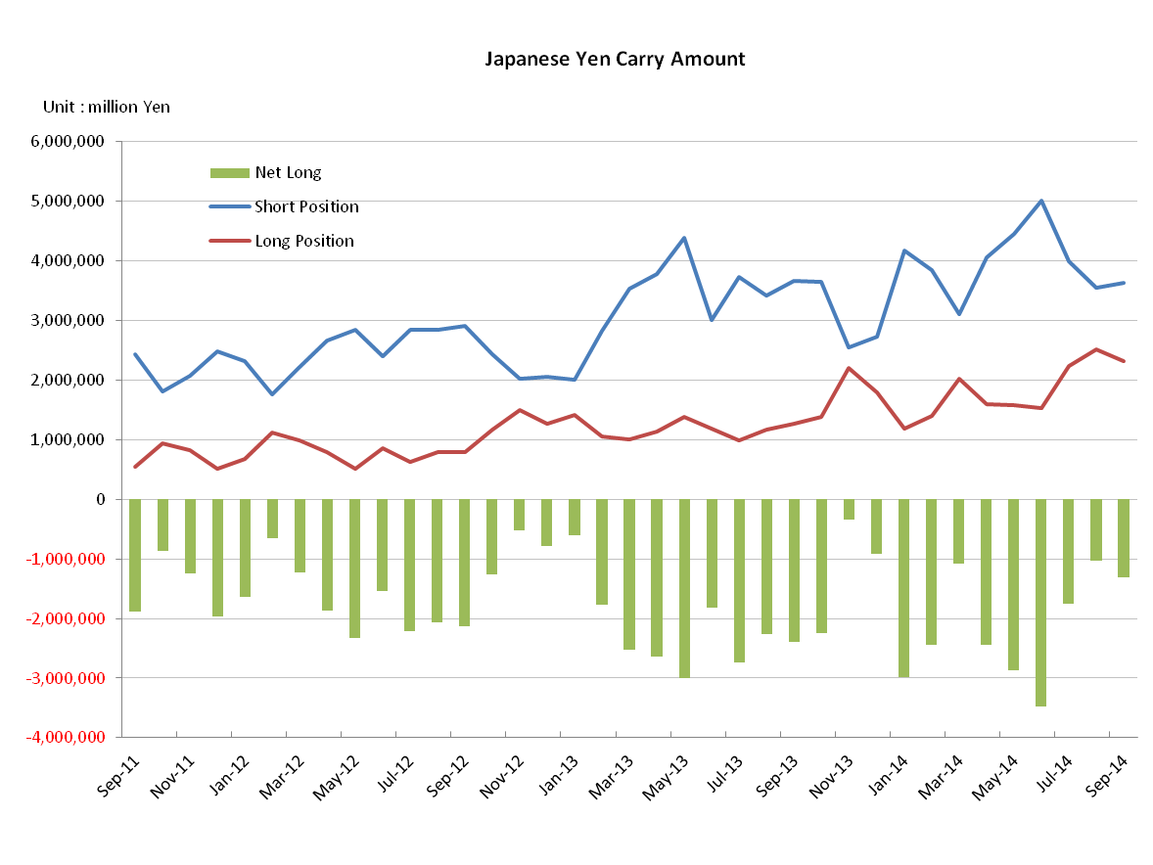
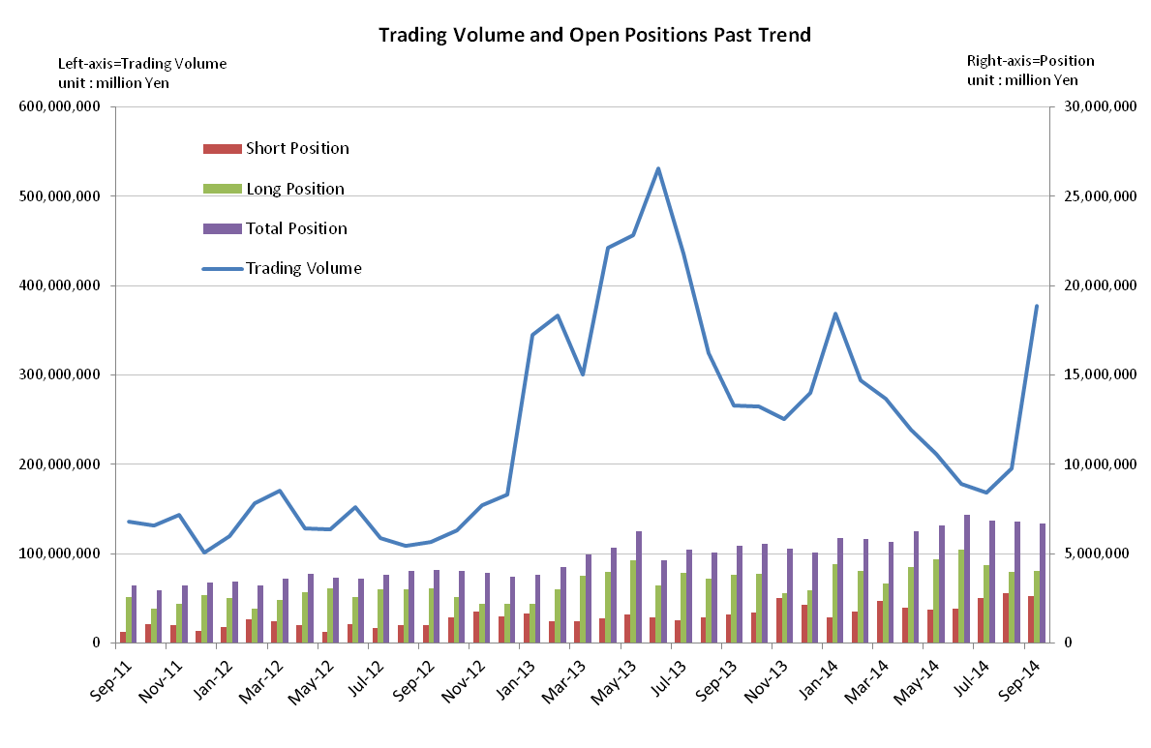

Monthly statistical report on Over-The-Counter Retail FX Margin Trading

：August , 2014
Publication date : 12 September. 2014

Number of Over-The-Counter Retail FX Margin Trading Operators as of 31 August. 2014 :61
Number of members reported :50

【Trading Volume】
(Unit: hundred million Yen, %)
 | Over-The-Counter | USDJPY, Cross Yen | On-Exchange*(for reference)
August | 1,957,611 | 1,777,783 | 22,218
Previous month | 1.684,122 | 1,528,368 | 19,081
Change | 16.2 | 16.3 | 16.4
*source : Monthly Trading Volume of Osaka Securities Exchange
: Monthly Trading Volume of Tokyo Financial exchange Inc.(The FFAJ converts the total number of contracts into the trading volume on the settlement prices of the end of the month)

【Open Positions】
(Unit: hundred million Yen)
 | Short | Long | Total
August | 27,890 | 39,858 | 67,748
Previous month | 25,394 | 43,382 | 68,776
Change | 2,496 | -3,523 | -1,027

・USDJPY, Cross Yen Open Positions
(Unit: hundred million Yen)
 | ① Short | ② Long | Net long=②-①
August | 35,533 | 25,136 | -10,396
Previous month | 39,824 | 22,365 | -17,458

（Reference：USDJPY Monthly Rate＊）
（Unit: Yen）
End of last Month*1 | Highest of the Month | Lowest of the Month | End of the Month*1 | Average*2
102.87 | 104.27 | 101.51 | 103.83 | 102.96
*source : BOJ's Main Time-series Statistics (Monthly)
*1) Spot Rate at 17:00 in JST, End of Month, Tokyo Market
*2) Average of Central Rate in the Month, Tokyo Market

○ Notes
Although the trading volume of this month did not reach the monthly mark of 200 trillion yen, it was 195 trillion yen and increased by 16.2% compared to the previous month, after reduction in continuation for six months. The Yen short positions of the end of the month decreased by 700 billion Yen compared to the previous month, in response to the depreciation of Japanese yen.

～Tables and Historical Graphs～

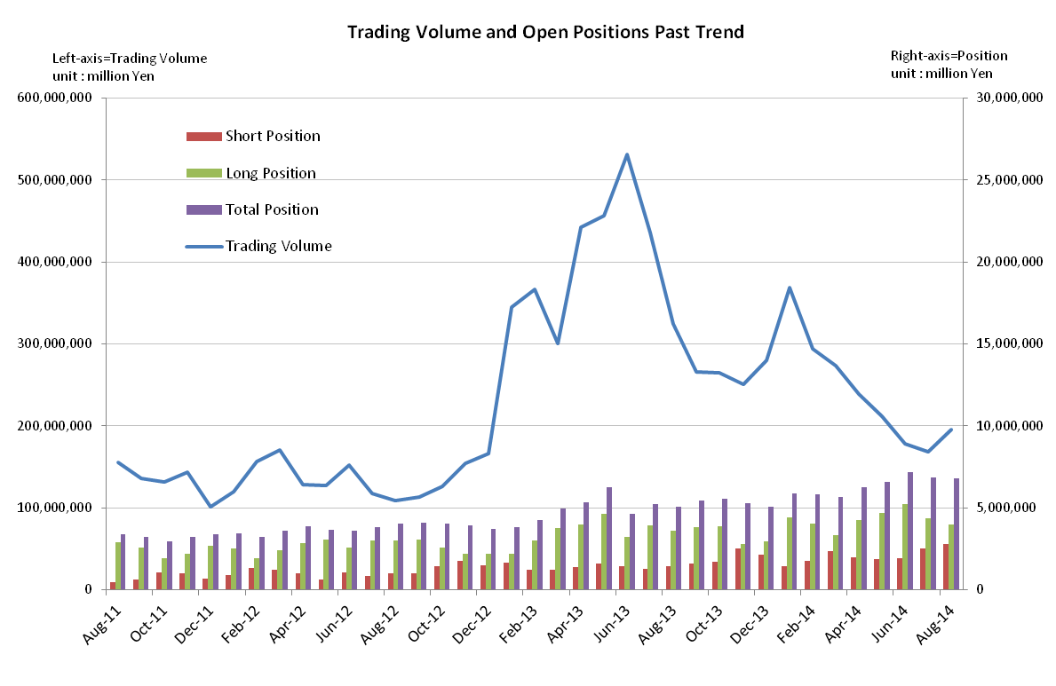

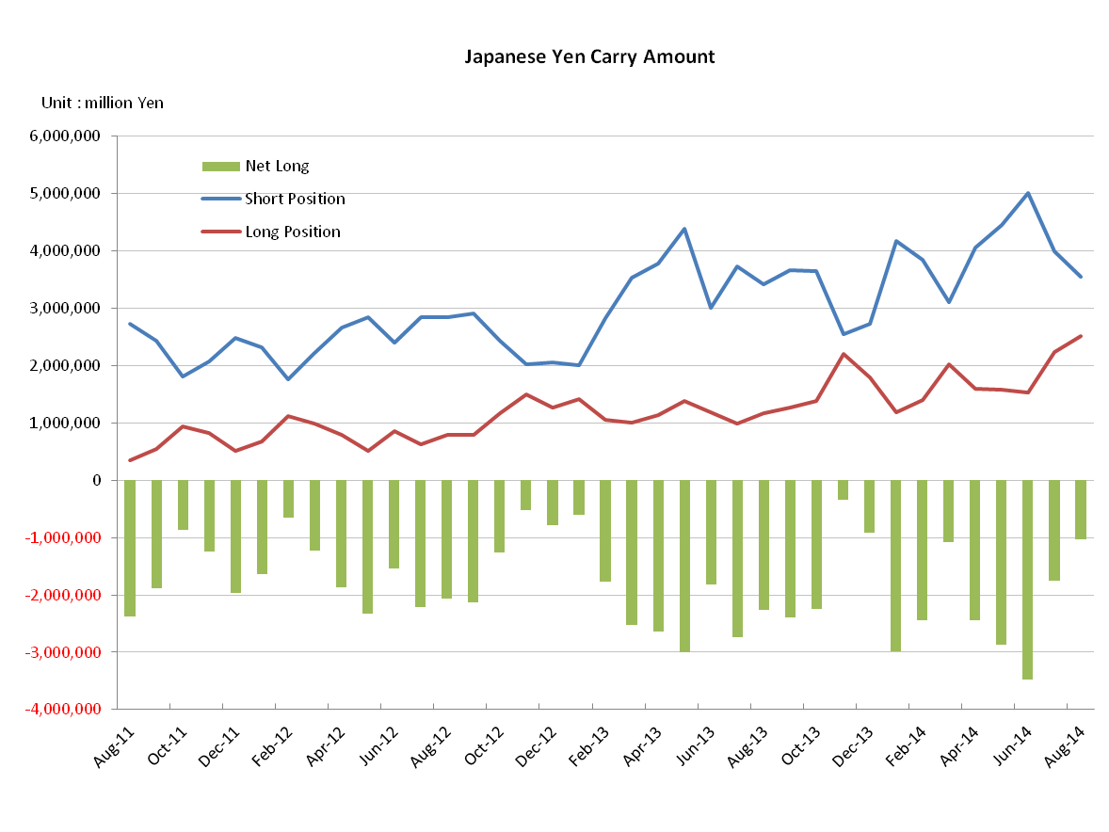

Monthly statistical report on Over-The-Counter Retail FX Margin Trading

：July , 2014
Publication date : 14 August. 2014

Number of Over-The-Counter Retail FX Margin Trading Operators as of 31 July. 2014 : 61
Number of members reported : 51

【Trading Volume】
(Unit: hundred million Yen, %)
 | Over-The-Counter | USDJPY, Cross Yen | On-Exchange*(for reference)
Juｌｙ | 1.684,122 | 1,528,368 | 19,081
Previous month | 1,779,098 | 1,596,445 | 18,319
Change | -5.3 | -4.2 | 4.1
*source : Monthly Trading Volume of Osaka Securities Exchange
: Monthly Trading Volume of Tokyo Financial exchange Inc.(The FFAJ converts the total number of contracts into the trading volume on the settlement prices of the end of the month)

【Open Positions】
(Unit: hundred million Yen)
 | Short | Long | Total
Juｌｙ | 25,394 | 43,382 | 68,776
Previous month | 19,300 | 52,532 | 71,833
Change | 6,094 | -9,150 | -3,056

・USDJPY, Cross Yen Open Positions
(Unit: hundred million Yen)
 | ① Short | ② Long | Net long=②-①
Juｌｙ | 39,824 | 22,365 | -17,458
Previous month | 50,072 | 15,231 | -34,840

（Reference：USDJPY Monthly Rate＊）
（Unit: Yen）
End of last Month*1 | Highest of the Month | Lowest of the Month | End of the Month*1 | Average*2
101.39 | 102.89 | 101.09 | 102.87 | 101.09
*source : BOJ's Main Time-series Statistics (Monthly)
*1) Spot Rate at 17:00 in JST, End of Month, Tokyo Market
*2) Average of Central Rate in the Month, Tokyo Market

○ Notes
While monthly trading volume of On-exchange FX margin trading started to increase, Trading volume of OTC FX margin trading volume of July was decreased consecutively for six months and the open position at end of month also declined.
The Net Yen short positions of the end of the month was halved from the previous month due to the steep decreasing of Short yen positions and increasing of Long yen positions.

～Tables and Historical Graphs～
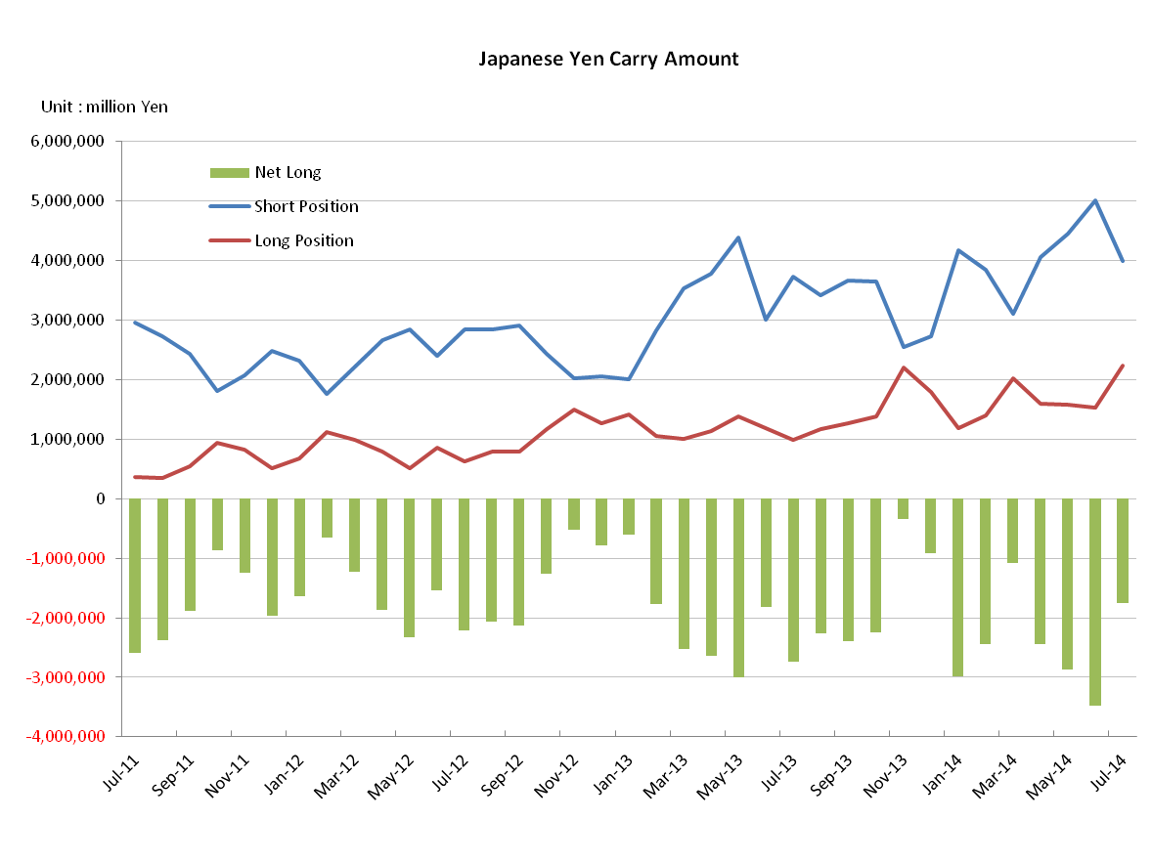
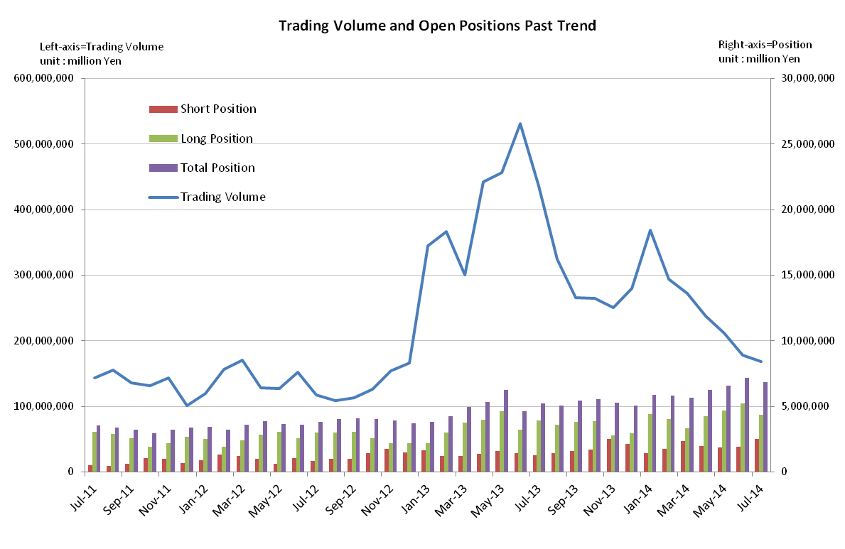

Monthly statistical report on Over-The-Counter Retail FX Margin Trading

：June , 2014
Publication date : 14 July. 2014

Number of Over-The-Counter Retail FX Margin Trading Operators as of 30 June. 2014 : 62
Number of members reported : 51

【Trading Volume】
(Unit: hundred million Yen, %)
 | Over-The-Counter | USDJPY, Cross Yen | On-Exchange*(for reference)
June | 1,779,098 | 1,596,445 | 18,319
Previous month | 2,115,793 | 1,969,504 | 21,777
Change | -15.9 | -18.9 | -15.8
*source : Monthly Trading Volume of Osaka Securities Exchange
: Monthly Trading Volume of Tokyo Financial exchange Inc.(The FFAJ converts the total number of contracts into the trading volume on the settlement prices of the end of the month)

【Open Positions】
(Unit: hundred million Yen)
 | Short | Long | Total
June | 19,300 | 52,532 | 71,833
Previous month | 18,790 | 47,009 | 65,799
Change | 510 | 5,523 | 6,033

・USDJPY, Cross Yen Open Positions
(Unit: hundred million Yen)
 | ① Short | ② Long | Net long=②-①
June | 50,072 | 15,231 | -34,840
Previous month | 44,497 | 15,732 | -28,764

（Reference：USDJPY Monthly Rate＊）
（Unit: Yen）
End of last Month*1 | Highest of the Month | Lowest of the Month | End of the Month*1 | Average*2
101.64 | 102.8 | 101.24 | 101.39 | 102.05
*source : BOJ's Main Time-series Statistics (Monthly)
*1) Spot Rate at 17:00 in JST, End of Month, Tokyo Market
*2) Average of Central Rate in the Month, Tokyo Market

○ Notes
Trading volume of this month was 179 trillion yen and decreased in the third consecutive month by more than 10% compared to the previous month, and it was lower than the 200 trillion yen a month since December 2012.
In terms of open position, It should be noted that total position was the 71,833 hundred million yen compared to 37,082 hundred million yen of 2012 December 31, it was a level of 1.9 times the end of the month.

～Tables and Historical Graphs～

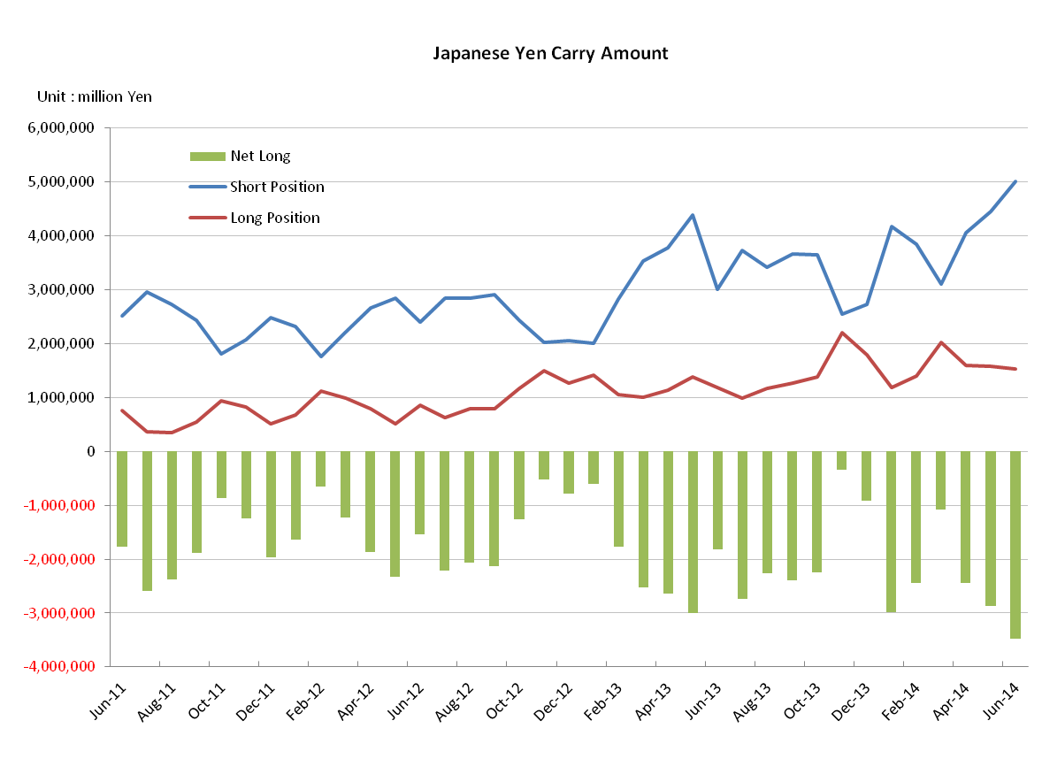
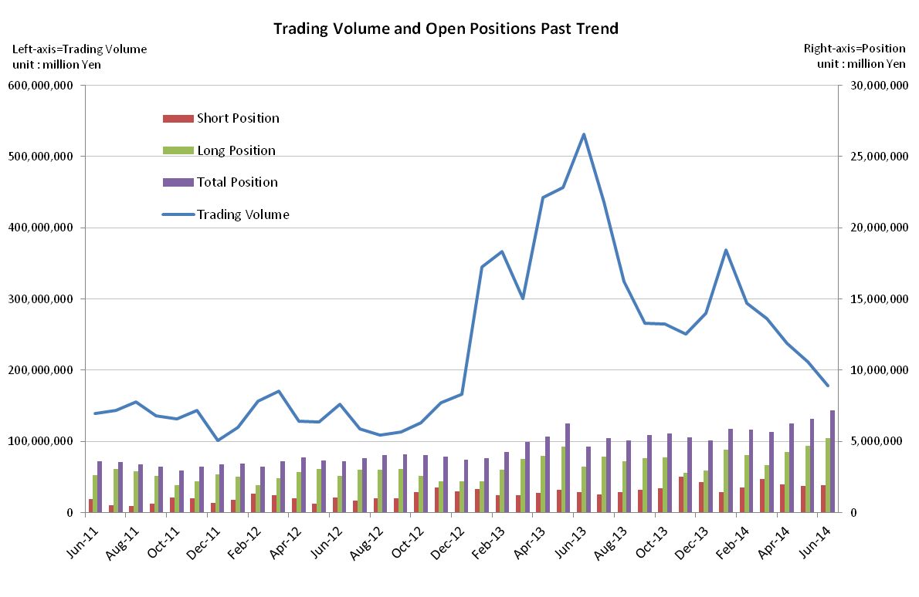

Monthly statistical report on Over-The-Counter Retail FX Margin Trading

：May , 2014
Publication date : 13 June. 2014

Number of Over-The-Counter Retail FX Margin Trading Operators as of 31 May. 2014 : 62
Number of members reported : 51

【Trading Volume】
(Unit: hundred million Yen, %)
 | Over-The-Counter | USDJPY, Cross Yen | On-Exchange*(for reference)
May | 2,115,793 | 1,969,504 | 21,777
Previous month | 2,381,805 | 2,258,523 | 25,566
Change | -11.1 | -12.7 | -14.8
*source : Monthly Trading Volume of Osaka Securities Exchange
: Monthly Trading Volume of Tokyo Financial exchange Inc.(The FFAJ converts the total number of contracts into the trading volume on the settlement prices of the end of the month)

【Open Positions】
(Unit: hundred million Yen)
 | Short | Long | Total
May | 18,790 | 47,009 | 65,799
Previous month | 19,784 | 42,547 | 62,331
Change | -993 | 4,461 | 3,467

・USDJPY, Cross Yen Open Positions
(Unit: hundred million Yen)
 | ① Short | ② Long | Net long=②-①
May | 44,497 | 15,732 | -28,764
Previous month | 40,487 | 15,988 | -24,498

（Reference：USDJPY Monthly Rate＊）
（Unit: Yen）
End of last Month*1 | Highest of the Month | Lowest of the Month | End of the Month*1 | Average*2
102.51 | 102.50 | 100.81 | 101.64 | 101.79
*source : BOJ's Main Time-series Statistics (Monthly)
*1) Spot Rate at 17:00 in JST, End of Month, Tokyo Market
*2) Average of Central Rate in the Month, Tokyo Market

○ Notes
Although the trading volume of this month was decreased consecutively for four months by the down of 53.6% compared with the same month of previous year, the milestone of 200 trillion yen level which followed from January 2013 was kept.
At the end of the month the short open position was decreased by about 1000 hundred million yen and the long open position was increased by about 4500 hundred million yen.
The Net Yen short positions of the end of the month increased rapidly due to the steep increasing of Short yen positions by more than 4000 hundred million yen, on the other hand Long yen positions were almost flat.

～Tables and Historical Graphs～

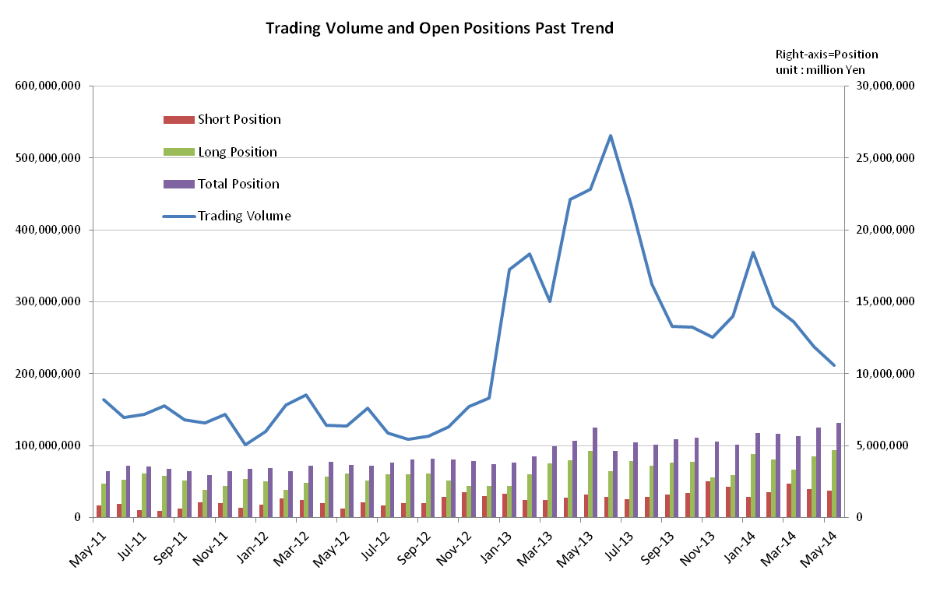

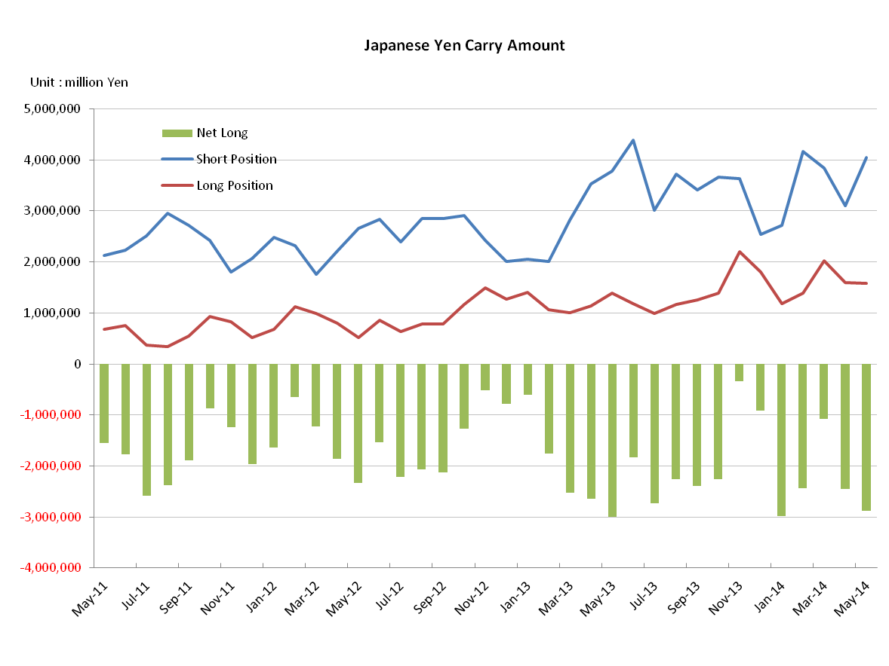

Monthly statistical report on Over-The-Counter Retail FX Margin Trading

：April 2014
Publication date : 16 May. 2014

Number of Over-The-Counter Retail FX Margin Trading Operators as of 30 April. 2014 : 62
Number of members reported : 51

【Trading Volume】
(Unit: hundred million Yen, %)
 | Over-The-Counter | USDJPY, Cross Yen | On-Exchange*(for reference)
April | 2,381,805 | 2,258,523 | 25,566
Previous month | 2,727,544 | 2,586,379 | 30,442
Change | -12.6 | -12.6 | -16.0
*source : Monthly Trading Volume of Osaka Securities Exchange
: Monthly Trading Volume of Tokyo Financial exchange Inc.(The FFAJ converts the total number of contracts into the trading volume on the settlement prices of the end of the month)

【Open Positions】
(Unit: hundred million Yen,)
 | Short | Long | Total
April | 19,784 | 42,547 | 62,331
Previous month | 23,501 | 33,347 | 56,847
Change | -15.8 | 27.5 | 9.6

・USDJPY, Cross Yen Open Positions
(Unit: hundred million Yen)
 | ① Short | ② Long | Net long=②-①
April | 40,487 | 15,988 | -24,498
Previous month | 31,050 | 20,242 | -10,807

（Reference：USDJPY Monthly Rate＊）
（Unit: Yen）
End of last Month*1 | Highest of the Month | Lowest of the Month | End of the Month*1 | Average*2
102.98 | 104.07 | 101.32 | 102.51 | 102.56
*source : BOJ's Main Time-series Statistics (Monthly)
*1) Spot Rate at 17:00 in JST, End of Month, Tokyo Market
*2) Average of Central Rate in the Month, Tokyo Market

○ Notes
Trading volume of this month was decreased by 12.6%. The Yen short positions of the end of the month increased by 900 billion Yen compared to the previous month due to the steep increasing of Long positions against Japanese Yen.

～Tables and Historical Graphs～

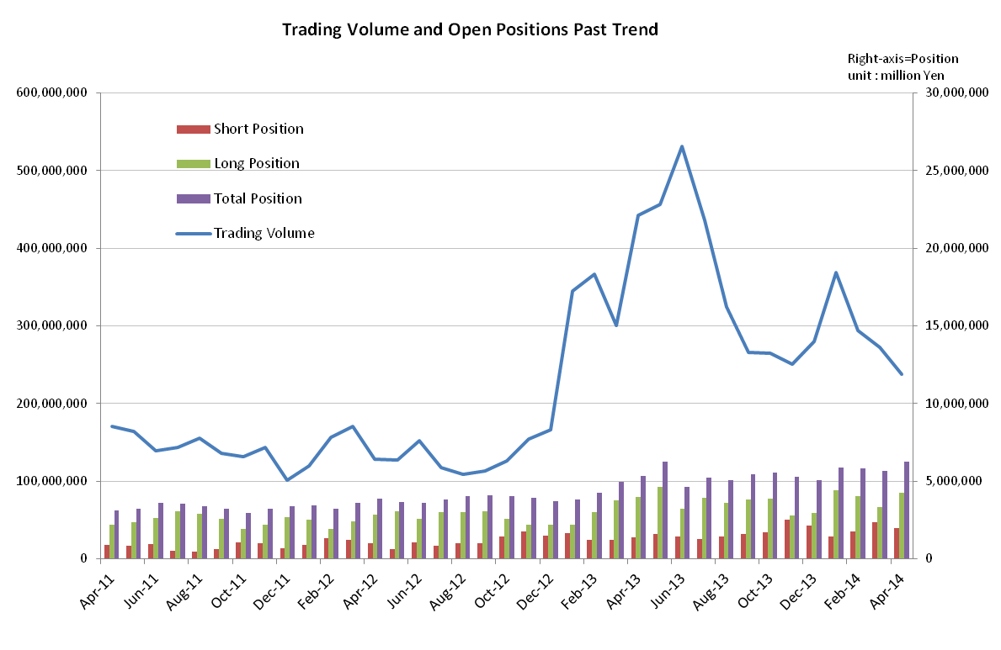

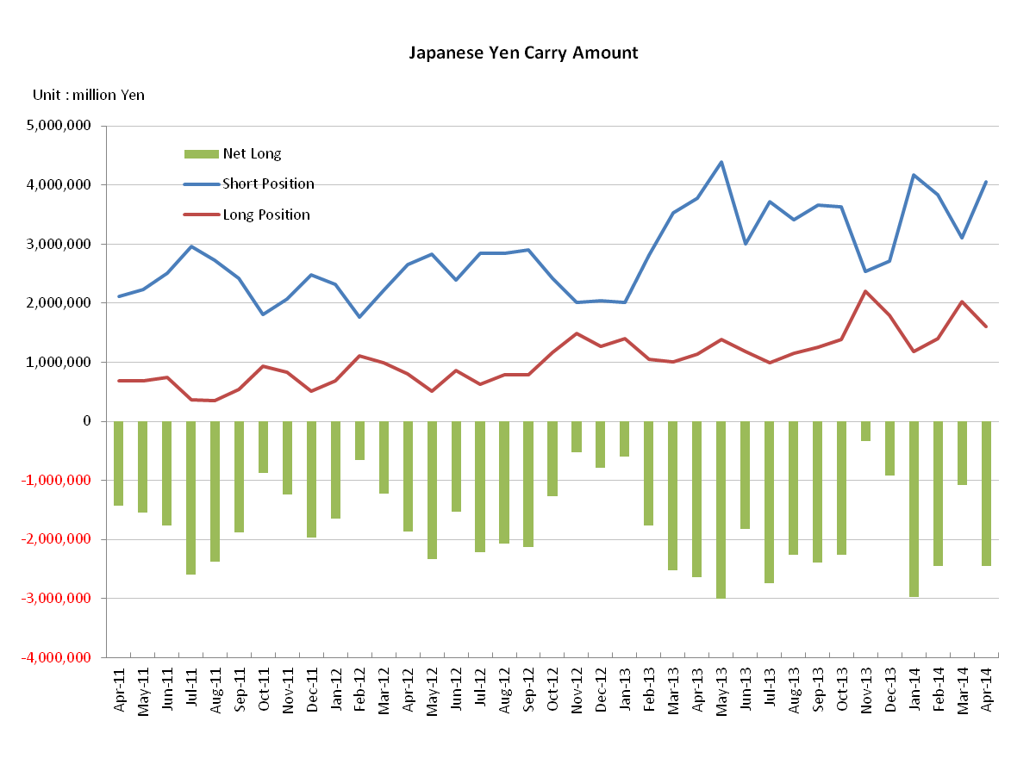

Monthly statistical report on Over-The-Counter Retail FX Margin Trading

: Mar. 2014

Publication date : 14 Apr. 2014

Number of Over-The-Counter Retail FX Margin Trading Operators as of 31 Mar. 2014 : 62
Number of members reported : 52

【Trading Volume】
(Unit: hundred million Yen, %)
 | Over-The-Counter | UsdYen, Cross Yen | On-Exchange*(for reference)
March | 2,727,544 | 2,586,380 | 30,442
Previous month | 2,942,041 | 2,808,046 | 28,878
Change | -7.2 | -7.8 | +5.4
*source : Monthly Trading Volume of Osaka Securities Exchange
: Monthly Trading Volume of Tokyo Financial exchange Inc.(The FFAJ converts the total number of contracts into the trading volume on the settlement prices of the end of the month)

【Open Positions】
(Unit: hundred million Yen,)
 | Short | Long | Total
March | 23,501 | 33,347 | 56,848
Previous month | 17,528 | 40,601 | 58,129
Change | +34.0 | -17.8 | -2.2

・USDJPY, Cross Yen Open Positions
(Unit: hundred million Yen)
 | ① Short | ② Long | Net long=②-①
March | 31,051 | 20,242 | -10,808
Previous month | 38,374 | 13,947 | -24,427

（Reference：USDJPY Monthly Rate＊）
（Unit: Yen）
End of last Month*1 | Highest of the Month | Lowest of the Month | End of the Month*1 | Average*2
101.66 | 103.43 | 101.26 | 102.98 | 102.27
*source : BOJ's Main Time-series Statistics (Monthly)
*1) Spot Rate at 17:00 in JST, End of Month, Tokyo Market
*2) Average of Central Rate in the Month, Tokyo Market

○ Notes
Trading volume of this month was decreased by 7.2% and it was 270 trillion yen level.
As to the volume of the major currency pairs, the trading volume of EURJPY was soaring up to 383,595 hundred million yen and increased by 29.1% compared with the previous month.
～Tables and Historical Graphs～

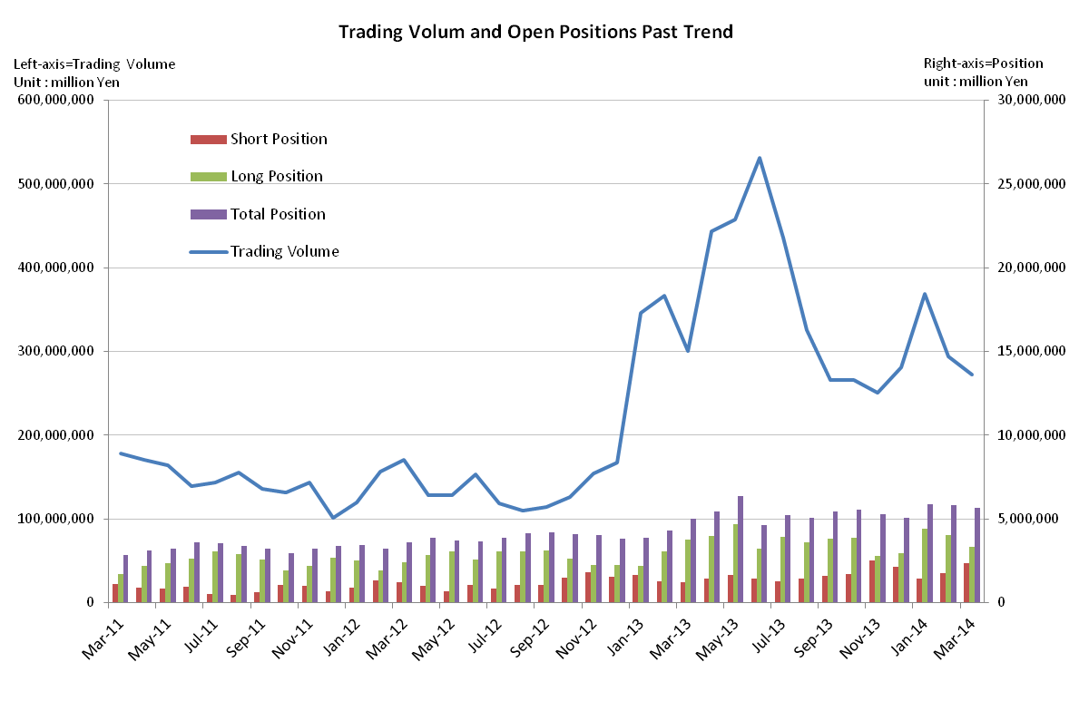

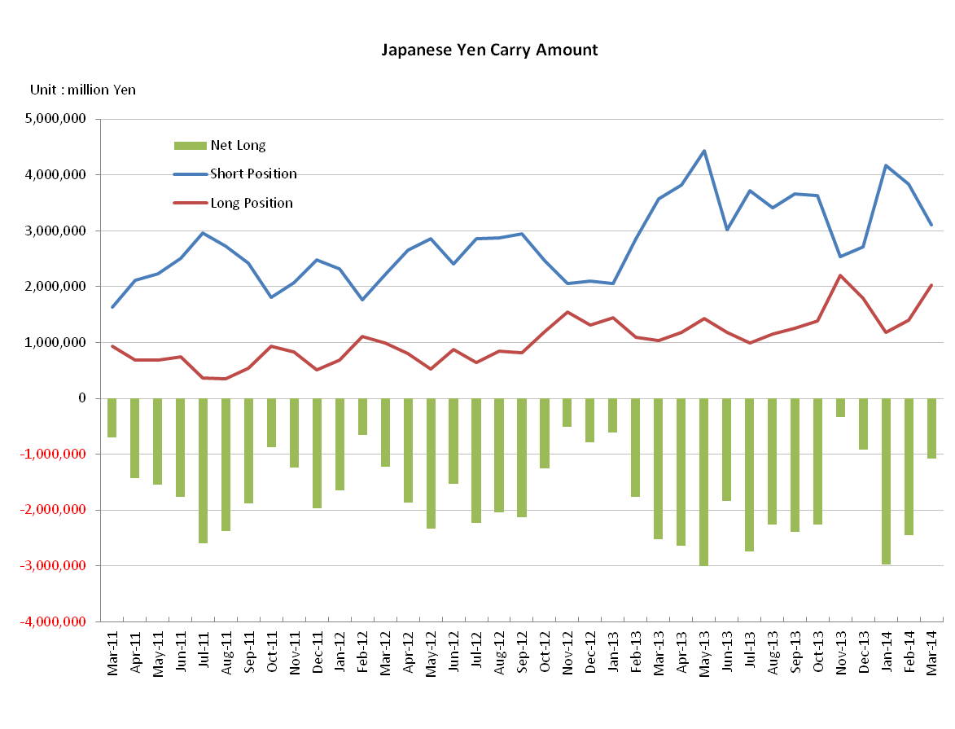

Monthly statistical report on Over-The-Counter Retail FX Margin Trading

: Feb. 2014

Publication date : 14 Mar. 2014

Number of Over-The-Counter Retail FX Margin Trading Operators as of 28 Feb. 2014 : 62
Number of members reported : 53

【Trading Volume】
(Unit: hundred million Yen, %)
 | Over-The-Counter | UsdYen, Cross Yen | On-Exchange*(for reference)
February | 2,942,041 | 2,808,046 | 28,878
Previous month | 3,685,263 | 3,503,467 | 38,722
Change | -20.1 | -19.8 | -25.4
*source : Monthly Trading Volume of Osaka Securities Exchange
: Monthly Trading Volume of Tokyo Financial exchange Inc.(The FFAJ converts the total number of contracts into the trading volume on the settlement prices of the end of the month)

【Open Positions】
(Unit: hundred million Yen,)
 | Short | Long | Total
February | 17,528 | 40,601 | 58,129
Previous month | 14,608 | 43,928 | 58,536
Change | 2,920 | -3,326 | -406

・USDJPY, Cross Yen Open Positions
(Unit: hundred million Yen)
 | ① Short | ② Long | Net long=②-①
February | 38,374 | 13,947 | -24,427
Previous month | 41,665 | 11,881 | -29,783

（Reference：USDJPY Monthly Rate＊）
（Unit: Yen）
End of last Month*1 | Highest of the Month | Lowest of the Month | End of the Month*1 | Average*2
102.49 | 102.74 | 100.76 | 101.66 | 102.13
*source : BOJ's Main Time-series Statistics (Monthly)
*1) Spot Rate at 17:00 in JST, End of Month, Tokyo Market
*2) Average of Central Rate in the Month, Tokyo Market

○ Notes
Trading volume of this month was decreased by 20.1% and less than 300trillion yen. The AUDJPY became 7.64% of increase compared with the previous month while the volume of the major currency pairs decreased generally.
In addition, on February 25, 2014, Osaka Securities Exchange published a plan to suspend On-exchange FX margin trading in October, 2014.
～Tables and Historical Graphs～

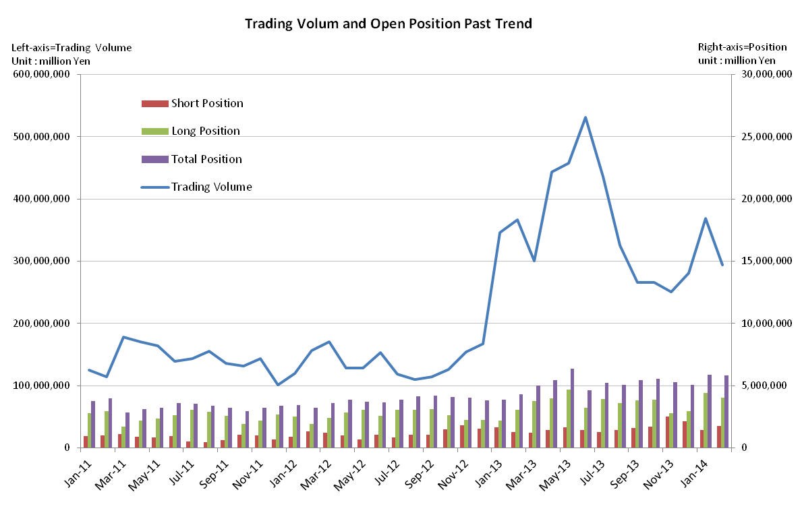

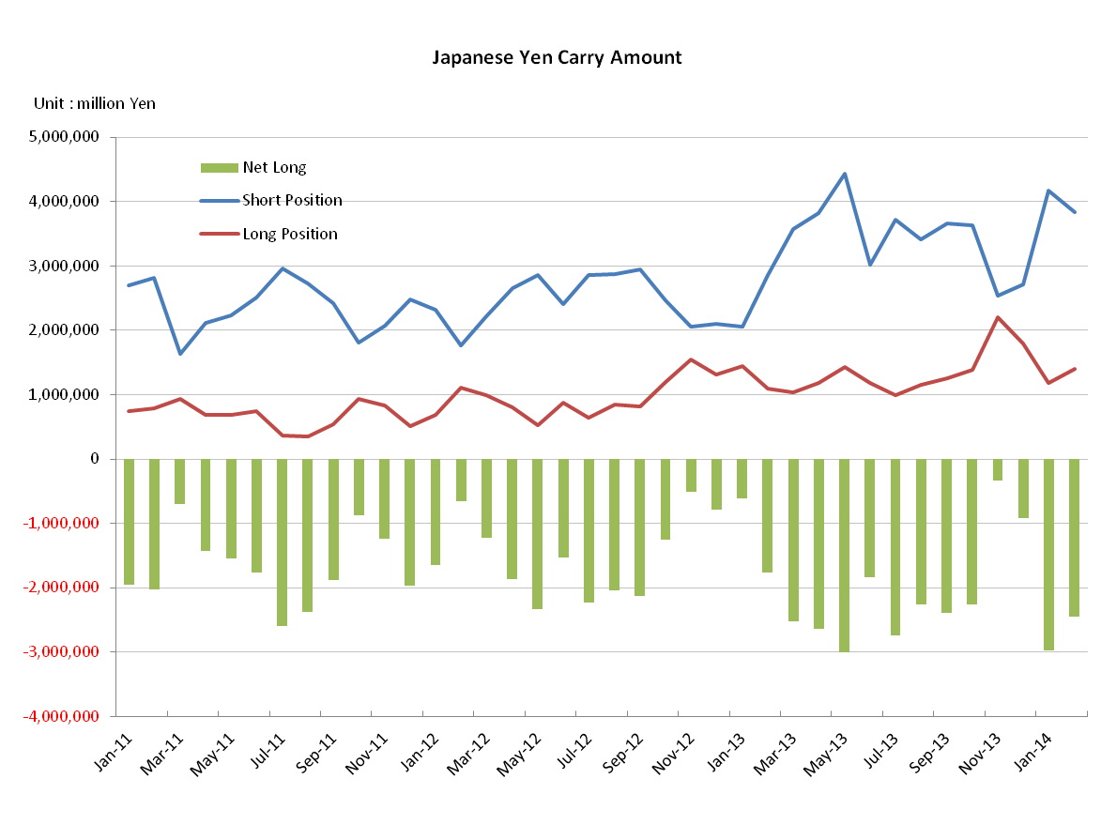

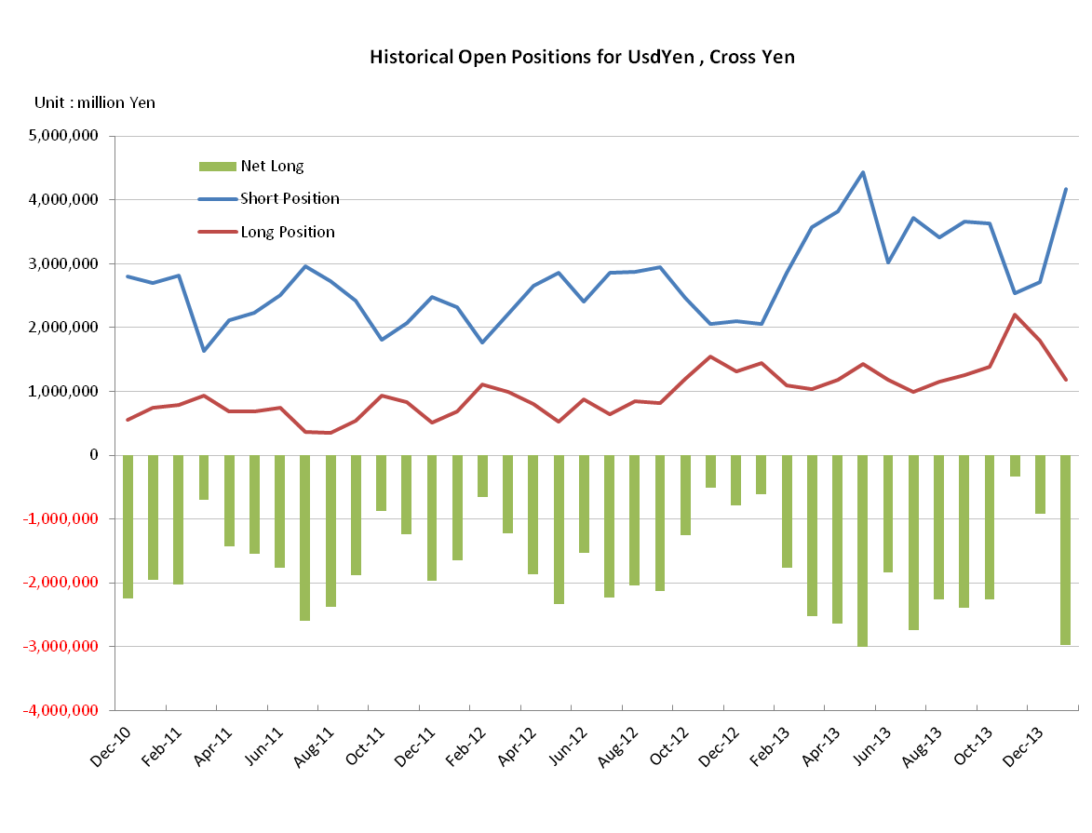
Monthly statistical report on Over-The-Counter Retail FX Margin Trading

: Jan. 2014

Publication date : 17 Feb. 2014

Number of Over-The-Counter Retail FX Margin Trading Operators as of 31 Jan. 2014 : 63
Number of members reported : 52

【Trading Volume】
(Unit: hundred million Yen, %)
 | Over-The-Counter | UsdYen, Cross Yen | On-Exchange*(for reference)
January | 3,685,263 | 3,503,467 | 38,722
Previous month | 2,806,433 | 2,632,062 | 35,720
Change | +31.3 | +33.1 | +8.4
*source : Monthly Trading Volume of Osaka Securities Exchange
: Monthly Trading Volume of Tokyo Financial exchange Inc.(The FFAJ converts the total number of contracts into the trading volume on the settlement prices of the end of the month)

【Open Positions】
(Unit: hundred million Yen,)
 | Short | Long | Total
January | 14,608 | 43,928 | 58,536
Previous month | 21,477 | 29,443 | 50,921
Change | -6,869 | 14,484 | 7,614

・USDJPY, Cross Yen Open Positions
(Unit: hundred million Yen)
 | ① Short | ② Long | Net long=②-①
January | 41,665 | 11,881 | -29,783
Previous month | 27,182 | 17,977 | -9,205

（Reference：USDJPY Monthly Rate＊）
（Unit: Yen）
End of last Month*1 | Highest of the Month | Lowest of the Month | End of the Month*1 | Average*2
105.37 | 105.13 | 101.77 | 102.49 | 103.94
*source : BOJ's Main Time-series Statistics (Monthly)
*1) Spot Rate at 17:00 in JST, End of Month, Tokyo Market
*2) Average of Central Rate in the Month, Tokyo Market

○ Notes
Trading volume of USDJPY transactions was increased by 33%, and the proportion became 71% for the amount of all currency pairs.
The Net Yen short positions of the end of the month increased rapidly due to the steep increasing of Long positions of USDJPY with 66% by the month-to-month basis.
～Tables and Historical Graphs～

