Over-The-Counter FX Monthly Report
(January 2013～December 2013)

The Financial Futures Association of Japan

Monthly Report
December 2013
November 2013
October 2013
September 2013
August 2013
July 2013
June 2013
May 2013
April 2013
March 2013
February 2013
January 2013

This material is the revised report previously issued by the Financial Futures Association of Japan(FFAJ).
This is not intended to make solicitation for investments.

Announcement date：1/20/2014

Over-The-Counter FX Monthly Report（December 2013）
The Association publishes monthly trading volume, short open positions and long open positions of over-the-counter foreign exchange margin transactions since November 2008 with the help of members who participate to this project. 52 members participated to the report of December 2013.
The trading volume of all currency pairs in Yen for December 2013 was 280,643.3 billion Yen (+11.7% from November), and short and long open positions as of the end of December were 2,147.7 billion Yen (-15.1％ from the end of November) and 2,944.3 billion Yen (+6.0％ from the end of November), respectively. So-called Yen carry amount (net Yen short position) was 920.5 billion Yen (+172.1％ from the end of November ).
The trading volume and the open positions reported by such 52 participants amounted to 99.85％ and 97.92％ of the quarterly volume and open positions for July to September 2013 (61 members reported the trading record of over-the-counter foreign exchange margin transactions for the quarterly report).

a. December 2013
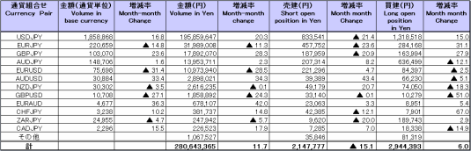
(Unit: millions of base currency; millions of Yen, %)

b. January 2013 to December 2013
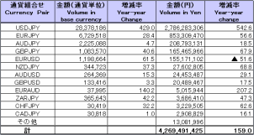
(Unit: millions of base currency; millions of Yen, %)

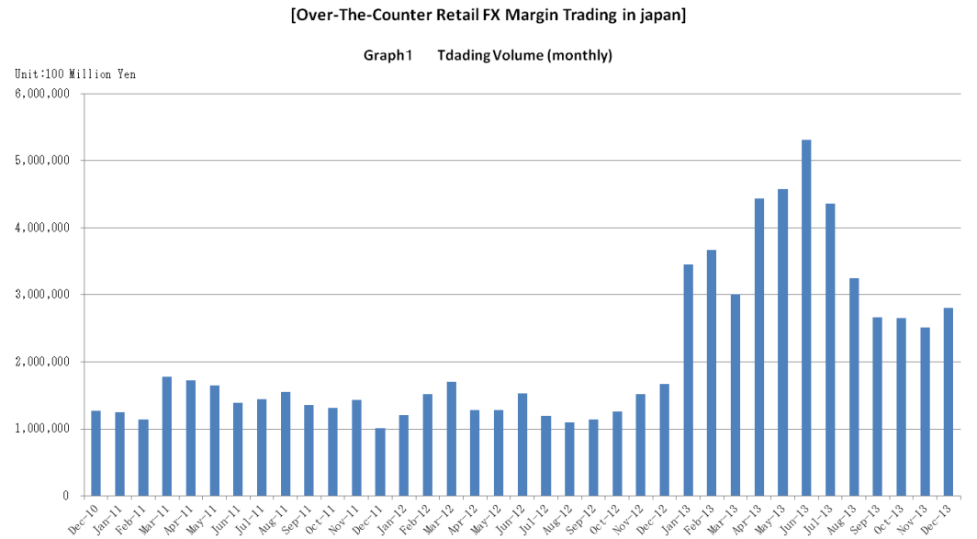

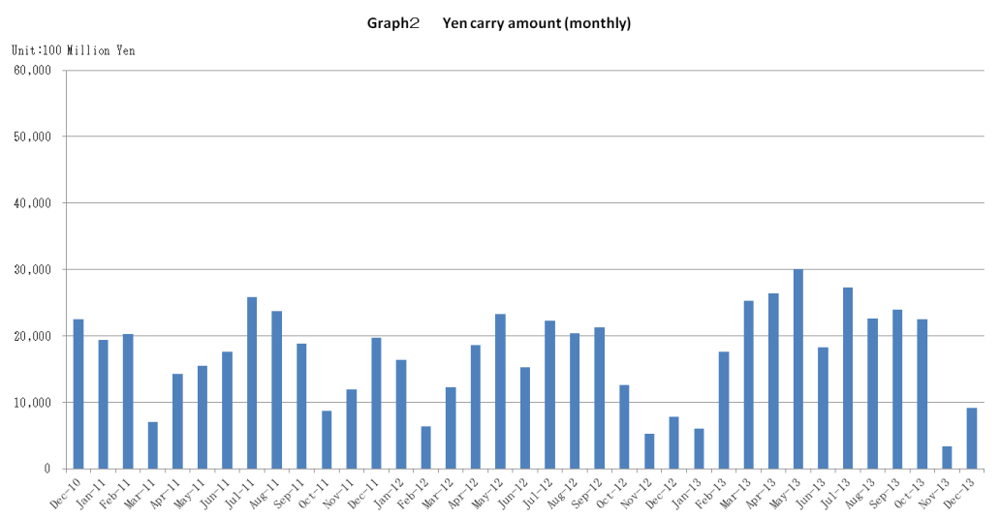

Announcement date：12/13/2013

Over-The-Counter FX Monthly Report（November 2013）
The Association publishes monthly trading volume, short open positions and long open positions of over-the-counter foreign exchange margin transactions since November 2008 with the help of members who participate to this project. 52 members participated to the report of November 2013.
The trading volume of all currency pairs in Yen for November 2013 was251,178.4 billion Yen (-5.4% from October), and short and long open positions as of the end of November were 2,531.4 billion Yen (+48.0％ from the end of October) and 2,776.5 billion Yen (-27.8％from the end of October), respectively. So-called Yen carry amount (net Yen short position) was 338.2 billion Yen (-84.9％ from the end of October ).
The trading volume and the open positions reported by such 52 participants amounted to 99.85％ and 97.92％ of the quarterly volume and open positions for July to September 2013 (61 members reported the trading record of over-the-counter foreign exchange margin transactions for the quarterly report).

a. November 2013
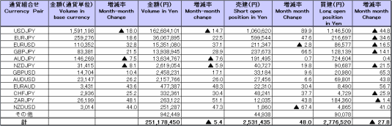
(Unit: millions of base currency; millions of Yen, %)

b. January 2013 to November 2013
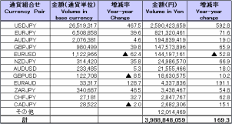
(Unit: millions of base currency; millions of Yen, %)

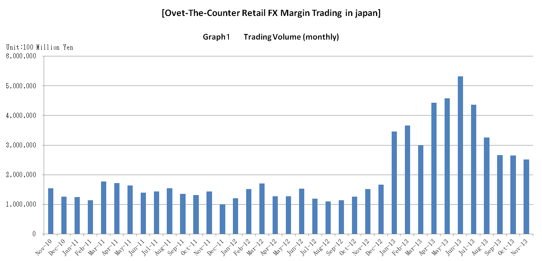

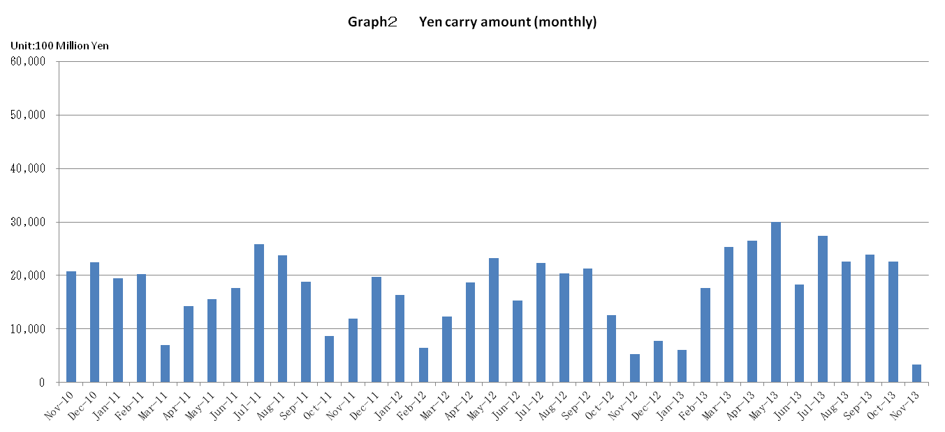

Announcement date：11/15/2013

Over-The-Counter FX Monthly Report（October 2013）
The Association publishes monthly trading volume, short open positions and long open positions of over-the-counter foreign exchange margin transactions since November 2008 with the help of members who participate to this project. 52 members participated to the report of October 2013.
The trading volume of all currency pairs in Yen for October 2013 was 265,522.8 billion Yen (-0.3% from September), and short and long open positions as of the end of October were 1,710.0 billion Yen (+7.5％ from the end of September) and 3,849.8 billion Yen (+0.1％from the end of September), respectively. So-called Yen carry amount (net Yen short position) was 2,254.0 billion Yen (-5.8％ from the end of September ).
The trading volume and the open positions reported by such 52 participants amounted to 99.85％ and 97.93％ of the quarterly volume and open positions for July to September 2013 (61 members reported the trading record of over-the-counter foreign exchange margin transactions for the quarterly report).

a. October 2013
(Unit: millions of base currency; millions of Yen, %)
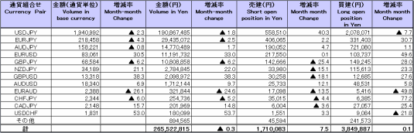

b. January 2013 to October 2013
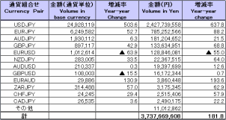
(Unit: millions of base currency; millions of Yen, %)

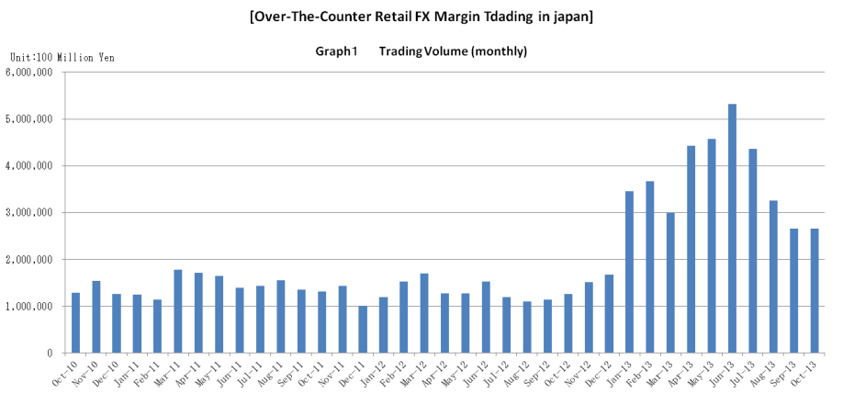

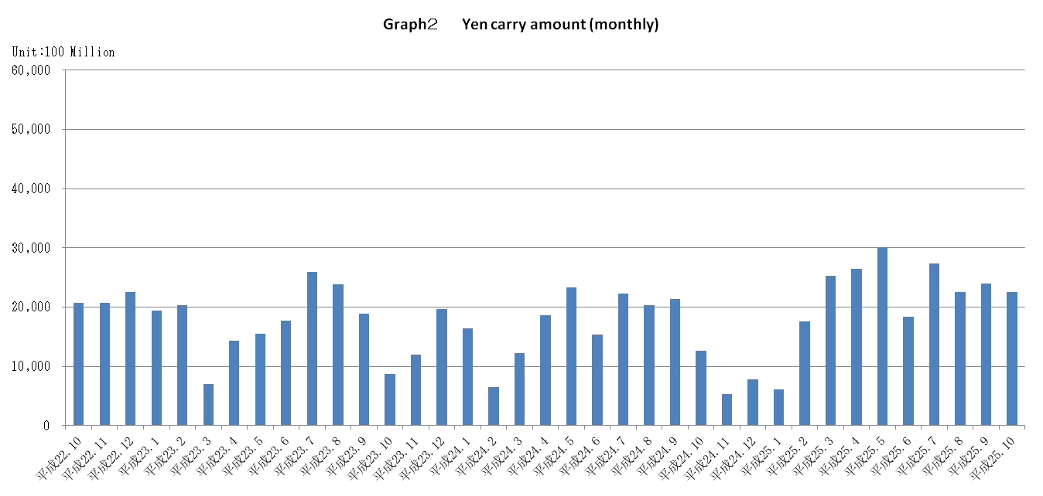

Announcement date：10/15/2013

Over-The-Counter FX Monthly Report（September 2013）
The Association publishes monthly trading volume, short open positions and long open positions of over-the-counter foreign exchange margin transactions since November 2008 with the help of members who participate to this project. 51 members participated to the report of September 2013.
The trading volume of all currency pairs in Yen for September 2013 was 266,462.7 billion Yen (-18.0% from August), and short and long open positions as of the end of September were 1,589.8 billion Yen (+10.1％ from the end of August ) and 3,845.0 billion Yen (+5.9％from the end of August), respectively. So-called Yen carry amount (net Yen short position) was 2,393.3 billion Yen (+5.9％ from the end of August ).
The trading volume and the open positions reported by such 51 participants amounted to 99.85％ and 98.06％ of the quarterly volume and open positions for April to June 2013 (62 members reported the trading record of over-the-counter foreign exchange margin transactions for the quarterly report).

a. September 2013
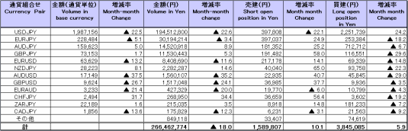
(Unit: millions of base currency; millions of Yen, %)

b. January 2013 to September 2013
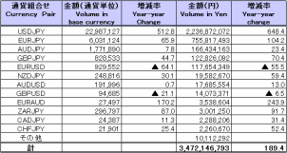
(Unit: millions of base currency; millions of Yen, %)

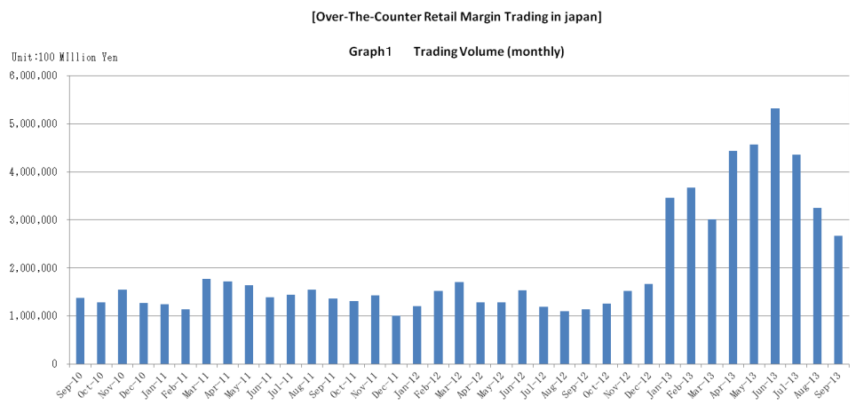

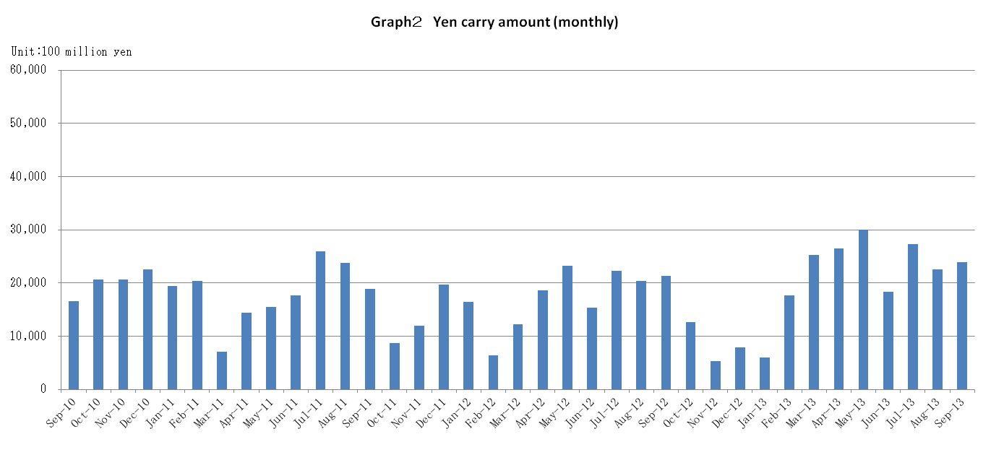

Announcement date：9/13/2013

Over-The-Counter FX Monthly Report（August 2013）
The Association publishes monthly trading volume, short open positions and long open positions of over-the-counter foreign exchange margin transactions since November 2008 with the help of members who participate to this project. 51 members participated to the report of August 2013.
The trading volume of all currency pairs in Yen for August 2013 was 325,251.1 billion Yen (-25.4% from July), and short and long open positions as of the end of August were 1,443.8 billion Yen (+12.1％ from the end of July ) and 3,628.2 billion Yen (-7.5％from the end of July), respectively. So-called Yen carry amount (net Yen short position) was 2,257.9 billion Yen (-17.4％ from the end of July).
The trading volume and the open positions reported by such 51 participants amounted to 99.85％ and 98.06％ of the quarterly volume and open positions for April to June 2013 (62 members reported the trading record of over-the-counter foreign exchange margin transactions for the quarterly report).

a. August 2013
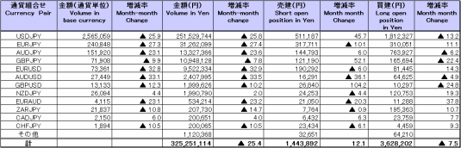
（単位：百万通貨単位、百万円、％）

b. January 2013 to August 2013
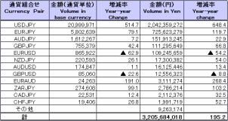
（単位：百万通貨単位、百万円、％）

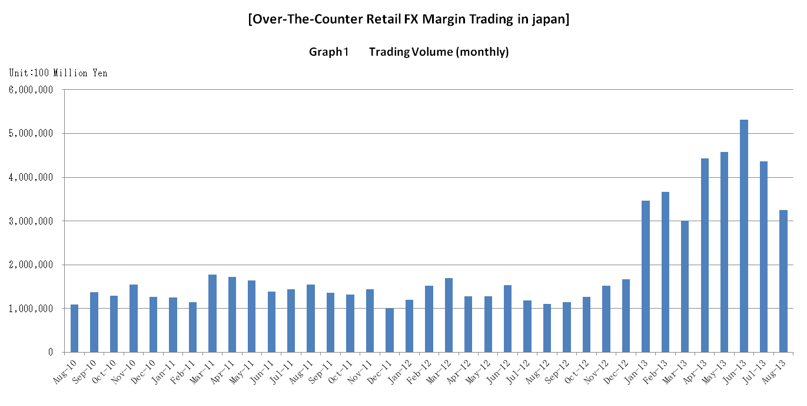

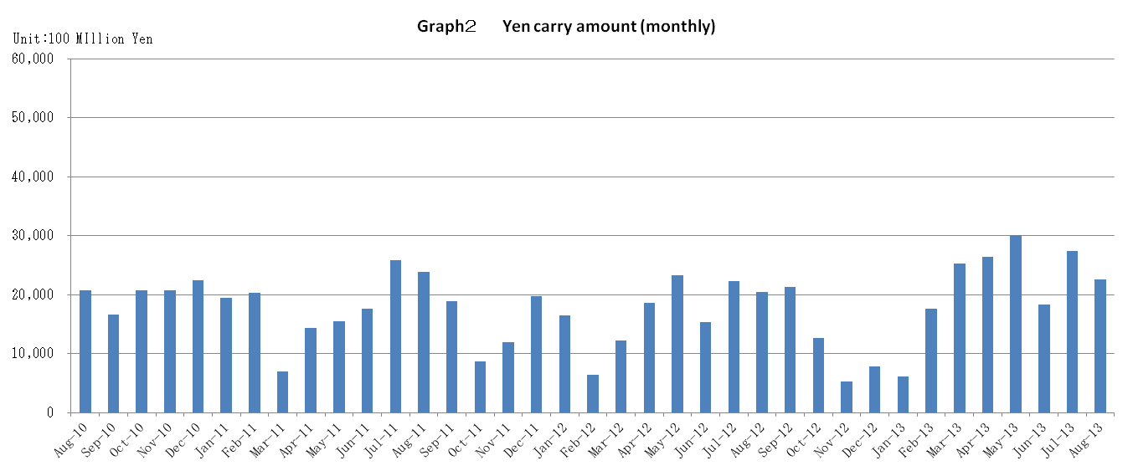

Announcement date：8/14/2013

Over-The-Counter FX Monthly Report（July 2013）
The Association publishes monthly trading volume, short open positions and long open positions of over-the-counter foreign exchange margin transactions since November 2008 with the help of members who participate to this project. 51 members participated to the report of July 2013.
The trading volume of all currency pairs in Yen for July 2013 was 436,029.9 billion Yen (-18.0% from June), and short and long open positions as of the end of July were 1,287.9 billion Yen (-9.0％ from the end of June ) and 3,924.9 billion Yen (+21.6％from the end of June), respectively. So-called Yen carry amount (net Yen short position) was 2,735.2 billion Yen (+49.2％ from the end of June).
The trading volume and the open positions reported by such 51 participants amounted to 99.90％ and 98.52％ of the quarterly volume and open positions for January to March 2013 (61 members reported the trading record of over-the-counter foreign exchange margin transactions for the quarterly report).
Corrections were made by one participant for June report. Volumes and open positions after such corrections are shown in the June 2013 Archives.

a. July 2013
(Unit: millions of base currency; millions of Yen, %)
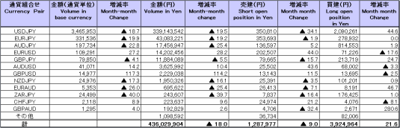

b. January 2013 to July 2013
(Unit: millions of base currency; millions of Yen, %)
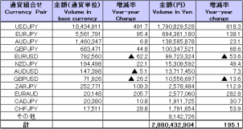

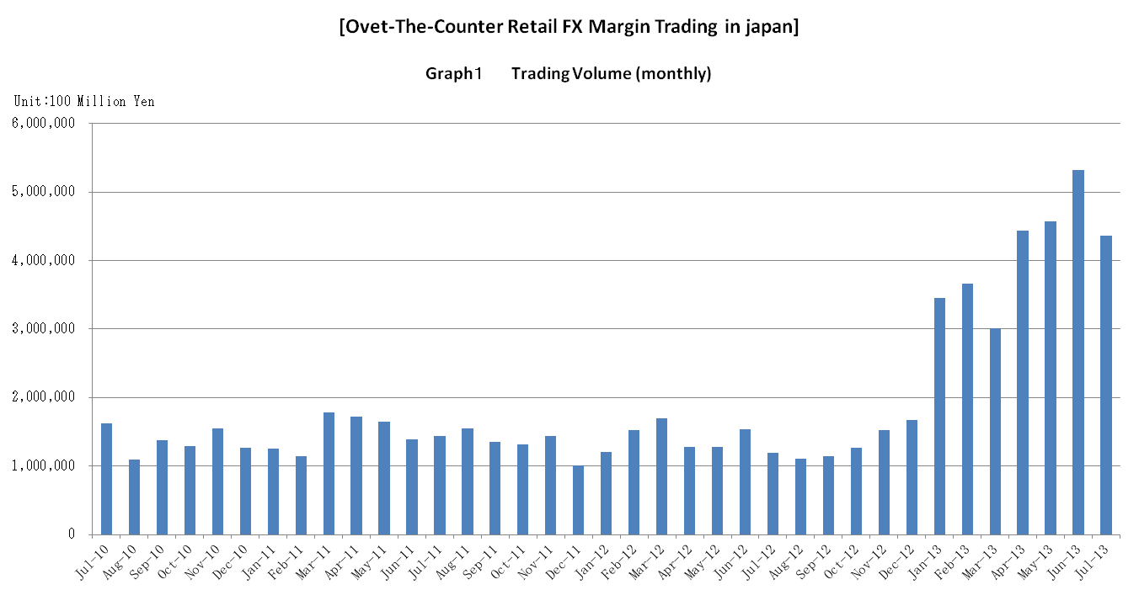

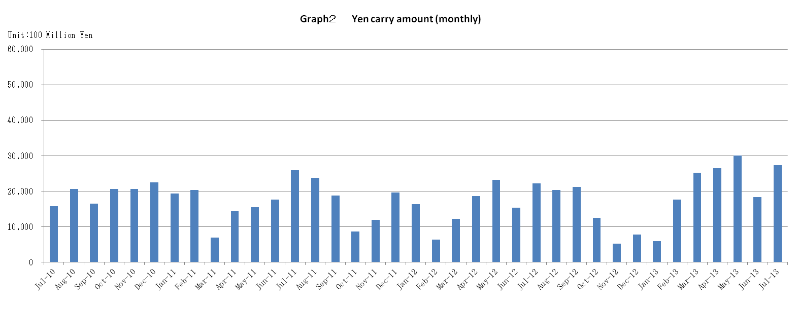

Announcement date：7/12/2013

Over-The-Counter FX Monthly Report（June 2013）
The Association publishes monthly trading volume, short open positions and long open positions of over-the-counter foreign exchange margin transactions since November 2008 with the help of members who participate to this project. 51 members participated to the report of June 2013.
The trading volume of all currency pairs in Yen for June 2013 was 532,148.3 billion Yen (+16.3% from May), and short and long open positions as of the end of June were 1,486.6 billion Yen (-10.2％ from the end of May ) and 3,296.0 billion Yen (-29.6％from the end of May), respectively. So-called Yen carry amount (net Yen short position) was 1,832.8 billion Yen (-39.0％ from the end of May).
The trading volume and the open positions reported by such 51 participants amounted to 99.90％ and 98.53％ of the quarterly volume and open positions for January to March 2013 (61 members reported the trading record of over-the-counter foreign exchange margin transactions for the quarterly report).
Corrections were made by one participant for May report. Volumes and open positions after such corrections are shown in the May 2013 Archives.

a. June 2013
(Unit: millions of base currency; millions of Yen, %)
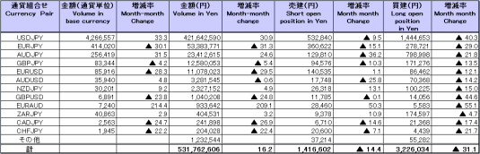

Because corrections are sometimes made by participants after the publication of the FX monthly report, there may be some differences between the figures shown in the text and the ones shown in the chart. In that case, the figures in the chart are accurate.

b. January 2013 to June 2013
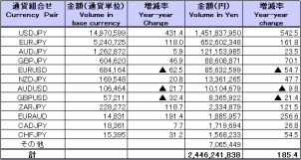
(Unit: millions of base currency; millions of Yen, %)

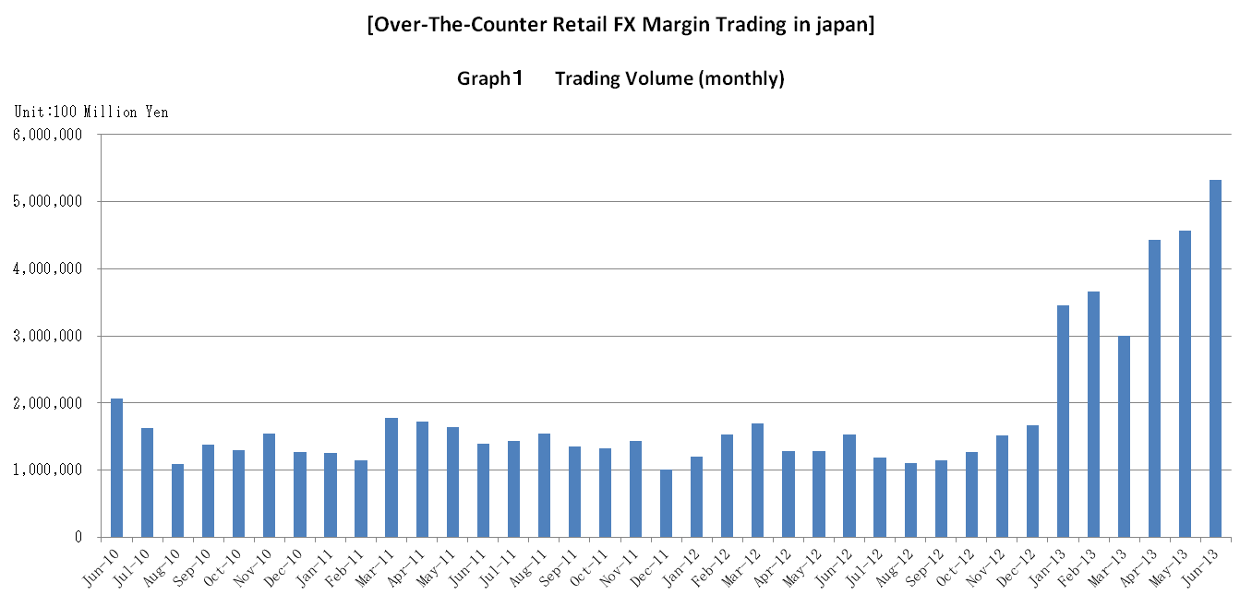

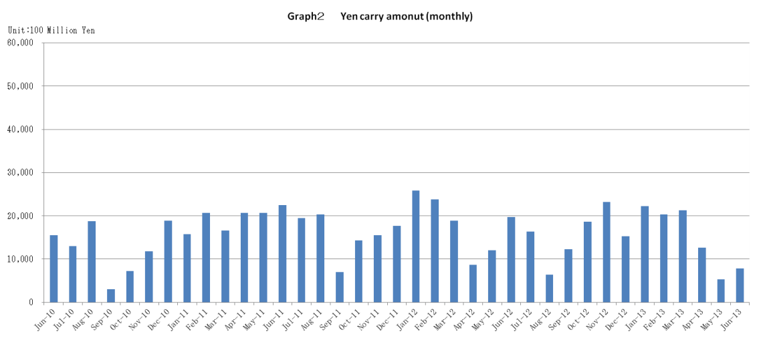

Announcement date：6/14/2013

Over-The-Counter FX Monthly Report（May 2013）
The Association publishes monthly trading volume, short open positions and long open positions of over-the-counter foreign exchange margin transactions since November 2008 with the help of members who participate to this project. 50 members participated to the report of May 2013.
The trading volume of all currency pairs in Yen for May 2013 was 457,305.5 billion Yen (+3.1% from April), and short and long open positions as of the end of May were 1,335.9 billion Yen (-6.0％ from the end of April ) and 4,374.3 billion Yen (+9.3％from the end of April), respectively. So-called Yen carry amount (net Yen short position) was 3,015.7 billion Yen (+14.0％ from the end of April).
The trading volume and the open positions reported by such 50 participants amounted to 99.90％ and 98.53％ of the quarterly volume and open positions for January to March 2013 (61 members reported the trading record of over-the-counter foreign exchange margin transactions for the quarterly report).

a. May 2013
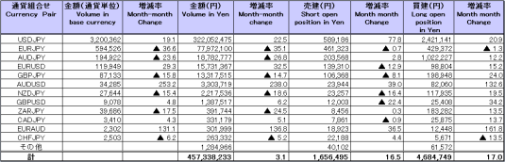
(Unit: millions of base currency; millions of Yen, %)

Because corrections are sometimes made by participants after the publication of the FX monthly report, there may be some differences between the figures shown in the text and the ones shown in the chart. In that case, the figures in the chart are accurate.

b. January 2013 to May 2013
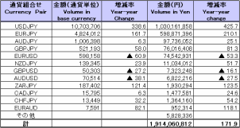
(Unit: millions of base currency; millions of Yen, %)

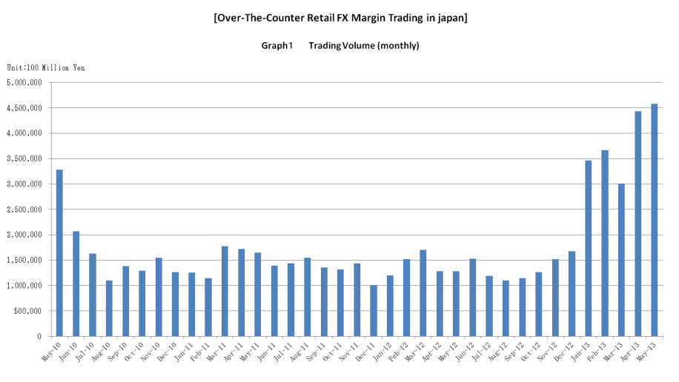

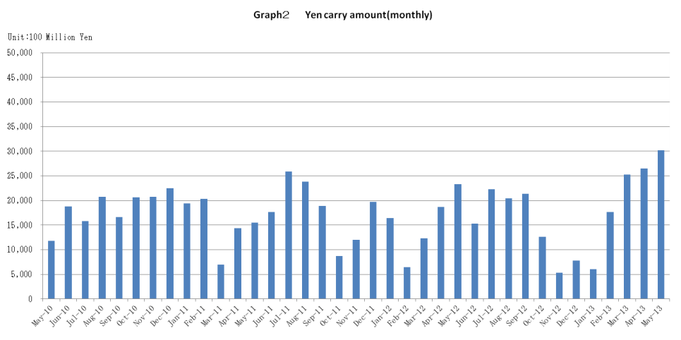

Announcement date：5/16/2013

Over-The-Counter FX Monthly Report（April 2013）
The Association publishes monthly trading volume, short open positions and long open positions of over-the-counter foreign exchange margin transactions since November 2008 with the help of members who participate to this project. 50 members participated to the report of April 2013.
The trading volume of all currency pairs in Yen for April 2013 was 443,362.1 billion Yen (+47.4% from March), and short and long open positions as of the end of April were 1,421.3 billion Yen (+14.8％ from the end of March ) and 4,001.8 billion Yen (+5.9％from the end of March), respectively. So-called Yen carry amount (net Yen short position) was 2,644.7 billion Yen (+4.6％ from the end of March).
The trading volume and the open positions reported by such 50 participants amounted to 99.90％ and 98.53％ of the quarterly volume and open positions for January to March 2013 (61 members reported the trading record of over-the-counter foreign exchange margin transactions for the quarterly report).

a. April 2013
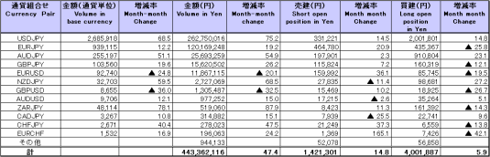
(Unit: millions of base currency; millions of Yen, %)

b. January 2013 to April 2013
(Unit: millions of base currency; millions of Yen, %)
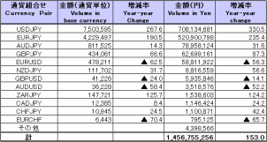

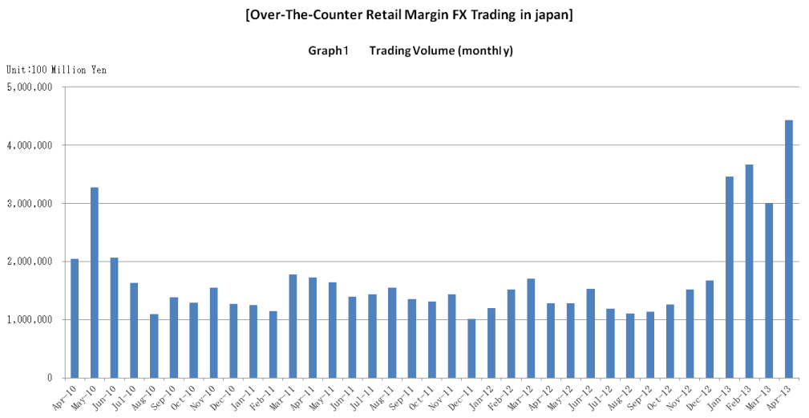

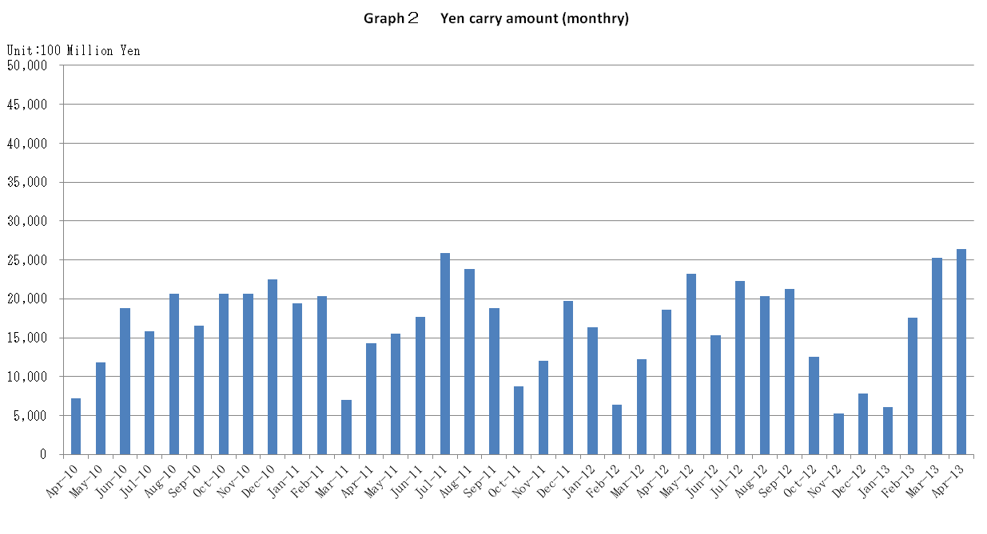

Announcement date：4/12/2013

Over-The-Counter FX Monthly Report（March 2013）
The Association publishes monthly trading volume, short open positions and long open positions of over-the-counter foreign exchange margin transactions since November 2008 with the help of members who participate to this project. 50 members participated to the report of March 2013.
The trading volume of all currency pairs in Yen for March 2013 was 300,746.5 billion Yen (-17.9% from February 2013), and short and long open positions as of the end of March 2013 were 1,237.3 billion Yen (-3.1％ from the end of February ) and 3,776.0 billion Yen (+23.6％from the end of February), respectively. So-called Yen carry amount (net Yen short position) was 2,527.0 billion Yen (+43.3％ from the end of February).
The trading volume and the open positions reported by such 50 participants amounted to 98.71％ and 98.55％ of the quarterly volume and open positions for October to December 2012 (67 members reported the trading record of over-the-counter foreign exchange margin transactions for the quarterly report).
Corrections were made by one participant for February report. Volumes and open positions after such corrections are shown in the February 2012 Archives.

a. March 2013
（単位：百万通貨単位、百万円、％）
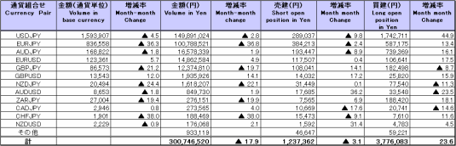

b. January 2013 to March 2013
（単位：百万通貨単位、百万円、％）
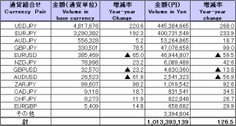

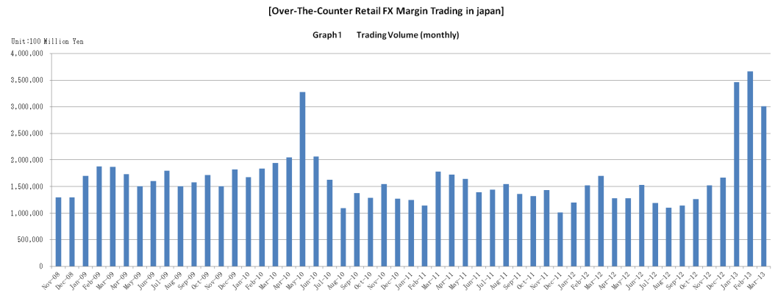

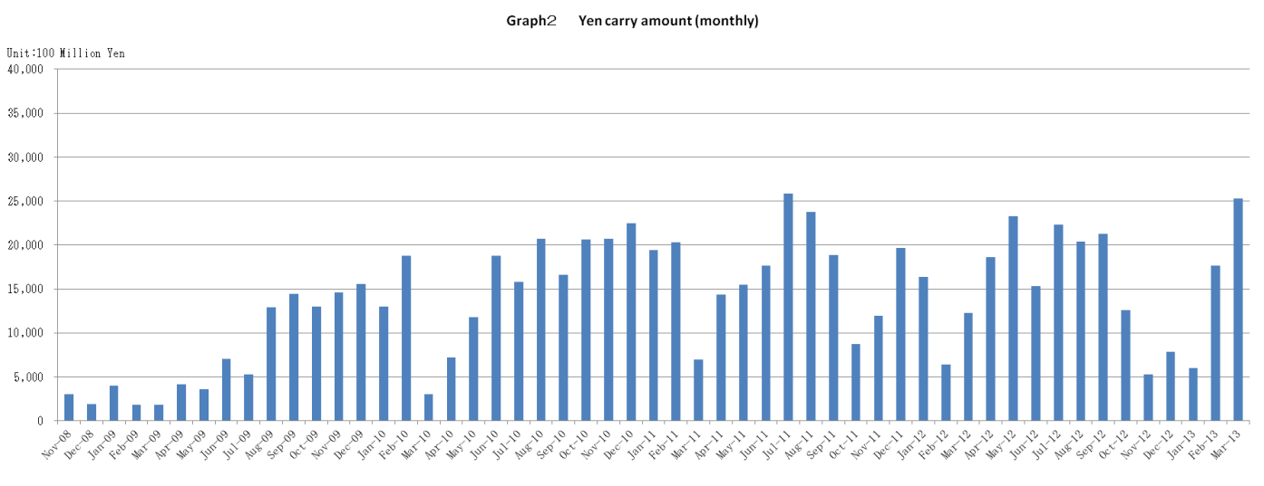

Announcement date：3/14/2013

Over-The-Counter FX Monthly Report（February 2013）
The Association publishes monthly trading volume, short open positions and long open positions of over-the-counter foreign exchange margin transactions since November 2008 with the help of members who participate to this project. 51 members participated to the report of February 2013.
The trading volume of all currency pairs in Yen for February 2013 was 366,682.7 billion Yen (+6.0% from the end of January 2013), and short and long open positions as of the end of February 2013 were 1,278.1 billion Yen (-23.8％from the end of January ) and 3,053.8 billion Yen (+37.6％from the end of January), respectively. So-called Yen carry amount (net Yen short position) was 1,762.9 billion Yen (+191.7％ from the end of January).
The trading volume and the open positions reported by such 51 participants amounted to 97.96% and 99.74％of the quarterly volume and open positions for October to December 2012 (67 members reported the trading record of over-the-counter foreign exchange margin transactions for the quarterly report).
Corrections were made by one participant for January report. Volumes and open positions after such corrections are shown in the January 2012 Archives.

a. February 2013
(Unit: millions of base currency; millions of Yen, %)
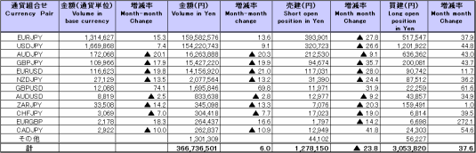

Because corrections are sometimes made by participants after the publication of the FX monthly report, there may be some differences between the figures shown in the text and the ones shown in the chart. In that case, the figures in the chart are accurate.

b. January 2013 to February 2013
(Unit: millions of base currency; millions of Yen, %)
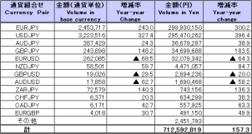

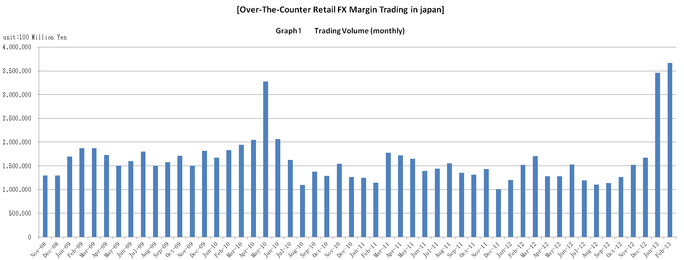

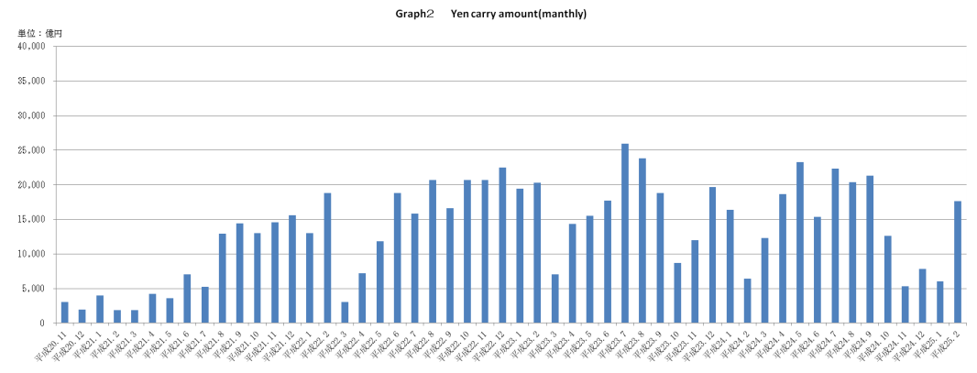

Announcement date：2/15/2013

Over-The-Counter FX Monthly Report（January 2013）
The Association publishes monthly trading volume, short open positions and long open positions of over-the-counter foreign exchange margin transactions since November 2008 with the help of members who participate to this project. 53 members participated to the report of January 2013.
The trading volume of all currency pairs in Yen for January 2013 was 345,910.1 billion Yen (+107.0% from December 2012), and short and long open positions as of the end of January 2013 were 1,677.5 billion Yen (+9.2％from the end of December) and 2,208.7 billion Yen (-2.8％from the end of December), respectively. So-called Yen carry amount (net Yen short position) was 594.8 billion Yen (-24.0% from the end of December).
The trading volume and the open positions reported by such 53 participants amounted to 98.33% and 97.69％of the quarterly volume and open positions for October to December 2012 (67 members reported the trading record of over-the-counter foreign exchange margin transactions for the quarterly report).

January 2013
(Unit: millions of base currency; millions of Yen, %)
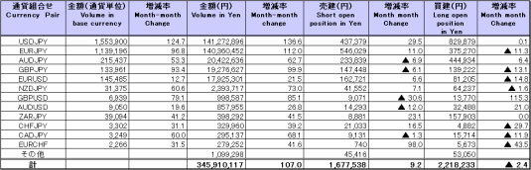

Because corrections are sometimes made by participants after the publication of the FX monthly report, there may be some differences between the figures shown in the text and the ones shown in the chart. In that case, the figures in the chart are accurate.

