Over-The-Counter FX Monthly Report
(January 2012～December 2012)

The Financial Futures Association of Japan

Monthly Report
December 2012
November 2012
October 2012
September 2012
August 2012
July 2012
June 2012
May 2012
April 2012
March 2012
February 2012
January 2012

This material is the revised report previously issued by the Financial Futures Association of Japan(FFAJ).
This is not intended to make solicitation for investments.

Announcement date：1/18/2013

Over-The-Counter FX Monthly Report（December 2012）
The Association publishes monthly trading volume, short open positions and long open positions of over-the-counter foreign exchange margin transactions since November 2008 with the help of members who participate to this project. 53 members participated to the report of December 2012.
The trading volume of all currency pairs in Yen for December 2012 was167,033.6 billion Yen (+8.0% from the end of November), and short and long open positions as of the end of December 2012 were 1,535.3 billion Yen (-14.3％from the end of November) and 2,272.9 billion Yen (+2.2％from the end of November), respectively. So-called Yen carry amount (net Yen short position) was 782.8 billion Yen (+51.94% from the end of November).
The trading volume and the open positions reported by such 53 participants amounted to 98.87% and 98.35％of the quarterly volume and open positions for July to September 2012 (70 members reported the trading record of over-the-counter foreign exchange margin transactions for the quarterly report).
Corrections were made by two participants for November report. Volumes and open positions after such corrections are shown in the November 2012 Archives.

a. December 2012
(Unit: millions of base currency; millions of Yen, %)
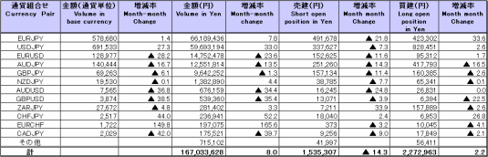

b. January 2012 to December 2012
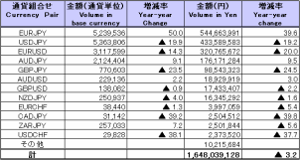
(Unit: millions of base currency; millions of Yen, %)

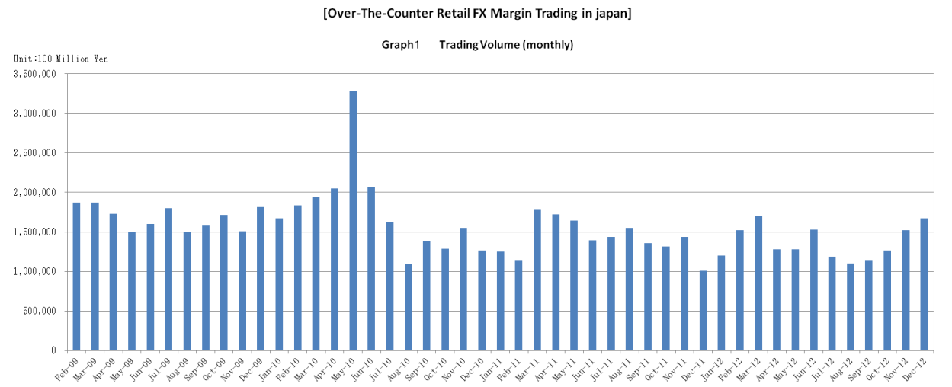

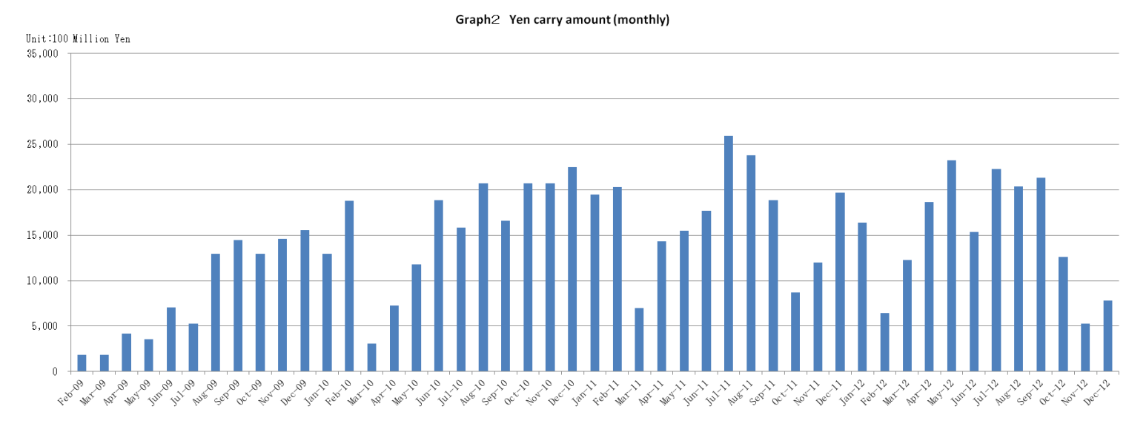

Announcement date：12/14/2012

Over-The-Counter FX Monthly Report（November 2012）
The Association publishes monthly trading volume, short open positions and long open positions of over-the-counter foreign exchange margin transactions since November 2008 with the help of members who participate to this project. 53 members participated to the report of November 2012.
The trading volume of all currency pairs in Yen for November 2012 was 151,931.0 billion Yen (+20.1% from the end October), and short and long open positions as of the end of November 2012 were 1,782.5 billion Yen (+21.5％from the end of October) and 2,229.8 billion Yen (-15.5％from the end of October), respectively. So-called Yen carry amount (net Yen short position) was 529.7 billion Yen (-57.94% from the end of October).
The trading volume and the open positions reported by such 53 participants amounted to 96.20% and 97.55％of the quarterly volume and open positions for July to September 2012 (70 members reported the trading record of over-the-counter foreign exchange margin transactions for the quarterly report).

a. November 2012
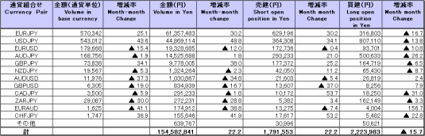
(Unit: millions of base currency; millions of Yen, %)

Because corrections are sometimes made by participants after the publication of the FX monthly report, there may be some differences between the figures shown in the text and the ones shown in the chart. In that case, the figures in the chart are accurate.

b. January 2012 to November 2012
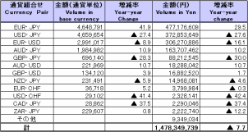
(Unit: millions of base currency; millions of Yen, %)

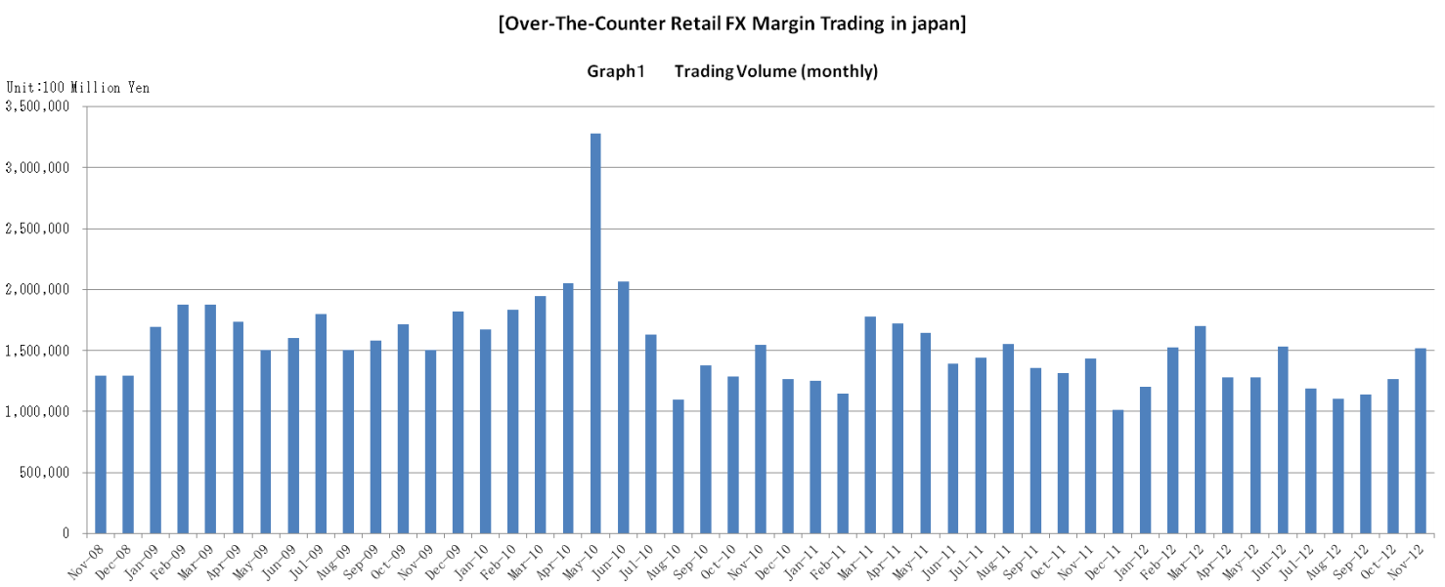

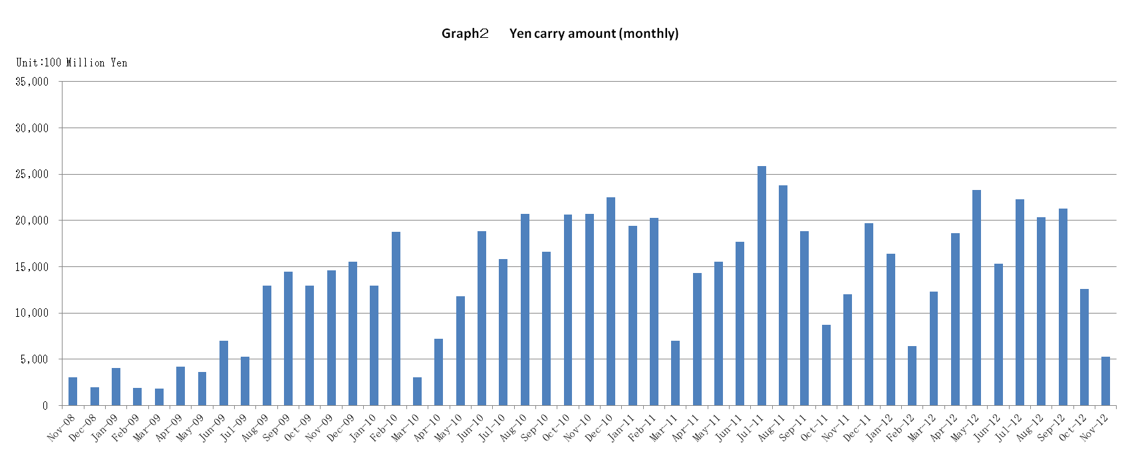

Announcement date：11/14/2012

Over-The-Counter FX Monthly Report（October 2012）
The Association publishes monthly trading volume, short open positions and long open positions of over-the-counter foreign exchange margin transactions since November 2008 with the help of members who participate to this project. 53 members participated to the report of October 2012.
The trading volume of all currency pairs in Yen for October 2012 was 126,470.5 billion Yen (+10.8% from the end September), and short and long open positions as of the end of October 2012 were 1,466.4 billion Yen (+38.7％from the end of September) and 2,638.9 billion Yen (-15.6％from the end of September), respectively. So-called Yen carry amount (net Yen short position) was 1,259.5 billion Yen (-40.89% from the end of September).
The trading volume and the open positions reported by such 53 participants amounted to 98.87% and 98.37％of the quarterly volume and open positions for July to September 2012 (70 members reported the trading record of over-the-counter foreign exchange margin transactions for the quarterly report).

a. October 2012
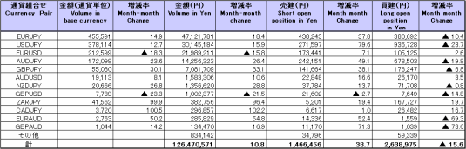
(Unit: millions of base currency; millions of Yen, %)

b. January 2012 to October 2012
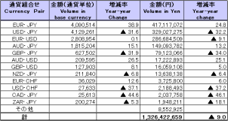
(Unit: millions of base currency; millions of Yen, %)

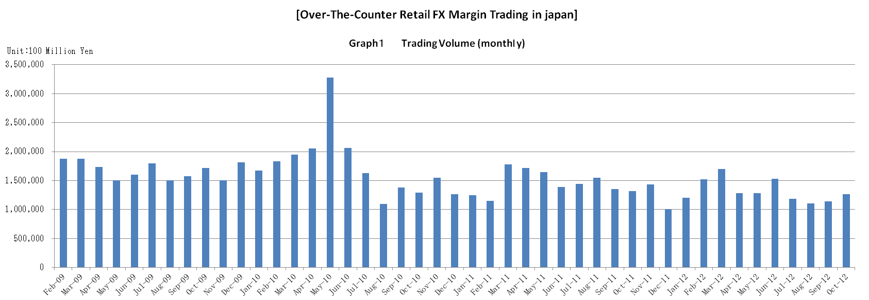

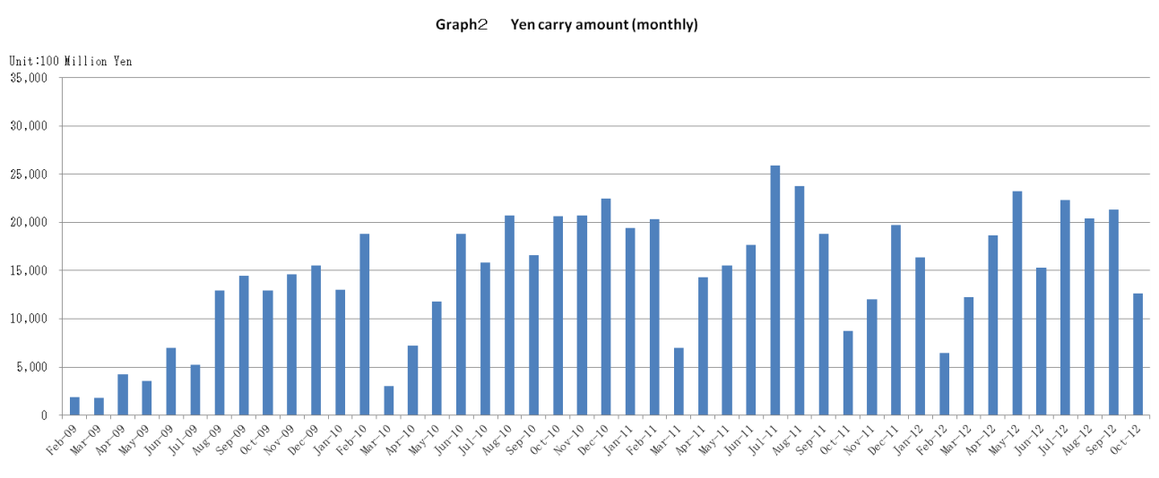

Announcement date：10/15/2012

Over-The-Counter FX Monthly Report（September 2012）
The Association publishes monthly trading volume, short open positions and long open positions of over-the-counter foreign exchange margin transactions since November 2008 with the help of members who participate to this project. 53 members participated to the report of September 2012.
The trading volume of all currency pairs in Yen for September 2012 was 114,076.9 billion Yen (+3.5% from the end August), and short and long open positions as of the end of September 2012 were 1,057.1billion Yen (-2.5％from the end of August) and 3,128.5 billion Yen (＋2.0％from the end of August), respectively. So-called Yen carry amount (net Yen short position) was 2,130.9 billion Yen (+4.54% from the end of August).
The trading volume and the open positions reported by such 53 participants amounted to 99.207% and 98.934％of the quarterly volume and open positions for April to June 2012 (69 members reported the trading record of over-the-counter foreign exchange margin transactions for the quarterly report).

a. September 2012
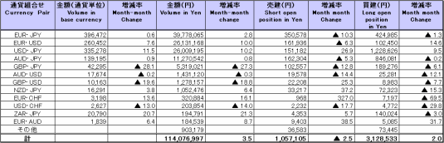
(Unit: millions of base currency; millions of Yen, %)

b. January 2012 to September 2012
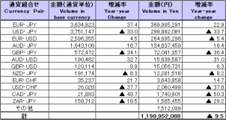
(Unit: millions of base currency; millions of Yen, %)

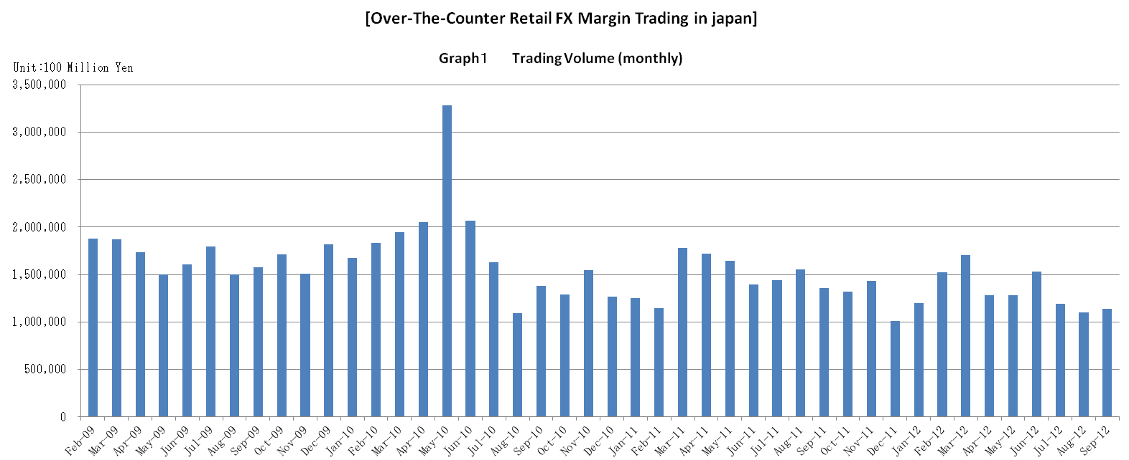

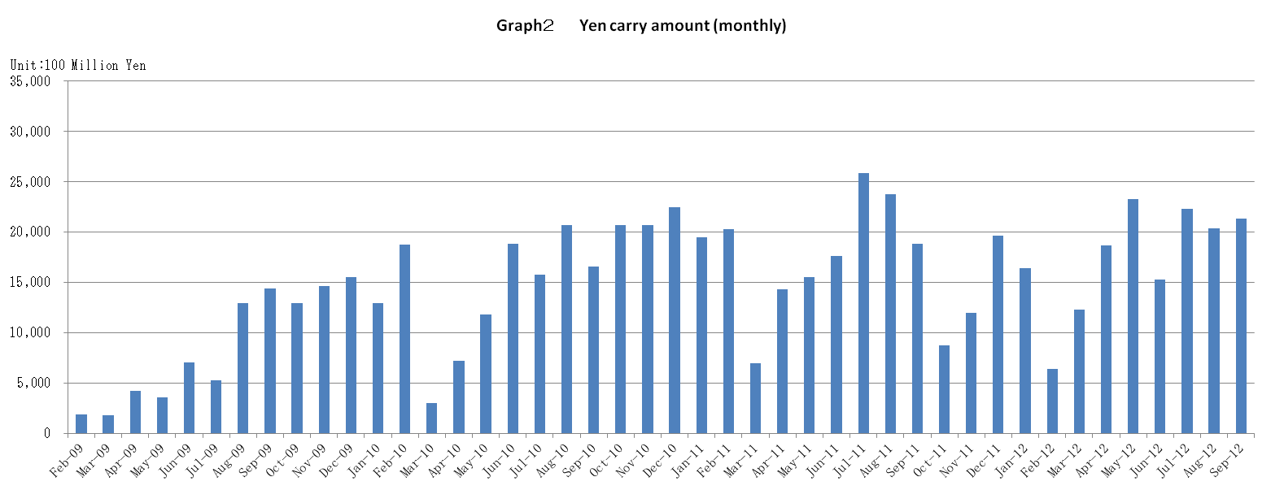

Announcement date：9/14/2012

Over-The-Counter FX Monthly Report（August 2012）
The Association publishes monthly trading volume, short open positions and long open positions of over-the-counter foreign exchange margin transactions since November 2008 with the help of members who participate to this project. 53 members participated to the report of August 2012.
The trading volume of all currency pairs in Yen for August 2012 was 110,218.1 billion Yen (-7.0% from July), and short and long open positions as of the end of August 2012 were 1,084.8billion Yen (＋29.1％from the end of July) and 3,066.3 billion Yen (＋0.6％from the end of July), respectively. So-called Yen carry amount (net Yen short position) was 2,038.3 billion Yen (-8.3% from the end of July).
The trading volume and the open positions reported by such 53 participants amounted to 99.21% and 98.40％of the quarterly volume and open positions for April to June 2012 (69 members reported the trading record of over-the-counter foreign exchange margin transactions for the quarterly report).
Corrections were made by two participants for July report. Volumes and open positions after such corrections are shown in the July 2012 Archives.

a. August 2012
(Unit: millions of base currency; millions of Yen, %)
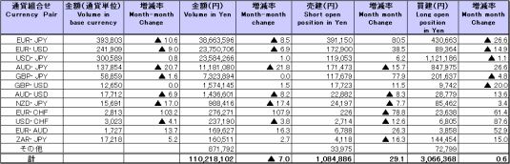

b. January 2012 to August 2012
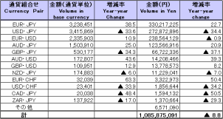
(Unit: millions of base currency; millions of Yen, %)

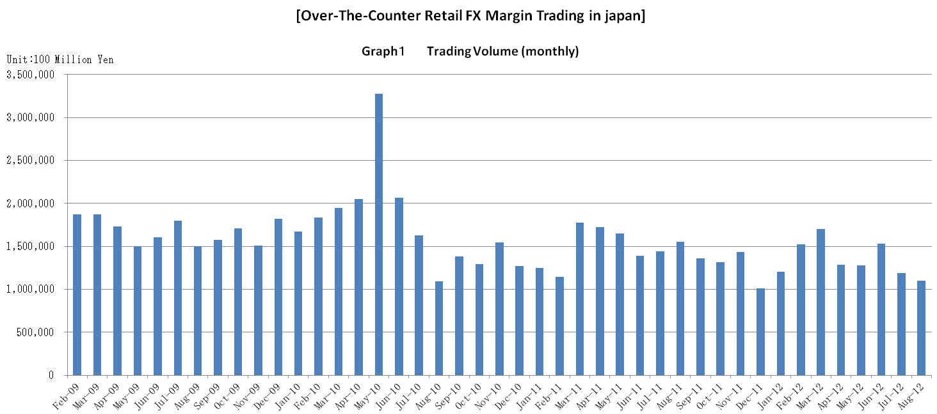

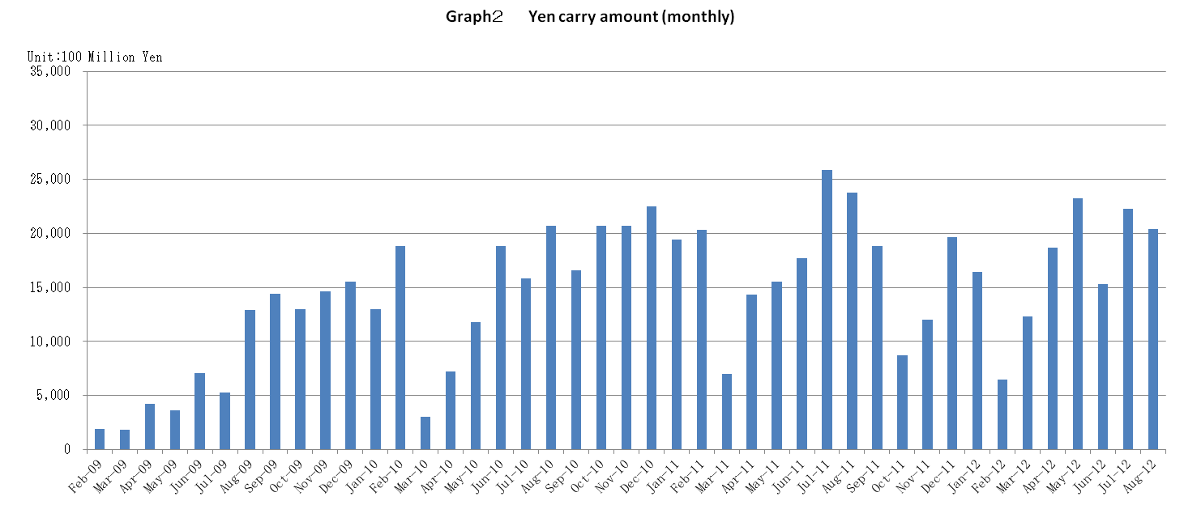

Announcement date：8/14/2012

Over-The-Counter FX Monthly Report（July 2012）
The trading volume of all currency pairs in Yen for July 2012 was 118,992.5 billion Yen (-22.2% from June), and short and long open positions as of the end of July 2012 were 834.7 billion Yen (-21.4％from the end of June) and 3,055 billion Yen (＋18.5％from the end of June), respectively. So-called Yen carry amount (net Yen short position) was 2,228.8 billion Yen (＋45.46% from the end of June).
The trading volume of all currency pairs in Yen for June 2012 was 153,109.4 billion Yen (＋19.4% from May), and short and long open positions as of the end of June 2012 were 1,062.6 billion Yen (＋59.9％from the end of May) and 2,575.9 billion Yen (-15.8% from the end of May), respectively. So-called Yen carry amount (net Yen short position) was 1,532.2 billion Yen (-34.141% from the end of May).
The trading volume and the open positions reported by such 53 participants amounted to 99.605% and 99.425％of the quarterly volume and open positions for January to March 2012 (68 members reported the trading record of over-the-counter foreign exchange margin transactions for the quarterly report).
Corrections were made by one participant for April report.Volumes and open positions after such corrections are shown in the April 2012 Archives.

a. July 2012
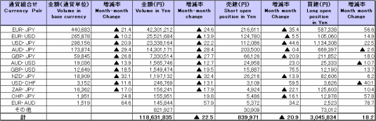
(Unit: millions of base currency; millions of Yen, %)

Because corrections are sometimes made by participants after the publication of the FX monthly report, there may be some differences between the figures shown in the text and the ones shown in the chart. In that case, the figures in the chart are accurate.

b. January 2012 to July 2012
(Unit: millions of base currency; millions of Yen, %)
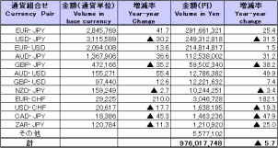

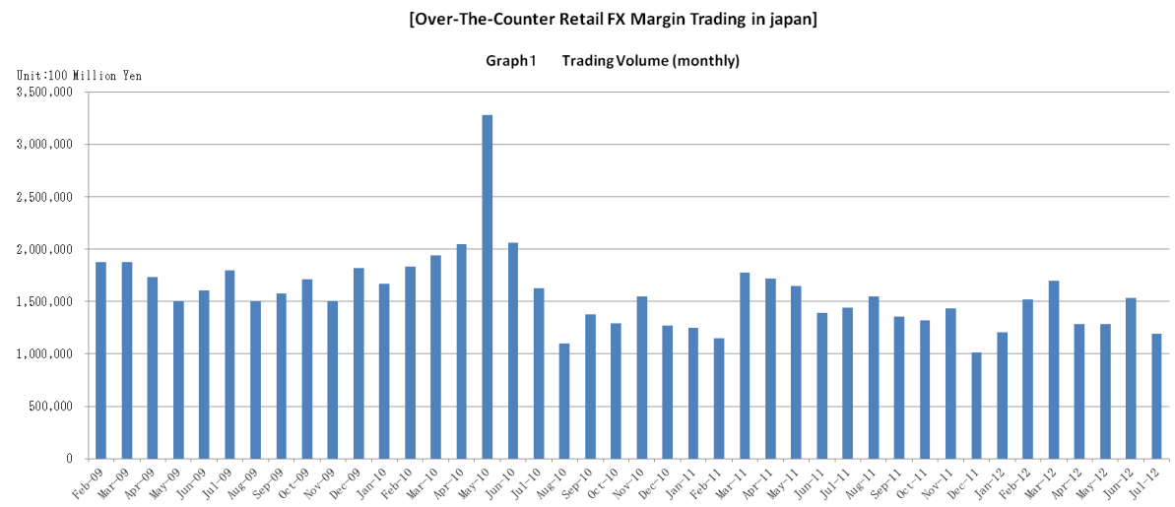

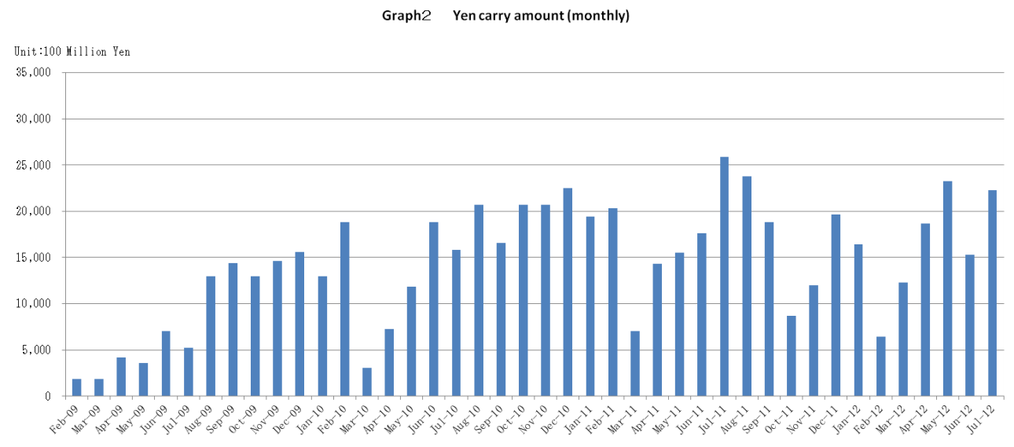

Announcement date：7/13/2012

Over-The-Counter FX Monthly Report（June 2012）
The Association publishes monthly trading volume, short open positions and long open positions of over-the-counter foreign exchange margin transactions since November 2008 with the help of members who participate to this project. 53 members participated to the report of June 2012.
The trading volume of all currency pairs in Yen for June 2012 was 153,109.4 billion Yen (＋19.4% from May), and short and long open positions as of the end of June 2012 were 1,062.6 billion Yen (＋59.9％from the end of May) and 2,575.9 billion Yen (-15.8% from the end of May), respectively. So-called Yen carry amount (net Yen short position) was 1,532.2 billion Yen (-34.141% from the end of May).
The trading volume and the open positions reported by such 53 participants amounted to 99.605% and 99.425％of the quarterly volume and open positions for January to March 2012 (68 members reported the trading record of over-the-counter foreign exchange margin transactions for the quarterly report).
Corrections were made by one participant for May report. Volumes and open positions after such corrections are shown in the May 2012 Archives.

a. June 2012
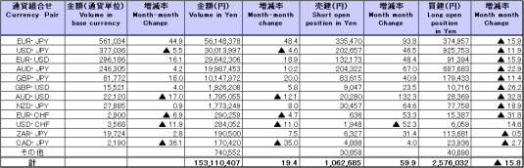
(Unit: millions of base currency; millions of Yen, %)

Because corrections are sometimes made by participants after the publication of the FX monthly report, there may be some differences between the figures shown in the text and the ones shown in the chart. In that case, the figures in the chart are accurate.

b. January 2012 to June 2012
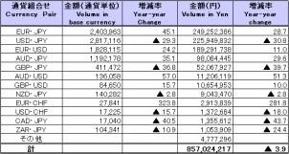
(Unit: millions of base currency; millions of Yen, %)

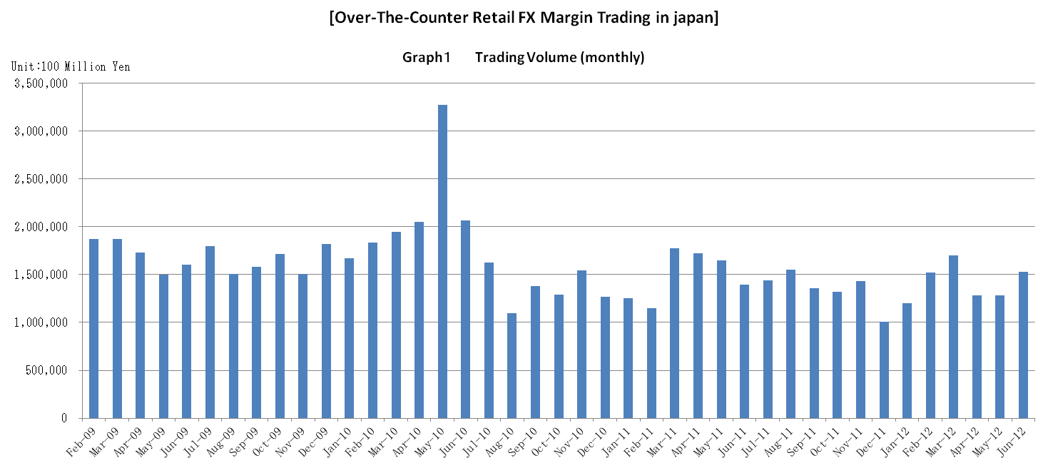

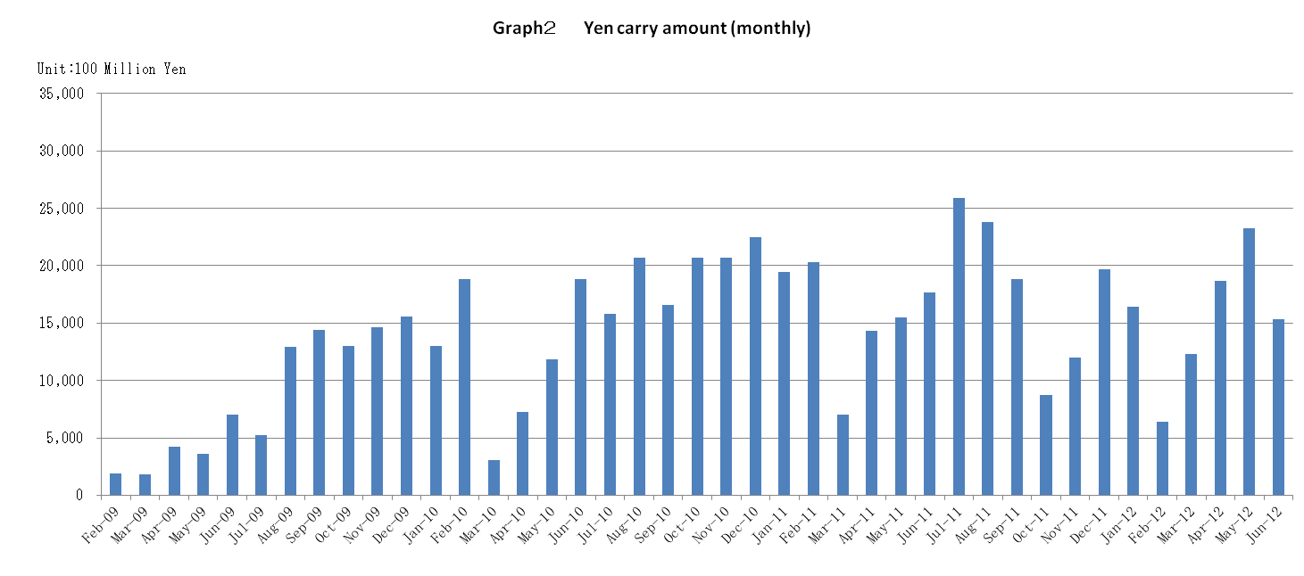

Announcement date：6/14/2012

Over-The-Counter FX Monthly Report（May 2012）
The Association publishes monthly trading volume, short open positions and long open positions of over-the-counter foreign exchange margin transactions since November 2008 with the help of members who participate to this project. 52 members participated to the report of May 2012.
The trading volume of all currency pairs in Yen for May 2012 was 128,190.8 billion Yen (-0.1% from April), and short and long open positions as of the end of May 2012 were 664.3 billion Yen (-35.5％from the end of April) and 3,061.1billion Yen (＋8.1% from the end of April), respectively. So-called Yen carry amount (net Yen short position) was 2,326.5 billion Yen (+24.76% from the end of April).
The trading volume and the open positions reported by such 52 participants amounted to 99.605% and 99.425％of the quarterly volume and open positions for January to March 2012 (68 members reported the trading record of over-the-counter foreign exchange margin transactions for the quarterly report).
Corrections were made by one participant for April report. Volumes and open positions after such corrections are shown in the April 2012 Archives.

a. May 2012
(Unit: millions of base currency; millions of Yen, %)
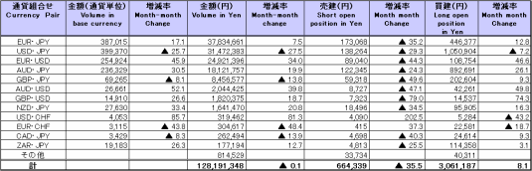

Because corrections are sometimes made by participants after the publication of the FX monthly report, there may be some differences between the figures shown in the text and the ones shown in the chart. In that case, the figures in the chart are accurate.

b. January 2012 to May 2012
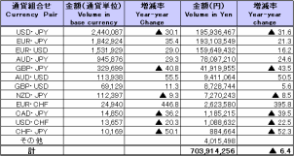
(Unit: millions of base currency; millions of Yen, %)

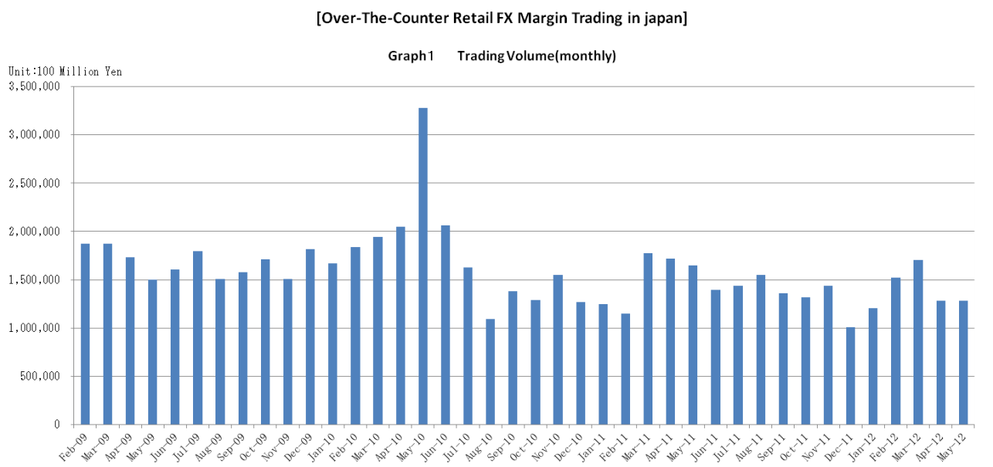

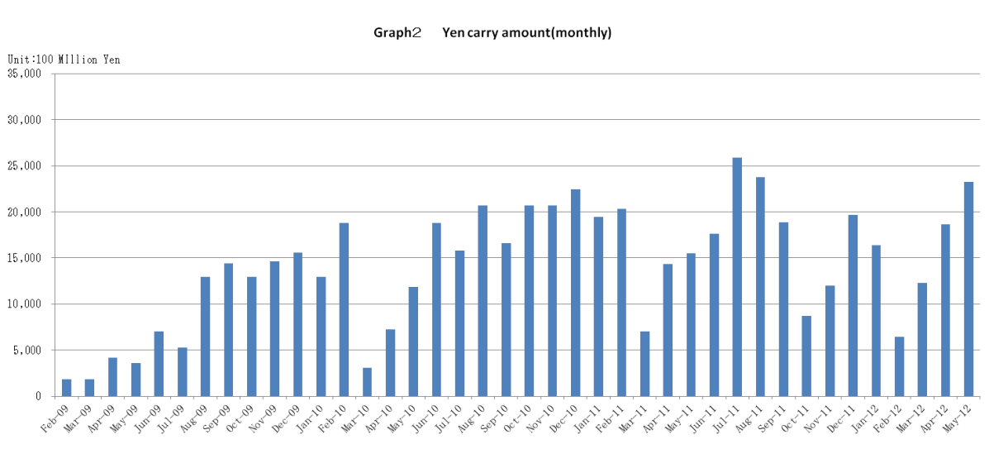

Announcement date：5/16/2012

Over-The-Counter FX Monthly Report（April 2012）
The Association publishes monthly trading volume, short open positions and long open positions of over-the-counter foreign exchange margin transactions since November 2008 with the help of members who participate to this project. 51 members participated to the report of April 2012.
The trading volume of all currency pairs in Yen for April 2012 was 128,212.5 billion Yen (-24.7% from March), and short and long open positions as of the end of April 2012 were 1,030.3 billion Yen (-14.1％from the end of March) and 2,830.3 billion Yen (＋16.8% from the end of March), respectively. So-called Yen carry amount (net Yen short position) was 1,864.7billion Yen (+51.5% from the end of March).
The trading volume and the open positions reported by such 51 participants amounted to 99.169% and 95.249％of the quarterly volume and open positions for January to March 2012 (68 members reported the trading record of over-the-counter foreign exchange margin transactions for the quarterly report).
Corrections were made by three participants for February and March reports. Volumes and open positions after such corrections are shown in the tables below.

a. April 2012
(Unit: millions of base currency; millions of Yen, %)
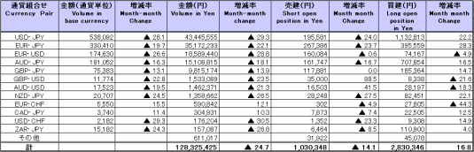

Because corrections are sometimes made by participants after the publication of the FX monthly report, there may be some differences between the figures shown in the text and the ones shown in the chart. In that case, the figures in the chart are accurate.

b. January 2012 to April 2012
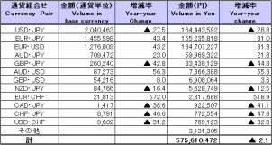
(Unit: millions of base currency; millions of Yen, %)

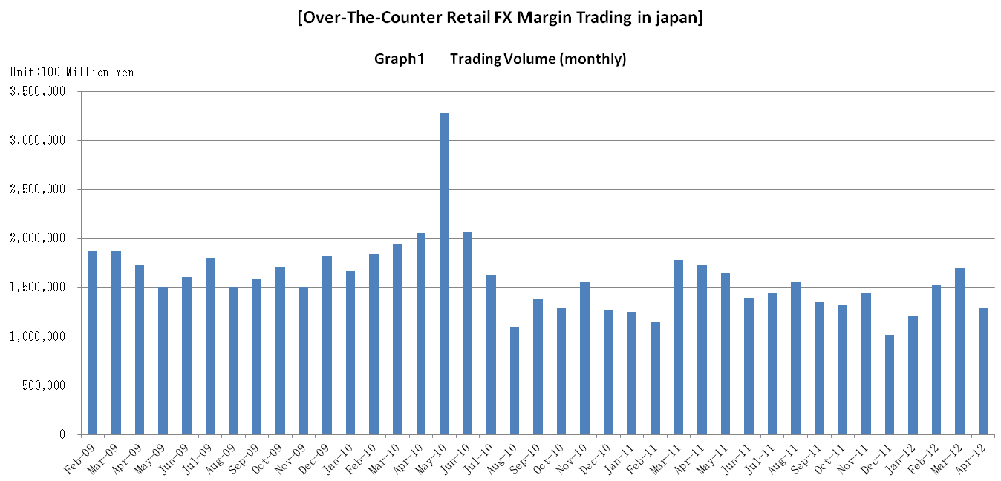

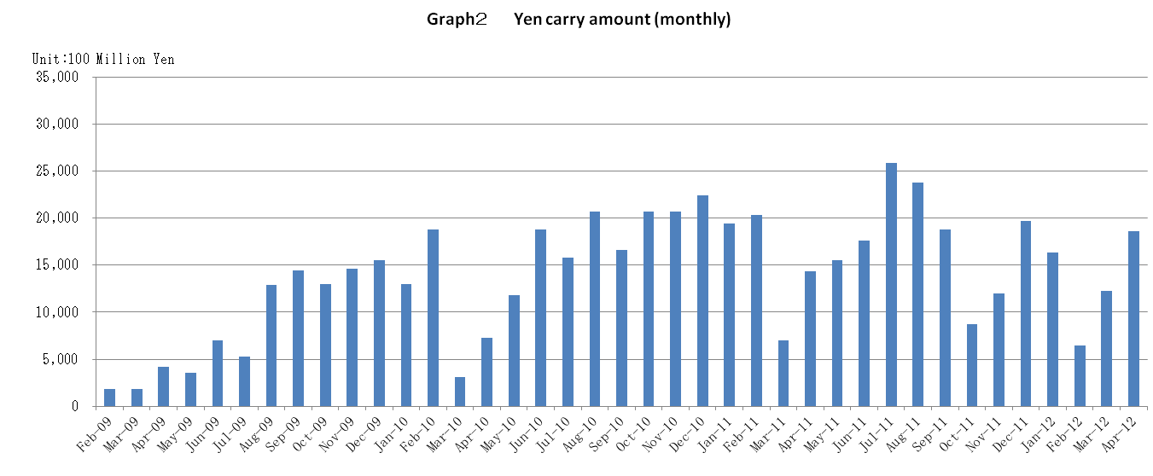

Announcement date：4/13/2012

Over-The-Counter FX Monthly Report（March 2012）
The Association publishes monthly trading volume, short open positions and long open positions of over-the-counter foreign exchange margin transactions since November 2008 with the help of members who participate to this project. 52 members participated to the report of March 2012.
The trading volume of all currency pairs in Yen for March 2012 was 170,139.5 billion Yen (＋11.7% from February), and short and long open positions as of the end of March 2012 were 1,196.8 billion Yen (-8.1％from the end of February) and 2,416.6 billion Yen (＋25.4% from the end of February), respectively. So-called Yen carry amount (net Yen short position) was 1,227.8billion Yen (+90.8% from the end of February).
The trading volume and the open positions reported by such 52 participants amounted to 99.21% and 97.45％of the quarterly volume and open positions for October to December 2011 (70 members reported the trading record of over-the-counter foreign exchange margin transactions for the quarterly report).

a. March 2012
(Unit: millions of base currency; millions of Yen, %)
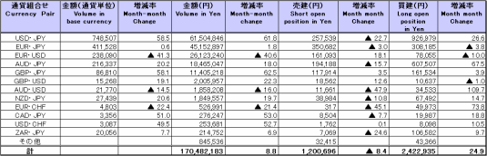

Because corrections are sometimes made by participants after the publication of the FX monthly report, there may be some differences between the figures shown in the text and the ones shown in the chart. In that case, the figures in the chart are accurate.

b. January 2012 to March 2012
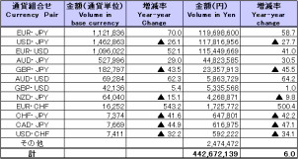
(Unit: millions of base currency; millions of Yen, %)

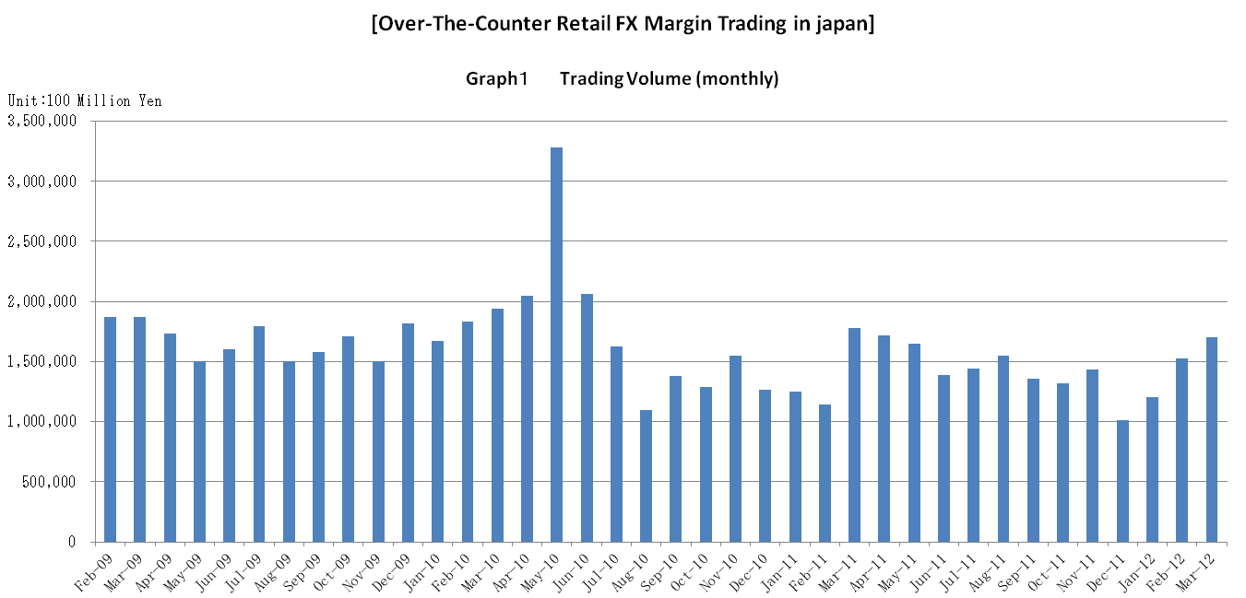

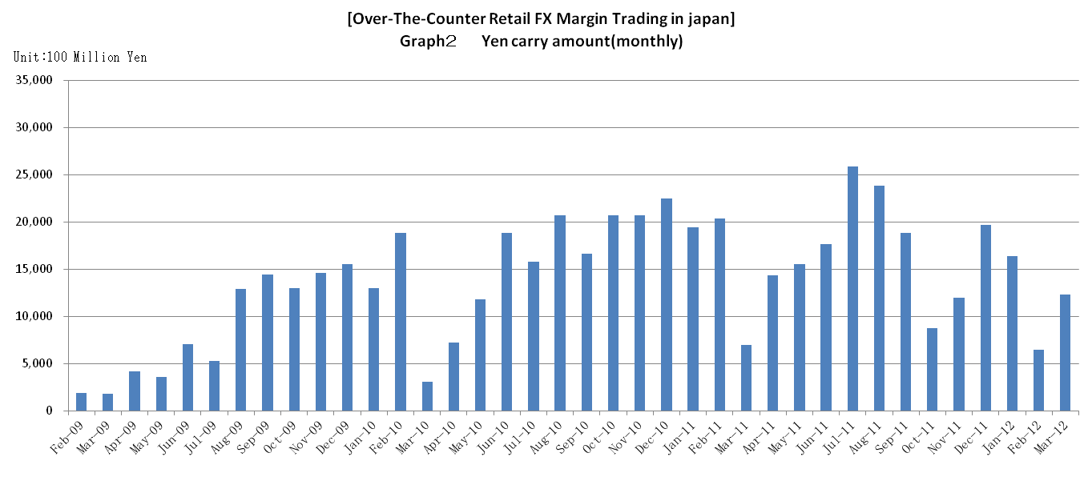

Announcement date：3/14/2012

Over-The-Counter FX Monthly Report（February 2012）
The Association publishes monthly trading volume, short open positions and long open positions of over-the-counter foreign exchange margin transactions since November 2008 with the help of members who participate to this project. 52 members participated to the report of February 2012.
The trading volume of all currency pairs in Yen for February 2012 was 152,269.2 billion Yen (＋26.6% from January), and short and long open positions as of the end of February 2012 were 1,302.6 billion Yen (＋46.4％from the end of January) and 1,926.5 billion Yen (-24.0% from the end of January), respectively. So-called Yen carry amount (net Yen short position) was 643.5 billion Yen (-60.75% from the end of January).
The trading volume and the open positions reported by such 52 participants amounted to 99.21% and 97.45％of the quarterly volume and open positions for October to December 2011 (70 members reported the trading record of over-the-counter foreign exchange margin transactions for the quarterly report).

a. February 2012
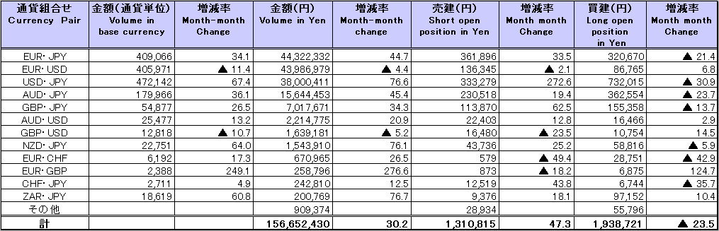
（単位：百万通貨単位、百万円、％）

Because corrections are sometimes made by participants after the publication of the FX monthly report, there may be some differences between the figures shown in the text and the ones shown in the chart. In that case, the figures in the chart are accurate.

b. January 2012 to February 2012
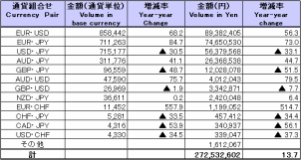
(Unit: millions of base currency; millions of Yen, %)

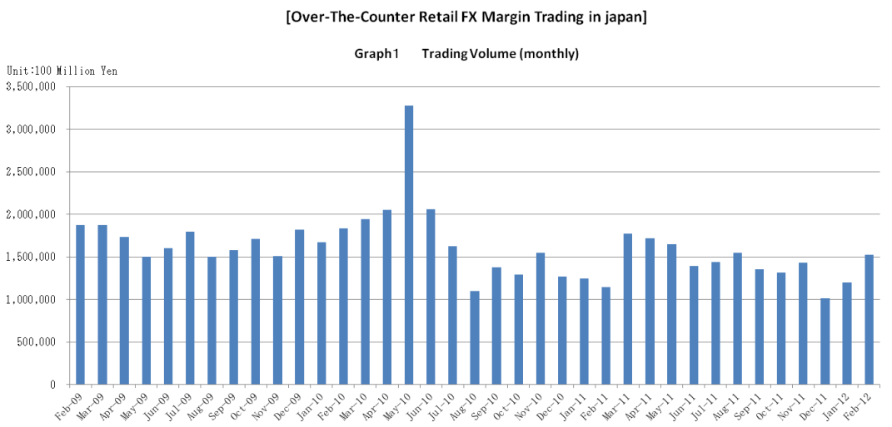

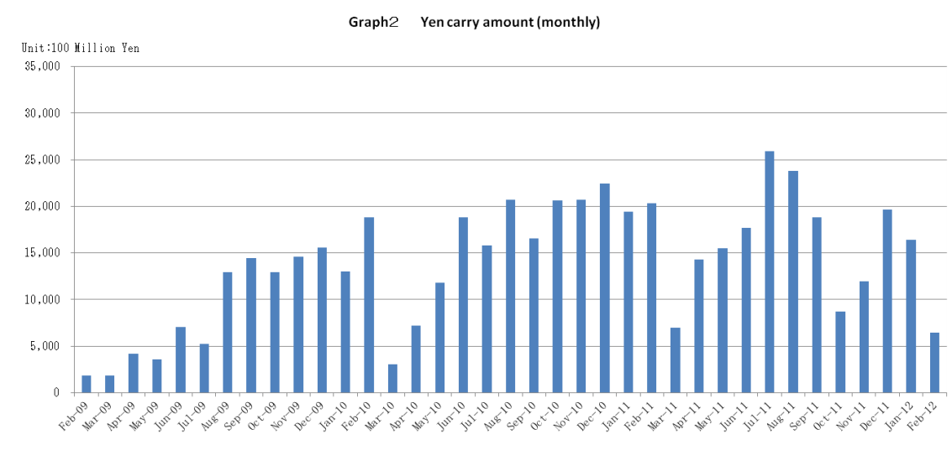

Announcement date：2/14/2012

Over-The-Counter FX Monthly Report（January 2012）
The Association publishes monthly trading volume, short open positions and long open positions of over-the-counter foreign exchange margin transactions since November 2008 with the help of members who participate to this project. 52 members participated to the report of January 2012.
The trading volume of all currency pairs in Yen for January 2012 was 120,263.3 billion Yen (＋18.9% from December), and short and long open positions as of the end of January 2012 were 889.3 billion Yen (＋28.2％from the end of December) and 2,536 billion Yen (-5.5% from the end of December), respectively. So-called Yen carry amount (net Yen short position) was 1,639.6 billion Yen (-16.56% from the end of December).
The trading volume and the open positions reported by such 52 participants amounted to 99.21% and 97.45％of the quarterly volume and open positions for October to December 2011 (70 members reported the trading record of over-the-counter foreign exchange margin transactions for the quarterly report).
Corrections were made by one participant for November and December report. Volumes and open positions after such corrections are shown in the tables below.

a. January 2012
(Unit: millions of base currency; millions of Yen, %)
