Over-The-Counter FX Monthly Report
(January 2011～December 2011)

The Financial Futures Association of Japan

Monthly Report
December 2011
November 2011
October 2011
September 2011
August 2011
July 2011
June 2011
May 2011
April 2011
March 2012
February 2012
January 2012

This material is the revised report previously issued by the Financial Futures Association of Japan(FFAJ).
This is not intended to make solicitation for investments.

Announcement date：1/18/2012

Over-The-Counter FX Monthly Report（December 2011）
The Association publishes monthly trading volume, short open positions and long open positions of over-the-counter foreign exchange margin transactions since November 2008 with the help of members who participate to this project. 52 members participated to the report of December 2011.
The trading volume of all currency pairs in Yen for December 2011 was 101,093.1 billion Yen (-29.5% from November), and short and long open positions as of the end of December 2011 were 693.7 billion Yen (-30.7％from the end of November) and 2,688.9 billion Yen (+21.8% from the end of November), respectively. So-called Yen carry amount (net Yen short position) was 1,986.3 billion Yen (＋58.09% from the end of November).
The trading volume of all currency pairs in Yen for the period of January 2011 to December 2011 was 1,702,747.8 billion Yen (-19.6% from the period of January to December 2010).
The trading volume and the open positions reported by such 52 participants amounted to 99.35% and 97.20％of the quarterly volume and open positions for July to September 2011 (73 members reported the trading record of over-the-counter foreign exchange margin transactions for the quarterly report).
Corrections were made by one participant for November report. Volumes and open positions after such corrections are shown in the tables below.

a. December 2011
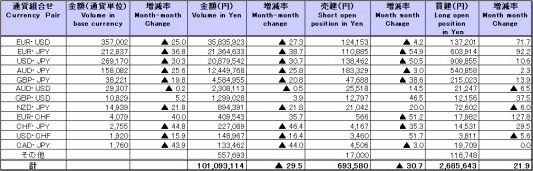
(Unit: millions of base currency; millions of Yen, %)

Because corrections are sometimes made by participants after the publication of the FX monthly report, there may be some differences between the figures shown in the text and the ones shown in the chart. In that case, the figures in the chart are accurate.

b. January 2011 to December 2011
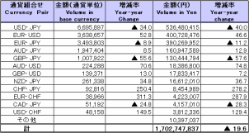
(Unit: millions of base currency; millions of Yen, %)

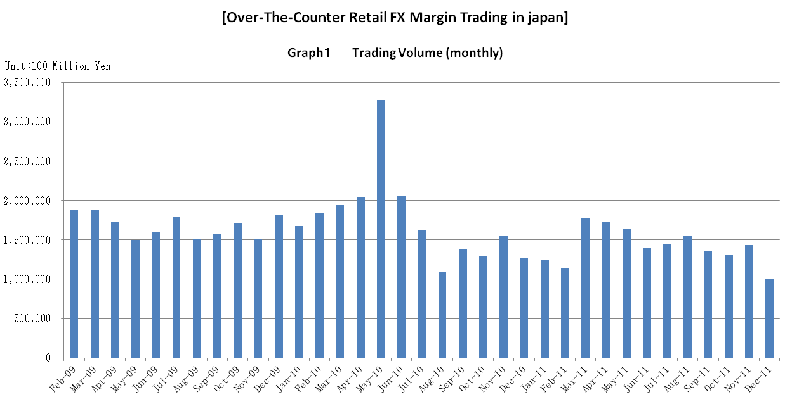

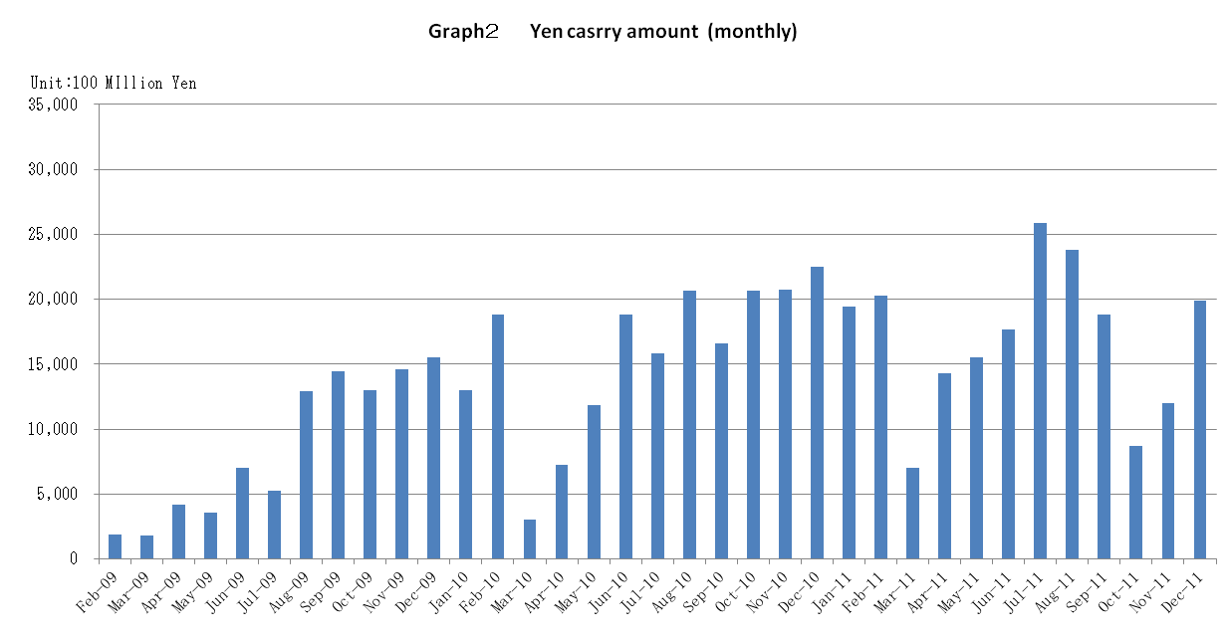

Announcement date：12/14/2011

Over-The-Counter FX Monthly Report（November 2011）
The Association publishes monthly trading volume, short open positions and long open positions of over-the-counter foreign exchange margin transactions since November 2008 with the help of members who participate to this project. 52 members participated to the report of November 2011.
The trading volume of all currency pairs in Yen for November 2011 was 143,470.4 billion Yen (＋8.9% from October), and short and long open positions as of the end of November 2011 were 1,002.9 billion Yen (-5.9％from the end of October) and 2,225.6 billion Yen (+16.4% from the end of October), respectively. So-called Yen carry amount (net Yen short position) was 1,198.9 billion Yen (＋37.59% from the end of October).
The trading volume of all currency pairs in Yen for the period of January 2011 to November 2011 was 1,601,694.7 billion Yen (-19.5% from the period of January to November 2010).
The trading volume and the open positions reported by such 52participants amounted to 99.34% and 97.11％of the quarterly volume and open positions for July to September 2011 (73 members reported the trading record of over-the-counter foreign exchange margin transactions for the quarterly report).

a. November 2011
(Unit: millions of base currency; millions of Yen, %)
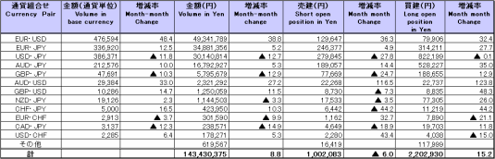

Because corrections are sometimes made by participants after the publication of the FX monthly report, there may be some differences between the figures shown in the text and the ones shown in the chart. In that case, the figures in the chart are accurate.

b. January 2011 to November 2011
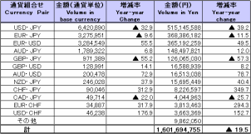
(Unit: millions of base currency; millions of Yen, %)

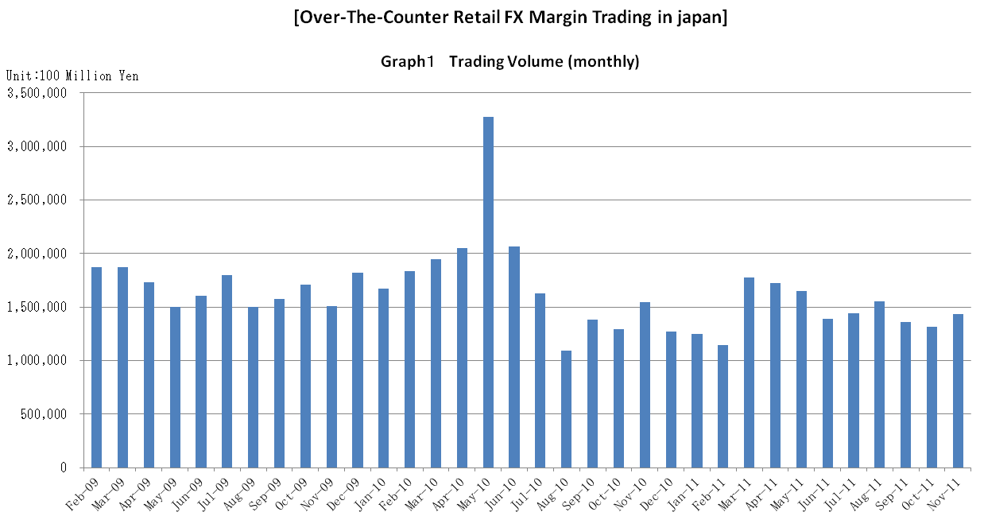

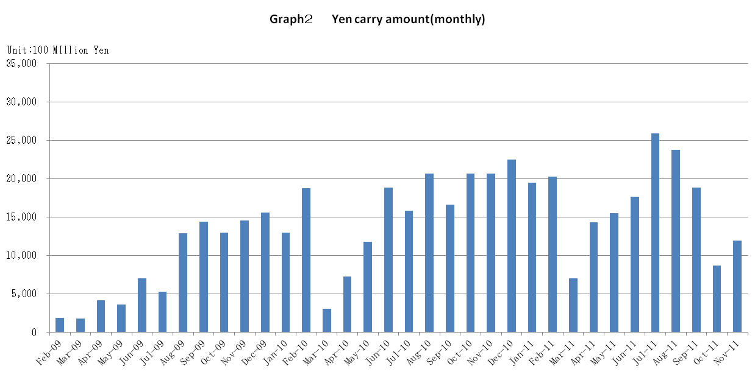

Announcement date：11/15/2011

Over-The-Counter FX Monthly Report（October 2011）
The Association publishes monthly trading volume, short open positions and long open positions of over-the-counter foreign exchange margin transactions since November 2008 with the help of members who participate to this project. 53 members participated to the report of October 2011.
The trading volume of all currency pairs in Yen for October 2011 was 131,744.6 billion Yen (-2.9% from September), and short and long open positions as of the end of October 2011 were 1,066.1 billion Yen (+65.0％ from the end of September) and 1,991.5 billion Yen (-25.1% from the end of September), respectively. So-called Yen carry amount (net Yen short position) was 871.3 billion Yen (-53.74% from the end of September).
The trading volume of all currency pairs in Yen for the period of January 2011 to October 2011 was 1,458,224.3 billion Yen (-20.5% from the period of January to October 2010).
The trading volume and the open positions reported by such 53 participants amounted to 99.34% and 97.05％of the quarterly volume and open positions for July to September 2011 (73 members reported the trading record of over-the-counter foreign exchange margin transactions for the quarterly report).

a. October 2011
(Unit: millions of base currency; millions of Yen, %)
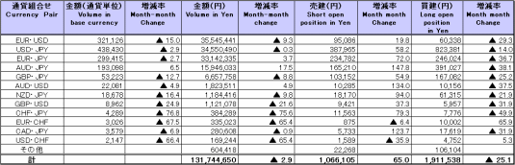

b. January 2011 to September 2011
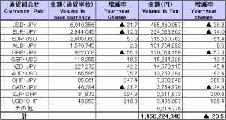
(Unit: millions of base currency; millions of Yen, %)

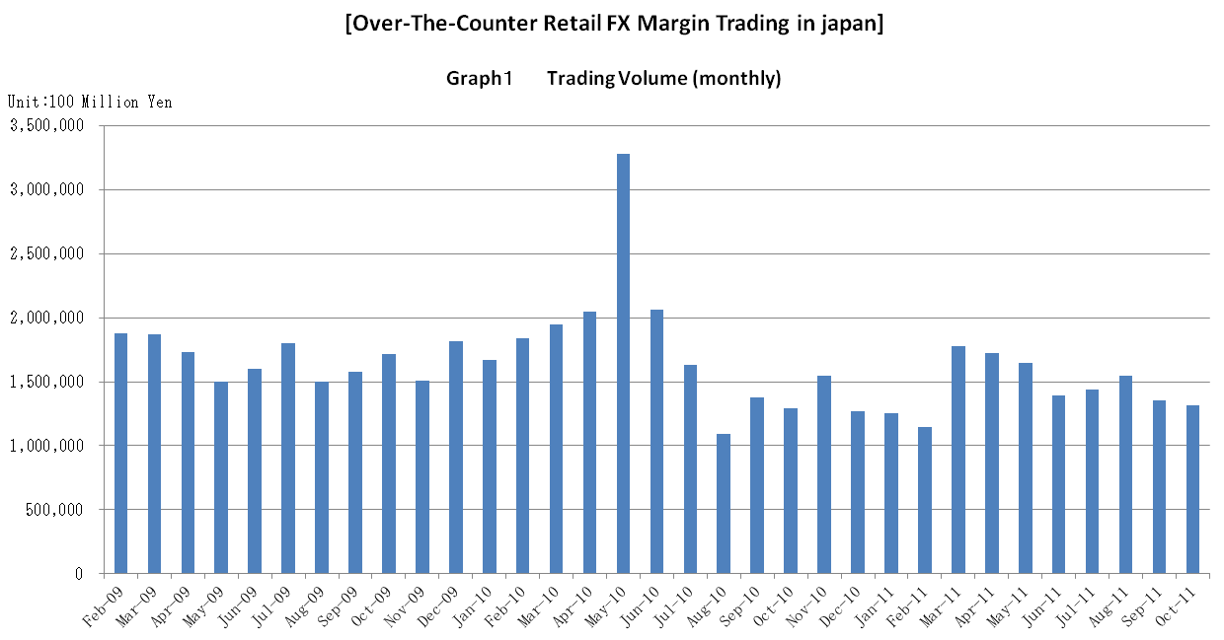

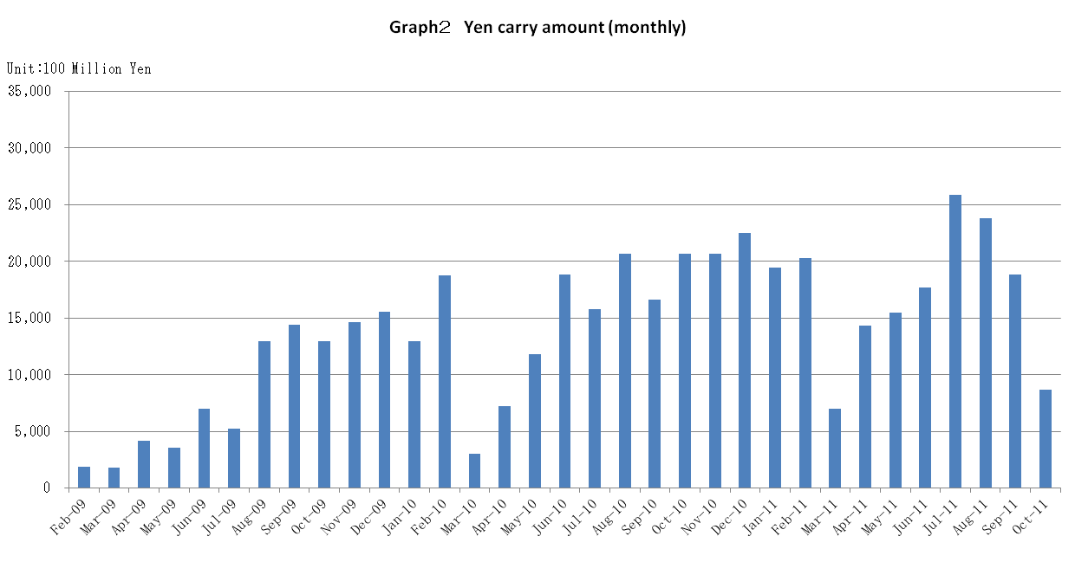

Announcement date：10/17/2011

Over-The-Counter FX Monthly Report（September 2011）
The Association publishes monthly trading volume, short open positions and long open positions of over-the-counter foreign exchange margin transactions since November 2008 with the help of members who participate to this project. 52 members participated to the report of September 2011.
The trading volume of all currency pairs in Yen for September 2011 was 135,730.2 billion Yen (-12.5% from August), and short and long open positions as of the end of September 2011 were 645.8 billion Yen (+39.8％ from the end of August) and 2,554.0 billion Yen (-12.5% from the end of August), respectively. So-called Yen carry amount (net Yen short position) was 1,883.7 billion Yen (-20.81% from the end of August).
The trading volume of all currency pairs in Yen for the period of January 2011 to September 2011 was 1,326,479.6 billion Yen (-22.2 % from the period of January to September 2010).
The trading volume and the open positions reported by such 52 participants amounted to 99.41% and 97.74％of the quarterly volume and open positions for April to June 2011 (77 members reported the trading record of over-the-counter foreign exchange margin transactions for the quarterly report).
Corrections were made by one participant for August report. Volumes and open positions after such corrections are shown in the tables below.

a. September 2011
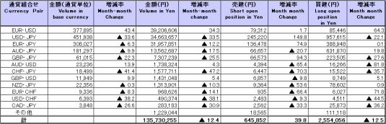
(Unit: millions of base currency; millions of Yen, %)

b. January 2011 to September 2011
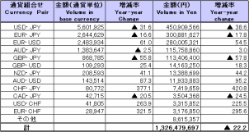
(Unit: millions of base currency; millions of Yen, %)

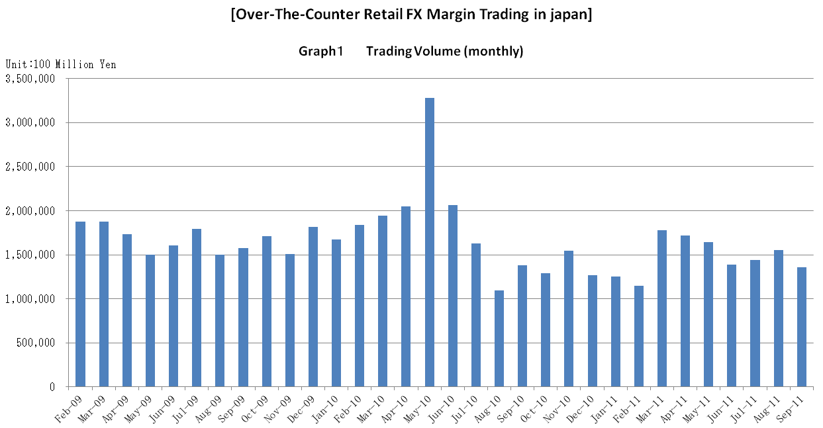

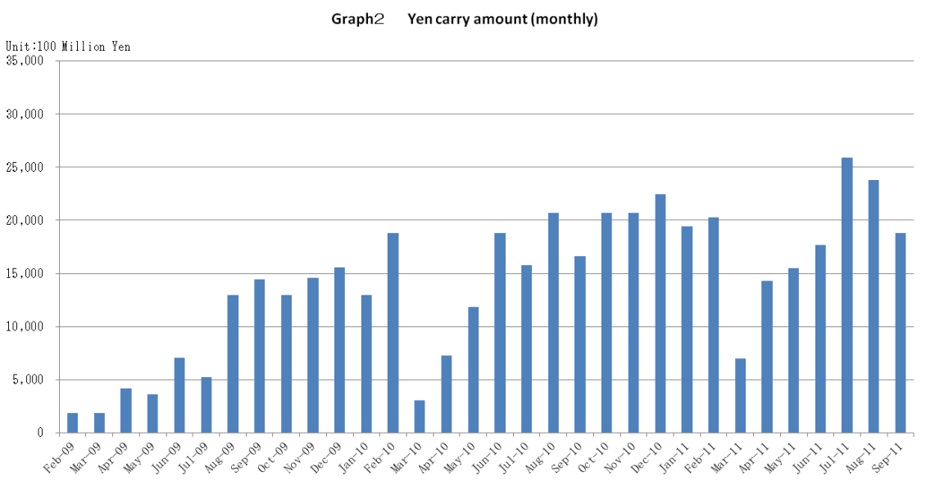

Announcement date：9/14/2011

Over-The-Counter FX Monthly Report（August 2011）
The Association publishes monthly trading volume, short open positions and long open positions of over-the-counter foreign exchange margin transactions since November 2008 with the help of members who participate to this project. 52 members participated to the report of August 2011.
The trading volume of all currency pairs in Yen for August 2011 was 155,008.7 billion Yen (+7.7% from July), and short and long open positions as of the end of August 2011 were 461.7billion Yen (-9.3％ from the end of July) and 2,921.1billion Yen (-4.2% from the end of July), respectively. So-called Yen carry amount (net Yen short position) was 2,379billion Yen (-8.125% from the end of July).
The trading volume of all currency pairs in Yen for the period of January 2011 to August 2011 was 1,190,749.5 billion Yen (-24.0% from the period of January to August 2010).
The trading volume and the open positions reported by such 52 participants amounted to 99.45% and 97.847％of the quarterly volume and open positions for April to July 2011 (77 members reported the trading record of over-the-counter foreign exchange margin transactions for the quarterly report).

a. August 2011
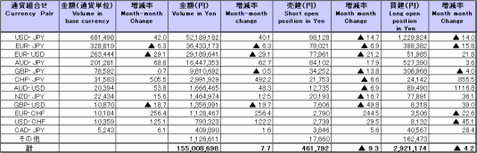
(Unit: millions of base currency; millions of Yen, %)

Because corrections are sometimes made by participants after the publication of the FX monthly report, there may be some differences between the figures shown in the text and the ones shown in the chart. In that case, the figures in the chart are accurate.

b. January 2011 to August 2011
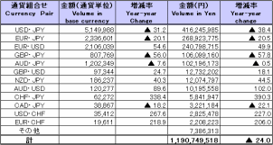
(Unit: millions of base currency; millions of Yen, %)

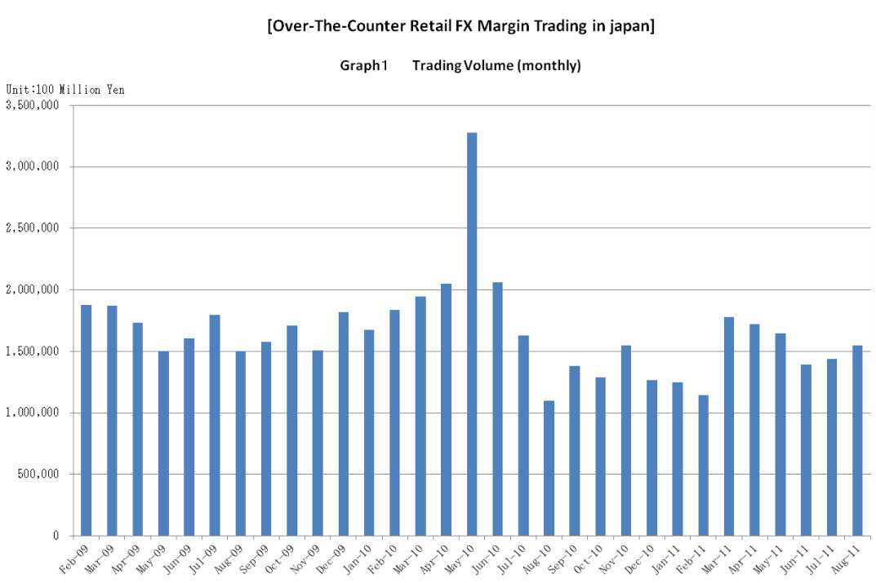

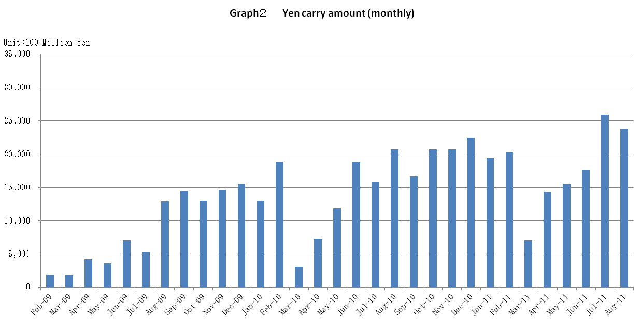

Announcement date：8/12/2011

Over-The-Counter FX Monthly Report（July 2011）
The Association publishes monthly trading volume, short open positions and long open positions of over-the-counter foreign exchange margin transactions since November 2008 with the help of members who participate to this project. 52 members participated to the report of July 2011.
The trading volume of all currency pairs in Yen for July 2011 was 143,911 billion Yen (+3.4% from June), and short and long open positions as of the end of July 2011 were 509.5billion Yen (-47.2％ from the end of June) and 3,050.1billion Yen (＋15.5% from the end of June), respectively. So-called Yen carry amount (net Yen short position) was 2,589.3billion Yen (＋46.60% from the end of June).
The trading volume of all currency pairs in Yen for the period of January 2011 to July 2011 was 1,035,740.7 billion Yen (-28.9% from the period of January to July 2010).
The trading volume and the open positions reported by such 52 participants amounted to 99.28% and 97.80％of the quarterly volume and open positions for April to June 2011 (77 members reported the trading record of over-the-counter foreign exchange margin transactions for the quarterly report).

a. July 2011
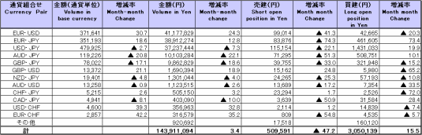
(Unit: millions of base currency; millions of Yen, %)

b. January 2011 to July 2011
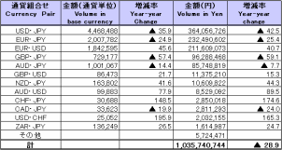
(Unit: millions of base currency; millions of Yen, %)

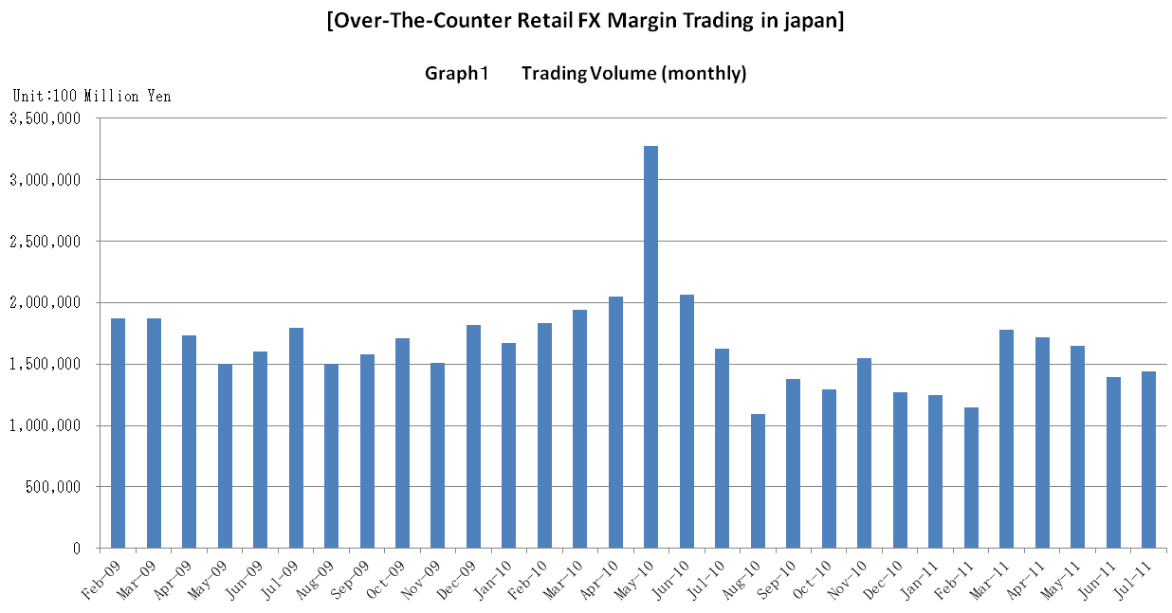

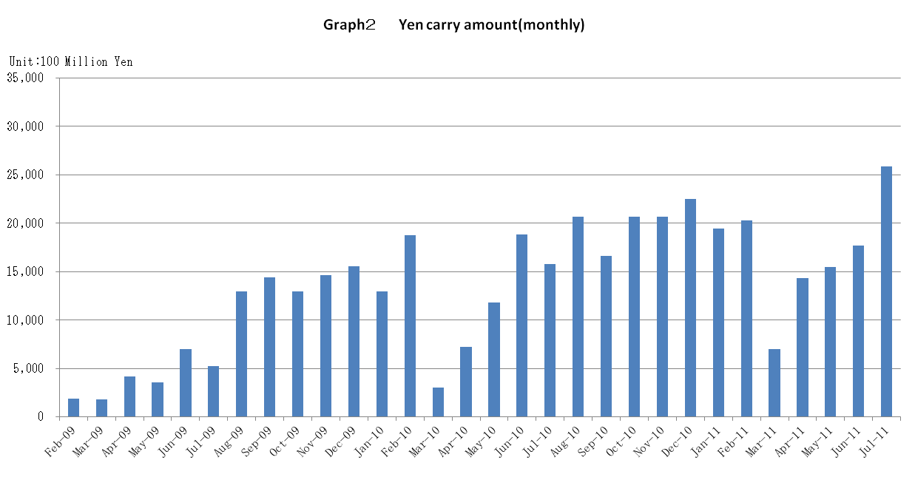

Announcement date：7/14/2011

Over-The-Counter FX Monthly Report（June 2011）
The Association publishes monthly trading volume, short open positions and long open positions of over-the-counter foreign exchange margin transactions since November 2008 with the help of members who participate to this project. 54 members participated to the report of June 2011.
The trading volume of all currency pairs in Yen for June 2011 was 139,168.5 billion Yen (-15.4% from May), and short and long open positions as of the end of June 2011 were 966.7billion Yen (+12.1％ from the end of May) and 2,640.6 billion Yen (＋11.7% from the end of May), respectively. So-called Yen carry amount (net Yen short position) was 1,766.2billion Yen (＋13.89% from the end of May).
The trading volume of all currency pairs in Yen for the period of January 2011 to June 2011 was 891,829.6 billion Yen (-31.1% from the period of January to June 2010).
The trading volume and the open positions reported by such 54 amounted to 99.50% and 97.24％of the quarterly volume and open positions for January to March 2011 (78 members reported the trading record of over-the-counter foreign exchange margin transactions for the quarterly report).

a. June 2011
(Unit: millions of base currency; millions of Yen, %)
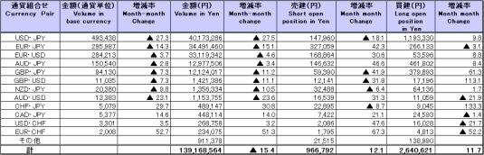

b. January 2011 to June 2011
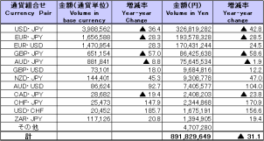
(Unit: millions of base currency; millions of Yen, %)

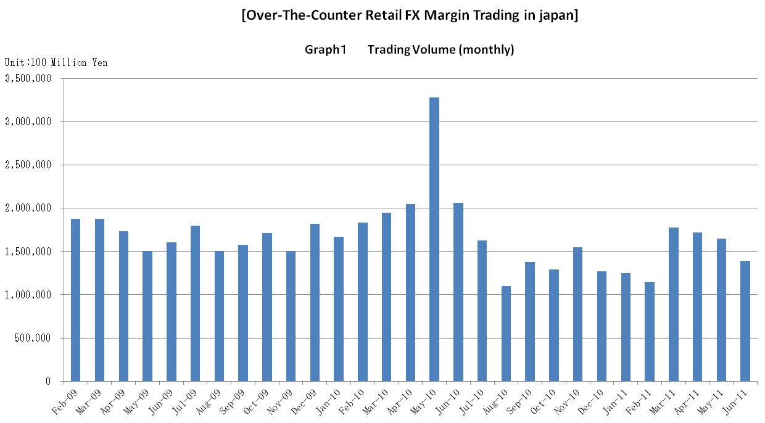

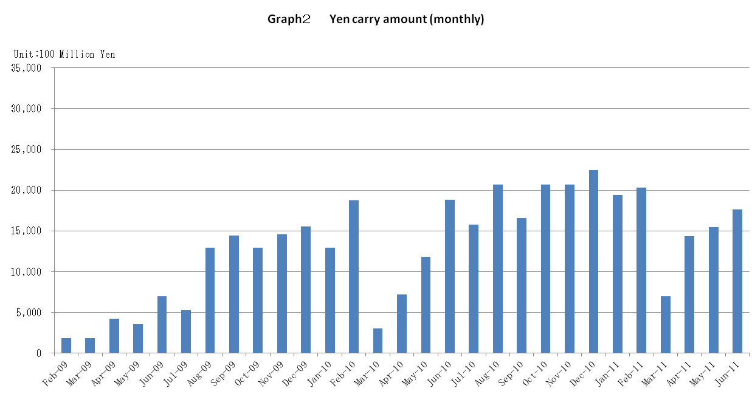

Announcement date：6/14/2011

Over-The-Counter FX Monthly Report（May 2011）
The Association publishes monthly trading volume, short open positions and long open positions of over-the-counter foreign exchange margin transactions since November 2008 with the help of members who participate to this project. 56 members participated to the report of May 2011.
The trading volume of all currency pairs in Yen for May 2011 was 164,604.4 billion Yen (-3.5% from April), and short and long open positions as of the end of May 2011 were 8,622.9 billion Yen (-4.3％ from the end of April) and 2,363.9 billion Yen (＋6.5% from the end of April), respectively. So-called Yen carry amount (net Yen short position) was 1,550.8 billion Yen (＋8.23% from the end of April).
The trading volume of all currency pairs in Yen for the period of January 2011 to May 2011 was 752,661 billion Yen (-30.8% from the period of January to May 2010).
The trading volume and the open positions reported by such 56 participants amounted to 99.57% and 98.03％of the quarterly volume and open positions for January to March 2011 (78 members reported the trading record of over-the-counter foreign exchange margin transactions for the quarterly report).
Corrections were made by one participant for April report. Volumes and open positions after such corrections are shown in the tables below.

a. May 2011
(Unit: millions of base currency; millions of Yen, %)

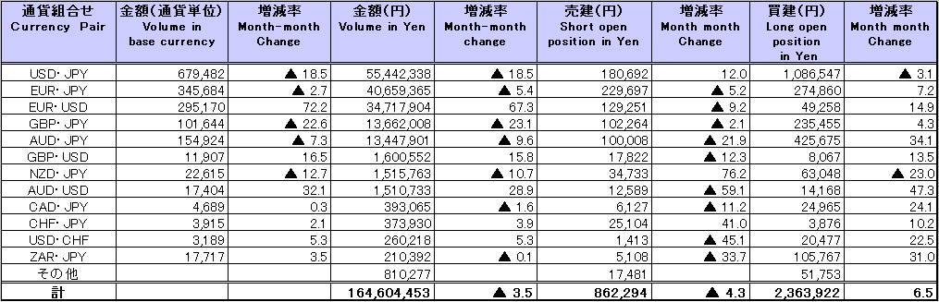

b. January 2011 to May 2011
(Unit: millions of base currency; millions of Yen, %)
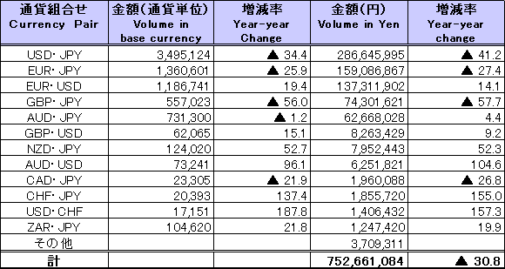

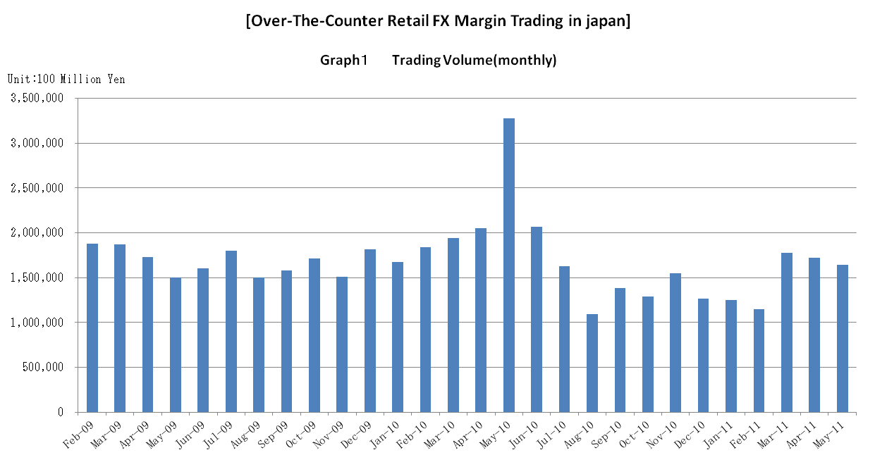

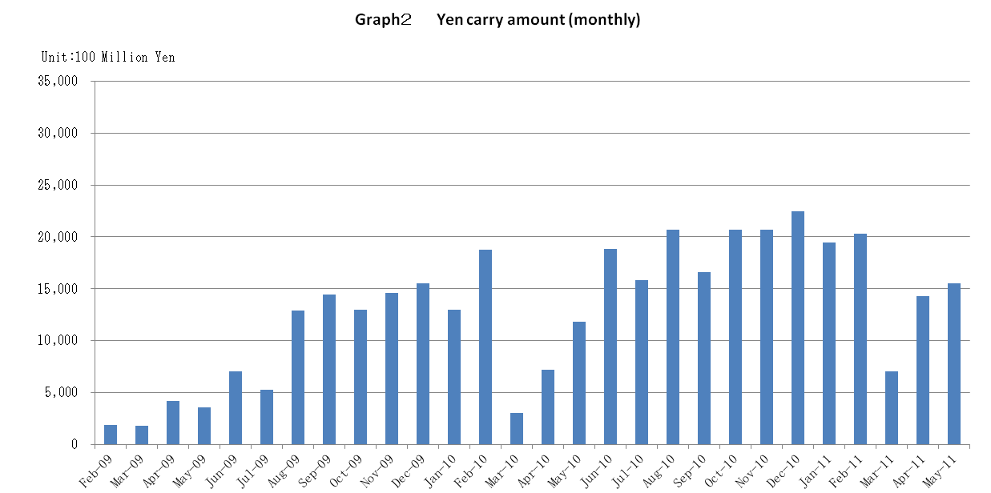

Announcement date：5/18/2011

Over-The-Counter FX Monthly Report（April 2011）
The Association publishes monthly trading volume, short open positions and long open positions of over-the-counter foreign exchange margin transactions since November 2008 with the help of members who participate to this project. 55 members participated to the report of April 2011.
The trading volume of all currency pairs in Yen for April 2011 was 172,092.7 billion Yen (-3.1% from March), and short and long open positions as of the end of April 2011 were 9,067.9 billion Yen (-19.7％ from the end of March) and 2,244.4 billion Yen (＋28.2% from the end of March), respectively. So-called Yen carry amount (net Yen short position) was 1,433.1 billion Yen (＋104.44% from the end of March).
The trading volume of all currency pairs in Yen for the period of January 2011 to April 2011 was 589,503.8 billion Yen (-22.5% from the period of January to April 2010).
The trading volume and the open positions reported by such 55 participants amounted to 99.25% and 97.97％ of the quarterly volume and open positions for January to March 2011 (78 members reported the trading record of over-the-counter foreign exchange margin transactions for the quarterly report).
Corrections were made by one participant for January, March reports and one participant for January report. Volumes and open positions after such corrections are shown in the tables below.

a. April 2011
(Unit: millions of base currency; millions of Yen, %)

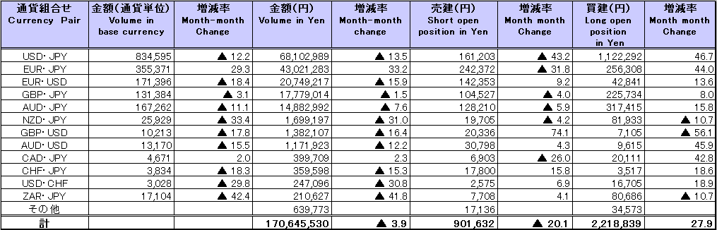
Because corrections are sometimes made by participants after the publication of the FX monthly report, there may be some differences between the figures shown in the text and the ones shown in the chart. In that case, the figures in the chart are accurate.

b. January 2011 to April 2011
(Unit: millions of base currency; millions of Yen, %)

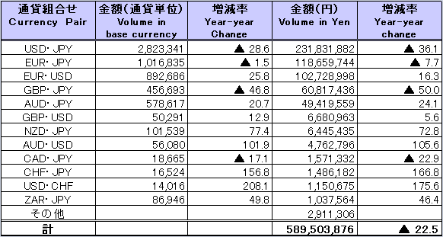

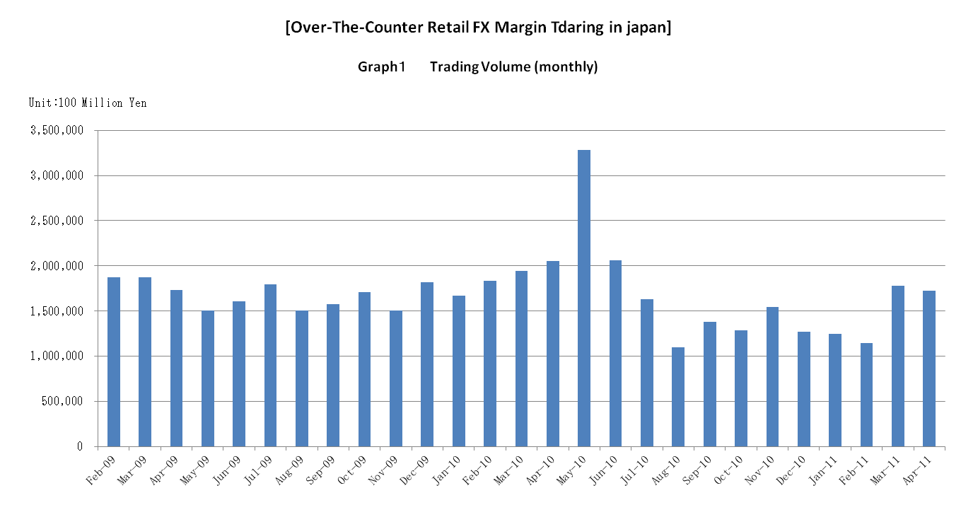

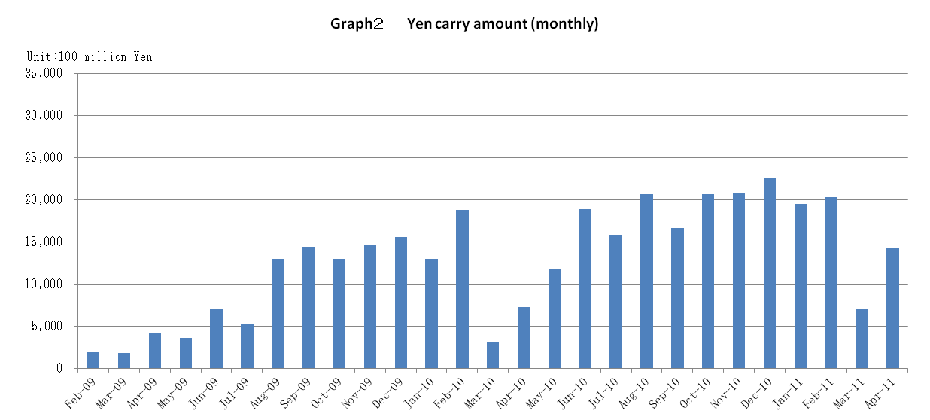

Announcement date：4/14/2011

Over-The-Counter FX Monthly Report（March 2011）
The Association publishes monthly trading volume, short open positions and long open positions of over-the-counter foreign exchange margin transactions since November 2008 with the help of members who participate to this project. 56 members participated to the report of March 2011.
The trading volume of all currency pairs in Yen for March 2011 was 177,735.3 billion Yen (-40.8% from February), and short and long open positions as of the end of March 2011 were 1,129.4 billion Yen (＋10.3％ from the end of February) and 1,734.2 billion Yen (-40.8.0% from the end of February), respectively. So-called Yen carry amount (net Yen short position) was 700.9 billion Yen (-64.49% from the end of February).
The trading volume of all currency pairs in Yen for January 2011 to March 2011 was 417,388.1 billion Yen (-24.9% from January to March 2010).
The trading volume and the open positions reported by such 56 participants amounted to 99.47% and 98.29％ of the quarterly volume and open positions for October to December 2010 (83 members reported the trading record of over-the-counter foreign exchange margin transactions for the quarterly report).

a. March 2011
(Unit: millions of base currency; millions of Yen, %)
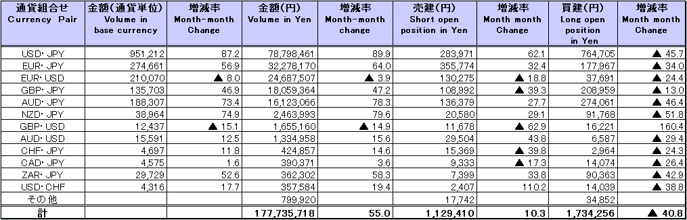

b. January 2011 to March 2011
(Unit: millions of base currency; millions of Yen, %)
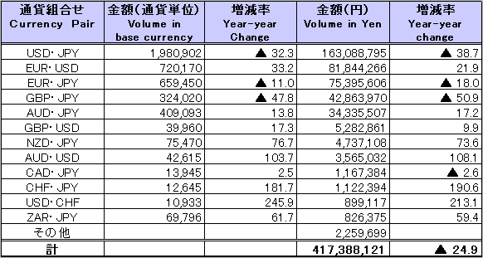

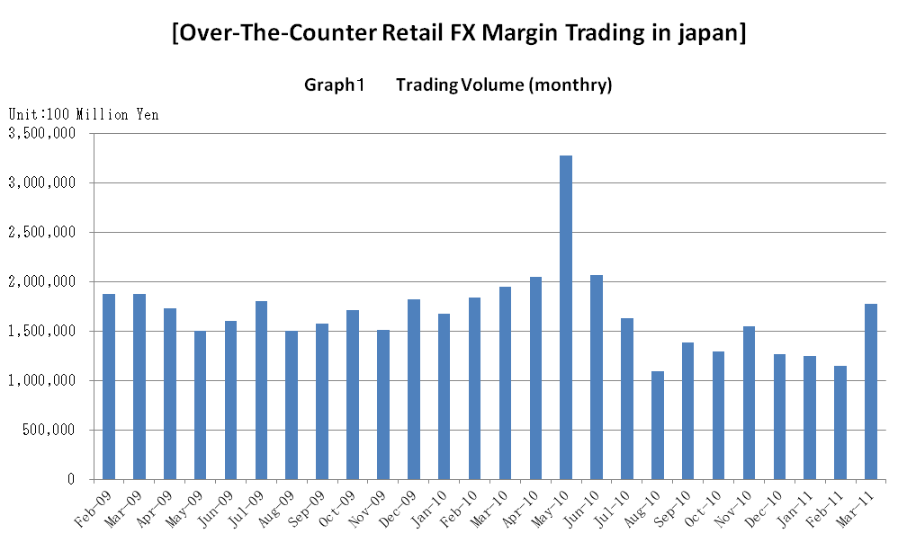

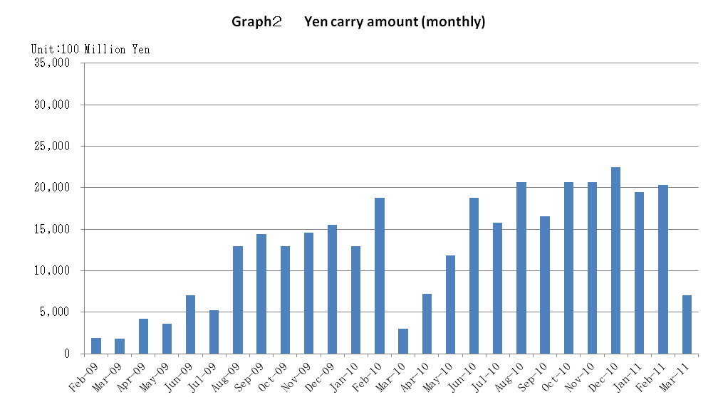

Announcement date：3/14/2011

Over-The-Counter FX Monthly Report（February 2011）
The Association publishes monthly trading volume, short open positions and long open positions of over-the-counter foreign exchange margin transactions since November 2008 with the help of members who participate to this project. 57 members participated to the report of February 2011.
The trading volume in Yen for February 2011 was 114,616.8 billion Yen (-8.3% from January), and short and long open positions as of the end of February 2011 were 1,023 billion Yen (＋7.2％ from the end of January) and 2,933.6 billion Yen (＋5.0% from the end of January), respectively. So-called Yen carry amount (net Yen short position) was 2,031.2 billion Yen (＋4.43% from the end of January).
The trading volume and the open positions reported by such 57 participants amounted to 99.47% and 98.29％ of the quarterly volume and open positions for October to December 2010 (83 members reported the trading record of over-the-counter foreign exchange margin transactions for the quarterly report).
Corrections were made by one participant for October, November and December reports . Volumes and open positions after such corrections are shown in the tables below.

(Unit: millions of base currency; millions of Yen, %)

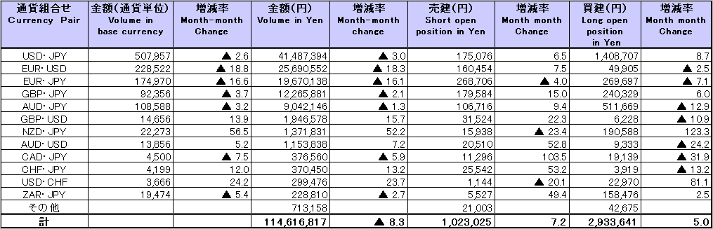

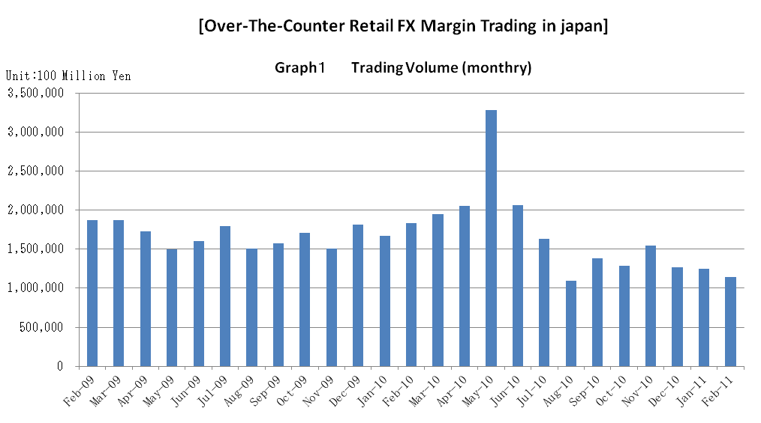

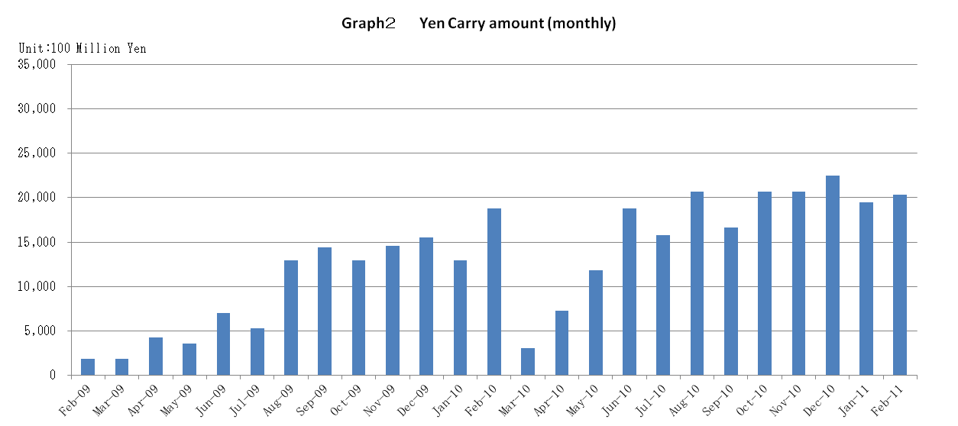

Announcement date：2/15/2011

Over-The-Counter FX Monthly Report（January 2011）
The Association publishes monthly trading volume, short open positions and long open positions of over-the-counter foreign exchange margin transactions since November 2008 with the help of members who participate to this project. 57 members participated to the report of January 2011.
The trading volume in Yen for January 2011 was 125,035.9 billion Yen (-1.6% from December), and short and long open positions as of the end of January 2011 were 953.6 billion Yen (＋32.3％from the end of December) and 2,791.5billion Yen (-5.0% from the end of December), respectively. So-called Yen carry amount (net Yen short position) was 1,945 billion Yen (-13.36 % from the end of December).
The trading volume and the open positions reported by such 57 participants amounted to 99.47% and 98.29％ of the quarterly volume and open positions for October to December 2010 (83 members reported the trading record of over-the-counter foreign exchange margin transactions for the quarterly report). Volumes and open positions after such corrections are shown in the tables below.

(Unit: millions of base currency; millions of Yen, %)
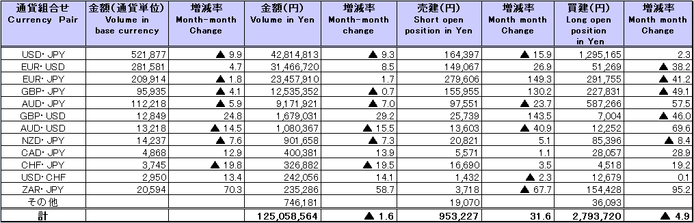
Because corrections are sometimes made by participants after the publication of the FX monthly report, there may be some differences between the figures shown in the text and the ones shown in the chart. In that case, the figures in the chart are accurate.

