Over-The-Counter FX Monthly Report
(January 2010～December 2010)

The Financial Futures Association of Japan

Monthly Report
December 2010
November 2010
October 2010
September 2010
August 2010
July 2010
June 2010
May 2010
April 2010
March 2010
February 2010
January 2010

This material is the revised report previously issued by the Financial Futures Association of Japan(FFAJ).
This is not intended to make solicitation for investments.

Announcement date：1/18/2011

Over-The-Counter FX Monthly Report（December 2010）
The Association publishes monthly trading volume, short open positions and long open positions of over-the-counter foreign exchange margin transactions since November 2008 with the help of members who participate to this project. 57 members participated to the report of December 2010.
The trading volume in Yen for December 2010 was 126,807.6billion Yen (-18.1% from November), and short and long open positions as of the end of December 2010 were 721.1 billion Yen (＋1.1％from the end of November) and 2,943.3 billion Yen (＋3.5% from the end of November), respectively. So-called Yen carry amount (net Yen short position) was 2,247.9 billion Yen (+8.55 % from the end of November).
The trading volume and the open positions reported by such 57 participants amounted to 99.24% and 97.92％ of the quarterly volume and open positions for July to September 2010 (85 members reported the trading record of over-the-counter foreign exchange margin transactions for the quarterly report).

(Unit: millions of base currency; millions of Yen, %)
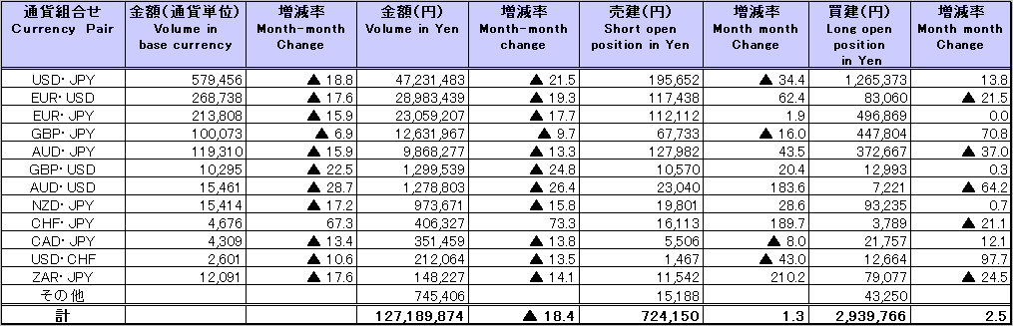
Because corrections are sometimes made by participants after the publication of the FX monthly report, there may be some differences between the figures shown in the text and the ones shown in the chart. In that case, the figures in the chart are accurate.

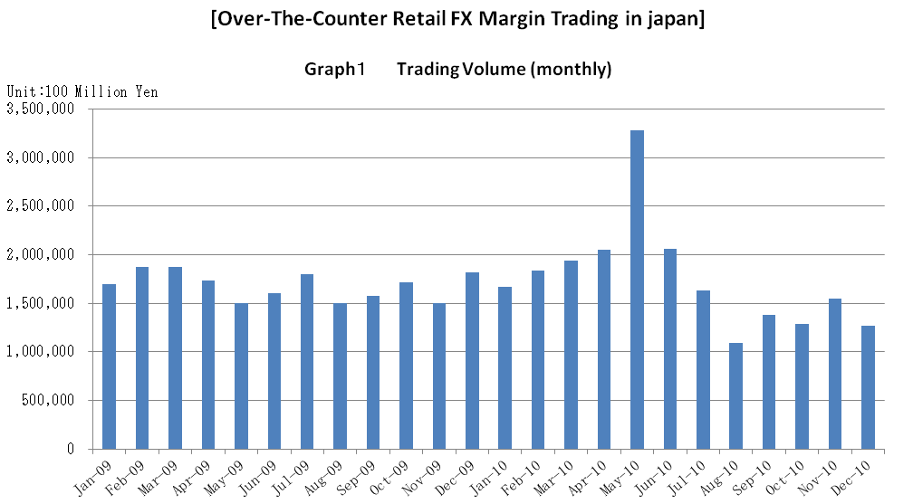

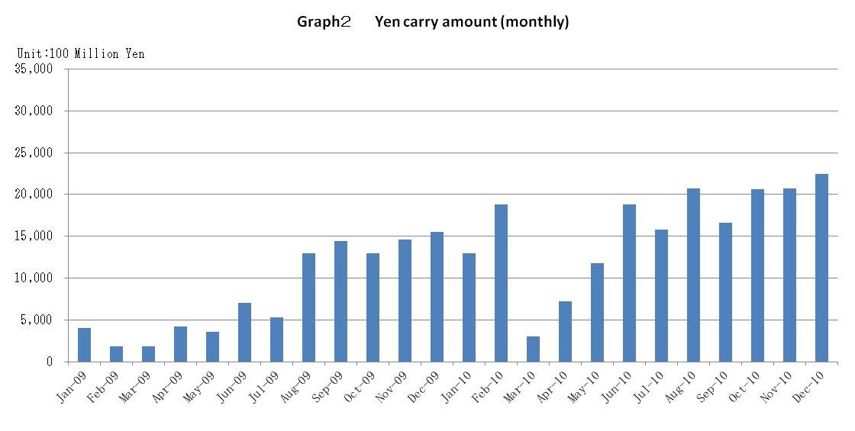

Announcement date：12/14/2010

Over-The-Counter FX Monthly Report（November 2010）
The Association publishes monthly trading volume, short open positions and long open positions of over-the-counter foreign exchange margin transactions since November 2008 with the help of members who participate to this project. 58 members participated to the report of November 2010.
The trading volume in Yen for November 2010 was 154,796.8 billion Yen (＋19.9% from October), and short and long open positions as of the end of November 2010 were 711.6 billion Yen (＋11.3％from the end of October) and 2,839.2 billion Yen (＋7.1% from the end of October), respectively. So-called Yen carry amount (net Yen short position) was 2,070.7 billion Yen (+0.14 % from the end of October).
The trading volume and the open positions reported by such 58 participants amounted to 99.25% and 98.05％ of the quarterly volume and open positions for July to September 2010 (85 members reported the trading record of over-the-counter foreign exchange margin transactions for the quarterly report).

(Unit: millions of base currency; millions of Yen, %)
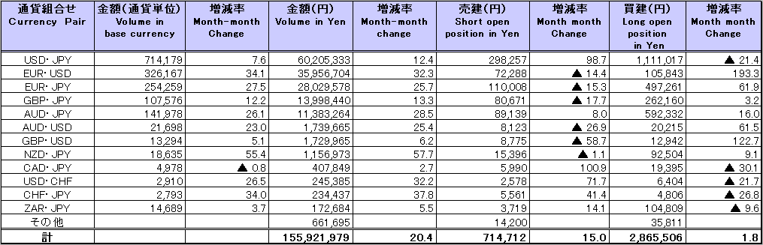
Because corrections are sometimes made by participants after the publication of the FX monthly report, there may be some differences between the figures shown in the text and the ones shown in the chart. In that case, the figures in the chart are accurate.

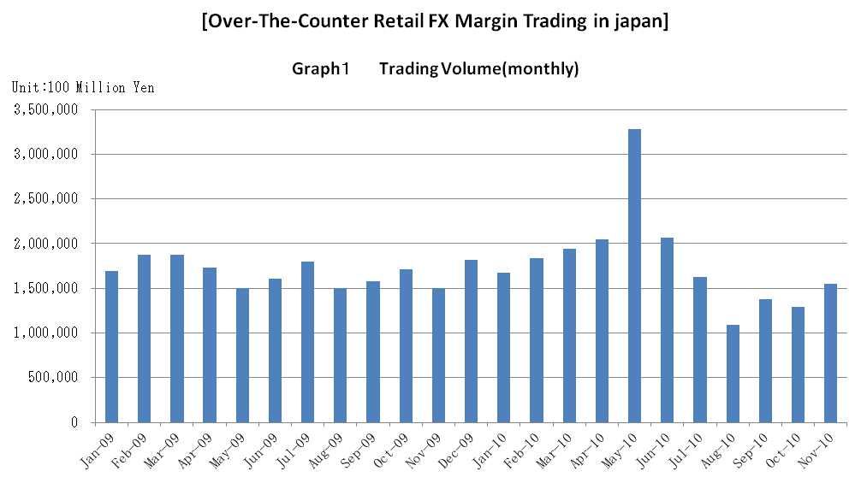

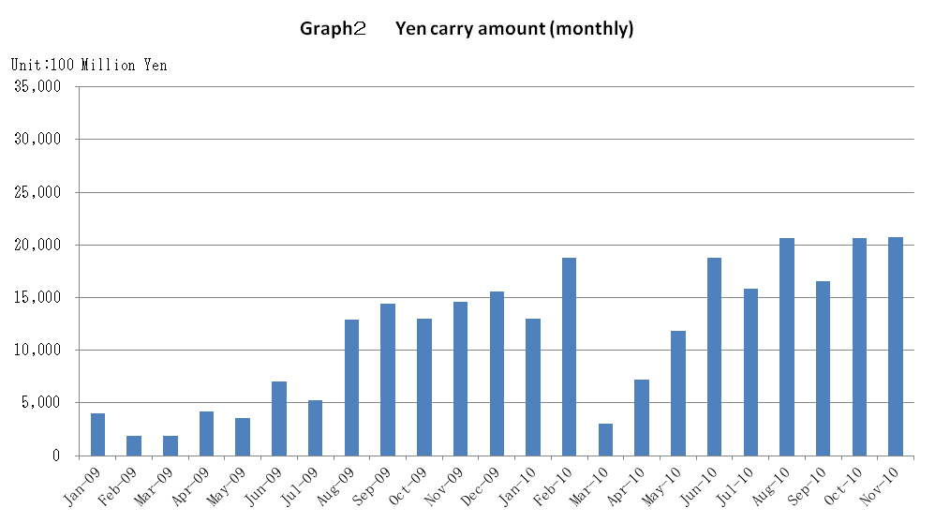

Announcement date：11/15/2010

Over-The-Counter FX Monthly Report（October 2010）
The Association publishes monthly trading volume, short open positions and long open positions of over-the-counter foreign exchange margin transactions since November 2008 with the help of members who participate to this project. 59 members participated to the report of October 2010.
The trading volume in Yen for October 2010 was 129,016.2 billion Yen (-6.5% from September), and short and long open positions as of the end of October 2010 were 639 billion Yen (-11.8％from the end of September) and 2,649.3billion Yen (＋12.9.% from the end of September), respectively. So-called Yen carry amount (net Yen short position) was 2,067.7 billion Yen (+24.56 % from the end of September).
The trading volume and the open positions reported by such 59 participants amounted to 99.25% and 98.05％ of the quarterly volume and open positions for July to September 2010 (85 members reported the trading record of over-the-counter foreign exchange margin transactions for the quarterly report).

(Unit: millions of base currency; millions of Yen, %)
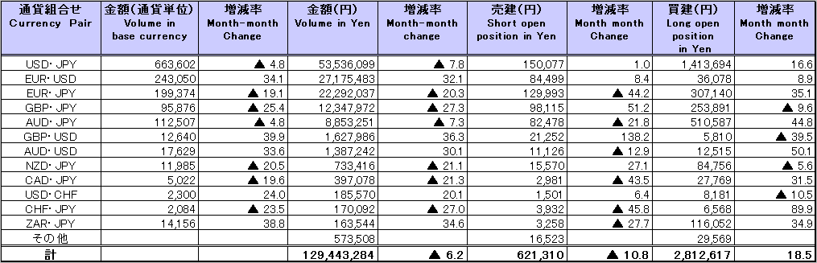
Because corrections are sometimes made by participants after the publication of the FX monthly report, there may be some differences between the figures shown in the text and the ones shown in the chart. In that case, the figures in the chart are accurate.

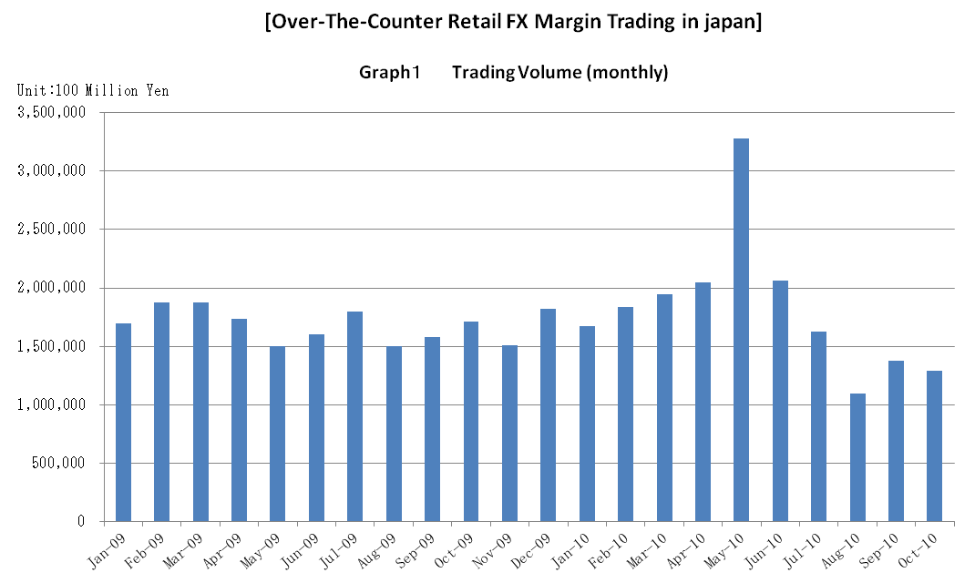

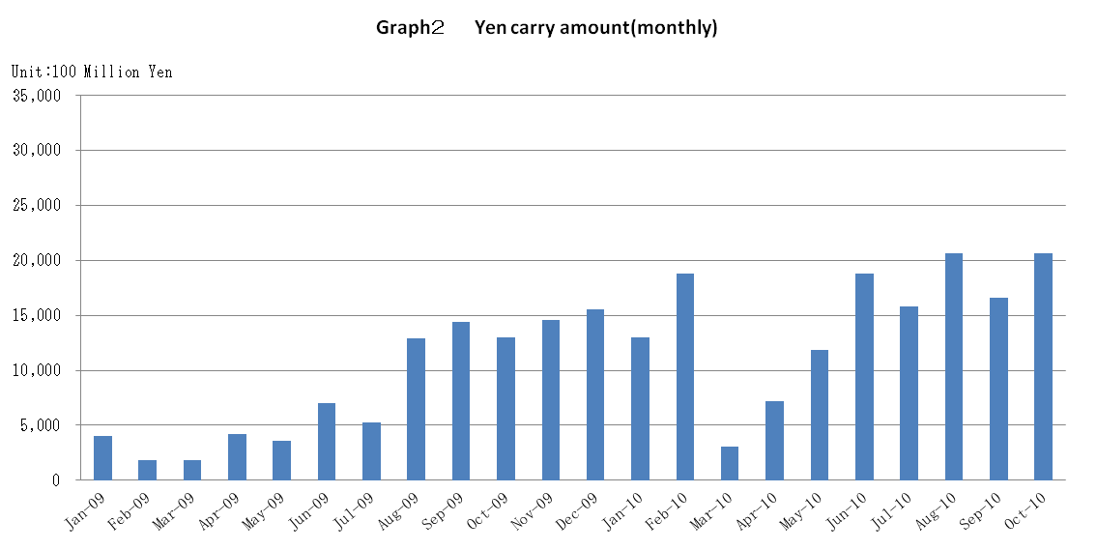

Announcement date：10/15/2010

Over-The-Counter FX Monthly Report（September 2010）
The Association publishes monthly trading volume, short open positions and long open positions of over-the-counter foreign exchange margin transactions since November 2008 with the help of members who participate to this project. 58 members participated to the report of September 2010.
The trading volume in Yen for September 2010 was 138,016.8 billion Yen (＋25.9% from August), and short and long open positions as of the end of September 2010 were 724.7 billion Yen (＋75.5％from the end of August) and 2,345.1billion Yen (-5.9% from the end of August), respectively. So-called Yen carry amount (net Yen short position) was 1,660 billion Yen (-19.75% from the end of August).
The trading volume and the open positions reported by such 58 participants amounted to 98.37% and 95.64％ of the quarterly volume and open positions for April to June 2010 (87 members reported the trading record of over-the-counter foreign exchange margin transactions for the quarterly report).

(Unit: millions of base currency; millions of Yen, %)
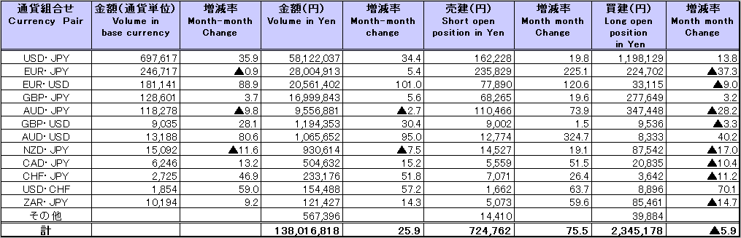

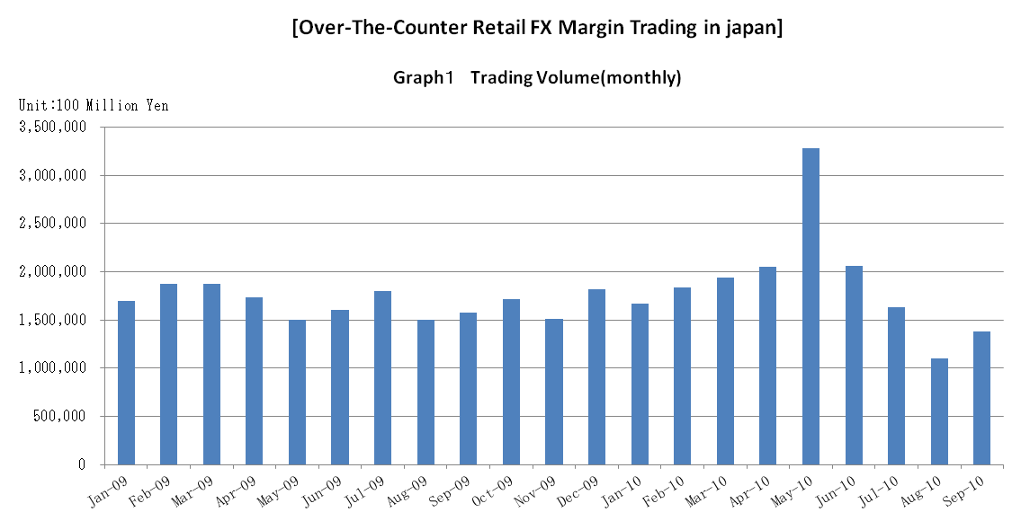

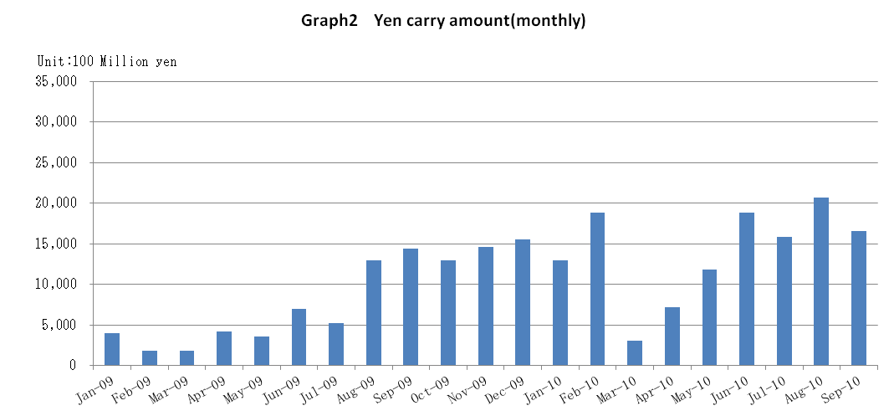

Announcement date：9/14/2010

Over-The-Counter FX Monthly Report（August 2010）
The Association publishes monthly trading volume, short open positions and long open positions of over-the-counter foreign exchange margin transactions since November 2008 with the help of members who participate to this project. 58 members participated to the report of August 2010.
The trading volume in Yen for August 2010 was 109,615.5billion Yen (-32.6% from July), and short and long open positions as of the end of August 2010 were412.7billion Yen (-32.4％from the end of July) and 2,494.0billion Yen (+14.3% from the end of July), respectively. So-called Yen carry amount (net Yen short position) was 2,068.8 billion Yen (+30.9% from the end of July).
The trading volume and the open positions reported by such 58 participants amounted to 98.37% and 95.64％ of the quarterly volume and open positions for April to June 2010 (87 members reported the trading record of over-the-counter foreign exchange margin transactions for the quarterly report).

(Unit: millions of base currency; millions of Yen, %)
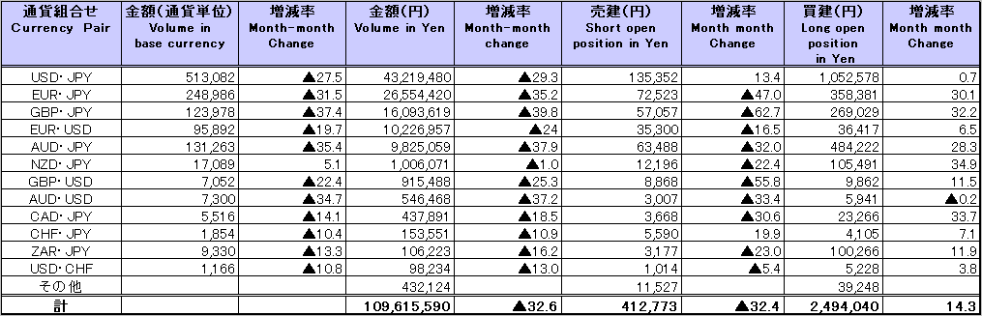

Announcement date：8/16/2010

Over-The-Counter FX Monthly Report（July 2010）
The Association publishes monthly trading volume, short open positions and long open positions of over-the-counter foreign exchange margin transactions since November 2008 with the help of members who participate to this project. 58 members participated to the report of July 2010.
The trading volume in Yen for July 2010 was 162,868 billion Yen (-21.0% from June), and short and long open positions as of the end of July 2010 were 611.1 billion Yen (＋19.1％from the end of June) and 2108.3 billion Yen (-10.4% from the end of June), respectively. So-called Yen carry amount (net Yen short position) was 1580.2 billion Yen (-16.8% from the end of June).
The trading volume and the open positions reported by such 58 participants amounted to 98.37% and 95.59％ of the quarterly volume and open positions for April to June 2010 (87 members reported the trading record of over-the-counter foreign exchange margin transactions for the quarterly report).
Corrections were made by two participants for June record. Please refer to back number June2010.And the number of members which reported the trading record of over-the-counter foreign exchange margin transactions for the January to March 2010 was 88 (instead of 91).

(Unit: millions of base currency; millions of Yen, %)
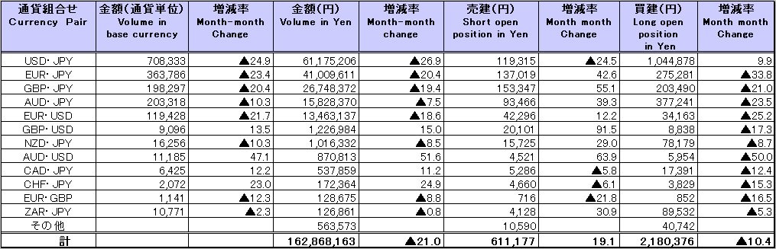

Announcement date：7/14/2010

Over-The-Counter FX Monthly Report（June 2010）
The Association publishes monthly trading volume, short open positions and long open positions of over-the-counter foreign exchange margin transactions since November 2008 with the help of members who participate to this project. 57 members participated to the report of June2010.
The trading volume in Yen for June 2010 was 206,392 billion Yen (-37.0% from May), and short and long open positions as of the end of June 2010 were 517.3 billion Yen (-22.4％from the end of May) and 2,420.5 billion Yen (+28.2% from the end of May), respectively. So-called Yen carry amount (net Yen short position) was 1,882.5 billion Yen (+59.3% from the end of May).
The trading volume and the open positions reported by such 57 participants amounted to 98.78% and 96.17％ of the quarterly volume and open positions for January to March 2010 (91 members reported the trading record of over-the-counter foreign exchange margin transactions for the quarterly report).

(Unit: millions of base currency; millions of Yen, %)
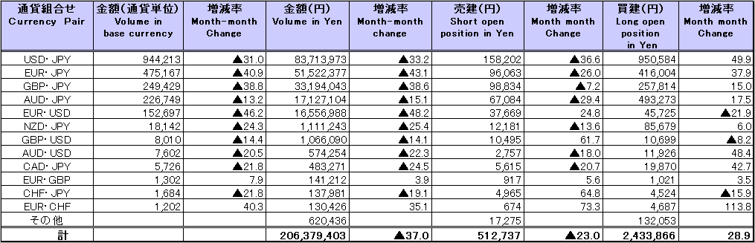

Announcement date：6/14/2010

Over-The-Counter FX Monthly Report（May 2010）
The Association publishes monthly trading volume, short open positions and long open positions of over-the-counter foreign exchange margin transactions since November 2008 with the help of members who participate to this project. 57 members participated to the report of May 2010.
The trading volume in Yen for May 2010 was 327,796.6 billion Yen (+59.9% from April), and short and long open positions as of the end of May 2010 were 666.7 billion Yen (-39.3％from the end of April) and 1,887.7 billion Yen (+0.4% from the end of April), respectively. So-called Yen carry amount (net Yen short position) was 1,181.7 billion Yen (+63.33% from the end of April).
The trading volume and the open positions reported by such 57 participants amounted to 98.79% and 95.25% of the quarterly volume and open positions for January to March 2010 (91 members reported the trading record of over-the-counter foreign exchange margin transactions for the quarterly report).

(Unit: millions of base currency; millions of Yen, %)
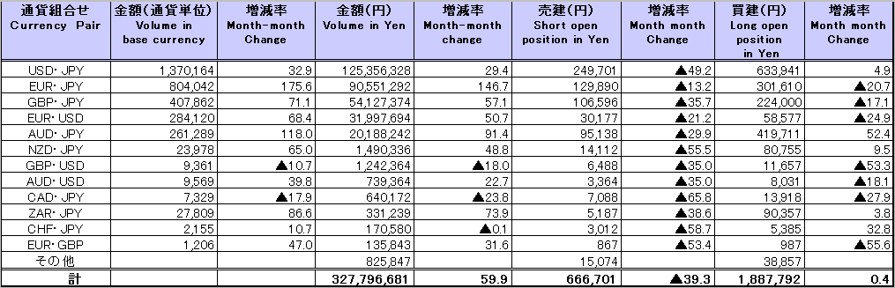

Announcement date：5/19/2010

Over-The-Counter FX Monthly Report（April 2010）
The Association publishes monthly trading volume, short open positions and long open positions of over-the-counter foreign exchange margin transactions since November 2008 with the help of members who participate to this project. 58 members participated to the report of April 2010.
The trading volume in Yen for April 2010 was 204,991.5 billion Yen (+5.7% from March), and short and long open positions as of the end of April 2010 were 1,099.2 billion Yen (-13.1％from the end of March) and 1,879.6 billion Yen (+17.3% from the end of March), respectively. So-called Yen carry amount (net Yen short position) was 723.5 billion Yen (+139.2% from the end of March).
The trading volume and the open positions reported by such 58 participants amounted to 98.79% and 95.91% of the quarterly volume and open positions for January to March 2010 (91 members reported the trading record of over-the-counter foreign exchange margin transactions for the quarterly report).
Corrections were made by two participants for March record. The second and third tables below show figures after the corrections.

(Unit: millions of base currency; millions of Yen, %)
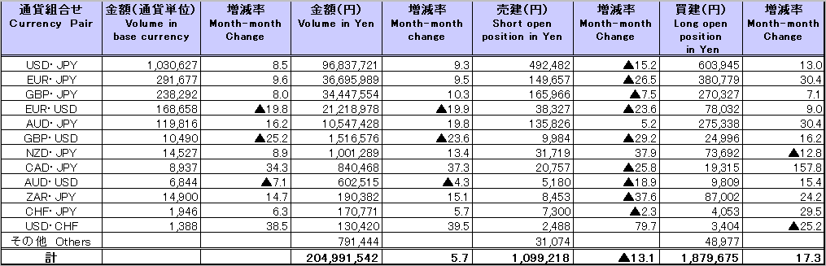

Announcement date：4/14/2010

Over-The-Counter FX Monthly Report（March 2010）
The Association publishes monthly trading volume, short open positions and long open positions of over-the-counter foreign exchange margin transactions since November 2008 with the help of members who participate to this project. 59 members participated to the report of March 2010.
The trading volume in Yen for March 2010 was 194,384.6 billion Yen (+5.8% from February), and short and long open positions as of the end of March 2010 were 1,264.4 billion Yen (+143.4％from the end of February) and 1,602 billion Yen (-34.1% from the end of February), respectively. So-called Yen carry amount (net Yen short position) was 305.2 billion Yen (-83.75% from the end of February).
The trading volume and the open positions reported by such 59participants amounted to 98.89% and 95.33% of the quarterly volume and open positions for October to December 2009 (91 members reported the trading record of over-the-counter foreign exchange margin transactions for the quarterly report).
There were corrections to Yen figures for the report of January 2010. Foreign exchange rates as of January 2009 were used instead of January 2010. We apologize for this inconvenience.
The second table below shows figures after the corrections.

(Unit: millions of base currency; millions of Yen, %)
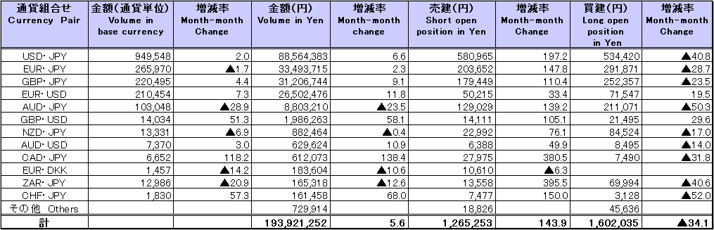

Announcement date：3/12/2010

Over-The-Counter FX Monthly Report(February 2010)

The Association publishes monthly trading volume, short open positions and long open positions of over-the-counter foreign exchange margin transactions since November 2008 with the help of members who participates to this project. 60 members participated to the report of February 2010.
The trading volume in Yen for February 2010 was 183,575.5 billion Yen (+9.7 % from January), and short and long open positions as of the end of February 2010 were 518.5 billion Yen (-13.5% from the end of January) and 2,431.4 billion Yen (+24.4% from the end of January), respectively. So-called Yen carry amount (net Yen short position) was 1,879.2 billion Yen (+44.8% from the end of January).
The trading volume and the open positions reported by such 60 participants amounted to 98.8% and 95.3% of the quarterly volume and open positions for October to December 2009 (91 members reported the trading record of over-the-counter foreign exchange margin transactions for the quarterly report).

(Unit: millions of base currency; millions of Yen, %)
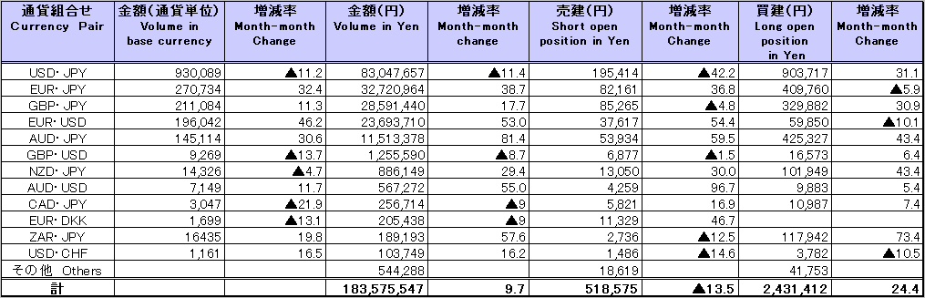

Announcement date：2/15/2010

Over-The-Counter FX Monthly Report（January 2010）
The Association publishes monthly trading volume, short open positions and long open positions of over-the-counter foreign exchange margin transactions since November 2008 with the help of members who participates to this project. 60 members participated to the report of January 2010.
The trading volume in Yen for January 2010 was 167,236.3 billion Yen (-7.6 % from December), and short and long open positions as of the end of January 2010 were 600.1 billion Yen (-41.9% from the end of December) and 1,955.3 billion Yen (+25.8% from the end of December), respectively. So-called Yen carry amount (net Yen short position) was 1,298.4 billion Yen (+174.3% from the end of December).
The trading volume and the open positions reported by such 60 participants amounted to 98.7% and 94.9% of the quarterly volume and open positions for October to December 2009 (91 members reported the trading record of over-the-counter foreign exchange margin transactions for the quarterly report).

(Unit: millions of base currency; millions of Yen, %)
