Over-The-Counter FX Monthly Report
(November 2009～December 2009)

The Financial Futures Association of Japan

Monthly Report
December 2009
November 2009

This material is the revised report previously issued by the Financial Futures Association of Japan(FFAJ).
This is not intended to make solicitation for investments.

Announcement date：1/18/2010

Over-The-Counter FX Monthly Report (December2009)

The Association publishes monthly trading volume, short open positions and long open positions of over-the-counter foreign exchange margin transactions since November 2008 with the help of members who participates to this project. 60 members participated to the report of December 2009.
The trading volume in Yen for December 2009 was 181,777.8 billion Yen (+20.6 % from November), and short and long open positions as of the end of December 2009 were 1,036.3 billion Yen (+59.1% from the end of November) and 1,556.4 billion Yen (-25.6% from the end of November), respectively. So-called Yen carry amount (net Yen short position) was 474.0 billion Yen (-67.5% from the end of November).
The trading volume and the open positions reported by such 60 participants amounted to 98.58% and 94.72% of the quarterly volume and open positions for July to September 2009 (98 members reported the trading record of over-the-counter foreign exchange margin transactions for the quarterly report).

(Unit: millions of base currency; millions of Yen, %)
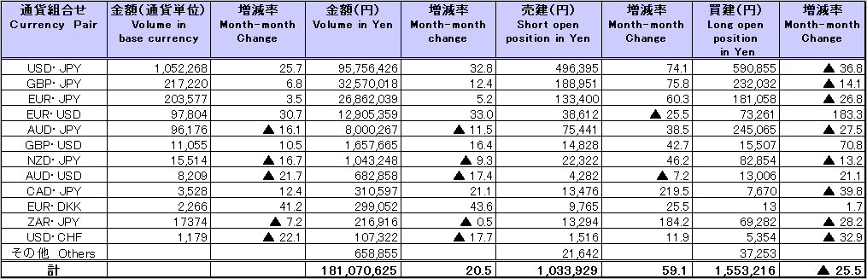

Announcement date：12/14/2009

Over-The-Counter FX Monthly Report (November 2009)

The Association publishes monthly trading volume, short open positions and long open positions of over-the-counter foreign exchange margin transactions since November 2008 with the help of members who participates to this project. 61 members participated to the report of November 2009.
The trading volume in Yen for November 2009 was 150,664.8 billion Yen (-12.0 % from October), and short and long open positions as of the end of November 2009 were 651 billion Yen (-8.2% from the end of October) and 2,092.5 billion Yen (+3.2% from the end of October), respectively. So-called Yen carry amount (net Yen short position) was 1,460.5 billion Yen (+12.6% from the end of October).
The trading volume and the open positions reported by such 61 participants amounted to 96.8% and 95.3% of the quarterly volume and open positions for July to September 2009 (98 members reported the trading record of over-the-counter foreign exchange margin transactions for the quarterly report).

(Unit: millions of base currency; millions of Yen, %)
